 | World Radiocommunication Conference (WRC-23)  Dubai, 20 November - 15 December 2023 |  | 
PLENARY MEETING |  | Document 123-E
 |  | 29 October 2023
 |  | Original: English
Solomon Islands/Tonga (Kingdom of)
PROPOSALS FOR THE WORK OF THE CONFERENCE
Agenda item 7(A)
7 to consider possible changes, in response to Resolution 86 (Rev. Marrakesh, 2002) of the Plenipotentiary Conference, on advance publication, coordination, notification and recording procedures for frequency assignments pertaining to satellite networks, in accordance with Resolution 86 (Rev.WRC-07), in order to facilitate the rational, efficient and economical use of radio frequencies and any associated orbits, including the geostationary-satellite orbit;
7(A) Topic A - Tolerances for certain orbital characteristics of non-GSO space stations in the FSS, BSS or MSS
Proposal summary
Based on studies as detailed below, the signatory countries justify the need for a minimum altitude tolerance value of 70 km for all regulatory purposes, i.e. complying with Appendix 4 of the ITU Radio Regulations (RR), bringing-into-use (BIU), and deployment milestones in Resolution 35 (WRC-19).
Background
Orbital tolerances are a delicate subject, which does not involve only interference-related issues. Actually, as it has been demonstrated via ITU-R studies, it is straightforward to ensure that the interference into other systems is not increased. There are broader issues linked to orbital tolerances, which affect co-existence of non-geostationary-satellite orbit (non-GSO) systems at similar orbit altitudes as well as space safety in general. Consequently, when deciding on the appropriate tolerance value, it is important to take all aspects into account and do not overly-constrain systems and generate unintended long-term consequences for the sustainable use of orbit resources. While it may sound as counter-intuitive, studies have shown that a strict orbital tolerance value, e.g. 30 km or less, would result in a de facto monopoly/warehousing or orbital shells, which would negatively affect the use of orbital resources. On the contrary, a more flexible approach to tolerances, i.e. granting a minimum of 70 km tolerance, would ensure that even large systems can co-exist at similar orbits or, in the worst-case, one system would be allowed to move to another safe orbit without regulatory consequences.
The latest Working Party (WP) 4A meeting (June/July 2023) received contributions showing how determining orbital tolerances is a complex exercise and implies taking into account several factors, including:
• Characteristics of the non-GSO system involved and LEO orbits.
• Orbit optimization to avoid collisions between satellites in the same constellation and keep altitude constant at given latitudes (e.g. frozen orbits).
• Physical co-existence between collaborative and non-collaborative systems at similar orbital altitudes.
• For systems flying lower than 600/700 km, the effect of atmospheric drag on satellites and the variations of such atmospheric drag with solar activity.
Other aspects like launch orbit injection accuracy.
The driving factor in terms of tolerance value was shown to be co-existence of systems at similar orbits. In case of collaborative systems and based on WP 4A studies, an absolute minimum tolerance of 50 km would be needed. In case of non-collaborative systems, operators will require an absolute minimum tolerance of 70 km (considering a reasonable buffer of 5-10 km).
Let’s start from operations of individual systems in isolation. These systems, especially the large ones, implement orbit optimization techniques, e.g. frozen orbits or repeat ground track. A frozen orbit (see: https://leonardotimes.com/2016/09/22/frozen-orbits/) is one chosen to minimize the effect of perturbations on a selected set of mean orbital elements. For many systems, frozen orbits are chosen to keep altitude constant at given latitudes. For example, if an argument of perigee is selected at 90 degrees, then perigee will always be at the highest Northern latitude and apogee will always be at the highest Southern latitude. One use of frozen orbits for large constellations is to reduce the number of conjunction events within the same orbital shell and between shells in close proximity. In most cases, increasing eccentricity, and therefore a difference in apogee and perigee, is used to implement frozen orbits.
The Figure below analyses a scenario in which two large systems plan to co-exist at the same orbit altitude and they both implement frozen orbits while they filed circular orbits at the ITU.
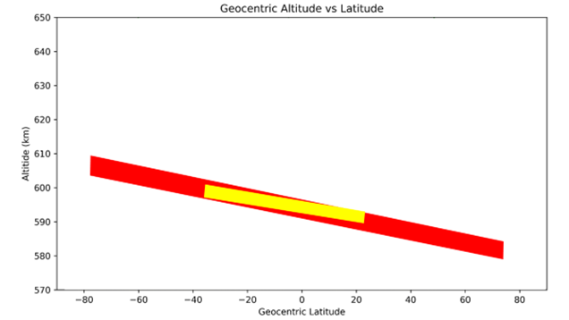
Let’s first consider the red system in isolation. Only because of the frozen orbits optimization, the red system needs 30 km tolerance. Technically, the red system should notify the precise parameters of the frozen orbits (or anyway the orbital disposition) at notification stage, but this is not possible (and this is why they file perfectly circular orbits), as an operator cannot predict those parameters. Moreover, those parameters have to be adapted / changed during the course of the lifetime of the system and the eccentricity value of the single satellites may have to be changed several / numerous times. So, flexibility is needed.
Now let’s move to considering the addition of another system (in this example the yellow system) that wants to co-exist at the same orbit altitude. When the yellow system is added, these systems cannot co-exist like that, there is a need for an additional tolerance and one of the two need to move up or down by a specific minimum amount. On top of the 30 km you need to add 10 km for the actual tolerance movement and then 5/10 km safety buffer, thus leading to the calculated 50 km tolerance in case of collaborative systems (see below). They can now easily co-exist. They exchange information regularly and they co-exist without risks. But you need 50 km to accommodate the needs of both.
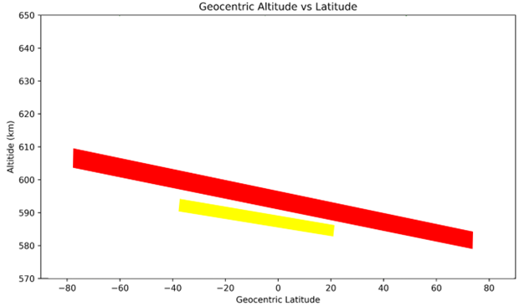
In brief, even in case of collaborative systems, a tolerance less than 50 km would lead to monopoly / warehousing of orbital space and orbital shells, which is something the ITU should avoid, as it goes against the principle of sustainable use of orbital resources. Then you have cases of non-collaborative systems. In those cases, a tolerance up to 70 km will be needed, as one of the systems has to move out of the way.
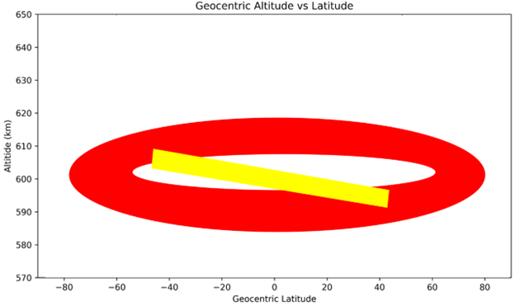
To conclude, studies have shown that a tolerance less than 50 km would basically result in orbit warehousing by a single system even in case of collaborative systems. And this value elevates to 70 km in case of non-collaborative systems.
On a last note, the latest WP 4A meeting demonstrated how straightforward is to manage interference into potential victims so that it is not worsened. In the downlink it is enough to keep the pfd constant on the ground. In the uplink it is enough to respect the uplink emission envelope of the filing or the e.i.r.p. mask submitted as per of the epfd submission.
Some administrations expressed the view that providing a wide tolerance such as 70 km would result in uncertainty for other systems / new entrants. This is not the case. Every non-GSO operator, before launching, makes the needed arrangements and agreements with other relevant non-GSO operators in order to minimize threats and risks. These arrangements / agreements do not depend on ITU, and in most cases they are bilateral agreements. Consequently, these kind of analyses and agreements would be in place even if the ITU did not decide on tolerances or if the tolerances were as little as 1 km or as large as 150 km. In brief, the ITU’s decision on tolerances would not impact in any way the strategic decision of operators to launch at specific altitudes and with specific orbit parameters. The first party interested in ensuring safe flights operations and pacific co-existence with others is the system operator itself, and its decisions are not dependant on ITU’s ruling on Topic A. And every concerned party knows well where the satellites of the others are at any point in time thanks to commonly-used real-time databases and tools.
In conclusion, based on studies and to avoid orbit warehousing by individual systems, we justify the need for a minimum altitude tolerance value of 70 km, and this value is needed in operations, i.e. after Notification.

Contact: | Stan Ahio  Ministry of Communications,  Tonga | Email: sahio@mic.gov.to

______________

