 | World Radiocommunication Conference (WRC-23)  Dubai, 20 November - 15 December 2023 |  | 
PLENARY MEETING |  | Document 121-E
 |  | 29 October 2023
 |  | Original: English
Kiribati (Republic of)/Micronesia (Federated States of)/Nauru (Republic of)/Papua New Guinea/Solomon Islands/Tonga (Kingdom of)/Tuvalu
PROPOSALS FOR THE WORK OF THE CONFERENCE
Agenda item 10
10 to recommend to the ITU Council items for inclusion in the agenda for the next world radiocommunication conference, and items for the preliminary agenda of future conferences, in accordance with Article 7 of the ITU Convention and Resolution 804 (Rev.WRC-19),
Proposal for future agenda item to study regulatory provisions for protection of geostationary-satellite orbit (GSO) fixed-satellite service (FSS) and broadcasting-satellite service (BSS) networks from unacceptable interference from non-GSO FSS systems in portions of the frequency bands 3 700-4 200 MHz, 5 925-6 725 MHz, 10.7-14.5 GHz, 17.3-20.2 GHz and 27.5-30 GHz in which RR Article 22 epfd limits apply.
Background
Non-GSO satellite systems capable of connecting the world’s unconnected are a reality and more systems will be deployed in the coming years. These systems deliver high-speed, low-latency broadband connectivity anywhere in the world, even in places where Internet access was previously too expensive, unreliable, or completely inaccessible. As of September 2023, publicly available data shows that non-GSO FSS systems serve more than two million users worldwide with the ambitious objective to play a significant role in connecting the 2 billion unconnected people. This would mean significant and tangible benefits for the global community.
Non-GSO FSS systems are completely dependent on shared spectrum. Article 22 of the Radio Regulations (RR) and Resolution 76 (Rev.WRC-15) contain equivalent power flux-density limits (epfd) developed in 1997 and 2000 to protect GSOs from unacceptable interference from non-GSOs. However, none of the systems for which the epfd limits were designed based on have ever been brought into operation. Today’s and future non-GSO FSS systems have evolved both in design and operational capabilities when compared to the systems that were considered when the RR Article 22 epfd limits were developed nearly twenty-five years ago. Of equal importance, both the technology and spectrum management principles of GSO networks have advanced far beyond the predecessor systems used to define the sharing regime in RR Article 22 and Resolution 76 (Rev.WRC-15). Finally, our knowledge of how non-GSO systems and GSO networks co-operate in the same spectrum has advanced significantly over the past two decades in which these sharing rules were derived.
Just in the past decade, our collective hours innovating on satellite design, improving operational efficiencies, and inserting customer experience back into the design process has created an iterative process that can inform the future of GSO and non-GSO spectrum sharing. Now, the 25-year-old policies tailored to the satellite networks and systems of their era are a hinderance to the efficient use of spectrum that is demanded by technologists, policy makers, and end-users. Technological progress in radio communications allows satellite systems to use innovative technologies, including smaller spot beams, adaptive coding and modulation, and frequency reuse. These technologies allow modern satellite systems to use spectrum more efficiently while also making them more resilient to interference. than the satellite systems of two decades ago. This is true for the fixed-satellite service, whether it operates in geostationary or non-geostationary orbits.
RR Article 22 epfd limits are spectrally inefficient, as demonstrated during work under WRC-19 agenda item (AI) 1.6 and included in Report ITU-R S.2462-0 (07/2019). The studies in Report ITU-R S.2462 indicated that “sharing methodologies between non-GSO and GSO FSS systems based on epfd limits masks as was done in frequency bands below 30 GHz are extremely system dependent” and “this situation can result in spectrum inefficiencies”. It further indicated that the “Optimal use of orbit and spectrum resources in the 50/40 GHz requires a more equitable regulatory environment between GSO networks and non-GSO FSS systems than has been established in bands below 30 GHz in order to take advantage of next generation satellite technology to provide high-capacity broadband services, while utilizing benefits of both non-GSO and GSO satellite orbits”. Given that the studies have already identified spectrum inefficiencies and inaccuracies issues below 30 GHz and that WRC-19 has adopted an improved regulatory framework applicable to bands above 30 GHz, it is clear that studies and regulatory solutions are necessary to develop possible remedies for spectrum sharing between non-GSO FSS and GSO networks in frequencies below 30 GHz.
Fundamentally, epfd limits were developed without considering long-term GSO protection criteria, which is antithetical to well-reasoned spectrum management practices. Epfd limits were developed considering a short-term aggregate protection criterion contained in recommends 3.1 of Recommendation ITU-R S.1323, that is, a 10% decrease in unavailability, and then subdividing these limits by a notional 3.5 operational non-GSO systems to obtain the single-entry limits. Consequently, because the sharing and regulatory provisions of RR Article 22 frequency bands where epfd limits apply have been shown to be inefficient and lacking any consideration of long-term protection thresholds, these deficiencies restrict the operation of non-GSO systems and hinder technological progress and the ability to provide services. Thus, it is urgent and necessary to review and update these limits.
Focusing on the inefficiencies of the existing epfd limits, it is possible for some non GSO satellites to exceed the aggregate epfd limits even though they passe the GSO protection criteria outlined in Recommendation ITU-R S.1323. Likewise, scenarios can arise in which a particular non-GSO system will meet a particular epfd limit but will not pass the sharing criteria outlined in Recommendation ITU-R S.1323. The inability to translate between regulation and the methodology used to create that regulation is an undeniable flaw. Notably, these deficiencies were studied for frequency bands below 30 GHz and these studied concluded that the epfd limits for these bands are inefficient and could be improved upon to allow for the ability for more spectral efficiency for modern non-GSO satellite systems. Namely, these studies, as contained in Report ITU-R S.2462 identified that the technology for non-GSO systems developed for frequency bands below 30 GHz is not consistent with technology of modern non-GSO networks and the spectrum management techniques used to develop those limits is not consistent with modern protections of GSO networks, i.e. multi-orbit and long-term protections. These study results were addressed in WRC-19 for the 50/40 GHz frequency bands, leading to a new and more efficient sharing framework for those bands and the entry into force of Resolutions 770 (WRC-19) and 769 (WRC-19).
In addition to the spectrum inefficiency that results from the methodology used to derive the aggregate epfd limits, long-term epfd limits for non-GSO system protection of GSO networks are disconnected from operational reality. The following scenario demonstrates the issues of the epfd limits below 30 GHz that restrict the operation of non-GSO systems. Recommendation ITU-R S.1432 recommends that the interference from non-GSO systems should be 25% of the clear sky, which is −6.02 dB. By re-using the 3.5 non-GSO systems assumptions from 1997 and 2000, such a value corresponds to −11.5 single entry. Figures 1-3 below show RR Article 22 epfd limits in the Ka- and Ku-band translated into I/N by using a earth station antenna noise temperature of 195 K and using a reference frequency of 17.8 GHz, 19.7 GHz and 10.7 GHz, respectively. All I/N curves, corresponding to the epfd limits for different diameter GSO receive antennas, have I/N well below −11.5 dB I/N at long term percentages of time.
Figure 1
Epfd limits in the Ka-band (17.8- 18.6 GHz) translated into I/N curves by assuming
a noise temperature of 195 K
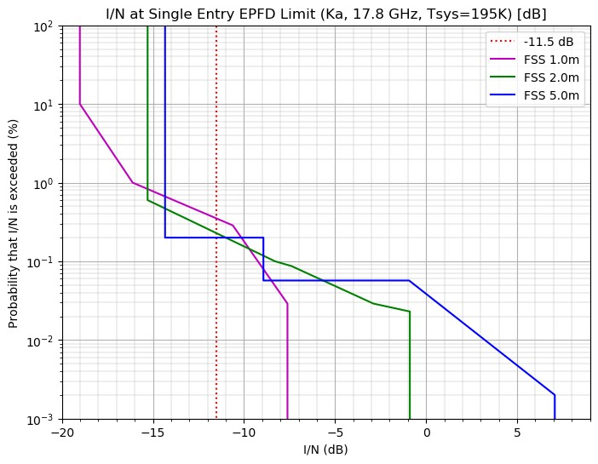

FIGURE 2
Epfd limits in the Ka-band (19.7-20.2 GHz) translated into I/N curves by assuming
a noise temperature of 195 K
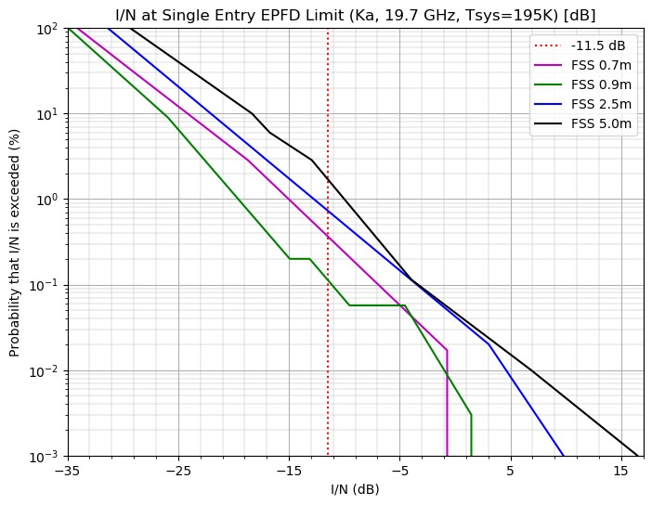
Figure 3
Epfd limits in the FSS Ku-band (10.7-11.7 GHz) translated into I/N curves by assuming
a noise temperature of 195 K
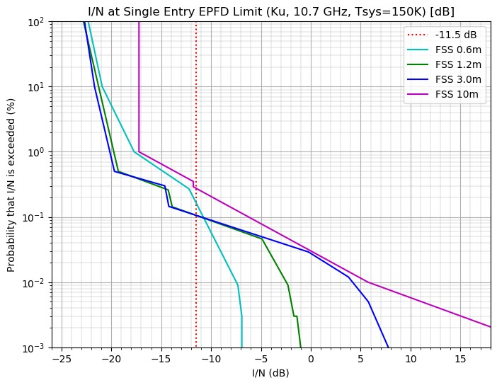

Figure 4
Epfd limits in the BSS Ku-band (11.7-12.7 GHz) translated into I/N curves by
assuming a noise temperature of 195 K
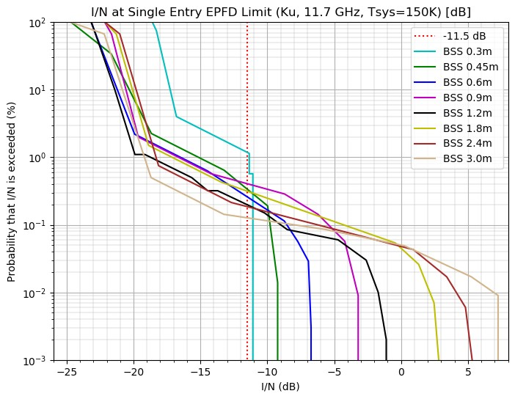
The proposal below seeks to improve the ability of non-GSO FSS systems to use the band frequencies subject to RR No. 22 epfd limits (including the aggregate limits in Resolution 76 (Rev.WRC-15). The impact of current limits on non-GSO operations is significant: as demonstrated by studies submitted at Working Party (WP) 4A in June/July 2023 (Doc. 4A/971), there is a potential reduction in capacity up to 8 times between current limits and a more efficient framework meeting Recommendation ITU-RS.1323 protection requirements. If non-GSO systems will be able to more efficiently share their spectrum while meeting aggregate limits to protect GSOs, there will be an impact on every non-GSO system, as the total spectrum utilization will be maximized facilitating greater access to this finite shared resource.
Finally, it is acknowledged that this new Agenda Item will partially overlap with the consideration of possible revisions to Resolution 76 (Rev.WRC-15) within AI 7, Topic J of WRC-23, which considers the establishment of a consultation process for assuring conformity with and rectifying potential exceedances of the aggregate epfd limits in that resolution and RR No. 22.5K. It is proposed to include those discussions as part of the work under this proposed Agenda Item.

Figure 5
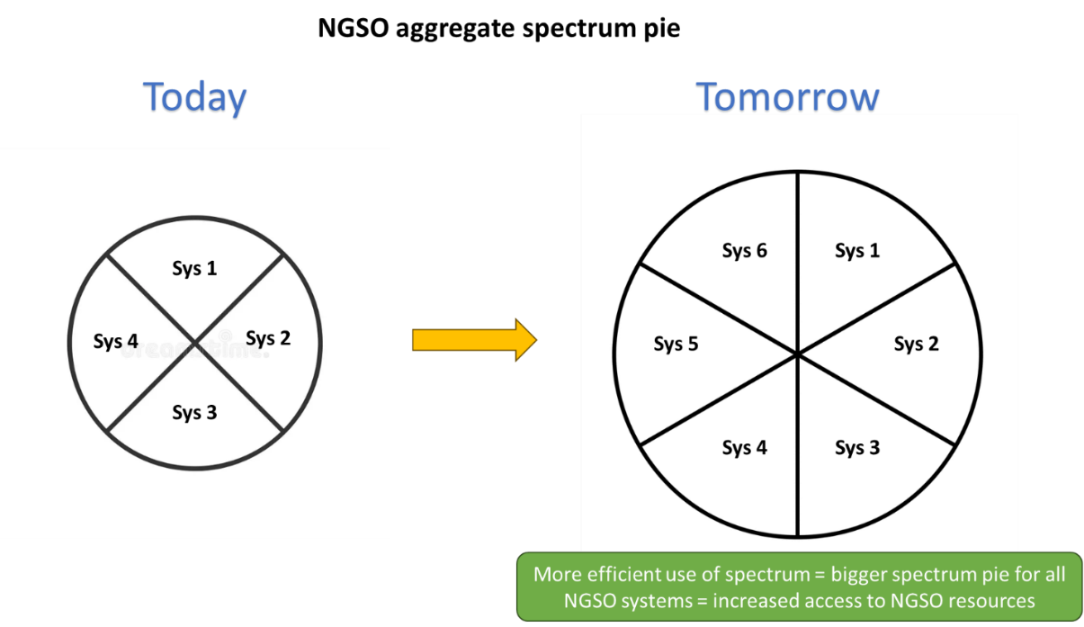
Lastly, it is very important to highlight that updating the RR Article 22 epfd limits is beneficial also for GSO networks, as they would benefit from the possibility of introducing in the new studies their current and planned reference links, which would encompass their modern operations, for example, by including small terminals, which were not considered 25 years ago. This would give further reassurance that their operations are adequately protected.
Remarks
As stated several times in the contribution, regardless of the solution that may be agreed upon at WRC-27, GSOs will be protected as per RR Article 22.2, which obliges non-GSO systems not to cause unacceptable interference into GSO networks. Consequently, no risk for GSO operations and investments.
Some GSO operators expressed the view that the I/N threshold used when demonstrating the GSO overprotection for single-entry limits is inappropriate and a different more conservative value should be used, i.e. −17.6. Even by using the threshold of −17.6 I/N suggested by these operators, which is not the correct GSO protection criteria as demonstrated above still demonstrates significant margin to GSO protection. The maximum exceedance would still be a whopping 5-16 dB depending on the frequency bands used. The plots below focus on aggregate epfd limits and they include both thresholds, −6.02 (which, as shown in this contribution, is the appropriate value) and −12.2 I/N.

Figure 6
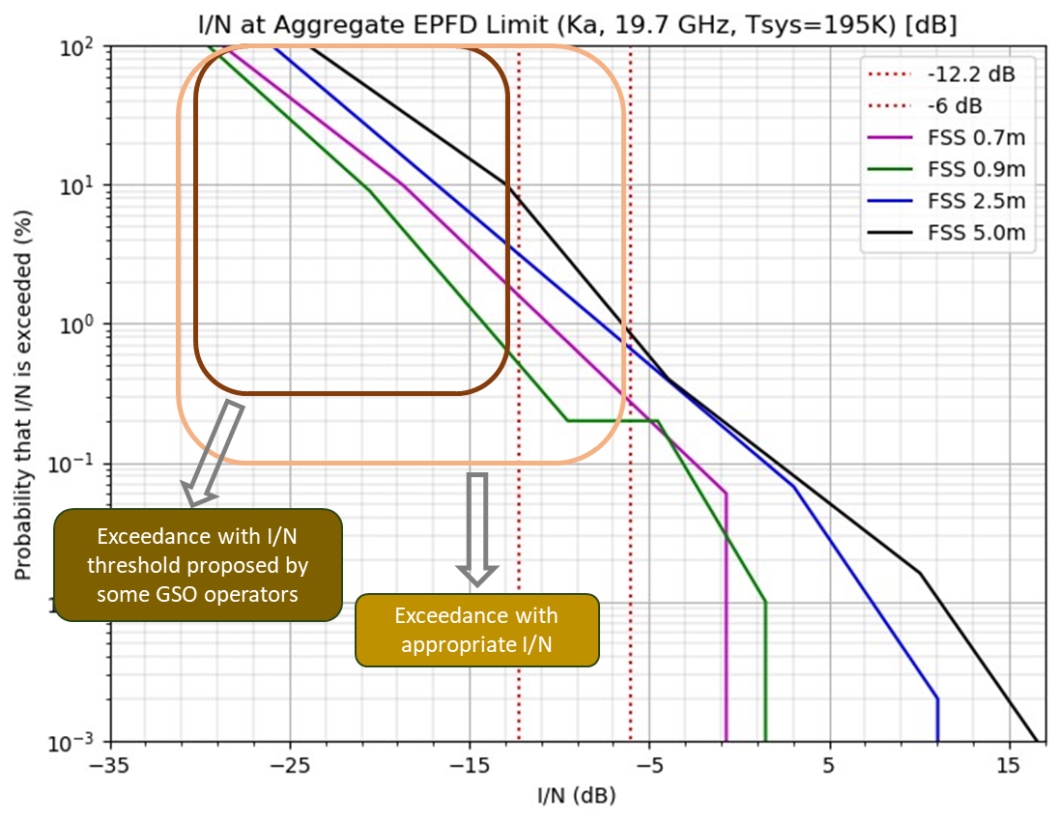
Figure 7
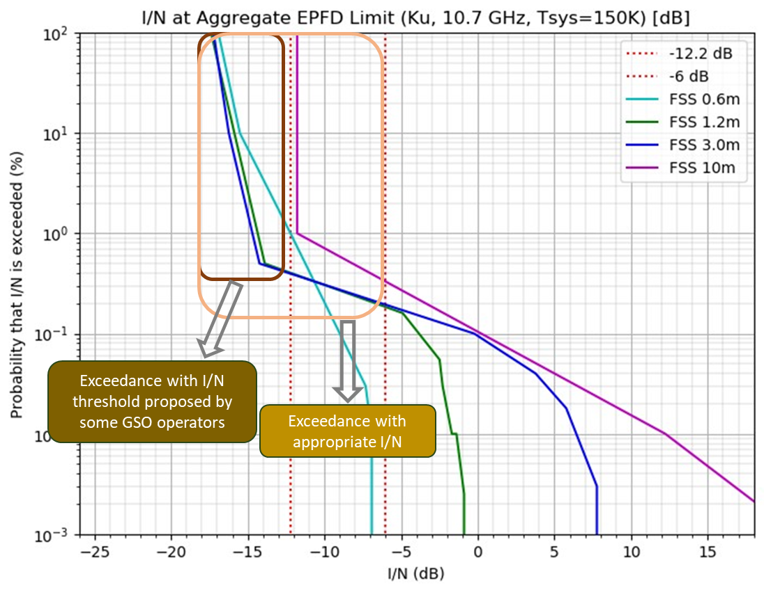

Figure 8
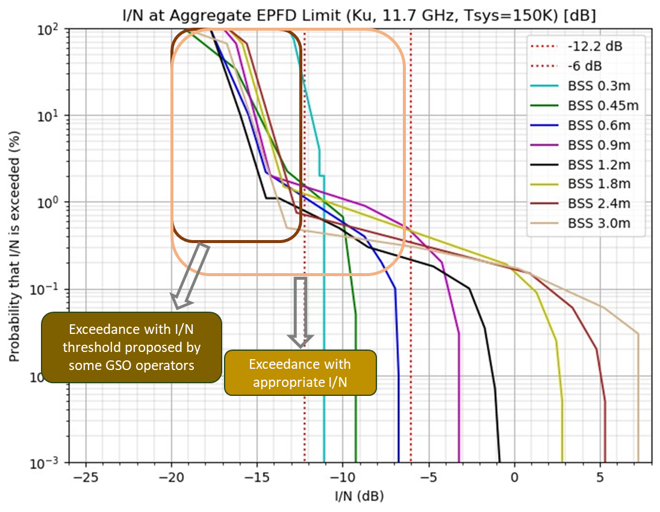
An additional important aspect to consider is the complementarity between this agenda item and the on-going work at ITU-R on the modelling of non-GSO systems operations, especially Recommendation ITU-R S.1503. That work is focused at improving as much as possible our ability to model non-GSO operations as accurately as possible while respecting existing limits. Consequently, the proposal to study and review the limits and the on-going ITU-R work go hand in hand and they both aim at efficient use of spectrum resources.
Figure 9
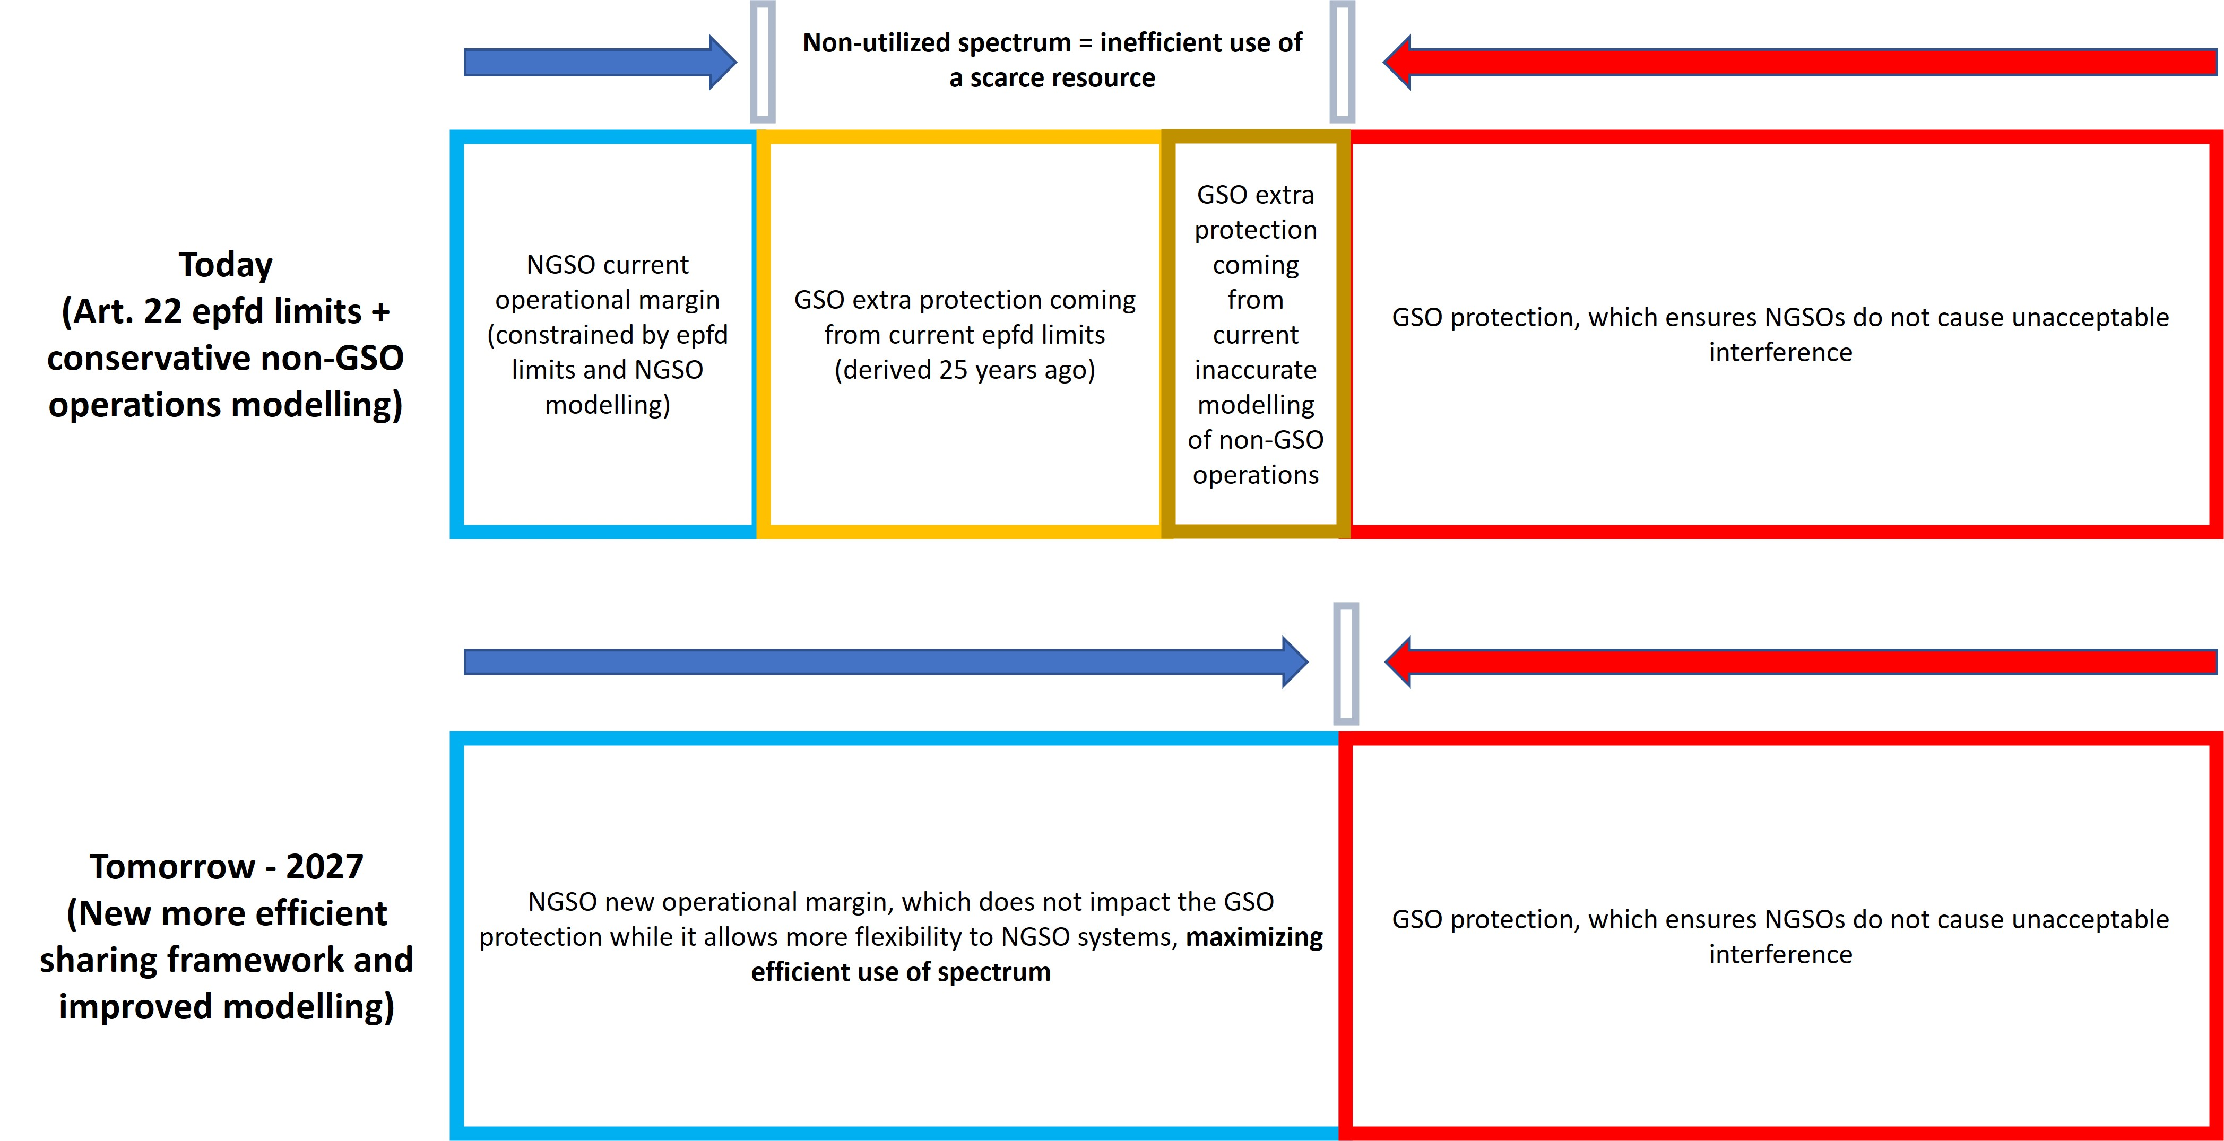
Proposal
The signatory countries propose to conduct, and complete in time for WRC-27, studies of the current regulatory provisions, including epfd limits, for non-GSO FSS systems to protect GSO FSS and BSS networks from unacceptable interference in the portions of the frequency bands 3 700-4 200 MHz, 5 925-6 725 MHz, 10.7-14.5 GHz, 17.3-20.2 GHz and 27.5-30 GHz where RR Article 22 epfd limits apply, including evaluation by administrations of the aggregate epfd limits in Resolution 76 (Rev.WRC-15), and the implementation of those regulatory provisions, without modifying the requirements or conditions for coordination under RR Nos. 9.7A and 9.7B, with the objective of protecting GSO networks in accordance with RR No. 22.2 and improving efficient use of the spectrum resource. Based on the results of the studies, and as appropriate, potential modifications could be developed to the regulatory provisions, including epfd limits, for non-GSO FSS systems to protect GSO FSS and BSS networks from unacceptable interference in the portions of the frequency bands 3 700-4 200 MHz, 5 925-6 725 MHz, 10.7-14.5 GHz, 17.3-20.2 GHz and 27.5-30 GHz where RR Article 22 epfd limits apply, or replacement of the epfd framework with another approach and development of associated limits, without modification to RR No. 22.2.

ADD KIR/FSM/NRU/PNG/SLM/TON/TUV/121/1
DRAFT NEW RESOLUTION [TON-10-2027] (WRC-23)
Agenda for the 2027 World Radiocommunication Conference
The World Radiocommunication Conference (Dubai, 2023),
considering
a) that, in accordance with No. 118 of the ITU Convention, the general scope of the agenda for a world radiocommunication conference (WRC) should be established four to six years in advance and that a final agenda shall be established by the ITU Council two years before the conference;
b) Article 13 of the ITU Constitution relating to the competence and scheduling of WRCs and Article 7 of the Convention relating to their agendas;
c) the relevant resolutions and recommendations of previous world administrative radio conferences (WARCs) and WRCs,
recognizing
a) that this conference has identified a number of urgent issues requiring further examination by WRC-27;
b) that, in preparing this agenda, some items proposed by administrations could not be included and have had to be deferred to future conference agendas,
resolves
to recommend to the Council that a WRC be held in 2027 for a maximum period of four weeks, with the following agenda:
1 on the basis of proposals from administrations, taking account of the results of WRC-23 and the Report of the Conference Preparatory Meeting, and with due regard to the requirements of existing and future services in the frequency bands under consideration, to consider and take appropriate action in respect of the following items:
...
1.x to study, review, and update or replace, as appropriate, the regulatory provisions for the protection of GSO FSS and BSS networks from unacceptable interference from non-GSO FSS systems in portions of the frequency bands 3 700-4 200 MHz, 5 925-6 725 MHz, 10.7-14.5 GHz, 17.3-20.2 GHz and 27.5-30 GHz in which Article 22 epfd limits apply, and implementation of those provisions, in accordance with Resolution [EPFD REVISION] (WRC-23),
invites the ITU Council
to finalize the agenda and arrange for the convening of WRC-27, and to initiate as soon as possible the necessary consultations with Member States,
instructs the Director of the Radiocommunication Bureau
1 to make the necessary arrangements to convene meetings of the Conference Preparatory Meeting (CPM) and to prepare a report to WRC-27;
2 to submit a draft report on any difficulties or inconsistencies encountered in the application of the Radio Regulations referred in agenda item 9.2 to the second session of the CPM and to submit the final report at least five months before the next WRC,
instructs the Secretary-General
to communicate this Resolution to international and regional organizations concerned.
Reasons: To provide for studies to review and possibly revise, as appropriate, the regulatory provisions for protection of GSO FSS and BSS networks from unacceptable interference from non-GSO FSS systems in the frequency bands below 30 GHz in which RR Article 22 epfd limits apply, and the implementation of those provisions.
ADD KIR/FSM/NRU/PNG/SLM/TON/TUV/121/2
DRAFT NEW RESOLUTION [EPFD REVISION] (WRC-23)
Study of regulatory provisions for protection of GSO FSS and BSS networks from unacceptable interference from non-GSO FSS systems in portions of the frequency bands 3 700-4 200 MHz, 5 925-6 725 MHz, 10.7-14.5 GHz, 17.3-20.2 GHz and 27.5-30 GHz in which Article 22 epfd limits apply
The World Radiocommunication Conference (Dubai, 2023),
considering
a) that the ITU and United Nations has recognized the need for access to broadband to underserved and unserved regions of the world and has launched initiatives through the Partner2Connect initiative with a goal of developing meaningful connectivity and digital transformation globally, with a focus on but not limited to communities without access to digital connections;
b) that systems based on the use of new technologies associated with both geostationary-satellite orbit (GSO) fixed-satellite service (FSS) and broadcasting-satellite service (BSS) networks and non-geostationary-satellite orbit (non-GSO) FSS constellations in frequency bands below 30 GHz in which Article 22 equivalent power flux-density (epfd) limits apply are capable of providing high-capacity means of communication to rural and remote regions of the world;
c) that both non-GSO FSS systems and GSO FSS networks are more technologically advanced than the systems that were considered in the development of Article 22 epfd limits in WRC-1997 and WRC-2000;
d) that GSO links used in the derivation of epfd limits for WRC-97 may not reflect the operations of modern GSO networks;
e) that the GSO orbit and its associated spectrum are a valuable resource that is heavily utilized around the world;
f) that non-GSO satellite orbit systems have been deployed recently in the bands referred to in considering a) above;
g) that the epfd limits applicable to non-GSO FSS systems in the frequency bands below 30 GHz in which Article 22 epfd limits apply may not accurately reflect the protection required by GSO FSS and BSS networks;
h) that there is a need to encourage the development and implementation of both GSO and non-GSO technologies to meet the growing demand for satellite services globally;
i) the need to encourage the development and implementation of both GSO and non-GSO technologies in the frequency bands below 30 GHz, in accordance with No. 5.484A;
j) that there is a need to ensure efficient use of co-frequency spectrum resources for non-GSO FSS systems and GSO FSS and BSS networks;
k) that the certainty of the interference environment provided by epfd limits has enabled technological advancements to date and appropriate limits will be critical for continued innovation in GSO and non-GSO networks and services;
l) that non-GSO FSS systems could be based on multiple filings for the same frequency bands;
m) that currently the BR assesses compliance with the single-entry Article 22 limits based on individual filings;
n) that GSO and non GSO FSS systems may benefit from an updated review of the implementation of Article 22 epfd limits consistent with No. 22.2,
noting
that Recommendations ITU-R S.1323, ITU-R S.1325, ITU-R S.1328, ITU-R S.1529, ITU-R S.1557, ITU-R S.2131, among others, provide information on system characteristics, operational requirements and protection criteria that may be used in sharing studies,
recognizing
a) that according to No. 22.2, non-GSO systems shall not cause unacceptable interference to, and shall not claim protection from geostationary orbit satellite networks in the fixed-satellite services and the broadcasting-satellite service.
b) that the Article 22 and Resolution 76 (Rev.WRC-15) epfd limits apply to non-GSO FSS systems to protect GSO FSS and BSS satellite networks from unacceptable interference from non-GSO FSS satellite systems;
c) that WRC-2000 adopted provisions, including epfd limits in relevant provisions of No. 22.5 to quantify No. 22.2 in order to protect GSO FSS and BSS satellite networks from non-GSO FSS satellite systems in the frequency bands below 30 GHz in which the Article 22 epfd limits apply;
d) that Article 22 and Resolution 76 (WRC-19) of the Radio Regulations contains provisions that include uplink, downlink and inter-satellite equivalent power flux-density (epfd↑, epfd↓, and epfd_{is}) limits; and that an administration operating a non-GSO FSS system in compliance with these limits is considered as having fulfilled its obligations under No. 22.2;
e) that any revision to Article 22 epfd limits must protect GSO FSS and BSS satellite networks consistent with No. 22.2;
f) that WRC-2000 agreed that additional protection above that provided by the epfd↓ limits in the portions of the frequency bands 30/20 GHz in which Article 22 epfd limits apply is required for certain GSO FSS networks with specific receive earth stations with very large antennas and that, in order to provide this additional protection, WRC-2000 adopted a procedure for identifying the need for coordination under Nos. 9.7A and 9.7B;
g) that the procedure for identifying the need for coordination under Nos. 9.7A and 9.7B is based on bandwidth overlap and the conditions specified in Appendix 5 for the GSO FSS earth station antenna maximum isotropic gain, G/T and emission bandwidth and the epfd↓ radiated by the non-GSO FSS satellite system into the earth station employing the very large antenna;
h) that Recommendation ITU-R S.1323 provides information on operational requirements and protection criteria that may be used in epfd sharing studies;
i) that Article 22 and Resolution 76 (Rev.WRC-15) epfd limits were derived taking into account only a short-term protection criterion;
j) that WRC-19 adopted Nos. 22.5L and 22.5M for the frequency bands 50/40 GHz, which is an alternative protection framework for GSO FSS networks;
k) that the approach for the frequency bands 50/40 GHz referred to recognizing n), or other approaches to resolve specific issues identified with the current epfd limits, including modifying the existing epfd limits, could be considered in studies to ensure the protection of GSO FSS and BSS networks from unacceptable interference as required by No. 22.2;
l) that there are currently both GSO FSS and BSS networks and non-GSO FSS systems filed and operating in the frequency bands subject to Article 22 epfd limits and any change to this framework may require transitional measures in order not to disrupt these services and to take due regard of the requirements of these existing and planned GSO networks;
m) that Resolution 76 (Rev.WRC-15) contains aggregate epfd limits not to be exceeded by non-GSO FSS systems that apply to operational non-GSO FSS systems to protect GSO FSS and BSS satellite networks from unacceptable interference from all co-frequency operational non-GSO FSS systems;
n) that Resolution 76 (Rev.WRC-15) aggregate epfd limits are not examined by the Bureau as they are considered operational limits, however there are no agreed methodologies to compute the aggregate interference or how to address cases where the aggregate epfd limits are exceeded and this results in uncertainty for GSO networks;
o) that there may be a need to improve the ability to measure non-GSO operational parameters that ensure the protection of GSO networks;
p) that Article 22 contains provisions for the protection of GSO BSS and FSS networks from non-GSO FSS systems in both the short term and long term,
recognizing further
a) that the Article 21 limits apply for protection of terrestrial services;
b) that there have been difficulties experienced regarding examination of compliance with the single-entry epfd limits due to issues of modelling complex non-GSO constellations and reliance on multiple ITU filings by one non-GSO system,
resolves to invite ITU-R
1 to conduct, and complete in time for WRC-27, studies of the current regulatory provisions, including epfd limits, for non-GSO FSS systems to protect GSO FSS and BSS networks from unacceptable interference in the portions of the 3 700-4 200 MHz, 5 925-6 725 MHz, 10.7-14.5 GHz, 17.3-20.2 GHz and 27.5-30 GHz frequency bands where Article 22 epfd limits apply, including evaluation by administrations of the aggregate limits in Resolution 76 (Rev.WRC-15), and the implementation of those regulatory provisions, without modifying the requirements or conditions for coordination under Nos. 9.7A and 9.7B, with the objective of protecting GSO networks in accordance with No. 22.2 and improving efficient use of the spectrum resource;
2 to develop, based on the results of the studies referred to in resolves 1, and as appropriate, potential modifications to the regulatory provisions, including epfd limits, for non-GSO FSS systems to protect GSO FSS and BSS networks from unacceptable interference in the portions of the 3 700-4 200 MHz, 5 925-6 725 MHz, 10.7-14.5 GHz, 17.3-20.2 GHz and 27.5-30 GHz frequency bands where Article 22 epfd limits apply, or replacement of the epfd framework with another approach and development of associated limits, without modification to No. 22.2;
3 to identify any other consequential changes to the Radio Regulations resulting from any modification under resolves 2 to ensure that continuity of operations of existing and planned GSO networks and non-GSO systems is not disrupted, in accordance with No. 22.2, through developing transitional measures as needed;
4 to ensure the protection of GSO networks as required by the ITU Radio Regulations;
5 to complete by WRC-27, development of a suitable methodology for accurately modelling non-GSO systems and calculating the applicable aggregate limits produced by all non-GSO FSS systems operating or planning to operate co-frequency with GSO FSS and BSS networks and other necessary elements required for administrations to hold consultation meetings to confirm compliance with the applicable aggregate limits;
6 to develop, based on the results of the studies referred to in resolves 1 and on resolves 2, procedures to be used by administrations to confirm compliance with the applicable aggregate limits;
7 to develop a suitable methodology to ensure compliance with the applicable aggregate limits, in case these limits are exceeded;
8 to develop as soon as possible, based on the results of studies in resolves to invite ITU-R 1 and 2 any additional methodologies or tools that may be required for the Bureau to examine non-GSO system filings for compliance with single entry epfd limits;
9 to study and identify means to ensure that single-entry limits to protect GSO networks are applied per complete system and not per individual filing,
invites the 2027 World Radiocommunication Conference
to consider the results of the above studies and take necessary regulatory actions, as appropriate.
Reasons: To provide for studies in frequency bands below 30 GHz where RR Article 22 epfd limits apply of the regulatory provisions, including epfd limits, applicable to non-GSO FSS systems for the protection of GSO FSS and BSS networks from unacceptable interference and for potential modification of those provisions, while ensuring the protection from unacceptable interference of incumbent and planned GSO networks as required by the ITU Radio Regulations and develop as needed transitional measures to ensure continuity of operations of existing and planned GSO networks and non-GSO systems are not disrupted.
_______________

