 | World Radiocommunication Conference (WRC-23)  Dubai, 20 November - 15 December 2023 |  | 
PLENARY MEETING |  | Addendum 2 to  Document 111(Add.26)-E
 |  | 30 October 2023
 |  | Original: Chinese
China (People's Republic of)
Proposals for the work of the conference
Agenda item 9.3
9 to consider and approve the Report of the Director of the Radiocommunication Bureau, in accordance with Article 7 of the ITU Convention;
9.3 on action in response to Resolution 80 (Rev.WRC-07);
Introduction
This Administration noted and appreciates the Report of the Radio Regulations Board. Our views and proposals with respect to Section 4.13 of the Report, “Long-term sustainability and equitable access and rational use of the non-GSO orbit/spectrum resources”, are provided in this document.
Proposals
This Administration submits its views and proposals with respect to the specific item for further discussions during the Conference.

GENERAL MATTERS
CHN/111A26A2/1

4.13 Long-term sustainability and equitable access and rational use of the non-GSO orbit/spectrum resources
WRC-23 is invited to instruct the ITU-R to carry out studies to identify additional information requirements for non-GSO systems and to develop ITU-R recommendations and reports that address the long-term sustainability of the non-GSO and spectrum resources and the equitable access to those orbits and frequencies.
WRC-23 is also invited to urge administrations of Member States of their obligations to continue giving due consideration to the principles of the ITU Constitution, Convention, and Radio Regulations (in particular Article 44 of the Constitution) when developing national policies and regulations to authorize satellite networks or systems.
Views and proposal: China supports to carry out in-depth studies on this issue, but simply providing additional information for non-GSO systems and developing ITU-R recommendations and reports is not sufficient. Therefore, it is recommended that this issue be included in an agenda item for WRC-27 and that further studies be conducted to develop an appropriate regulatory framework for non-GSO satellite systems so as to ensure the long-term sustainability and equitable access and rational use of the non-GSO orbit and spectrum resources.
Reasons: LEO orbital resources are scarce. We have conducted some analyses on the non-GSO satellite system filings submitted by Member States and have identified the following issues for consideration by the Conference.

1 The distribution of non-GSO satellites on different orbits reveals that orbits within the range of 300 to 700 km are the most congested
In total, 621 232 satellites have been filed through non-GSO satellite system CR filings, with 99% of them located in LEO orbits below 1 500 km. In particular, orbits below 700 km are the most crowded, with three-quarters of non-GSO satellites declared at 300-700 km. The distribution of satellites in CR filings is shown in the following chart.
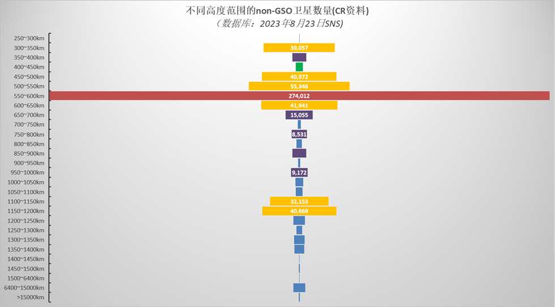
NUMBER OF SATELLITES IN NGSO CR FILINGS
(Database: SNS on 23 August 2023)

In the Master Register, all non-GSO satellite systems have filed a total of 136 000 satellites, with 82% of them positioned in LEO below 1 500 km, as illustrated in the following chart.
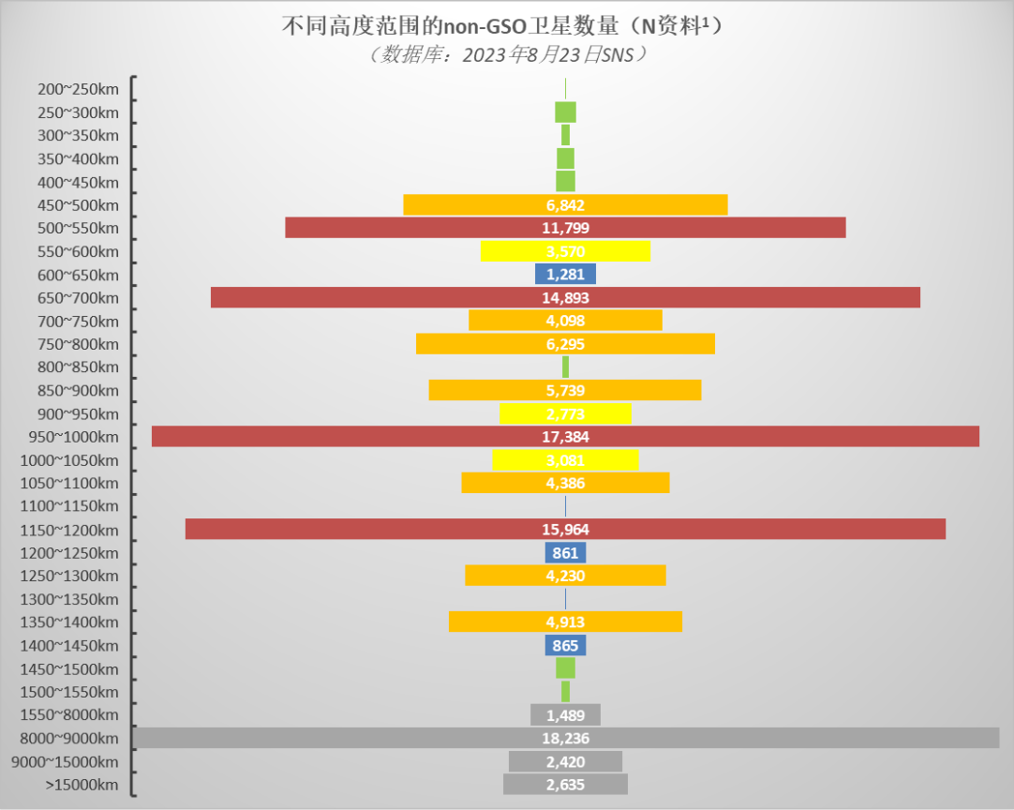
NUMBER OF SATELLITES IN NGSO N FILINGS¹
(Database: SNS on 23 August 2023)
1: The notification information here only includes Part II-S, not Part I-S or Part III-S.

2 Many non-GSO satellites are being filed with the same or similar orbital altitudes, and the deployment of a mega-constellation could potentially stifle opportunities for others to enter the space
Many non-GSO satellite system filings are submitted for the same or similar orbital altitudes. Taking into account the coordination challenges between operators and countries, the deployment of a very large constellation could potentially stifle opportunities for other operators to enter the space.
We analysed the statistics of LEO filings and satellites, using an apogee bin of 5 km. The most congested altitude is 500 km (i.e. the apogee altitude between 495 km and 500 km, with the 5 km bin), for which a total of 48 CR filings from 40 operators for 17 750 satellites have been submitted, and 49 N filings from 35 operators for 6 747 satellites.
The orbital altitudes with the highest number of submissions are listed in the table below.

Orbital altitude  (bin of 5 km) | CR filings |  |  | N filings
 | Number of filings | Number of operators | Number of satellites | Number of filings | Number of operators | Number of satellites
400 km | 7 | 7 | 325 | 19 | 8 | 365
450 km | 11 | 10 | 398 | 20 | 14 | 303
500 km | 48 | 40 | 17 750 | 49 | 35 | 6 747
510 km | 6 | 6 | 3 685 | 11 | 8 | 71
520 km | 4 | 4 | 4 645 | 9 | 8 | 10 808
525 km | 15 | 11 | 10 087 | 11 | 10 | 40
530 km | 5 | 3 | 6 722 | 9 | 9 | 13
535 km | 10 | 5 | 6 534 | 14 | 9 | 48
540 km | 13 | 7 | 9 353 | 13 | 13 | 21
550 km | 39 | 28 | 13 910 | 42 | 31 | 710
575 km | 13 | 11 | 7 011 | 11 | 10 | 265
600 km | 42 | 25 | 164 865 | 43 | 29 | 2 917
650 km | 16 | 12 | 5 357 | 24 | 21 | 1 194
700 km | 19 | 13 | 7 186 | 18 | 14 | 13 168
750 km | 8 | 7 | 540 | 13 | 11 | 21
800 km | 21 | 13 | 8 399 | 20 | 14 | 5 998
850 km | 7 | 6 | 1 708 | 6 | 5 | 80
900 km | 13 | 8 | 5 818 | 12 | 9 | 5 722
1 000 km | 15 | 9 | 8 175 | 10 | 7 | 17 380
1 200 km | 20 | 9 | 34 547 | 12 | 8 | 11 716
1 400 km | 10 | 5 | 5 347 | 7 | 7 | 4 196
The number of filings for satellites operating at the same orbit on all LEO orbits are shown in the figures below.

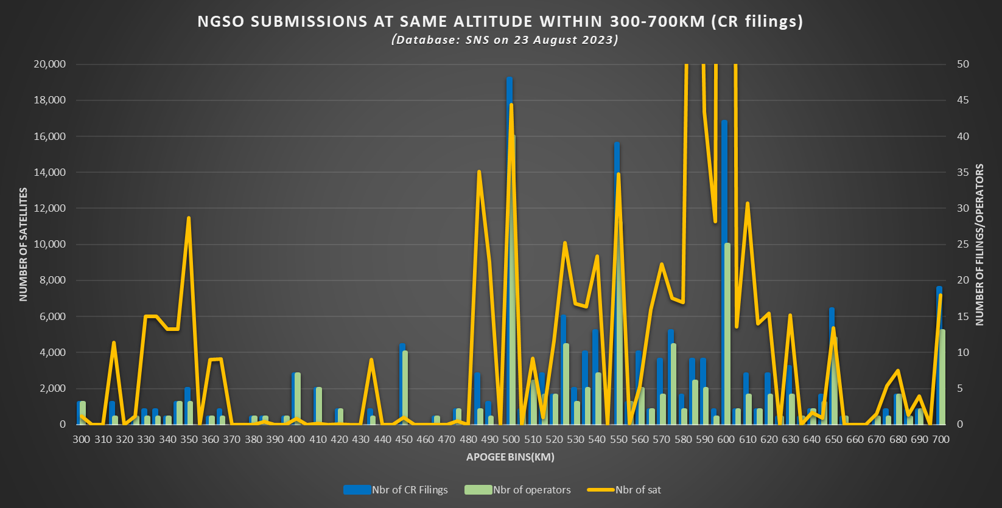

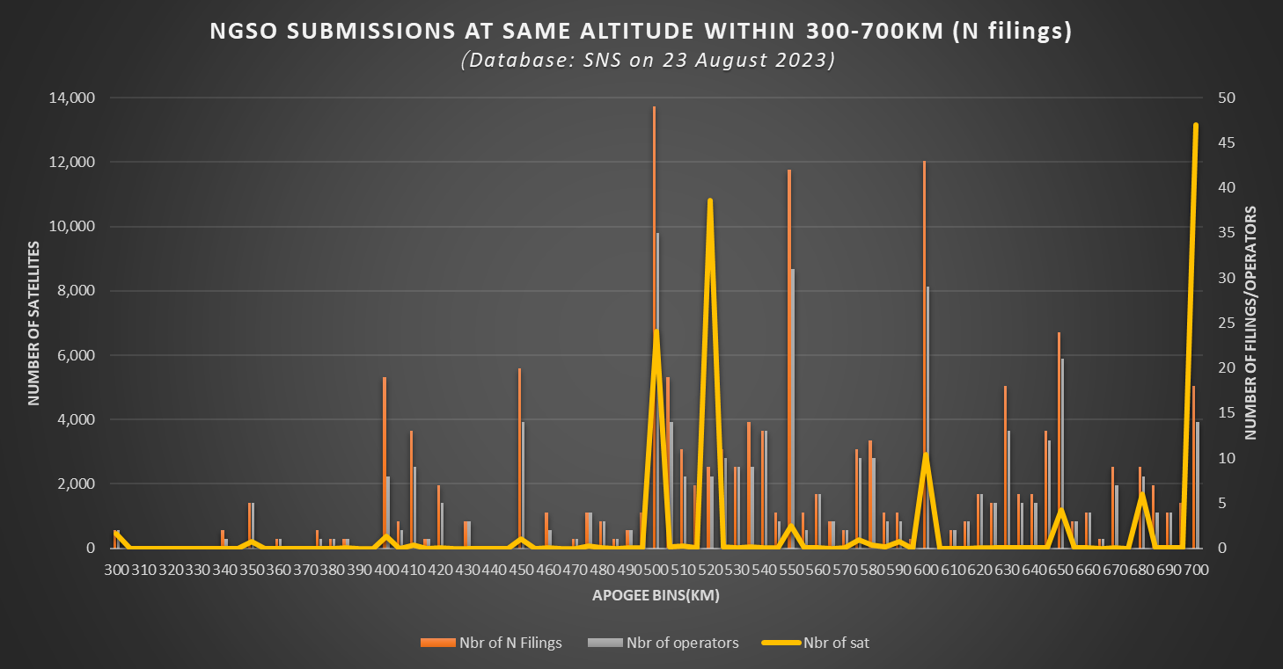

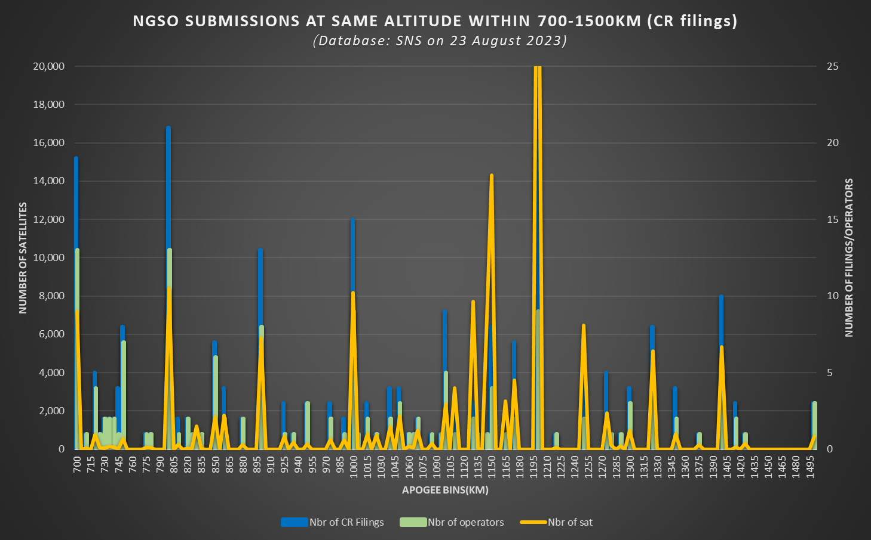

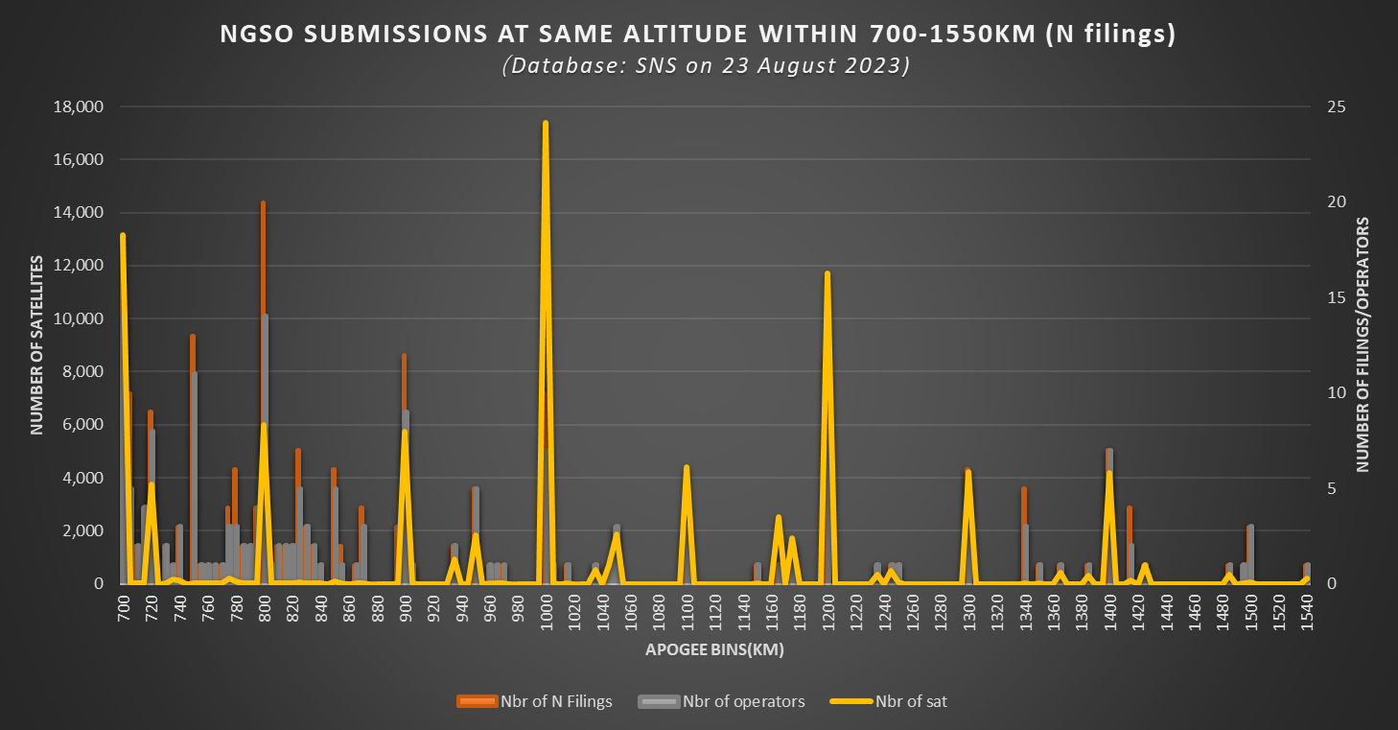

3 The very large number of polar-orbiting satellite filings submitted may lead to significant collision risk
Our analysis shows that there is a very large number of polar-orbiting satellites. Within the orbital inclination of 80 to 100 degrees, CR filings have been submitted for a total of 120 897 satellites, and N filings for 58 914 satellites. It is important to highlight that the space over the Earth's polar regions is really limited, therefore the satellites might cluster together, leading to a high risk of potential collisions. Even when polar-orbiting satellites are located at different orbital altitudes, there remains a significant risk of collisions during the orbit raising phase of non-GSO satellites.
The distribution of non-GSO satellites with different orbital inclinations is shown in the figure below.
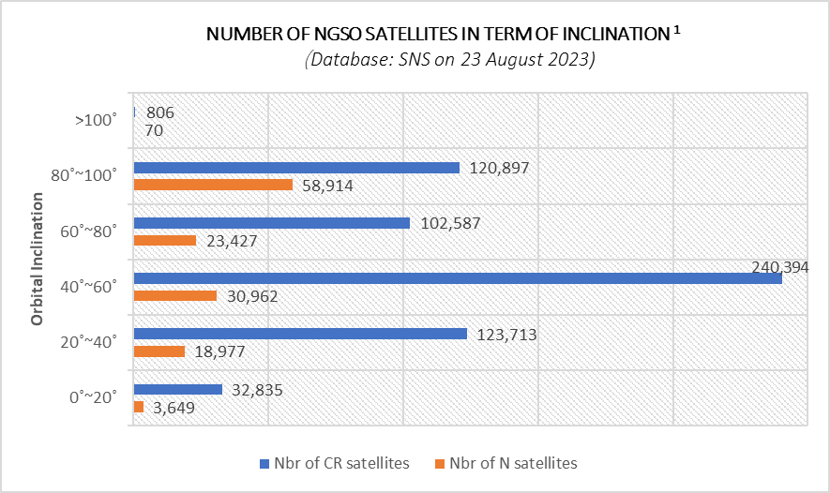
NUMBER OF NGSO SATELLITES IN TERMS OF INCLINATION ¹
1: The notification information here only includes Part II-S, not Part I-S or Part III-S.

4 Study on orbital resources is an urgent matter
With so many satellite filings submitted by the administrations, a natural concern arises: can space, especially low-Earth orbit, accommodate such a large number of satellites?
The capacity of orbital resources is a highly complex subject that necessitates in-depth studies. Different satellite constellations may have varying orbital shells, inclinations and configurations. Furthermore, space is populated by over a million items of debris larger than 1 cm.
China hopes this proposal draws the attention of the Conference to this critical issue and encourages all parties to conduct relevant studies.

______________

