 | World Radiocommunication Conference (WRC-23)  Dubai, 20 November - 15 December 2023 |  | 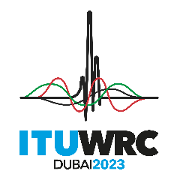
PLENARY MEETING |  | Addendum 5 to  Document 100(Add.27)-E
 |  | 27 October 2023
 |  | Original: English
Arab States Common Proposals
PROPOSALS FOR THE WORK OF THE CONFERENCE
Agenda item 10
10 to recommend to the ITU Council items for inclusion in the agenda for the next world radiocommunication conference, and items for the preliminary agenda of future conferences, in accordance with Article 7 of the ITU Convention and Resolution 804 (Rev.WRC-19),

SUP ARB/100A27A5/1
RESOLUTION 250 (WRC-19)
Studies on possible allocations to the land mobile service (excluding International Mobile Telecommunications) in the frequency band 1 300-1 350 MHz for use by administrations for the future development of terrestrial mobile-service applications

_______________

