|  |  |  |  |
| --- | --- | --- | --- |
|  | **World Radiocommunication Conference (WRC-23) Dubai, 20 November - 15 December 2023** | |  |
|  | |  | |
|  | |  | |
| COMMITTEE 6 | | **Revision 1 to Document 99(Add.27)(Add.3)-E** | |
|  | | **24 November 2023** | |
|  | | **Original: English** | |
|  | | | |
| Japan | | | |
| PROPOSALS FOR THE WORK OF THE CONFERENCE | | | |
|  | | | |
| Agenda item 10 | | | |

10to recommend to the ITU Council items for inclusion in the agenda for the next world radiocommunication conference, and items for the preliminary agenda of future conferences, in accordance with Article 7 of the ITU Convention and Resolution **804 (Rev.WRC‑19)**,

Views on the proposal of WRC‑27 agenda item to review and update regulatory provisions for sharing between non-GSO systems and GSO networks in the portions of frequency bands 14/11 GHz and 30/20 GHz in which Article 22 epfd limits apply

Introduction

The 5th and 6th Meetings of the APT Conference Preparatory Group for WRC‑23 (hereinafter referred to as “APG23-5” and “APG23-6” respectively) (20-25 February 2023, Busan, Republic of Korea for APG23-5 and 14-19 August 2023, Brisbane, Australia for APG23-6) received similar proposals (APG23-5/INP-[85](https://www.apt.int/sites/default/files/2023/02/APG23-5-INP-85_Tonga-WP5-Preliminary_View_on_WRC-23_Agenda_Item_10.docx), APG23-6/INP-[12](https://www.apt.int/sites/default/files/2023/07/APG23-6-INP-12_Kiribati_AI_10.docx), [125](https://www.apt.int/sites/default/files/2023/08/APG23-6-INP-125_Multicountry_WP5_PACP_WRC-23_Agenda_Item_10.docx)) for WRC-23 agenda item 10 from, in total, four (4) APT member countries which reiterated:

“Non-geostationary-satellite (“non-GSO”) systems in the Ka- and Ku-bands have recently become an important reality. Article **22** of the Radio Regulations (RR) contains provisions for uplink and downlink equivalent power flux-density (epfd↑ and epfd↓) limits. However, non-GSO systems and GSO networks are vastly different today than the systems that were considered in developing the original RR Article **22** epfd limits in 1997 and 2000. Our knowledge about how non-GSO systems and GSO networks operate in practice has advanced significantly. Taking these and other aspects into account, RR Article **22** epfd limits may need to be reviewed.”

These proposals were intensely discussed in both APG23-5 and APG23-6, but none of these meetings reached consensus due to a lot of concerns raised by other APT Member countries and after all neither APT Views nor APT Common Proposals were developed on this matter. ITU‑R Working Party (WP) 4A, in its June-July 2023 meeting, also received a similar contribution (Doc. [4A/971](https://www.itu.int/md/R19-WP4A-C-0971/en)) from one of the said APT member countries and just noted the contribution without developing any output document.

Japan is one of the Administrations which have serious concerns about this proposal, and cordially submits this document to share its views as well as some technical backgrounds on this matter and consequently to oppose inclusion of this topic in any agenda items of future WRCs.

Background

The aggregate epfd limits contained in Resolution **76 (Rev.WRC-15)** and the single-entry epfd limits contained Article **22** of the Radio Regulations (RR), which are currently in force as mandatory conditions for relevant non-GSO systems to comply with, were originally developed and agreed by all the ITU Member States under agenda item 1.13 of WRC-2000. According to Section 3.1.2 of the Report of the CPM to WRC-2000 (<https://www.itu.int/itudoc/itu-r/archives/rsg/1998-00/report99/cpmrep-e.html>), in order to develop those epfd limits, Circular Letters CR/92 and CR/116 had invited administrations to supply data on existing and planned GSO FSS links in certain frequency bands, and then the parameters for over 600 14/11 GHz and approximately 200 30/20 GHz carriers were collected in the CR92/CR116 database. Descriptions of GSO FSS systems are contained in Recommendation ITU R S.1328. In addition to traditional 14/11 GHz and 30/20 GHz fixed margin FSS systems, i.e. systems that use power to compensate for rain fade, the database and Recommendation ITU R S.1328 includes a 30/20 GHz GSO FSS system employing adaptive coding to compensate for rain fade. The ITU-R agreed that in deriving candidate epfd limits, different methodologies can be used (e.g. Recommendation ITU R S.1323-1), and then using procedure D included in Annex 2 of Recommendation ITU R S.1323-1 to verify compliance with the requirement that the interference from all non-GSO systems should not account for more than 10% of the short-term time allowance and refine the candidate masks. These methodologies do not apply to 20/30 GHz GSO FSS systems employing adaptive coding. In order to apply the 10% criterion to carriers in the CR/116 database, it was agreed that the following treatment should be given to links where the time percentage of unavailability without non-GSO interference (Tf) is not equal to 90% of the time percentage Tt corresponding to the unavailability target (fading plus interference): the total allowable unavailability time percentage (with non-GSO interference) should be (Tf + Tt/10). The 10% of unavailability time allowance criterion leads to the derivation of aggregate epfd limits. A method was needed to derive a single-entry mask from each aggregate mask just as a validation mask, with which the compliance will be checked by the BR for each individual non-GSO FSS system under No. **11.31** of the RR, in conjunction with operational limits in Tables **22-4** of the RR that adequately protect GSO FSS systems. It was agreed that the following method be employed to convert any epfd↓ versus %-of-time curve required to protect GSO downlinks, having earth station antennas of approximately 10 m and larger in the 10.7-12.75 GHz band and 5 m and larger in the 17.8-18.6 GHz and 19.7-20.2 GHz bands, from the aggregate interference from Neffective (equal to 3.5 *see § 3.1.1.1 d) and 3.1.1.2 of the Final CPM Report to WRC-2000) non-GSO FSS systems, to the corresponding curve for interference from a single non-GSO FSS system:

– The aggregate mask is drawn using a linear abscissa scale for the epfd in decibel units increasing to the right, and a logarithmic scale for percentage of time increasing upwards. A second line is then drawn, 10 log(Neffective) dB to the left of the first line, thus representing power division. A third line is then drawn, dividing the first line by a factor of Neffective, thus representing time division. The single-entry mask is then formed by taking the second line from 100%-of-time to the point where it crosses the third line, the third line between that point and the point where the third line reaches 0.01%-of-time, and the first (i.e. aggregate) line for percentages of time below 0.001%. The single-entry mask is completed by drawing a straight line between the 0.01%-of-time epfd and the 0.001% of time epfd.

– For smaller earth station antennas, the third line is taken for all percentages of time less than the point where it crosses the second line. In those cases where the time-shifted and the power-shifted curves do not intersect, the following procedure is applied:

1) a point P greater than or equal to the 1% of time on the aggregate curve is selected;

2) the corresponding point P on the time-shifted and the corresponding point P on the power shifted are connected;

3) the single entry curve consists of the power-shifted portion for time between 100% and P%, the segment created in 2) for the time between P% and (P/ Neffective)% and the time-shifted segment for times less than (P/ Neffective)%;

4) using the derived single-entry mask, the reverse procedure is applied to derive a new aggregate mask. The new aggregate mask is then verified to ensure that it is not greater than the original aggregate mask. If this condition is not met, a new point P is chosen and steps 2) and 3) are repeated.

The agreed aggregate and single-entry epfd↓ limits can be translated into *I/N* as provided in Figures 1 to 4 below. These examples are based on the aggregate and single-entry epfd↓ limits in Resolution **76 (Rev.WRC-15)** and Tables **22-1A**, **22-1B**, **22-1C** and **22-1D** of Article **22** of the RR respectively for 10.7-12.75 GHz (*for FSS and/or BSS), 17.8-18.6 GHz and 19.7-20.2 GHz bands and using noise temperatures of 120 K for a reference frequency of 10.7 GHz (Table **22-1A**), 195 K for reference frequencies of 17.8 GHz (Table **22-1B**) and 19.7 GHz (Table **22-1C**) and those in Annex 6 to **Appendix 30** for a reference frequency of 11.7 GHz (Table **22-1D**) as assumptions. These *I/N* curves, especially those corresponding to the epfd↓ limits in Resolution **76 (Rev.WRC‑15)** for different diameter GSO receive antennas, clearly shows that the GSO FSS/BSS networks are obliged to automatically accept the aggregate interference which significantly exceeds −12.2 dB, corresponding to 6% increase in ΔT/T, from the non-GSO systems at long‑term percentages of time.

Figure 1

Single-entry and aggregate epfd limits in the 17.8-18.6 GHz band translated into *I*/*N* curves   
by assuming a noise temperature of 195 K

Figure 2

Single-entry and aggregate epfd limits in the 19.7-20.2 GHz band translated into *I*/*N* curves   
by assuming a noise temperature of 195 K

Figure 3

Single-entry and aggregate epfd limits in the 10.7-12.75 GHz FSS band translated into *I*/*N* curves   
by assuming a noise temperature of 120 K

Figure 4

Single-entry and aggregate epfd limits in the 11.7-12.7 GHz BSS band translated into *I/N* curves   
by assuming noise temperatures specified in Annex 6 to Appendix 30

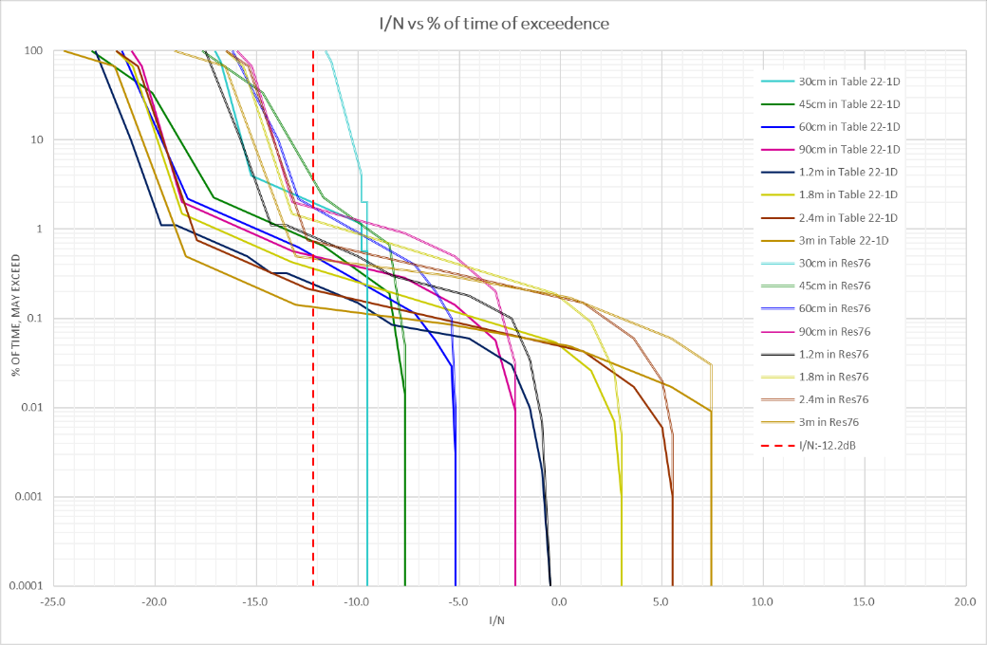

As explained above, ITU-R and its Member States, under agenda item 1.13 of WRC-2000, agreed to define the epfd limits because there was a need to provide a regulatory mechanism that would ensure protection of GSO FSS/BSS networks from the maximum aggregate interference produced by multiple non-GSO FSS systems in frequency bands where epfd limits had been adopted. So, it is not appropriate just to compare the masks of single-entry epfd↓ limits with some commonly used protection criteria of GSO FSS/BSS networks, such as Recommendation ITU-R S.1432 etc. In this respect, the current epfd limits contained in Resolution **76** **(Rev.WRC-15)** and Article **22** of the RR are undoubtedly sufficient to adequately protect GSO FSS/BSS networks from all non-GSO FSS systems, which individually need to meet the limits Article **22** of the RR, especially RR No. **22.2** in principle, while allowing reasonable flexibility for non-GSO FSS systems.

Although WRC-19 developed a slightly different sharing framework for the Q/V bands, such as RR Nos. **22.5L** and **22.5M** and their associated Resolutions **770 (WRC-19)** and **769 (WRC-19)**, the Section 3.2.4 (“Frequency outside of range 10-30 GHz”) of the Final CPM Report to WRC‑2000 also mentioned that:

*(Quote)*

*There are fundamental differences between the situation in the 10‑30 GHz FSS bands identified in Resolution* ***130 (WRC‑97)*** *where a non‑GSO FSS service concept is being overlaid upon an existing and/or imminent GSO FSS service and other bands where both GSO and non‑GSO FSS systems are just now beginning to emerge. In these 10‑30 GHz bands, there is extensive deployment or long‑standing development of GSO systems and GSO operators have limited or no flexibility to adjust to the introduction of non‑GSO systems. In these bands, non‑GSO systems must thus bear most or all of the burden of implementing technical criteria to protect the GSO arc. In bands where there has been little or no deployment of satellite systems to date and satellite networks (GSO and non‑GSO alike) have only recently begun to be communicated to ITU‑R, the absence of current and imminent use by GSO and non‑GSO FSS systems means that both types of operators should expect to exhibit greater flexibility in achieving the appropriate balance among the competing technical, regulatory and policy considerations that will affect their sharing environment.*

*(Unquote)*

Japan believes this situation is still the case.

In addition to the points raised above, ITU-R has recognized some fundamental problems regarding the proper application of the aggregate epfd limits contained in Resolution **76** **(Rev.WRC-15)** and the single-entry epfd limits contained Article **22** of the RR as follows:

– While the mandatory aggregate epfd limits are specified in Resolution **76 (Rev.WRC-15)**, there is no clear methodology nor procedures outlined in Resolution **76 (Rev.WRC-15)** for the administrations involved to collaboratively determine whether these aggregate levels are exceeded. This means, at this moment, nobody can officially validate the compliance with Resolution **76 (Rev.WRC-15)**, whileseveral large-scale non-GSO FSS systems have been already in use. This matter will be discussed under Topic J of WRC-23 agenda item 7.

– The practice of splitting a non-geostationary satellite system into several filed systems, which may affect the effectiveness of single-entry epfd limits contained in RR Article **22** to protect geostationary systems or have an impact in the implementation of Resolution **76** **(Rev.WRC-15)**, is questioned. The only reason for misapplication of these single entry epfd limits by artificially splitting or combining non-GSO FSS systems, will be to lower the epfd levels and therefore to get a favourable finding status as a result of the regulatory examination performed by the Radiocommunication Bureau under RR No. **11.31**. This problem has been raised by the Director of the Radiocommunication Bureau in its Report to WRC-23 (Section 3.1.4 of [Addendum 2 to Doc. 4](https://www.itu.int/dms_pub/itu-r/md/23/wrc23/c/R23-WRC23-C-0004!A2!MSW-E.docx)).

Therefore, Japan also believes that, under such circumstances, it is totally unreasonable to change the epfd limit itself without solving these potential misapplications of Resolution **76 (Rev.WRC‑15)** as well as RR Article **22** by some notifying administrations of non-GSO FSS systems.

Finally, Japan should emphasize another important aspect that ITU-R WP 4A, in its June-July 2023 meeting, developed a work plan (Doc. [4A/978 Annex 9](https://www.itu.int/dms_ties/itu-r/md/19/wp4a/c/R19-WP4A-C-0978!N09!MSW-E.docx)) for a revision to Recommendation ITU‑R S.1503 to improve accuracy of modelling of non-GSO satellite systems within the Recommendation in a way that continues to protect GSO satellite networks while facilitating development of non-GSO satellite systems. Any parallel review to RR Article **22** epfd limits might adversely affect the work of WP 4A because it is almost like changing the “goal” of the planned study which needs comparable results.

Views and Proposals

J/99A27A3/1

Considering the above background as well as the importance to retain the current aggregate and single-entry epfd limits which are broadly taken into account as design objectives of huge amount of operational GSO FSS/BSS satellite networks, Japan is of the view that it is not appropriate to review and update the regulatory provisions relevant to these epfd limits in the portions of the frequency bands 14/11 GHz and 30/20 GHz, therefore opposes any new agenda items of future WRCs on this topic.

Japan is also of the view that, while it does not support to further discuss this matter within ITU-R, if the proponents of this topic still insist on setting up new agenda items of future WRCs, such discussions may also address the following aspects:

– the protection criteria for GSO FSS systems employing adaptive coding should be sufficiently reflected on the potentially updated epfd↓ limits, somehow like Table **22-1C** in Article **22** of the current RR, also in Ku-band and in a portion of Ka-band in which the current epfd↓ limits, such as Tables **22-1A** and **22-1B,** are solely based on the protection requirement of fixed link margin systems, considering that nowadays adaptive coding systems are more commonly deployed in GSO FSS networks in entire Ku-band and Ka-band;

– regarding the protection of the GSO BSS Plan/List satellite networks under Appendices **30**/**30A** to the RR, since no interference contributions from non-GSO systems operated in conformity with RR No. **5.487A** in the relevant frequency bands are taken into account for the calculation of the equivalent protection margin (EPM) of these GSO BSS satellite networks but the relevant frequency assignments to these non-GSO systems can be finally registered in the MIFR, appropriate technical measures should be developed to verify the implications of EPM degradations caused by the cumulative interference from the non-GSO systems, especially those so-called “Mega-Constellations” which consist of thousands (or even tens of thousands of) satellites, operated in the same service area as the GSO BSS Plan/List satellite networks;

– regarding the protection of the FSS Plan/List satellite networks under RR Appendix **30B**,in the same way as the matter of BSS Plan/List satellite networks, appropriate technical measures should also be developed to address how the interference caused by the non-GSO systems can be reflected on the Reference Situations which currently consider the cumulative effects of the interference from the RR AP**30B** GSO FSS satellite networks only. More notably, in order to keep these Reference Situations at the manageable level, similar procedures to RR Nos. **6.6** and/or **6.16** of Appendix **30B** might bediscussedwith respect to the use of the frequency assignments to non-GSO FSS systems, which are currently dealt with as Un‑Planned assignments while using the same frequency bands as RR AP**30B** Plan bands and whose service areas can be expanded anytime, anywhere the notifying administrations want (i.e. even outside their jurisdictions) without the requirements of “explicit agreement” at least under the current framework of the RR.

_____________