 | World Radiocommunication Conference (WRC-23)  Dubai, 20 November - 15 December 2023 |  | 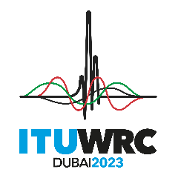
PLENARY MEETING |  | Addendum 13 to  Document 87-E
 |  | 23 October 2023
 |  | Original: English
African Common Proposals
PROPOSALS FOR THE WORK OF THE CONFERENCE
Agenda item 1.13
1.13 to consider a possible upgrade of the allocation of the frequency band 14.8-15.35 GHz to the space research service, in accordance with Resolution 661 (WRC-19);

NOC AFCP/87A13/1
ARTICLES

NOC AFCP/87A13/2
APPENDICES

SUP AFCP/87A13/3
RESOLUTION 661 (WRC-19)
Examination of a possible upgrade to primary status of the secondary allocation to the space research service in the frequency band 14.8-15.35 GHz
Reasons: Given that the methods do not prevent harmful interference to the incumbent services and do not protect systems of primary services in the frequency band 14.8-15.35 GHz. This position may change if usage conditions can ensure incumbent services are protected from harmful interference.
ATU Administrations are invited to continue to consider developments under this agenda item and to examine the possible upgrade of the space research service in the frequency band 14.8-15.35 GHz while protecting the primary services in this frequency band, with a view to possibly support either Method E1 or E2 upon satisfying the requirement for protection of the fixed and mobile services as well as the radio astronomy service.
Note: the Administration of Tunisia adopts a different Method for WRC-23 agenda item 1.13 than the adopted AFCP without opposition to the AFCP.
______________

