|  |  |  |  |
| --- | --- | --- | --- |
|  | **World Radiocommunication Conference (WRC-23) Dubai, 20 November - 15 December 2023** | |  |
|  | |  | |
|  | |  | |
| **PLENARY MEETING** | | **Addendum 1 to Document 85(Add.4)(Add.1)-E** | |
| **22 October 2023** | |
| **Original: Russian** | |
| Regional Commonwealth in the field of Communications Common Proposals | | | |
| proposals for the work of the conference | | | |
|  | | | |
| Agenda item 1.4 | | | |

1.4 to consider, in accordance with Resolution **247 (WRC‑19)**, the use of high-altitude platform stations as IMT base stations (HIBS) in the mobile service in certain frequency bands below 2.7 GHz already identified for IMT, on a global or regional level;

Introduction

Under WRC-23 agenda item 1.4, studies have been carried out in ITU-R on the impact of interference from HIBS on radio stations of existing radio services in the frequency band 694-960 MHz. One of those services is the land mobile service. On the basis of the studies carried out in ITU-R on the effect of HIBS on IMT-2020, power flux-density masks have been developed to ensure the protection of IMT‑2020 stations. However, it should be noted that most countries of the world, including RCC countries, are still using previous-generation standards in the frequency band 694-960 MHz, in particular IMT-2000 and IMT‑Advanced, and plan to continue doing so in the long term. Therefore, separate studies are required to verify the masks developed in terms of their ability to protect IMT-2000 and IMT‑Advanced from the interference impact of HIBS in view of the differences in characteristics between IMT-2000/IMT-Advanced and IMT‑2020.

This document presents a study on electromagnetic compatibility between HIBS transmitters and IMT-2000 and IMT-Advanced terrestrial networks. The study includes an analysis of interference from HIBS transmitters into IMT-2000 and IMT-Advanced networks (considering both uplink and downlink channels in IMT-2000/IMT-Advanced networks). Capacity losses in IMT-2000/IMT-Advanced terrestrial networks in the presence of interference from HIBS in a cross-border scenario are calculated. In the simulation, IMT-2000 and IMT-Advanced were deployed in an urban environment. The interference impact was assessed using a Monte Carlo statistical analysis approach.

Proposal

It is proposed that this contribution be considered at WRC-23 under agenda item 1.4 for the frequency band 694‑960 MHz as an additional justification for Method A1: No changes to Volumes I and II of the Radio Regulations.

Studies on the impact of interference from HIBS on IMT-2000 and IMT‑Advanced radio systems in the frequency band 694-960 MHz

Background

When conducting frequency sharing and compatibility studies for IMT-2000/IMT-Advanced networks, it is important to take into account the proposed frequency arrangements in accordance with Recommendation ITU-R M.1036 when evaluating scenarios of cross-border interference from HIBS. One must also consider the possibility of HIBS using time-division duplex (TDD), which may lead to scenarios where the HIBS downlink causes interference to the uplink of IMT‑2000/IMT-Advanced networks.

Figure 1 shows an example of an interference scenario from HIBS into IMT-2000/IMT-Advanced networks.

FIGURE 1

Scenario of interference impact from HIBS into IMT-2000/IMT-Advanced networks

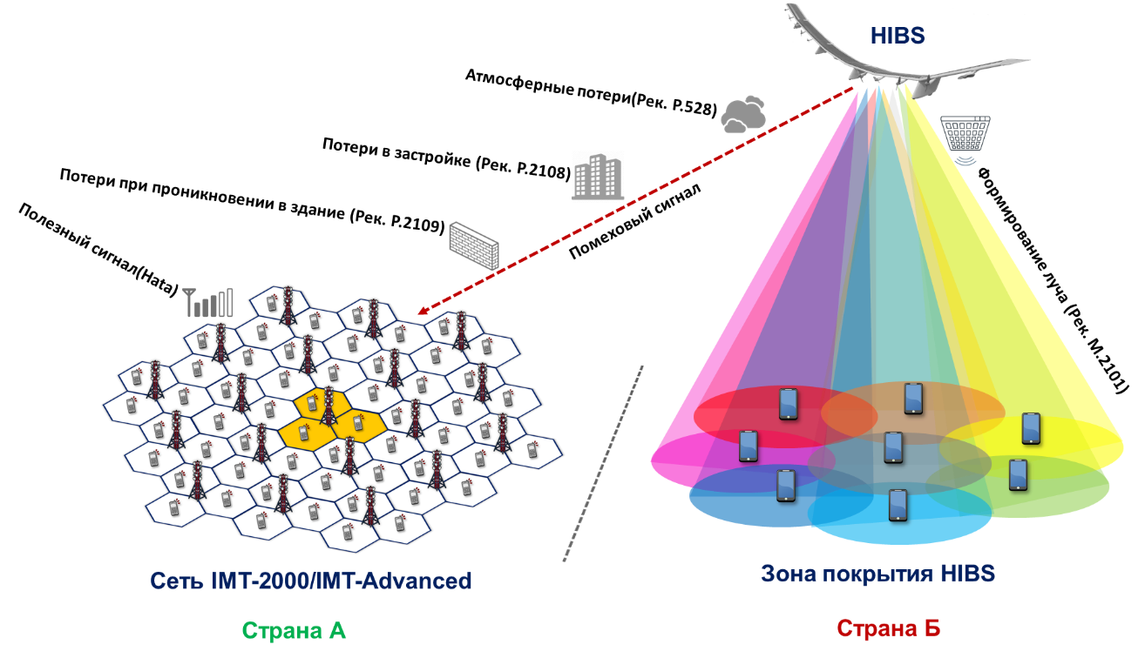

As can be seen from the scenario, in terms of the interference impact, additional signal loss may be caused by building clutter (in urban areas), and when the user equipment (UE) is indoors.

Characteristics of HIBS

Table 1 contains the characteristics of HIBS in the frequency band 694-960 MHz presented in WP5D, including characteristics relating to deployment and characteristics relating to the base station, which were used in the compatibility simulation in this study.

TABLE 1

Characteristics of HIBS in the frequency band 694-960 MHz

| Parameter | Value |
| --- | --- |
| Type of duplex | FDD/TDD |
| Channel bandwidth | 20 МHz |
| ACLR | 45 dB |
| Spurious emissions | −13 dBm/−30 dBm |
| Service area radius | 100 km |
| Height above ground | 20-50 km |
| Number of cells/HIBS | 7 |
| Antenna pattern | Recommendation ITU-R M.2101 |
| Element gain | 8 dBi |
| Horizontal/vertical 3 dB beamwidth of single element | 65º for both H/V |
| Horizontal/vertical front-to-back ratio | 30 dB for both H/V |
| Antenna polarization | Linear/±45 degrees |
| Antenna array configuration  (Row × Column) | 2 × 2 elements (1st layer cell), 4 × 2 elements (2nd layer cell) |
| Horizontal/vertical radiating element spacing | 0.5 of wavelength for both H/V |
| Ohmic losses | 2 dB |
| HIBS platform antenna tilt | 90º (1st layer cell), 33º (2nd layer cell) |
| Conducted power per antenna element | 37 dBm (1st layer cell),  34 dBm (2nd layer cell) |
| HIBS platform e.i.r.p./cell | 55 dBm (1st layer cell),  58 dBm (2nd layer cell) |
| HIBS platform e.i.r.p. spectral density/cell | 42 dBm/MHz (1st layer cell), 45 dBm/MHz (2nd layer cell) |
| UE density for equipment transmitting simultaneously | 3 UEs per cell |
| UE height | 1.5 m |

HIBS uses a beamforming antenna pattern in accordance with Recommendation ITU-R M.2101. The beamforming antenna array consists of a number of radiating elements located at a separation distance of λ/2 from each other. Figures 2 and 3 show the e.i.r.p. diagrams of the HIBS first and second-layer cells.

FIGURE 2

E.i.r.p. of a HIBS first-layer cell as a function of azimuth and elevation angle  
(a) 3D visualization (b) 2D visualization

|  |  |
| --- | --- |
|  |  |
| (a) | (b) |

FIGURE 3

E.i.r.p. of a HIBS second-layer cell as a function of azimuth and elevation angle  
(a) 3D visualization (b) 2D visualization

|  |  |
| --- | --- |
|  |  |
| (a) | (b) |

The HIBS service area has a multi-layer structure with a multi-beam configuration. The first layer comprises three cells with antennas pointing towards the nadir. The second layer comprises seven cells with antennas pointing at angles of 23-33 degrees depending on the frequency band.

Figures 4 and 5 show an example of a HIBS with its antenna patterns and coverage area (−3 dB contour) plotted for first- and second-layer cells, respectively.

FIGURE 4

HIBS station antenna patterns for first- and second-layer cells

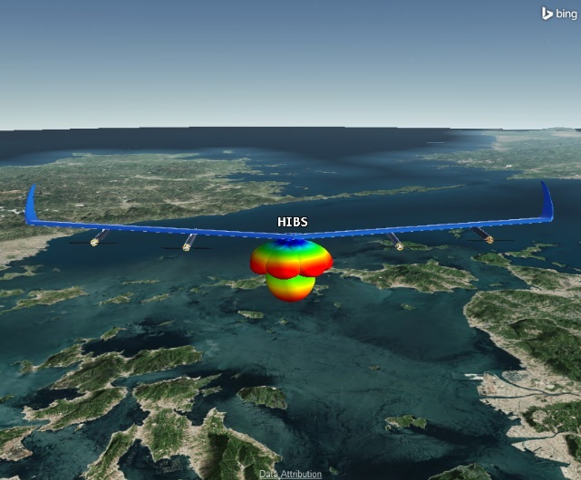

FIGURE 5

Typical HIBS deployment scenario with HIBS coverage areas for first- and second-layer cells

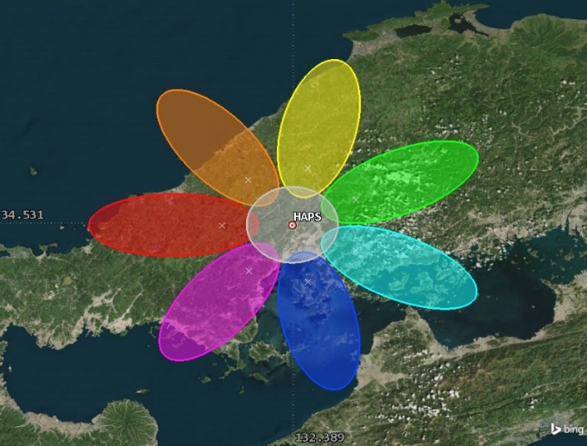

As stated earlier, the above characteristics have been used to conduct compatibility studies with IMT-2020 in the frequency band 694-960 MHz. The studies demonstrated that with these HIBS parameters, IMT-2020 stations would experience unacceptable interference at significant distances. Accordingly, several variants of power flux-density (pfd) masks were proposed to ensure the protection of IMT stations. Specifically, for the purpose of protecting IMT mobile stations in the territory of other administrations in the frequency band 694-960 MHz, the pfd level per HIBS produced at the surface of the Earth in the territory of other administrations shall not exceed the following limit, unless explicit agreement of the affected administration is provided:

−114 dB(W/(m2 · MHz)) for 0° < θ ≤ 90°

where θ is the angle of arrival of the incident wave above the horizontal plane, in degrees.

The above-mentioned mask can generally protect IMT-2020 stations. However, IMT-2000 and IMT-Advanced, which are currently used by a number of RCC administrations, have wider base station (BS) antenna patterns, as well as a number of other different parameters. Therefore, a separate verification of the specified mask is required with respect to compatibility with IMT-2000 and IMT-Advanced.

Characteristics of IMT-2000 and IMT-Advanced

For the simulation of IMT-2000 and IMT-Advanced networks, it was assumed that they were located in urban environment, so as to take into account the clutter and building entry losses for UEs located indoors. The characteristics of the IMT-2000 and IMT-Advanced networks used in the simulations are shown in Tables 2 and 3 and Figure 6, and are taken from Report ITU-R M.2292.

TABLE 2

Characteristics of IMT-Advanced for frequency bands below 1 GHz

| Parameter | Value |
| --- | --- |
| Cell radius | 2 km |
| Antenna height | 30 m |
| Below rooftop BS antenna deployment | 30% |
| Sectorization | 3 sectors |
| BS antenna downtilt | 3° |
| Channel bandwidth | 10 MHz |
| Feeder loss | 3 dB |
| BS output power | 46 dBm |
| BS antenna gain | 15 dBi |
| BS e.i.r.p./sector | 58 dBm |
| Average BS activity factor | 50% |
| Average BS e.i.r.p./sector taking into account activity factor | 55 dBm |
| BS noise figure | 5 dB |
| Indoor UE usage | 70% |
| Average indoor UE penetration loss | 20 dB |
| Maximum UE output power | 23 dBm |
| Average UE output power with power control | −9 dBm |
| UE noise figure | 12 dB |
| UE antenna gain | −3 dBi |
| Body loss | 4 dB |

TABLE 3

Characteristics of IMT-2000 for frequency bands below 1 GHz

|  |  |
| --- | --- |
| Parameter | Value |
| Cell radius | 2 km |
| Antenna height | 30 m |
| Below rooftop BS antenna deployment | 30% |
| Sectorization | 3 sectors |
| BS antenna downtilt | 3° |
| Channel bandwidth | 3.84 MHz |
| Feeder loss | 3 dB |
| BS output power | 43 dBm |
| BS antenna gain | 15 dBi |
| BS e.i.r.p./sector | 55 dBm |
| BS noise figure | 5 dB |
| Average BS activity factor | 50% |
| Average BS e.i.r.p./sector taking into account activity factor | 52 dBm |
| Eb/Nt threshold for BS (voice) | 7.9 dB |
| BS adjacent channel selectivity (ACS) | 46 dB |
| EU antenna height | 1.5 m |
| Indoor UE usage | 70% |
| Average indoor UE penetration loss | 20 dB |
| Maximum UE output power | 24 dBm |
| Average UE output power with power control | −9 dBm |
| UE noise figure | 12 dB |
| UE antenna gain | −3 dBi |
| Body loss | 4 dB |
| Eb/Nt threshold for UE (voice) | 6.1 dB |
| UE adjacent channel selectivity (ACS) | 33 dB |

FIGURE 6

IMT-2000 and IMT-Advanced BS antenna pattern  
(a) Antenna pattern in the azimuthal plane (b) Antenna pattern in the elevation angle plane

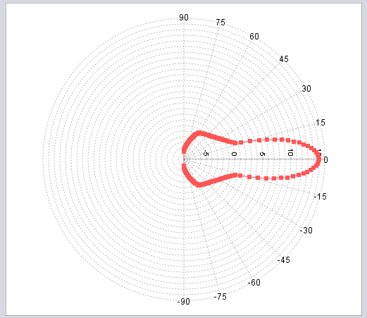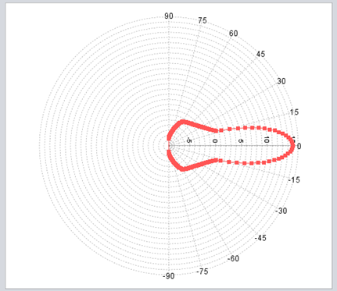

|  |  |
| --- | --- |
| (a) | (b) |

Method of calculating electromagnetic compatibility and results

The Monte Carlo method was used in the study. The Monte Carlo method is a statistical computational method that is employed to model random processes and estimate the probabilistic characteristics of a system. This method is based on the generation of random samples according to specified probability distributions.

In interference estimation, the Monte Carlo method can be used to simulate various random parameters such as location of interference sources, their power, direction of antenna patterns, propagation range of signals, etc. Then, many random iterations are performed, in each of which the parameters for the model are randomly selected according to given probability distributions.

For each trial, the level of interference impact on the system of interest is calculated. After performing a large number of iterations (50 000 iterations in this study), the resulting mean values, probability distributions or other characteristics help to estimate the probabilities, statistical characteristics and behaviour of the system under random impacts.

The Monte Carlo method makes it possible to obtain more accurate estimates, especially in complex systems where analytical methods may be difficult due to the complexity of the mathematical computations or the non-linearity of the equations. Figure 7 shows an example of a simulation of interference from HIBS into an IMT network.

FIGURE 7

Example of a simulation of interference from HIBS into an IMT network

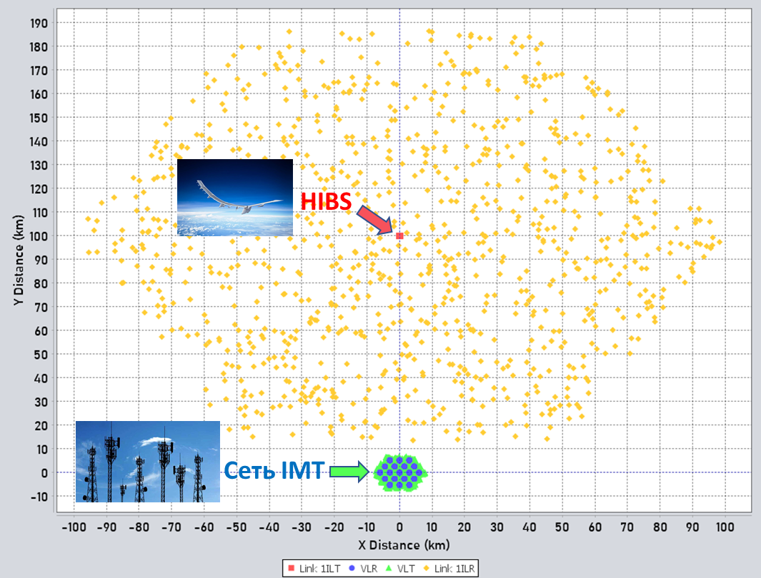

The IMT networks exposed to the interference included 19 three-sector cells located in an urban environment.

The HIBS network was one platform with three sectors for a first-layer cell and seven sectors for a second-layer cell. The capacity losses of the IMT networks were calculated at different distances between the IMT network and the HIBS. They were presented as a table with the percentage loss, and as distribution functions allowing a graphical representation of the reduction in capacity.

In this study, the HIBS was simulated on the basis of the parameters in Table 1, although the output power was adjusted so that the specified pfd limit at the Earth's surface (−114 dB(W/(m2 · MHz)) could not be exceeded even if the victim of the interference is directly aligned with the main lobe of the HIBS radiation pattern; for such a case the HIBS BS power is 23 dBm/20 MHz.

When choosing the distances between the HIBS nadir and the IMT-2000/IMT-Advanced network exposed to the interference, it was taken into account that the radius of the HIBS service area is 100 km, so the HIBS nadir point cannot be closer than 100 km to the network impacted by the interference and located in a neighbouring country. Therefore, interference exposure at distances less than 100 km has not been considered. The capacity degradation threshold for IMT-2000 and IMT-Advanced networks is 5% according to 3GPP specifications.

Each study seeks to evaluate capacity loss, based on calculation of the signal-to-noise ratio (SINR). Calculating the SINR requires evaluations of the wanted signal in the IMT network and the interfering signal from the HIBS.

The wanted signal of the IMT network was calculated using the following expression:



where:

*PIMT*: IMT BS/UE output power, dBm;

*GIMT*: IMT BS/UE transmitting antenna gain in the direction of the IMT receiver, dBi;

*Lp*: propagation loss from the BS/UE transmitter to the IMT receiver, dB;

*Aactivity*: activity factor, dB.

Propagation loss in the wanted signal was estimated using the extended HATA model for urban environments.

The interference level from the HIBS into each IMT receiver was then calculated using the following expression:



where:

*PHIBS*: HIBS output power, dBm;

*GHIBS*: HIBS transmitting station a gain in the direction of the interference victim, dBi;

*GIMT*: IMT BS/UE gain in the direction of the HIBS, dBi;

*Lp*: propagation loss from the HIBS transmitter to the BS/UE receiver, dB;

*Aactivity*: HIBS activity factor, dB ;

*ATDD*: HIBS TDD factor, dB (when operating in FDD mode, this is equal to 0 dB).

To estimate propagation loss in the interfering signals, a propagation model based on Recommendation ITU-R P.528 was applied. This model allows the calculation of communication paths in three modes: air-to-ground, ground-to-air and air-to-air. It should be noted that this model takes into account the curvature of the Earth, which is especially important when calculating over-the-horizon paths.

Signal losses in clutter conditions were calculated using a model based on Recommendation ITU-R P.2108. To estimate building entry losses used to calculate the wanted signal of IMT networks, the IMT-2000/IMT-Advanced specifications were used in which the building entry losses are specified.

After calculating the HIBS interference levels and IMT wanted signal levels for each link, the SINR can be obtained using the following expression:



where:

*N*: noise level at the IMT receiver input, dBm;

*I*: Level of interference from the HIBS, dBm;

*C*: IMT wanted signal level, dBm.

Calculation of IMT-Advanced capacity loss

The Round-Robin model was applied for the IMT-Advanced network simulation. This method is used to allocate resources or tasks among several devices or processes in a cyclic order. In the context of networks and telecommunications, the Round-Robin method can be used, for example, when planning access to channel resources among different devices or subscribers. When devices or subscribers request to access resources, the Round-Robin algorithm allocates access in turn, ensuring that resources are utilized evenly among participants. This can be useful when resources need to be divided equally among multiple users or devices.

The OFDMA network modelling algorithm applied assumes full system load of 100% with full buffer traffic and 1/1 frequency reuse (i.e. a single-frequency network), and takes into account intra-system interference in the reference cell due to UEs located in neighbouring cells using the same resource blocks, as well as interference from UEs located in the reference cell using different resource blocks. The methodology assumes that UEs are located randomly throughout the network area according to a homogeneous geographical distribution.

Figure 8 shows an example of network topology with interference victims for simulation of a an IMT-Advanced network.

FIGURE 8

Example of an IMT-Advanced network topology with interference victims

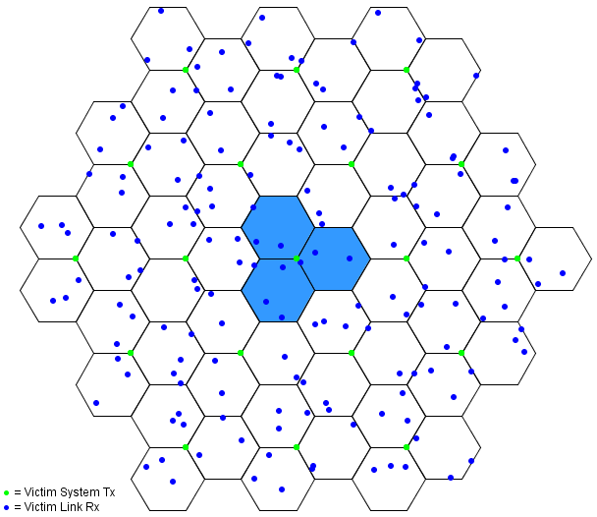

To calculate the capacity loss on the uplink and downlink channels of an IMT-Advanced network, it is necessary to estimate the signal-to-noise ratio (SNR) for each link in the IMT-Advanced network and determine the aggregate interference (I) from the transmitters of high-intensity wireless systems (HIBS) for each of the links. The HIBS interference level is then added to the noise level at the input of each victim/receiver of the IMT-Advanced network. The resulting SINR values are used to calculate the throughput capacity of each network link. The average throughput capacity for all links can then be determined and compared to the initial capacity of the IMT-Advanced network links before interference.

The capacity per IMT-Advanced link can be calculated using the following expression:



where:

*BitRate*: maximum throughput capacity, Mbit/s;

*NRB_per_UE*: number of resource blocks per user;

*Ntotal_RBs*: total number of resource blocks;

*B*: channel bandwidth, MHz;

*Scapacity*: spectral efficiency as a function of SINR, bit/Hz.

Figure 9 shows curves plotting IMT-Advanced spectral efficiency against SINR levels for the uplink and downlink channels.

FIGURE 9

Curve showing IMT-Advanced spectral efficiency against SINR levels  
 (a) Uplink channel and (b) Downlink channel

|  |  |
| --- | --- |
|  |  |
| (a) | (b) |

Figures 10-13 and Tables 4-5 show the results of the simulation of interference from HIBS into IMT-Advanced downlink and uplink channels. The results are presented in terms of percentage capacity loss and capacity distribution functions for IMT-Advanced.

FIGURE 10

IMT-Advanced downlink channel capacity loss cumulative distribution function

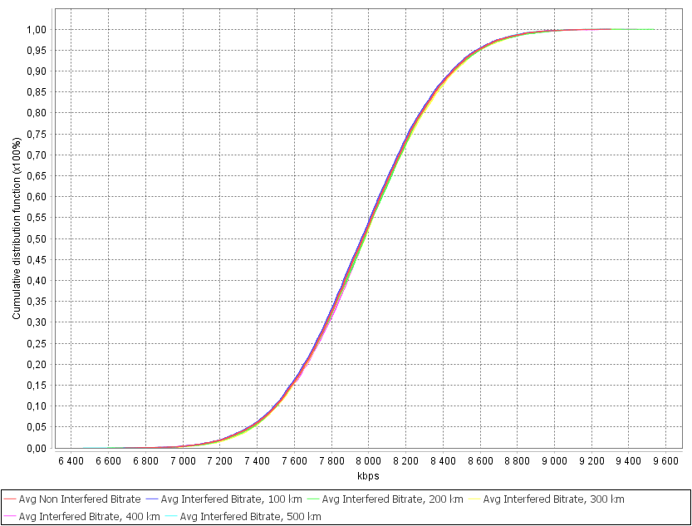

FIGURE 11

IMT-Advanced downlink channel capacity loss probability distribution function

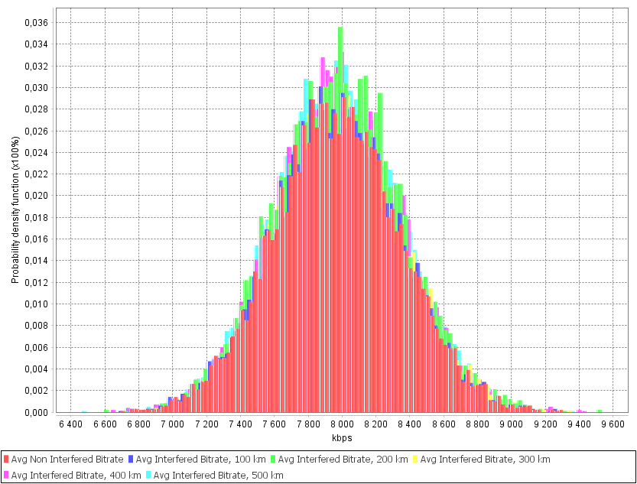

TABLE 4

IMT-Advanced downlink channel capacity loss

|  |  |  |  |  |  |
| --- | --- | --- | --- | --- | --- |
| Distance between the centre of the IMT network and the HIBS nadir point | 100 km | 200 km | 300 km | 400 km | 500 km |
| IMT-Advanced capacity degradation | 0.083% | 0.016% | 0.006% | 0.003% | 0.002% |

FIGURE 12

IMT-Advanced uplink channel capacity loss cumulative distribution function

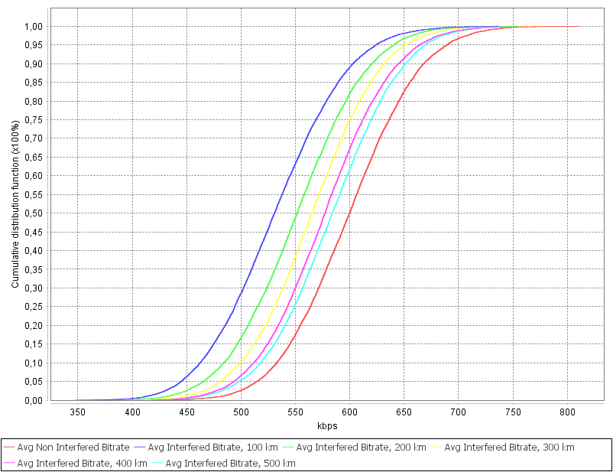

FIGURE 13

IMT-Advanced uplink channel capacity loss probability distribution function

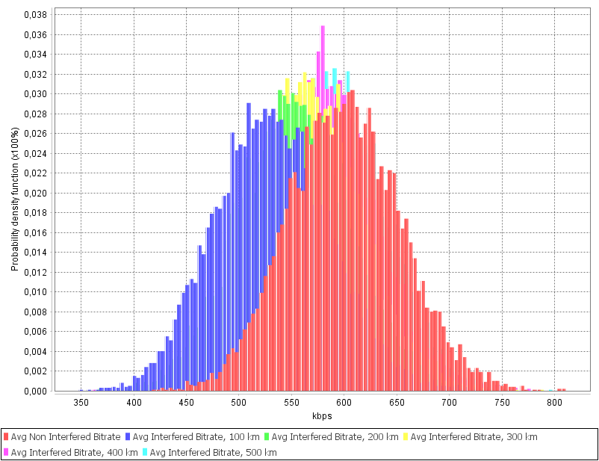

Table 5

IMT-Advanced uplink channel capacity loss

|  |  |  |  |  |  |
| --- | --- | --- | --- | --- | --- |
| Distance between the centre of the IMT network and the HIBS nadir point | 100 km | 200 km | 300 km | 400 km | 500 km |
| IMT-Advanced capacity degradation | 11.337% | 8.227% | 5.508% | 3.686% | 2.596% |

The study conducted demonstrated that the uplink channel capacity loss for IMT-Advanced exceeds the acceptable threshold capacity reduction of 5% at separation distances between the IMT‑Advanced network and the HIBS nadir point of less than 300 km, and ranges from 11% to 5%. While the downlink capacity degradation is negligible, at less than 0.1%, it should be noted that this is due to the victim EUs being shielded from interference by clutter in an urban environment, whereas for open-terrain scenarios the downlink capacity loss can be significantly higher.

Calculation of interference impact on IMT-2000 networks

IMT-2000 networks use code-division multiple access (CDMA) systems, which gives rise to an additional noise level in the system and the phenomenon of "cell breathing". In order to calculate capacity loss in CDMA-based systems, a simulation was first performed to determine system capacity in the absence of external interference. The IMT-2000 network was then gradually filled with UEs until the threshold noise level was exceeded. The noise level increase is measured as a linear average in dB over all base stations.

In CDMA-based systems, a user can be simultaneously connected to multiple base stations (soft handover). Due to soft handover, there is a change in the amount of power transmitted by each base station for a given user, so it is necessary to determine whether the user is being served by one or more base stations. A simplified soft handover algorithm is applied in the simulation that takes into account the main effects of soft handover without having to introduce complex algorithms. Base stations connected to a user are included in the "active set" of that user. A base station is initially selected for inclusion in the active set on the basis of the ratio of its pilot signal strength to background interference. Each base station transmits a certain fixed percentage of its maximum power on the pilot channel. The noise interference consists of the non-orthogonal energy received on other channels of base stations in the "active set" as well as the aggregate broadcast power of base stations not in the active set. The base station selection criterion, "pilot *Ec*/*Io*", is defined using the following equation:



 where:

*Ec*: energy in the *i*-th BS chip;

*I*0: spectral power density of the interference level;

*Pmax*,*I*: maximum received power from the *i*-th BS;

*W*: system bandwidth;

*Pj*: level of the wanted signal from the *j*-th BC;

*F*: UE noise factor;

*N*0: spectral power density of the IMT-2000 receiver;

*Iext*: level of external interference.

Figure 14 shows a simulation example of capacity loss in an IMT-2000 system, where red dots represent active users, yellow dots represent active users in soft handover mode, and grey dots represent users who have been disconnected from the network due to external interference from HIBS.

FIGURE 14

Example of a simulation of IMT-2000 network capacity loss

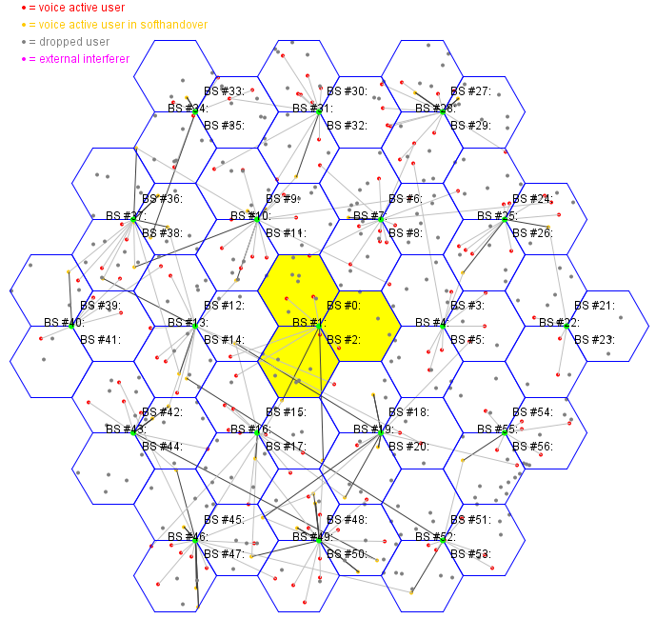

Figures 15-18 and Tables 6-7 show the results of the simulation of interference from HIBS into IMT-2000 downlink and uplink channels. The results are presented in terms of percentage capacity loss and capacity distribution functions for IMT-Advanced.

FIGURE 15

IMT-2000 downlink channel capacity loss cumulative distribution function

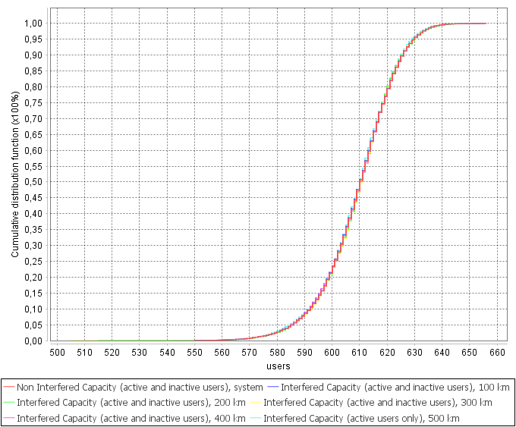

FIGURE 16

IMT-2000 downlink channel capacity loss probability distribution function

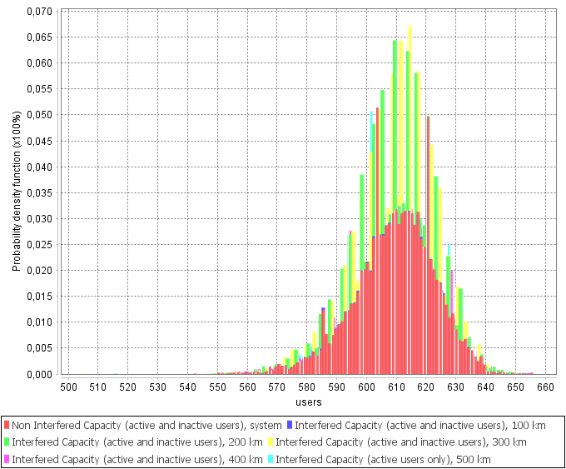

TABLE 6

IMT-2000 downlink channel capacity loss

|  |  |  |  |  |  |
| --- | --- | --- | --- | --- | --- |
| Distance between the centre of the IMT network and the HIBS nadir point | 100 km | 200 km | 300 km | 400 km | 500 km |
| IMT-2000 capacity degradation | 0.013% | 0.0019% | 0% | 0% | 0% |

FIGURE 17

IMT-2000 uplink channel capacity loss cumulative distribution function

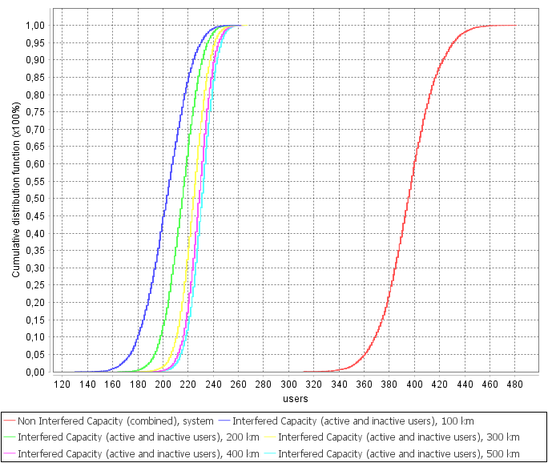

FIGURE 18

IMT-2000 uplink channel capacity loss probability distribution function

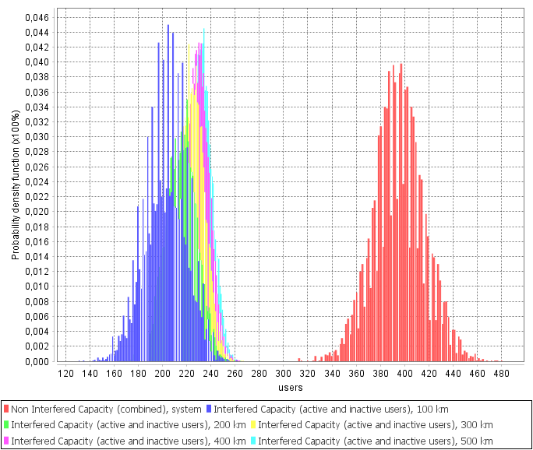

TABLE 7

IMT-2000 uplink channel capacity loss

|  |  |  |  |  |  |
| --- | --- | --- | --- | --- | --- |
| Distance between the centre of the IMT network and the HIBS nadir point | 100 km | 200 km | 300 km | 400 km | 500 km |
| IMT-2000 capacity degradation | 48.685% | 45.514% | 43.199% | 42.07% | 41.498% |

The study conducted demonstrated that the capacity degradation of the IMT-2000 network uplink channel in the presence of HIBS interference is more than 40% at separation distances of between 100 km and 500 km between the IMT-2000 network and the HIBS nadir point. While the capacity degradation from interference on the IMT-2000 downlink is negligible, at less than 0.01%, it should be noted that this is due to the receiving EUs being shielded by clutter in urban environments, whereas for open-terrain scenarios the downlink capacity loss can be significantly higher.

Conclusion

The results of the study on the impact of HIBS on IMT-2000 and IMT-Advanced for urban deployment in a cross-border scenario demonstrated the following:

– The interference impact on the IMT-Advanced and IMT-2000 downlink channel is negligible, at less than 0.1%. It should be noted, however, that for rural deployment, the interference impact may be significantly higher and in some scenarios a capacity degradation exceeding the threshold level is possible.

– The interference impact on the IMT-2000 uplink channel ranges from 48% to 40% at separation distances of 100 to 500 km, which significantly exceeds the threshold level of 5%.

– The interference impact on the IMT-Advanced uplink channel ranges from 11% to 5% at separation distances of 100 to 300 km, which exceeds the threshold level of 5%.

Thus, the use of HIBS may cause significant problems for neighbouring countries in the frequency band 694-960 MHz in respect of IMT-2000 and IMT-Advanced uplink channels.

On the basis of the findings, the RCC Administrations propose Method A1 (No changes to Volumes I and II of the Radio Regulations) as a solution for WRC-23 agenda item 1.4 for the frequency band 694-960 MHz

______________