 | World Radiocommunication Conference (WRC-23)  Dubai, 20 November - 15 December 2023 |  | 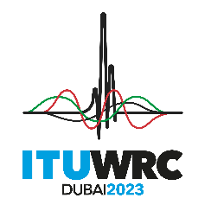
PLENARY MEETING |  | Addendum 18 to  Document 85-E
 |  | 22 October 2023
 |  | Original: Russian
Regional Commonwealth in the field of Communications Common Proposals
PROPOSALS FOR THE WORK OF THE CONFERENCE
Agenda item 1.18
1.18 to consider studies relating to spectrum needs and potential new allocations to the mobile-satellite service for future development of narrowband mobile-satellite systems, in accordance with Resolution 248 (WRC-19);
Proposal

RCC/85A18/1
The RCC Administrations do not support the new allocations to the mobile-satellite service in the frequency bands 1 695-1 710 MHz, 3 300-3 315 MHz and 3 385-3 400 MHz.
The RCC Administrations consider that the new allocation to the MSS in the frequency band 2 010-2 025 MHz (Region 1) in the Earth-to-space direction for the future development of narrowband IoT systems is only possible if the technical and regulatory conditions for their use are established, ensuring the protection of existing and planned radiocommunication service systems in the same or adjacent frequency bands allocated in accordance with RR Article 5.
The RCC Administrations support the consideration at WRC-27 of a possible new primary allocation to the MSS (including narrowband IoT systems) in frequency bands below 3 GHz.
Reasons: The spectrum needs of narrowband mobile-satellite systems shall be accommodated if the technical and regulatory conditions for their use are established, ensuring the protection of existing and planned radiocommunication service systems in the same or adjacent frequency bands.

______________

