 | World Radiocommunication Conference (WRC-23)  Dubai, 20 November - 15 December 2023 |  | 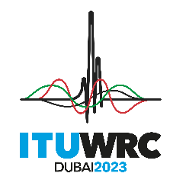
PLENARY MEETING |  | Document 74-E
 |  | 17 October 2023
 |  | Original: Spanish
Paraguay (Republic of)
PROPOSALS for the work of the Conference
Agenda item 8
8 to consider and take appropriate action on requests from administrations to delete their country footnotes or to have their country name deleted from footnotes, if no longer required, taking into account Resolution 26 (Rev.WRC-19);
Introduction
In accordance with Resolution 26 (Rev.WRC-19), the Administration of Paraguay has examined the footnotes to the Table of Frequency Allocations and proposes that the country name of Paraguay be deleted from footnote No. 5.185.
Proposals

ARTICLE 5
Frequency allocations
Section IV – Table of Frequency Allocations
(See No. 2.1)
MOD PRG/74/1
5.185 Different category of service: in the United States, the French overseas departments and communities in Region 2 and Guyana, the allocation of the frequency band 76-88 MHz to the fixed and mobile services is on a primary basis (see No. 5.33). (WRC-23)
Reasons: In Paraguay the allocation to the fixed and mobile services on a primary basis is no longer required.

______________

