 | World Radiocommunication Conference (WRC-23)  Dubai, 20 November - 15 December 2023 |  | 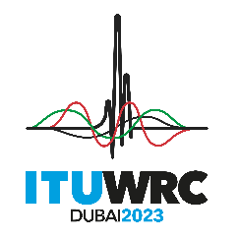
PLENARY MEETING |  | Document 64-E
 |  | 28 September 2023
 |  | Original: English
Mali (Republic of)
Proposals for the work of the conference
Agenda item 1.2
1.2 to consider identification of the frequency bands 3 300-3 400 MHz, 3 600-3 800 MHz, 6 425-7 025 MHz, 7 025-7 125 MHz and 10.0-10.5 GHz for International Mobile Telecommunications (IMT), including possible additional allocations to the mobile service on a primary basis, in accordance with Resolution 245 (WRC-19);

ARTICLE 5
Frequency allocations
Section IV – Table of Frequency Allocations
(See No. 2.1)
NOC MLI/64/1
2 700-3 600 MHz
Allocation to services
Region 1 | Region 2 | Region 3
3 300-3 400  RADIOLOCATION | 3 300-3 400  RADIOLOCATION  Amateur  Fixed  Mobile | 3 300-3 400  RADIOLOCATION  Amateur
5.149 5.429 5.429A 5.429B 5.430 | 5.149 5.429C 5.429D | 5.149 5.429 5.429E 5.429F
Reasons: The 3.3-3.4 GHz band is used in Mali by radiolocation services, this band is crucial for this country. Because Mali, for around ten years, has been facing a multidimensional crisis, with terrorist attacks on a large part of the territory. This requires the Armed and security forces to intervene using aircraft with on-board radars using this frequency band.
The Mali Administration wishes not to make any changes (NOC) to Article 5 of the Radio Regulations concerning the 3.3-3.4 GHz band.
______________

