 | World Radiocommunication Conference (WRC-23)  Dubai, 20 November - 15 December 2023 |  | 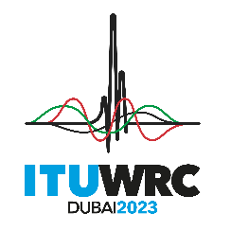
PLENARY MEETING |  | Addendum 3 to  Document 44-E
 |  | 26 June 2023
 |  | Original: English
Member States of the Inter-American Telecommunication Commission (CITEL)
Proposals for the work of the conference
Agenda item 1.3
1.3 to consider primary allocation of the frequency band 3 600-3 800 MHz to the mobile service in Region 1 and take appropriate regulatory actions, in accordance with Resolution 246 (WRC-19);
Proposal
IAP/44A3/1
WRC-23 agenda item 1.3 addresses the consideration of a possible primary allocation of the frequency band 3600-3800 MHz to the mobile service, except aeronautical mobile, in Region 1. It should be noted that Regions 2 and 3 already have primary mobile, except aeronautical mobile, service allocation in the frequency band 3600-3800 MHz which could be harmonized with other Regions depending on the results of this agenda item at WRC-23. Any changes made to the Radio Regulations under WRC-23 agenda item 1.3 must not impact the existing allocations and identifications for Region 2, nor subject Region 2 to any changed procedural or regulatory provisions. Therefore, no change is proposed for Region 2 and this proposal does not address Regions 1 and 3.

______________

