 | World Radiocommunication Conference (WRC-23)  Dubai, 20 November - 15 December 2023 |  | 
PLENARY MEETING |  | Addendum 2 to  Document 44(Add.27)-E
 |  | 13 October 2023
 |  | Original: English
Member States of the Inter-American Telecommunication Commission (CITEL)
PROPOSALS FOR THE WORK OF THE CONFERENCE
Agenda item 10
10 to recommend to the ITU Council items for inclusion in the agenda for the next world radiocommunication conference, and items for the preliminary agenda of future conferences, in accordance with Article 7 of the ITU Convention and Resolution 804 (Rev.WRC-19),
Part 2
Background
The fixed-satellite service (FSS) has undergone major growth over the past few decades in terms of the number of satellites launched, the number of industry players, the development of applications, and the growing need for better performances. Satellite technology has also followed this trend, with user equipment that makes it possible to have higher data speeds, smaller user terminals, and increasingly more flexible products. This widespread growth of FSS has applied pressure on available and limited spectrum resources needed to provide this service.
At present, the Ku-band continues to be one of the most important resources for FSS, and the growing demand for Ku-band spectrum for connectivity, using smaller user terminals, is exerting pressure on the uplink frequency band 14-14.5 GHz, which is currently the only part of the uplink spectrum that it is usable for smaller user terminals. Over the past few years, the technology has evolved and is heading toward the use of smaller and more flexible user terminals.
WARC-92 added an allocation to FSS ( Earth-to-space) in the frequency band 13.75-14 GHz shared with other services and approved, on the basis of footnotes, certain values that would be applied until they would be revised by the CCIR and by a future competent conference (WARC-92)). The first revisions were made by WRC-95 and WRC-2000 and, on the basis of Resolution 733 (WRC-2000), WRC-2003 adopted the latest modifications to notes Nos. 5.502 and 5.503 that are now in force in the Radio Regulations (RR).
In particular for this frequency band 13.75-14 GHz, RR Nos. 5.502 and 5.503 limit the antenna size to a minimum of 1.2 m and impose power and pfd limits at sea for antennas of GSO systems and the minimum antenna restriction is 4.5 m for antennas of non-GSO systems, which hinders the efficient use of the frequencies and the use of smaller antennas.
Moreover, the limitations imposed on antenna sizes in parts of the uplink spectrum (13.75-14 GHz and 14.5-14.75 and 14.5-14.8 GHz, depending on the Region) creates an imbalance between the uplink spectrum and the downlink, which restricts efficient use of the band.
The following chart represents the Ku-band satellite frequencies not subject to RR Appendices 30, 30A, or 30B and highlights the frequencies where there are restrictions on the size of user terminals.

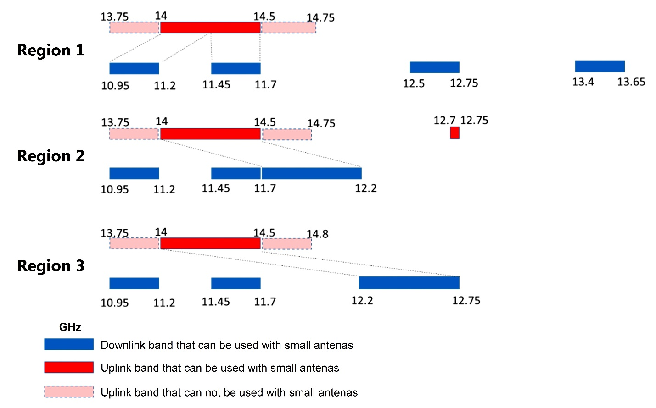
In view of the above, it can be observed that there is the need to identify further uplink capacity that could be used efficiently by smaller antennas.
As mentioned above, the conditions in the frequency band 13.75-14 GHz, as imposed in RR Nos. 5.502 and 5.503 were last revised at WRC-03 and continue to be too restrictive for the rollout of smaller antennas for uplink transmission and for the limited locations for rolling them out because of the limits of pfd at sea. Because these provisions date back to more than 20 years and in view of current technology breakthroughs, it would now be appropriate to review the possible loosening of the limits that were imposed so as to allow for a more efficient use of the spectrum in the frequency band 13.75-14 GHz.
There is a pressing and growing need for Ku-band spectrum to be available to meet the increasing demand for connectivity, particularly for the use of smaller user terminals, including ubiquitously deployed very small aperture terminals (VSATs). This growing demand has placed tremendous strain on the available spectrum for satellite services utilizing the frequency band 14.0-14.50 GHz. Considering the figure above, it can be seen that there is a need to identify more uplink capacity that can be used by smaller antennas efficiently.
While the frequency band 14-14.5 GHz can be used for smaller antennas, the frequency band 14.5-14.75/14.8 GHz is shared with the RR Appendix 30A feeder-link Plan and List and use beyond that also is limited to those countries identified in Resolutions 163 (WRC-15) and 164 (WRC-15). Moreover, such use outside RR Appendix 30A is limited to antenna sizes of 6 m and above and is also subject to power limits that makes this band unusable for smaller antennas. Similarly, for the frequency band 13.75-14 GHz, RR Nos. 5.502 and 5.503 limits the antenna size to a minimum of 1.2 m and imposes power and pfd limits that hinders efficient use and use of smaller antennas. In Region 1, also the frequency band 13.4-13.65 GHz is allocated for downlinks. However, due to the large separation to the other downlink bands and its placement between satellite uplink bands, together with the limitations of RR Nos. 5.499A and 5.499B, it may be questionable how efficient this frequency band could be for used by small antennas in the FSS downlink. The frequency band 12.5-12.75 GHz is also allocated to FSS uplinks in Region 1. However, since the band is also allocated to FSS downlinks and moreover because the band is heavily used for FSS downlinks in the Region, it is doubtful if the band can be used efficiently also for uplinks, especially by smaller earth stations deployed in larger numbers or at unknown locations (e.g. SNGs or VSATs operating under a blanket license). In Region 2, the frequency band 12.7-12.75 GHz is also allocated to FSS uplinks. However, noting that this represents only 50 MHz of bandwidth which is far from the other Ku-band unplanned uplink capacity, its practical use is questionable.
As shown in the table below, it can be seen that for all three ITU-R Regions, there is a significant mismatch between the uplink and downlink bandwidth that can efficiently be used to provide services for smaller antennas, e.g. HTS or broadband user terminals, VSATs, satellite news gathering, etc.
Table 1
Ku frequency bands for smaller antennas in FSS, not subject to Appendix 30, 30A or 30B
 | Bandwidth (MHz) in the frequency range 10-15 GHz, not subject to RR Appendices 30, 30A or 30B, that can be used by smaller antennas
 | Downlink | Uplink | Lack of uplink bandwidth to feed downlink bandwidth
Region 1 | 750 (1000) | 500 | 250 (500)
Region 2 | 1000 | 500 | 500
Region 3 | 1050 | 500 | 550
To enable efficient use of orbit and spectrum resources to meet demands for current and emerging satellite applications, it can be seen that in all three ITU-R Regions, it is critical to identify more uplink capacity in the frequency range 10-15 GHz that can be used efficiently by smaller uplink antennas.
The frequency band 13.75-14 GHz was allocated globally by WARC-92 for FSS, but with limitations introduced in RR Nos. 5.502 and 5.503 to enhance compatibility with radiolocation, radionavigation services and geostationary space stations in the space research service for which information for advance publication had been received by the Bureau prior to 31 January 1992. WRC-03 reviewed these two footnotes and made some changes to these, but still such that efficient use by the frequency band for smaller uplink antennas is not possible. These considerations and provisions were made 30-20 years ago at a time when FSS satellites and their associated applications and requirements were very different from today. Similarly, it would seem likely that the use by other services sharing the band and their applications have changed over these decades.
Proposals

ADD IAP/44A27A2/1
Draft New Resolution [AI WRC-27] (WRC-23)
Agenda of the 2027 World Radiocommunication Conference
The World Radiocommunication Conference (Dubai, 2023),
considering
a) that, according to No. 118 of the ITU Convention, the general scope of the agenda of a world radiocommunication conference (WRC) should be established four to six years in advance and that the Council must set the final agenda two years before the conference;
b) Article 13 of the ITU Constitution on the competence and calendar of WRCs and Article 7 of the ITU Convention on their agendas;
c) relevant resolutions and recommendations of previous world administrative radio conferences (WARCs) and WRCs,
recognizing
a) that this Conference has identified various subjects that require continued study at WRC-27;
b) that, when drawing up the present agenda, many of the items proposed by the administrations could not be included and had to be deferred to the agendas of future conferences,
resolves
to recommend to the Council a four-week WRC in 2027 on the basis of the following agenda:
1 on the basis of the proposals made by the administrations, taking into account the results of WRC-23 and the Report on the Conference Preparatory Meeting, and with due consideration given to the needs of existing and future services in the frequency bands, to consider and take adequate measures in regard to the following subjects:
1.[X] to study and revise the conditions and constraints in Nos. 5.502 and 5.503 to enable a more efficient use and sharing of the frequency band 13.75-14 GHz by the FSS uplink of geostationary and non-geostationary fixed-satellite service (FSS) earth stations, including FSS earth stations using smaller antenna sizes, while considering the sharing conditions with applications of other services sharing the band as outlined in these footnotes, in accordance with new Resolution [AI-10-13.75-14 GHz small antennas] (WRC-23);
…
invites the ITU Council
to finalize the agenda and take the measures needed to convene WRC-27 and to begin as quickly as possible the necessary consultations with Member States,
instructs the Director of the Radiocommunication Bureau
1 to take the necessary measures to convene the sessions of the Conference Preparatory Meeting (CPM) and draw up a report to WRC-27;
2 to submit to the second session of the CPM a draft report on the difficulties or inconsistencies observed in applying the Radio Regulations in regard to agenda item 9.2 and to submit the final Report at least five months before the next WRC,
instructs the Secretary-General
to forward the present Resolution to interested international and regional organizations.
Reasons: The need to identify additional uplink FSS capacity in the frequency range 13.75-14 GHz that can be used efficiently by smaller earth station antennas to provide other satellite applications to smaller user terminals.
ADD IAP/44A27A2/2
Draft New Resolution [AI-10-13.75-14 GHz
small antennas] (WRC-23)
Studies and revision of the conditions for using and sharing the frequency band 13.75-14 GHz to allow for the efficient use of the band by earth stations of the uplink FSS, including earth stations in the FSS that use smaller antennas
The World Radiocommunication Conference (Dubai, 2023),
considering
a) that WARC-92 added an allocation to the fixed-satellite service (FSS) (Earth-to-space) in the frequency band 13.75-14 GHz;
b) that WRC-03 introduced changes to Nos. 5.502 and 5.503 that made it possible to use earth station antennas in the range of 1.2 m to 4.5 m for the geostationary FSS networks with limits on power flux-density and e.i.r.p. density limits;
c) that WRC-03 did not introduce any changes in Nos. 5.502 and 5.503 in regard to earth stations for non-geostationary-satellite systems;
d) that there is congestion in the geostationary orbit;
e) that many new satellite systems are being introduced into non-geostationary orbits;
f) that it is necessary to guarantee that orbit and spectrum resources are used efficiently and rationally to facilitate the introduction of new satellite networks, in particular the networks of new satellite operators;
g) that there is a lack of uplink broadband in the frequency range 13-15 GHz, which could be used efficiently worldwide, even by smaller earth station antennas, to build up the downlink capacity in the frequency range 10-13 GHz;
h) that this band is shared with the radiolocation service on the basis of conditions set forth in No. 5.502;
i) that the space research service (SRS) is allocated to this band on a secondary basis;
j) that the geostationary space stations of the SRS for which the Bureau has received information for its advance publication before 31 January 1992 shall be operating on an equal footing with the stations in the FSS; after that date, the new geostationary space stations of the SRS shall operate on a secondary basis;
k) that until the geostationary space stations of the SRS for which the Bureau has received information for its advance publication before 31 January 1992 stop operating in that frequency band, the frequency band 13.77-13.78 GHz shall be shared with the SRS under the conditions set forth in No. 5.503;
l) that, in the Master International Frequency Register (MIFR), there is currently only a very limited number of earth stations and satellite networks of the SRS in the frequency band 13.77-13.78 GHz for which advance publication was received before 31 January 1992;
m) that the use of the services that share this band with the fixed-satellite service and the necessary related conditions of coexistence may have changed;
n) that, in some countries, the band is also allocated to the fixed service and the mobile service (Nos. 5.499 and 5.500) and to the radionavigation service (No. 5.501);
o) that the enhancement of operating conditions of the earth stations in the frequency band 13.75-14 GHz shall help to meet the changing needs of satellite applications and shall facilitate an efficient and rational use of the Earth-to-space and space-to-Earth frequency bands corresponding to the frequency range 13-15 GHz and 10-13 GHz,
recognizing
a) that it is necessary to conduct studies to develop regulatory changes that would meet growing needs for spectrum that earth stations of the FSS uplink could efficiently use, including smaller earth station antennas in the frequency range 13-15 GHz;
b) that, taking into account the frequency band 13.75-14 GHz, it is necessary to determine the conditions of coexistence between the services that share this band and to strike an adequate balance between them,
resolves to invite the ITU Radiocommunication Sector
1 to conduct studies, on time for their consideration by WRC-27, on the sharing conditions for the earth stations in the fixed-satellite service uplink, as indicated in Nos. 5.502 and 5.503, for the purpose of revising the constraints on earth stations that would facilitate an effective use of the band by earth stations of the FSS uplink, including the earth stations of the FSS that use smaller antennas and its associated power limitations to facilitate a rational use of the orbit of the fixed-satellite service Earth-to-space and space-to-Earth and the spectrum resources in the frequency bands 13-15 GHz and 10-13 GHz and to meet the changing needs of satellite networks;
2 to identify, on time for their consideration by WRC-27, possible alternative sharing conditions other than those indicated in Nos. 5.502 and 5.503;
3 to identify, on time for their consideration by WRC-27, possible changes to Nos. 5.502 and 5.503 and/or other relevant regulatory changes to the Radio Regulations.

SUP IAP/44A27A2/3
RESOLUTION 812 (WRC-19)
Preliminary agenda for the 2027 World Radiocommunication Conference*
Reasons: This resolution should be suppressed because WRC-23 shall be drawing up a new Resolution that will incorporate the WRC-27 agenda.

ATTACHMENT
Proposal for an additional item on the agenda to review the conditions of use and sharing of the frequency band 13.75-14 GHz to allow efficient use of the band by uplink FSS earth stations, including earth stations of FSS using smaller antenna sizes
Subject: Proposed future WRC-27 agenda item for possible revisions to the constraints in RR Nos. 5.502 and 5.503 to enable efficient use of the frequency band 13.75-14 GHz
Origin: CITEL
Proposal:
to review the conditions of use and sharing of the frequency band 13.75-14 GHz to allow efficient use of the band by uplink FSS earth stations, including FSS earth stations using smaller antenna sizes.
Background/reason:
The critical need to identify additional uplink FSS capacity in the frequency range 10-15 GHz that can be used efficiently by smaller earth station antennas to provide broadband and other satellite applications to smaller user terminals.
Radiocommunication services concerned:
Fixed-satellite service
Indication of possible difficulties:
to meet the increasing demand for connectivity in the Ku-band spectrum, particularly for the use of smaller user terminals.
Previous/ongoing studies on the issue:
Related studies have been already commenced in the ITU-R WP 4A.
Studies to be carried out by:  ITU-R Working Party 4A | with the participation of:  ITU-R membership
ITU-R study groups concerned:
ITU-R Study Group 4
ITU resource implications, including financial implications (refer to CV126):
Minimal, as the proposed agenda item should be studied by ITU-R WP 4A within its existing framework of meetings.
Common regional proposal: Yes | Multicountry proposal: Yes  Number of countries: 6
Remarks

________________

* The appearance of square brackets around certain frequency bands in this Resolution is understood to mean that WRC-23 will consider and review the inclusion of these frequency bands with square brackets and decide, as appropriate.

