 | World Radiocommunication Conference (WRC-23)  Dubai, 20 November - 15 December 2023 |  | 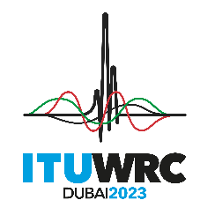
PLENARY MEETING |  | Document 4-E
 |  | 8 November 2023
 |  | Original: English
Director, Radiocommunication Bureau
REPORT OF THE DIRECTOR ON THE ACTIVITIES OF THE RADIOCOMMUNICATION SECTOR
This Report on the activities of the Radiocommunication Sector since the last world radiocommunication conference is submitted to WRC-23 pursuant to the provisions of CV180 and item 9 of the agenda. To facilitate the consideration of the variety of subjects dealt with in this Report, it is structured in various parts, and each part is presented in a separate addendum, as indicated in the summary table.

Part No. | Subject | Addendum No.
1 | Activities of the Radiocommunication Sector in the period between WRC-19 and WRC-23 | 1
2 | Experience in the application of the radio regulatory procedures and other related matters | 2
3 | Activities of the Radio Regulations Board | 3
4 | Management of the MMSI numbering resource (Issues referred to in Resolution 344 (Rev.WRC-19) and other related issues) | 4
5 | Changes in the allocation of call signs series between WRC-19 and WRC-23 and related issues | 5
6 | Analysis of the methods contained in the CPM Report to satisfy agenda items of WRC-23 | 6
7 | ICAO progress on standards and recommended practices (SARPs) preparation for Remotely Piloted Aircraft Systems | 7

______________

