Radiocommunication Advisory Group | 
 |  | Document RAG/76-E
 |  | 16 March 2026
 |  | Original: English
ITALY
further development under resolution 55 (REV.WRC-23)
ONLINE SUBMISSION OF COMMENTS TO BR IFIC ADVANCED PUBLICATIONS INFORMATION

1 Background
The Italian Administration appreciates the continued efforts by the Radiocommunication Bureau (BR) in implementing Resolution 55 (Rev. WRC-23), which instructs the BR to develop and improve the e-Submission of Satellite Network Filings, e-Communications, and SIRRS platforms to meet the needs of the Radio Regulations.
At the 32nd meeting of the Radiocommunication Advisory Group (RAG-32), the Japanese Administration presented Document RAG/40-E, outlining comprehensive proposals for further development of e-Submission and e-Communications systems. The Italian Administration fully supports the objectives and proposals put forward in Document RAG/40-E.
Building upon the aforementioned proposals, the Italian Administration wishes to propose additional developments aimed at simplifying and streamlining the process of submitting comments related to BR IFIC publications, particularly for Advance Publication Information (API).

2 Current Situation and Challenges
Under the current procedures as laid in art. 9.3 RR , when the BR publishes satellite network filings in the BR IFIC, Administrations that identify potential frequency overlapping or interference concerns, must submit their comments through separate correspondence to the BR and to the individual Administrations concerned. This process implies:
● Manual identification of potentially affected satellite networks from BR IFIC publications
● Preparation and submission of individual letters via e-Communications for each affected filing
● Significant volume of preliminary correspondence on e-Communications platform
● Potential delays in identifying all concerned parties for coordination
While the e-Communications platform has improved the efficiency of correspondence between Administrations and the BR, as recognized in Document RAG/40-E, there remains an opportunity to further streamline the initial comment submission process for BR IFIC advanced publications (API).

3 Proposal

3.1 Development of an Online Tool for Direct Submission of Comments to BR IFIC Publications
The Italian Administration proposes that the BR develop a software tool that enables the direct online submission of initial comments on API publications, without the need to send separate letters to individual Administrations. This tool would be integrated within the existing e-Submission and e-Communications infrastructure.
The proposed system would function as follows:
Step 1: Automatic Identification of Potential Overlaps
When an Administration accesses the online comment tool, the system would:
● Allow the Administration to select their identity from a drop-down menu in the "Affected Administration" field
● Automatically query the BR IFIC database (Following BRSIS logic) to identify all satellite networks belonging to the Administration, that have potential frequency overlap with the new publication
● Display a pre-populated list of potentially affected satellite networks by the new publication.
Step 2: Confirmation and Refinement
The affected Administration would then be able to:
● Review the automatically identified list of potentially affected satellite networks
● Confirm or deselect individual satellites from the pre-populated list
● Manually add/remove additional satellite networks or systems not automatically identified by the software analysis
● Provide specific technical comments or concerns for each selected satellite network
Step 3: Submission
Upon confirmation of overlaps (by clicking individual buttons or a "CONFIRM ALL" option. See Figure 1), the system would automatically generate a structured report identifying both the commenting Administrations and the specific satellite systems potentially affected.
Step 4: Publication
The BR would subsequently publish this information in the next BR IFIC API/B clearly indicating:
● Which Administrations have submitted comments
● Which specific satellite systems are potentially affected
● Eventual technical comments for each satellite system potentially affected

3.2 System Interface and User Experience
The proposed tool would feature an intuitive web-based interface, similar in design philosophy to the improvements requested by Japanese Administration for BR Space Software (as outlined in section 2.4 of Document RAG/40-E).
The interface would include:
● Drop-down menus for Administration selection
● Auto-populated tables showing potential frequency overlaps
● Checkboxes for confirming or deselecting affected satellites
● Free-text fields for technical comments
● Batch confirmation option ("CONFIRM ALL")
● Real-time validation before submission
● Integration with existing e-Submission and e-Communications credentials and workflows

Visual Example as follows in Figure 1:

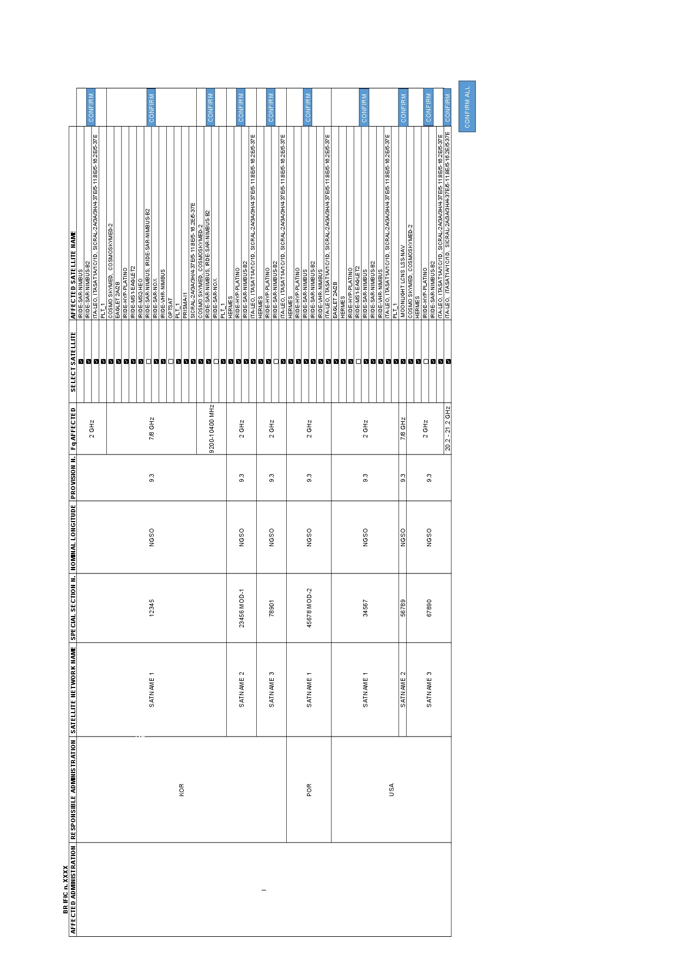

4 Advantages of the Proposed System
The Italian Administration believes that implementation of this online comment tool would provide significant benefits to all stakeholders:

4.1 Reduced Volume of Correspondence on e-Communications
By channelling initial comments through a dedicated online tool rather than through individual correspondence, the e-Communications platform would be reserved primarily for subsequent coordination discussions and technical exchanges. This would significantly reduce the volume of preliminary "notice of potential interference" letters, helping Administrations to filter congestion to focus instead, on substantive coordination activities.

4.2 Improved Efficiency of the Coordination Process
The preliminary identification of potentially affected satellite networks would:
● Reduce the time Administrations spend manually reviewing BR IFIC publications
● Minimize the risk of overlooking relevant frequency overlaps
● Accelerate the identification of all parties requiring coordination
● Provide a clear and immediate picture of coordination requirements for the publishing Administration

4.3 Enhanced Clarity
The publishing Administration will receive a clear, tabular report identifying:
● All Administrations that have submitted comments
● The specific satellite networks requiring coordination
● The technical basis for coordination requirements
This clarity would allow for more efficient planning, a clearer coordination scenario and a better allocation of resources for coordination activities.

4.4 Improved Data Management and Accessibility
All submitted comments and identified coordination requirements would be:
● Stored in the ITU database in a structured format
● Readily retrievable and shareable online
● Available for analysis and reporting purposes

4.5 Consistency with Resolution 55 (Rev. WRC-23)
The proposed implementation directly supports the objectives of Resolution 55 (Rev. WRC-23), particularly:
● Resolves 8: Whereas administrative correspondence related to advanced publication, coordination, notification and recording processes shall be communicated whenever possible, using the ITU e-Communications platform
● Resolves 10: Traditional means of communication (telegram, telex, fax), involved in the advanced publication, coordination, notification and recording processes should be replaced with e-communications platforms
● A general mandate to continue developing and improving electronic systems for satellite coordination

5 Implementation Considerations
The Italian Administration recognizes that implementation of this proposal would require:
● Development and testing of the online interface and database query functionality
● Integration with existing e-Submission and e-Communications infrastructure
● Training and guidance materials for Administrations
● A transition period during which both traditional and online comment submission methods could be used
The Italian Administration stands ready to support the BR in this development through:
● Voluntary contributions, as appropriate
● Participation in pilot testing and user feedback
● Sharing technical expertise and best practices

6 Conclusion
The Italian Administration appreciates the leadership demonstrated by the Japanese Administration in Document RAG/40-E and fully supports the continued development of e-Submission and e-Communications systems under Resolution 55 (Rev. WRC-23).
The additional proposal outlined in this document aims to extend and complement the RAG/40-E objectives by:
● Further reducing the administrative burden on Administrations and the BR
● Improving efficiency and clarity in the satellite coordination process
● Leveraging ITU’s existing database infrastructure to provide enhanced automation
● Reducing unnecessary correspondence volume on the e-Communications platform
● Providing clearer coordination pathways from the earliest stages of the advanced publication and coordination processes
● Avoid heavy downloads and updates in local Administrations’ storages
The Italian Administration kindly requests the BR to consider this proposal as a complementary enhancement to the ongoing development efforts outlined by the honorable Japanese Administration, and to explore opportunities for implementation in coordination with other system improvements under Resolution 55 (Rev. WRC-23).

7 References
[1] Document RAG/40-E, "Further development under Resolution 55 (Rev. WRC-23) – Electronic submission and publication of satellite network filings," Japan, 26 March 2025.
[2] Resolution 55 (Rev. WRC-23), "Electronic submission of, and communications on, notice forms for satellite networks, earth stations and radio astronomy stations and reports of harmful interference affecting space services"
[3] "e-Submission of Satellite Network Filings / e-Communications," ITU World Radiocommunication Seminar 2024 (WRS-24).

______________

