Radiocommunication Advisory Group | 
 |  | Document RAG/69-E
 |  | 12 March 2026
 |  | Original: English
JAPAN
further development under resolution 55 (REV.WRC-23)
ELECTRONIC SUBMISSION AND PUBLICATION OF
SATELLITE NETWORK FILINGS

1 Background
Resolution 908 (Rev. WRC-15) instructed the Director of the Radiocommunication Bureau (BR) to implement a secure paperless electronic approach for the electronic submission and publication of satellite network filings and comments (e-Submission). Following WRC-23, Resolution 908 (Rev. WRC-15) was integrated into Resolution 55 (Rev. WRC-23) which instructs the BR to continue to develop and improve the e-Submission of Satellite Network Filings, e-Communications and SIRRS platforms to meet the needs of the Radio Regulations with respect to the submission of, and comments on, satellite network filings, as well as the associated correspondence.
Since May 2017, the Administration of Japan has been supporting the BR’s activity through voluntary contributions to support the implementation of Resolution 908 (Rev. WRC-15), and would like to continue its support for these projects.
The 32nd meeting of the RAG in 2025 discussed two contributions (RAG/40 and RAG/45) addressing further development under Resolution 55 (Rev. WRC-23) regarding the electronic submission and publication of satellite network filings, and invited BR to pursue further developments within the financial limitations.

2 Proposals
While Japan recognizes that the BR's efforts in this project have made significant progress, Japan would like to reiterate the importance of expanding e-Submission and e-Communications, and the need to further improve the related software in order to increase the efficiency and speed of satellite coordination procedures, including the BR's review and publication procedures.
As a follow up to discussions from previous RAGs, Japan would like to propose the following suggestions in 2.1 to 2.3.

2.1 Make the e-Communications system available for use by satellite operators and encourage administrations to use the system
Communication between administrations and satellite operators has been mainly by e-mail. On the other hand, communication between the BR and administrations is increasingly being carried out by e-Communications. In Resolution 55 (Rev. WRC-23), it was resolved as follows.

Resolves
…..
8 that administrative correspondence between administrations and BR related to the advance publication, coordination, notification and recording processes, including correspondence related to Appendices 30, 30A and 30B, for satellite networks, earth stations and radio astronomy stations shall be communicated, whenever possible, using the ITU e-Communications platform;
10 that, wherever the words “telegram”, “telex” or “fax” are inserted in provisions related to the advance publication, coordination, notification and recording processes for satellite systems or networks, earth stations and radio astronomy stations, including the provisions contained in Appendices 30, 30A and 30B and related Resolutions, the e-Communications platform shall be used instead;
…..

As noted in RAG/40, the usage rate of the e-Communications has gradually increased since its introduction and has recently been around 80%^{[1]}. The e-Communications platform shall be used in accordance with Resolution 55 (Rev. WRC-23) if there is no difficulty in its usage.

The Bureau has made progress in its work to enable operating agencies to use the e-Communications system, in response to the requests made at the previous RAG meetings, as noted in RAG/58. The consistent use of e-Communications by administrations and operators will further streamline communications for satellite coordination.

In order to further enhance the capability of the system, Japan would like to request that the BR:
- Continue examining the possibility to enable satellite operators to use e-Communications so that each administration can efficiently coordinate with its domestic satellite operators. As discussed at the previous RAG, the system should be designed such that the operators cannot access information belonging to other operators (Figure 1 shows this concept image. The image is same as RAG/40), and it should be left to the sole discretion of each administration to determine on a case-by-case basis what information to share, to what extent, and with whom.
- Add a function to the e‑Communications settings that allows users to automatically insert some predefined standard text into the message body, such as the sender’s signature, similar to standard email client applications, since the current system does not automatically insert text, such as the officer’s name, title, alternative contact details, etc. Considering that some administrations routinely reuse a standard template text, the inclusion of such settings would significantly enhance operational efficiency.
- Encourage administrations to make use of e-Communications and analyse the reasons why some administrations do not use the system, and reflect the findings to further system development.
- It may be helpful to increase the number of administrations who use e-Communications as their sole means of communications, in order to streamline the communications process between administrations and BR. Therefore, it is requested that BR continues to update the list of administrations which have stated their willingness to use e-Communications as the only means of communication, and that the BR also provides concrete guidance in various ways on how administrations can inform the BR of their willingness.
- Provide an update on the recent usage of e-Communications and e-Submissions at future World Radiocommunication Seminars (WRSs).
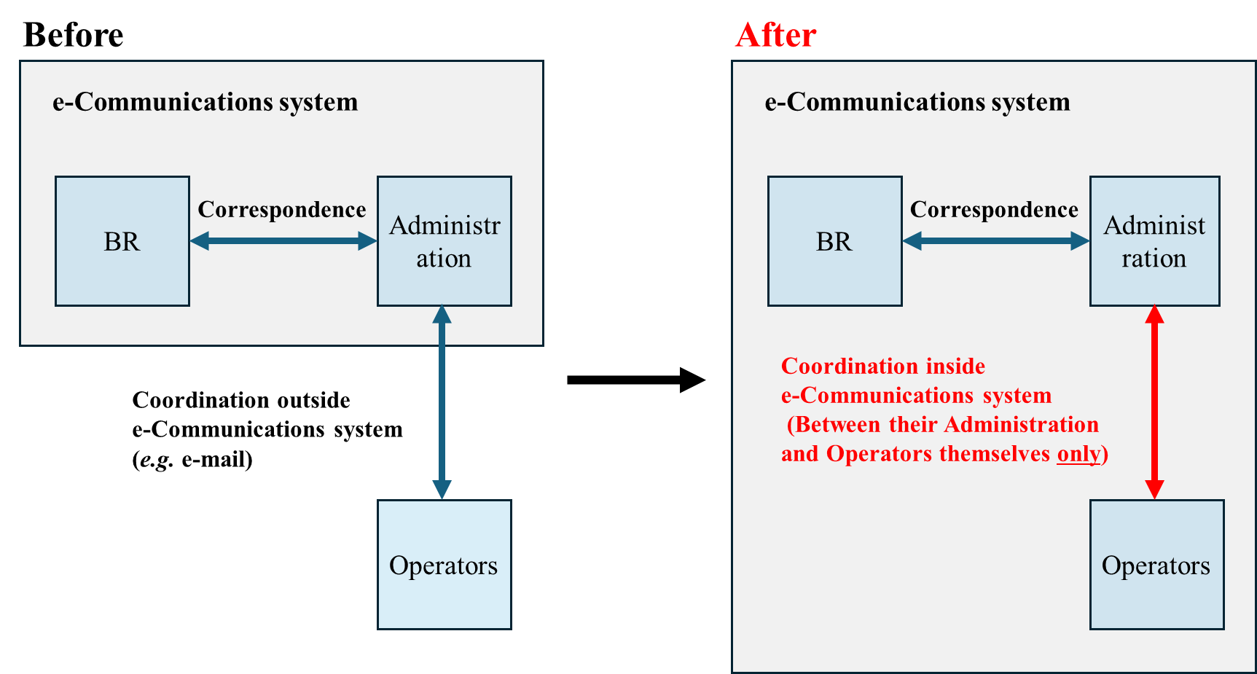
Figure 1 Concept image of updated e-Communications system

2.2 Migration of legacy systems, particularly SpaceCom, to online software
It is greatly appreciated that BR has continued its efforts to modernize legacy information systems, such as the launch of SpaceExplorer, as well as the ongoing work to upgrade SpaceCap, which was written in Visual Basic 6. The BR is encouraged to continue updating the user interfaces of the offline software, including legacy interfaces, with more user‑friendly designs.
In particular, the BR is invited to consider the migration of SpaceCom to an online platform. Currently, SpaceCom operates only in a local environment to generate comments on filings that are uploaded, validated and submitted through e-Submission to the BR.
It is expected that moving SpaceCom online offers the following advantages:
1. Eliminates the need for software installation or updates in the local environment
2. Eliminates the task of uploading comment files created in SpaceCom to e-Submission.
3. Enables users to view comments submitted by other administrations on their own filings quickly and initiate any necessary actions.

2.3 Address inconsistencies in software validation
As discussed in the previous RAG meeting, there are sometimes inconsistencies arising from differences in update timing between the offline and online software. In particular, improvements are necessary given that verification errors in e-Submission continue to occur, despite no errors being detected by BR-SIS.

3 Conclusion
The Administration of Japan kindly requests the BR to further develop and improve the systems continuously as mentioned above, under Resolution 55 (Rev. WRC-23).

4 Reference
[1] “e-Submission of Satellite Network Filings / e-Communications”, ITU World Radiocommunication Seminar 2024 (WRS-24)

______________

https://www.itu.int/en/ITU-R/space/e-communications/Pages/list_of_registered_administrations.aspx https://www.itu.int/online/mm/scripts/org_br_admin.list?_group=BR_SSD

