Radiocommunication Advisory Group | 
Addendum 2 to
Document RAG/58-E
 |  | 19 February 2026
 |  | Original: English
Director, Radiocommunication Bureau
report TO the tHIRTY-THIRD meeting
of the radiocommunication advisory group
TRANSLATION STATUS

Corporate website (primarily SharePoint with mixed technologies)
The availability of content in the six ITU languages covers the main landing pages of departments/topics (level 0) and pages accessible with one click.
Current status: 76% of content is available in multiple languages (incl. 8% automated translation), with the remaining 24% consisting of:
- SG activities/sessions (commonly in English only)
- Workshops and regional events like RRS (in the regional language(s))
- SSD webpages (formerly available only in English, French and Spanish)
- ITU-R Publications pages on DMS (English, French and Spanish)

1.1 Technology Composition and Impact on Multilingual Support
The corporate website is primarily built on SharePoint, with several other technologies integrated:
- SharePoint: Primary platform for content
- Classic ASP: Old pages with content that remains in-force (particularly in Study Groups)
- Web Applications .NET, Node.js (React/NextJS), etc. : applications primarily in English only, due to their technical nature
- Document Management System (DMS): Used for publications with limited language options
This technological composition explains the variation in multilingual availability across different sections of the website.

1.2 Planned Archives System
ITU is currently establishing an archives system similar to that used by the United Nations Office at Geneva (UNOG). This system will allow frozen historical pages to be properly archived and detached from the corporate website, which will:
- Preserve historical content for reference purposes
- Improve the overall multilingual statistics of the active corporate website
- Create a clear separation between current and archived content
- Allow for more focused translation efforts on active content

1.3 Statistics
Overall status: 76% average multilingual availability (total pages: 1,850).
By Language:
- English: 100% (source language)
- French: 80%
- Spanish: 77%
- Arabic: 73%
- Chinese: 70%
- Russian: 67%

WordPress platform
WordPress sites use an automated translation system for content that doesn't require specialized human translation.
Overall status: 90% of WordPress content (225 of 250 pages) is available in multiple languages, with 62% using automated translation.

2.1 WordPress Sites
The following sites have been developed with multilingual support:
- Global ITU/WMO Hub | ITU and World Meteorological Organization (WMO)
Joint ITU/WMO training activities for the period leading up to WRC-27
Number of pages translated: 11/20 = 55%
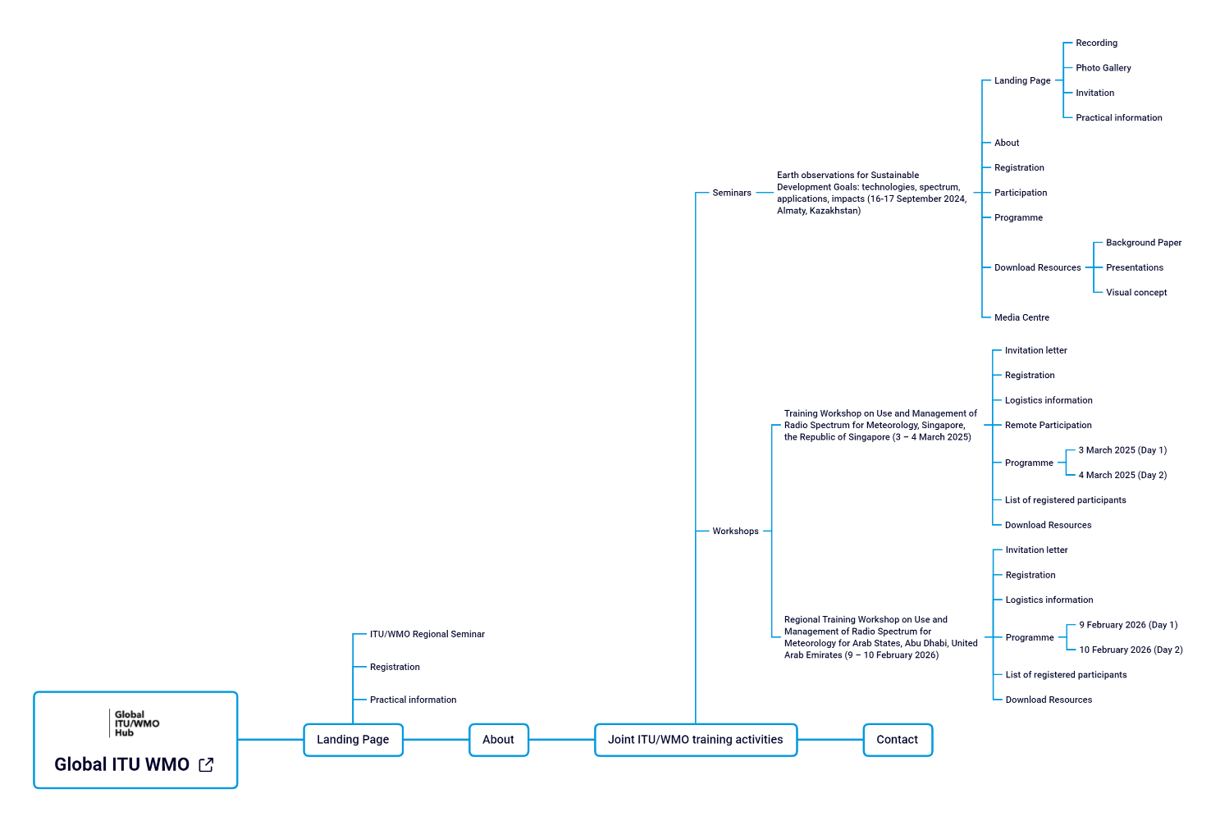

- Space Sustainability Forum (SSF)
Number of pages translated: 28/28 (all automated) à 100% (automated)

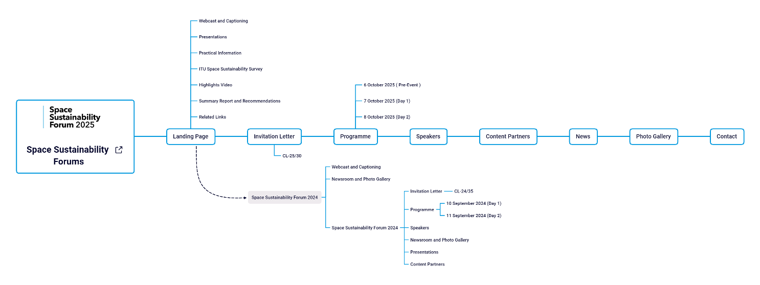

- Space Sustainability Gateway
Number of pages translated: 11/11 (all automated) à 100% (automated)
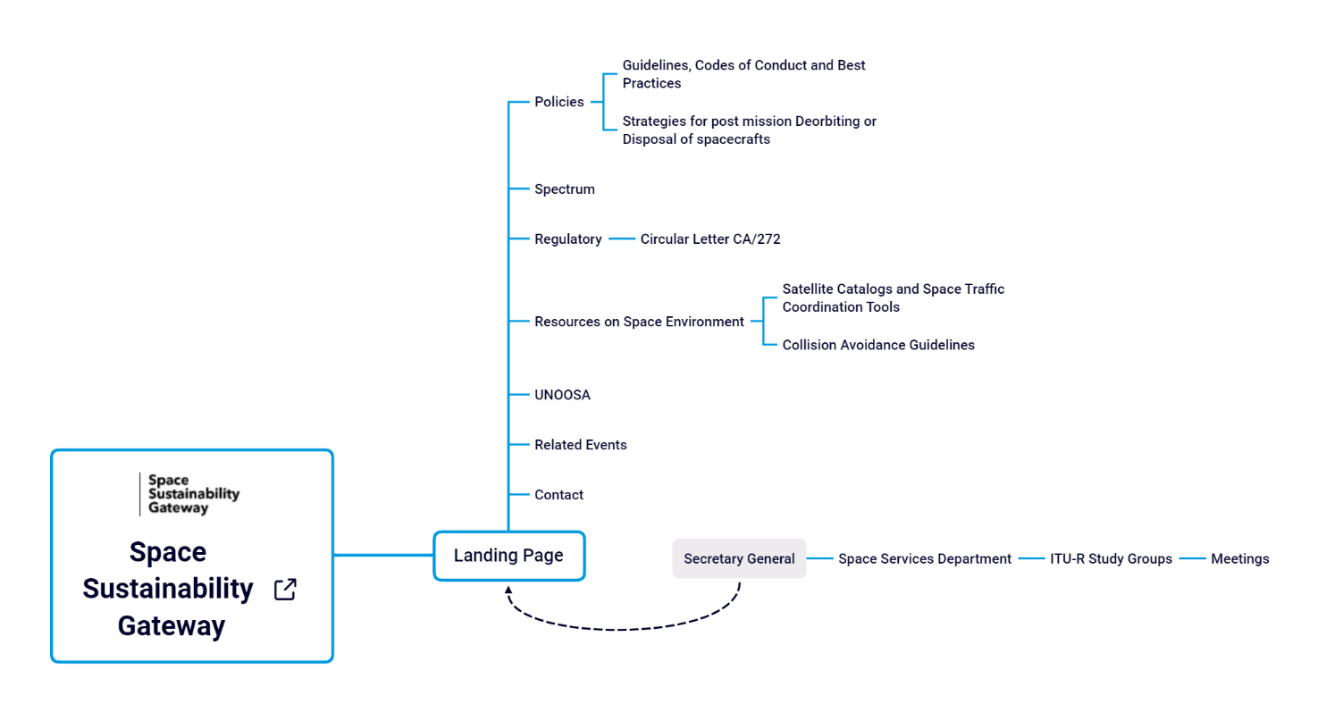

- Connecting the World from the Skies
Number of pages translated: 2/2 (all automated) à 100% (automated)
- BR IFIC Hub (microsite)
Number of pages translated: 1/1 (all automated) à 100% (automated)
- Space Connect
Number of pages translated: 17/17 (all automated) à 100% (automated)
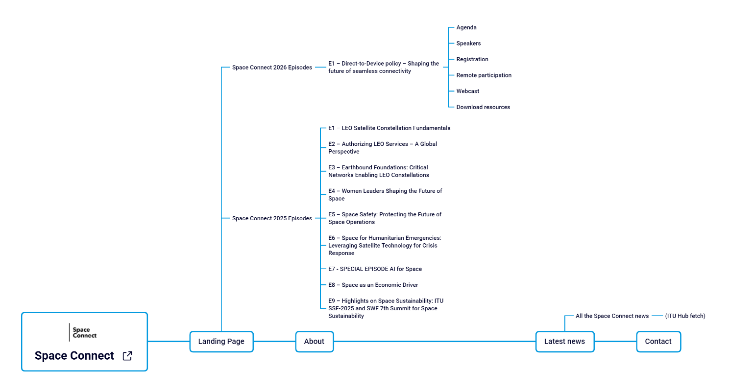
- Network of Women for WRC-27
Number of pages translated: 8/8 (all automated) à 100% (automated)

- IRIS-WRC-27
Number of pages translated: 11/11 (all automated) à 100% (automated)
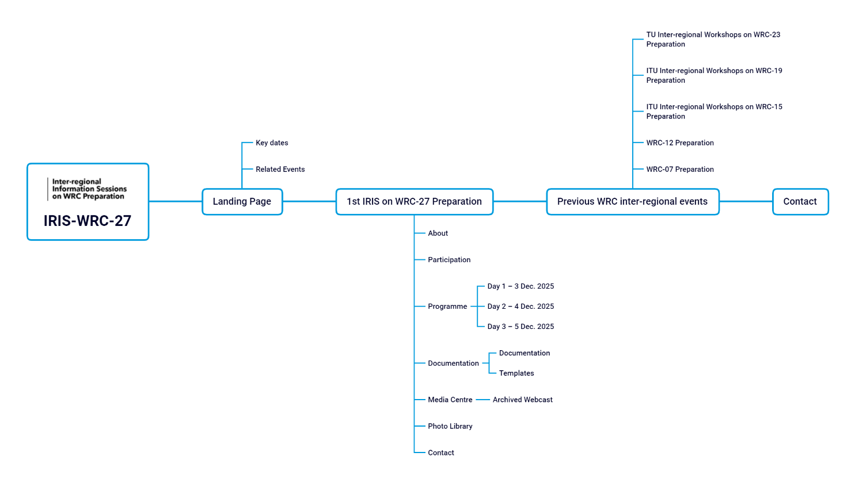
- WRC-27
Number of pages translated: 27/27 (all automated) à 100% (automated)
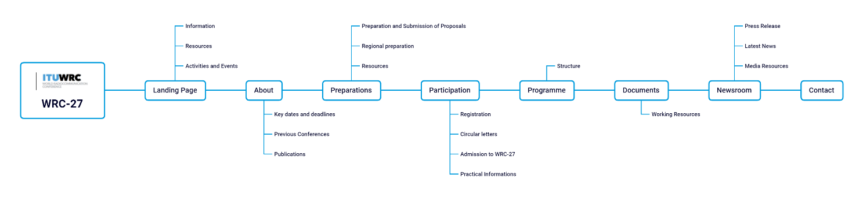
- RA-27
Number of pages translated: 15/15 (all automated) à 100% (automated)
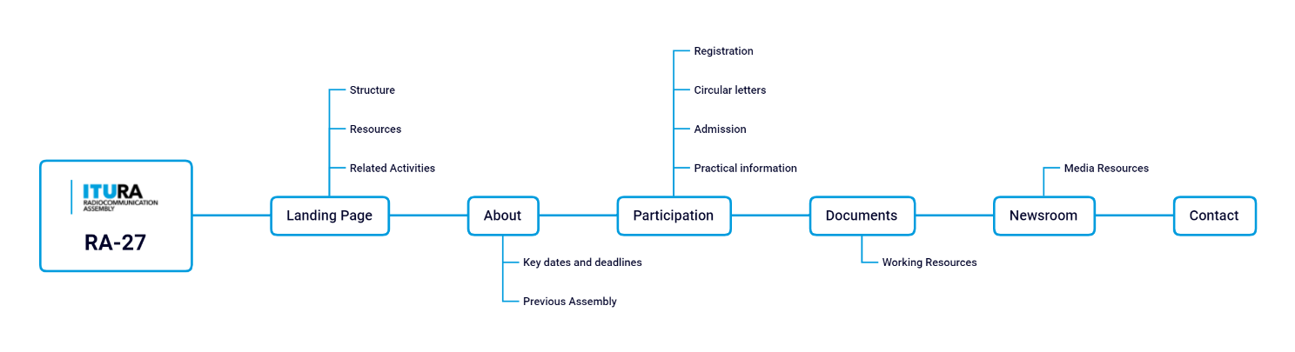
- ITU-R Membership
Number of pages translated: 25/25 (all automated) à 100% (automated)
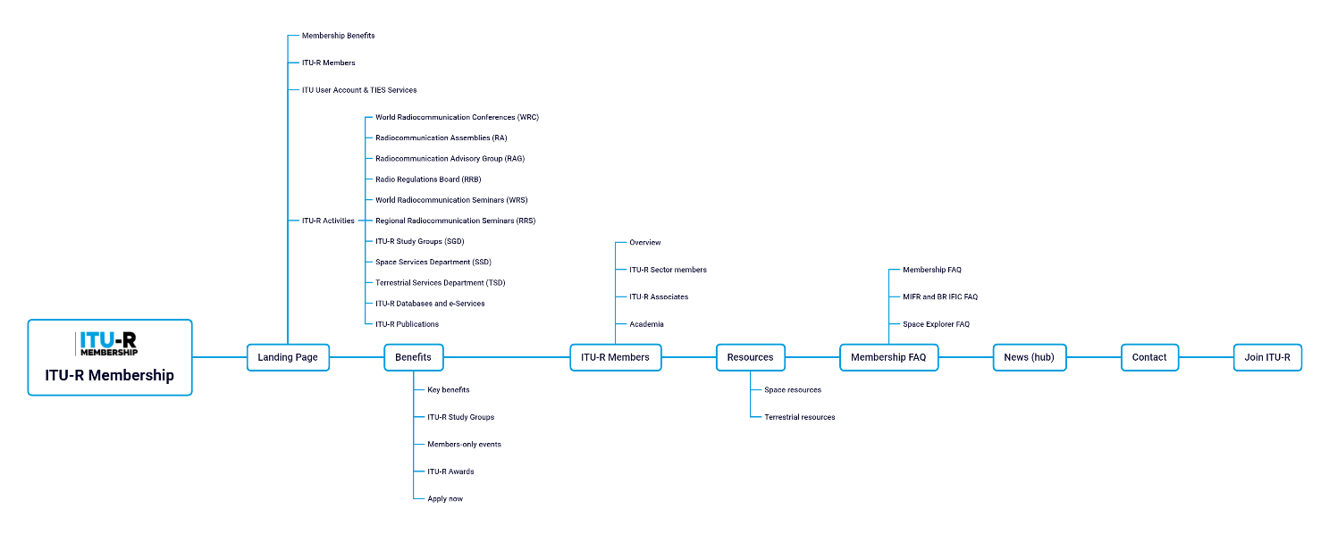
- WRS-24
Number of pages translated: 32/32 (all automated) à 100% (automated)
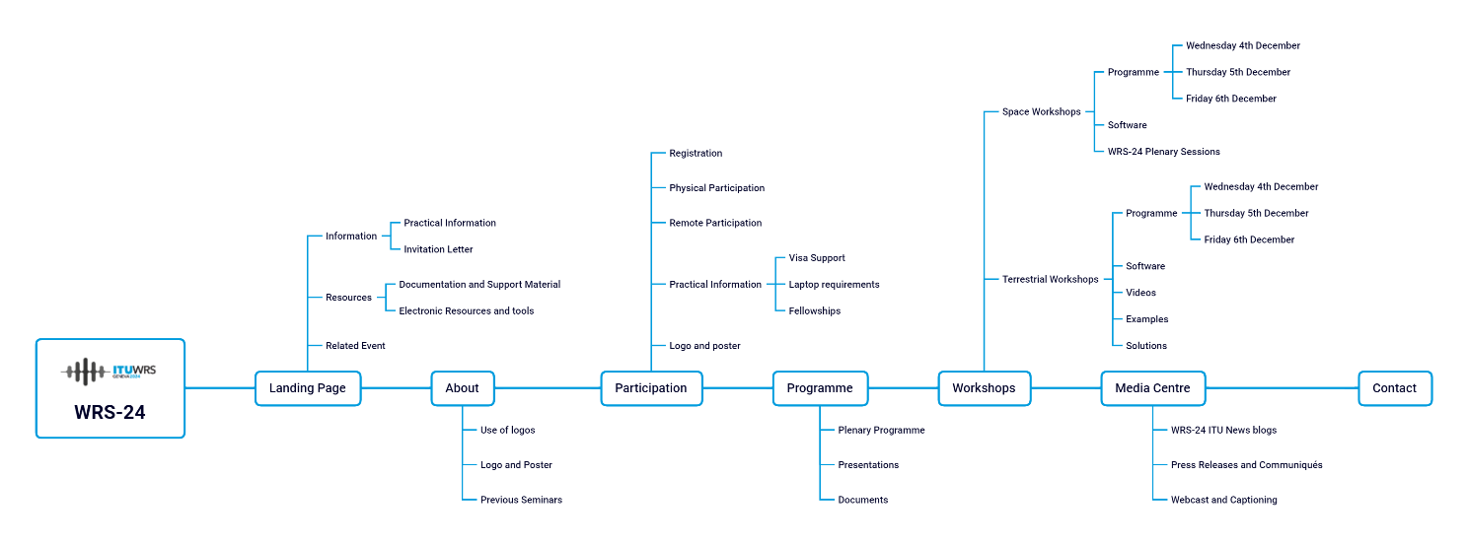
- RAG
Number of pages translated: 18/18 (all automated) à 100% (automated)
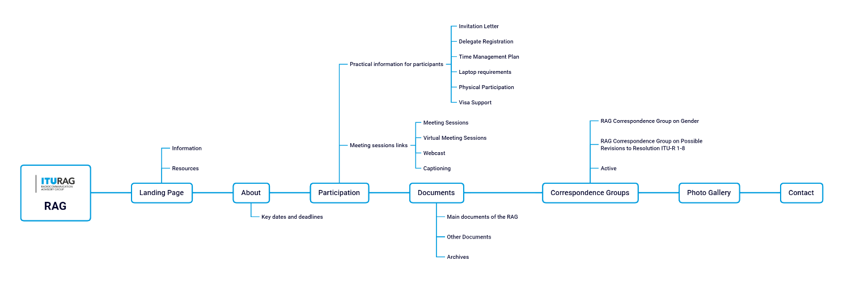
- RRB30Years (microsite)
Number of pages translated: 1/1 (all automated) à 100% (automated)
- Space-Argus (microsite)
Number of pages translated: 2/2 (all automated) à 100% (automated)
- Harmful Interference to RNSS (microsite)
Number of pages translated: 1/1 (all automated) à 100% (automated)
- Network of Women (microsite)
Number of pages translated: 2/2 (all automated) à 100% (automated)
- Space Networks Regulatory Hub (microsite)
Number of pages translated: 1/1 (all automated) à 100% (automated)

3 Use of On-Demand Machine Translation for RAG documents
In addition to the official translation of RAG documents, on-demand machine translation was enabled for the RAG documents using ITU Translate, a neural machine translation tool developed in-house for ITU documents and websites.

4 Conclusion
The main pages of the website are available in the six official languages. The corporate website is primarily SharePoint-based. It incorporates frozen content, which cannot be updated with additional translations; as well as technical applications (e.g. .NET and Node.js-based), which are maintained primarily in English, reflecting their specialised nature.
WordPress sites (approximately 90% multilingual) demonstrate higher language availability than the corporate website (approximately 76% multilingual). This difference is due to the earlier deployment of translation tools within the WordPress environment and to the inclusion of frozen content and technical applications within the corporate site. The planned archives system is expected to improve the accuracy of multilingual statistics by separating active content from historical material.
In 2026, priority will be given to high-traffic SharePoint pages that remain editable and suitable for translation. The implementation of the archives system should be accelerated to ensure the preservation of historical content, improve multilingual indicators for active pages, and allow more targeted translation efforts.
Consideration may be given to assessing multilingual requirements for technical applications in light of their intended audience. Options to enhance translation functionality within SharePoint or to accelerate migration to WordPress may also be examined. Mechanisms to monitor translation quality and periodic reviews of multilingual coverage could further support continuous improvement.
______________

