|  |  |  |
| --- | --- | --- |
| **Radiocommunication Advisory Group** | C:\Users\murphy\AppData\Local\Temp\Temp1_ITU logo Entire package.zip\jpg\ITU official logo_blue_RGB.jpg | |
|  | |  |
|  | |  |
|  | | **Document RAG/40-E** |
| **26 March 2025** |
| **Original: English** |
| |  | | --- | | JAPAN | | further development under resolution 55 (REV.WRC-23)   ELECTRONIC SUBMISSION AND PUBLICATION OF  SATELLITE NETWORK FILINGS | | | |

# 1 Background

Resolution **908 (Rev. WRC-15)** instructed the Director of the Radiocommunication Bureau (BR) to implement a secure paperless electronic approach for the electronic submission and publication of satellite network filings and comments (e-Submission). Following WRC-23, Resolution **908 (Rev. WRC-15)** was integrated into Resolution **55 (Rev. WRC-23)** which instructs the BR to continue to develop and improve the e-Submission of Satellite Network Filings, e-Communications and SIRRS platforms to meet the needs of the Radio Regulations with respect to the submission of, and comments on, satellite network filings, as well as the associated correspondence.

Since May 2017, the Administration of Japan has been supporting the BR’s activity through voluntary contributions to support the implementation of Resolution **908 (Rev. WRC-15)**. Japan has continued this support, contributing to streamlining and speeding up the entire satellite coordination process. In line with Resolution **55 (Rev. WRC-23)**, Japan would like to continue its support for these projects.

At the 29th meeting of the RAG in 2022, to achieve an efficient and prompt process for satellite coordination, Japan requested the following 3 points to the BR:

1 to integrate the e-Submission and e-Communications systems, for greater convenience, to allow Administrations to submit their filings and to communicate with each other through one system.

2 to open the e-Communications system to satellite operators, to facilitate communication between Administrations and their satellite operators.

3 to develop online applications of BR Space Software.

Based on Japan’s proposals, the following updates were introduced. We appreciate the support from the BR in these matters.

*a)* In 2023, “Published in BR IFIC” status was introduced for e-Submission; and e-Examination, an online validation process, was also introduced. These updates improved the user experience and convenience of e-Submission.

*b)* In March 2024, the integration of e-Submission and e-Communications was implemented, allowing users to use the two systems integrally. This update will contribute to the smooth processing of submissions and smooth communication between Administrations, as well as between the BR and Administration. In addition, correspondence from BR will now be shown with the due date, and users can receive reminders.

Furthermore, the submissions of notice in SNS V10 format is only acceptable for e-Submission from 1st January 2025. We also appreciate the work by the BR for this successful update and the smooth transition.

# 2 Proposals

While Japan recognizes that the BR's efforts in this project have made significant progress, Japan would like to reiterate the importance of expanding e-Submission and e-Communications and the further improving the related software in order to increase the efficiency and speed of satellite coordination procedures, including the BR's review and publication procedures.

As a follow up to discussions during previous RAGs, Japan would like to propose the following suggestions from 2.1 to 2.4.

## 2.1 Make the e-Communications system available for use by satellite operators

Communication between Administrations and satellite operators has been mainly by e-mail. On the other hand, communication between the BR and administrations is increasingly being carried out by e-Communications. In Resolution **55 (Rev. WRC-23)**, it was resolved as follows.

Resolves

…..

8 that administrative correspondence between administrations and BR related to the advance publication, coordination, notification and recording processes, including correspondence related to Appendices 30, 30A and 30B, for satellite networks, earth stations and radio astronomy stations shall be communicated, whenever possible, using the ITU e-Communications platform;

9 that reports of harmful interference affecting space services and associated correspondence exchanged between administrations and BR in accordance with Article 15 and No. 13.2 shall be submitted, whenever possible, using the ITU SIRRS platform and following the guidance provided in the most recent version of Recommendation ITU-R SM.2149;

10 that, wherever the words “telegram”, “telex” or “fax” are inserted in provisions related to the advance publication, coordination, notification and recording processes for satellite systems or networks, earth stations and radio astronomy stations, including the provisions contained in Appendices 30, 30A and 30B and related Resolutions, the e-Communications platform shall be used instead;

11 that other, traditional means of communication can be used in the case of difficulty encountered in applying resolves 8, 9 and 10,

We request that the BR continue to consider enabling operators to use e-Communications to communicate with their administration efficiently, and also to promote administrations to use e-Communications. Please note that the permission of each operator should be designed in such a way that the operator is able to view only the communications between its administration and itself.

Figure 1 shows this concept image.

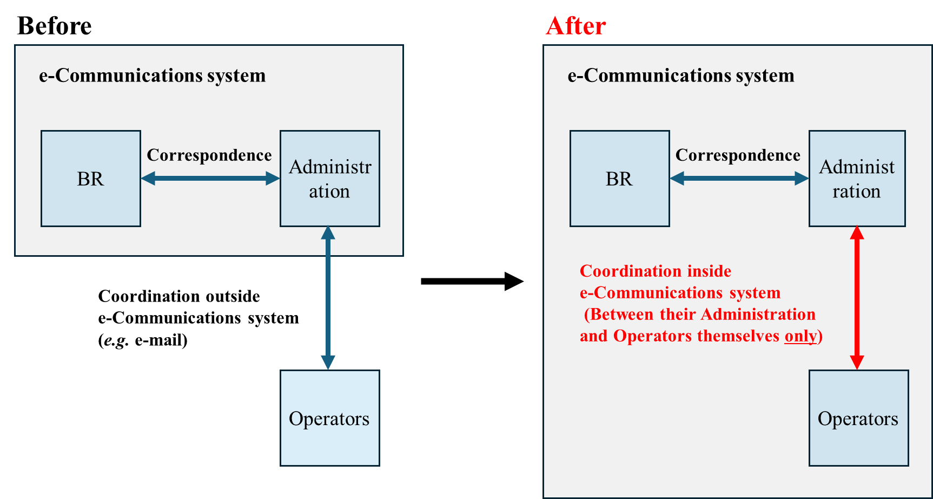

Figure 1 Concept image of updated e-Communications system

## 2.2 Further improvement of e-Communications

The update in 2024 has introduced a clear indication of the due date on correspondence sent from the BR, along with reminder notifications. This feature is very useful as it allows users to easily identify whether a response to the BR is required, and it prevents users from forgetting to reply to the correspondence.

It is important to continue making the necessary updates to improve the efficiency and usability of e-Communications for all involved administrations. Therefore, Japan requests the BR to further improve the systems continuously.

## 2.3 Encourage administrations to use the e-Communications platform and identify barriers to usage

More than five years have passed since e-Communications was officially introduced in October 2019. Moreover, according to the BR's presentation material, the usage rate has gradually increased since its introduction and has recently been around 80%. [1] As mentioned in section 2.1, the e-Communications platform shall be used basically in accordance with Resolution **55 (Rev. WRC-23)** if there is no difficulty in usage of e-Communications. The consistent use of e-Communications by administrations and operators will further streamline communications for satellite coordination. The previous updates described in the Background have also made e-Communications increasingly easy to use.

Considering the above, Japan proposes that all administrations actively use the e-Communications platform, and requests that the BR take necessary action to further encourage administrations to use the e-Communications, based on the analysis of reasons that some administrations do not currently use the system.

## 2.4 Improve BR Space Software and develop online applications

We request that the BR continue to upgrade the existing BR space software. In particular, Japan proposes the following items.

● There are an increasing number of online tools on the web in the private sector and the public sector, with easy to use and very sophisticated user interfaces. Japan would therefore like for space software such as SpaceCap to be updated with a more user-friendly interface, in line with other available tools.

● SpaceCom functions should be brought online so that comments can be made online more smoothly. Japan requests the BR to accelerate this development.

● If users have access to the software as an online service, they will be able to use the service without having to install the software on their PCs. In addition, users currently have to upload files created by the software to e-Submission, but by linking e-Submission and the online service, users will be able to skip these uploads.

● When submitting filings via e-Submission, validation errors sometimes occur, even though we have confirmed that there are no errors in BR-SIS, so we would like to request the BR to fix the discrepancy.

In addition, as described in the summary record of the RAG-31 meeting, it is noted that the development of an online application of the BR space software were supported by several administrations. Considering the above situation, voluntary contributions from member countries, the active use of relevant systems, and feedback regarding current functions are desirable to promote further software development and improvement.

# 3 Conclusion

The Administration of Japan kindly requests the BR to develop and improve systems continuously as mentioned above, under Resolution **55 (Rev. WRC-23)**.

# 4 Reference

[1] “e-Submission of Satellite Network Filings / e-Communications”, ITU World Radiocommunication Seminar 2024 (WRS-24)

\_\_\_\_\_\_\_\_\_\_\_\_\_\_