Radiocommunication Advisory Group | 
Addendum 2 to
Document RAG/30-E
 |  | 28 February 2025
 |  | Original: English
Director, Radiocommunication Bureau
report TO the tHIRTY-SECOND meeting
of the radiocommunication advisory group
TRANSLATION STATUS

Corporate website under SharePoint
Availability status in the six ITU official languages refers to the landing pages of the various departments and topics (level 0) and the pages accessible via one click only (level 1).
This status is approximately 75% (incl. 5% automated translation), taking into consideration that the 25% left is due to:
- SG activities/sessions (commonly in English only)
- Workshops and regional events like RRS (in the regional language(s))
- SSD webpages (formerly available only in English, French and Spanish)
- ITU-R Publications pages on DMS (English, French and Spanish)

Sites under WordPress
An automated translation process from English to other languages is available in WordPress (for pages that don’t require human translation).
The total number of pages (E) translated (A/C/F/R/S) under WordPress (including pages developed before 2024): 215/242 (incl. 133 automated), which amounts to 89% (incl. 62% automated translation).
Note: In the site maps below, the ‘number of pages translated’ means the number of original English pages translated into the other 5 languages of the Union. E.g. Number of pages translated: 9/10, this means that 9 pages were translated into the 5 other languages (totaling 54 (9x6) pages) and 1 page is available in English only (so 5 pages in other languages are still to be developed).
Sites developed in 2024 using WordPress:

- Global ITU/WMO Hub | ITU and World Meteorological Organization (WMO)
Joint ITU/WMO training activities for the period leading up to WRC-27
Number of pages translated: 11/19 = 58%
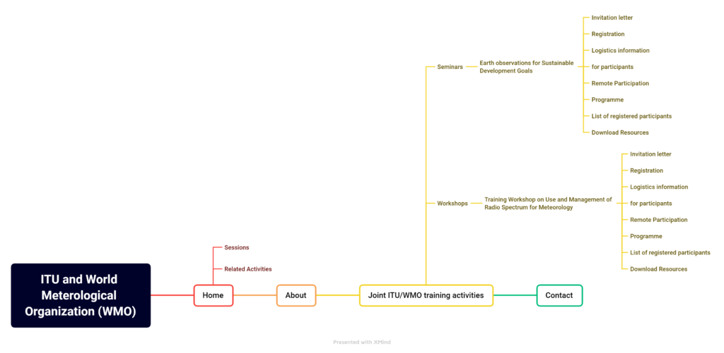
- Space Sustainability Forum 2024
Number of pages translated: 17/17 (all automated) à 100% (automated)
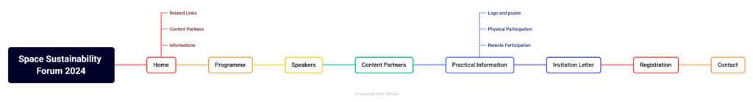
- Space Sustainability Gateway
Number of pages translated: 11/11 (all automated) à 100% (automated)
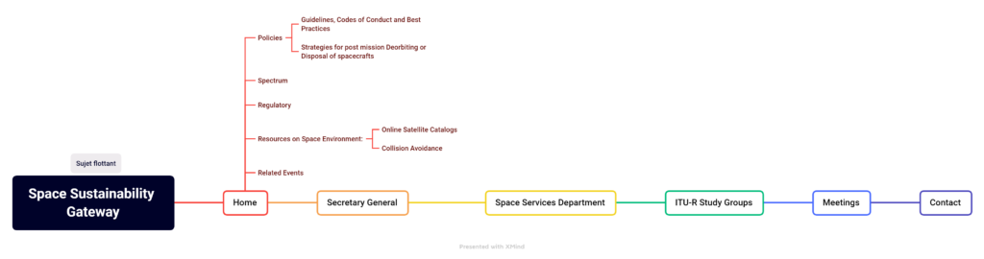
- Connecting the World from the Skies
Number of pages translated: 2/2 (all automated) à 100% (automated)
- BR IFIC Hub (microsite)
Number of pages translated: 1/1 (all automated) à 100% (automated)
- Space Connect (microsite)
Number of pages translated: 5/5 (all automated) à 100% (automated)
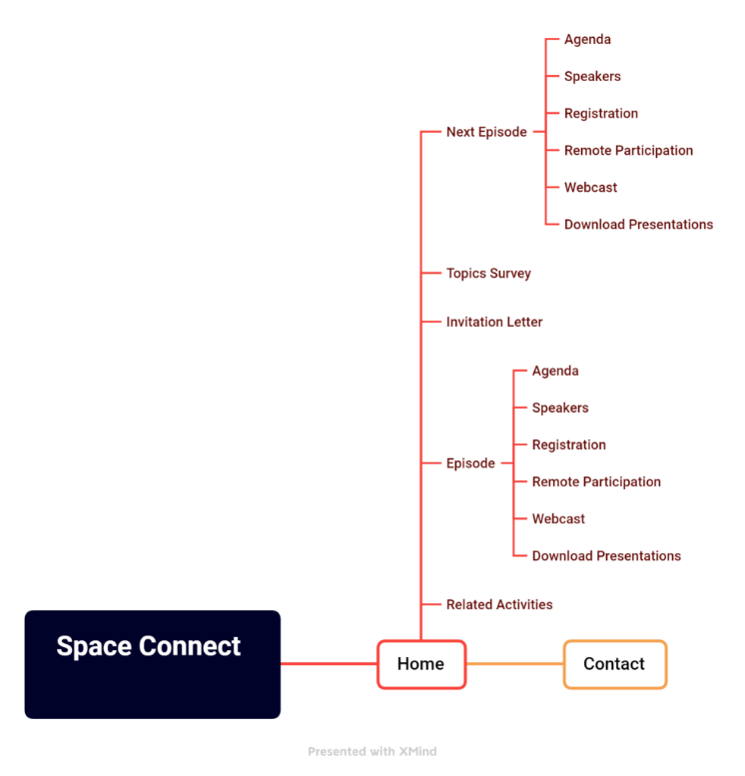
- Network of Women for WRC-27
Number of pages translated: 7/7 (all automated) à 100% (automated)
- WRS-24
Number of pages translated: 33/33 (all automated) à 100% (automated)
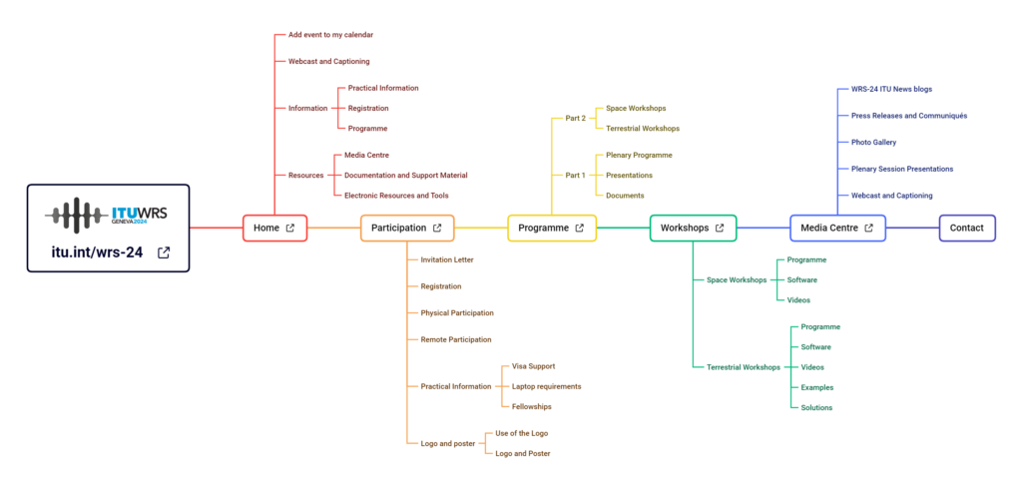

3 Use of On-Demand Machine Translation for RAG documents
In addition to the official translation of RAG documents, on-demand machine translation was enabled for the RAG-25 documents using ITU Translate, a neural machine translation tool developed in-house for ITU documents and websites.
______________

