Radiocommunication Advisory Group | 
Addendum 2 to
Document RAG/1-E
 |  | 23 February 2024
 |  | Original: English
Director, Radiocommunication Bureau
report TO the tHIRTY-FIRST meeting
of the radiocommunication advisory group
TRANSLATION STATUS

Corporate website under SharePoint
Availability status in the six ITU official languages refers to the landing pages of the various departments and topics (level 0) and the pages accessible via one click only (level 1).
This status is still approximately 70%, taking into consideration the 30% left is mainly due to:
- SG activities/sessions (commonly in English only)
- Workshops and regional events like RRS (in the regional language(s))
- SSD webpages (formerly available only in English, French and Spanish)
- ITU-R Publications pages (see note below) on DMS (English, French and Spanish)
Note: The ITU Hub (under WordPress) will replace the DMS pages for Publications and has automated translation process from English to all other languages. For operational reasons BR decided to stay on DMS for the time being, as well as TSB and SG. Only BDT is partially under the Hub for their publications.

Working methods
Concerning the sites running under WordPress, an automated translation process is available (for pages that doesn’t require human translations that are more accurate). The translation status is higher, but pertinence/quality of translations is sometimes less of course.
Sites currently on production under WordPress (not illustrated above for Corporate SharePoint because too many sites and pages):
- Best of WRS 20 – The Best of the 2020 World Radiocommunication Seminar (itu.int)
Number of pages translated: 5/12 = 42%
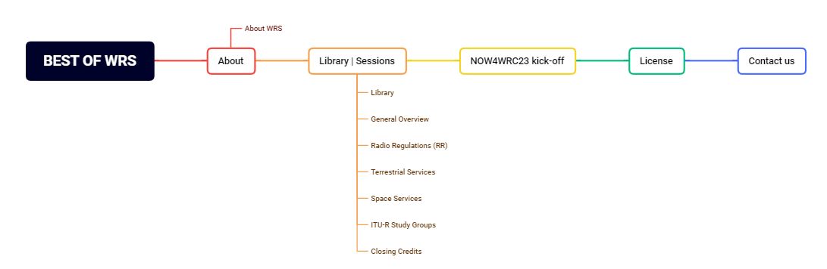
- WRS-22 – World Radiocommunication Seminar 2022 (itu.int)
Number of pages translated: 14/14 (all automatically) 100% (auto)
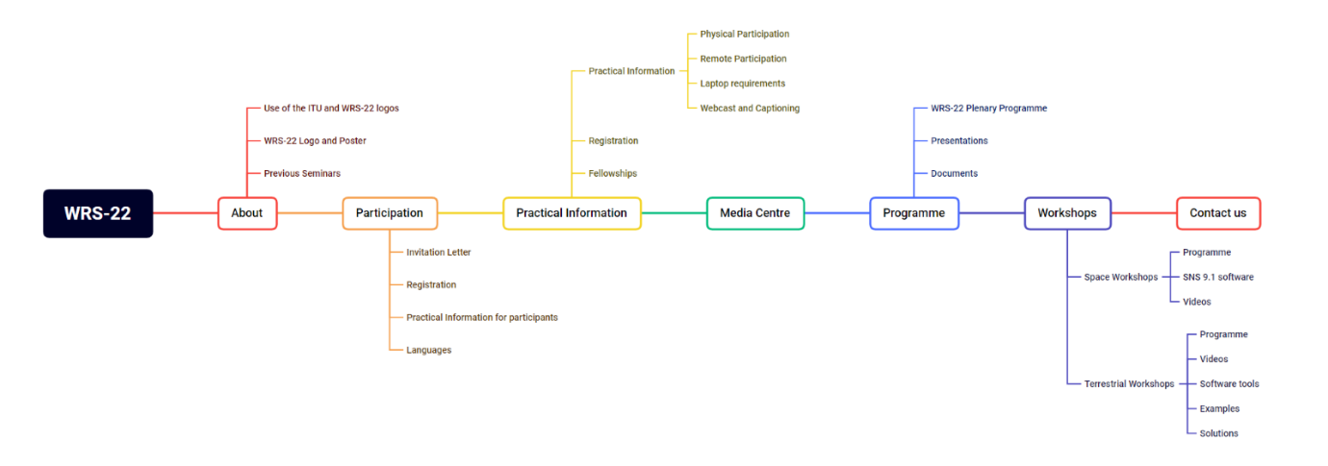

- NOW4WRC23 – a forum for networking, mentoring, and knowledge sharing (itu.int)
Number of pages translated: 5/6 83%
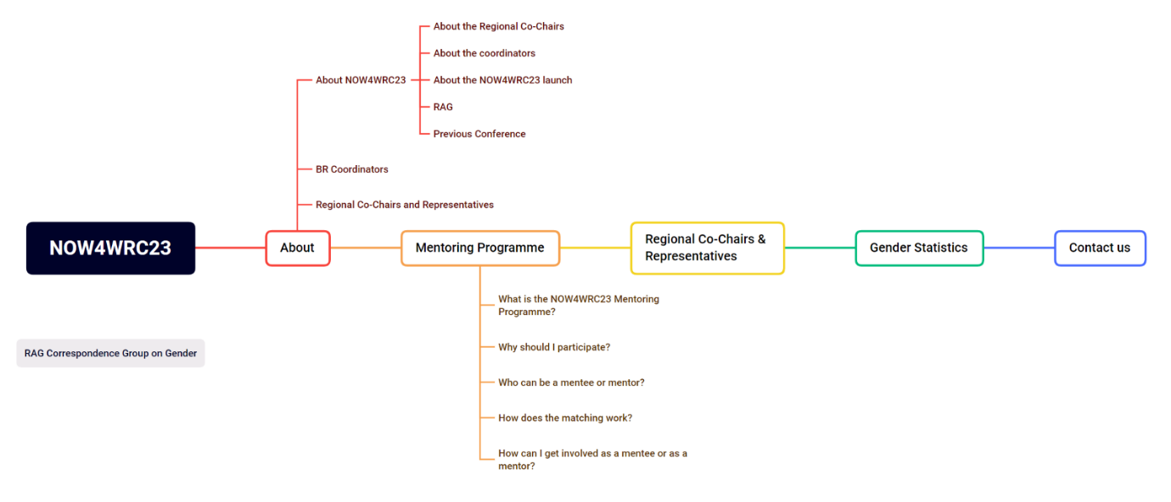

- RA-23 – Radiocommunication Assemblies (RA) (itu.int)
Number of pages translated: 22/24 (incl. 5 automatically) 92% (incl. 23% auto)
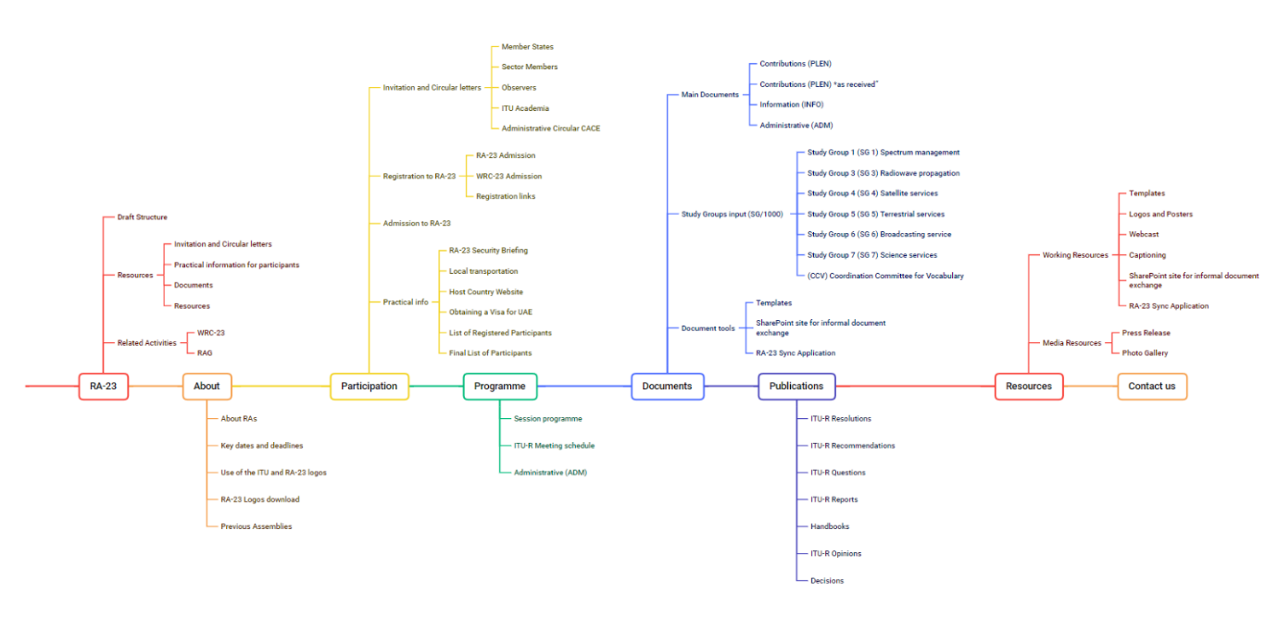
- WRC-23 – World Radiocommunication Conferences (WRC) (itu.int)
Number of pages translated: 33/42 (incl. 9 automatically) 79% (incl. 27% auto)
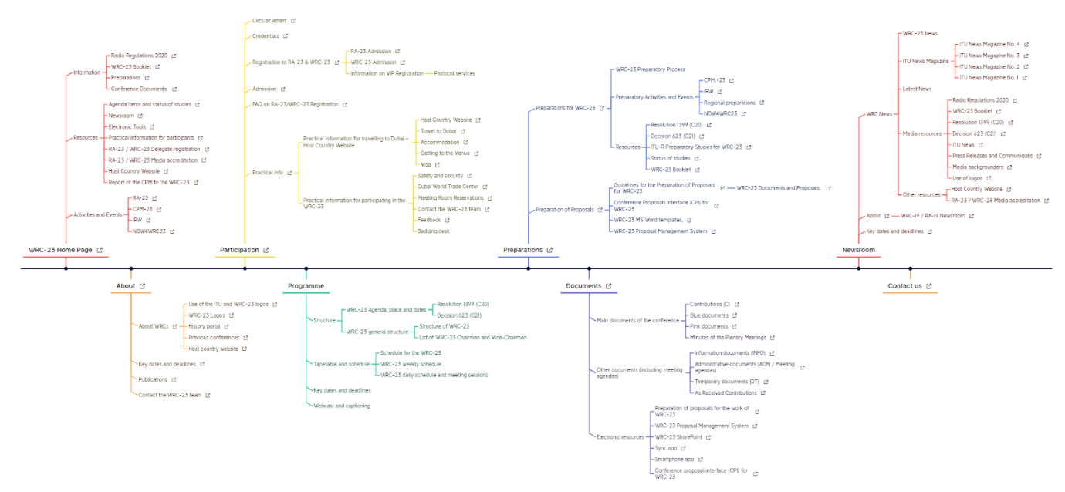
- RAG – Radiocommunication Advisory Group (itu.int)
Number of pages translated: 11/11 (all automatically) 100% (auto)
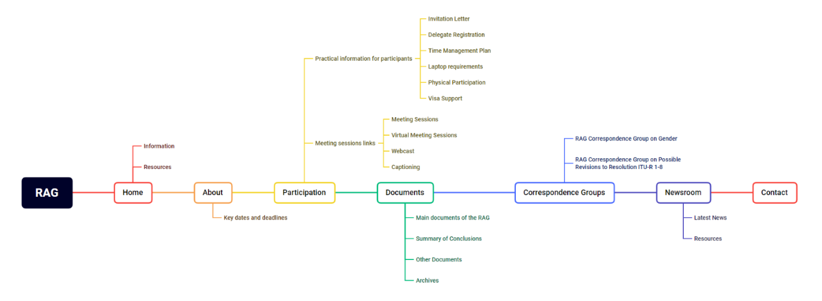

- And 4 additional pages (microsites): 4/4 (incl. 3 auto) 100% (incl. 75% auto)
The total number of pages translated under WordPress:
- 94/113 (incl. 42 automatically) 83% (incl. 45% auto)

______________

