|  |  |  |
| --- | --- | --- |
| **Radiocommunication Advisory Group** | C:\Users\murphy\AppData\Local\Temp\Temp1_ITU logo Entire package.zip\jpg\ITU official logo_blue_RGB.jpg | |
|  | |  |
|  | |  |
|  | | **Document RAG/INFO/6-E** |
| **23 March 2021** |
| **English only** |
| Director, BR | | |
| OVERVIEW OF ITU-R EVENT PARTICIPATION IN 2020 | | |

This information document presents an overview of the participation to ITU-R events held in 2020.

# 1. ITU-R Events

The table below provides the list of ITU-R events (block meetings) held in 2020. It includes statutory ITU-R events (working party, study group, advisory group, RRB), regional seminars and other events hosting by the Bureau.

All 2020 ITU-R events from March onwards were fully held online (virtual meetings). Events cancelled due to the COVID-19 are not included in the table below.

| **Event (2020)** | **Event Type** | **Meeting** | **Start Date** | **End Date** |
| --- | --- | --- | --- | --- |
| ITU-R WPs 6A, 6B, 6C & SG 6 | Study Group | ITU-R SG 6  ITU-R WP 6A  ITU-R WP 6B  ITU-R WP 6C | 03.02.2020 | 14.02.2020 |
| ITU-R Working Party 5D | Study Group | ITU-R WP 5D | 19.02.2020 | 26.02.2020 |
| ITU-R SG 7 & WPs 7B & 7C | Study Group | ITU-R SG 7  ITU-R WP 7B  ITU-R WP 7C | 20.04.2020 | 24.04.2020 |
| Radiocommunication Advisory Group | RAG | RAG | 25.05.2020 | 27.05.2020 |
| ITU-R WPs 4A, 4B & 4C | Study Group | ITU-R WP 4A  ITU-R WP 4B  ITU-R WP 4C | 28.05.2020 | 29.05.2020 |
| ITU-R Working Party 5D | Study Group | ITU-R WP 5D | 23.06.2020 | 09.07.2020 |
| Radio Regulation Board (RRB) | RRB | RRB20.1  RRB20.2  RRB20.3 | 01.03.2020 | 31.12.2020 |
| RRS-20-Americas | Seminar | RRS-20-Americas | 13.07.2020 | 05.08.2020 |
| ITU-R WPs 5A, 5B, 5C & SG 5 | Study Group | ITU-R SG 5  ITU-R WP 5A  ITU-R WP 5B  ITU-R WP 5C | 20.07.2020 | 31.07.2020 |
| ITU-R WPs 3J, 3K, 3L, 3M & SG 3 | Study Group | ITU-R SG 3  ITU-R WP 3J  ITU-R WP 3K  ITU-R WP 3L  ITU-R WP 3M | 10.08.2020 | 21.08.2020 |
| ITU-R WPs 7A, 7B, 7C & 7D | Study Group | ITU-R WP 7A  ITU-R WP 7B  ITU-R WP 7C  ITU-R WP 7D | 14.09.2020 | 02.10.2020 |
| GE84 Plan optimization for Africa | Other | CG1: FRENCH  CG2: ENGLISH  CG3: FRENCH  CG4: ENGLISH | 21.09.2020 | 14.10.2020 |
| ITU-R Working Party 5D | Study Group | ITU-R WP 5D | 05.10.2020 | 16.10.2020 |
| ITU-R WPs 6A, 6B, 6C, SG 6 & TG 6/1 | Study Group | ITU-R SG 6  ITU-R TG 6/1  ITU-R WP 6A  ITU-R WP 6B  ITU-R WP 6C | 05.10.2020 | 23.10.2020 |
| Res. 609 Consultation Meeting | Other | Res. 609 | 06.10.2020 | 08.10.2020 |
| RRS-20-Asia&Pacific | Seminar | RRS-20-Asia&Pacific | 19.10.2020 | 30.10.2020 |
| ITU-R WPs 4A, 4B, 4C & SG 4 | Study Group | ITU-R SG 4  ITU-R WP 4A  ITU-R WP 4B  ITU-R WP 4C | 21.10.2020 | 06.11.2020 |
| ITU-R WPs 5A, 5B, 5C, 5D & SG 5 | Study Group | ITU-R SG 5  ITU-R WP 5A  ITU-R WP 5B  ITU-R WP 5C  ITU-R WP 5D | 04.11.2020 | 23.11.2020 |
| ITU-R WPs 1A, 1B, 1C & SG 1 | Study Group | ITU-R SG 1  ITU-R WP 1A  ITU-R WP 1B  ITU-R WP 1C | 24.11.2020 | 03.12.2020 |
| **Total: 19 events** |  | **Total: 55 meetings** |  |  |

An overview of the 2020 ITU-R event attendance is presented below.

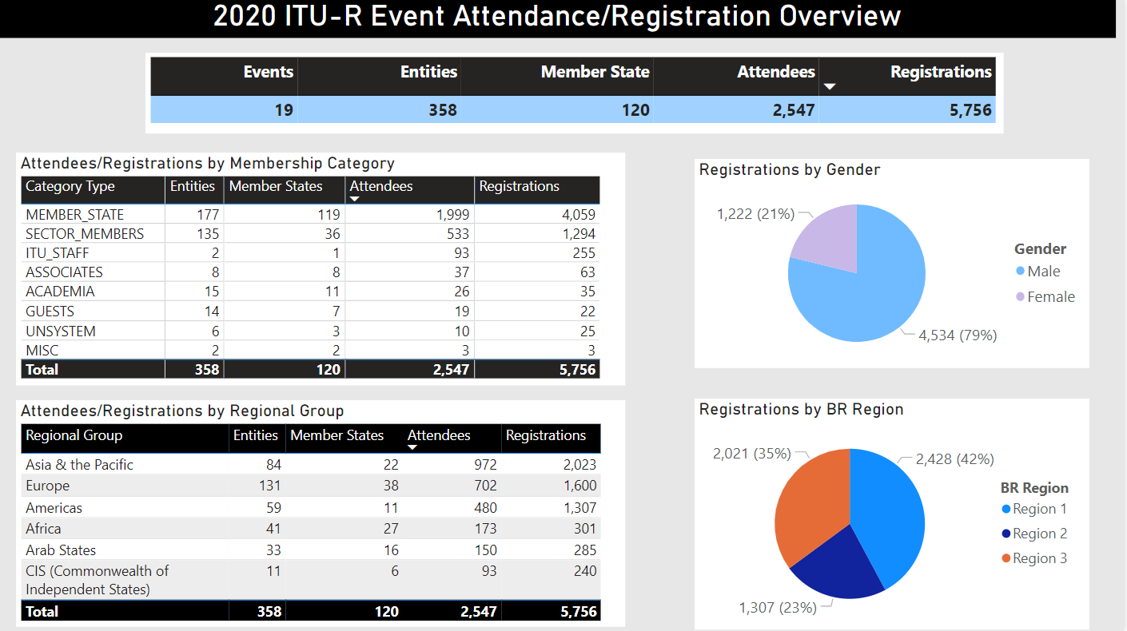NOTES:   
The above takes into account actual participation (presence) to an ITU-R event.

Attendee: unique participant indicated as present to an event.   
Registration: confirmed registration and presence to an event.

**Summary: 2020 ITU-R Event Registration - Member State only**

| **Member State** | **Count** | **Attendees** | **Registrations** |
| --- | --- | --- | --- |
| United States | 1 | 205 | 607 |
| China | 1 | 248 | 423 |
| Japan | 1 | 146 | 288 |
| Korea (Rep. of) | 1 | 98 | 220 |
| Russian Federation | 1 | 55 | 168 |
| France | 1 | 65 | 161 |
| Brazil | 1 | 71 | 151 |
| Germany | 1 | 68 | 149 |
| India | 1 | 68 | 148 |
| Canada | 1 | 50 | 145 |
| Australia | 1 | 44 | 103 |
| United Kingdom | 1 | 52 | 94 |
| Iran (Islamic Republic of) | 1 | 37 | 91 |
| South Africa | 1 | 24 | 86 |
| Nigeria | 1 | 47 | 67 |
| Indonesia | 1 | 47 | 61 |
| Thailand | 1 | 50 | 61 |
| Saudi Arabia | 1 | 31 | 52 |
| Tunisia | 1 | 19 | 50 |
| Egypt | 1 | 17 | 42 |
| Switzerland | 1 | 14 | 42 |
| Turkey | 1 | 34 | 39 |
| Netherlands | 1 | 26 | 37 |
| Singapore | 1 | 18 | 33 |
| Malaysia | 1 | 18 | 31 |
| Kazakhstan | 1 | 16 | 29 |
| Viet Nam | 1 | 19 | 25 |
| Algeria | 1 | 23 | 24 |
| Mexico | 1 | 16 | 24 |
| Sweden | 1 | 12 | 24 |
| Morocco | 1 | 9 | 23 |
| Hungary | 1 | 15 | 22 |
| United Arab Emirates | 1 | 7 | 22 |
| Finland | 1 | 12 | 21 |
| Italy | 1 | 9 | 21 |
| Kenya | 1 | 14 | 20 |
| Uzbekistan | 1 | 11 | 20 |
| Colombia | 1 | 15 | 19 |
| Paraguay | 1 | 12 | 19 |
| Argentina | 1 | 10 | 18 |
| Cameroon | 1 | 11 | 17 |
| Samoa | 1 | 5 | 15 |
| Ghana | 1 | 12 | 14 |
| Luxembourg | 1 | 6 | 14 |
| Côte d'Ivoire | 1 | 9 | 13 |
| Israel | 1 | 10 | 13 |
| Sudan | 1 | 5 | 12 |
| Austria | 1 | 6 | 11 |
| Romania | 1 | 8 | 11 |
| Norway | 1 | 6 | 10 |
| Czech Republic | 1 | 4 | 9 |
| Greece | 1 | 8 | 9 |
| Lithuania | 1 | 5 | 9 |
| New Zealand | 1 | 4 | 9 |
| Poland | 1 | 8 | 9 |
| Ukraine | 1 | 9 | 9 |
| Zimbabwe | 1 | 4 | 9 |
| Azerbaijan | 1 | 3 | 8 |
| Ireland | 1 | 4 | 8 |
| Mozambique | 1 | 4 | 8 |
| Lao P.D.R. | 1 | 7 | 7 |
| Myanmar | 1 | 5 | 7 |
| Niger | 1 | 5 | 7 |
| Rwanda | 1 | 3 | 7 |
| Costa Rica | 1 | 2 | 6 |
| Bahrain | 1 | 4 | 5 |
| Belarus | 1 | 3 | 5 |
| Guinea | 1 | 3 | 5 |
| Latvia | 1 | 5 | 5 |
| Malta | 1 | 2 | 5 |
| Tanzania | 1 | 4 | 5 |
| Bhutan | 1 | 4 | 4 |
| Chad | 1 | 3 | 4 |
| Papua New Guinea | 1 | 1 | 4 |
| Somalia | 1 | 1 | 4 |
| Uganda | 1 | 4 | 4 |
| Zambia | 1 | 3 | 4 |
| Armenia | 1 | 2 | 3 |
| Benin | 1 | 2 | 3 |
| Denmark | 1 | 2 | 3 |
| Namibia | 1 | 2 | 3 |
| Senegal | 1 | 3 | 3 |
| South Sudan | 1 | 2 | 3 |
| Spain | 1 | 3 | 3 |
| Uruguay | 1 | 1 | 3 |
| Vatican | 1 | 1 | 3 |
| Albania | 1 | 2 | 2 |
| Belgium | 1 | 2 | 2 |
| Bosnia and Herzegovina | 1 | 2 | 2 |
| Brunei Darussalam | 1 | 2 | 2 |
| Burkina Faso | 1 | 1 | 2 |
| Estonia | 1 | 1 | 2 |
| Eswatini | 1 | 1 | 2 |
| Fiji | 1 | 2 | 2 |
| Georgia | 1 | 1 | 2 |
| Maldives | 1 | 2 | 2 |
| Mongolia | 1 | 2 | 2 |
| Oman | 1 | 1 | 2 |
| Portugal | 1 | 1 | 2 |
| Qatar | 1 | 2 | 2 |
| Togo | 1 | 1 | 2 |
| Afghanistan | 1 | 1 | 1 |
| Bulgaria | 1 | 1 | 1 |
| Burundi | 1 | 1 | 1 |
| Central African Rep. | 1 | 1 | 1 |
| Comoros | 1 | 1 | 1 |
| Croatia | 1 | 1 | 1 |
| Djibouti | 1 | 1 | 1 |
| Dominica | 1 | 1 | 1 |
| Gabon | 1 | 1 | 1 |
| Haiti | 1 | 1 | 1 |
| Iraq | 1 | 1 | 1 |
| Jordan | 1 | 1 | 1 |
| Lebanon | 1 | 1 | 1 |
| Liberia | 1 | 1 | 1 |
| Mali | 1 | 1 | 1 |
| Moldova | 1 | 1 | 1 |
| San Marino | 1 | 1 | 1 |
| Serbia | 1 | 1 | 1 |
| **Total** | **119** | **2,001** | **4,060** |

# 2. ITU Satellite Webinars

The Radiocommunication Bureau hosted the ITU Satellite Webinarsseries, open to all and held online:

* **Episode 1: Interference to Satellite Systems: preventing or protecting?**16 September 2020
* **Episode 2: Non-Geostationary Satellite Systems: entering into the era of broadband service delivery**  
  7 October 2020
* **Episode 3: Geostationary Satellite Systems: a world of innovations 36000 km high**11 November 2020

The ITU Satellite Webinars series participation is summarized below.

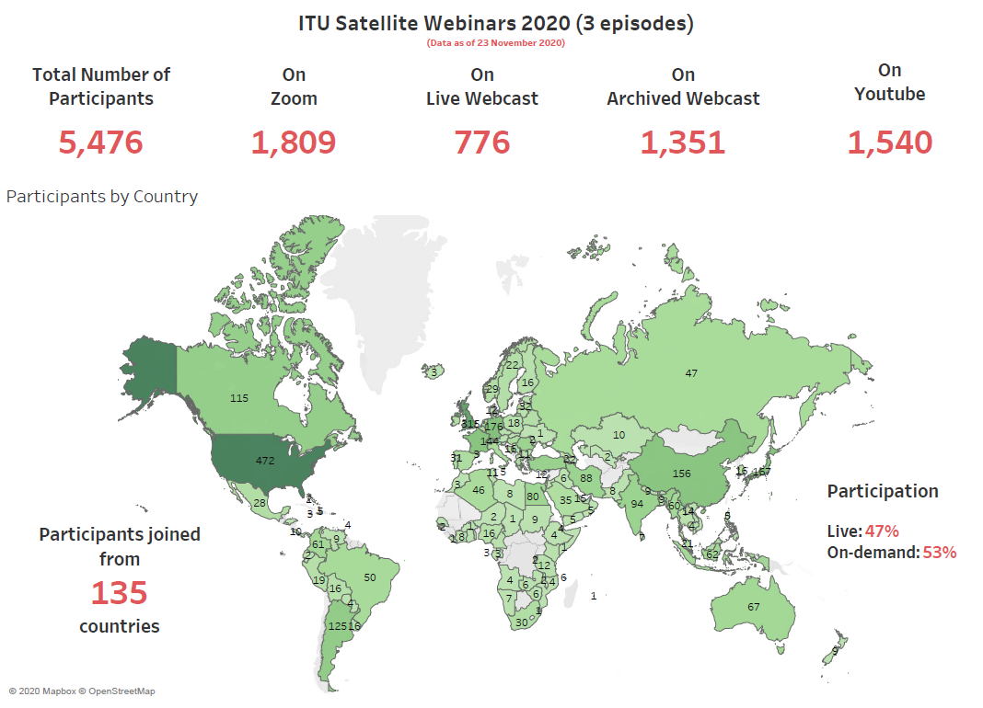

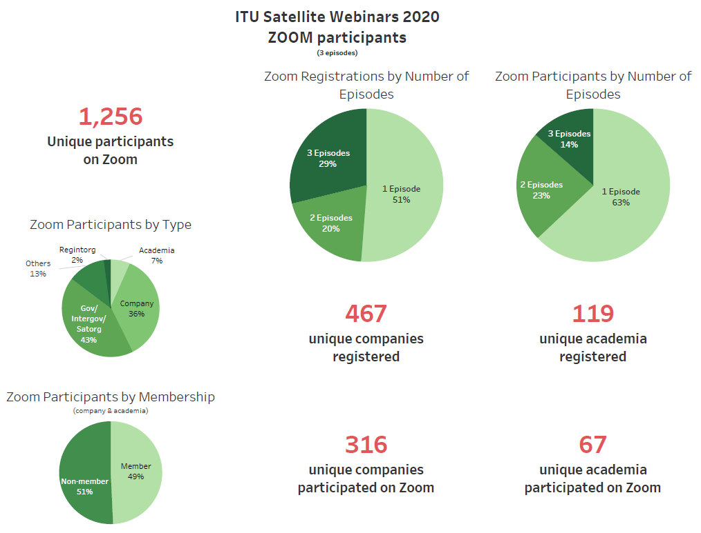

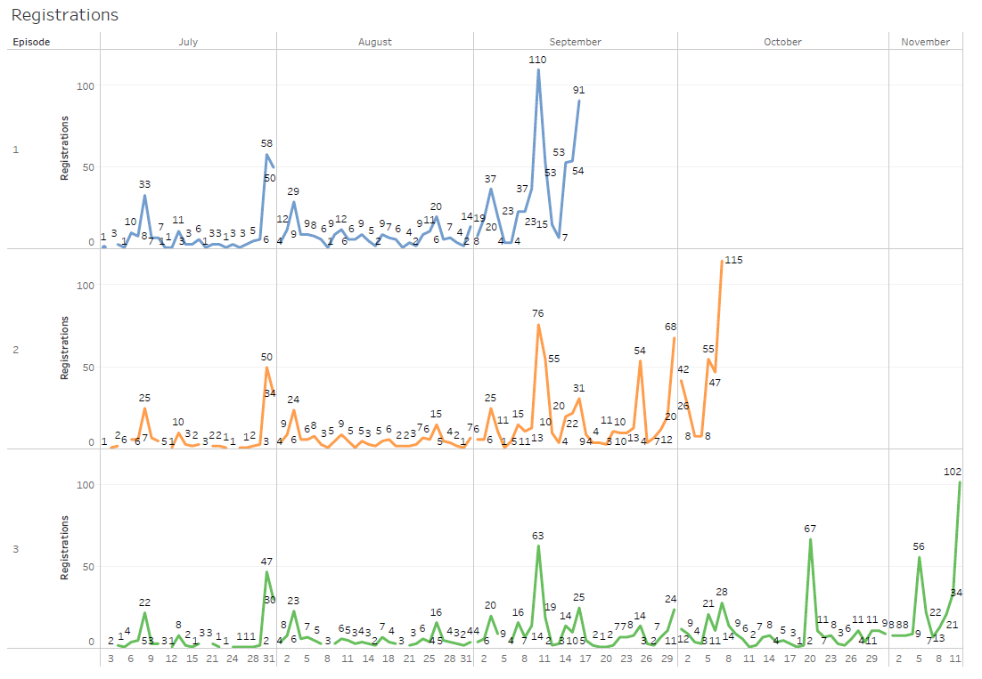

# 3. WRS-20 - Plenary Sessions

The World Radiocommunication Seminar (WRS-20) Online - Plenary Sessions was held from 30 November to 4 December 2020.

Attendance, which was open to all, is summarized in the document embedded below.

# 4. WRS-20 - Workshops

The World Radiocommunication Seminar (WRS-20) Online - Space and Terrestrial Workshops was held from 7 to 11 December 2020.

Attendance, which was restricted to ITU Member States and Academia as well as ITU-R Sector Members and Associates, is summarized in the document embedded below.

[](http://www.itu.int/en/ITU-R/seminars/wrs/2020/Documents/WRS20stats.pdf)

URL: [www.itu.int/en/ITU-R/seminars/wrs/2020/Documents/WRS20stats.pdf](http://www.itu.int/en/ITU-R/seminars/wrs/2020/Documents/WRS20stats.pdf)

\_\_\_\_\_\_\_\_\_\_\_\_\_\_