|  |  |  |  |
| --- | --- | --- | --- |
| **Radiocommunication Advisory Group Geneva, 25-27 May 2020** | | C:\Users\murphy\AppData\Local\Temp\Temp1_ITU logo Entire package.zip\jpg\ITU official logo_blue_RGB.jpg | |
|  | | |  |
|  |  | | |
|  | **Document RAG20/INFO/3-E** | | |
| **19 May 2020** | | |
| **English only** | | |
| Director, BR | | | |
| br report on the Project for the implementation of Resolution 908 (Rev. WRC-2015) | | | |

# 1 Preamble

Resolution 908 (Rev. WRC-15) resolves that administrations shall submit all satellite network filings and comments, if required, using a secure paperless electronic approach upon being advised that the means for such electronic submission of a satellite network filing for satellite networks or systems has been implemented and upon receiving assurances that such means are indeed secure. It instructs the Director of the Radiocommunication Bureau to implement a secure paperless electronic approach for the electronic submission and publication of satellite network filings and comments, if required, for satellite networks or systems, and to study and implement, as appropriate, a consolidated approach for the electronic submission of both satellite network filings and their related correspondence.

To meet the requirements of Resolution 908 (Rev.WRC-15), the Bureau has embarked on a Project to implement a system for the electronic submission, processing and publication of all satellite network notices and comments. At the same time, the Bureau has also been developing a secure electronic communication system to satisfy the requirements of both Resolution 908 ((Rev.WRC‑15) as well as Resolution 907 (Rev.WRC-15).

# 2 Status and progress of the project

The development of the e-Submission system, as required under Resolution 908 (Rev. WRC-15), has been successfully completed and launched in 2018. This system was incorporated into the Rules of Procedure on receivability as the mandatory system to be used for submission of all satellite network filings and comments since 1 August 2018. The system has functioned well since its initial introduction and has undergone continuous improvement based on internal and external feedback. Since January 2019, all notices submitted to BR have been done through the e-Submission system. To complement the submission system, BR also developed and implemented an e-Communications system on 23 October 2019.

The progress of the project has been regularly reported to RAG, RRB as well as to CPM-19 and WRC-19.

BR has set up a helpdesk that provides user support via email as well as telephone. BR also provides hands-on training to administrations and operators during various BR workshops and seminars.

The number of registered external users of e-Submission are as follows (as of 30 April 2020):

- number of administrations: 129 Administrations

- number of 637 users, with the following breakdown:

- Administration managers and users: 397

- Operator managers and users: 236

- Intergovernmental Satellite Organization managers and users: 4

The number of registered users and administrations have been increasing continuously since the official introduction of e-Submission, as shown in Annex 1 in this report.

Annex 2 provides a report on the status of the various activities carried out under the project for the period June 2018 to May 2020.

A report on the specific technical development conducted by BR/IAP/SAS (Space Application Software Division) is shown in Annex 3.

# 3 Ongoing and future works

Beyond the online submission and correspondence systems, as envisaged under the Resolution 908 project, additional developments undertaken during this period, as indicated in Annex 2, are expected to extend into the next 2 years. Many additional tasks are still to be developed, as reflected in Annex 4.

Some of the major tasks identified for future work under the project are as follows:

* modernization of SNS online and SNL online
* online publication of the BRIFIC
* online capture of notices and comments
* creation of an internal management information system

# 4 Acknowledgements

Taking this opportunity, the Bureau would like to express the appreciation of the support for this project to the administration of Japan.

Annex 1: Number of registered users and administrations

**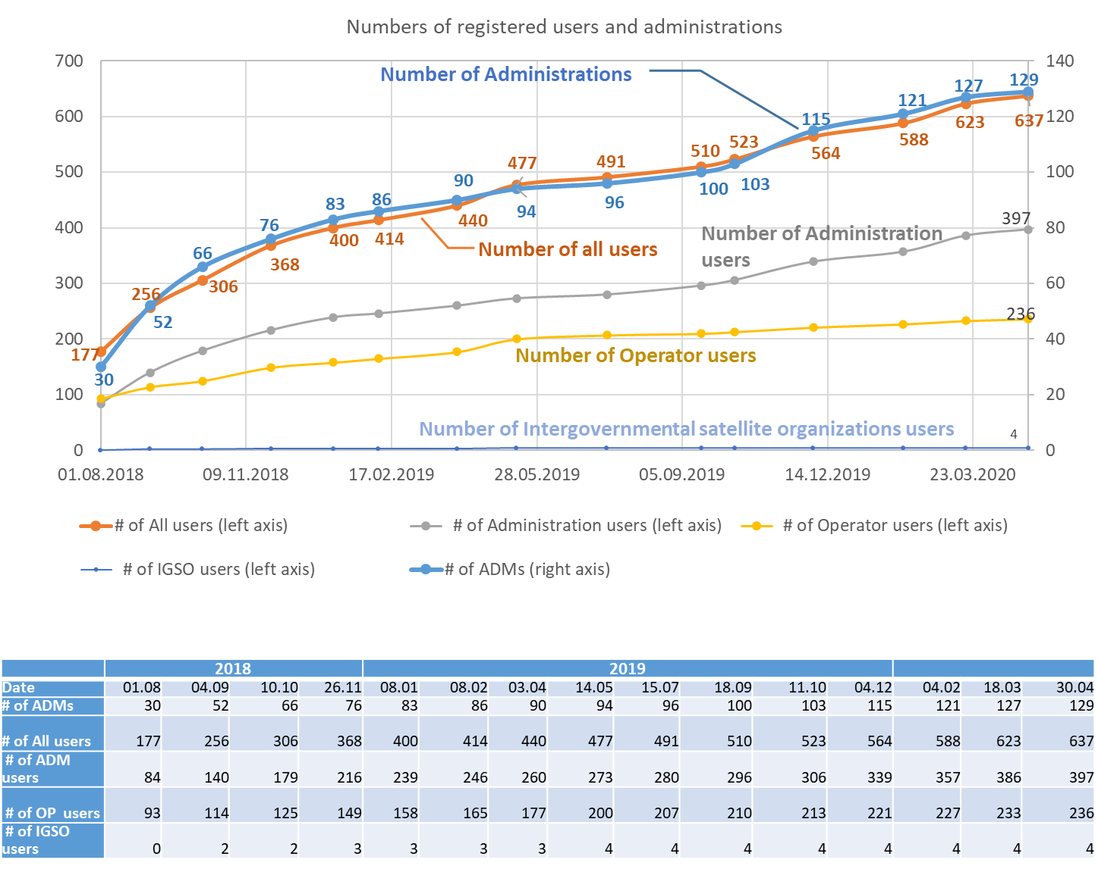**

Annex 2: Summary of Progress

The following is a summary of the progress of various activities carried out under the Project for the period June 2018 to May 2020:

|  |  |
| --- | --- |
| Advancement of validation of notices against SNS | A totally rewritten version of the space validation software, BR SIS-Validation was released in January 2020 and successfully integrated into e-Submission system. This new software was able to effectively overcome various unexpected problems of the validation process previously encountered by users when submitting a notice for validation.  Validation process on e-Submission was updated for SpaceCom (block incomplete comments).  Online validation was updated for API and CRC for additional AP4 data in February 2020 according to the decision at WRC-19.  Further work is ongoing for validation of notices against SNS. |
| Revisions to SNS processing of all space notices including the development of a formal correspondence system and the review of SNS database structure where required: | Preliminary specifications for an online communication tool were provided in late 2018, and a prototype was presented during the 2nd quarter of 2019. Based on the prototype, specifications were completed, and detailed development commenced.  The online communication tool for correspondence related to space services (e-Communications) was developed, made available for external test from 1 August to 30 September 2019, and released in October 2019.  SNS database structure is under reviewing based on the decision at WRC-19 and there is no requirements identified specifically for Res 908 so far. |
| Development of the online receivability processing system | This was implemented on e-Submission and continued to be updated for internal processing.  Automatic processing, such as checking of satellite name, allocation of ID no. and creation of records in SNTrack have been further improved in this year.  Automatic generation of summary reports for internal processing were done for the various notices, which assisted BR significantly in the treatment of notices.  Additional work is envisaged for this system. |
| Development of management information system (MIS): | Concerning SNTrack Online and e-Folder:  The work to gather requirements and create specifications commenced, and requirements are still being consolidated across the various divisions.  The technical discussion to develop tools and prototyping started in the development team.  Concerning Cost recovery management function:  The work to create gather requirements started in October 2018, involving the BR/SSD, BR/IAP, Information Services Department, and Finance Department.  Final version was delayed due to priorities arising from decisions taken at WRC-2019.  Finalization of the system is expected in second half of 2020. |
| Development of system for online submission of comments: | Initial specifications were created on February 2019, and preliminary development work on a “SpaceCom Online” commenced. However, due to resource constraints and the urgency to deal with other higher priority issues to be ready for WRC-19, this activity has been postponed. |
| Update of SNS Online queries: | Discussion and work for initial specifications commenced in early 2019.  A prototype was presented to SSD management in 1Q 2020.  The target for the delivery of phase 1 of the revamped SNS online system will be end 2020.  Further development is envisaged for 2021/2022 for subsequent phases. |
| Development of tools for regulatory checks: | Setting of regulatory date limits have been implemented.  Further regulatory checks will be specified and developed. |
| Development of tools for maintenance of MIFR: | Specifications are being developed in early 2020, in particular for those concerning the implementation of Resolution 35 (WRC-19). |
| Activity reporting (RAG, CPM-19 WRC-19)**:** | Reports were submitted regularly to the meetings of RAG (15-17 April 2019) and RRB.  Reports were submitted to CPM-19 (Feb 2019) and WRC-19 (Oct-Nov 2019). |

Annex 3: Report on technical developments

## Main Goals

To further improve the e-Submission system; better align it with the business goals of the Radiocommunications Bureau; and encourage end-user feedback by using the best practices and strategies of continuous integration, testing, delivery and performance monitoring to ensure the highest quality value to the end-users.

## Infrastructure:

## Training infrastructure:

A training platform was set up for administrations’ users, which serves as a training environment during the BR workshops and seminars. This platform is installed on the latest generation servers and allows many users to connect and simultaneously use it across the globe. The feedback from end-users after the seminars has been very positive and some of the proposals were implemented as part of the continuous improvement of the system.

## Production infrastructure:

In order to improve the end-user perception of the portal, the performance and the capacity of the servers (web, application, database) were significantly increased. Monitoring of the memory, disk I/O, CPU, DB locks and other parameters helped to detect and fix the bottlenecks. This helped to improve the performance and increase the capacity by 100% as compared to initial levels.

Concerning the improvement of the database performance, SAS developers and ITU database administrators worked together to put in place many improvements like indexing, caching, and essential changes in the database configuration tools.

## Software Architecture:

## AppFramework:

Based on the experience gained while refining e-Submission client-side code with Components.JS, a new AppFramework concept was developed to facilitate the creation of new modern front-end applications and to allow the modernization of the existing applications. Also, mechanisms for better integration between different applications were provided for a seamless data exchange and improved user experience.

The newly developed AppFramework includes several crucially important features for successful front-end application development and incorporates best industry-wide practices applied in modern JavaScript frameworks, such as React, Vue and Angular.

Key features are:

* Ability to extend existing web-applications with modern JavaScript client-side components for improving the user experience.
* Capability to integrate web-components from one application to others allowing improved data exchange, reusability and development productivity.
* Application of industry best practices and standard processes to the front-end applications development.

## Test automation:

Tools were implemented to support the automation of quality-assurance processes for better software quality, enabling a more reliable and satisfying end-user experience. These are:

* Tools for automated testing of applications and services for storing data in Microsoft SQL Server databases.
* A tool for allowing to run automated tests under LocalDb and/or Docker (currently under development).
* Tools for automated testing of web-services and application APIs that provide data exchange between server and client-side applications (in JSON or XML format).

## User management:

In order to improve the user management and allow its cross-application use in a more flexible, secure and stable way, V2.0 of this component was implemented. It was built on AppFramework (UI) and Web API (server-side) in such a way that it can be integrated with different web applications or can be used as a standalone application.

The User Management component was split up into NuGet packages that allow much faster and easier integration of the new requirements compared to the old system. The structure of NuGet packages allows flexible changes in the applications. There is no obligation to update all applications (e-Submission, SIRRS, e-Communications, etc.) that use User Management at the same time, especially in case of user interface changes. This was not possible with the old version.

The User Management API uses Dependency Injection Container and allows for setting up specific custom validation rules for different custom applications. User Management also uses the Membership module - a security focused system that ensures data and applications security for the end-users. A user inside the membership module has access only to the application functionality and to their own data and there is no access allowed to other membership-specific functionality and data.

The new version of User Management does not use Server-side rendering. It works as a single page application and has improved performance compared to the previous version.

The new infrastructure includes front-end and server-side components for developing a standalone user-management portal as well as support for integrating user-management features into existing and new web-applications. Improvements include:

* Better user experience;
* Improved stability and security;
* Integration with other software systems and components;
* Improved software-development productivity.

Key features include:

* Modern component delivery infrastructure with NuGet packages;
* Ability to integrate user-management features into existing applications;
* Extensibility and customization support with easily customizable rules and additional extensions;
* Improved security by restricting access to management functions on the software-system level;
* Compatibility with modern Single-Page applications (SPA).

## As-Received portal:

In order to optimize the development time, the following enhancements were implemented:

* Developed a new field generator permitting to have one centralized system for managing field validation, parameters, security, and display.
* Improved search criteria – currently there is a possibility of carrying out searches in most parts of the database.
* Put in place a data export feature - this feature was requested by several administrations and it allows to export the list data in a csv format. Planned next steps in this development are to allow the export in several formats such as XML, JSON, MDB…

## Internal processing:

In order to improve the performance of the internal processing, several report generators were implemented and the quality of these reports were continuously improved to aid in internal processing. Furthermore, the following were carried out:

* Developed a workflow system that will be used in the future to monitor the receivability processing of submissions. This system is used to manage additional functionality via an internal menu available only for BR users. It will be used for the future implementation of the Management Information System to manage the status of the submissions.
* Implemented a manager of SNS unique notice id - this generator helps to centralize the list of notice ids and to avoid duplications.
* Improved the Documentum connector library - this library is the link between the external portal and the internal Documentum repository. Several issues related to the data exporting to Documentum were fixed. A special tool allowing a manual export to Documentum directly from the applications was put on place for the rare cases of failure of the automated export.
* Developed a jobs server to automate as much as possible several tasks, such as checking the integrity of data, generation of reports, and sending of notifications. This server is also used for importing and exporting data between the different applications’ databases and Documentum.
* Implemented a synchronization system between e-Submission and the local shared folder.

## Implementation of new requirements:

In addition to continuous integration, continuous deployment was adopted by the SAS developer team as a method to avoid being obliged to release in production the entire code. Parts of the code are kept under “mute” by using a large set of toggled features. When the code is ready and the feature tested, the corresponding toggle is turned on. Examples of such features are the implementation of SpaceCom comments, Resubmission of notifications of space and Earth stations, and Resolution 40. The system of toggled features gives the flexibility to turn on the features to certain groups of users and for internal groups of BR colleagues.

## Testing aspects:

## Platform stress test:

SAS division developed our own stress test platform, which allows the simulation of hundreds of simultaneous connections for performing user’s tasks. This platform permits us to test the capacity of the system under a large demand of the submission of notices.

## Continuous integration and tests tasks:

SAS division performed the following tasks:

* Continuously gained business knowledge needed for the functionality testing – to understand better end users’ needs and tasks to be accomplished with e-Submission.
* Reviewed any software requirement specifications as soon as they were received. Asked questions to clarify business processes for better mapping them to the technical tasks of development.
* Used Jira for new feature development tasks and for the defect management process.
* Used Confluence as a unique place for software requirement specifications.
* Used a test environment as a close replica of the production environment that has been regularly updated and maintained.
* Created, uploaded on Confluence, and followed-up various common web application test scenarios covering system, performance, usability, database and integration tests.
* Based the final test plan before releases on the decision of what to deliver to e-Submission end-users.  The plan was reviewed at regular intervals to identify and improve key areas of testing and includes:
  + - Regression tests of fixed bugs;
    - Testing of new features;
    - Cross-user testing of the application;
    - Cross-browser testing;
    - Use of automated tests for system, performance and integration testing;
    - Reports of discovered defects.
* Held post-release reviews to focus on the continuous and incremental improvement of the e-Submission system by covering larger functionality and by achieving better quality and greater user satisfaction.
* Regularly delivered the following main features:
  + 1. Stricter data control prior to sending the data to the BR and thereby lowering the need for additional corrections of erroneous data.
    2. Continuous improvements of the system based on users’ feedback.
    3. Business continuity support services, including solving technical errors in a very short time and often before users noticed there was an issue.
    4. Testing of the training environment of e-Submission and setting up training data before trainings organized by the BR for skill-building and education of the end-users.

# Concrete deliveries:

* Implementing the new AppFramework framework.
* Implementing the new Users management (V2.0).
* The As-Received application was given a new layout to display submissions (using a single code-base with e-Submission).
* The notification system of e-Submission was updated. Added support to send different types of messages (templates) depending on the type of submission.
* Updated the email sending system to support email types from different applications.
* Enlarged the permissions system to include the new possibility to manage Documentum uploads, such as a user permission to upload submissions to Documentum manually.
* Created a mechanism to request assistance from the BR in real time. Users of e-Submission have the possibility to send a request to the BR for assistance related to a specific submission. The user request is transferred to the BR as a new message containing the submission details and the requester explanation.
* Created an archived submission list. A new menu allows the user access to the list of archived submissions.
* Created a separate system for file access allowing support of 2-level caching to resolve the issue of parallel access to MDB files.
* The plugin for creating file timestamps was added to the file access system.
* Extended the Background.Job library to use a personal server queue for applications to avoid executing tasks with server-side code and avoid version-mismatch of executed code. Added an application personal queue for each application. Added the possibility to pass options and attributes to the native Hangfire library.
* Extended the Background.Job library to use DI-container. Added the possibility to use non-static classes for execution of background tasks.
* Developed a distributed application lock module to manage parallel access to shared resources from different applications located on different servers.
* Added the possibility to export all submission lists, including the applied filters.
* Created a set of filters for the submission list based on different criteria. Added support for filtering the satellite networks by GSO/NGSO criteria.
* Made available export of “All Filings” and “As-Received” publications in a csv file on different user levels.
* Saving additional submission information in the SNTrack system (on submit).
* Deployment of recent SpaceVal validation as a background task.
* Implemented business rules for providing additional data items required under the revised Appendix 4 by WRC-19 for API and CR/C filings.
* Developed SAP (CRM) provider to get information such as: administration official email, user email, language used by administration, etc.
* Publication of RES49 (non-plan, AB30/30A and AP30B) filings as “As-Received”.
* Publication of resubmissions of notifications of space and Earth stations as “As-Received”.
* Improvements for radio astronomy notifications and publishing them as “As-Received”.
* Implementation of RES40 in e-Submission
* Implementation of Resubmission of notifications of space and Earth stations in e-Submission.
* Several improvements requested by BR users, such as search by notice ID in the lists, Circulation slip generation, etc.

Annex 4: Future developments

The following are activities that are identified for further developments under the project:

* Development of online capture/edit for certain types of notices**:** 
  + Online capture tool for notices under Res 40 has been developed and is currently under testing
  + Specifications for online capture for notices under Res 35 is being developed.
  + Based on the user experience of these simple notices, BR will assess whether the appropriate method to extend online capture to other more complex notices
* Development of online technical examination system:
  + Several of the examination software has been updated to a modern programming language, and work is still ongoing for others.
  + This software will be made available for Administration users and Operator users on the e-Submission system to check their notices before submission
* Development of online browsing of BRIFIC and submission of comments and revision of BRIFIC online:
  + The ISO image of the BRIFIC DVD has been made available online since March 2014
  + Following the suspension of the delivery of the BRIFIC DVD in March 2020, there is a large pressure to ensure that the ISO image of the BRIFIC DVD is easily available to Member States and subscribers. ITU sales department and BR are working to provide support to these users to ensure that the required information is available for them.
  + Work is being done to improve the SSD web pages relevant to the BRIFIC to make them more usable for a web-based approach to consuming the BRIFIC.
  + Due to resources constraints, BR has put the priority so far on the submission part of Resolution 908. More development work will now be done on the online publication process of BRIFIC over the next 2 years.
* Further update of SNS Online and SNL online:
  + Work is ongoing on this project, as mentioned in Annex 2.
* Development of online tool for checking of notice against Table of frequency allocation:
  + Due to resources constraints, work on this activity is postponed to after the completion of the final acts of WRC-19.
* Update of the systems based on the decisions of WRC-19 and other related ITU conferences:
  + E-Submission was updated to accommodate some parts of revision of Radio Regulations. (PDF forms were created for the submission of additional AP4 data for API, CRC and notification notices.)
  + The preparation of updates for the various BR space software and SNS database structure are being carried out in 2020 and is expected to be ready by the end of the year to be available for the coming into force of the Final Acts on 1 January 2021. The relevant software will be incorporated into the e-Submissions system as needed.
* Other necessary updates and maintenance of the systems.

\_\_\_\_\_\_\_\_\_\_\_\_\_\_