Radiocommunication Advisory Group  Geneva, 25-27 May 2020 | 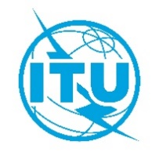
 |  | Document RAG20/ADM/1-E
 |  | 21 May 2020
 |  | English only
DRAFT AGENDA FOR THE TWENTY-SEVENTH MEETING OF THE RADIOCOMMUNICATION ADVISORY GROUP
(E-meeting, 25-27 May 2020)

1 | Opening remarks | -
2 | Approval of the agenda | ADM/1
3 | Council issues | 1-Rev1(§2)
4 | Result of RA-19 and WRC-19 and consequential actions | 1-Rev1(§3), 7, 11, 13,  15, 16, 19, 21
5 | WRC-23 preparation | 1-Rev1(§5)
6 | Study Group activities | 1-Rev1(§4), 1-Add1, 12-Rev1, 14, 18
7 | Inter-sector activities | ITU-T/TSAG: 2, 3, 6, 9, 5-Rev1, 8  ITU-D/TDAG: 4
8 | Operational Planning | 1-Rev1(§6), 10, 20
9 | BR Information System | 1-Rev1(§7), 17, 22, 23
10 | Outreach | 1-Rev1(§8)
11 | Date of next meeting
12 | Any other business

Access to the virtual meeting room / daily meeting sessions
ITU/TIES user account required (credentials used to register to the event)

Mr Daniel OBAM
Chairman, Radiocommunication Advisory Group
dobam@ncs.go.ke

