|  |  |
| --- | --- |
| **Radiocommunication Study Groups** |  |
|  |  |
|  |  |
| Source: Document 5C/TEMP/23, [5C/4](https://www.itu.int/md/meetingdoc.asp?lang=en&parent=R19-WP5C-C-0004) | **Annex 12 to Document 5C/59-E** |
| **6 August 2020** |
| **English only** |
| Annex 12 to Working Party 5C Chairman’s Report | |
| working document towards preliminary draft revision of RECOMMENDATION ITU-R F.749-3[1]* | |
| Radio-frequency arrangements for systems of the fixed service operating in sub-bands in the 36-40.5 GHz band | |

(Question ITU-R 247/5)

(1992-1994-2001-2012)

Scope

This Recommendation provides specifications for radio-frequency channel arrangements for systems in the fixed service with channel separations ranging from 2.5 to 112 MHz in the bands 36‑37 GHz, 37.0‑39.5 GHz, 38.6-40 GHz and 39.5-40.5 GHz. One Annex (Annex 2) includes block‑based arrangements with bandwidths of 50 MHz and 60 MHz in the frequency range 38.06 to 40 GHz.

The ITU Radiocommunication Assembly,

considering

*a)* that the band 36.0-40.5 GHz is allocated to the fixed and mobile services and that the propagation characteristics of this band are ideally suited to short-range digital and analogue radio system applications;

*b)* that differing applications of various administrations may require different radio-frequency (RF) channel arrangements;

*c)* that the band may also be used for broadband wireless access (BWA) systems in the fixed service;

*d)* that several services with various transmission signal characteristics and capacities may be in simultaneous use in this frequency band;

*e)* that lower and upper limits of the bands are not uniform and vary internationally;

*f)* that the applications in this frequency band may require differing channel bandwidths;

*g)* that a high degree of compatibility between radio-frequency channels of different arrangements can be achieved by selecting channel centre frequencies within a homogeneous basic pattern;

*h)* that the differing digital hierarchies used in various countries or regions may require the use of homogeneous basic patterns with differing intervals;

*j)* that allocation of frequency blocks to BWA systems allows flexible deployment of various technologies including provisions for intersystem/services operation and overall spectrum efficiency,

recommends

1 that the preferred RF channel arrangements for the band 36.0-40.5 GHz should be based on homogeneous patterns;

2 that the homogeneous pattern with a preferred 3.5 MHz interval be defined by the relation:

*fp* = *fr* + 1 + 3.5 *p* MHz

where:

1 ≤ *p* ≤ 1 285

*fr*: reference frequency of the homogeneous pattern;

3 that the homogeneous pattern with a preferred 2.5 MHz interval be defined by the relation:

*fp* = *fr*  + 2.5 *p* MHz

where:

1 ≤ *p* ≤ 1 799

*fr*: reference frequency of the homogeneous pattern;

4 that the reference frequency of the homogeneous pattern for international connections should be 36 000 MHz;

5 that all go channels should be in one half of any bidirectional band, and all return channels in the other;

6 that the channel spacings, *XS*, the centre gap, *YS*, and the distance to the lower and upper‑band limits, *Z*1*S* and *Z*2*S*, should be agreed by the administrations concerned, dependent on the application and channel capacity envisaged (see Recommendation ITU‑R F.746 for definitions of *XS*, *YS* and *ZS*);

7 that allocated blocks should result from aggregation of contiguous channels in accordance with the homogeneous patterns.

NOTE 1 – Examples of RF channel arrangements based on *recommends*2 and 3 are described in Annexes 1 and 2.

NOTE 2 – Due regard has to be taken that, in certain countries, a 3.5 MHz homogeneous pattern, interleaved by 1.75 MHz from that referred in *recommends* 2, is used in conjunction with the main pattern.

NOTE 3 – Examples of BWA system block (sub-band) arrangements are described in Annex 3.

Annex 1  
  
Radio-frequency channel arrangements in the band 37.0-39.5 GHz used by  
some CEPT administrations in accordance with *recommends* 2

The radio-frequency channel arrangement for carrier spacings of 224 MHz, 112 MHz, 56 MHz, 28 MHz, 14 MHz, 7 MHz and 3.5 MHz shall be derived as follows:

Let *f*0 be the centre frequency of 38 248 MHz  *f*  1  (642  3.5) MHz;

*f* be the centre frequency of a RF channel in the lower half of the band (MHz);

be the centre frequency of a RF channel in the upper half of the band (MHz);

then the frequencies of individual channels are expressed by the following relationships:1 Co-channel arrangements

a) for systems with a carrier spacing of 112 MHz:

lower half of band: *f* = *f*0 – 1 246 + 112 *n* MHz

upper half of band: = *f*0 + 14 + 112 *n* MHz

where:

*n* = 1, 2, 3, . . . 10

b) for systems with a carrier spacing of 56 MHz:

lower half of band: *f* = *f*0 – 1 218 + 56 *n* MHz

upper half of band: = *f*0 + 42 + 56 *n* MHz

where:

*n* = 1, 2, 3, . . . 20

c) for systems with a carrier spacing of 28 MHz:

lower half of band: *f* = *f*0 – 1 204 + 28 *n* MHz

upper half of band: = *f*0 + 56 + 28 *n* MHz

where:

*n* = 1, 2, 3, . . . 40.

In addition, where practical, administrations may consider the use of channels with index *n*=0 and 41;

d) for systems with a carrier spacing of 14 MHz:

lower half of band: *f* = *f*0 – 1 197 + 14 *n* MHz

upper half of band: = *f*0 + 63 + 14 *n* MHz

where:

*n* = 1, 2, 3, . . . 80.

In addition, where practical, administrations may consider the use of channels with index *n =* −2, −1, 0 and 81, 82, 83.

e) for systems with a carrier spacing of 7 MHz:

lower half of band: *f* = *f*0– 1 193.5 + 7 *n* MHz

upper half of band: = *f*0 + 66.5 + 7 *n* MHz

where:

*n* = 1, 2, 3, . . . 160.

In addition, where practical, administrations may consider the use of channels with index *n*= −5, −4, −3, −2, −1, 0 and 161, 162, 163, 164, 165, 166;

f) for systems with a carrier spacing of 3.5 MHz:

lower half of band: *f* = *f*0 – 1 191.75 + 3.5 *n* MHz

upper half of band: = *f*0 + 68.25 + 3.5 *n* MHz

where:

*n* = 1, 2, 3, . . . 320.

In addition, where practical, administrations may consider the use of channels with index *n*= −11, −10, ..., −1, 0 and 321, 322, ..., 331, 332.

2 Interleaved channel arrangements

Administrations may consider merging any two adjacent 112 MHz channels recommended in 1a) to create 224 MHz channels, with centre frequencies between the merged channels in interleaved arrangements as in the formulas below and as shown in Figure 2.

For systems with a carrier spacing of 224 MHz:

Lower half of band: *fn* = *(f*0 − 1 190 + 112 *n*) MHz

Upper half of band: *f´n* = (*f*0 + 70 + 112 *n*) MHz

where:

*n* = 1, 2, 3, …. 9

NOTE 1 – The RF channel arrangements of a) to e) above use channel centre frequencies *fn* and selected from the homogeneous pattern of *recommends*2. The arrangement f) above uses channel centre frequencies spaced by 3.5 MHz but interleaved between the homogeneous pattern of *recommends*2, with an offset of 1.75 MHz.

figure 1

Occupied spectrum in co-channel arrangement: 37.0 GHz-39.5 GHz band



NOTE1 – One additional 28 MHz channel.

NOTE2 – 42 MHz for additional 3.5, 7 and 14 MHz channels.

Figure 2

Interleaved channel arrangement with channel width of 224 MHz

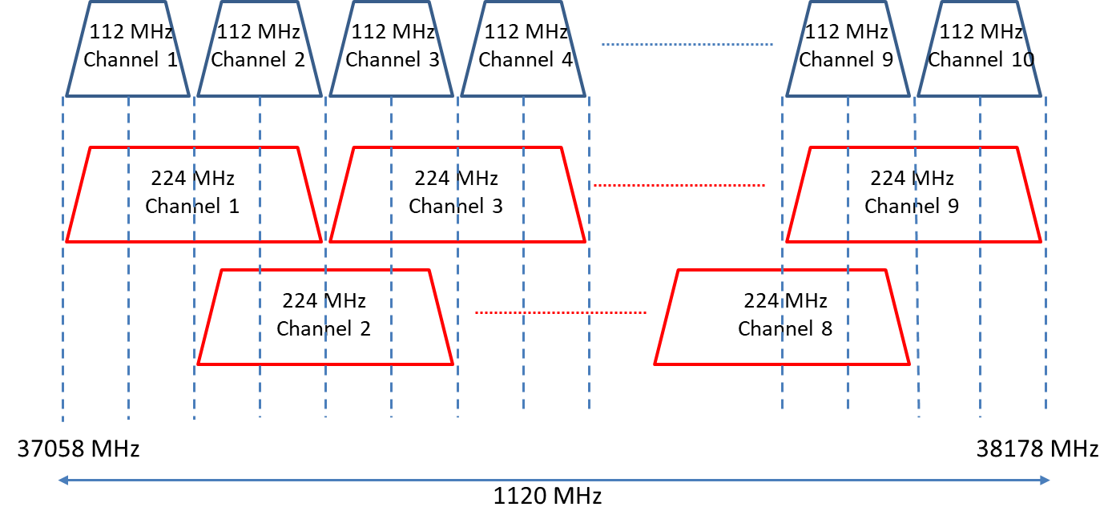

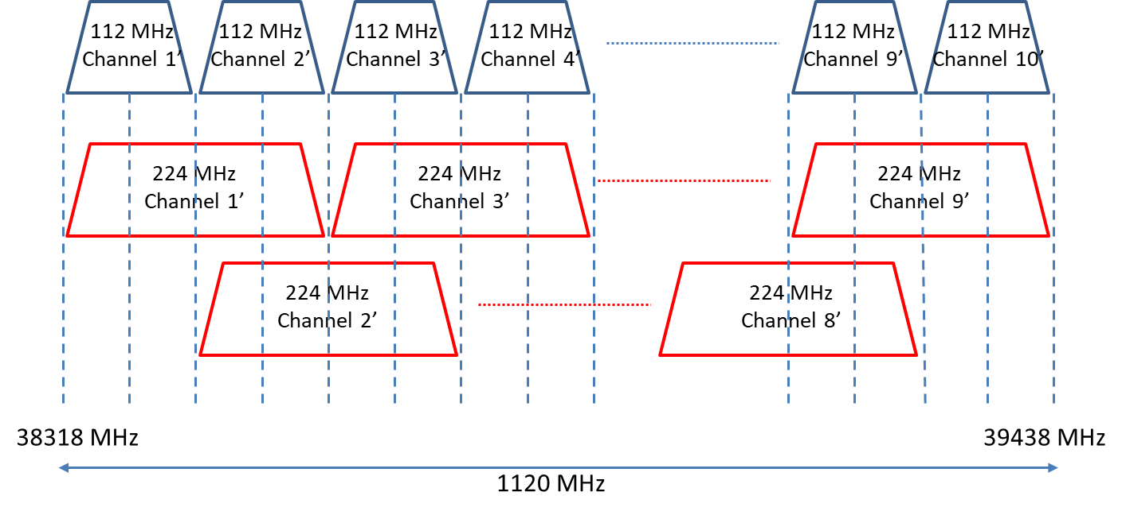

Annex 2  
  
RF channel arrangements for radio-relay systems operating   
in the 36.0-37.0 GHz and in the 39.5-40.5 GHz bands   
in accordance with *recommends* 2 (Russia)

The RF channel arrangement for carrier spacings of 112 MHz, 56 MHz, 28 MHz, 14 MHz, 7 MHz and 3.5 MHz shall be derived as follows:

Let *f*0 be the centre frequency of 36 498 MHz = *f* + 1 + (142 × 3.5) MHz for the frequency band 36 000-37 000 MHz, and

*f*0 be the centre frequency of 39 998 MHz = *f* + 1 + (1 142 × 3.5) MHz for the frequency band 39 500-40 500 MHz;

*f* be the centre frequency of a RF channel in the lower half of the band (MHz);

be the centre frequency of a RF channel in the upper half of the band (MHz);

then the frequencies of individual channels are expressed by the following relationships:

a) for systems with a carrier spacing of 112 MHz:

lower half of band: *f* = *f*0 – 532 + 112 *n* MHz

upper half of band: = *f*0 – 70 + 112 *n* MHz

where:

*n* = 1, 2, 3, 4

b) for systems with a carrier spacing of 56 MHz:

lower half of band: *f* = *f*0 – 476 + 56 *n* MHz

upper half of band: = *f*0 – 14 + 56 *n* MHz

where:

*n* = 1, 2, . . . 8

c) for systems with a carrier spacing of 28 MHz:

lower half of band: *f* = *f*0 – 448 + 28 *n* MHz

upper half of band: = *f*0 + 14 + 28 *n* MHz

where:

*n* = 1, 2, . . . 15

d) for systems with a carrier spacing of 14 MHz:

lower half of band: *f* = *f*0 – 434 + 14 *n* MHz

upper half of band: = *f*0+ 28 + 14 *n* MHz

where:

*n* = 1, 2, . . . 29

e) for systems with a carrier spacing of 7 MHz:

lower half of band: *f* = *f*0– 427 + 7 *n* MHz

upper half of band: = *f*0 + 35 + 7 *n* MHz

where:

*n* = 1, 2, ... 57

f) for systems with a carrier spacing of 3.5 MHz:

lower half of band: *f* = *f*0 *–* 423.5 + 3.5 *n* MHz

upper half of band: = *f*0+ 38.5 + 3.5 *n* MHz

where:

*n* = 1, 2, . . . 113.

NOTE 1 – The centre and edge guardbands may be reduced, by agreement between the administrations concerned, for lower capacity systems by the addition of extra channels using frequencies derived from the homogeneous pattern of *recommends* 2.

Annex 3  
  
RF block arrangements in the band 38.6-40.0 GHz using the homogeneous pattern in accordance with *recommends* 7

# 1 Arrangement in Canada and the United States of America

## 1.1 Radio-frequency block arrangement description

In Canada and the United States of America the band 38.6-40.0 GHz is divided into 14 paired frequency blocks (50 MHz + 50 MHz) as follows:

|  |  |  |
| --- | --- | --- |
| Block designation | Lower frequency blocks | Upper frequency blocks |
| Frequency band limits (MHz) | |
| 1 | 38 600-38 650 | 39 300-39 350 |
| 2 | 38 650-38 700 | 39 350-39 400 |
| 3 | 38 700-38 750 | 39 400-39 450 |
| 4 | 38 750-38 800 | 39 450-39 500 |
| 5 | 38 800-38 850 | 39 500-39 550 |
| 6 | 38 850-38 900 | 39 550-39 600 |
| 7 | 38 900-38 950 | 39 600-39 650 |
| 8 | 38 950-39 000 | 39 650-39 700 |
| 9 | 39 000-39 050 | 39 700-39 750 |
| 10 | 39 050-39 100 | 39 750-39 800 |
| 11 | 39 100-39 150 | 39 800-39 850 |
| 12 | 39 150-39 200 | 39 850-39 900 |
| 13 | 39 200-39 250 | 39 900-39 950 |
| 14 | 39 250-39 300 | 39 950-40 000 |

## 1.2 Usage

– Block designations are A/A' to N/N' for Canada, and 1-A/1-B to 14-A/14-B for the United States of America.

– Frequency blocks are paired to facilitate frequency division duplex systems. Preference is given to the lower frequency blocks for downlink operation and to the upper frequency blocks for uplink operation. Time division duplex systems may operate in either the lower or upper frequency blocks.

– Operators may subdivide the 50 MHz blocks according to their needs.

– Larger frequency blocks can be made available through the aggregation of 50 MHz paired blocks.

# 2 Arrangement in Japan

## 2.1 Radio-frequency block arrangement description

In Japan the band 38.06-38.48/39.06-39.48 GHz is divided into seven paired frequency blocks (60 MHz  60 MHz) as follows:

|  |  |  |
| --- | --- | --- |
| Paired block | Lower frequency block (MHz) | Upper frequency block (MHz) |
| C1/C'1 | 38 060-38 120 | 39 060-39 120 |
| C2/C'2 | 38 120-38 180 | 39 120-39 180 |
| C3/C'3 | 38 180-38 240 | 39 180-39 240 |
| C4/C'4 | 38 240-38 300 | 39 240-39 300 |
| C5/C'5 | 38 300-38 360 | 39 300-39 360 |
| C6/C'6 | 38 360-38 420 | 39 360-39 420 |
| C7/C'7 | 38 420-38 480 | 39 420-39 480 |

## 2.2 Usage

– Frequency blocks are paired to facilitate frequency division duplex systems. Preference is given to the lower frequency blocks for uplink operation and to the upper frequency blocks for downlink operation. Time division duplex systems may operate in either the lower or upper frequency blocks.

– Operators may subdivide the 60 MHz blocks according to their needs.

– Larger frequency blocks can be made available through the aggregation of 60 MHz paired blocks.

1. * Radiocommunication Study Group 5 made editorial amendments to this Recommendation in 2012 in accordance with Resolution ITU-R 1.