|  |  |
| --- | --- |
| **Radiocommunication Study Groups** |  |
|  |  |
|  |  |
| Source: Documents 5C/TEMP/7, [5C/33](https://www.itu.int/md/meetingdoc.asp?lang=en&parent=R19-WP5C-C-0033)  Subject: Preliminary draft new Report ITU-R F.[CSA] | **Annex 5 to Document 5C/59-E** |
| **4 August 2020** |
| **English only** |
| Annex 5 to Working Party 5C Chairman’s Report | |
| PRELIMINARY DRAFT NEW REPORT ITU-R F.[CSA] | |
| Technical and operational characteristics of radio frequency central alarm systems operating in the fixed service in the frequency range 450-470 MHz | |

# 1 Introduction

Radio Frequency Central Station Alarm (RF CSA) systems make use of fixed service (FS) allocations in the frequency range 450-470 MHz. This same frequency range is also shared with point-to-point and point-to-multipoint systems in the FS, as well as systems in the mobile service including maritime mobile, IMT and precursors, and the land mobile service. In the 460-470 MHz frequency range the MetSat service has Data Collection Systems (DCS) and the EESS makes use of downlinks for geostationary and non-geostationary orbiting (GSO and non-GSO) spacecraft.

## 1.1 Description

This report presents a description of the technical and operational characteristics of fixed service radio frequency mesh network systems. Mesh radio technology is conceptually simple. Signals that need to get from a monitored alarm panel to the central alarm monitoring station may either go directly from the protected premises at the alarm panel to the receiver in the central station, or it will “hop” through other subscriber radios along the way, via one of many possible routes until it gets a confirmed delivery at the central station. Mesh networks have an inherent capability for route diversity between a pair of nodes. If one of the wireless links within a route between a pair of source and destination nodes becomes unavailable for some reason, the traffic on the wireless route will automatically be rerouted.

A typical RF CSA network design is shown in Figure 1. The wireless mesh network consists of wireless nodes, which are either customer sites, relay nodes without originating/terminating traffic, or points of interface (POI) to other networks. Wireless nodes are connected via RF signals; the end-to-end traffic is conveyed over single and/or multi-hop routes. The use of Multipoint to Multipoint (MP-MP) systems with mesh network technology is considered an effective means of mitigating the degradation of telecommunication quality in the fixed wireless systems (FWSs) operating in frequency band 460-470 MHz. This has proven especially true in the communication of safety alarms using RF CSA mesh networks.

Figure 1

Typical RF CSA Mesh Network Configuration

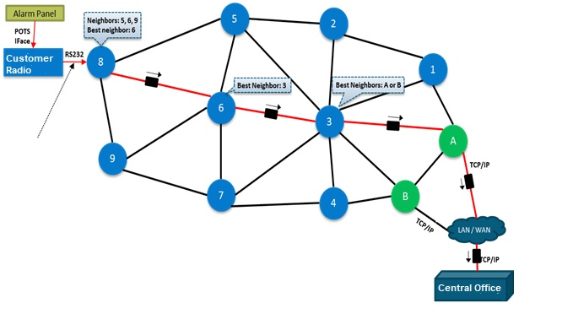

RF CSA mesh network systems are employed to transmit data regarding events such as fires, medical emergencies, home invasions, dangerous carbon monoxide levels, and other urgent circumstances, as well as check‑in and status messages. In the United States, for example, these mesh network systems use the 460-470 MHz frequency range and operate with frequencies as specified in Table 1. Globally, RF CSA mesh networks operate in frequency range of 450‑470 MHz. In the United States these RF CSA systems monitor at least 470 000 homes, businesses and government facilities to report fires, medical emergencies, home invasions and other urgent circumstances, allowing central stations to alert first responders. The alarm panel in the protected premise receives input regarding an emergency condition, and activates a dedicated radio on one of the centre frequencies shown in Table 2 to relay wireless alarm signals via the mesh network to the central station, which can use this data to coordinate a response by the relevant public safety personnel. At least 200 000 alarm radios in this band are used in many other countries, with some operating in the UHF band and some operating in the VHF band, depending on the spectrum allocation of the relevant administration.

RF CSA systems use mesh network technology to relay burglar and fire alarms as well as housekeeping messages to IP link stations (sometimes called concentrator nodes) or to the central station. Due to the nature of the networks, received signal strengths may be less than ideal, hence the interference criteria are based on the minimum discernible signal. An image of a typical RF CSA transceiver appears in Figure 2.

Figure 2

Fire Transceiver

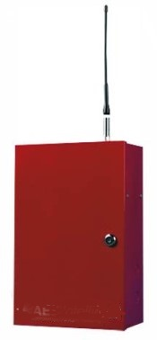

In the United States, these systems operate under a low power requirement as given in national regulations [47 CFR § 90.267]. The use of RF CSA systems is increasing significantly over time, due to the reduced vulnerability of wireless alarm connections to tampering and the retirement of the traditional wired telephone network. These networks are implemented on an ad hoc basis and may include links that operate at or near the minimum discernable signal level. The RF CSA mesh networks do not include large margins in general.

# 2 Technical characteristics of RF CSA central station mesh network systems

The technical characteristics of RF CSA central station mesh network systems are presented in this section.

## 2.1 RF CSA mesh network equipment characteristics

The technical characteristics for RF CSA mesh network central, IP link, and subscriber stations are provided in Table 1. System characteristics obtained from industry representatives and measurements are included.

TABLE 1

Characteristics for radio frequency central alarm systems in the band 450-470 MHz

|  |  |
| --- | --- |
| **Parameter** | **Value** |
| Frequency range (MHz) | 450 - 470 |
| Center frequencies employed in the 460-470 MHz band (MHz) (increment by 0.00625 MHz) | See details in Table 2 below |
| Receiver noise bandwidth (MHz) | 0.0125 |
| Maximum antenna gain range (dBi) | 2 (typical subscriber),  10 (central station and IP link) |
| Interference criteria (measured at transceiver input terminals) (dBW/12.5 kHz) | -159.2 |
| Performance criteria | Interference criteria not exceeded for more than 90 seconds |
| Losses (dB for IP link and central stations)  Losses (dB for subscriber units) | 3  1 |

TABLE 2

Center frequencies employed in the 460-470 MHz band

|  |  |
| --- | --- |
| Base Frequency | Response Frequency |
| 460.90000 | 465.90000 |
| 460.90625 | 465.90625 |
| 460.91250 | 465.91250 |
| 460.91875 | 465.91875 |
| 460.92500 | 465.92500 |
| 460.93125 | 465.93125 |
| 460.93750 | 465.93750 |
| 460.94375 | 465.94375 |
| 460.95000 | 465.95000 |
| 460.95625 | 465.95625 |
| 460.96250 | 465.96250 |
| 460.96875 | 465.96875 |
| 460.97500 | 465.97500 |
| 460.98125 | 465.98125 |
| 460.98750 | 465.98750 |
| 460.99375 | 465.99375 |
| 461.00000 | 466.00000 |
| 461.00625 | 466.00625 |
| 461.01250 | 466.01250 |
| 461.01875 | 466.01875 |

## 2.2 Interference criteria

There are many methodologies that may be used to ensure coexistence with RF CSA mesh network systems. RFI criteria have been directly measured as the level at which messages would be blocked assuming that the link(s) under investigation are operating at or near the minimum discernable signal level. This measurement has been referenced to the transceiver input in Table 1. Due to the nature of the networks, received signal strengths may be less than ideal.

## 2.3 Performance criteria

RF CSA central station mesh network systems are designed to deliver alarm and other messages to a central station. The critical measure is that messages be delivered to the central station within 90 seconds. In the United States, for example, this criterion is based in part on the requirements of Section 26.6.5.2.2*(1) of the National Fire Protection Association[1] Code 72 (Maximum Operating Time), which provides that “there shall be a 90 percent probability that the time between the initiation of a single alarm signal until it is recorded at the supervising station will not exceed 90 seconds”.

1. The National Fire Protection Association (NFPA) is a nonprofit organization, established in 1896 in the United States. It is devoted to eliminating death, injury, property and economic loss due to fire, electrical and related hazards. NFPA creates and maintains private, copyrighted standards and codes for usage and adoption by local governments. Alarm companies must generally comply with NFPA 72 pursuant to alarm industry standards and insurance requirements.