|  |  |
| --- | --- |
| **Radiocommunication Study Groups** |  |
|  |  |
|  |  |
| Source: Documents 5C/TEMP/8, [5C/43](https://www.itu.int/md/meetingdoc.asp?lang=en&parent=R19-WP5C-C-0043)  Subject: Working Document towards a Preliminary Draft New Handbook ITU-R [HF Adaptive Handbook] | **Annex 1 to Document 5C/59-E** |
| **4 August 2020** |
| **English only** |
| Annex 1 to Working Party 5C Chairman’s Report | |
| Working document towards a Preliminary draft new handbook ITU-R [HF Adaptive handbook] | |
| A tutorial on frequency adaptive communication systems in the HF bands | |

TABLE OF CONTENTS

CHAPTER 1 - General overview of deploying adaptive systems 3

1.1 Background 3

1.2 Deploying adaptive systems 3

1.2.1 Frequency agile/adaptive – RTCE & LQA 3

1.2.2 Automatic link establishment 4

1.2.3 Automatic channel switching 6

CHAPTER 2 - Building an adaptive network 8

2.1 Frequency Pool 8

2.1.1 General 8

2.1.2 Frequency Management Method 8

2.1.3 Dynamic Frequency Selection (DFS) 9

2.2 Adaptive Equipment Use 10

2.3 Operation Protocols 10

2.4 Operational Considerations 10

CHAPTER 3 - Regulatory Considerations 11

3.1 Operations 11

3.2 Technical Limits 11

3.3 Sharing 11

CHAPTER 4 - Operational Considerations 13

4.1 Comparison to Static systems 13

4.1.1 Static system 13

4.1.2 Adaptive system 13

4.2 Operations in International Environment 14

4.3 Building Networks 14

4.3.1 Characteristics of HF communication network 14

4.3.2 Network type 14

4.4 Monitoring 16

4.4.1 Overview 16

4.4.2 The classification of monitoring 17

4.4.3 Self-optimization of monitoring 18

4.4.4 Evaluation of monitoring 18

Chapter 1

General overview of deploying adaptive systems

## 1.1 Background

According to the characteristics of HF communication and its increasing demand for stability, reliability and emergency recovery, the HF adaptive system appears first in the 1980s.

During years of technical development, standards are being proposed and updated by organizations, practical systems are being researched and applied, and also ITU-R keeps updating Recommendations concerned with the HF adaptive system. For standards, the United States of America developed the ALE (automatic link establishment) standard of which military version as MIL-STD-181-141A (now updated to MIL-STD-181-141C) and civilian version as FED‑STD‑1045A. As the most influential one, it becomes the worldwide de facto standard for digitally initiating and sustaining HF radio communications.

With such standard progressing, various HF adaptive systems came forth with the same general functions. These general functions are also typically described in the Recommendation [ITU-R F.1110-3](http://www.itu.int/rec/R-REC-F.1110/en):

“Basically, an adaptive system has a triple function:

– automatic selection of the frequency and of other system parameters to be used;

– automatic operation as regards calling, establishing the communication (with possible switch-over to the peripheral equipment needed for the type of service to be provided), and disconnecting;

– adaptivity during the communication so as to optimize at all times the quality of service according to the ionospheric conditions and spectrum congestion.”

## 1.2 Deploying adaptive systems

While deploying a HF adaptive system, the above triple functions may be implemented by using techniques or operating under flows as follow.

### 1.2.1 Frequency agile/adaptive – RTCE & LQA

Among adaptivity techniques, the frequency agile is the core method in HF adaptive communication, while RTCE (real-time channel evaluation) is the basis and key of frequency agile. The term RTCE was first proposed by Darnell in 1978:

“RTCE is the process of measuring appropriate parameters of a set of channels in real time and of employing the data thus obtained to describe quantitatively the states of those channels and hence their relative capabilities for passing a given class, or classes, of communication traffic.”

The RTCE technique contains ionospheric pulse sounding, chirp sounding (described in Recommendation ITU-R [F.1337](https://www.itu.int/rec/R-REC-F.1337/en)), CHEC sounding, 8FSK sounding, etc. The requirements for RTCE are both accurate and rapid, which runs counter each other. The more accurate, the more parameters should be measured, such as Signal to Noise and Distortion ratio(SINAD), multiple path(MP), fading, bit error ratio(BER), Doppler shifts, statistic characteristics of noise/interference, harmonic distortion, etc. In actual engineering, measuring such many parameters leads to passive real time data processing and requires high performance of signal processor, which is obviously not economical. It has been proved that by measuring SINAD, MP, BER would mostly reflect the evaluation of channels.

While the overall processing of applying the RTCE technique in a HF adaptive system to make, assess and analyze measurements of channels, is called LQA (link quality analysis). LQA is often conducted before communication or in the communication gap, and the achieved data is stored in LQA matrix. According to each channel’s evaluation score in LQA matrix, the best communication frequencies could be chosen in proper order. Considering the time cost of a complete LQA circuit, in general, 10 to 20 frequencies are stored in a frequency pool, but some adaptive systems have the capability to store and use up to several hundred frequencies.

An example of LQA matrix is shown below:

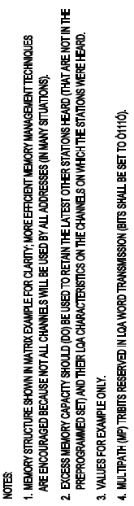

FIGURE 1-1

Connectivity and LQA memory example [MIL-STD-188-141C]

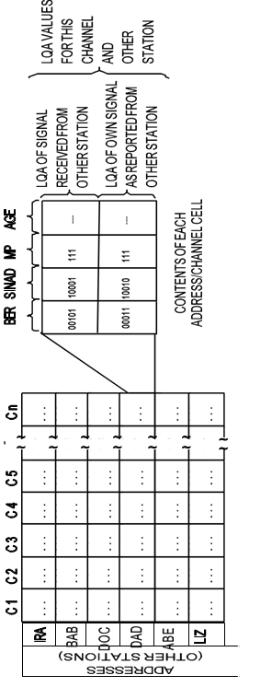

### 1.2.2 Automatic link establishment

Based on automatic scanning, selective calling and LQA, automatic link establishment is the final purpose of HF adaptive communication. The operating process of ALE could be simply described as follow:

Assume that there are two stations in the link, calling station is A, receiving station is B. Before link is established, both station keep scanning assigned channels. For calling station, when A starts calling, signal will be transmitted on frequencies in LQA matrix from the best to the worst. After transmitting the calling signal, A waits for receiving B’s respond signal. If no respond signal is received, A will switch to the next channel and start another calling. The calling won’t be stopped until A receive B’s respond signal. For receiving station, when B monitors a calling signal, scanning status will be stopped immediately and B checks the call sign. If the call sign is not B, B keeps scanning; if it is, B send a respond signal (usually B’s call sign) on the same channel and turns status from “RECEIVING” to “STANDBY”. When A confirms it is B’s respond signal, the transmitter turns status from “CALLING” to “READY”. Then a communication link is established.

The process above shall be completed by the control unit. Which is based on a computer. The integration of LQA, scan receiving, selective calling, transmitter and receiver controlling makes it possible to operate without manual operation.

The process of establishing a communication link can be simply indicated as follow:

FIGURE 1-2

Flow chart of control unit at the Calling status

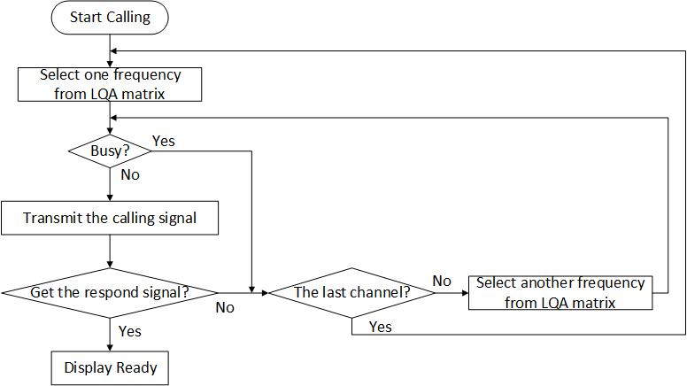

*{Editor’s note: Clarify the use of either “channel” or “frequency” in block “Select another frequency from LOA matrix”.}*

FIGURE 1-3

Flow chart of control unit at the Receiving status

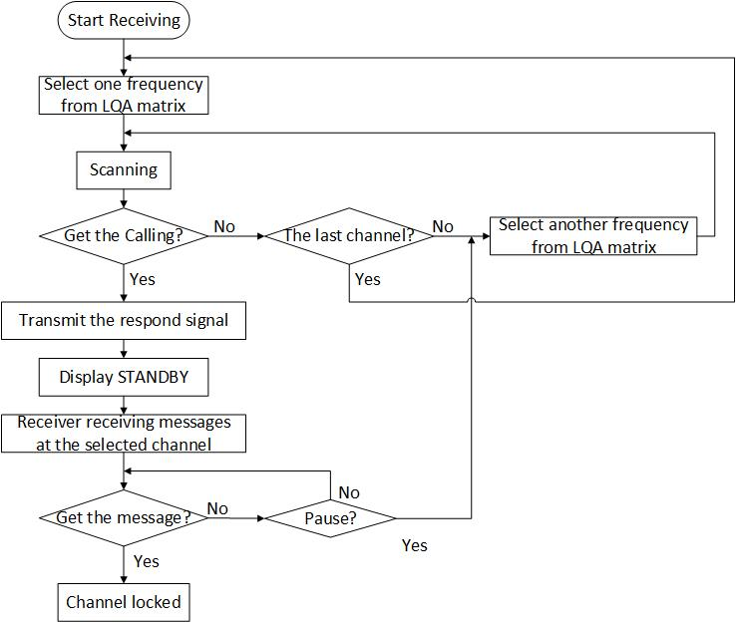

*{Editor’s note: Clarify the use of either “Channel” or “frequency” in block “Select another frequency from LOA matrix”.}*

### 1.2.3 Automatic channel switching

An established link may be affected by complex environment changes, to maintain a high quality communication requires automatic channel switching. The control unit should initiate a new ALE procedure immediately if the established link breaks or degrades.

The process of switching to another channel can be indicated as follow:

FIGURE 1-4

Flow chart of Channel Switching

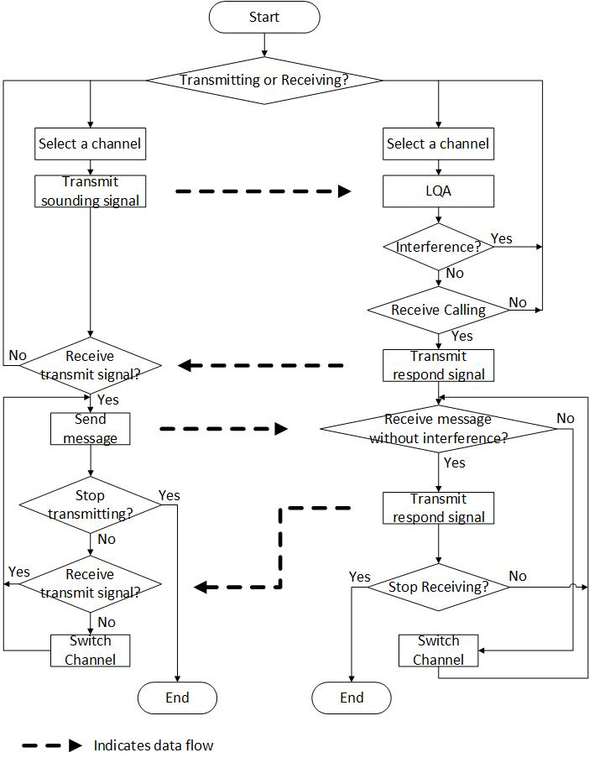

CHAPTER 2

Building an adaptive network

## 2.1 Frequency Pool

### 2.1.1 General

Frequency pool planning is to determine the number and distribution of all available frequencies in the network. In a limited area covered by a single network, the number of available frequencies depends on the number of users, the type of user (fixed or mobile), the type of service (voice or data), and so on. More specifically, it is necessary to calculate the whole frequency quantity required according to the bandwidth required by the service, the number of channels required by the user, the required pass-through rate, the chain building and unbuilding time of different services and other parameters, and then plan number of frequencies in the frequency pool.

In a wide area that needs more than one network coverage, the size of the coverage area determines the number and distribution of networks, which determines whether frequency reuse is required.

### 2.1.2 Frequency Management Method

In order to adapt to the uncertain changes in the ionosphere or communication environment, and to keep the communication uninterrupted, it is necessary to select the appropriate communication frequency and update the frequency in the communication process, which requires an enduring frequency management method.

The first-generation link establishment technology provides optimal frequency information for the communication system by detecting the HF channel. And the second and third generation of ALE (automatic link establishment) technology, based on the optimized frequency information obtained from the HF channel detection, works out the available working frequency group, and selects frequency in real time within the relatively fixed working frequency group to automatically establish the communication link. The main problems are as follows: the channel detection system and the actual communication system are independent of each other, and the interaction information is not timely, and even the information interaction cannot be carried out under certain conditions, resulting in that the frequency used in the actual communication is not the optimal frequency in real time.

With the development of HF communication technology, especially the rapid development of high-speed DSP and large-scale FPGA technology, the combination of channel real-time detection system and HF communication system becomes possible. In the new HF communication system, the real-time channel detection based on spectrum sensing can be closely combined with the ALE process. The frequency management strategy is described as follows:

(1) Frequency preplanning based on medium- or long-term frequency prediction

When frequency allocation is carried out in a communication network, factors such as geographical distribution, network topology and equipment performance should be considered. Frequency preplanning achieves this function by adopting different optimization algorithms. When building a communication network, it is usually divided by geographic region or specific task. Stations in different areas are divided into multiple resident groups, each of which selects a communication station to be responsible for sending information within the group. To establish reliable communication, frequencies need to be assigned to each group. The distribution of frequency can be determined either by medium- or long-term frequency prediction, an available frequency band can be produced by frequency prediction software.

(2) Local noise analysis based on spectrum sensing

As HF communication is obviously affected by environmental background noise, each station requires real-time monitoring of local noise and interference by FFT transform and cyclic spectrum analysis technology, shielding some of the frequencies with serious interference.

(3) Frequency monitoring

For each station, the signal of the target station or the broadcast station are monitored and received. Through such one-way interception of signals from known geographical location, the propagation characteristics of the HF channel are analyzed, and the standby frequency group is selected.

(4) Bidirectional frequency detection

The bidirectional frequency detection of the target station can be started by timing or manual means to obtain the most direct and reliable channel quality information. The third-generation HF communication is a very effective link quality analysis mechanism, which is not to analyze link quality by means of pre-detection, but to evaluate link quality by accumulating every communication connection. During communication, the calling station sends a call protocol data unit (PDU) on a certain frequency. After receiving the data, the called station immediately analyzes the communication quality of the channel and quantifies it into a specific score. After scoring, the called station needs to send a handshake PDU to the calling station and send the score back to the calling party. Similar to this process, after receiving the handshake PDU, the calling station conducts a quality analysis on the current communication link again, and a score can also be obtained on the own side. The final score of the current channel is obtained by adding the two scores of the calling station as a criterion for evaluating channel quality. If the current channel can meet the business requirements, the frequency can be used for normal business communication. If the requirements cannot be met, the above procedure is repeated to select the channel and call again.

(5) Memory-based frequency information processing

Establish the frequency LQA matrix library for all possible target stations, and update the LQA matrix library according to the current detection results and historical information, so as to provide basis for reasonable frequency selection in the future.

### 2.1.3 Dynamic Frequency Selection (DFS)

The existing spectrum management of HF communication adopts the method of fixed allocation of spectrum, which leads to low spectrum utilization and can not meet the demand of HF users for spectrum resources. To address the problem of HF broadband spectrum constraints, several new HF standards and 3G-ALE synchronization systems allow HF communication system designers to use dynamic spectrum allocation strategies. By using HF dynamic spectrum selection (DFS) technology, the spectrum utilization can be improved and the capacity of HF communication system can be increased.

In the case that many communication stations have spectrum sensing ability, the specific real-time frequency change process needs to exchange some real-time information such as frequency monitoring or detection and information about priority control. In order to facilitate the establishment of efficient communication in each station, it is suggested to design a dynamic frequency selection protocol suitable for the communication function of both parties, and achieve a dialogue mechanism through frequency selection network.

Carrier sensed multiple access (CSMA) is a network access method used on shared network topologies such as Ethernet to control access to the network, which seems competent with real time channel evaluation (RTCE) process. For CSMA, the station first listens to the channel before sending data, and if the channel is occupied, it will defer to the next time slot to listen again. CSMA competitive access mechanism cannot fundamentally solve the collision conflict problem, especially in the case of large number of station users, the possibility of collision is more. Time division multiple address (TDMA) can avoid collision more effectively. Therefore, under the condition of synchronization, TDMA access mechanism is a feasible technical approach for chain construction.

The TDMA access mechanism divides the transmission time into non-overlapping time slots periodically. A repetition period is defined as a frame, and each channel corresponds to a time slot. Although TDMA access mechanism can effectively avoid collisions, when the traffic volume is not balanced, it will lead to the waste of time slots and reduce the overall efficiency of the system. In order to improve network capacity, TDMA combined with CDMA access mechanism can be used.

The channel access strategy combining TDMA and CDMA firstly codes each station in advance at the physical layer, allocates the call and reply slots to which the station belongs, and also assigns spread spectrum identification codes to each station. According to the demand of business volume, multiple stations can be allowed to call or reply within the same time slot, and the reply time slot is allocated accordingly.

In order to ensure the communication needs of key stations and key regions, a prioritized frequency selection protocol should be designed: in the case of extremely bad communication conditions, priority should be given to meeting the frequency selection needs of key departments and key regions, that is, as long as there is an optimal frequency, users can choose to use it, while other users must give up this optimal channel. The other cooperation protocol is on the contrary. It is applicable to the frequency selection needs when both parties have the same priority or the communication environment is good. Both parties should invoke a standard (such as different communication services) according to the actual situation and negotiate to solve the conflict problem of the optimal frequency.

Dynamic frequency management can maintain the monitoring of communication links, track changes in link conditions and adjust frequency allocation schemes accordingly to adapt to such changes. When a station moves its position in a large range or the available frequency of the station is seriously interfered during the communication process, the current working frequency should be updated timely. The frequency management station should be able to acquire the destination location in time, re-select the communication frequency, and inform each station in the network through broadcast to ensure the normal communication.

## 2.2 Adaptive Equipment Use (what adaptive equipment is available and how it impacts operations)

[TBD]

## 2.3 Operation Protocols (how operational protocols can improve adaptive equipment use)

[TBD]

## 2.4 Operational Considerations (interference, link quality, reliability, etc.)

[TBD]

*{Editor’s note: Contributions are encouraged from the membership to Chapter 2 in order to advance the work on this Handbook.}*

Chapter 3

# Regulatory Considerations

## 3.1 Operations

While adaptive HF systems may be utilized in any radiocommunication service, such systems must be operated in accordance with the ITU Radio Regulations and applicable domestic regulations.   
The frequency agility of an adaptive HF system does not give regulatory authority to transmit on a frequency outside of the allocations to the radiocommunication service in which the adaptive system operates. Further, an administration may assign frequencies to stations within an adaptive HF system as a condition of licensure.

## 3.2 Technical Limits

Stations within the adaptive HF system must transmit within an allocation to the radiocommunication service with which it operates. Stations within the adaptive HF system must be authorized via an administration’s licensing process and the authorizing administration may assign frequencies to be used by stations the adaptive HF system.

The ITU Radiocommunication Sector has adopted several Recommendations that licensees and administrations may consider in determining appropriate conditions of licensure for stations in an adaptive HF system. These include:

– Recommendation ITU-R [F.1110](https://www.itu.int/rec/R-REC-F.1110/en), *Adaptive radio systems for frequencies below about 30 MHz*, specifies the general characteristics of adaptive HF systems.

– Recommendation ITU-R [F.1337](https://www.itu.int/rec/R-REC-F.1337/en), *Frequency management of adaptive HF radio systems using FMCW oblique-incidence sounding*, recommends that automatic and adaptive management schemes be utilized for adaptive HF networks and describes one such technique (the use of brief sounding transmissions to determine appropriate operating frequency).

– Recommendation ITU-R [F.1611](https://www.itu.int/rec/R-REC-F.1611/en), *Prediction methods for adaptive HF system planning and operation*, recommends that administrations explore the use of HF performance prediction models, including, but not limited to, those contained in the current version of Recommendation ITU-R P.533, in advance of deployment to establish adaptivity bounds.

– Recommendation ITU-R [F.1778](https://www.itu.int/rec/R-REC-F/en), *Channel access requirements for HF adaptive systems in the fixed and land mobile services*, recommends that adaptive HF systems utilize the minimum possible number of active channels out of their available frequency pools, and describes and recommends the use of dynamic frequency selection procedures.

## 3.3 Sharing

The frequencies assigned to an adaptive HF system may or may not also be assigned, either by the same administration or by different administrations, to other stations operating in the same radiocommunication service. The nature of HF propagation is such that occasional conflicts between stations utilizing the same frequency may be expected. Properly operating adaptive HF systems with adequate frequency pools have a high, but not certain, probability of resolving many such conflicts automatically, and thus, can effectively share a frequency band with the same and other radiocommunication services.

An adaptive HF system is more likely to achieve a link with minimal interference when transmissions are kept short (minimizing the time over which a station occupies a channel). An adaptive system is also more likely to achieve a useable link when its authorized frequency pool contains several authorized frequencies within each frequency band of interest. The frequency pool will be most useful if it has frequencies in several bands potentially suitable for the intended communications path. Protocols for the adaptive selection of operating frequency can determine which of the several bands is most suited for the intended communications path at the time of transmission, taking into account propagation variations throughout the day. These protocols can also provide guidance as to which of the several authorized frequencies within the selected band is most suitable at the time of transmission, if any one frequency is more suitable than others.

Chapter 4

# Operational Considerations

## 4.1 Comparison to Static systems

### 4.1.1 Static system

A generalized HF communication system incorporates both static and mobile terminals. Static system is a wording corresponding to adaptive system, an HF static system literally refers to static terminals in fixed service, which requires a high quality static communication link. It operates with a defined frequency complement on a regular schedule.

Under given communication quality and success ratio, to design and build up a high quality static link for traditional HF communication, the following aspects must be considered:

Frequency range;

Modulation and shift keying type;

Antenna type;

Diversity reception;

Error control;

Minimum transmitting power.

The most important step is frequency prediction.

*{Editor’s note: Additional material will be provided for this section}*

### 4.1.2 Adaptive system

Due to the HF channel is obviously time varying, the frequency selection is very important. For traditional static HF communication, operators on both sides of long communication can only through complicated manual operation (selecting frequency, calling, switching channels, etc.) to overcome the impact, which is low timeliness and it is difficult to guarantee operation accuracy. In order to make communication process becomes more reliable and convenient, the Automatic Link Establishment (ALE) technique comes out.

ALE contains three parts, including channel evaluation, link establishment and link maintenance. Channel evaluation is to complete the link quality analysis through active detection, passive detection and local noise estimation. Based on results of link quality analysis, link establishment select the optimal channel automatically for point-to-point single call and point to multi-point network call, through the two-way handshake protocol to establish a link. Due to the time-varying channel, in the process of communication, link maintenance continuously monitoring the change of channel quality, through channel switching, frequency agility to ensure continuous and reliable communication.

The ALE technique develops by three generations. The first generation is an independent real time detection system, applying ionosphere detection techniques to choose the optimal frequency for communication. The second generation is based on known frequency sets, using FSK waveform detecting channel to achieve automatic link establishment. On the basis of the second generation, the third generation makes use of PSK waveform detecting channel to achieve business management and comprehensive networking, further improving the communication quality of HF communication system.

*{Editor’s note: Additional material will be provided for this section}*

## 4.2 Operations in International Environment

*{Editor’s note: Additional material will be provided for this section}*

## 4.3 Building Networks

### 4.3.1 Characteristics of HF communication network

Comparing with other communication network, HF communication network has the following characteristics:

(1) Poor channel quality. In the channel of an HF system, some factors will have negative impact on signal transmission, such as multipath propagation effect, Rayleigh fading, Doppler frequency shift, etc. Besides, the HF bands are highly occupied, which usually brings in serious mutual interference and self-interference of HF systems.

(2) Limited transmission bandwidth. The total bandwidth of HF bands is less than 30 MHz. Channel competition and collision are inevitable due to limited available time slot and transmission bandwidth, making the actual available bandwidth even scarcer.

(3) Wide area covered. HF communication covers short distance by ground wave and long distance by ionospheric reflection. It is a wide-area covered communication and its networks are wide area networks (WAN).

(4) Dynamic change of network topology. Due to the time-varying property of HF channels, the HF communication links might change at any time, the related network topology would correspondingly change in a dynamically, which is difficult to accurately predict.

### 4.3.2 Network type

According to the application, scale and operating environment, the HF network topology structures are differed into the types of star network, self-organizing network, hierarchical self-organizing network and so on.

(1) Star network

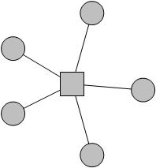

In star network, one station initiates the communication call to multiple stations. As for collisions may occur when multiple stations making response at the same time, the time division access mode can be applied to avoid collisions. In this mode, each network member uses the allocated time slot and address, which are informed to all network members in advance. When the calling station initiates a call to all, each station will respond in its own slot in the order of certain sequence. Then a collision free network is built.

(2) Self-organizing network

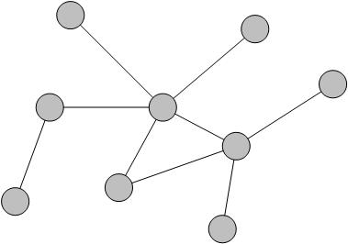

In self-organizing network, all nodes have equal status. Each node has the ability of sending, receiving and forwarding messages, which means each node operates as a terminal and a router. All nodes are randomly distributed in the communication area and free to move.

It is worth pointing out that, in general wireless self-organizing network, the change of topology structure is mainly caused by nodes mobility. While in the HF network, the change of topology structure is caused by the change of channel characteristics.

Generally, the above mentioned completely self-organizing mode is rarely applied in practical experience of network building. The main reasons are as following:

1) It is difficult to ensure the reliable connection between nodes, making the self-organizing network difficult to be established and operated.

2) Due to low transmission rate of HF channel and large differences of transmission rate among all nodes, the link maintenance will cost a relatively large bandwidth and time, as a result, the proportion of the bandwidth used for efficiently transmitting data will be relatively small. Therefore, the efficiency of the self-organizing networks is low.

3) The mobility of nodes and time-variant property of HF channel result in the network topology structure are always changing, thus users might suffer from long time off the network, which means the self-organizing network will be partially paralyzed.

Based on above reasons, the HF self-organizing network is suitable for application scenarios which are small coverage range and mainly through ground wave propagation. In such scenario, the mobility of nodes and the time variation of HF channels can be ignored. The links between nodes are reliable, it could support higher transmission rate.

To build an HF communication network in wide area, hierarchical self-organizing network is a better solution.

(3) Hierarchical self-organizing network

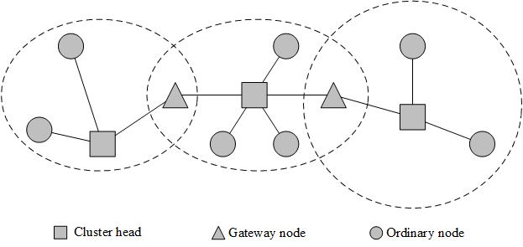

Differed from the whole equivalent self-organizing network, in a hierarchical self-organizing network, the nodes are divided into several sub groups, and these sub groups are cross linked and overlapped. The nodes are classified into cluster head, gateway node and ordinary node. The cluster head takes control of the whole sub groups; the gate way is responsible for providing links between neighbored sub groups to exchange information; the ordinary node is ordinary HF subscriber.

In hierarchical self-organizing network, any node can act as mentioned three types, and it could dynamically convert its identity during networking process. The hierarchical self-organizing network is suitable for application scenarios which are wide coverage range and contains large numbers of nodes. With the dynamic change of network topology structure, the topology of each node needs to be updated constantly, making the network adjust its topology structure in time to guarantee the continuity of communication. During practical HF networking process, in order to improve the efficiency and ensure a reliable connection, the cluster heads are often linked by cable, fiber, etc. The function of gateway node is integrated into the cluster head, which mainly refers to complete the conversion between wireless network protocol and cable network protocol. Generally, the cluster heads are fixed stations with large transmitting power, to ensure the effective coverage within the sub group area. The wide area property of HF communication leads to multiple coverage between sub groups, so that users can select the optimized access node among sub groups.

## 4.4 Monitoring

### 4.4.1 Overview

In general, the monitoring of HF communication system is all life-time monitoring (Fig.4-1), including all the function modules, e.g., antenna/ antenna array, transmitter, receiver, channel status, signal analysis, etc.

Figure 4-1

All life-time monitoring of HF communication system

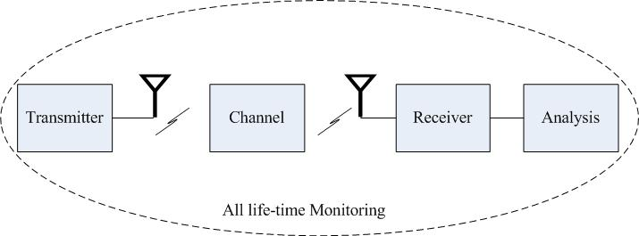

### 4.4.2 The classification of monitoring

Based on different characteristics, the monitoring of HF communication system can be classified into various categories. According to geographic location of HF communication system, the monitoring of HF communication system can be classified into local monitoring, remote monitoring, and hybrid monitoring (both local and remote).

– Local monitoring indicates that the distance of operation center and antenna/ antenna array is within a short distance range. The operators work at local monitoring station.

– Remote monitoring indicates that the distance of operation center and antenna/ antenna array is within a long distance range. The operators work at monitoring station that is far from the antenna/ antenna array. The monitoring data are transmitted to the operation center by wired or wireless communication link.

– Hybrid monitoring includes both local monitoring and remote monitoring.

According to monitoring content, the monitoring of HF communication system can be classified into interference monitoring, quality of service monitoring, reliability monitoring, etc.

– Interference monitoring concentrates on the interference issues among HF adaptive system and other systems.

– Quality of service monitoring refers to the monitoring of transmission quality of channels, so as to choose the optimal frequency for HF adaptive system.

– Reliability monitoring refers to the monitoring of link reliability for HF adaptive system.

According to time efficiency, the monitoring of HF communication system includes online monitoring, and offline monitoring.

– Online monitoring focuses on the real-time monitoring of communication status of HF adaptive system.

– Offline monitoring indicates that the monitoring is realized through offline analysis and processing.

### 4.4.3 Self-optimization of monitoring

In HF communication system, monitoring network needs to learn from historical experience and optimize the system performance. Based on the statistical analysis results of the monitoring performance, the monitoring strategy of HF communication systems can be adjusted and optimized, so as to achieve the optimal communication performance with the highest quality of service (Fig.4-2). Through self-optimization of monitoring, the HF communication system can improve the system performance timely and efficiently.

Figure 4-2

Self-optimization process of monitoring of HF communication system

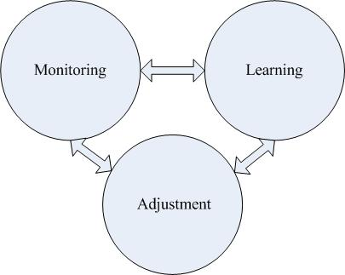

### 4.4.4 Evaluation of monitoring

To deploy a high-efficient HF adaptive system, it is necessary to evaluate the operation performance of the whole system by monitoring. The evaluation of monitoring for HF adaptive system mainly concentrates on the communication status of the whole HF adaptive system. Generally, the evaluation of monitoring of HF adaptive system includes four factors: the stability of HF adaptive system, the efficiency of HF adaptive system, the reliability of HF adaptive system, and the scalability of HF adaptive system.– The stability of HF adaptive system refers to the normal operation of the whole system. In response to the transmission demands of the various HF services, the system can operate in a stable circumstance. HF adaptive system needs to make sure that the link preparation, channel quality assessment, link establishment, information transmission of specific services, and disconnection can be run continuously and stably. And in case of communication failure, the HF adaptive system needs to be checked and maintained timely.

– The efficiency of HF adaptive system refers to the transmission experience of the HF adaptive system. Different HF services have different transmission needs, including the quality of transmission channel, the time-delay, bandwidth, data rate, etc. In order to provide better experience for the users of HF services, it is necessary for the HF adaptive system to evaluate the transmission efficiency of HF frequency band. So, the quality of service and efficiency should be taken into consideration for evaluation of monitoring the HF adaptive system. The system can set different score for the transmission quality of various HF services, and provides optimal experience for the users.

– The reliability of HF adaptive system focuses on the anti-interference ability of HF adaptive system. Considering that the HF transmission channel is time-varying, it is essential for the HF adaptive system to control the deterioration of system performance within an acceptable and tolerable range. If the packet loss is serious, the reliability of the HF adaptive system cannot be guaranteed. The evaluation of monitoring needs to consider the system reliability of whole system, especially the evaluation of monitoring of link reliability for HF adaptive system.

– The scalability of HF adaptive system considers the development of HF adaptive system, including the hardware and software scalability of the whole system. With the development and evolving of HF communication technology, the HF adaptive system needs to be continuously improved and upgraded. The evaluation of monitoring of HF adaptive system has a demand on the scalability of the whole system.

The evaluation of monitoring of HF adaptive system is to achieve better transmission experience for HF services. Through appropriate and rational evaluation, the operation status of the HF adaptive system can provide more stable and high-efficient communication quality for various HF services.