Radiocommunication Advisory Group  Geneva, 15-17 April 2019 |  | 
 | Document RAG19/TEMP/2-E
 | 16 April 2019
 | English only
Chairman, RAG
twentY-sixTH meeting of the
radiocommunication advisory group

DRAFT
SUMMARY OF CONCLUSIONS

ANNEX 1

Draft ITU-R 4-year Rolling Operational Plan
(source: Doc. RAG19/1 (Add.2))

Radiocommunication Advisory Group
Geneva, 15-17 April 2019
Revision 1 to
Addendum 2 to
Document RAG19/1-E
27 March 2019
Original: English
Director, Radiocommunication Bureau
REPORT TO THE TWENTY-SIXTH MEETING OF THE RADIOCOMMUNICATION ADVISORY GROUP

1 Introduction
The four-year rolling Operational Plan for the ITU-R, has been prepared in full alignment with the ITU Strategic Plan for 2020-2023, within the limits of the Financial Plan for 2020-2023 and the biennial budget 2020-2021. The structure follows the ITU results framework, outlining the Sector objectives, the corresponding outcomes and the indicators to measure their progress, as well as the outputs (products and services) produced by the activities of the Sector as well as the enablers by the Bureau.

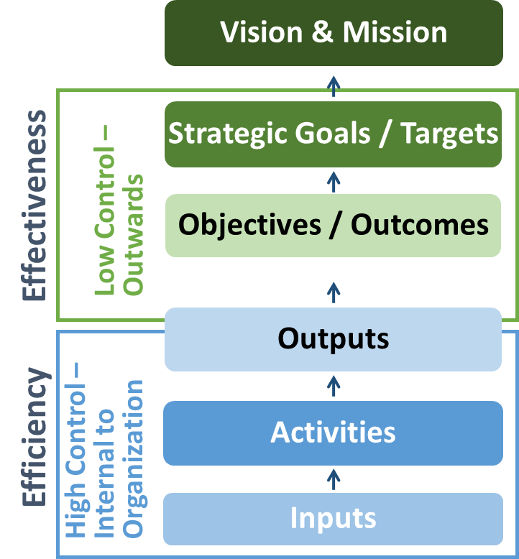 | 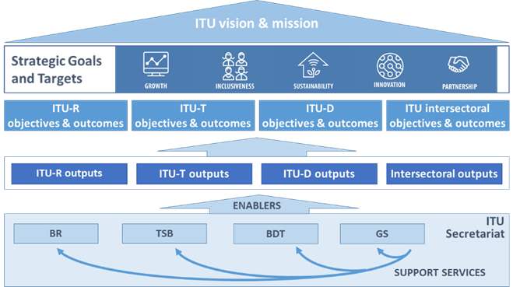

2 Key priorities

The ITU-R Sector

Outline and key priorities for the ITU-R Sector
The period 2020-2023 will be marked by the completion of the implementation of the decisions of RA-19 and WRC-19, the preparation of RA-23 and WRC-23 as well as the implementation of their decisions and the development of key standards and best practices in radiocommunications. The key issues are listed below, against the four operational activities of the ITU-R Sector and the supporting activities of the Radiocommunication Bureau:

2.1 To establish and update international regulations on the use of the radio-frequency spectrum and satellite orbits
- The implementation of the decisions of WRC-19,
- The adoption by the RRB of the associated Rules of Procedure.

2.2 To implement and apply international regulations on the use of the radio-frequency spectrum and satellite orbits
- The development and delivery to the membership of the software tools relating to the application of the Radio Regulations and associated Rules of Procedure,
- The proper and timely application of the provisions of the Radio Regulations and applicable Regional Agreements for terrestrial and space services, with the update of the Master International Frequency Register (MIFR) and assignment and/or allotment Plans and Lists,
- The monitoring of harmful interference cases and more generally of disputes in sharing spectrum/orbit resources and the resolution of these cases,
- The associated publications (BR IFIC, Maritime service publications, list of international monitoring stations).

2.3 To establish and update worldwide Recommendations, Reports and Handbooks for the most efficient use of the radio-frequency spectrum and satellite orbits
- The preparation of RA-23 and WRC-23 in ITU-R Study Groups and in close collaboration with the regional groups, including the development of draft technical, regulatory, and procedural texts in support of the CPM23-2,
- The development of key Recommendations, Reports and Handbooks, in particular on the radio interface of IMT-2020, in close cooperation with ITU-T, regional organizations and other standard-making bodies.

2.4 To inform and assist the ITU-R membership in radiocommunication matters
- The publication and promotion of the ITU-R products (such as Radio Regulations, Recommendations, Reports, and Handbooks).
- In close cooperation with the other Sectors, the ITU regional offices, the relevant regional organizations, and the membership,
  - The dissemination and sharing of information, including Worldwide and Regional Radiocommunication seminars, conferences, workshops and other events.
  - The assistance to the membership in facing the challenges raised by the development of their radiocommunication services, in particular in relation to the transition to digital television broadcasting and the use of the digital dividend.

2.5 Supporting activities of the Radiocommunication Bureau
- The continuing development, improvement, and maintenance of the BR software tools, with a view to maintaining a high level of efficiency, reliability, user-friendliness, and satisfaction of the membership.
- The logistical and administrative support to ITU-R Study groups and the participation in the related activities of the regional groups.
- The assistance to membership, in close collaboration with the other Bureaux, the ITU regional offices, and the regional organizations.

3 Objectives, outcomes and outputs

3.1 Allocation of resources to ITU-R objectives and outputs for 2020-2021

 |  | Planned allocation of resources per Output  R.1-1 Final acts of world radiocommunication conferences, updated Radio Regulations  R.1-2 Final acts of regional radiocommunication conferences, regional agreements  R.1-3 Rules of Procedure adopted by Radio Regulations Board (RRB)  R.1-4 Publication of space notices and other related activities  R.1-5 Publication of terrestrial notices and other related activities  R.2-1 Decisions of Radiocommunication Assembly, ITU-R resolutions  R.2-2 ITU-R recommendations, reports (including the CPM report) and handbooks  R.2-3 Advice from the Radiocommunication Advisory Group  R.3-1 ITU-R publications  R.3-2 Assistance to members, in particular developing countries and LDCs  R.3-3 Liaison/support to development activities  R.3-4 Seminars, workshops and other events | % of total  3%  1%  4%  35%  17%  1%  10%  2%  11%  7%  2%  7% | % of objective  4%  2%  7%  59%  28%  9%  73%  18%  39%  26%  9%  26%
R.1 Spectrum/orbit regulation and management  R.2 Radiocommunication standards  R.3 Knowledge sharing | 60%  13%  27%
* Cost of these Outputs is allocated to all the Objectives of the Union.

4 Risk analysis
Moving from strategy to implementation, the following top-level operational risks presented in the Table below have been identified, analysed and evaluated. The Bureaux and each Department will manage all the risks associated with the achievement of the corresponding outcomes.
RISK FOCUS | DESCRIPTION OF RISK | PROBABILITY | IMPACT LEVEL | MITIGATION ACTIONS
OPERATIONAL  RISK | - Total or partial loss of integrity of data in the MIFR or in any of the Plans, resulting in inadequate protection of the rights of administrations to use spectrum/orbit resources  - Total or partial loss of operations in the processing of notices, resulting in delays in the recognition of rights of administrations to use spectrum/orbit resources and risks for the corresponding investments. | Low | Very High | - Daily backup of data  - Development of high data security program  - Ability to restore data/operation within a limited time period
 | - Occurrence of harmful interference (e.g. due to lack of observance of the regulatory provisions), resulting in disruptions in the radiocommunication services provided by the membership. | Low | High | - Promote capacity building on international regulations, through worldwide and regional seminars, and any other appropriate events  - Provide BR assistance in applying the international regulations  - Promote regional or sub-regional coordination to resolve interference problems, with BR support  - Report, inform and assist in resolving cases of harmful interference in accordance with the instructions to the Director of the Bureau in Resolution 186 (Rev. Dubai 2018)
ORGANIZATIONAL  RISK | Inadequate facilities for meetings in ITU (e.g. due to lack of meeting rooms and overcrowded meetings schedule), resulting in membership dissatisfaction and delays in work programmes. | Medium | High | - Hold more meetings externally  - Increase the use of virtual meeting rooms for small meetings

5 Objectives, outcomes and outputs for 2020-2023
The objectives will be met by achieving the related outcomes, through the implementation of the outputs. Sector and inter-sectoral objectives, in the context of the remit of each Sector and the GS, contribute to the overarching goals of the Union.

5.1 ITU-R
R.1 Meet, in a rational, equitable, efficient, economical, and timely way, the ITU membership's requirements for radio-frequency spectrum and satellite-orbit resources, while avoiding harmful interference.

Outcome | Outcome Indicator | 2015 | 2016 | 2017 | 2018 | 2023 target | Source
R.1-1: Increased number of countries having satellite networks and earth stations recorded in the Master International Frequency Register (MIFR) | Number of countries having satellite networks recorded in the MIFR | 52 | 56 | 63 | 69 | 70 | BR/MIFR
 | Number of countries having earth stations recorded in the MIFR | 76 | 77 | 78 | 81 | 120
R.1-2: Increased number of countries having terrestrial frequency assignments recorded in the MIFR | Number of countries having terrestrial frequency assignments recorded in the MIFR | 190 | 190 | 190 | 192 | 193 | BR/MIFR
 | Number of countries which registered terrestrial assignments in the MIFR within the last 4-year period | 84 | 79 | 81 | 81 | 90
R.1-3: Increased percentage of assignments recorded in the MIFR with favourable finding | Subject to Coordination (Terrestrial) | 99.87% | 99.88% | 99.86% | 99.87% | 99.99% | BR/MIFR
 | Subject to a Plan (Terrestrial) | 74.46% | 74.32% | 74.40% | 74.46% | 75%
 | Others | 98.37% | 98.46% | 98.46% | 98.49% | 98.49%
R.1-4: Increased percentage of countries which have completed the transition to digital terrestrial television broadcasting | Percentage of countries which have completed the transition to digital terrestrial television | 27% | 28% | 30% | 30% | 70% | BR & BDT

Outcome | Outcome Indicator | 2015 | 2016 | 2017 | 2018 | 2023 target | Source
R.1-5: Increased percentage of spectrum assigned to satellite networks which is free from harmful interference | % of spectrum assigned to satellite networks which is free from harmful interference | 99.96% | 99.96% | 99.96% | 99.94% | 99.99% | BR/MIFR
R.1-6: Increased percentage of assignments to terrestrial services recorded in the MIFR which are free from harmful interference | Percentage of assignments to terrestrial services recorded in the Master Register which are free from harmful interference (based on the number of cases reported to the ITU) | 99.99% | 99.99% | 99.99% | 99.99% | 99.99% | BR/MIFR

Output | Financial resources (in k CHF)
 | 2020 | 2021 | 2022 | 2023
R.1-1 Final acts of world radiocommunication conferences, updated Radio Regulations | 1,622 | 1,685 | 1,958 | 8,934
R.1-2 Final acts of regional radiocommunication conferences, regional agreements | 644 | 637 | 258 | 344
R.1-3 Rules of Procedure adopted by Radio Regulations Board (RRB) | 2,387 | 2,055 | 2,311 | 2,322
R.1-4 Publication of space notices and other related activities | 21,608 | 21,280 | 16,933 | 16,933
R.1-5 Publication of terrestrial notices and other related activities | 10,321 | 10,138 | 8,412 | 8,083
Cost allocation to Plenipotentiary Conference and Council activities (PP, Council/CWGs)
Total for Objective R.1

R.2 Provide for worldwide connectivity and interoperability, improved performance, quality, affordability, and timeliness of service and overall system economy in radiocommunications, including through the development of international standards
Outcome | Outcome Indicator | 2014 | 2015 | 2016 | 2017 | 2018 | 2023 target | Source
R.2-1: Increased mobile-broadband access, including in frequency bands identified for international mobile telecommunications (IMT) | Number of subscriptions (bn) | 7.01 | 7.22 | 7.51 | 7.81 | 8.16 | 9.2 | ITU BDT ICT Statistics
 | % of mobile broadband subscriptions | 38% | 45% | 51%* | 55%* | 65%
 | Number of subscribers (bn) | 4.83 | 4.98 | 5.18 | 5.63 | 6.34 | 6.34
R.2-2: Reduced mobile-broadband price basket, as a percentage of gross national income (GNI) per capita | Mobile broadband price basket as percentage of GNI per capita (prepaid, handset 500 MB)  World | 5.50 | 3.88 | 3.61 | 3.6 | 3.6 | 4 | ITU BDT ICT Statistics
 | Developed Countries | 0.75 | 0.57 | 0.65 | 0.6 | 0.6
 | Developing Countries | 7.2 | 5.1 | 4.6 | 4.8 | 4.8
 | Least Developed Countries | 17.0 | 11.4 | 9.21 | 10.4 | 10.4
 | Number of countries with a price basket below 5% | 117 | 135 | 150 | 145 | 145 | 193
R.2-4: Increased number of households with digital terrestrial television reception | Number of households with DTT (millions) | 203.3 | 235.5 | 271.9 | 311 | 335 | 453 | Digital TV World Databook report, July 2017; Digital TV Research Ltd  Databook report
 | Number of households with ATT (millions) | 319.8 | 251.6 | 184.1 | 136 | 104
 | Total number of households DTT + ATT (millions) | 514.1 | 487.1 | 456 | 447 | 439
 | % of households with DTT | 10.3% | 11.8% | 13.5% | 14.90% | 15.80% | 22.70%
 | % of households with ATT | 16.3% | 12.6% | 9.1% | 6.50% | 4.90%
 | % of households with Terrestrial TV | 26.6% | 24.5% | 22.6% | 21.40% | 20.80%
R.2-5: Increased number of satellite transponders (equivalent 36 MHz) in operation and corresponding capacity (Tbit/s); Number of VSAT terminals; Number of households with satellite television reception | Number of satellite transponders (equivalent 36 MHz) in operation | 15997 | 17953 | 19772 | 25056 | 30742 |  | Euroconsult  (http://www.euroconsult-ec.com)
 | Corresponding capacity (in Tbit/s) | 1.095 | 1.269 | 1.491 | 1.978 | 2.581 |  | Euroconsult  (http://www.euroconsult-ec.com)
 | Number of VSATs (millions) | 3.786 | 3.891 | 3.838 | 3.972 | 4.082 | 4.35 | Global VSAT Forum  (https://gvf.org)
 | Number of DTH (millions) | 359.2 | 407.9 | 411.1 | 416 | 424 | 439 | Digital TV World Databook report, July 2017; Digital TV Research Ltd
R.2-6: Increased number of devices with radionavigation-satellite reception | Number of operational GNNS constellations/satellites | 2/48 | 4/75 | 5/90 |  | 6/137 | 6/144 | BR/MIFR
 | Number of devices with GNSS embedded Rx (billions) | 3.6 | 4.2 | 5.0 | 5.8* | 6.5* |  | European GNSS Agency:  GNNS Report  (https://www.gsa.europa.eu)
R.2-7: Increased number of Earth exploration satellites in operation, corresponding quantity and resolution of transmitted images and data volume downloaded (Tbytes) | Number of ERS satellites | 180 | 215 | 219 |  | 265 | 440 | BR/MIFR
 | Quantity of transmitted images (million) | 62 | 68 | 71 |  |  |  | To be obtained from UN OOSA, UN Special Working Group
 | Size of downloaded images (Terabytes) | 27,000 | 35,000 | 37,000 |  |  |  | To be obtained from UN OOSA, UN Special Working Group

Output | Financial resources (in k CHF)
 | 2020 | 2021 | 2022 | 2023
R.2-1 Decisions of the Radiocommunication Assembly, ITU-R resolutions | 711 | 703 | 8,670 | 9,019
R.2-2 ITU-R recommendations, reports (including the CPM report) and handbooks | 5,929 | 6,109 | 5,635 | 6,063
R.2-3 Advice from the Radiocommunication Advisory Group | 1,430 | 1,521 | 1,367 | 1,340
Cost allocation to Plenipotentiary Conference and Council activities (PP, Council/CWGs)
Total for Objective R.2

R.3 Foster the acquisition and sharing of knowledge and know-how on radiocommunications
Outcome | Outcome Indicator | 2015 | 2016 | 2017 | 2018 | 2023 target | Source
R.3-1: Increased knowledge and know-how on the Radio Regulations, Rules of Procedures, regional agreements, recommendations and best practices on spectrum use | Number of ITU-R free online publication downloads (millions) | 0.9 | 1.0 | 1.7 | 1.57 | 4 | ITU-R Events Registration Database
 | Number of capacity-building events organized/supported by BR (presence & virtual) | 25 | 38 | 37 | 34 | 29
 | Number of participants on capacity building events organized/supported by ITU/BR ( cumulated during the period between two WRCs) | 1,518 | 737 | 1,363 | 669 | 2,000
R.3-2: Increased participation in ITU-R activities (including through remote participation), in particular by developing countries | Number of technical assistances/events with BR participation | 93 | 100 | 111 | 110 | 100 | ITU-R Mission Plan
 | Number of countries receiving BR technical assistance/events | 78 | 61 | 62 | 74 | 80 | ITU-R Mission Plan
 | Number of participants/events in ITU-R conferences, assemblies and Study Group-related meetings (presence & virtual) | 8972/38 | 6042/48 | 7061/52 | 4560/47 | 4560/47 | ITU-R Events Registration Database
 | Number of countries participating in ITU-R seminars and workshops, SG and WP meetings and events (presence & virtual) | 161 | 130 | 78 | 137 | 193 | ITU-R Events Registration Database

Output | Financial resources (in k CHF)
 | 2020 | 2021 | 2022 | 2023
R.3-1 ITU-R publications | 6,611 | 6,495 | 7,237 | 5,938
R.3-2 Assistance to members, in particular developing countries and LDCs | 4,312 | 4,321 | 2,871 | 2,644
R.3-3 Liaison/support to development activities | 1,521 | 1,456 | 1,637 | 1,674
R.3-4 Seminars, workshops and other events | 4,355 | 4,625 | 3,862 | 3,677
Cost allocation to Plenipotentiary Conference and Council activities (PP, Council/CWGs)
Total for Objective R.3

_____________

² Risk owners will be appointed by the Director of the Bureau.
Estimates for 2022-2023. Allocation of resources for the subsequent years is subject to change upon Senior Management decisions.
“n/a” specifies that indicator values are not yet available. * Estimates.
Estimates for 2022-2023. Allocation of resources for the subsequent years is subject to change upon Senior Management decisions.. * Estimates.
This number is appropriate for comparison purposes only, as the download of a single document/publication might count as several downloads.
Estimates for 2022-2023. Allocation of resources for the subsequent years is subject to change upon Senior Management decisions.

