Radiocommunication Assembly (RA-19)  Sharm el-Sheikh, 21-25 October 2019 | 
PLENARY MEETING | Revision 1 to  Document RA19/PLEN/28-E
 | 20 October 2019
 | Original: English
CEPT – European Conference of Postal and
Telecommunications Administrations
European common PROPOSALS FOR THE WORK OF THE ASSEMBLY
This contribution presents the European common proposals for RA-19. These have been developed by the European Conference of Postal and Telecommunications Administrations (CEPT) Conference Preparatory Group (CPG).
The European Administrations welcome the opportunity offered by RA-19 for in-depth discussions with the ITU membership on the issues relevant to the work of the Assembly. To this effect, coordinators have been designated for each proposal to act as point of contact with the other administrations to contribute to the efforts of the Assembly in arriving at decisions that can be supported by all ITU-R countries.
Annex 1 to this contribution provides the list of European coordinators for each proposal to the RA-19.
The detailed proposals are provided in four addenda to this contribution. The table of contents for these addenda is provided in Annex 2.
The table of co-signatures by European Administrations is provided in Annex 3.
Annexes: 3
ANNEX 1
List of CEPT coordinators for RA-19
Overall coordination:
Mr Alexander Kühn (D)  CPG chairman  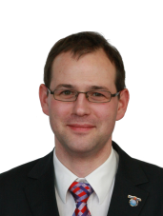  alexander.kuehn@bnetza.de | Mr Gerlof Osinga (HOL)  CPG vice-chairman  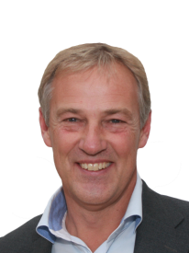  gerlof.osinga@agentschaptelecom.nl | Mr Alexandre Kholod (SUI)  CPG vice-chairman  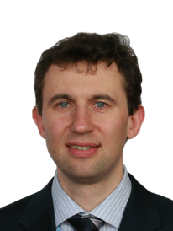  alaxandre.kholod@bakom.admin.ch
Proposal on draft revision of Resolution ITU-R 2-7
Mr Alexander Kühn (D)
alexander.kuehn@bnetza.de
Proposals on draft new Resolution on RSTT  Mr Karsten Buckwitz (D)  karsten.buckwitz@bnetza.de |  |  | 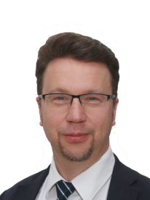
Proposal on draft new Resolution on ITS  Mr Tobias Vieracker (D)  tvieracker@apple.com |  |  | 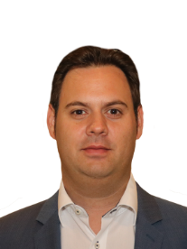
Proposal on draft revision of Resolution ITU-R 1-7  Mr Aljo von Dijken (HOL)  aljo.vdijken@agentschaptelecom.nl |  |  | 
ANNEX 2
Structure of the European common proposals for the
Radiocommunication Assembly
Document | Title
Main document | European common proposals for the work of the Assembly
Addendum 1 | Proposal on draft revision of Resolution ITU-R 2-7
Addendum 2 | Proposal on a new Resolution on RSTT
Addendum 3 | Proposal on a new Resolution on ITS
Addendum 4 | Proposal on draft revision of Resolution ITU-R 1-7

Annex 3
List of co-signatures of the European Common Proposals (ECPs) to RA-19

Addendum No. | 1 | 2 | 3 | 4
Item | 2-7 | RSTT | ITS | 1-7
ALB
AND
AUT | 1 | 1 | 1 | 1
AZE | 1 | 1 | 1
BEL
BIH
BLR
BUL
CVA | 1 | 1 | 1 | 1
CYP | 1 | 1 | 1 | 1
CZE
D | 1 | 1 | 1 | 1
DNK | 1 | 1 | 1 | 1
E | 1 | 1 | 1 | 1
EST | 1 | 1 | 1 | 1
F | 1 | 1 | 1 | 1
FIN
G | 1 | 1 | 1 | 1
GEO
GRC | 1 | 1 | 1 | 1
HNG | 1 | 1 | 1 | 1
HOL | 1 | 1 | 1 | 1
HRV | 1 | 1 | 1 | 1
I
IRL
ISL
LIE | 1 | 1 | 1 | 1
LTU
LUX | 1 | 1 | 1 | 1
LVA
MCO | 1 |  |  | 1
MDA | 1 | 1 | 1 | 1
MLT | 1 | 1 | 1 | 1
MNE | 1 | 1 | 1 | 1
NMD
NOR | 1 | 1 | 1 | 1
POL | 1 | 1 | 1 | 1
POR
ROU | 1 | 1 | 1 | 1
RUS
S | 1 | 1 | 1
SMR
SRB | 1 | 1 | 1 | 1
SUI | 1 | 1 | 1 | 1
SVK
SVN | 1 | 1 | 1 | 1
TUR | 1 | 1 | 1 | 1
UKR | 1 | 1 | 1 | 1
SUM | 29 | 28 | 28 | 27
______________

Members of CEPT (Europe) are: Albania (Republic of), Germany (Federal Republic of), Andorra (Principality of), Austria, Azerbaijani Republic, Belarus (Republic of), Belgium, Bosnia and Herzegovina, Bulgaria (Republic of), Cyprus (Republic of), Vatican City State, Croatia (Republic of), Denmark, Spain, Estonia (Republic of), Russian Federation, Finland, France, Georgia, Greece, Hungary (Republic of), Ireland, Iceland, Italy, Latvia (Republic of), Liechtenstein (Principality of), Lithuania (Republic of), Luxembourg, Malta, Moldova (Republic of), Monaco (Principality of), Montenegro, Norway, North Macedonia (Republic of), Netherlands (Kingdom of the), Poland (Republic of), Portugal, Slovak Republic, Czech Republic, Romania, United Kingdom of Great Britain and Northern Ireland, San Marino (Republic of), Serbia (Republic of), Slovenia (Republic of), Sweden, Switzerland (Confederation of), Turkey, Ukraine.

