2nd ITU INTER-REGIONAL WORKSHOP  ON WRC-23 PREPARATION  29 November – 1 December 2022 |  | 
 | Document WRC-23-IRW-22/INFO/1-E
 | 21 November 2022
 | English only
INFORMATION FOR PARTICIPANTS
Page
1 General 2
2 Place of the Workshop and meeting rooms 2
3 Identification badges 2
4 Working hours 2
5 Meeting Rooms 2
6 Documentation 2
7 Remote participation 3
8 Webcast and Captioning 3
9 IT facilities and Internet access 3
10 Practical information 3

1 General
The 2nd ITU Inter-regional Workshop on WRC-23 Preparation will be held online from 29 November to 1 December 2022. The website of the workshop is at: www.itu.int/go/ITU-R/wrc-23-irwsp-22.

2 Place of the Workshop and meeting rooms
The Workshop will be held in Room Popov of the ITU Headquarters Geneva, with an overflow in Room A (see the Plan of the ITU buildings in Annex 2). Please consult the screens for the final room allocation.
Note: For visually impaired delegates, an “AudioSpot beacon” system is available across the ITU Headquarters (see Annex 3).

3 Identification badges
At the time of registration, participants will receive an identification badge, which must be worn at all times when on the ITU premises. The registration service for these meetings is located in the Montbrillant building. Please note that unannounced participants should ask the Designated Focal Point (DFP) of their entity to communicate with the ITU-R Delegate Registration Service to confirm their participation to the meeting.
ACCESS to ITU HQ
Access Point | ENTRANCE | EXIT
Tower | Mon to Fri: 0700-2000 | Granted 24/7
Varembé | NOT granted | Granted 24/7
Montbrillant | Granted 24/7 | Granted 24/7

4 Working hours
As indicated in Administrative Circular CA/262, the workshop will open at 0930 hours (Geneva time) on the first day. The sessions will start at 0900 hours on the other two days.
Please refer to the latest information in the detailed programme of the Workshop available at:
http://itu.int/go/ITU-R/wrc-23-irwsp-22/program

5 Meeting Rooms
In addition to the information provided in Section 2 above, other meeting rooms could be reserved if necessary and upon availability for informal discussions through the management service (Office V.247, Mrs. Frédérique Ethore, E-mail: room.management@itu.int (for emails, please use the option “Request a read receipt” to ensure the request has been seen), 0830 – 1230 hours and 1330 – 1730 hours from Monday to Friday).

6 Documentation
The Workshop will be conducted in a “paperless” environment, i.e. Workshop proceedings will be available on the Workshop website.

7 Remote participation
Remote participation facilities will be provided during the Workshop.
Participants are invited to follow the guidelines provided hereafter and get familiar with the procedures to be implemented for ensuring a smooth running of the Workshop.
The platform to be used is Zoom and access to the Workshop sessions is available via the Restricted Virtual Events portal. The links will be made available about 30 minutes before the start of each session.
Delegates attending the workshop physically are strongly invited to connect with Zoom to the workshop as well. In order to facilitate the role of the chairman/moderator and for a clear understanding on the order of the requests for the floor, delegates must raise their hand using Zoom and not the country plate available in the meeting room. In addition, even if the documents will be displayed in the screens available in the room, having access to the documents via Zoom will allow delegates to have a better readability of the document.

8 Webcast and Captioning
In addition to the remote participation facilities, the ITU-R Secretariat is pleased to inform you that an audio and video webcast of the Workshop sessions will be provided through the ITU Internet Broadcasting Service (IBS). The “Webcast” on the Workshop website gives access to the relevant video-audio feeds.
“Captioning” is also available on the Workshop website.

9 IT facilities and Internet access
On ITU premises access to the Internet will be available using the wireless LAN technologies listed below:
- Wired:
a) in Rooms H, K, L, M, Popov and cybercafé of ITU;
b) use this whenever available.
– Wireless:
ITU provides IEEE 802.11a, g and n wireless LAN coverage throughout its premises. Configuration parameters to use the wireless facilities of the ITU premises:
a) select the SSID ITUwifi (better performance, 5 GHz devices only), otherwise select the SSID ITUwifi-legacy (same key as ITUwifi);
b) when prompted for the access key, enter the key provided on-site.
See Annex 1 for information on connecting to the ITU’s wireless facilities and access to printers.

10 Practical information
For practical information for participants arriving in Geneva to attend an event held at the ITU Geneva premises, please see:
www.itu.int/en/ITU-R/information/events
Annex 1
ITU’s Wireless LAN connectivity
http://www.itu.int/en/ITU-R/information/events/Pages/ITUwirelessLAN.aspx

Annex 2
Plan of the ITU buildings
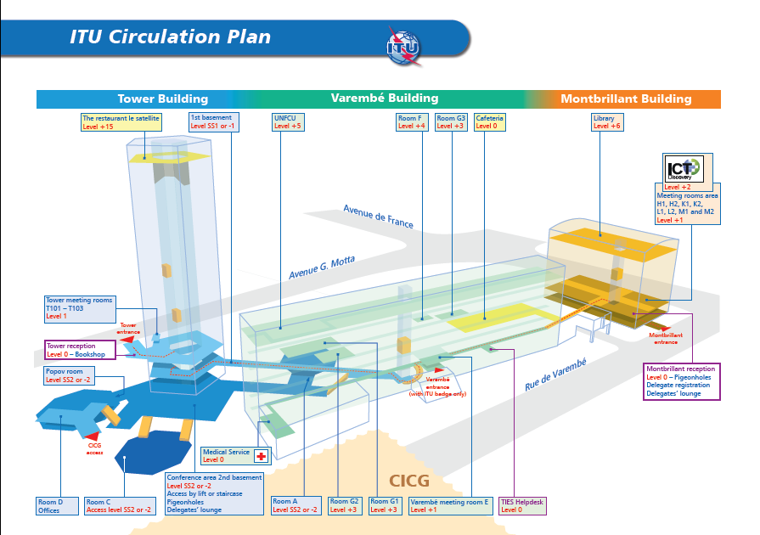

Annex 3
Geolocalisation




