|  |  |
| --- | --- |
| **Radio Regulations Board Geneva, 26 – 30 November 2018** |  |
|  |  |
|  |  |
|  | **Document RRB18-3/DELAYED/4-E** |
| **21 November 2018** |
| **Original: English** |
| Director, Radiocommunication Bureau | |

SUBMISSION BY THE ADMINISTRATION OF THE UNITED ARAB EMIRATES REGARDING THE BRINGING INTO USE OF THE YAHSAT-G6-17.5W SATELLITE NETWORK AND THE APPLICATION OF ARTICLE 48 OF THE ITU CONSTITUTION

The attached submission from the Administration of the United Arab Emirates, which complements the information contained in Document [RRB18-3/12](https://www.itu.int/md/R18-RRB18.3-C-0012/en), is for the consideration of the Radio Regulations Board.

Annex.

**Annex**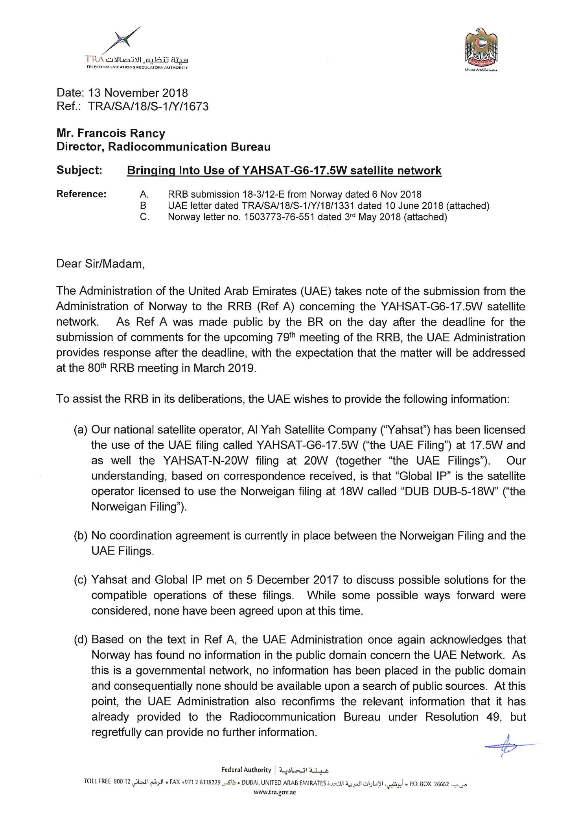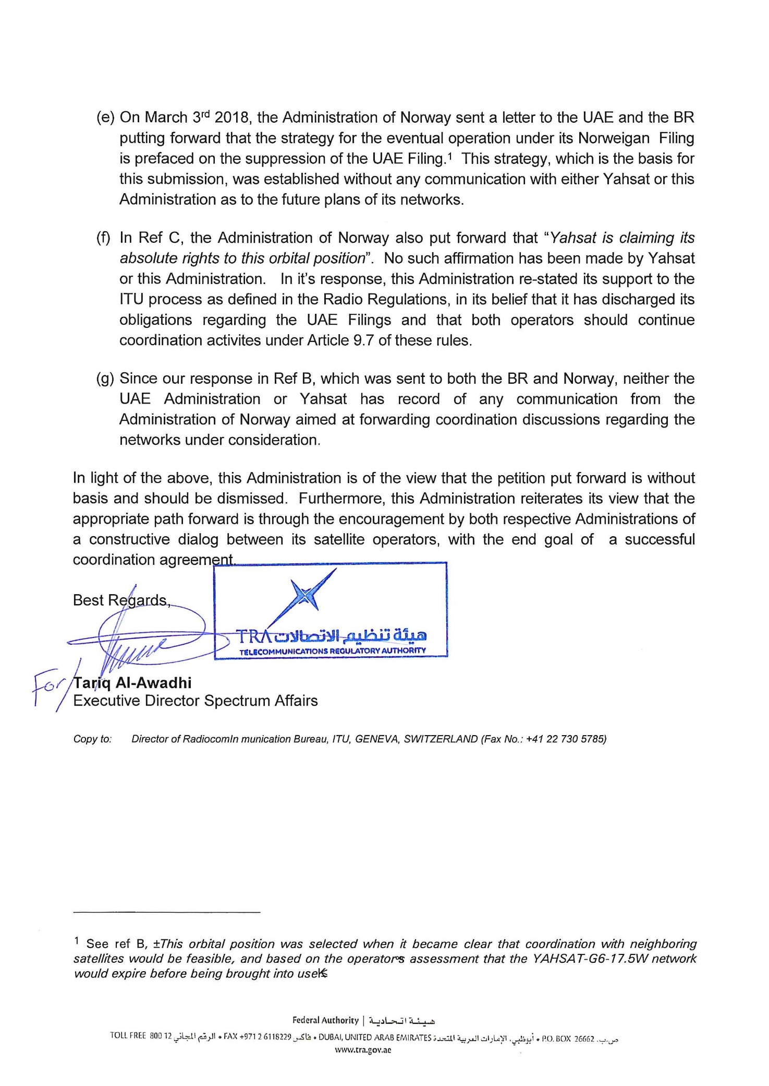

**[Ref A]**

**Document** [**RRB18-3/12**](https://www.itu.int/md/R18-RRB18.3-C-0012/en)

**[Ref. B]** 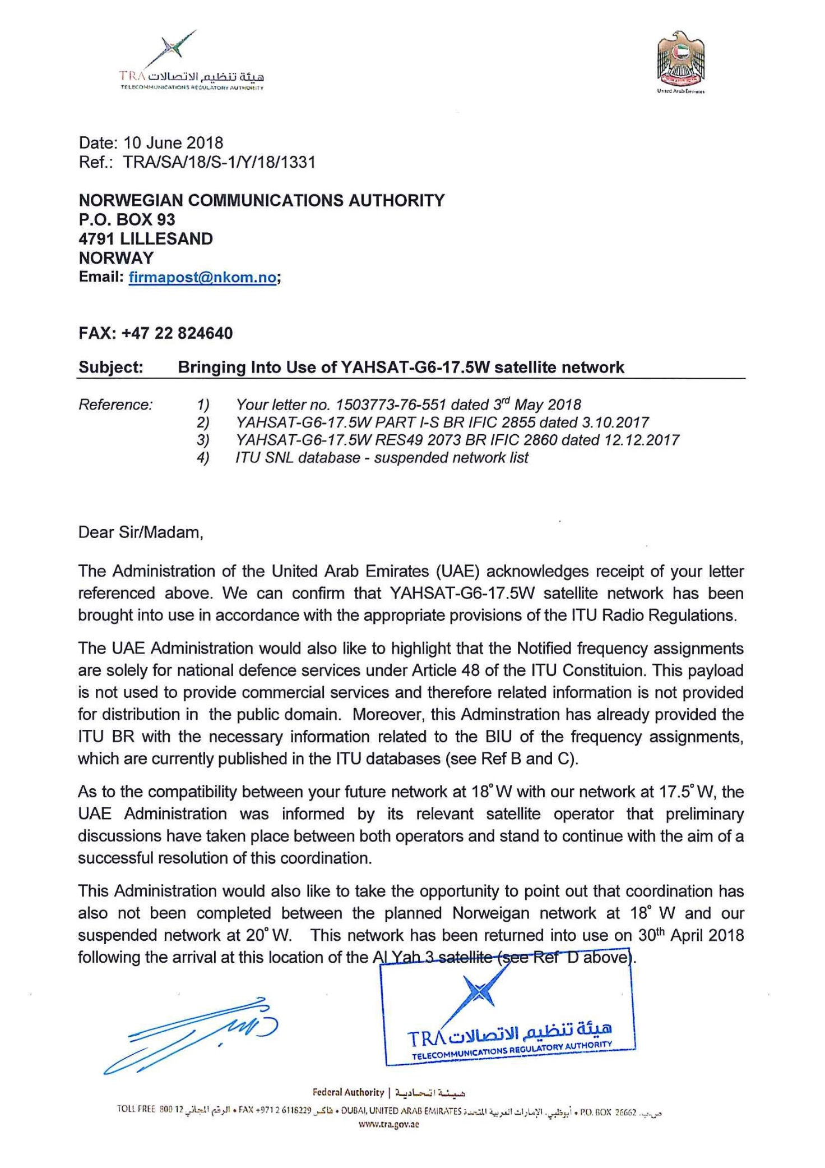

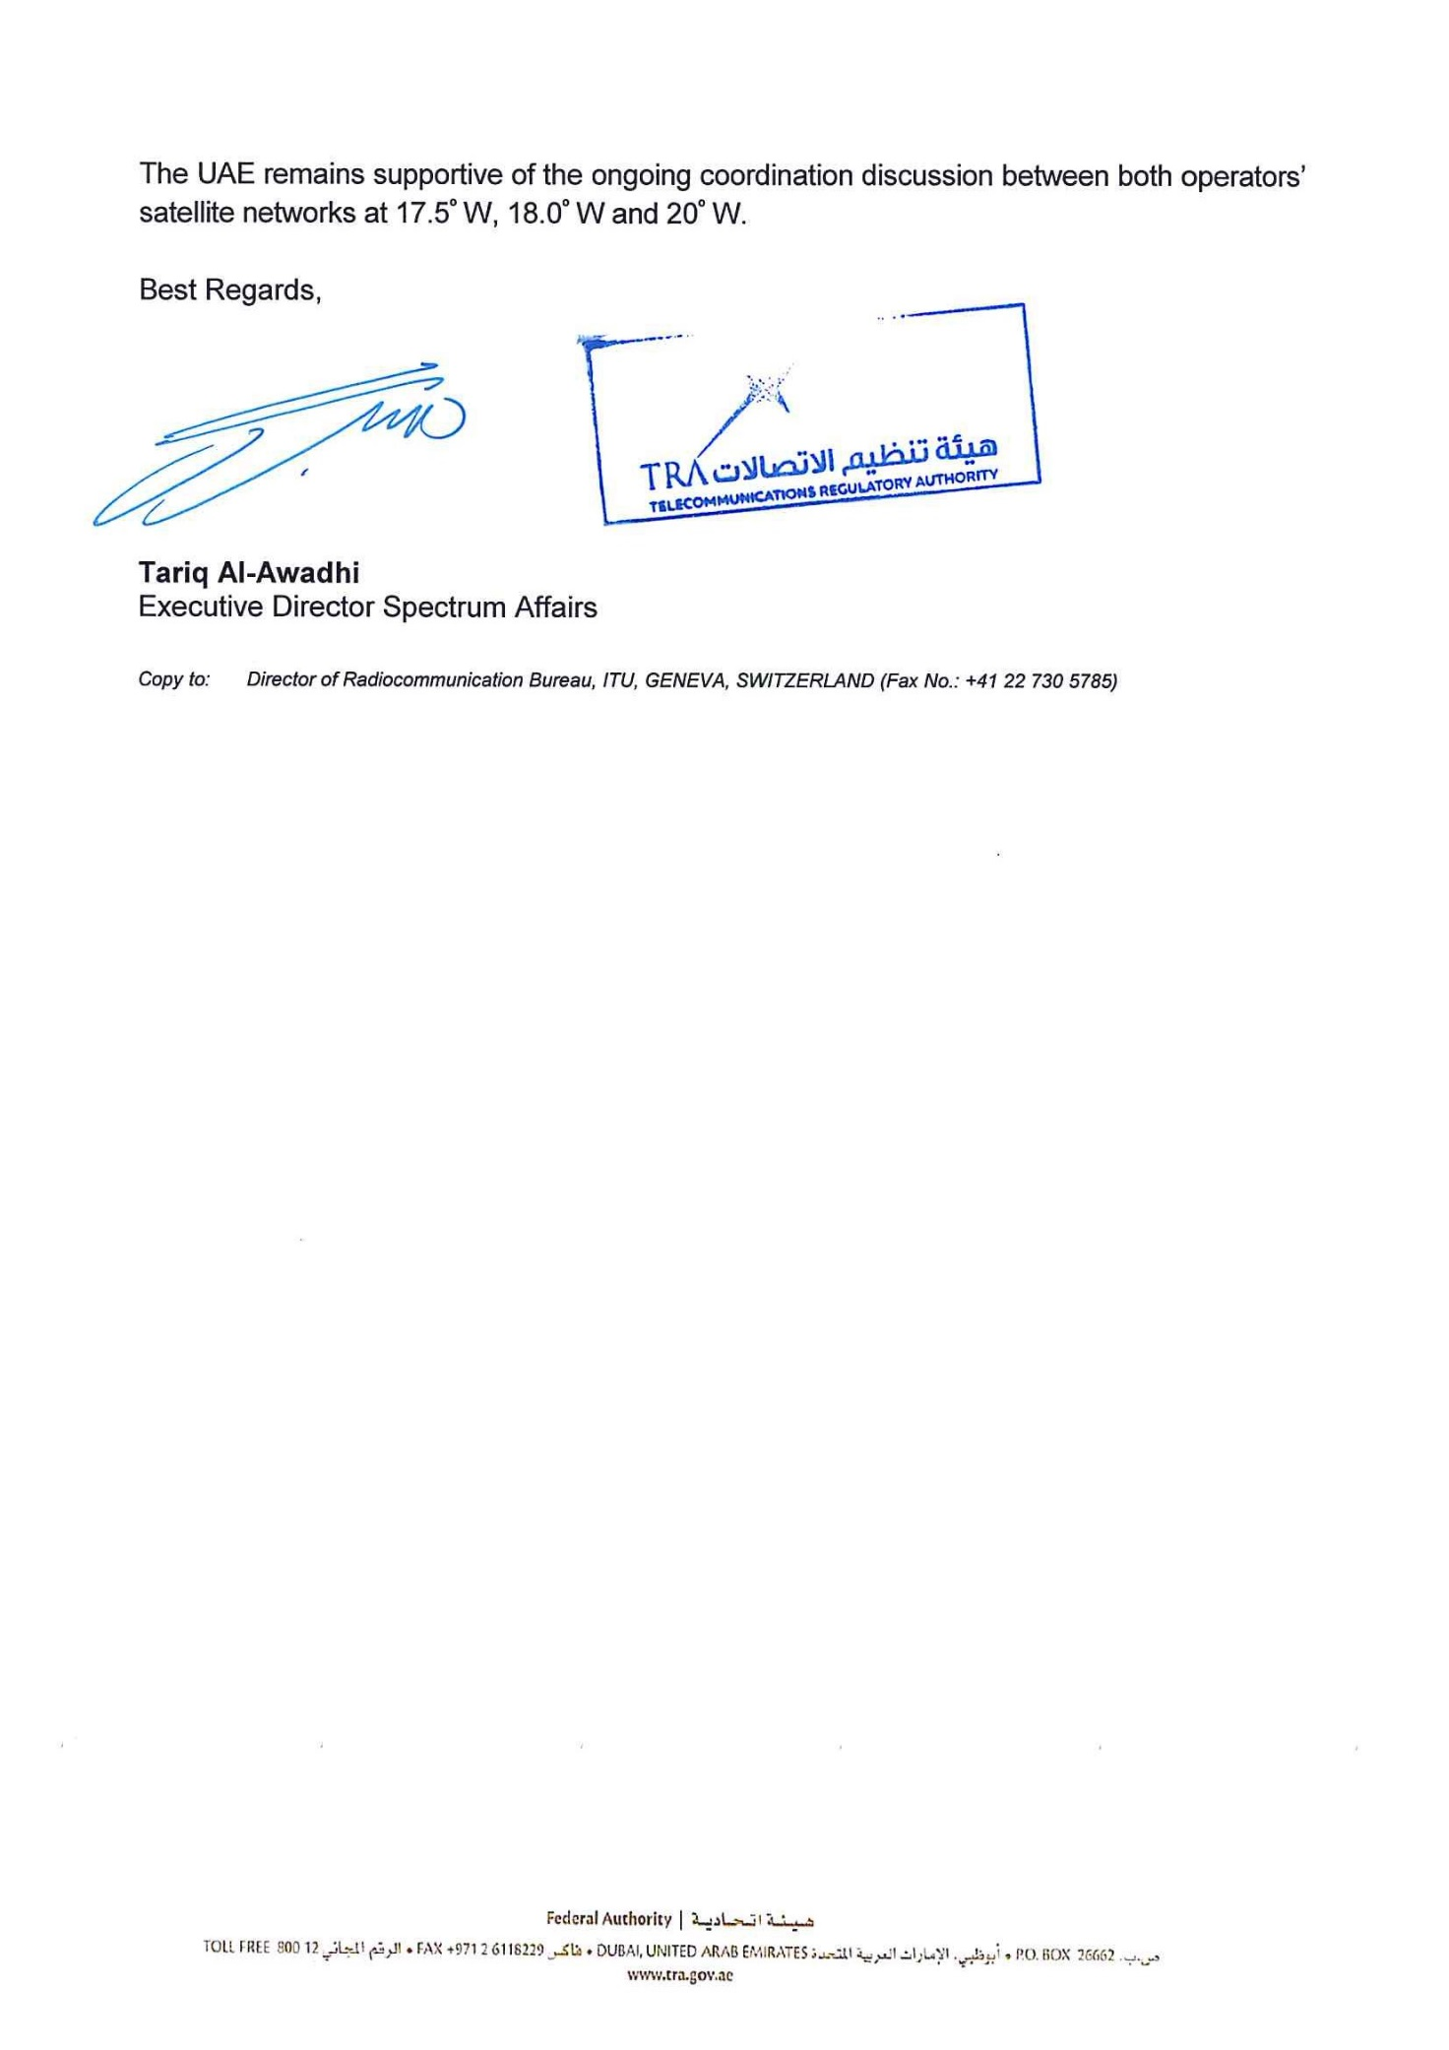

**[Ref. C]** 

