Radio Regulations Board  Geneva, 26 – 30 November 2018 | 
Corrigendum 1 to
Document RRB18-3/DELAYED/2-E
 | 27 November 2018
 | Original: English only
Director, Radiocommunication Bureau
FURTHER SUBMISSION BY THE ADMINISTRATION OF CHINA ON THE INVESTIGATION OF INTERFERENCE CASES AND EFFORTS IN ELIMINATION OF INTERFERENCE IN RESPONSE TO THE CONTRIBUTION RECEIVED FROM THE ADMINISTRATION OF THE UNITED KINGDOM OF GREAT BRITAIN AND
NORTHERN IRELAND REQUESTING CONSIDERATION
OF INTERFERENCE ISSUES AFFECTING UK
HF BROADCASTING STATIONS
Please replace page 8 of the original document with the annex contains in this corrigendum.

Annex.

Annex – English only

6 195 kHz
Report Time | Interference Report Details | Monitoring activities | Attachment
August 2017 | Ofcom reported that the broadcasting service of BBC World Service in Asia suffered regular harmful interference on 6 195 kHz on daily basis during 09:59-12:59 and 21:59-23:59 (UTC).  Direction-finding results indicated that the interference was from China. | Continuous monitoring detected broadcasting in English during 10:00-13:00 (UTC) on 6 195 kHz. Triangulation located a site outside China (E103°5′58″, N3°13′20″). | Triangulation of interference signals is shown in Figure 5.
During 1-10 August 2017, 12 monitoring engineers had worked a total of 240 hours.

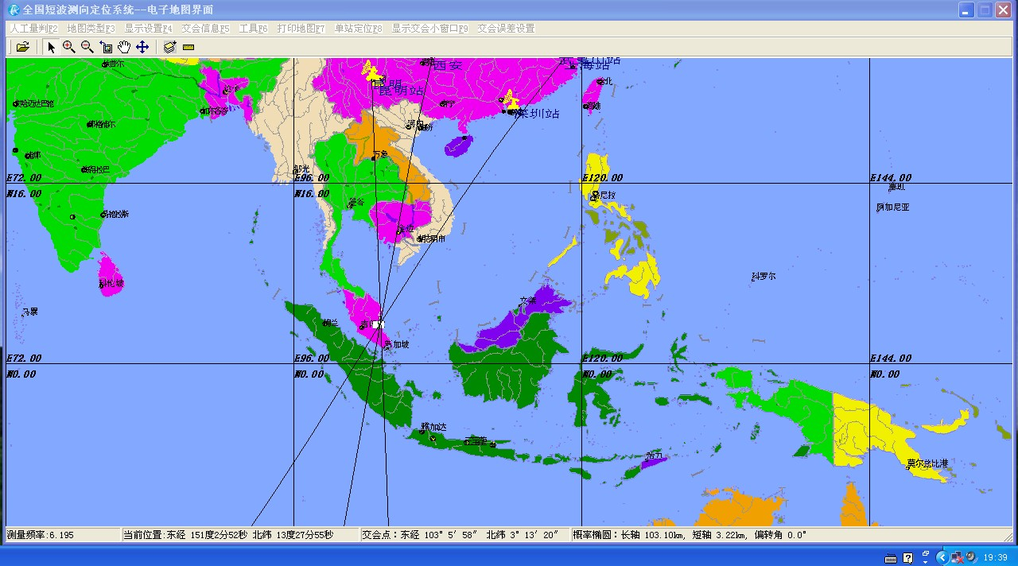
Figure 5 - Triangulation on 6 195 kHz

_____________

