|  |  |
| --- | --- |
| **Radio Regulations Board**  **Geneva, 16 – 20 July 2018** |  |
|  |  |
|  |  |
|  | **Document RRB18-2/DELAYED/2-E** |
| **11 July 2018** |
| **Original: English / Chinese** |
| Director, Radiocommunication Bureau | |
| Submission by the Administration of China regarding the status of the frequency assignments to the CTDRS-1-77E satellite network | |

The attached submission from the Administration of China regarding the status of the frequency assignments to the CTDRS-1-77E satellite network, including the in-orbit operational plan of the TL-01 satellite, which complements the information contained in Document [RRB18-2/9](https://www.itu.int/md/R18-RRB18.2-C-0009/en), is for the consideration of the Radio Regulations Board.

Annexes: 2

**Annex 1[1]**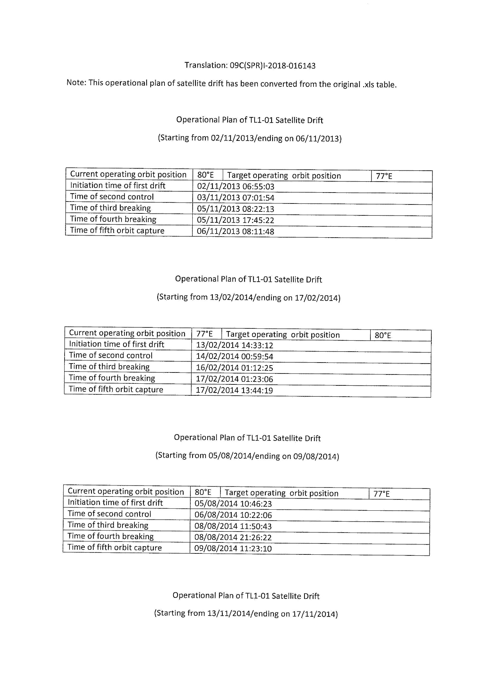

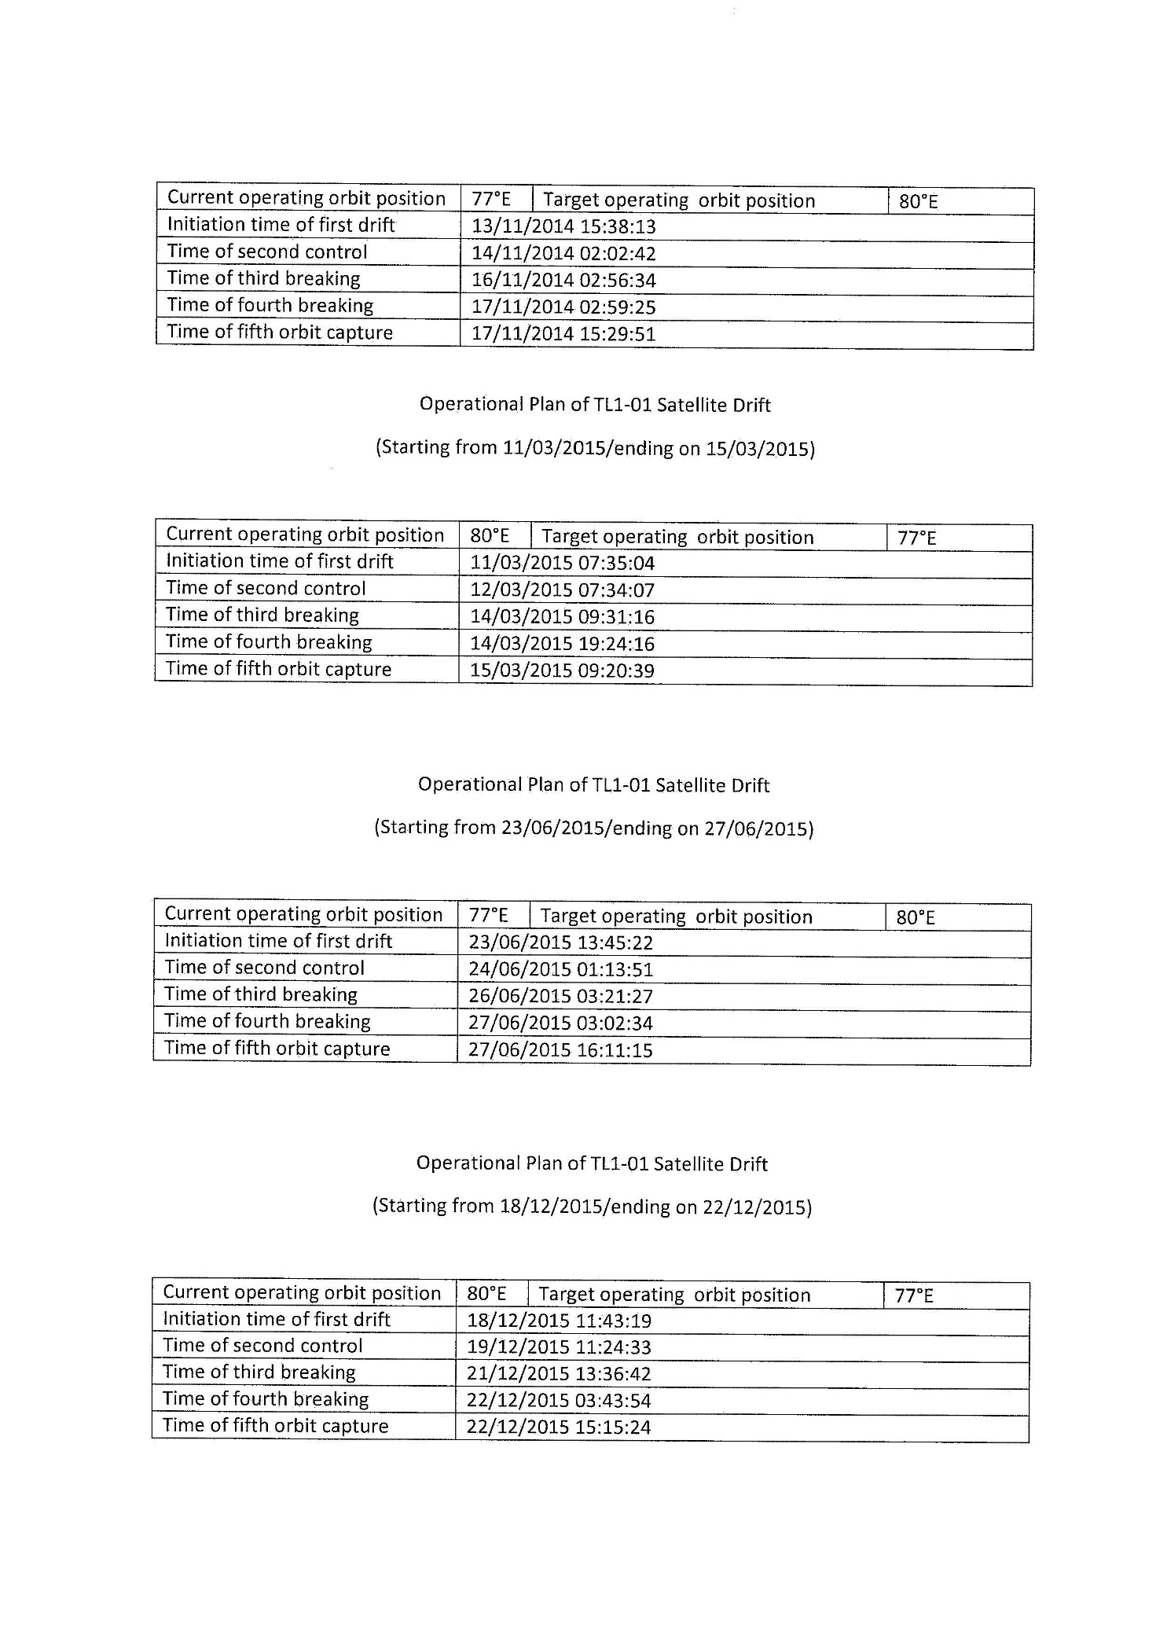

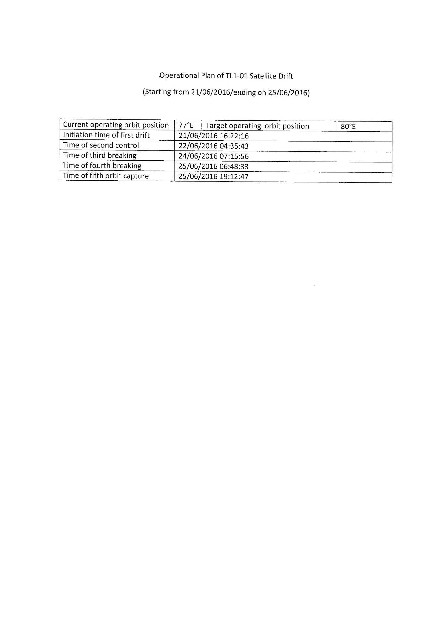

**Annex 2[2]**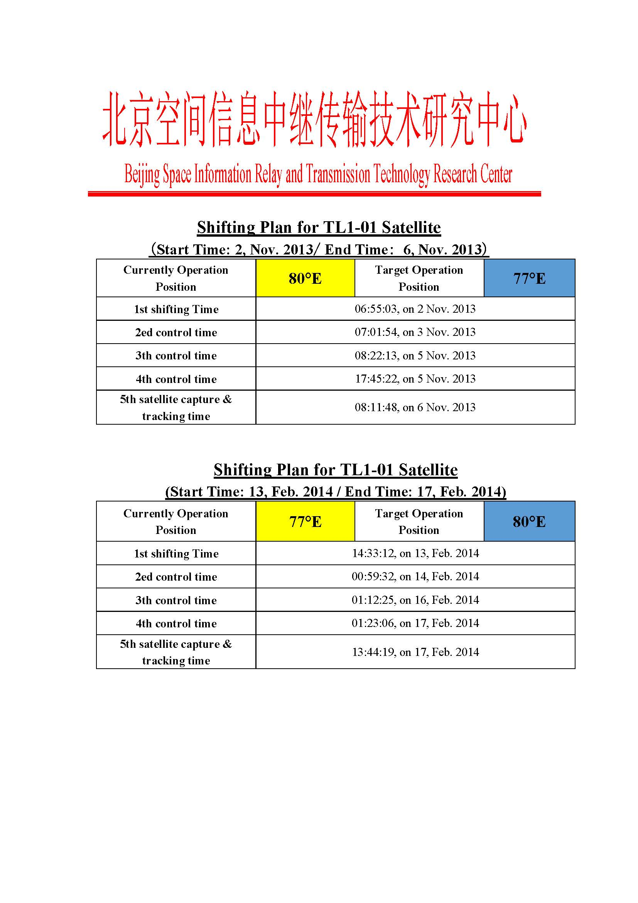

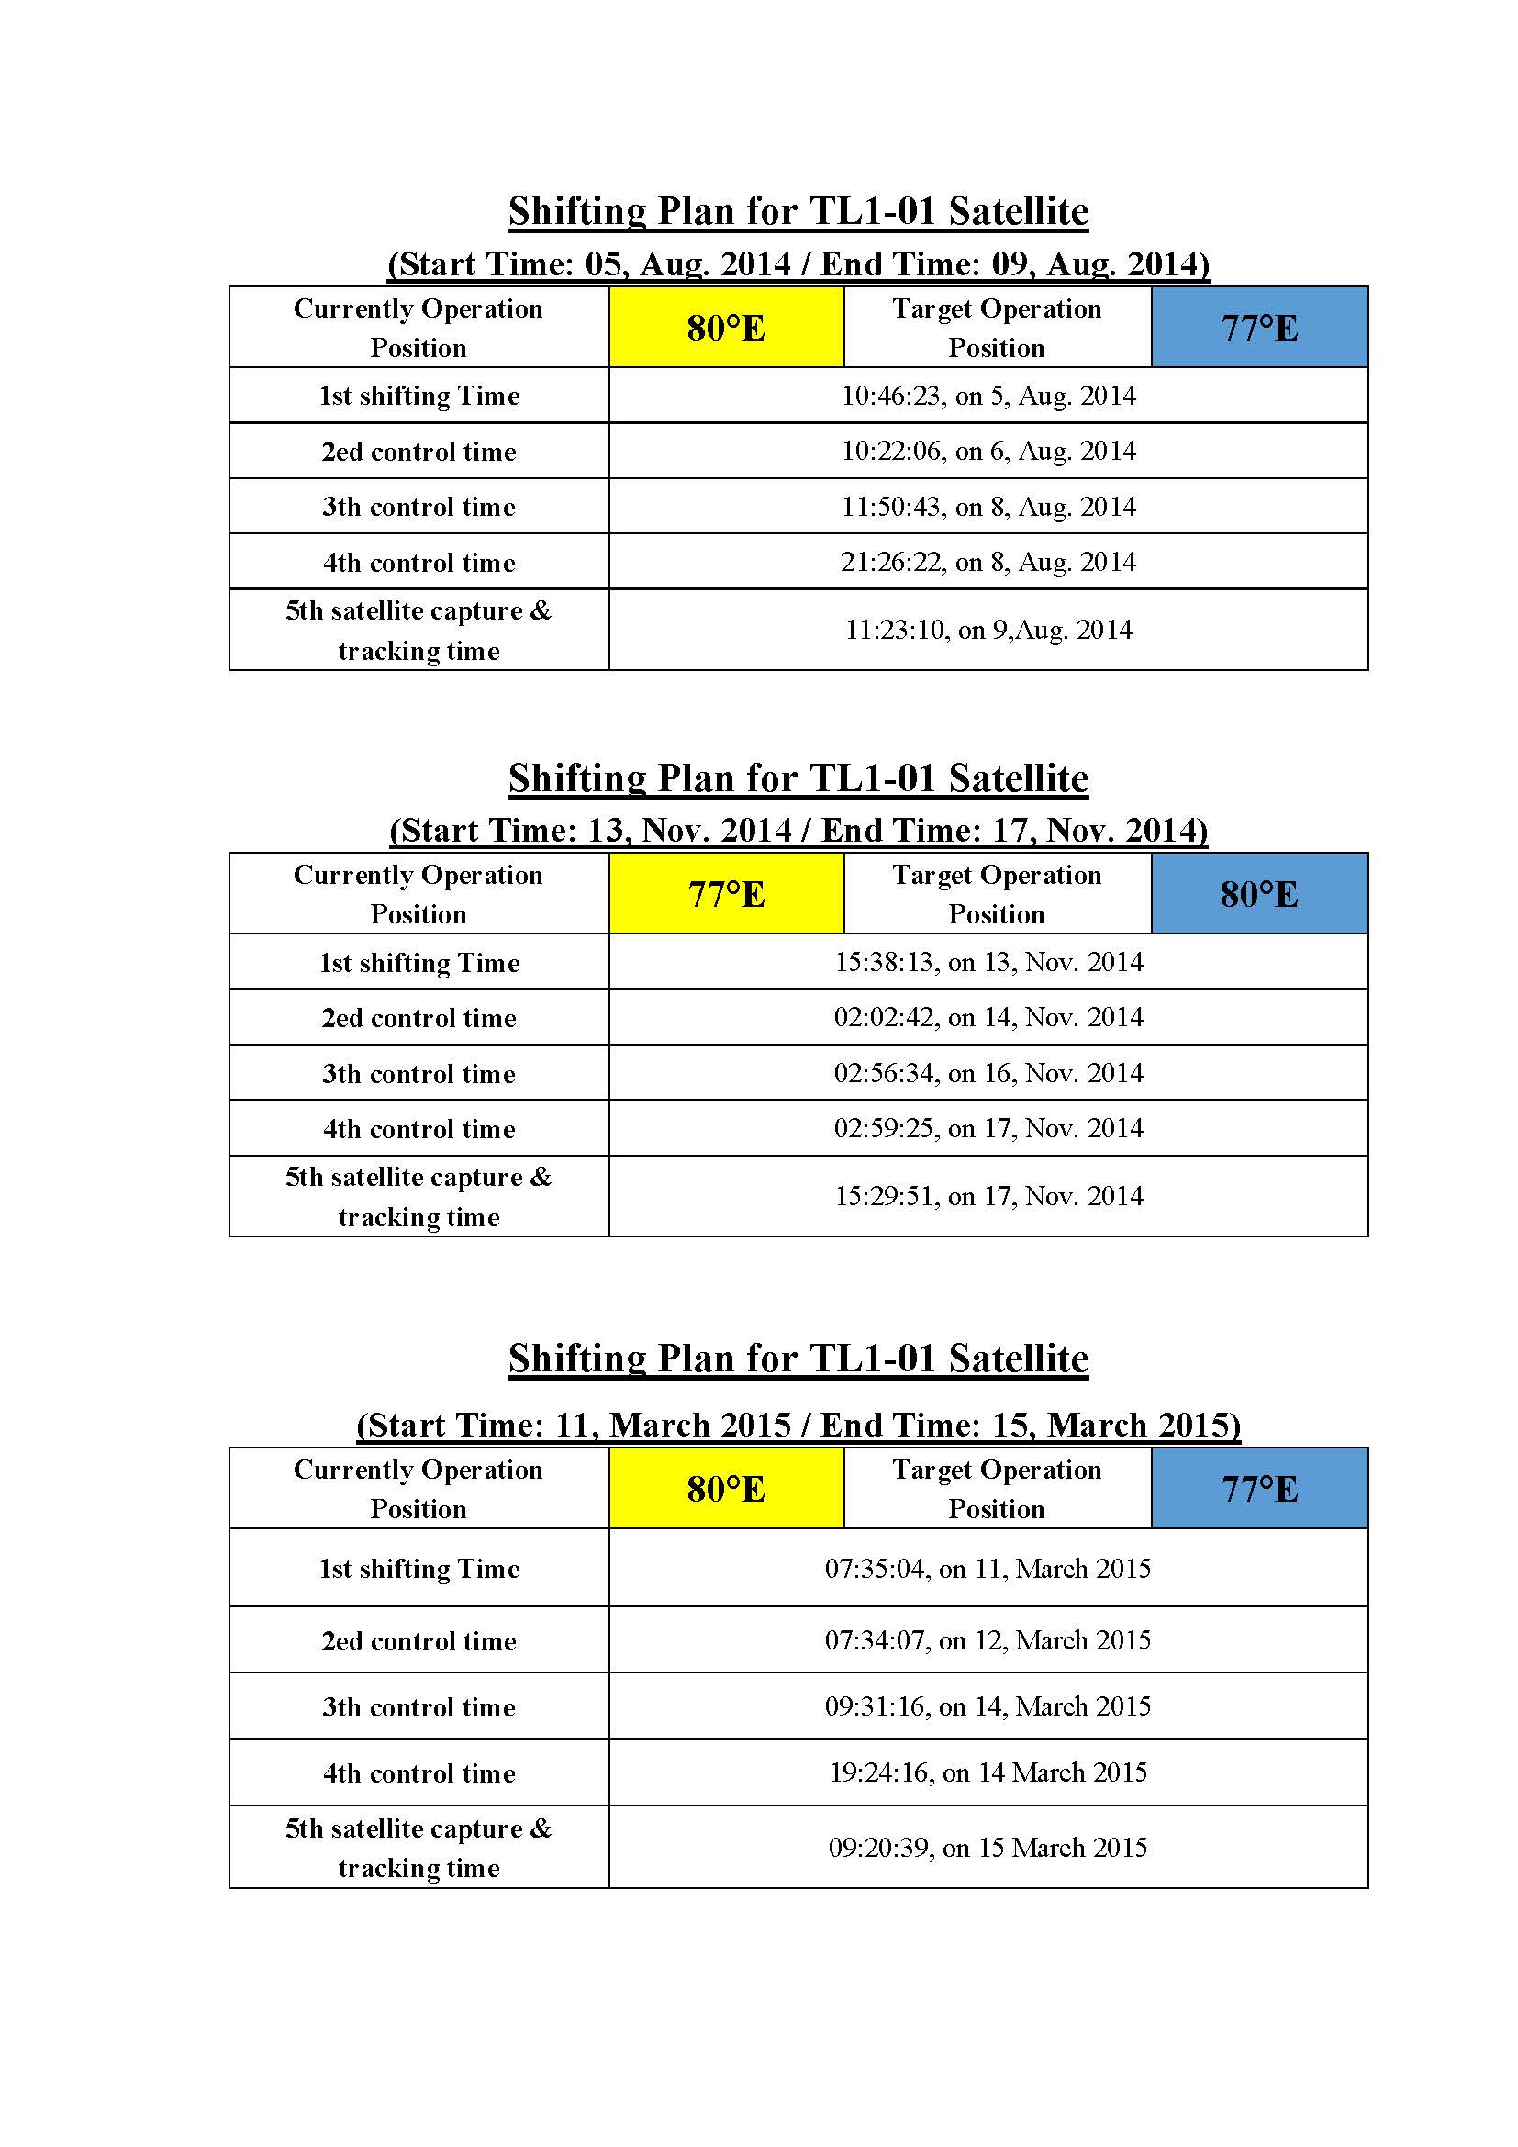

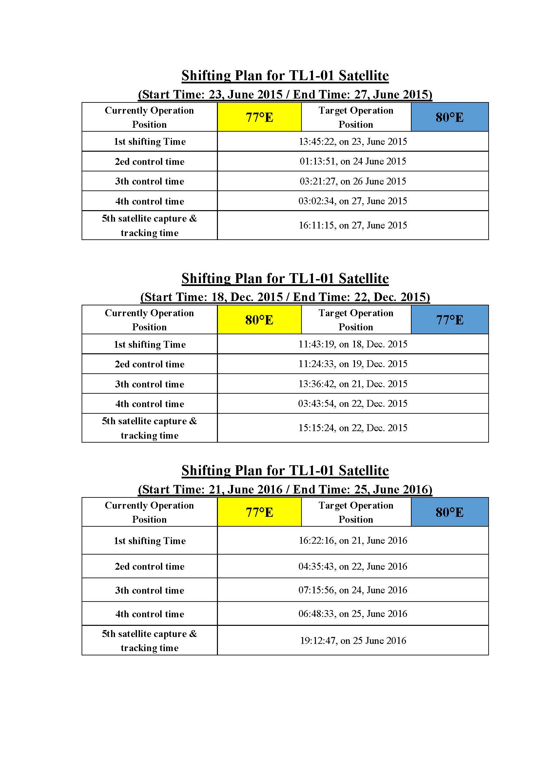

______________

1. English version translated by the ITU.
2. English version kindly provided by the Administration of China and received after the ITU translation was completed.