|  |  |  |
| --- | --- | --- |
| **Radiocommunication Advisory Group Geneva, 26-28 April 2017** |  | |
|  | |  |
|  | |  |
|  | | **Document RAG17/14-E** |
| **12 April 2017** |
| **Original: English** |
| Japan | | |
| Operation and Maintenance of the ITU-R Documents Database Search Facility | | |

# 1 Background

At its 19th meeting in 2012, the RAG invited the BR Director to develop a database that would enable ITU-R Recommendations to be searched and filtered by key characteristics such as frequency band, radio services and categories.

Japan has continuously supported the activities of the BR to encourage and expedite this search database development by granting voluntary contribution to the BR in March 2014 and as well as dispatching experts.

Thanks to the BR efforts, the search facility for ITU-R Recommendations, Questions, Reports, Resolutions and Handbooks has been now available for ITU Members on the ITU website as mentioned in the BR’s Report to the 24th RAG meeting (Section 8.1.5.2 in Document RAG17/1(Rev.1)).

Also, we believe that the BR has almost completed developing the substantial part of the working procedure to maintain the database.

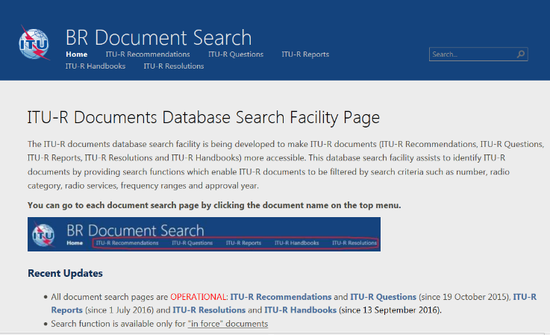

BR Document Search: <https://extranet.itu.int/brdocsearch>

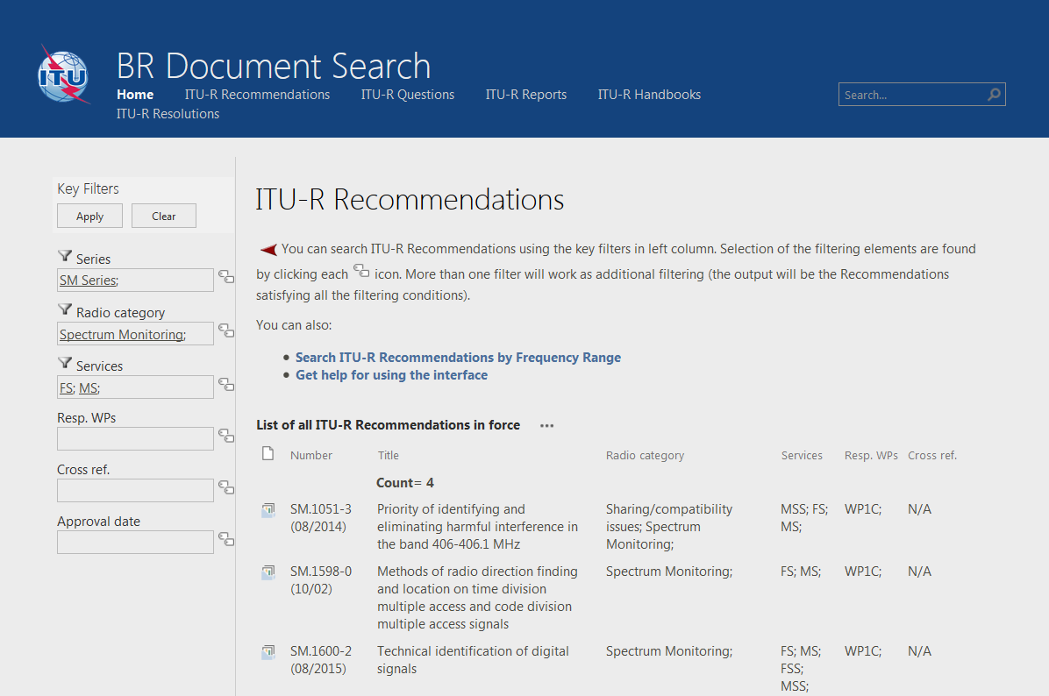

BR Document Search [ITU-R Recommendations]: <https://extranet.itu.int/brdocsearch/R-REC/>

# 2 Proposal

The useful database search facility has been developed by the BR efforts. To keep it useful for ITU Members, Japan wishes to further invite the BR:

1) according to the developed working procedure, to establish an operational mechanism to efficiently update the database for all the ITU-R documentation;

2) to consider further improvement of this database search facility, including e.g. development of a search application accessible by mobile terminals;

3) to cooperate with external standardization organizations for wider use of the database, if appropriate;

4) in doing the above, to collaborate with ITU-R SGs/WPs, as required.

______________