|  |  |  |
| --- | --- | --- |
| **Radiocommunication Advisory Group Geneva, 26-28 April 2017** |  | |
|  | |  |
|  | |  |
|  | | **Document RAG17/12-E** |
| **12 April 2017** |
| **Original: English** |
| Japan | | |
| Contribution to the activity for implementation of resolution 908 (rev.WRC-15) | | |

# 1 Background

The volume of advance publication information (API), coordination requests (CR/C), notifications and filings under Appendices 30, 30A and 30B for satellite networks or systems is increasing with the rapid development of satellite communication technologies and the growing needs of broadband communications. Both administrations and the Bureau have to perform a huge amount of consideration and correspondence for coordination and notification. Moreover, there is a growing number of new entrants such as universities conducting scientific research and nano- or pico- satellite ventures entering the satellite market.

Resolution 908 (Rev.WRC-15) instructs the Director of the BR to implement a secure paperless electronic approach for the electronic submission and publication of satellite network filings and comments.

At its 23rd meeting in 2016, the RAG agreed to establish a Rapporteur Group to follow up on the software developments related to the implementation of Resolutions 907 (Rev.WRC-15) and 908 (Rev.WRC-15).

As stated in the BR’s Report to the 24th RAG meeting (Section 3.1 in Document RAG17/1(Rev.1)), the Administration of Japan decided to support the BR’s activity through a voluntary contribution for the implementation of the Resolution to facilitate the electronic submission, processing and publication of all satellite network notices and comments.

The BR is developing a consolidated approach for the implementation of the Resolution. The preliminary draft work Plan is shown in its report, which includes many tasks to be developed as follows:

– development and implementation of “As-received” and API publication system in response to revised API procedure and Res. 55;

– development of system for online upload of filings;

– extension of system to online capture/edit of filings;

– system design;

– revisions to SNS processing of notices;

– development of receivability processing tools;

– development of management information system;

– development of system for online comments;

– development of user self-service portal;

– update of SNS online;

– development of examination tools;

– revision of publication process;

– revision of BR IFIC online;

– development of tools for regulatory checks 11.44;

– development of tools for maintenance of MIFR;

– monitoring of operations, maintenance and provision of user support.

# 2 Proposal

Japan considers that this project should fully take into account that:

1) the new systems are built up to drastically reduce procedural workload and improve the efficiency for the correspondence between administrations and the Bureau;

2) the new systems are easily used by the new entrants, using a so called user-friendly interface;

3) the new systems shall confirm the certainty and security of the procedure between administrations and the Bureau (for this consideration, the outcome of the Resolution 907 (Rev.WRC-15) project should also be taken into account).

We would like to take this opportunity to propose several ideas for improvement by addressing current systems as they are as follows:

– It is desirable that IFIC comments by an administration are automatically forwarded to relative administrations and the BR when the administration submits the IFIC comments by filling electronic formats on the BR IFIC website.

– Appearance of Space Network System Online website should be improved in order for us to understand immediately what we are able to do at a glance, for instance through pictograms or pictures. (There have been a lot of useful functions in SNS online to access SNS databases, but currently it just lists links and explanations for the functions only by text.)

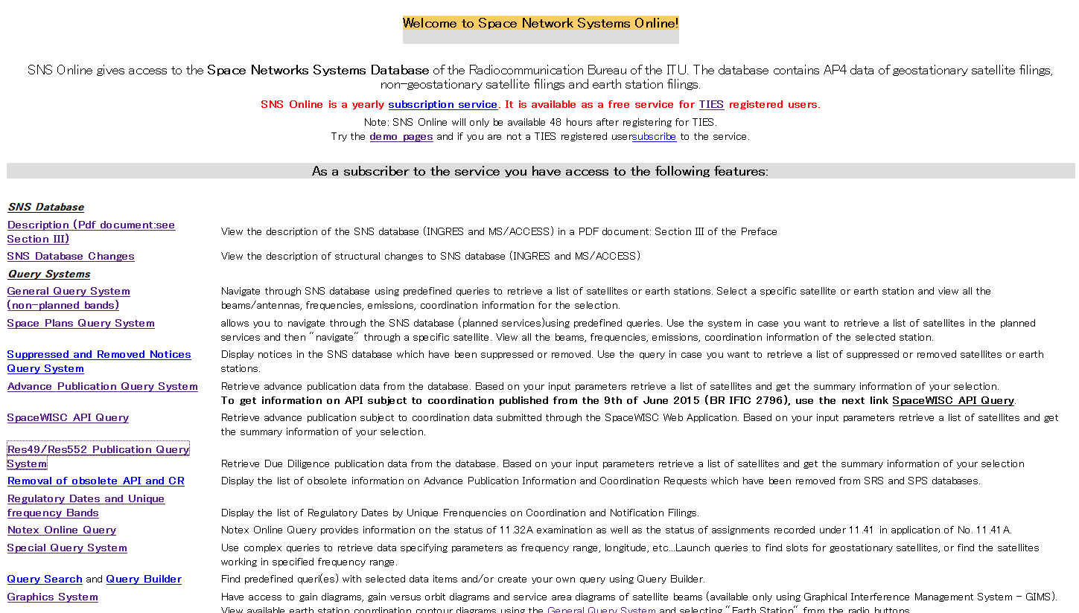

**Just lists explanations**

**Just lists links**

– The result of SNS online query should be easy-to-understand so that the user does not need to refer to “the Preface to the BR IFIC” or click links (i.e. just a “symbol” such as G/I/V is not used as much as possible).

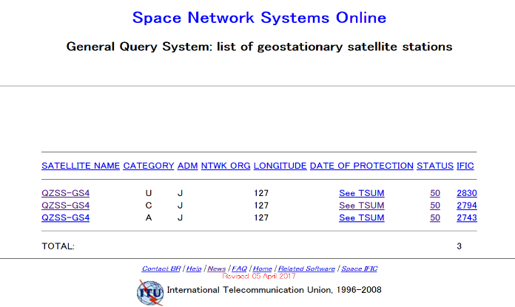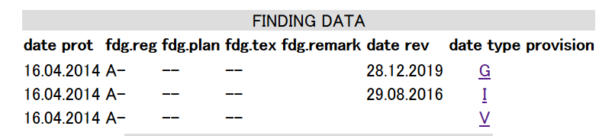

However, the output of Special Query System of Res. 49 is relatively easy to understand because all items have explanations without using just a “symbol”.

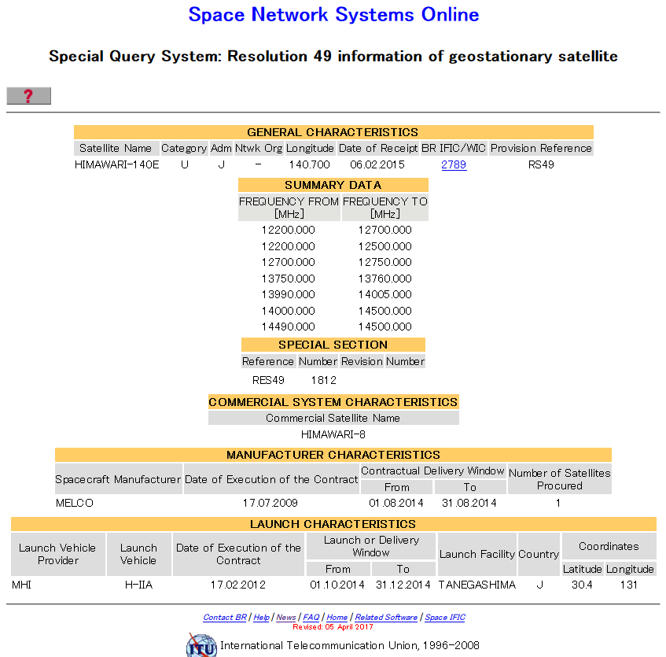

– MOD filings can be displayed integratedly with original filing at the request of a user.

– Information such as service area, contour and coordination requests should be displayed easily without using BR software and MDB files on the BR IFIC website.

______________