Radiocommunication Advisory Group  Geneva, 26-28 April 2017 | 
 |  | Document RAG17/3-E
 |  | 16 February 2017
 |  | Original: English
Director, Radiocommunication Bureau
110th anniversary of the itu radio regulations
(1906-2016)

1 Background
Last year, the ITU celebrated the 110th anniversary of the Radio Regulations. In 1906 the first International Radiotelegraph Conference gathered 29 states in Berlin to sign the International Radiotelegraph Convention establishing the principle of compulsory intercommunication between vessels at sea and the land.
Since then, 38 World Radiocommunication Conferences have revised the ITU Radio Regulations to respond to technological and social development. The 2016 version was adopted by the World Radiocommunication Conference 2015 (WRC-15). As with previous versions, it was adopted by consensus, which is the guarantee that this treaty as it evolves, will continue to be reflected in national legislations and enforced by national governments.
The Radio Regulations are a success story of international cooperation among Members States with the inestimable support of telecommunication industry partners.

2 Anniversary celebrations
Anniversary celebrations took place on 12 December 2016 in CICG, Geneva, in conjunction with the ITU World radiocommunication Seminar. They included addresses by Mr Malcolm Johnson, ITU's Deputy Secretary General, and Mr François Rancy, Director, BR. Two panel discussions about the ITU Radio Regulations impact on the ICT industry and the challenges, opportunities and future of the ITU Radio Regulations were held with attendance of over 540 registered participants from 106 countries and Radiocommunication Sector members as well as Radiocommunication associates and academic experts. Industry partners attending the ceremony's panel discussions included representatives of GSMA, ESOA, EBU, GSA, BAKOM, OneWeb, Facebook, BBC and the US State Department. The full ceremony programme, including summaries of the discussions held during both panel sessions can be found at:
http://www.itu.int/en/ITU-R/RR110/Documents/RR110-Programme.pdf.
Former officials of the Union, current and former members of the Radio Regulations Board (RRB) and former IFRB, current chairmen and vice-chairmen of ITU-R Study Groups and chairmen of former CCIR Study Groups were also present during the celebrations.

3 Branding and Communications Plan for the Radio Regulations 110th anniversary
As reported to the 2016 session of the RAG (see Document RAG16/9), the Branding and Communications Plan for the 110th anniversary of the Radio Regulations included a series of communications carried out throughout the anniversary year of 2016, targeting mainly ITU-R membership, specialized technical magazines and media, ITU staff and the general public.

3.1 Branding
The following design was retained for the Logo and Pin, which was added onto all ITU-R Publication-covers to be published and issued in 2016 as well as on all promotional materials, flyers, rollups and e-posters for all BR events occurring during 2016:
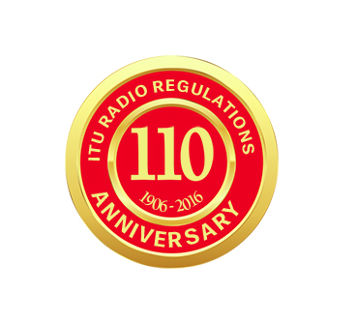
The Logo was stamped into a PIN, which was distributed during all scheduled ITU events in 2016.

3.2 Communication
As mentioned above, the communication campaign targeted mainly ITU-R membership, specialized technical magazines and media, ITU staff and the general public. The main communication actions undertaken throughout 2016 included:
- Dedicated Webpage and online Newsroom – URL: http://www.itu.int/en/ITU-R/RR110/
The web page includes links to the following communications and information, among others:
  - ITU e-news magazine RR110th anniversary “special edition”
  - Video message from the BR Director
  - Anniversary celebrations highlights, video and photos
  - e-Newsroom: PRs, Media Advisories, speeches, videos, etc.
  - Branding communications: images, e-poster, logo, pins, image-pack, etc.
  - FAQ on Radio Regulations: (historical background to complement the already existing FAQ)
- Social Media outreach: on ITU-R twitter hashtags: #RR110 and #ITU Radio Regulations.
______________

