|  |  |
| --- | --- |
| **World Radiocommunication Conference (WRC-19) Sharm el-Sheikh, Egypt, 28 October – 22 November 2019** |  |
|  |  |
|  |  |
| PLENARY MEETING | **Addendum 22 to Document 80-E** |
|  | **7 October 2019** |
|  | **Original: English** |
|  | |
| Japan | |
| Proposals for the work of the conference | |
|  | |
| Agenda item 9.2 | |

9 to consider and approve the Report of the Director of the Radiocommunication Bureau, in accordance with Article 7 of the Convention:

9.2 on any difficulties or inconsistencies encountered in the application of the Radio Regulations[1]*; and

Introduction

This document contains a proposal from Japan for WRC-19 agenda item 9.2 for consideration by the Conference. The proposal can be found at the bottom of this contribution.

Background

No. **4.6** of the Radio Regulations (RR) stipulates, in its English version, that: “For the purpose of resolving cases of harmful interference, the radio astronomy service shall be treated as a radiocommunication service. However, protection from services in other bands shall be afforded the radio astronomy service only to the extent that such services are afforded protection from each other”.

In a Note dated 2 November 2017 to the Director of the Radiocommunication Bureau, ITU-R Working Party (WP) 7D indicated that at its October 2017 meeting, it had received input Document 7D/106 addressing issues with No. **4.6** of the Radio Regulations. This document discusses the origin of No. **4.6** of the Radio Regulations, noting that several footnotes of the current RR are based on protection criteria for the radio astronomy service but not based on RR No. **4.6**, and that there are inconsistencies between its English and French versions. Such inconsistencies have often resulted in protracted arguments at ITU-R meetings. In fact, the second sentence of RR No. **4.6** has never been applicable for protection of the radio astronomy service, at least not in the last 25 years. Thus it was proposed to remove the second sentence of RR No. **4.6**, and such removal will also resolve the inconsistencies in this particular case.

As noted in the preliminary draft Report of the Director to WRC-19, Section 3.1.1.1 of Document CPM19-2/17[2]*, these issues were brought to the attention of the RRB at its 77th meeting on 19‑23 March 2018, where the Board concluded that the requested modification to the Regulations is outside its purview and instructed the Director to include this matter in the Report to WRC-19.

In order to understand this problem properly, the origin and the history of RR No. **4.6** is shown below, which was reproduced from Document 7D/106.

The History of RR No. 4.6

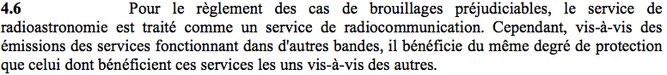

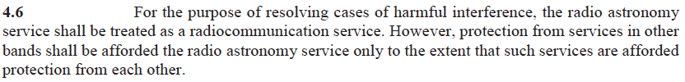

# 1 The regulatory framework before 1960

Radio astronomy was discussed at the CCIR, which advised the ITU on matters dealing with the radio spectrum. There was some reluctance at CCIR to give too much recognition to radio astronomy on account of its extreme sensitivity and the difficulty of fitting passive radio science into a regulatory regime for transmitters. But it was also recognized that an effort was needed to foster the development of radio astronomy by providing an international framework for protection of its use of spectrum. The CCIR developed Recommendations (56; 118; 173 …) that read as follows in 1956:

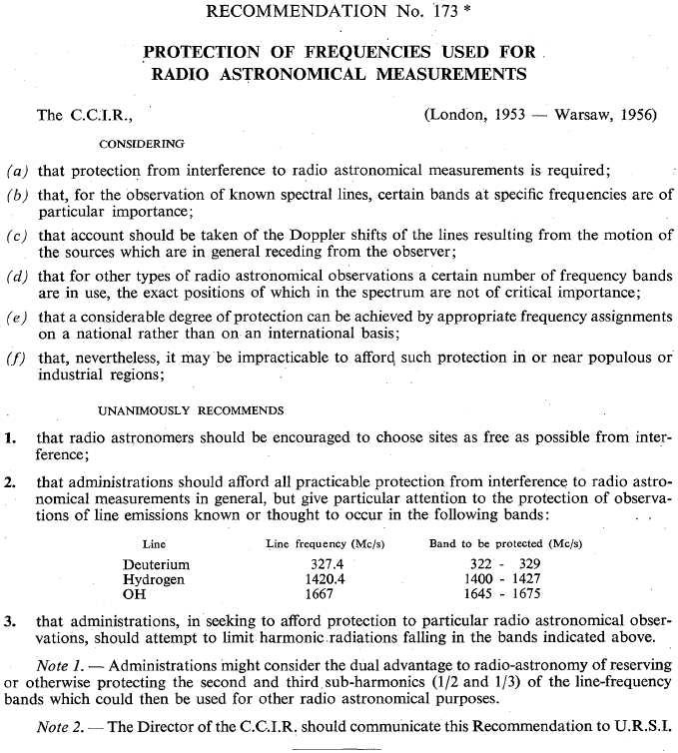

# 2 The Administrative Radio Conference, Geneva, October 1959

The Administrative Radio Conference recognized radio astronomy as a radio service in RR Article **1**

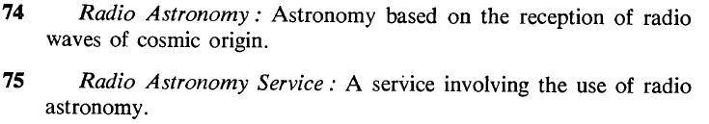

and allocated the 1 400-1 427 MHz band to radio astronomy in near-absolute terms:

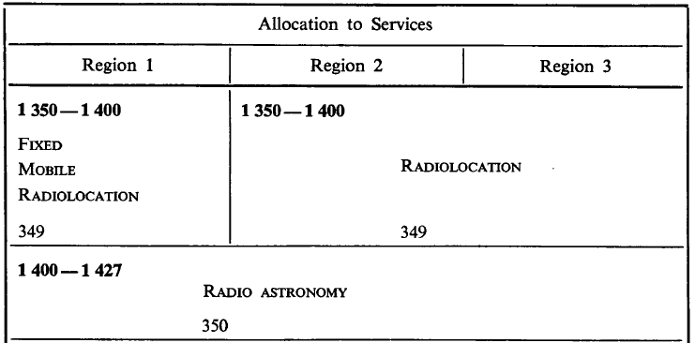



But in all other “radio astronomy” bands the frequency allocation table looked like this:

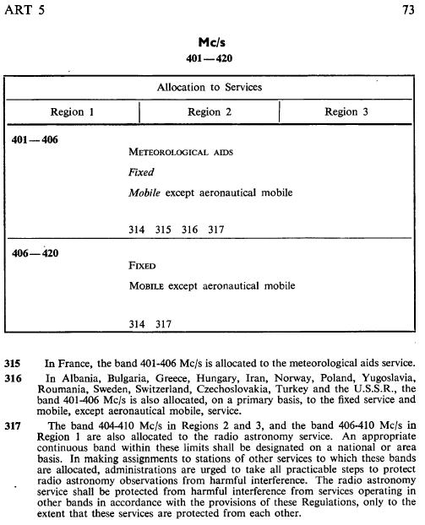

Footnotes for other spectrum bands read just like footnote RR No. **317**. In them we recognize the wording of the present-day RR No. **5.149** in the text beginning “In making assignments …” and that of the present-day RR No. **4.6** in the final sentence.

In French:

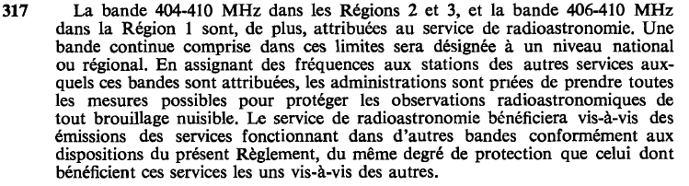

The French and English versions of the last sentence of the footnote text differed in the same way that the French and English versions of RR No. **4.6** differ now, one using “… du même degré …” and the other “.... only to the extent that”

I. 1963 – The Extraordinary Administrative Radio Conference

As the USA noted in its input to the Extraordinary Administrative Radio Conference in 1963[3], the radio astronomy footnotes used the term “harmful interference,” which constituted a contradiction because the radio astronomy service was not a radiocommunication service and was not covered in the definition of harmful interference:

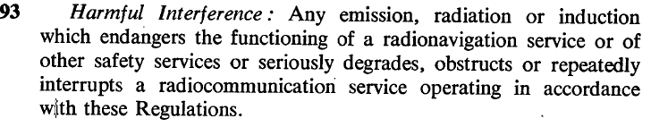

The USA said:



In response, the 1963 Conference changed the footnotes to remove the mention of unwanted emissions

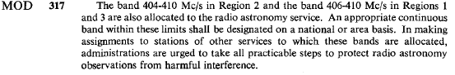

and the Conference created the original version of RR No. **4.6**:

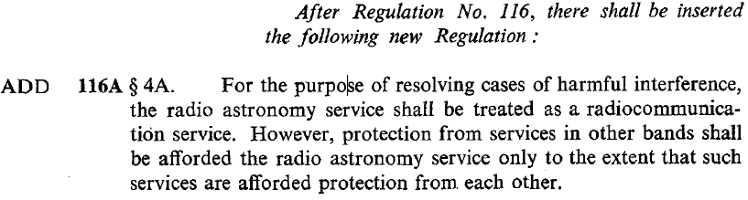

Or, in French:

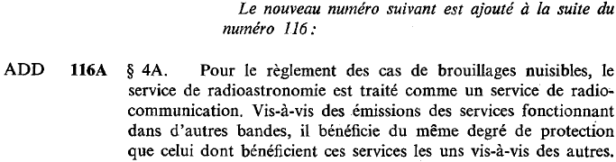

There is a subtle aspect to this change that should not be overlooked. When the 1 400-1 427 MHz band was allocated to radio astronomy by the 1959 Conference, the band was not subject to footnote text concerning unwanted emissions. By moving the unwanted emissions clause into an Article, radio astronomy use of the 1 400-1 427 MHz band became subject to the clause. RR No. **5.340** to the rescue? It didn’t exist then.

# 3 From 1960 to the present

When the radio astronomy footnotes and the original text of RR No. **4.6** were created, radio astronomy was not a radiocommunication service and as such it had no protection criteria. In fact, it seemed to have no use for protection criteria because, i) it had no status in the footnoted bands and was obliged to accept all interference from the services that were allocated in the bands, and, ii) it had exclusive and absolute use of the 1 400-1 427 MHz band except in the seven administrations mentioned in footnote RR No. **350**.

With time, the radio astronomy service matured and was granted a variety of primary allocations in bands both shared and not shared with active services. The radio astronomy service developed protection criteria (chiefly Recommendations ITU-R RA. 769 and ITU-R RA. 1513) and RA-series ITU-R Recommendations for in-band sharing and compatibility with unwanted emissions from other bands:

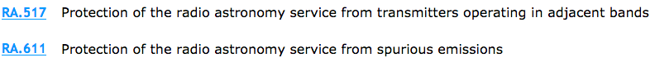



Footnotes such as RR No. **5.551H** place limits on adjacent band interference into particular radio astronomy bands using the criteria in Recommendations ITU-R RA. 769 and ITU-R RA. 1513:

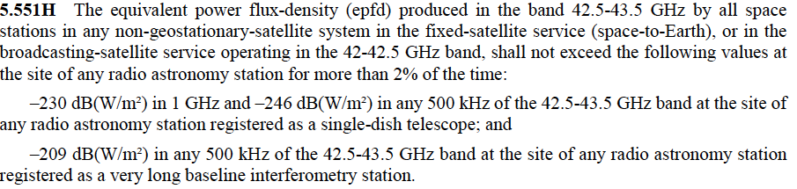

Similar examples may be found in RR Nos. **5.511F**, **5.551I** and the tables of ITU-R Resolution **739**, which resulted from the work of TG 1/3, 1/5, 1/7 and 1/9.

# 4 What is the meaning of RR No. 4.6, really? The need for reconsideration.

Radio astronomy now has its own protection criteria that are applied to unwanted emissions, and the radio astronomy service is treated as a radiocommunication service in all respects regarding interference. The first sentence of RR No. **4.6** is strictly observed and RR No. **4.6** is cited repeatedly for this reason in Article **29** where the most general operating principles of the radio astronomy service are described. So how, then, are we to understand the second sentence of RR No. **4.6**, notwithstanding the fact that the French and English versions may not express exactly the same thought?

The second sentence of RR No. **4.6** is an anachronism, carried over from the times when radio astronomy was at first not a radio service and then for some while had no protection criteria. RR No. **4.6** should be truncated after the first sentence to make the Radio Regulations internally consistent.

Japan’s View

Japan recognizes that there are two issues to be addressed:

1) The second sentence of RR No. **4.6** has not been used for sharing and compatibility studies conducted in the ITU-R. Several provisions exist in the current RR, which were approved in past WRCs based on technical studies conducted in the ITU-R without referring to the second sentence of RR No. **4.6**. It would not be realistic for the ITU-R to revisit such provisions based on RR No. **4.6**, since it would impose unnecessary burdenfor the administrations and the Sector members to coordinate adjacent band interference. According to the history of RR No. **4.6** shown in the “background” above,Japan understands thatit was an interim measure for relevant active services while there were no protection criteria to be applied to the radio astronomy service. The second sentence of RR No. **4.6** should have been eliminated from RR No. **4.6** when the protection criteria were first summarized in 1963 as CCIR Report 224[4], or when Recommendation ITU-R RA.769 was approved in 1992; and

2) There exists an inconsistency in RR No. **4.6** between its French and English versions. Article 173 of the ITU Constitution states, “In case of discrepancy or dispute, the French text shall prevail.”

**Proposal**

ARTICLE 4

Assignment and use of frequencies

MOD J/80A22/1

4.6 For the purpose of resolving cases of harmful interference, the radio astronomy service shall be treated as a radiocommunication service.     (Rev. WRC-19)

**Reasons:** Since the second sentence of RR No. **4.6** has not been used in sharing and compatibility studies in the ITU-R for a long time, the elimination will not pose any impairment on the RR. The proposed elimination of the second sentence of RR No. **4.6** would be the simplest solution that will be able to remove the reported inconsistencies between the French and the English versions. The first sentence should be kept unchanged since the radio astronomy service is not a radiocommunication service according to RR Nos. **1.6**, **1.7** and **1.8**.

______________

1. * This agenda item is strictly limited to the Report of the Director on any difficulties or inconsistencies encountered in the application of the Radio Regulations and the comments from administrations.
2. * Note by the Secretariat: see same section 3.1.1.1 in WRC-19 Doc. 4 (Add.2).
3. Document 8-E submitted to the [Extraordinary Administrative Radio Conference to allocate frequency bands for space radiocommunication purposes (Geneva, 1963)](http://handle.itu.int/11.1004/020.1000/4.89) see the “Conference Documents” tab and Documents 1-100, <http://handle.itu.int/11.1004/020.1000/4.89.51.en.101>
4. http://search.itu.int/history/HistoryDigitalCollectionDocLibrary/4.282.43.en.1002.pdf