World Radiocommunication Conference (WRC-19)  Sharm el-Sheikh, Egypt, 28 October – 22 November 2019 | 
PLENARY MEETING | Addendum 7 to  Document 80(Add.19)-E
 | 7 October 2019
 | Original: English
Japan
PROPOSALS FOR THE WORK OF THE CONFERENCE
Agenda item 7(G)
7 to consider possible changes, and other options, in response to Resolution 86 (Rev. Marrakesh, 2002) of the Plenipotentiary Conference, an advance publication, coordination, notification and recording procedures for frequency assignments pertaining to satellite networks, in accordance with Resolution 86 (Rev.WRC-07), in order to facilitate rational, efficient and economical use of radio frequencies and any associated orbits, including the geostationary-satellite orbit;
7(G) Issue G - Updating the reference situation for Regions 1 and 3 networks under RR Appendices 30 and 30A when provisionally recorded assignments are converted into definitive recorded assignments
Introduction
The Administration of Japan considers that EPM criterion should be maintained and the reference EPM should be updated properly, since the EPM criterion contributes to alleviate the problem of "sensitive satellite network" having very low transmitting power and contribute to the efficient use of the geostationary satellite orbit.
The modification of § 4.1.18bis of Appendices 30 and 30A of the Radio Regulations (RR) (Method G1 of the CPM Report), where the reference situation of the interfered-with network should be updated in consultation with, and only with the agreement of, the affected administration, leads to the abolition of the EPM criteria in the future. Furthermore, Method G1 does not work sufficiently to protect the interfered-with satellite networks. Instead, the harmful interference can be eliminated by appropriate actions based on § 4.1.20 of RR Appendices 30 and 30A.
Therefore, the Administration of Japan supports NOC (Method G3 of the CPM Report).
§ 4.1.20 of RR Appendices 30 and 30A may be modified for clarification, if necessary. An example revision is given in order to reflect the actions of § 4.1.20 and update EPM properly as a matter of consequential action after eliminating the interference.

APPENDIX 30 (REV.WRC-15)*
Provisions for all services and associated Plans and List1 for
the broadcasting-satellite service in the frequency bands
11.7-12.2 GHz (in Region 3), 11.7-12.5 GHz (in Region 1)
and 12.2-12.7 GHz (in Region 2) (WRC-03)
ARTICLE 4 (Rev.WRC-15)
Procedures for modifications to the Region 2 Plan or
for additional uses in Regions 1 and 3³

4.1 Provisions applicable to Regions 1 and 3
NOC J/80A19A7/1
4.1.18 If, in spite of the application of § 4.1.16 and 4.1.17, there is still continuing disagreement and the assignment which was the basis of the disagreement is not an assignment in the Regions 1 and 3 Plan, or in the Region 2 Plan or for which the procedure of § 4.2 has been initiated, and if the notifying administration insists that the proposed assignment be included in the Regions 1 and 3 List, the Bureau shall provisionally enter the assignment in the Regions 1 and 3 List with an indication of those administrations whose assignments were the basis of the disagreement; however, the entry shall be changed from provisional to definitive recording in the List only if the Bureau is informed that the new assignment in the Regions 1 and 3 List has been in use, together with the assignment which was the basis for the disagreement, for at least four months without any complaint of harmful interference being made. (WRC-03)

NOC J/80A19A7/2
4.1.18bis When requesting the application of § 4.1.18, the notifying administration shall undertake to meet the requirements of § 4.1.20 and provide to the administration in respect of which § 4.1.18 is applied, with a copy to the Bureau, a description of the steps by which it undertakes to meet these requirements. Once an assignment is entered in the List provisionally under the provisions of § 4.1.18, the calculation of the equivalent protection margin (EPM)9 of an assignment in the Regions 1 and 3 List or for which the procedure of Article 4 has been initiated and which was the basis for the disagreement shall not take into account the interference produced by the assignment for which the provisions of § 4.1.18 have been applied. (WRC-03)

APPENDIX 30A (REV.WRC-15)*
Provisions and associated Plans and List1 for feeder links for the broadcasting-satellite service (11.7-12.5 GHz in Region 1, 12.2-12.7 GHz
in Region 2 and 11.7-12.2 GHz in Region 3) in the frequency bands
14.5-14.8 GHz2 and 17.3-18.1 GHz in Regions 1 and 3,
and 17.3-17.8 GHz in Region 2 (WRC-03)
ARTICLE 4 (Rev.WRC-15)
Procedures for modifications to the Region 2 feeder-link Plan
or for additional uses in Regions 1 and 3

4.1 Provisions applicable to Regions 1 and 3
NOC J/80A19A7/3
4.1.18 If, in spite of the application of § 4.1.16 and 4.1.17, there is still continuing disagreement and the assignment which was the basis of the disagreement is not an assignment in the Regions 1 and 3 Plan, or in the Region 2 Plan or for which the procedure of § 4.2 has been initiated, and if the notifying administration insists that the proposed assignment be included in the Regions 1 and 3 feeder-link List, the Bureau shall provisionally enter the assignment in the Regions 1 and 3 feeder-link List with an indication of those administrations whose assignments were the basis of the disagreement; however, the entry shall be changed from provisional to definitive recording in the feeder-link List only if the Bureau is informed that the new assignment in the Regions 1 and 3 feeder-link List has been in use, together with the assignment which was the basis for the disagreement, for at least four months without any complaint of harmful interference being made. (WRC-03)

NOC J/80A19A7/4
4.1.18bis When requesting the application of § 4.1.18, the notifying administration shall undertake to meet the requirements of § 4.1.20 and provide to the administration in respect of which § 4.1.18 is applied, with a copy to the Bureau, a description of the steps by which it undertakes to meet these requirements. Once an assignment is entered in the feeder-link List provisionally under the provisions of § 4.1.18, the calculation of the equivalent protection margin (EPM)11 of an assignment in the Regions 1 and 3 feeder-link List or for which the procedure of Article 4 has been initiated and which was the basis for the disagreement shall not take into account interference produced by the assignment for which the provisions of § 4.1.18 have been applied. (WRC-03)
Reasons:
1) The EPM (Equivalent Protection Margin) criterion solves the problem of “sensitive satellite network” of low transmitting power
In Figure 1, Sat. P is the network in the List. Then the low transmitting power Sat . Q can enter the List without coordination with Sat. P, for example, at 3 deg. separation of orbital position from Sat. P. Since the transmitting power is so small that Sat. P is not identified as being affected by Sat. Q. Instead, the EPM of Sat. Q becomes very low, e.g. −15dB due to the interference from Sat. P.
When the junior Sat. R tries to enter the List, the threshold value in terms of pfd (power flux-density) with respect to Sat. Q is −124 dB(W/(m² · MHz)) under the EPM criterion in this example, while it becomes −136 dB(W/(m² · MHz)) under the pfd criterion. The difference is about 12 dB and it is easier for Sat. R to enter the List under the EPM criterion. In another word, Sat. Q works as blocking a newcomer if the EPM criterion is abolished and only the pfd criterion remains.
Therefore, the EPM criterion contributes to alleviate the problem of “sensitive satellite network” having very low transmitting power and contribute to the efficient use of the geostationary satellite orbit. The EPM criterion should be maintained.
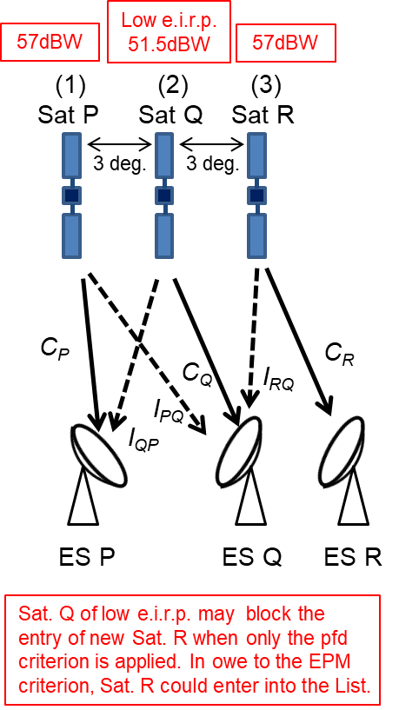 | 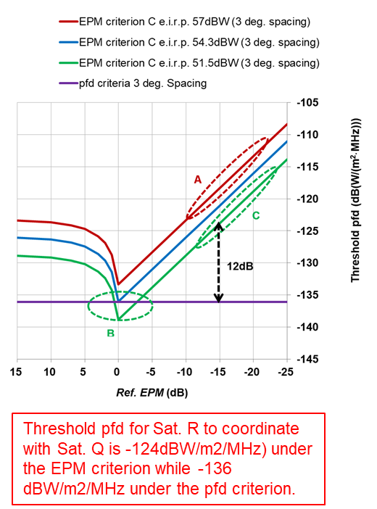
Figure 1: Problem of “sensitive satellite network” of low transmitting power (Sat. Q) and the threshold value in terms of pfd with respect to Sat. Q. The e.i.r.p. value is per 27 MHz
If the EPM criterion is suppressed, it is very difficult for junior Sat. R to enter the List. This situation would happen to the senior Sat. P after the expiration after 15 + 15 years (RR of Appendices 30 and 30A § 4.1.24), since it is difficult to enter the List since it cannot satisfy the pfd criterion to protect Sat. Q.
2) The problem of high transmitting power satellite, which Method G1 intends to solve
In Figure 2, Sat. L is the network in the List. Then the high transmitting power Sat. M enters the List provisionally by applying § 4.1.18 against Sat. L. Sat. M did not transmit the high power for 4 months, then no claim was received by Sat. L. Then Sat. M can be converted to definitive and the reference EPM of Sat. L is updated according to § 4.1.18bis. As a result, the reference EPM of Sat. L degrades, for example, from 0 dB o −5.5 dB.
Sat. L is no more identified as affected by a junior Sat. N, since the reference EPM of Sat. L is degraded, for example, and the threshold value in terms of pfd increases from −133 dB(W/(m² · MHz)) to −128 dB(W/(m² · MHz)).
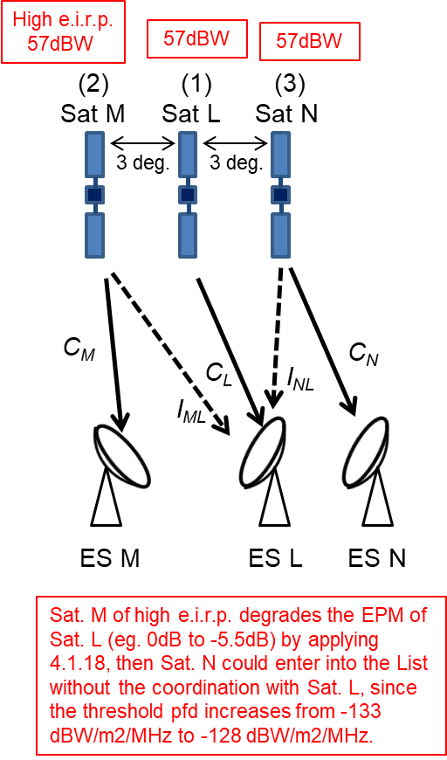 | 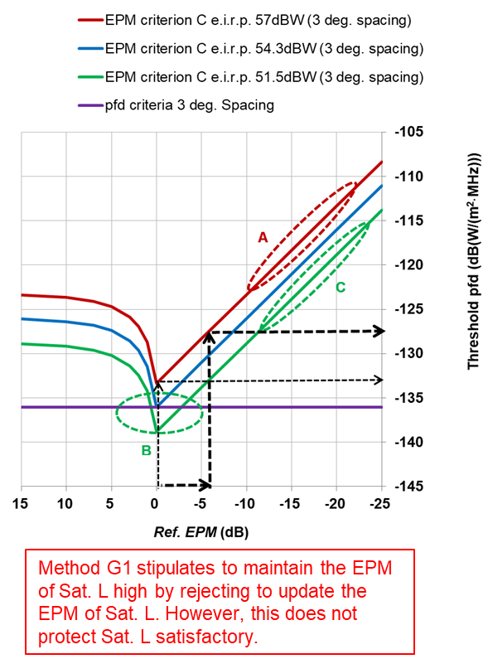
Figure 2: Problem of high transmitting power (Sat. M) and the threshold value in terms of pfd
with respect to Sat. L. The e.i.r.p. value is per 27 MHz
3) Method G1 shown in the CPM Report
Method G1 stipulates to maintain the EPM of Sat. L high by rejecting to update the EPM of Sat. L when Sat. M becomes definitive. However, it is very difficult for Sat. M to obtain the agreement from Sat. L actually. Then the reference EPM is never updated, and the EPM criterion may be suppressed in the future as follows.
Difficult to obtain the agreement
↓
No update of reference EPM
↓
No function of the EPM criterion
↓
Abolition of the EPM criterion in the future
Furthermore, under Method G1, although Sat. L is identified as affected by Sat. N owing to maintaining the reference EPM high, Sat. N may apply § 4.1.18 against Sat. L. In this situation Sat. L cannot be protected at all, and the problem is not actually solved.
4) Solutions for the problem of high transmitting power satellite
The harmful interference from other satellites to Sat. L can be eliminated by applying § 4.1.20 of RR Appendices 30 and 30A at any time. The harmful interference is considered to include the virtual (artificial) interference which is not a real emission, since it gives an impact to Sat. L in the form of reducing the reference EPM.
It has been reported by BR that there was no example that a provisional assignment converted to definitive. It seems that § 4.1.20 works as a deterrent to convert the provisional assignment to definitive. BR has also stated that BR would report and consult with RRB when it received the request to convert a provisional assignment based on § 4.1.18 to a definitive one.
Even though the EPM value of a senior Sat. L becomes low due to the application of § 4.1.18 and § 4.1.18bis by a junior Sat. M against Sat. L, Sat. L has a chance to recover its EPM by applying § 4.1.20 against Sat. M. If Sat. M does not emit the wave and the EPM of Sat .L degrades, Sat. L can request the elimination of the virtual (artificial) interference from Sat. M by applying § 4.1.20 of RR Appendices 30 and 30A.
§ 4.1.20 of RR Appendices 30 and 30A may be modified, if necessary. An example revision is given as follows in order to reflect the actions of § 4.1.20 and update EPM properly as a matter of consequential action after eliminating the interference.
MOD
4.1.20 Should harmful interference be caused by an assignment included in the List under § 4.1.18 to any assignment in the List which was the basis of the disagreement, the administration using the frequency assignment included in the List under § 4.1.18 shall, upon receipt of a report providing the particulars relating to the harmful interference, immediately eliminate this harmful interference. (WRC-19)
ADD
4.1.20A In applying § 4.1.20 with respect to satellite networks, administrations involved shall cooperate in the elimination of harmful interference and may request the assistance of the Bureau and shall exchange relevant technical and operational information required to resolve the issue. Within 30 days when the harmful interference has been eliminated, the administration responsible for the assignment included in the List under § 4.1.18 shall provide the Bureau with the modified characteristics to that effect. The Bureau shall update the characteristics of this assignment and publish it in a Special Section of its BR IFIC. The equivalent protection margin (EPM) shall be updated accordingly. (WRC-19)
4.1.20B Should any administration involved in the matter inform the Bureau that all efforts to resolve the harmful interference have failed, the Bureau shall immediately inform other involved administrations and prepare a report, together with all necessary supporting documents (including comments from the administrations involved), for the next meeting of the Board for its consideration and any required action (including the possible cancellation of the assignment recorded under § 4.1.18), as appropriate. The Bureau shall thereafter implement the decision of the Board and inform the administrations concerned. (WRC-19)
MOD
4.1.20 Should harmful interference be caused by an assignment included in the feeder-link List under § 4.1.18 to any assignment in the List which was the basis of the disagreement, the administration using the frequency assignment included in the feeder-link List under § 4.1.18 shall, upon receipt of a report providing the particulars relating to the harmful interference, immediately eliminate this harmful interference. (WRC-19)
ADD
4.1.20A In applying § 4.1.20 with respect to satellite networks, administrations involved shall cooperate in the elimination of harmful interference and may request the assistance of the Bureau, and shall exchange relevant technical and operational information required to resolve the issue. Within 30 days when the harmful interference has been eliminated, the administration responsible for the assignment included in the List under § 4.1.18 shall provide the Bureau with the modified characteristics to that effect. The Bureau shall update the characteristics of this assignment and publish it in a Special Section of its BR IFIC. The equivalent protection margin (EPM) shall be updated accordingly. (WRC-19)
4.1.20B Should any administration involved in the matter inform the Bureau that all efforts to resolve the harmful interference have failed, the Bureau shall immediately inform other involved administrations and prepare a report, together with all necessary supporting documents (including comments from the administrations involved), for the next meeting of the Board for its consideration and any required action (including the possible cancellation of the assignment recorded under § 4.1.18), as appropriate. The Bureau shall thereafter implement the decision of the Board and inform the administrations concerned. (WRC-19)

______________

* The expression “frequency assignment to a space station”, wherever it appears in this Appendix, shall be understood to refer to a frequency assignment associated with a given orbital position. See also Annex 7 for the orbital limitations. (WRC-2000)
1 The Regions 1 and 3 List of additional uses is annexed to the Master International Frequency Register (see Resolution 542 (WRC-2000)**). (WRC-03) ** Note by the Secretariat: This Resolution was abrogated by WRC-03. Note by the Secretariat: Reference to an Article with the number in roman is referring to an Article in this Appendix.
3 The provisions of Resolution 49 (Rev.WRC-15) apply. (WRC-15)
9 For the definition of EPM, see § 3.4 of Annex 5. (WRC-03)
* The expression “frequency assignment to a space station”, wherever it appears in this Appendix, shall be understood to refer to a frequency assignment associated with a given orbital position. (WRC-03)
1 The Regions 1 and 3 feeder-link List of additional uses is annexed to the Master International Frequency Register (see Resolution 542 (WRC-2000)**). (WRC-03) ** Note by the Secretariat: This Resolution was abrogated by WRC-03.
2 This use of the band 14.5-14.8 GHz is reserved for countries outside Europe. Note by the Secretariat: Reference to an Article with the number in roman is referring to an Article in this Appendix.
11 For the definition of the EPM, see § 1.7 of Annex 3. (WRC-03)
4.1.20.1 When providing the particulars relating to the harmful interference under § 4.1.20, administrations involved shall use, to the maximum extent possible, the format prescribed in Appendix 10 of the Radio Regulations. (WRC-19)
4.1.20.1 When providing the particulars relating to the harmful interference under § 4.1.20, administrations involved shall use, to the maximum extent possible, the format prescribed in Appendix 10 of the Radio Regulations. (WRC-19)

