|  |  |
| --- | --- |
| **World Radiocommunication Conference (WRC-19) Sharm el-Sheikh, Egypt, 28 October – 22 November 2019** |  |
|  |  |
|  |  |
| PLENARY MEETING | **Addendum 1 to Document 80(Add.13)-E** |
|  | **7 October 2019** |
|  | **Original: English** |
|  | |
| Japan | |
| Proposals for the work of the conference | |
|  | |
| Agenda item 1.13 | |

1.13 to consider identification of frequency bands for the future development of International Mobile Telecommunications (IMT), including possible additional allocations to the mobile service on a primary basis, in accordance with Resolution **238 (WRC-15)**;

Introduction

This document presents the proposals from Japan for the frequency band 24.25-27.5 GHz under WRC-19 agenda item 1.13.

Proposal

As contained in the APT common proposals, Japan supports identifying the 24.25-27.5 GHz frequency band for IMT globally through Method A2 of the CPM Report together with a new WRC Resolution.

In order to complement these APT common proposals, Japan proposes a frequency range of the active service band to be specified in Resolution **750 (Rev.WRC-19)** associated with Condition A2a (Protection measures for the EESS (passive) in the 23.6-24 GHz frequency band).

Japan also proposes certain regulatory provisions to be specified in the new WRC Resolution associated with Condition A2e in the CPM Report (Protection measures for the ISS and FSS (Earth-to-space) receiving space stations). The detailed reasons of this proposal is explained in the Annex.

Furthermore, Japan proposes additional provisions in the new WRC Resolutions associated with Conditions A2c in the CPM Report (Protection measures for earth stations in the SRS/EESS (25.5-27 GHz (space-to-Earth))) and A2g in the CPM Report (Protection measures for multiple services).

ARTICLE 5

Frequency allocations

Section IV – Table of Frequency Allocations  
(See No. 2.1)

MOD J/80A13A1/1#49841

5.338AIn the frequency bands 1 350-1 400 MHz, 1 427-1 452 MHz, 22.55-23.55 GHz, 24.25-26.5 GHz, 30-31.3 GHz, 49.7‑50.2 GHz, 50.4-50.9 GHz, 51.4-52.6 GHz, 81-86 GHz and 92-94 GHz, Resolution **750 (Rev.WRC‑19)** applies.     (WRC‑19)

**Reasons:** For the protection measures for the EESS (passive) in the frequency band 23.6-24 GHz, it is proposed to choose Option 1 under Condition A2a in the CPM Report considering the active service band 24.25-27.5 GHz in Resolution **750 (Rev.WRC-19)**.

NOC J/80A13A1/2

5.536A Administrations operating earth stations in the Earth exploration-satellite service or the space research service shall not claim protection from stations in the fixed and mobile services operated by other administrations. In addition, earth stations in the Earth exploration-satellite service or in the space research service should be operated taking into account the most recent version of Recommendation ITU‑R SA.1862.    (WRC‑12)

**Reasons:** It is proposed not to choose Option 2 under Condition A2c in the CPM Report as the protection measures for earth stations in the SRS/EESS (25.5-27 GHz (space-to-Earth)).

NOC J/80A13A1/3

5.536B In Saudi Arabia, Austria, Bahrain, Belgium, Brazil, China, Korea (Rep. of), Denmark, Egypt, United Arab Emirates, Estonia, Finland, Hungary, India, Iran (Islamic Republic of), Ireland, Israel, Italy, Jordan, Kenya, Kuwait, Lebanon, Libya, Lithuania, Moldova, Norway, Oman, Uganda, Pakistan, the Philippines, Poland, Portugal, the Syrian Arab Republic, Dem. People’s Rep. of Korea, Slovakia, the Czech Rep., Romania, the United Kingdom, Singapore, Sweden, Tanzania, Turkey, Viet Nam and Zimbabwe, earth stations operating in the Earth exploration-satellite service in the frequency band 25.5-27 GHz shall not claim protection from, or constrain the use and deployment of, stations of the fixed and mobile services.     (WRC‑15)

**Reasons:** It is proposed not to choose Option 2 under Condition A2c in the CPM Report as the protection measures for earth stations in the SRS/EESS (25.5-27 GHz (space-to-Earth)).

NOC J/80A13A1/4

5.536C In Algeria, Saudi Arabia, Bahrain, Botswana, Brazil, Cameroon, Comoros, Cuba, Djibouti, Egypt, United Arab Emirates, Estonia, Finland, Iran (Islamic Republic of), Israel, Jordan, Kenya, Kuwait, Lithuania, Malaysia, Morocco, Nigeria, Oman, Qatar, Syrian Arab Republic, Somalia, Sudan, South Sudan, Tanzania, Tunisia, Uruguay, Zambia and Zimbabwe, earth stations operating in the space research service in the band 25.5-27 GHz shall not claim protection from, or constrain the use and deployment of, stations of the fixed and mobile services.     (WRC‑12)

**Reasons:** It is proposed not to choose Option 2 under Condition A2c in the CPM Report as the protection measures for earth stations in the SRS/EESS (25.5-27 GHz (space-to-Earth)).

MOD J/80A13A1/5#49845

RESOLUTION 750 (Rev.WRC‑19)

Compatibility between the Earth exploration-satellite service (passive) and relevant active services

The World Radiocommunication Conference (Sharm el-Sheikh, 2019),

…

resolves

1 that unwanted emissions of stations brought into use in the frequency bands and services listed in Table 1‑1 below shall not exceed the corresponding limits in that table, subject to the specified conditions;

…

TABLE 1-1

|  |  |  |  |
| --- | --- | --- | --- |
| EESS (passive) band | Active service band | Active service | Limits of unwanted emission power from active service stations in a specified bandwidth within the EESS (passive) band1 |
| … |  |  |  |
| 23.6-24.0 GHz | 24.25-26.5 GHz | Mobile | [TBD] dBW in the 200 MHz of the EESS (passive) band for IMT base stations5  [TBD] dBW in the 200 MHz of the EESS (passive) band for IMT mobile stations5 |
| 1 The unwanted emission power level is to be understood here as the level measured at the antenna port, unless specified in terms of total radiated power.  …  5 The unwanted emission power level is measured by total radiated power (TRP). The TRP is to be understood here as the integral of the power transmitted in different directions over the entire radiation sphere. | | | |

**Reasons:** For the protection measures for the EESS (passive) in the 23.6-24 GHz frequency band, it is proposed to choose Option 1 under Condition A2a. As for the TBD values, Japan is studying to choose a value from the range –42 to –34 dB(W/200 MHz) for IMT base stations and to choose a value from the range –38 to –30 dB(W/200 MHz) for IMT mobile stations, respectively.

ADD J/80A13A1/6#49920

DRAFT NEW RESOLUTION [J/A113-IMT 26 GHZ] (WRC-19)

International Mobile Telecommunications   
in frequency band 24.25-27.5 GHz

The World Radiocommunication Conference (Sharm el-Sheikh, 2019),

considering

…

*h)* that ITU‑R has studied, in preparation for WRC‑19, sharing and compatibility with services allocated in the frequency band 24.25-27.5 GHz and its adjacent band, based on characteristics available at that time;

*j)* that the results of ITU‑R compatibility studies of IMT‑2020 systems are probabilistic, and therefore the deployment parameters of IMT‑2020 systems that affect compatibility with satellite receivers may vary during practical implementation and deployment of IMT‑2020 networks;

*m)* that the pointing elevation of the main beam (electrical and mechanical) should normally be below the horizon for outdoor base stations;

*n)* that the coverage of outdoor hotspot has been assumed in sharing studies to be achieved with the deployment of base stations communicating with terminals on the ground and a very limited number of indoor terminals with positive elevation, resulting in an elevation of the main beam of outdoor base stations normally below the horizon, thus with high discrimination towards the satellites,

…

recognizing

…

*b)* that Resolution **750 (Rev.WRC‑19)** establishes limits on unwanted emissions in the frequency band 23.6-24 GHz from IMT base stations and IMT mobile stations within the 24.25-26.5 GHz frequency band;

*c)* that ITU-R demonstrated the feasibility of sharing between IMT and ISS/FSS (E-to-s) in the frequency band 24.25-27.5 GHz based on a set of baseline parameters including the IMT base stations deployment density of 1 200 per 10 000 km2;

resolves

…

2 that IMT base stations shall comply with the TRP limits given in Table 1. In addition, IMT base stations antenna pattern should be within approximated envelope according to Recommendation ITU-R M.2101:

Table 1

TRP* limits for IMT base stations

|  |  |
| --- | --- |
| Frequency bands | dB(W/200 MHz) |
| 24.25-27.5 GHz | [at most 7] |
| * Total radiated power (TRP) is to be understood here as the integral of the power transmitted in different directions over the entire radiation sphere. This limit is applicable for all foreseen modes of operation (i.e. maximum in-band power, electrical pointing, carrier configurations) | |

3 when deploying outdoor IMT base stations, it shall be ensured that each antenna normally[1]* transmits only with the main beam pointing below the horizon except when the base station is only receiving.

invites ITU‑R

…

2to develop an ITU‑R Recommendation to assist administrations in protecting existing and future SRS/EESS earth stations operating in the frequency band 25.5-27 GHz;

3 to regularly review the impact of the evolution of IMT technical and operational characteristics (including deployment and base-station density taking into account the baseline parameters referred to in *recognizing* *c)* above) on sharing and compatibility with other services (e.g. space services) and, as necessary, to take into account the results of these reviews in the development or revision of ITU‑R Recommendations/Reports, e.g. on IMT characteristics;

**Reasons:** Japan supports identifying the frequency band 24.25-27.5 GHz for IMT together with the conditions shown in the above new WRC Resolution.

ANNEX

Detailed reasons of the proposals from Japan associated with Condition A2e

Japan believes that it is essential to introduce the IMT identification in the band 24.25-27.5GHz by securing both the adequate protection for FSS (E-s) and the flexible deployment/operation for IMT.

Taking into account the ITU-R studies (i.e. TG 5/1 studies), CPM19-2 discussions and APT discussions, Japan is of the view that it is necessary to introduce certain technical conditions into NEW RESOLUTION **[J/A113-IMT 26 GHZ] (WRC-19)** regarding the following four (4) aspects:

1) Total Radiated Power (TRP) from IMT BS

2) IMT BS antenna pattern

3) Electrical tilt/antenna main beam pointing and/or Mechanical tilt/Mechanical pointing

4) IMT BS station deployments density

Japan further considers that the views and proposed conditions mentioned below are interrelated to each other in terms of appropriate protection of FSS space receivers. So, if one condition needs to be relaxed or even deleted, other conditions may need to be reviewed as a set of conditions.

# 1 View and Proposals on the above 1) & 2) conditions

In the ITU-R studies, −5 dBW/200MHz (i.e. 25 dBm/200 MHz) was used for the TRP value of an IMT base station as a baseline value, and additional 5 dB power could be assumed for sensitivity studies. Then, according to the results of ITU-R studies, about 10 to 20 dB positive margins are found when using the baseline value. Based on these relatively large positive margin, Japan does not insist on keeping the value less than 0 dBW as TRP limit.

In the case of the Japanese study in TG 5/1, Study C of Attachment 3 to Annex 3 to Document 5‑1/[478](https://www.itu.int/md/R15-TG5.1-C-0478/en), the margin is around +15 dB. If such margin as +15 dB is taken into account the TRP value could be increased up to 10 dBW/200 MHz (= −5 dBW/200 MHz + 15 dB) as a TPR limit for IMT base stations with still keeping protection of the FSS space stations.

However, Japan believes that it may not be appropriate for such margin (i.e. +15 dB) to be given to the TRP limit as a whole since it may also be needed for margins to be taken into consideration for other factors interfering the FSS space stations used in the sharing and compatibility studies. For example, where the antenna beam pointing of IMT-BS is allowed to above horizons, the Japanese updated study in ATTACHMENT to this document shows that the above-mentioned +15 dB margin would be decreased to around +13 dB margin as the worst case.

Based on the above consideration, Japan is of the view that the TRP value of at most **7 dBW/200 MHz** (= −5 dBW/200 MHz + 12 dB) to IMT base stations would be appropriate.

In addition, regarding the IMT BS antenna pattern model, all of the studies are performed based on the assumptions on the IMT base stations’ antenna pattern model indicated in Recommendation ITU-R M.2101 as baseline parameters and no other studies other than the use of this antenna pattern model was performed. Taking relatively large margin in total into account (but 12 dB was already expended by the above proposed TRP value increased), Japan is of the view that the use of the antenna pattern in this Recommendation would be appropriate as the use for the regulatory conditions, but where including this condition, it is appropriate that the text uses the language of “should” as a non-mandatory condition.

Proposal:

resolves

2 IMT base stations shall comply with the TRP limits given in Table 1. In addition, IMT base stations antenna pattern should be within approximated envelope according to Recommendation ITU-R M.2101:

Table 1

TRP* limits for IMT base stations

|  |  |
| --- | --- |
| Frequency bands | dB(W/200 MHz) |
| 24.25-27.5 GHz | [at most 7] |
| * Total radiated power (TRP) is to be understood here as the integral of the power transmitted in different directions over the entire radiation sphere. This limit is applicable for all foreseen modes of operation (i.e. maximum in-band power, electrical pointing, carrier configurations) | |

# 2 View and Proposal on the above 3) condition

Same as section 1 above, there would be still some positive margins even if TRP limit is increased up to 12 dB. In addition, a preliminary Japanese study for the impact of beam pointing above horizons (average percentage of UE existing at above horizons from IMT BSs : 10%) shows that the degradation level by the interference would be up to 2 dB in the case of elevation angle 15 degrees and “mean” probability (see ATTACHMENT to this document). Furthermore, Japan is of the view that if an appropriate condition for the antenna beam pointing is adopted, no condition for the mechanical tilt would be needed.

Based on the above, Japan would prefer not to include a text of the “mechanical pointing condition” and it is appropriate to include only a text for the main beam pointing condition as a non-mandatory condition.

Proposal:

resolves

3 when deploying outdoor IMT base stations, it shall be ensured that each antenna normally[2] transmits only with the main beam pointing below the horizon except when the base station is only receiving.

# 3 View and Proposal on the above 4) conditions

Japan is of the view that certain kinds of information to administrations regarding the IMT base station deployments density used in the ITU-R studies should be mentioned in this resolution, since this density is one of the important key factors of interference into FSS space receiver. However, Japan is simultaneously of the view that it would not be appropriate to introduce such kind of density as a mandatory condition, since a long term duration would be required to finalize such density. Therefore, Japan supports to insert the following “*invites ITU-R*”, together with “*recognizing*”, in order to place a possibility to review the appropriate IMT BS station deployments density by each administration, taking into account the future ITU-R studies.

Proposal:

recognizing

*c)* that ITU-R demonstrated the feasibility of sharing between IMT and ISS/FSS (E-to-s) in the frequency band 24.25-27.5 GHz based on a set of baseline parameters including the IMT base stations deployment density of 1 200 per 10 000 km2;

invites ITU‑R

3 to regularly review the impact of the evolution of IMT technical and operational characteristics (including deployment and base-station density taking into account the baseline parameters referred to in *recognizing* *c)* above) on sharing and compatibility with other services (e.g. space services) and, as necessary, to take into account the results of these reviews in the development or revision of ITU‑R Recommendations/Reports, e.g. on IMT characteristics.

ATTACHMENt to anneX

Sharing study of the fixed-satellite service (Earth-to-space) and IMT systems including drone type user terminals operating in the 24.25-27.5 GHz band

# 1 Technical and operational characteristics

This section provides the technical and operational characteristics used in this study.

## 1.1 IMT systems operating in the 24.25‑27.5 GHz frequency range

Two interference scenarios were evaluated as shown in Figure A-1. The a) scenario without drone type user terminals was modelled according to the same assumption as Study C of Attachment 3 to Annex 3 to Document 5-1/[478](https://www.itu.int/md/R15-TG5.1-C-0478/en), whereas the b) scenario including drone type user terminals was modelled according to the use of drone type user terminals with its specific parameters in Table A‑1. One (1) to ten (10) percent of all user terminals are assumed to be drone type user terminals. Height of a drone type user terminal is assumed to be distributed uniformly between 1.5 and 50 meters from the ground. Here it is assumed that the simulation of simultaneous transmission of BSs and UEs uses Recommendation ITU-R M.2101.

Other typical parameters of interfering IMT stations and its operational environment are assumed as shown in Table A-2 with referring to the information in Attachment 2 to Document 5-1/[36](https://www.itu.int/md/R15-TG5.1-C-0036/en).

Figure A-1

Interference scenarios for the analysis

**a) Scenario without drone type UEs b) Scenario including drone type UEs**

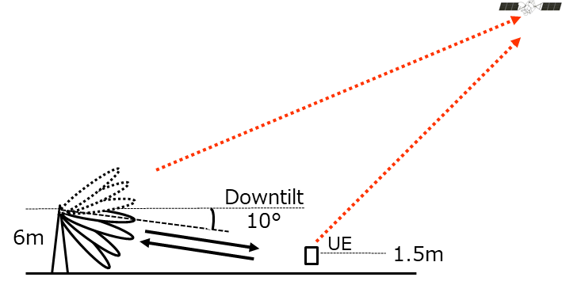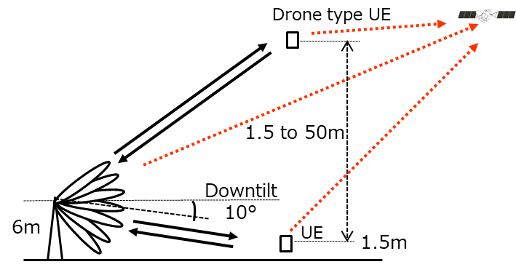

TABLE A-1

Specific parameters for drone type user terminal usage

|  |  |  |
| --- | --- | --- |
| IMT parameters | Outdoor suburban hotspot | Outdoor urban hotspot |
| User terminal characteristics | | |
| Drone type user terminal usage per all user terminals | 1 and 10 % | 1 and 10 % |
| User terminal height | 1.5 to 50 m  (uniform distribution) | 1.5 to 50 m  (uniform distribution) |
| Body loss resulting from proximity effects | 0 dB | 0 dB |

TABLE A-2

Typical parameters of IMT stations and their operational environment

| Parameter | BS | UE | Note |
| --- | --- | --- | --- |
| Maximum e.i.r.p. density | −65.0 dB(W/Hz) | −77.0 dB(W/Hz) | Calculated from Table 10 in Attachment 2 to Doc. 5‑1/36 (WP 5D)  48 dB(m/200 MHz) for BS  36 dB(m/200 MHz) for UE  In general, UE e.i.r.p density may be lower than the maximum value, as UE transmitter output power may be lower than the maximum transmitter output power due to power control. |
| Maximum antenna gain | 23 dBi | 17 dBi | Calculated from Table 10 in Attachment 2 to Doc. 5‑1/36 (WP 5D)  8x8 antenna array for BS  4x4 antenna array for UE |
| Deployment ratio | 0.12 (BSs/km2) | 0.395 (UEs/km2) | Calculated from Table 14 in Attachment 2 to Doc. 5‑1/36 (WP 5D)  BS density: 10 BSs/km2 (suburban), 30 BSs/km2 (urban)  Ra: 3% (suburban), 7% (urban)  Rb: 5%  (Ds_BS_suburban * Ra_suburban + Ds_BS_urban * Ra_urban) * Rb  UE density: 30 UEs/km2 (suburban), 100 UEs/km2 (urban)  (Ds_UE_suburban * Ra_suburban + Ds_UE_urban * Ra_urban) * Rb |
| Network loading factor | 20 % | N/A | 20% for wide area analysis |
| TDD activity factor | 80 % | 20 % |  |
| Array ohmic loss | 3 dB | 3 dB |  |
| Downtilt | 10 degrees | N/A |  |
| Body loss | N/A | 4 dB | Applied to scenario without drone type UEs |
| Indoor user terminal usage | N/A | 5 % |  |

## 1.2 Technical and operational characteristics of the fixed-satellite service (Earth-to-space) operating in the 24.65-25.25 GHz and 27-27.5 GHz frequency range

The typical parameters of FSS uplink operating in the 24.65-25.25 GHz and 27-27.5 GHz frequency band are assumed as shown in Table A-3 as obtained from Document 5-1/[89](https://www.itu.int/md/R15-TG5.1-C-0089/en) from Working Party 4A. The acceptable interference level at the satellite receiver is assumed as −10.5, −6 and 0 dB of the system noise level of satellite receiver for the different probabilities of 20% or average, 0.6% and 0.02%, respectively, which is under study in Working Party 4A.

TABLE A-3

Typical parameters in FSS uplink

| Parameter | Value | Note |
| --- | --- | --- |
| Satellite | Carrier #13, #14 | Doc. 5-1/89, 183 (WP 4A) |
| Receive frequency | 24.65-25.25, 27-27.5 GHz |  |
| System noise temperature (*Tsys*) | 400 K |  |
| Satellite antenna receive gain (*Gr*) | Section 1.1 of Annex 1 of  Rec. ITU-R S.672-4  LS=-25 | Peak value 46.6 dBi |
| Satellite *G/T* | 20.58 dB/K |  |
| Acceptable interference to noise ratio (*I/N*) | −10.5 dB (20% or average)  −6 dB (0.6%)  0 dB (0.02%) | Doc. 5-1/411 (WP 4A) |
| Beamwidth (3 dB down) | 0.80 degree |  |

## 1.3 Propagation models for sharing and compatibility studies in the 24.65-25.25 GHz and 27-27.5 GHz frequency range

Section 3.3 of Recommendation ITU-R P.2108 is applied to calculate the statistical distribution of clutter loss where the interference scenario is from IMT stations to a satellite station. It was used for applying clutter loss to take its random value based on the distribution of the stations for each calculation. Building entry loss was modelled according to Recommendation ITU-R P.2109, where building type of ‘traditional’ was conservatively assumed. In addition, free-space basic transmission loss, beam spreading loss, and atmospheric gas attenuation are taken into consideration based on Recommendation ITU-R P.619-3.

# 2 Methodology for the aggregate interference from IMT systems into FSS (Earth-to-space)

The geometry for the aggregate interference analysis in the FSS uplink is depicted in Figure A-2.

Figure A-2

Geometry for the uplink aggregate interface analysis

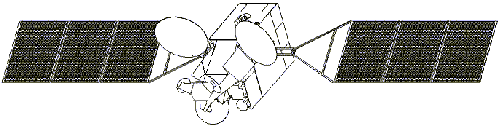

*ψ0*

the Earth

North

South

*x1*

*x2*

longitude

latitude

*y1*

*y2*

*ψ: off-axis angle*

3dB beam area

*H*

*R*

*α*

The methodology to calculate the ratio of the aggregated interference power to the receiver system noise, *I*/*N*, is as follows:

i)

The following equation (A-1) is repeated for all IMT stations (*i*) within the visible Earth (for *i*=1, 2,.. *N*).

 (A‑1)

where:

*Ii*: is the interference power spectrum density (dB(W/Hz)) received at the satellite from each IMT‑2020 station deployed in location (*i*);

*PIMT*: is the transmit power (dB(W/Hz)) of an IMT‑2020 station. For BS this is the maximum power, for UE this is the power which can be calculated using the up-link simulation methodology detailed in Recommendation ITU-R M.2101;

*GIMT,i*: is the IMT‑2020 station antenna gain (dBi) corresponding to the elevation angle to the satellite, which can be calculated using the simulation methodology detailed in Recommendation ITU-R M.2101;

*PL,i*: is the free space basic transmission loss (dB) over the interference path from the simulated IMT‑2020 deployed location (*i*) to the satellite detailed in Recommendation ITU-R P.619;

*Abs,i*: is the attenuation due to beam spreading (dB) over the interference path from the simulated IMT‑2020 deployed location (*i*) to the satellite detailed in Recommendation ITU-R P.619;

*Ag,i*: is the attenuation due to atmospheric gasses (dB) over the interference path from the simulated IMT‑2020 deployed location (*i*) to the satellite detailed in Recommendation ITU-R P.619;

*Lclutter,i*: is the random clutter loss in the interference path for location (*i*) (dB), calculated using the entire cumulative distribution of clutter losses as detailed in Recommendation ITU-R P.2108;

*PD*: is the polarization discrimination (dB);

*Lossbody*: is the loss due to the user’s body (only applicable where considering transmission from UEs) (dB);

*Gsat,n*: is the gain of the satellite receive antenna (dBi) in the direction of the IMT‑2020 deployed location (*i*);

*N*: is the number of IMT‑2020 BS or UE stations simulated.

ii)

The aggregated interference power density from BSs or UEs are calculated by equations (A-2a) and (A-2b), respectively.

 (A-2a)

 (A-2b)

where:

*Iagg_BS*: is the aggregated interference power density at the satellite receiver from IMT‑2020 BSs (dB(W/Hz));

*Iagg_UE*: is the aggregated interference power density at the satellite receiver from IMT‑2020 UEs (dB(W/Hz));

*PDL*: is BS TDD activity factor (as a ratio);

*PUL*: is UE TDD activity factor (as a ratio);

*NBS*: is the number of IMT-2020 BSs to be deployed within the visible Earth;

*NUE*: is the number of IMT-2020 UEs to be deployed within the visible Earth;

*Af*: is the IMT‑2020 network loading factor (as a ratio);

*IBS,i*: is the interference power spectrum density (dB(W/Hz)) received at the satellite from each IMT‑2020 BS deployed in location (*i*);

*IUE,i*: is the interference power spectrum density (dB(W/Hz)) received at the satellite from each IMT‑2020 UE deployed in location (*i*);

The total aggregated interference power density from all BSs and UEs is calculated by equation (A‑3).

 (A-3)

where:

*Iagg*: is the aggregated interference power density at the satellite receiver (dB(W/Hz));

iii)

The ratio of the aggregated interference power density to the receiver system noise density, *I*/*N*, is obtained by equation (A-4).

                dB (A-4)

where:

*k*: is Boltzmann’s constant = −228.6 dB(W/K/Hz);

*Tsys*: is satellite system noise temperature (K).

Further details of the methodology is referred to Study C in Attachment 3 to Annex 3 to Document 5-1/[478](https://www.itu.int/md/R15-TG5.1-C-0478/en).

# 3 Interim results

Both IMT BSs and UEs used beam forming antennas. The figure below shows the antenna gain distribution of micro BSs and UEs within the IMT network towards a satellite as for five locations with different elevation angles and distribution as for all deployment locations. Figure A-3 shows the antenna gain distribution, (a) from 342 micro BSs in 19 cells towards a satellite and (b) from 1 026 UEs in the 19 cells towards a satellite, for the scenario without drone type UEs. The Figure A-4 shows those for the scenario including drone type UEs. Simulations were performed with 10 000 snapshots based on Recommendation ITU-R M.2101.

Figure A-3

Antenna gain distribution from IMT network deployed in the 19 cells (342 micro BSs) towards satellite  
 (for the scenario without drone type UEs)

**a) IMT BS antenna gain towards satellite b) IMT UE antenna gain towards satellite**

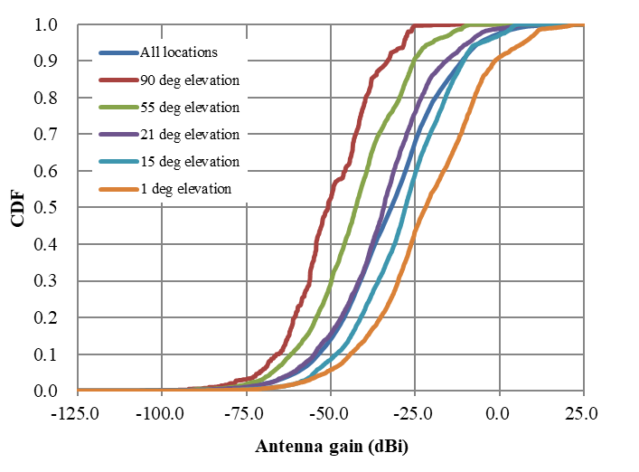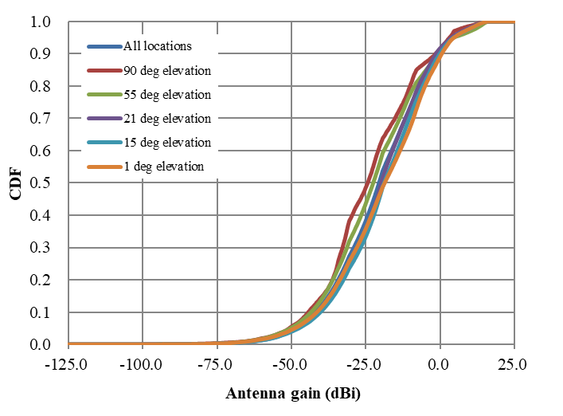

Figure A-4

Antenna gain distribution from IMT network deployed in the 19 cells (342 micro BSs) towards satellite  
 (for the scenario including drone type UEs (10% of all UEs))

**a) IMT BS antenna gain towards satellite b) IMT UE antenna gain towards satellite**

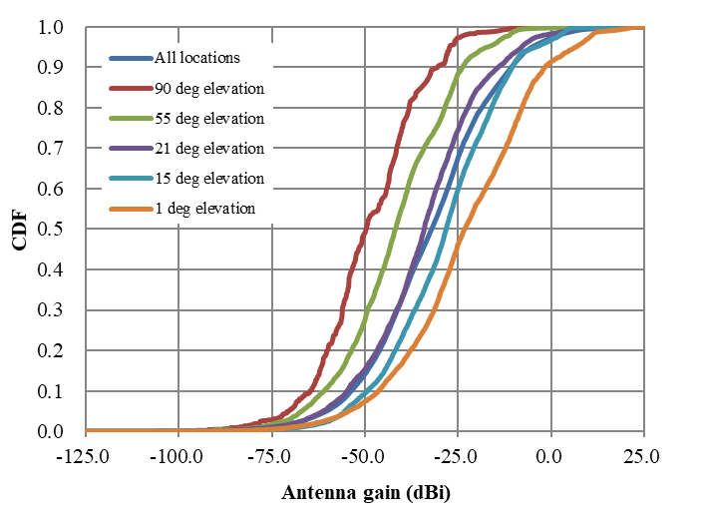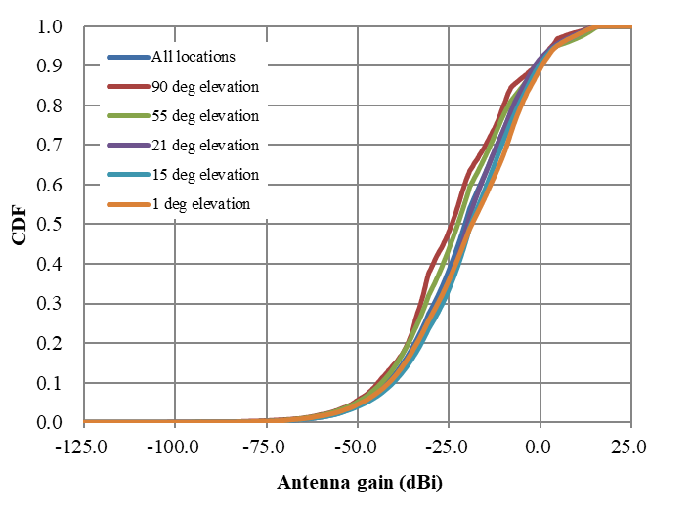

# 4 Simulation results for aggregated interference from distributed IMT network into FSS (Earth-to-space)

Figure A-5 shows the aggregated interference from a distributed IMT network to a satellite calculated by aggregating each scaled *I* value resulted from that in the 19 cells (342 micro BSs) for each deployment location (*n*) within visible Earth for the case without drone type UEs. In addition, Figures A-6 and A-7 show those for the cases including drone type UEs whose percentile of them is one and ten percent, respectively. Table A-4 shows a summary of the aggregated *I/N* from IMT‑2020 system to the satellite receiver where IMT networks are distributed within visible Earth for cases without drone type UEs and including drone type UEs.

Figure A-5

Aggregate *I/N* from IMT‑2020 system within visible Earth to the satellite receiver for cases of the satellite main beam pointing at 90, 45 and 15 degree elevation angles with random clutter loss  
 (for the scenario without drone type UEs)

**a) Aggregate *I/N* from BSs in visible Earth b) Aggregate *I/N* from UEs in visible Earth**

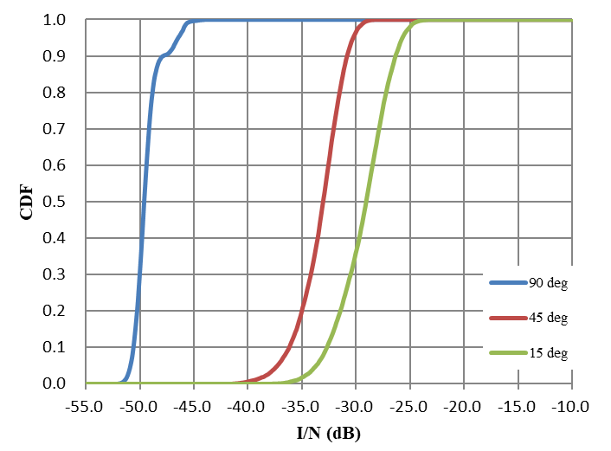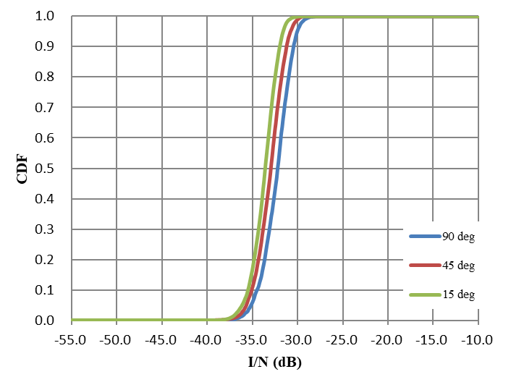

Figure A-6

Aggregate *I/N* from IMT‑2020 system within visible Earth to the satellite receiver for cases of the satellite main beam pointing at 90, 45 and 15 degree elevation angles with random clutter loss (for the scenario  
 including drone type UEs (1% of all UEs))

**a) Aggregate *I/N* from BSs in visible Earth b) Aggregate *I/N* from UEs in visible Earth**

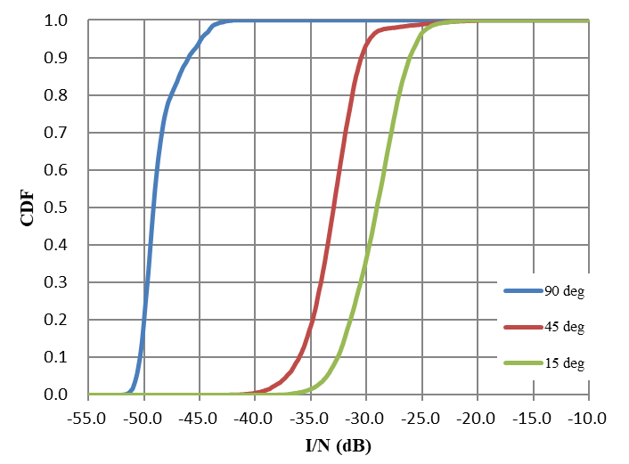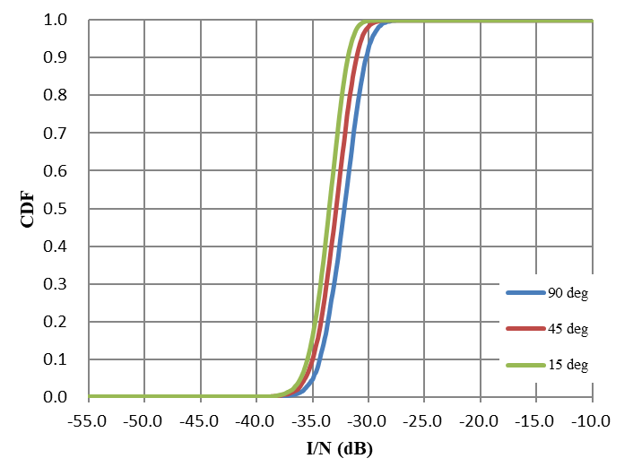

Figure A-7

Aggregate *I/N* from IMT‑2020 system within visible Earth to the satellite receiver for cases of the satellite main beam pointing at 90, 45 and 15 degree elevation angles with random clutter loss (for the scenario  
 including drone type UEs (10% of all UEs))

**a) Aggregate *I/N* from BSs in visible Earth b) Aggregate *I/N* from UEs in visible Earth**

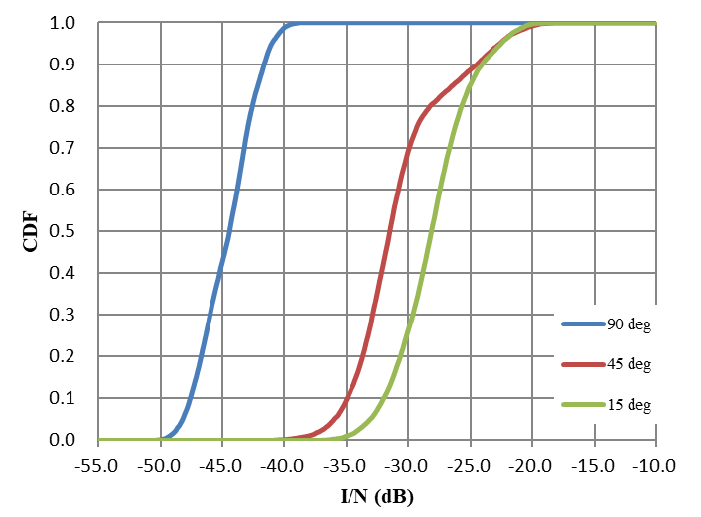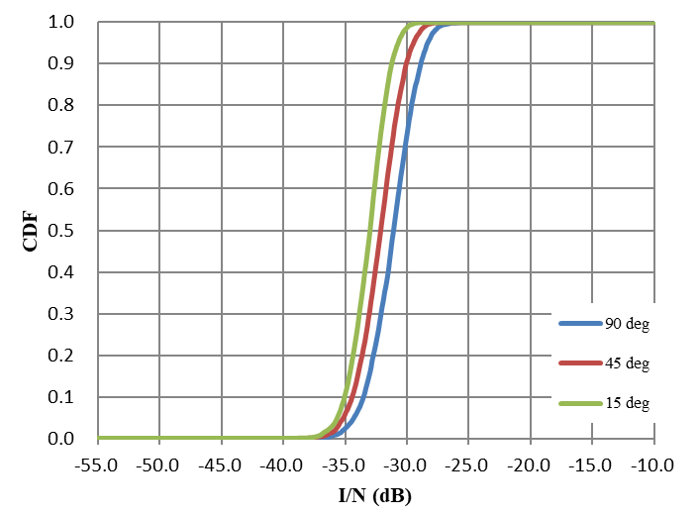

TABLE A-4

Summary of results of interference to noise ratio

|  |  |  |  |  |  |  |  |  |  |  |
| --- | --- | --- | --- | --- | --- | --- | --- | --- | --- | --- |
| Satellite main beam pointing (degree) | Probability (%) | Satellite protection criteria *I*/*N* (dB) | Without drone type UEs | | Including drone type UEs (1%) | | Degradation of aggregate *I*/*N*  (2)-(1) (dB) | Including drone type UEs (10%) | | Degradation of aggregate *I*/*N*  (3)-(1) (dB) |
| Aggregate *I*/*N* (dB) | Interference margin (dB) | Aggregate *I*/*N* (dB) | Interference margin (dB) | Aggregate *I*/*N* (dB) | Interference margin (dB) |
| 90 | 0.02 | 0 | −27.6 | 27.6 | −27.2 | 27.2 | 0.4 | −25.4 | 25.4 | 2.2 |
| 0.6 | −6 | −28.8 | 22.8 | −28.3 | 22.3 | 0.5 | −26.9 | 20.9 | 1.9 |
| 20 | −10.5 | −30.8 | 20.3 | −30.7 | 20.2 | 0.1 | −29.4 | 18.9 | 1.4 |
| mean | −31.9 | 21.4 | −31.8 | 21.3 | 0.1 | −30.5 | 20.0 | 1.4 |
| 45 | 0.02 | 0 | −25.4 | 25.4 | −19.2 | 19.2 | 6.2 | −17.6 | 17.6 | 7.8 |
| 0.6 | −6 | −26.4 | 20.4 | −22.2 | 16.2 | 4.2 | −19.1 | 13.1 | 7.3 |
| 20 | −10.5 | −28.5 | 18.0 | −28.4 | 17.9 | 0.1 | −26.3 | 15.8 | 2.2 |
| mean | −29.8 | 19.3 | −29.3 | 18.8 | 0.5 | −26.9 | 16.4 | 2.9 |
| 15 | 0.02 | 0 | −22.2 | 22.2 | −19.7 | 19.7 | 2.5 | −18.2 | 18.2 | 4.0 |
| 0.6 | −6 | −23.4 | 17.4 | −22.1 | 16.1 | 1.3 | −19.8 | 13.8 | 3.6 |
| 20 | −10.5 | −26.0 | 15.5 | −25.9 | 15.4 | 0.1 | −24.6 | 14.1 | 1.4 |
| mean | −27.4 | 16.9 | −27.2 | 16.7 | 0.2 | −25.9 | 15.4 | 1.5 |

# 5 Summary and analysis of the results

This study has addressed a scenario when IMT stations interfere to the FSS satellite for co-frequency scenario. The aggregate interference simulations from an IMT network towards the FSS satellite have been performed in the 24.25-27.5 GHz frequency band with considering drone type UE usage. This study provided calculated *I/N* values for such three different cases of elevation angles of the FSS satellite main beam pointing as 90, 45 and 15 degrees. The calculated mean value of *I/N* was less than −25.9 dB in any elevation angle, which satisfies −10.5 dB of the long-term protection criterion for FSS provided by WP4A. In addition, the calculated *I/N* values not exceeding the probabilities of 0.6 and 0.02 % were less than −19.1 and −17.6 dB, respectively, at any elevation angle, which satisfy −6 and 0 dB of short-term protection criteria for the FSS, respectively.

It is noted that the interference margin was 15.4 dB (= 1.5 dB degradation from the baseline assumption) even assuming the tenth percentile of all UEs as drone type UE, where the calculated *I/N* mean value was resulted, as the worst case, in the 15 degrees elevation angles of satellite main beam pointing with respect to the long-term FSS protection criteria (*I/N* −10.5 dB), while the worst-case margin was 13.1 dB (= 7.3 dB degradation from the baseline assumption) with respect to the short-term FSS protection criteria in the 45 degrees elevation angle of satellite main beam pointing. This means that the increase in the amount of interference from certain IMT base stations whose antenna pointing above the horizon would be dominant.

Furthermore, the probability of interference may vary according to the ratio of drone type UEs. When varying the ratio of drone type UEs from 1 to 10 percent, it is understood that the worst-case margin varies from 16.7 dB to 15.4 dB (0.2-1.5 dB degradation from the baseline assumption) with respect to the long-term FSS protection criteria, and from 16.1 dB to 13.1 dB (1.3-3 dB degradation from the baseline assumption) with respect to the short-term FSS protection criteria.

Based on the above, it could be concluded that there is still positive margin at least 13.1 dB in the case where the ratio of drone type UEs are from 1 to 10 percent of all UEs.

# 6 Conclusion

It is proposed that the restriction on the antenna main beam pointing of IMT base stations below the horizon should not be mandatory in options for Condition A2e to protect the FSS (Earth-to-space) receiving space stations in WRC-19 agenda item 1.13.

______________

1. * It is assumed that only a very limited number of IMT mobile stations will be communicating with IMT base stations whose main beam pointing are above the horizon.
2. It is assumed that only a very limited number of IMT mobile stations will be communicating with IMT base stations whose main beam pointing are above the horizon.