|  |  |
| --- | --- |
| **World Radiocommunication Conference (WRC-15) Geneva, 2–27 November 2015** |  |
| **INTERNATIONAL TELECOMMUNICATION UNION** |  |
|  |  |
| PLENARY MEETING | **Addendum 21 to Document 132-E** |
|  | **19 October 2015** |
|  | **Original: English** |
|  | |
| United Kingdom of Great Britain and Northern Ireland | |
| Proposals for the work of the conference | |
|  | |
| Agenda item 7(H) | |

7 to consider possible changes, and other options, in response to Resolution 86 (Rev. Marrakesh, 2002) of the Plenipotentiary Conference, an advance publication, coordination, notification and recording procedures for frequency assignments pertaining to satellite networks, in accordance with Resolution **86 (Rev.WRC‑07)** to facilitate rational, efficient, and economical use of radio frequencies and any associated orbits, including the geostationary‑satellite orbit;

7(H) Issue H – Using one space station to bring frequency assignments at different orbital locations into use within a short period of time

Introduction

It is generally acknowledged that the practice of using one space station to bring into use frequency assignments to stations of satellite networks located at different orbital locations within a short period of time may affect the equitable access to limited spectrum resources.

The United Kingdom also notes that making the practice above easier to carry out was not the intent of WRC-12 when that Conference adopted the revisions to Nos. 11.44, 11.44.1, 11.44B and 11.49.

Today, a single satellite may in theory be moved from one orbital location to another to bring into use the frequency assignments of the latter by operating there for a minimum of 90 days. In accordance with the current rules, the responsible administration may then suspend the same frequency assignments and move the same satellite to a third orbital location and repeat the process again. By carrying out this practice, that administration may keep its spectrum rights at multiple orbital locations for three years by just keeping a satellite there for a very limited period of time. Although we acknowledge that there may be legitimate reasons why an administration would carry out such a manoeuvre (e.g., to support a real satellite project which may suffer from a delay or an unexpected event), we believe that the current rules are open to misuse.

Taking into account that defining what constitutes misuse in the application of Nos. 11.44, 11.44.1, 11.44B and 11.49 would be a complex task, the UK is of the view that WRC-15 should put in place some rules which would introduce some constraints on the manoeuvres available to administrations for their satellites, without affecting those which need to manage their spacecraft to support real projects.

We are also of the view that the information related to the movement of satellites which are used to bring into use frequency assignments to stations of GSO networks and to the possible suspension of the same frequency assignments should be made available on the ITU website promptly in order to increase the transparency in the application of the abovementioned provisions. We propose that this comes into force as soon as practically possible after the end of WRC-15.

Furthermore, taking into account that it takes several years for a satellite project to be realised from its inception and from the start of the regulatory process, we propose that the limitations illustrated in Section 2 and detailed further in this document come into force in around 5 years’ time, so as to give to those administrations that have satellite projects which will make use of satellite filings well into the ITU process the necessary regulatory certainty to complete them successfully.

Proposal

Our experience suggests that when a satellite is used to bring into use assignments at several different orbital locations, the likelihood of this being a misuse of the regulations is greater if this is associated with a suspension.

In order to limit such a potential misuse we propose to limit to once in any three years the following three-step event, also illustrated in *Figure 1*:

• A satellite *S* uses one or more frequency assignments at a given orbital location *A*;

• Satellite *S* vacates the orbital location *A* and is moved to another orbital location *B*, bringing into use the associated frequency assignment(s);

• The administration responsible for satellite *S* suspends the relevant frequency assignment(s) at orbital location *A*.

Figure 1

Illustration of the proposed limitation

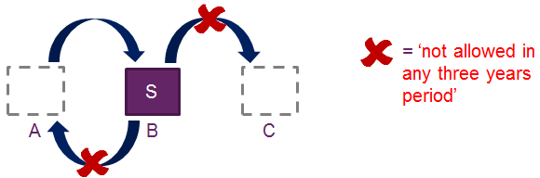

We also propose that, when declaring the bringing into use, or resumption of use after suspension, of frequency assignments to geostationary satellite networks, the relevant administration shall indicate to the Bureau whether this has been done with a newly-launched satellite or with an already in-orbit satellite. Furthermore, the administration should provide the Bureau with the following information, covering the timespan of at least three years prior to the date when the declaration is sent:

• the orbital location(s) where the in-orbit satellite was previously positioned;

• under which satellite network(s) at the previous orbital location(s) the in-orbit satellite was operating;

• if any frequency assignments at the previous orbital location(s) has been suspended; and

• the date at which the in-orbit satellite left the previous orbital location(s).

We propose for the information above to be published on the ITU website[1] promptly so as to improve the transparency available to administrations.

Taking into account the information above, the Bureau shall then verify whether the request of the administration would be in breach of the limitations illustrated in Figure 1; if it is, the Bureau shall refer the case to the Radio Regulations Board (RRB). Upon consideration, if the RRB confirms the Bureau’s conclusion, it shall consider the frequency assignments to the geostationary satellite network as not having been brought into use, or brought back into use, and instruct the Bureau accordingly.

In order to better understand the very limited reduction of flexibility to administrations from our proposal, we have carried out an analysis on several cases, comparing what is possible under the current rules and what would be possible under our proposal. A graphic summary of our analysis is available in Figure 2 below.

Figure 2

Analysis of the impact of the proposal

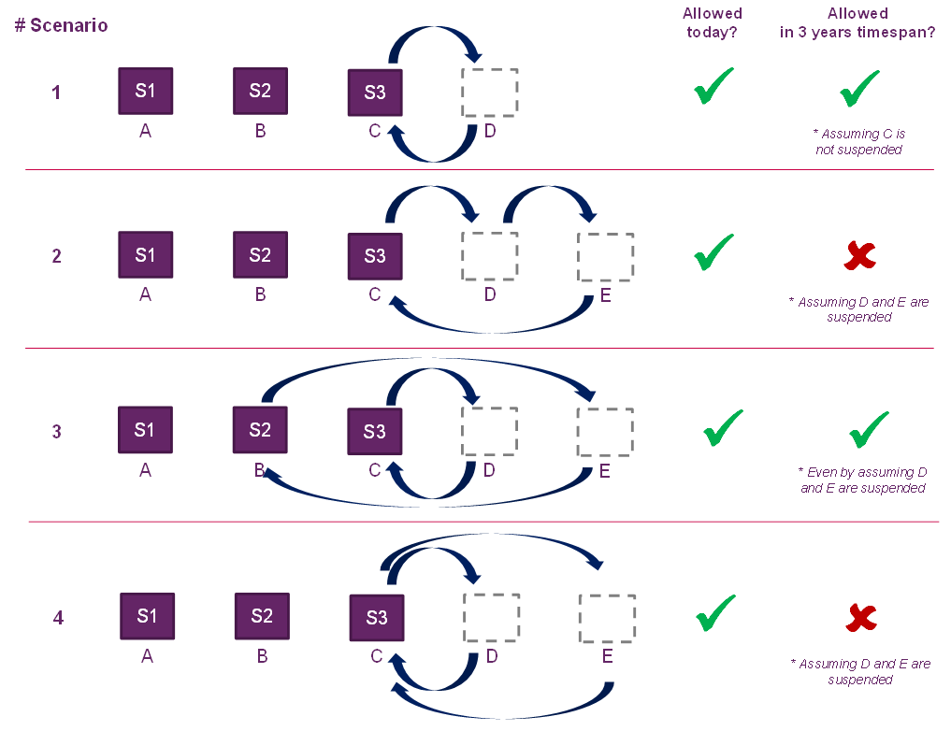

Proposed amendments to the Radio Regulations

ARTICLE 11

Notification and recording of frequency   
assignments1, 2, 3, 4, 5, 6, 7, 7*bis*    (WRC‑12)

Section II − Examination of notices and recording of frequency assignments   
in the Master Register

MOD G/132A21/1

11.44B A frequency assignment to a space station in the geostationary-satellite orbit shall be considered as having been brought into use when a space station in the geostationary-satellite orbit with the capability of transmitting or receiving that frequency assignment has been deployed and maintained at the notified orbital position for a continuous period of ninety days. The notifying administration shall so inform the Bureau within thirty days from the end of the ninety-day periodADD 11.44B.X.    (WRC‑15)

ADD G/132A21/2

_______________

11.44B.X Resolution [G-A7(H)] (WRC-15) applies.

ADD G/132A21/3

Draft New Resolution [G-A7(H)] (WRC-15)

Use of one space station to bring frequency assignments to geostationary satellite networks at different orbital locations into use within a short period of time

The World Radiocommunication Conference (Geneva, 2015),

considering

*a)* that the use of the same space station to bring into use frequency assignments to geostationary satellite networks located at different orbital locations within a short period of time could lead to an inefficient use of spectrum/orbit resources;

*b)* that there may be legitimate reasons why a notifying administration may need to move a spacecraft from one orbital position to a new orbital position, depending on the specific case;

*с)* that in developing new provisions, care needs to be taken not to constrain satellite manoeuvres due to legitimate fleet management;

*d)* that a satellite project takes several years to be realized from the initial conception of its design;

*e)* that one of the most significant risks that administrations wishing to deploy a real satellite project have to deal with consists in the regulatory uncertainty caused by entries in the BR International Frequency Information Circular (BR IFIC) and the Master International Frequency Register (MIFR) which do not correspond to real satellite networks and systems,

noting

*a)* that WRC‑12 recognized that in adopting revisions of Nos. **11.44**, **11.44.1**, **11.44B** and **11.49**,the issue of using one space station to bring into use frequency assignments at different orbital locations within a short period of time was not the intent of these new provisions;

*b)* that WRC‑12 requested the ITU‑R to further study this issue and decided that, until ITU‑R studies are completed, when an administration brings into use frequency assignments at a given orbital location using an already in-orbit satellite, the Bureau is requested to make an enquiry to that administration as to the last previous orbital location/frequency assignments brought into use with that satellite and make such information available,

resolves

1 that an administration responsible for a space station using one or more frequency assignments at a given orbital location shall not make such a space station vacate that orbital location, suspend the relevant frequency assignments, and bring into use, or bring back into use, with the same space station, one or more frequency assignments at another orbital location more than once within any three years;

2 that, when declaring bringing into use, or resumption of use after suspension, of frequency assignments to geostationary satellite networks, notifying administrations shall indicate to the Bureau whether this has been done with a newly-launched satellite or with an already in-orbit satellite (for the sole purpose of this Resolution, a newly-launched satellite is one that has never brought into use, or brought back into use, any other frequency assignments);

3 that, in cases where a notifying administration declares, pursuant to *resolves*2 above, that it has brought into use, or resumed the use after suspension of, frequency assignments to geostationary satellite networks with an already in-orbit satellite, the notifying administration shall also indicate the orbital location(s) where the in-orbit satellite was previously positioned, under which satellite network(s) at the previous orbital location(s) the in-orbit satellite was operating, if any frequency assignments at the previous orbital location(s) has been suspended and the date at which the in-orbit satellite left the previous orbital location(s); this information shall cover a timespan of at least three years prior to the date when the declaration is sent;

4 that, if the information provided by the notifying administration under *resolves* 3 above shows that the bringing into use or the bringing back into use after suspension contradicts *resolves* 1 above, the Bureau shall refer the case to the Radio Regulations Board;

5 that, if, following consideration of a case referred by the Bureau under *resolves*4 above, the Radio Regulations Board concludes that the bringing into use or the bringing back into use after suspension contradicts *resolves* 1 above, it shall instruct the Bureau to consider the frequency assignments to the geostationary satellite network as not having been brought into use, or brought back into use,

resolves further

1 that the provisions contained in *resolves* 2 and 3of this Resolution shall come into force immediately;

2 that the provisions contained in *resolves* 1, 4 and 5of this Resolution shall come into force on 1 January 2021;

instructs the Radiocommunication Bureau

to make available the information provided in *resolves*2 and 3 on the ITU website within 30 days of its receipt.

______________

1. As explained in Section 1, we propose that the mandatory publication of the information indicated in this paragraph shall come into force as soon as practically possible after WRC-15.