|  |  |
| --- | --- |
| **World Radiocommunication Conference (WRC-15) Geneva, 2–27 November 2015** |  |
| **INTERNATIONAL TELECOMMUNICATION UNION** |  |
|  |  |
| PLENARY MEETING | **Document 90-E** |
|  | **16 October 2015** |
|  | **Original: French** |
|  | |
| France | |
| Proposals for the work of the conference | |
|  | |
| Agenda item 1.5 | |

1.5 to consider the use of frequency bands allocated to the fixed-satellite service not subject to Appendices **30**, **30A** and **30B** for the control and non-payload communications of unmanned aircraft systems (UAS) in non-segregated airspaces, in accordance with Resolution **153 (WRC‑12)**;

Introduction

Resolution 153 (WRC-12) recognizes:

“*f)* that the use of FSS for the UAS CNPC links, including but not limited to the links between geostationary satellite and mobile elements of the UAS, has to ensure the protection of incumbent services”.

Thus, in the absence of a report validated by ITU-R on this subject and in the event of agreement on the other arrangements required to permit the authorization of FSS links for control and non-payload communications of drones in non-segregated airspace, the purpose of this contribution is to provide proposed technical arrangements for protection of the fixed service within the framework of WRC agenda item 1.5. The “Proposals” section presents the power-flux density masks at the Earth's surface to be respected by drones communicating with an FSS satellite in order to protect FS receiving stations, while the Annex to the document presents the hypotheses and methodology employed to obtain the masks as well as the results of simulations to back them up in regard to short- and long-term protection criteria for the fixed service.

Proposals

To ensure protection of the fixed service from an emission of a drone communicating with a satellite, the proposals consist in requiring compliance with the following technical arrangements in the candidate frequency bands for drones which are also used by the fixed service on a co-primary basis with FSS.

The proposals set out in this document are intended to be integrated in the multi-country contribution in WRC‑15 Document 115, in the annex setting the pfd limits to be respected by earth stations.

F/90/1

In the frequency band 14-14.5 GHz used by FS networks, within line-of-sight of the territory of an administration where FS networks are operating in this band, the maximum pfd produced at the surface of the Earth by emissions from a single station on board a drone and operating in the FSS should not exceed:

–124 dB(W/(m2 · MHz)) for θ ≤ 5°

–124+ 0.5 *( θ – 5)2 dB(W/(m2 · MHz)) for 5° < θ ≤ 10°

–122+ 28.5*log10(θ – 5) dB(W/(m2 · MHz)) for 10° < θ ≤ 50°

–75 dB(W/(m2 · MHz)) for 50° < θ ≤ 90°

where θ is the angle of arrival of the radio-frequency wave.

In the frequency band 27.5-28.6 GHz used by FS networks, within line-of-sight of the territory of an administration where FS networks are operating in this band, the maximum pfd produced at the surface of the Earth by emissions from a single station on board a drone and operating in the FSS should not exceed:

–131 dB(W/(m2 · MHz)) for θ ≤ 5°

–131+ 0.5 *( θ – 5)2 dB(W/(m2 · MHz)) for 5° < θ ≤ 10°

–128+ 23.8*log10(θ) dB(W/(m2 · MHz)) for 10° < θ ≤ 15°

–100 dB(W/(m2 · MHz)) for 15° < θ ≤ 90°

where θ is the angle of arrival of the radio-frequency wave.

**Reasons:** To protect terrestrial services in the bands 14-14.5 GHz and 27.5-29.5 GHz from interference that might be caused by emissions from earth stations on board drones.

Annex

Description of the methodology and simulation results

# 1 Introduction

This annex describes the studies carried out to determine the proposed pfd mask to ensure protection of all FS stations.

# 2 Methodology

a) Principle

The scenario consists in determining whether the protection criteria for an FS station are respected with non-stop co-channel line-of sight operation during a period of one month of a single drone.

The drone's flight plan is defined randomly on great-circle trajectories at constant altitude and speed.

b) Process

The figure below shows the stages of the methodology adopted.

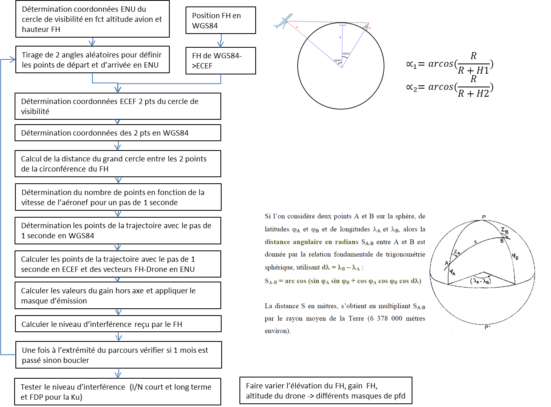

Vary the radio station height, radio station gain, drone altitude - > different pfd masks

Test the interference level (short- and long-term I/N and FDP for Ku)

At end of path, check 1 month has elapsed, otherwise restart

Calculate the level of interference received by the radio station

Calculate the off-axis gain values and apply the emission mask

Determine the path points with 1 second increments in ECEF and the radio station – drone vectors in ENU

Determine the path points with 1 second increments in WGS84

Radio station WGS84 > ECEF

WGS84 location of radio station

Determine the number of points according to the speed of the aircraft for a 1 second increment

Calculate the great-circle distance between the two points of the radio station circumference

Determine WGS84 coordinates of the two points

Determine ECEF coordinates for two points of line-of-sight circle

Draw two random angles to define ENU start and end points

Determine ENU coordinates of the circle according to aircraft altitude and radio station height

If we consider two points A and B on the sphere, of latitudes ϕA and ϕB and longitudes λA and λB , then the angular distance in radians SA-B between A and B is given by the fundamental spherical trigonometry relation, using dλ = λ B – λ A:

SA – B = arc cos (sin ϕA sin ϕB + cos ϕA cos ϕB cos dλ)

The distance S in metres is obtained by multiplying SA-B by the average radius of the Earth (approximately 6 378 000 m).

c) Geometry

**i) Principle**

According to WGS84  definitions:

Semi-major axis: a = 6 378 137 m

Flattening coefficient: f = 1/298.257223563

The following parameters are inferred:

Semi-minor axis: b = a(1-f) = 6 356 752.3142 m

First excentricity: e = $\sqrt{2f-f^{2}}$ = 8.1819190842622*10^-2

Second excentricity: e’ = $\sqrt{f\frac{2-f}{{(1-f)}^{2}}}$ = 8.2094437949696*10^-2

Mean radius of the semi-axes : R1 = 6 371 008.7714 m

The different references used are the following:

– ECEF (Earth-Centered, Earth-Fixed)

– WGS84 (World Geodetic System 84)

– ENU (East, North, Up).

They are presented in the figure below, where the angles φ and λ represent respectively the WGS84 latitude et la longitude.

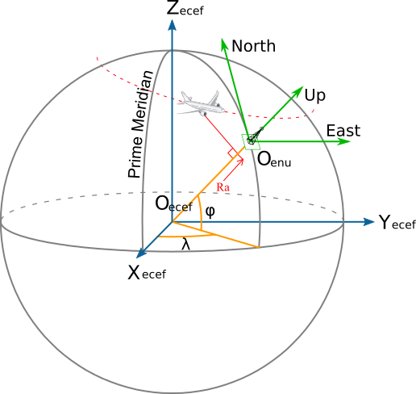

**ii) Receiver: Fixed-service station**

The position of the FS station is randomly defined:

– Latitude, 0°

– Longitude, 0°

The antenna height of the station used for the study is 30m.

**iii) Transmitter: Station on board the drone**

The drone’s trajectory is defined by an entry point and an exit point randomly selected on the radio station’s line-of-sight circle, then by the points linearly distributed on the major axis between those two points (see figure below for an example with a flight path over the radio station).

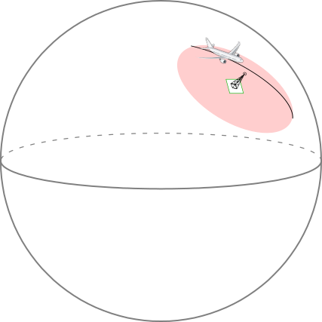

The figure below shows the parameters used to define the line-of-sight circle:

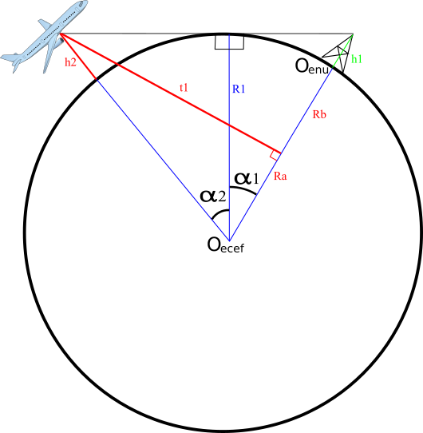

$$∝_{1}=arcos(\frac{R}{R+H1})$$

$$∝_{2}=arcos(\frac{R}{R+H2})$$

$$PtCirconference_ENU(θ)=\left\{\begin{aligned}\left(R+H2\right)*\sin\left(∝_{1}+∝_{2}\right)*cos(θ) \\ \left(R+H2\right)*\sin\left(∝_{1}+∝_{2}\right)*sin(θ) \\ -R+\left(R+H2\right)*cos\left(∝_{1}+∝_{2}\right)\end{aligned}\right.$$

# 3 Analysis in the band 14/10 GHz

a) Characteristics of the emission

**i) PFD masks**

Various masks in the band considered were analysed.

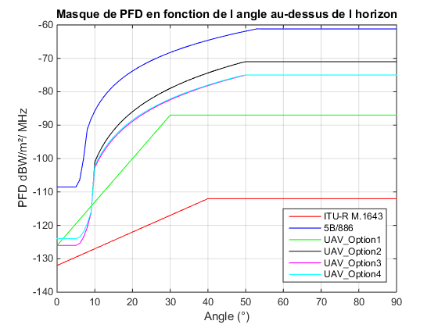

**PFD mask as a function of angle above horizon**

The proposed mask in Annex 1 corresponds to the mask UAV_Option4_Ku.

**b) Receiver characteristics**

**i) Receiver antenna gain**

The maximum antenna gain used for the studies is selected, respectively, as 49, 45, 35, 28 or 18 dBi.

The antenna pattern is based on Recommendation ITU-R F.1245 for point-to-point (P-P) links.

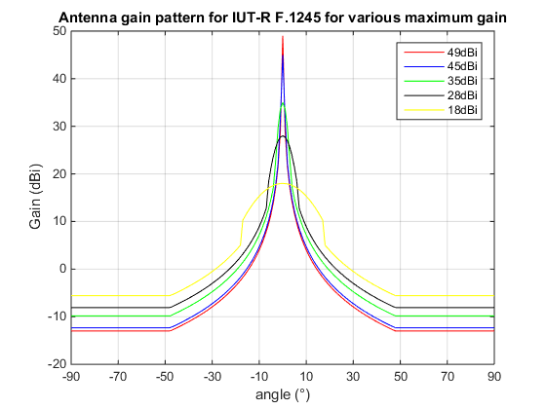

**ITU-R**

For point-to-multipoint (P-MP) links, the antenna pattern to be used would be that in Recommendation ITU-R F.1336.

**ii) Receiver antenna elevation**

For the receiver elevation, the following values are taken into account: 0°, 1°, 2°, 3°, 4° and 5°.

**iii) Analysis of FS protection criteria**

**1) Interference level**

The interference level is obtained by applying the following formula:

$I=PFD+G_{Rec}-10*log10({4π(\frac{f}{c})}^{2}$)

with: f in Hz

c in m/s

Thus: $I=PFD+G_{Rec}-44$ at 14 GHz.

**2) Noise level**

The noise level considered for 14 MHz was set at –126.5 dBW and for 1 MHz is set at –138 dBW, and obtained from the following equations, with a noise figure of 6 dB:

Receiver_Noise_dBm = –114 + 10.*log10(BANDWIDTH_MHz) + Noise_Figure_dB

Receiver_Noise_dBW = Receiver_Noise_dBm – 30;

**3) Protection criteria**

Recommendation ITU-R F.758 describes the principle and also levels for protection criteria in terms of I/N for both long-term and short-term time percentages, and in terms of fractional degradation in performance (FDP).

The long-term criterion consists in not exceeding an I/N level of –10 dB for more than 20% of the time in the case of co-primary services. In this case, the FDP must also respect a threshold of 10% according to the methodology set out in in Recommendation ITU-R F.1108.

Recommendation ITU-R F.1494 proposes a methodology for determining the short-term FS protection criterion.

The worst case corresponds to an I/N of 19 dB with a time percentage of 9.52.E-04.

Description

The total fade margin is taken at 37 dB for a bit error rate (BER) of 10-3 and automatic transmission power control (ATPC) of 13 dB. The fade margin for the severely errored second (SES) ratio is 1 dB less and 5 dB less for the errored second (ES) ratio. The short-term I/N criterion is selected such that the net calculated margin is positive.

The performance degradation is linked to the time percentage p by the following equation:

The time percentage associated with the I/N threshold is calculated with the following equation:

where:

EPO: error performance objective (%)

Error performance objective (EPO) is substituted by the parameters errored second ratio (ESR) and severely errored second ratio (SESR) (Rec. ITU-R F.1565).

DstEPO: standard EPO degradation (10% included in the calculations in the tables).

DP (%): performance degradation due to interference (cf. Rec. ITU-R F.1565; = ESR(%) or SESR(%) as appropriate).

p: percentage of time during which the short-term I/N ratio may be exceeded (%).

A: percentage of time during which the adopted fade margin may be exceeded (%) (see Recommendation ITU-R P.530)

Time percentage for the severely errored second (SES) ratio of an   
FS station participating in an international network

|  |  |  |
| --- | --- | --- |
| Parameters | Value | Source |
| FM for BER 10-3 (dB) | 37 | Rec. ITU-R F.1494 |
| FM for SES (dB) | 36 | Rec. ITU-R F.1494 |
| ATPC (dB) | 13 |  |
| Short-term *I/N* (dB) | 20 | Adopted value |
| Net FM for SES (dB) | 3 |  |
| SESR (%) | 0.0002 | Rec. ITU-R F.1565 Table 1a – 500 km |
| Probability of exceeding FM (%) | 3.3 | Rec. ITU-R P.530 |
| Short-term protection criterion time percentage (%) | 6.06E-03 |  |

Time percentage for the errored second (ES) ratio of an FS station   
participating in an international network

|  |  |  |
| --- | --- | --- |
| Parameters | Value | Source |
| FM for BER 10-3 (dB) | 37 | Rec. ITU-R F.1494 |
| FM for ES (dB) | 32 | Rec. ITU-R F.1494 |
| ATPC (dB) | 13 |  |
| Short-term *I/N* (dB) | 19 | Adopted value |
| Net FM for ES (dB) | 0 |  |
| ESR (%) | 0.001 | Rec. ITU-R F.1565 Table 1a – 500 km |
| Probability of exceeding FM (%) | 63 | Rec. ITU-R P.530 |
| Short-term protection criterion time percentage (%) | 1.59E-03 |  |

Time percentage for the severely errored second (SES) ratio of an FS station   
participating in a national long-distance network

|  |  |  |
| --- | --- | --- |
| Parameters | Value | Source |
| FM for BER 10-3 (dB) | 37 | Rec. ITU-R F.1494 |
| FM for SES (dB) | 36 | Rec. ITU-R F.1494 |
| ATPC (dB) | 13 |  |
| Short-term *I/N* (dB) | 20 | Adopted value |
| Net FM for SES (dB) | 3 |  |
| SESR (%) | 0.00012 | Rec. ITU-R F.1565 Table 3a – 50 km |
| Probability of exceeding FM (%) | 3.3 | Rec. ITU-R P.530 |
| Short-term protection criterion time percentage (%) | 3.64E-03 |  |

Time percentage for the errored second (ES) ratio of an FS station   
participating in a national long-distance network

|  |  |  |
| --- | --- | --- |
| Parameters | Value | Source |
| FM for BER 10-3 (dB) | 37 | Rec. ITU-R F.1494 |
| FM for ES (dB) | 32 | Rec. ITU-R F.1494 |
| ATPC (dB) | 13 |  |
| Short-term *I/N* (dB) | 19 | Adopted value |
| Net FM for ES (dB) | 0 |  |
| ESR (%) | 0.0006 | Rec. ITU-R F.1565 Table 3a – 50 km |
| Probability of exceeding FM (%) | 63 | Rec. ITU-R P.530 |
| Short-term protection criterion time percentage (%) | 9.52E-04 |  |

Time percentage for the severely errored second (SES) ratio of an FS station   
participating in a national short-distance network

|  |  |  |
| --- | --- | --- |
| Parameters | Value | Source |
| FM for BER 10-3 (dB) | 37 | Rec. ITU-R F.1494 |
| FM for SES (dB) | 36 | Rec. ITU-R F.1494 |
| ATPC (dB) | 13 |  |
| Short-term *I/N* (dB) | 20 | Adopted value |
| Net FM for SES (dB) | 3 |  |
| SESR (%) | 0.0015 | Rec. ITU-R F.1565 Table 5a |
| Probability of exceeding FM (%) | 3.3 | Rec. ITU-R P.530 |
| Short-term protection criterion time percentage (%) | 4.55E-02 |  |

Time percentage for the errored second (ES) ratio of an FS station participating   
in a national short-distance network

| Parameters | Value | Source |
| --- | --- | --- |
| FM for BER 10-3 (dB) | 37 | Rec. ITU-R F.1494 |
| FM for ES (dB) | 32 | Rec. ITU-R F.1494 |
| ATPC (dB) | 13 |  |
| Short-term *I/N* (dB) | 19 | Adopted value |
| Net FM for ES (dB) | 0 |  |
| ESR (%) | 0.0075 | Rec. ITU-R F.1565 Tables 4a and 5a |
| Probability of exceeding FM (%) | 63 | Rec. ITU-R P.530 |
| Short-term protection criterion time percentage (%) | 1.19E-02 |  |

**c) Examples of I/N ratio cumulative distribution function**

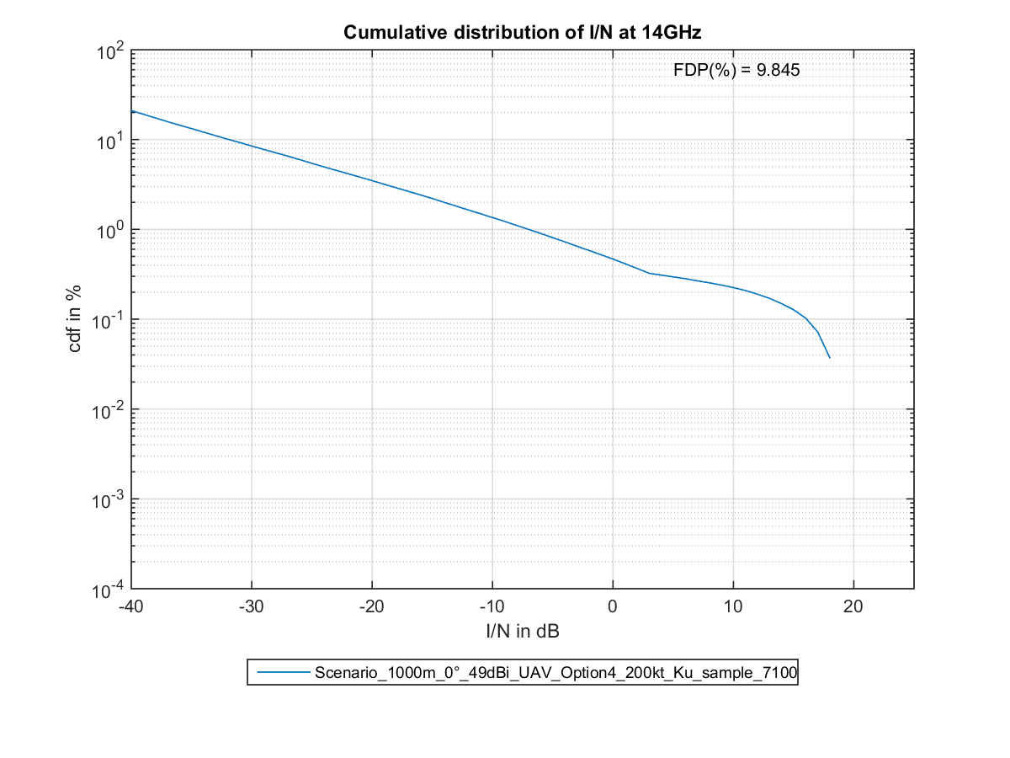

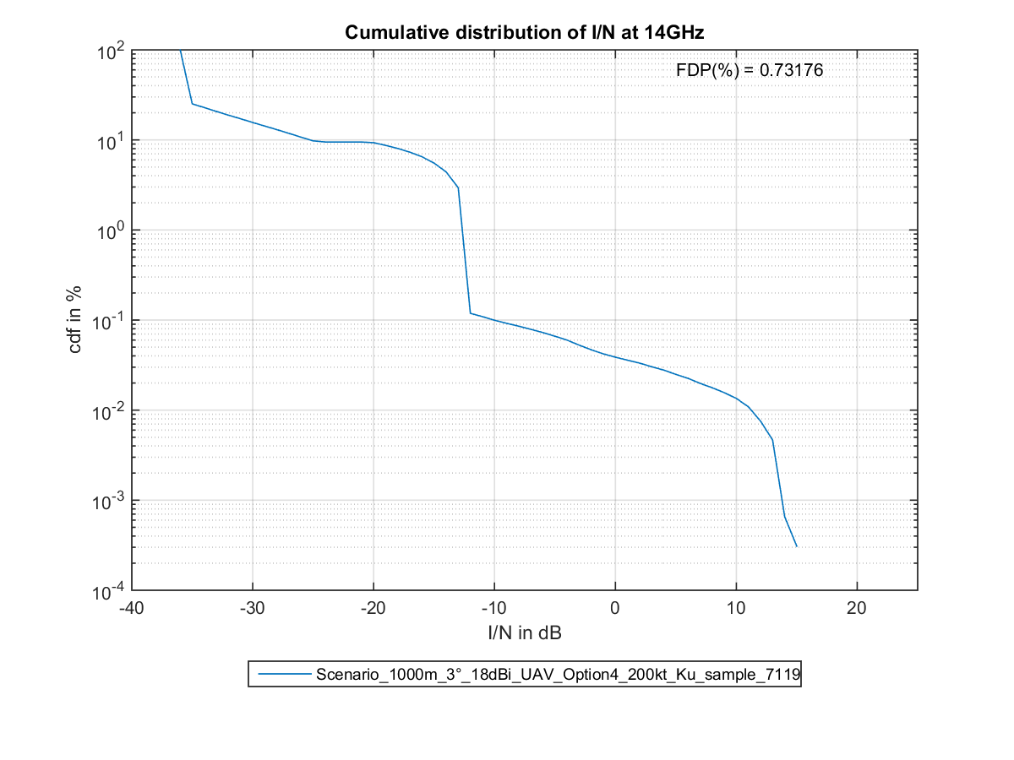

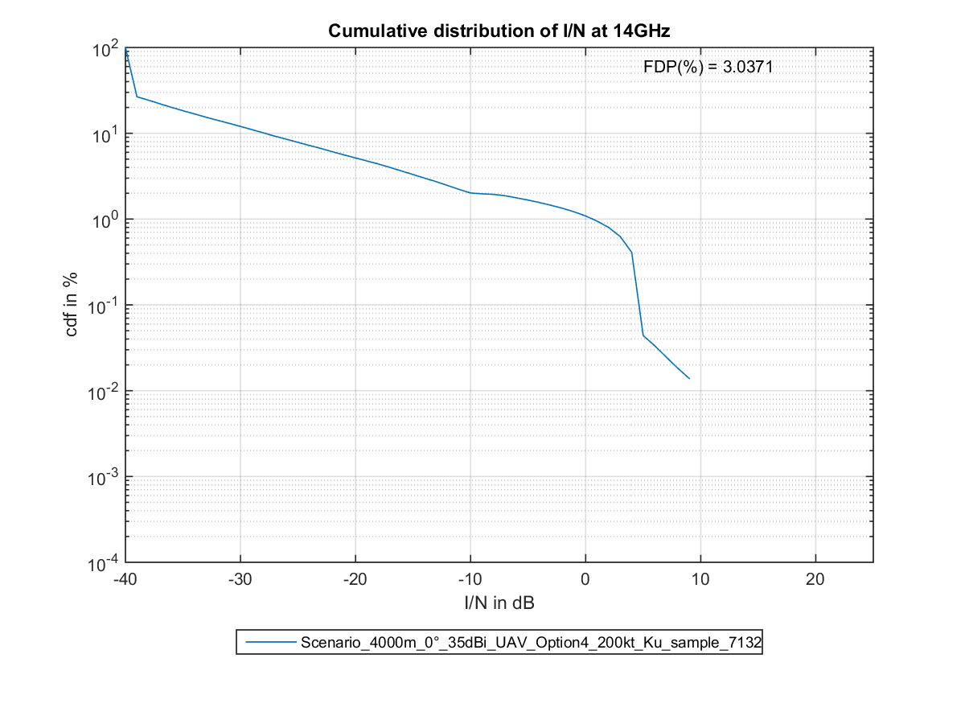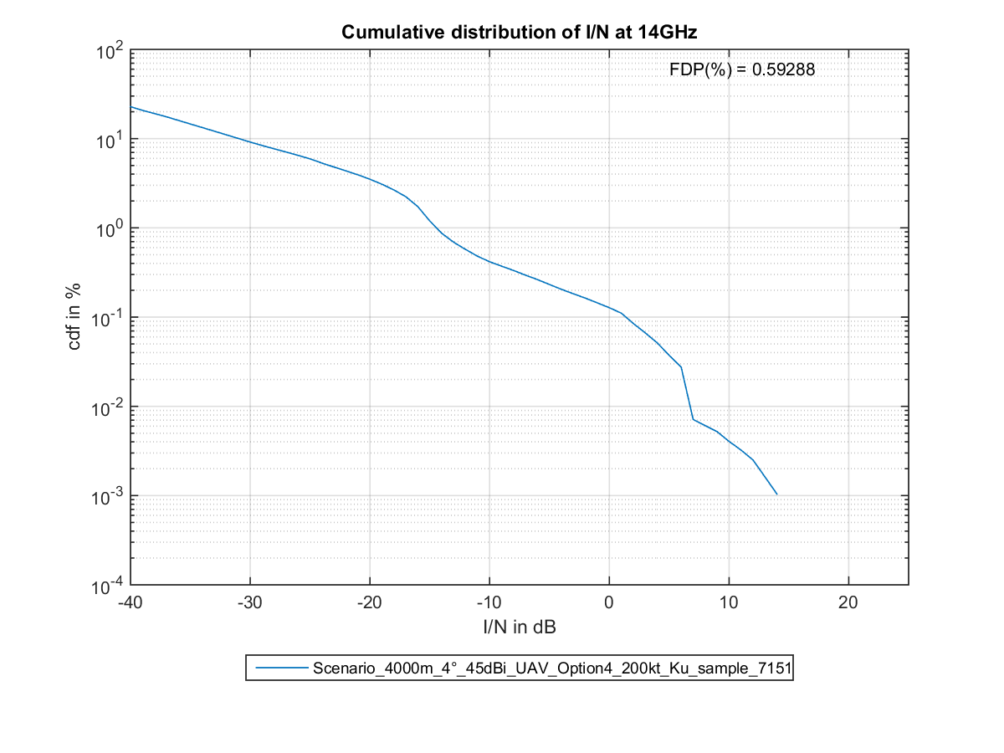

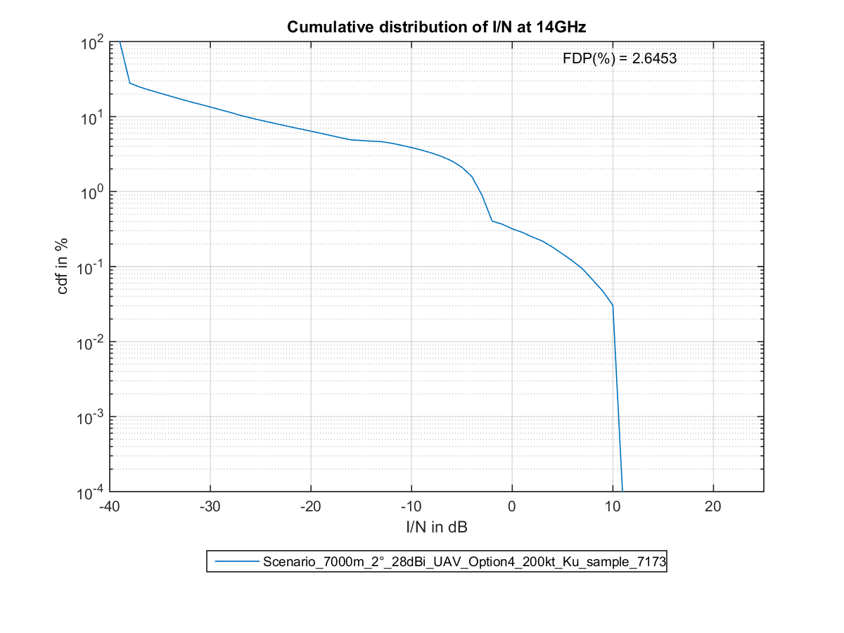

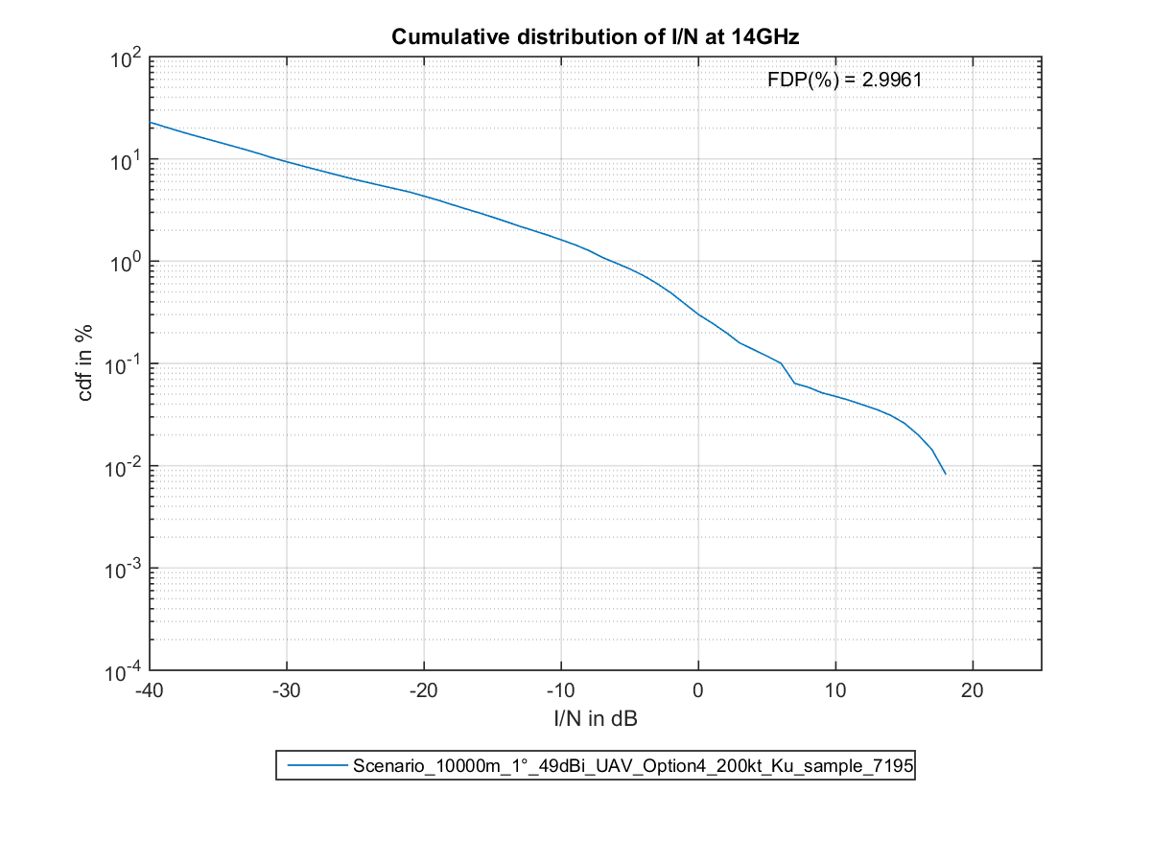

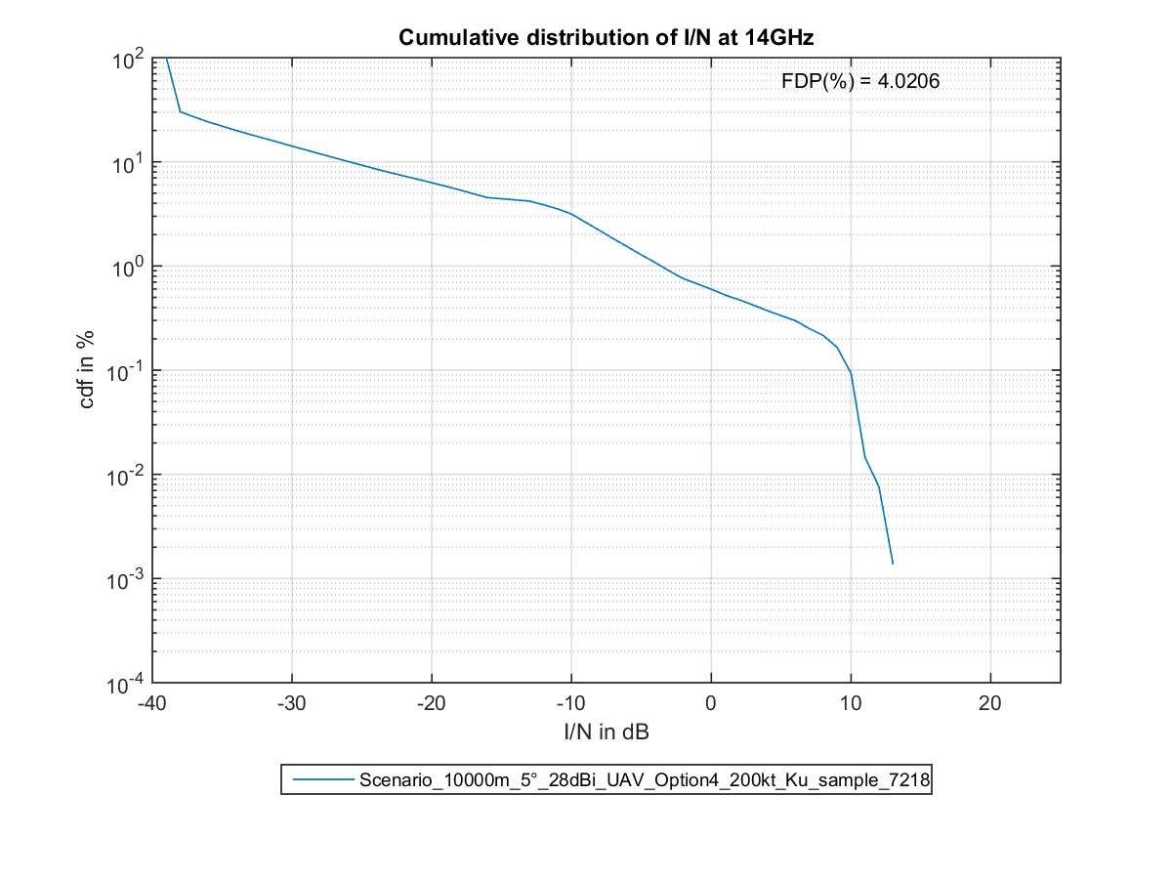

# 4 Analysis in the band 30/20GHz

**a) Characteristics of the emission**

**i) PFD masks**

Various masks in the band considered were analysed.

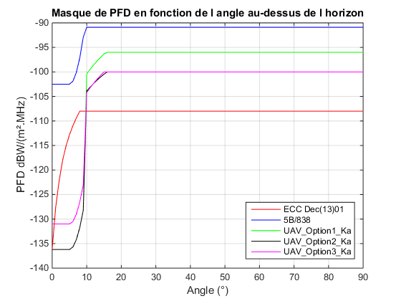

**PFD mask as a function of angle above horizon**

The proposed mask in Annex 1 corresponds to the mask UAV_Option3_Ka.

**b) Receiver characteristics**

**i) Receiver antenna gain**

The maximum antenna gain used for the studies is selected, respectively, as 49, 45, 35, 28 or 18 dBi.

The antenna pattern is based on Recommendation ITU-R F.1245 for point-to-point (P-P) links.



**ITU-R**

For point-to-multipoint (P-MP) links, the antenna pattern to be used would be that in Recommendation ITU-R F.1336.

**ii) Receiver antenna elevation**

For the receiver elevation, the following values are taken into account: 0°, 1°, 2°, 3°, 4° and 5°.

**iii) Analysis of FS protection criteria**

**1) Interference level**

The interference level is obtained by applying the following formula:

$I=PFD+G_{Rec}-10*log10({4π(\frac{f}{c})}^{2}$)

with: f in Hz

c in m/s

Thus:

$I=PFD+G_{Rec}-50$ at 28 GHz.

**2) Noise level**

The noise level considered for 14 MHz was set at -126.5 dBW and for 1 MHz is set at -138 dBW, and obtained from the following equations, with a noise figure of 6 dB:

Receiver_Noise_dBm = –114 + 10.*log10(BANDWIDTH_MHz) + Noise_Figure_dB

Receiver_Noise_dBW = Receiver_Noise_dBm – 30.

**3) Protection criteria**

Recommendation ITU-R F.758 describes the principle and also levels for protection criteria in terms of I/N for both long-term and short-term time percentages, and in terms of fractional degradation in performance (FDP).

The long-term criterion consists in not exceeding an I/N level of -10 dB for more than 20% of the time in the case of co-primary services. In this case, the FDP does not apply as there is no multi-pathing in this frequency band.

Recommendation ITU-R F.1494 proposes a methodology for determining the short-term FS protection criterion.

The worst case corresponds to an I/N of 7 dB with a time percentage of 9.52.E-04.

Description:

The total fade margin is taken at 37 dB for a bit error rate (BER) of 10-3 and automatic transmission power control (ATPC) of 13 dB. The fade margin for the severely errored second (SES) ratio is 1 dB less and 5 dB less for the errored second (ES) ratio. The short-term I/N criterion is selected such that the net calculated margin is positive.

The performance degradation is linked to the time percentage p by the following equation:

The time percentage associated with the I/N threshold is calculated with the following equation:

where:

EPO: error performance objective (%)

Error performance objective (EPO) is substituted by the parameters errored second ratio (ESR) and severely errored second ratio (SESR) (Rec. ITU-R F.1565).

DstEPO: Standard EPO degradation (10% included in the calculations in the tables).

DP (%): performance degradation due to interference (cf. Rec. ITU-R F.1565; = ESR(%) or SESR(%) as appropriate).

p: percentage of time during which the short-term I/N ratio may be exceeded (%).

A: percentage of time during which the adopted fade margin may be exceeded (%) (see Recommendation ITU-R P.530)

Time percentage for the severely errored second (SES) ratio of an FS station   
participating in an international network

|  |  |  |
| --- | --- | --- |
| Parameters | Value | Source |
| FM for BER 10-3 (dB) | 25 | RR Appendix 7 |
| FM for SES (dB) | 24 | Rec. ITU-R F.1494 |
| ATPC (dB) | 13 |  |
| Short-term *I/N* (dB) | 8 | Adopted value |
| Net FM for SES (dB) | 3 |  |
| SESR (%) | 0.0002 | Rec. ITU-R F.1565 Table 1a – 500 km |
| Probability of exceeding FM (%) | 3.3 | Rec. ITU-R P.530 |
| Short-term protection criterion time percentage (%) | 6.06E-03 |  |

Time percentage for the errored second (ES) ratio of an FS station participating in an international network

|  |  |  |
| --- | --- | --- |
| Parameters | Value | Source |
| FM for BER 10-3 (dB) | 25 | RR Appendix 7 |
| FM for ES (dB) | 20 | Rec. ITU-R F.1494 |
| ATPC (dB) | 13 |  |
| Short-term *I/N* (dB) | 7 | Adopted value |
| Net FM for ES (dB) | 0 |  |
| ESR (%) | 0.001 | Rec. ITU-R F.1565 Table 1a – 500 km |
| Probability of exceeding FM (%) | 63 | Rec. ITU-R P.530 |
| Short-term protection criterion time percentage (%) | 1.59E-03 |  |

Time percentage for the severely errored second (SES) ratio of an FS station   
participating in a national long-distance network

| Parameters | Value | Source |
| --- | --- | --- |
| FM for BER 10-3 (dB) | 25 | RR Appendix 7 |
| FM for SES (dB) | 24 | Rec. ITU-R F.1494 |
| ATPC (dB) | 13 |  |
| Short-term *I/N* (dB) | 8 | Adopted value |
| Net FM for SES (dB) | 3 |  |
| SESR (%) | 0.00012 | Rec. ITU-R F.1565 Table 3a – 50 km |
| Probability of exceeding FM (%) | 3.3 | Rec. ITU-R P.530 |
| Short-term protection criterion time percentage (%) | 3.64E-03 |  |

Time percentage for the errored second (ES) ratio of an FS station   
participating in a national long-distance network

|  |  |  |
| --- | --- | --- |
| Parameters | Value | Source |
| FM for BER 10-3 (dB) | 25 | RR Appendix 7 |
| FM for ES (dB) | 20 | Rec. ITU-R F.1494 |
| ATPC (dB) | 13 |  |
| Short-term *I/N* (dB) | 7 | Adopted value |
| Net FM for ES (dB) | 0 |  |
| ESR (%) | 0.0006 | Rec. ITU-R F.1565 Table 3a – 50 km |
| Probability of exceeding FM (%) | 63 | Rec. ITU-R P.530 |
| Short-term protection criterion time percentage (%) | 9.52E-04 |  |

Time percentage for the severely errored second (SES) ratio of an FS station   
participating in a national short-distance network

|  |  |  |
| --- | --- | --- |
| Parameters | Value | Source |
| FM for BER 10-3 (dB) | 25 | RR Appendix 7 |
| FM for SES (dB) | 24 | Rec. ITU-R F.1494 |
| ATPC (dB) | 13 |  |
| Short-term *I/N* (dB) | 8 | Adopted value |
| Net FM for SES (dB) | 3 |  |
| SESR (%) | 0.0015 | Rec. ITU-R F.1565 Table 5a |
| Probability of exceeding FM (%) | 3.3 | Rec. ITU-R P.530 |
| Short-term protection criterion time percentage (%) | 4.55E-02 |  |

Time percentage for the errored second (ES) ratio of an FS station   
participating in a national short-distance network

| Parameters | Value | Source |
| --- | --- | --- |
| FM for BER 10-3 (dB) | 25 | RR Appendix 7 |
| FM for ES (dB) | 20 | Rec. ITU-R F.1494 |
| ATPC (dB) | 13 |  |
| Short-term *I/N* (dB) | 7 | Adopted value |
| Net FM for ES (dB) | 0 |  |
| ESR (%) | 0.0075 | Rec. ITU-R F.1565 Tables 4a and 5a |
| Probability of exceeding FM (%) | 63 | Rec. ITU-R P.530 |
| Short-term protection criterion time percentage (%) | 1.19E-02 |  |

c) Examples of I/N ratio cumulative distribution function



