|  |  |
| --- | --- |
| **World Radiocommunication Conference (WRC-15) Geneva, 2–27 November 2015** |  |
| **INTERNATIONAL TELECOMMUNICATION UNION** |  |
|  |  |
| PLENARY MEETING | **Addendum 5 to Document 85-E** |
|  | **19 October 2015** |
|  | **Original: English** |
|  | |
| Burundi (Republic of), Kenya (Republic of), Uganda (Republic of),  Rwanda (Republic of), Tanzania (United Republic of) | |
| Proposals for the work of the conference | |
|  | |
| Agenda item 1.5 | |

1.5 to consider the use of frequency bands allocated to the fixed-satellite service not subject to Appendices **30**, **30A** and **30B** for the control and non-payload communications of unmanned aircraft systems (UAS) in non-segregated airspaces, in accordance with Resolution **153 (WRC‑12)**;

Introduction

Based on the [Report ITU‑R M.2171](http://www.itu.int/pub/R-REP-M.2171), the maximum amount of spectrum required for UAS CNPC links is 56 MHz for the satellite component assuming regional beams with suitable antenna discrimination. However this estimation could rise to 169 MHz when using small aperture antenna with limited discrimination in lower frequency bands.

Studies carried out in response to Resolution 153 (WRC‑12)have considered the bidirectional links between an unmanned aircraft earth station and associated FSS space station (Earth-to-space and space-to-Earth) as well as the FSS space station and the UACS (E-to-s and s-to-E). They have been developed in cooperation with ICAO.

ICAO recommends that the followings conditions should be met:

1) That the technical and regulatory actions be limited to the case of UAS using satellites, as studied, and not set a precedent that puts other aeronautical safety services at risk.

2) That all frequency bands which carry aeronautical safety communications be clearly identified in the ITU Radio Regulations.

3) That the assignments and use of the relevant frequency bands be consistent with Article 4.10 of the ITU Radio Regulations which recognizes that safety services require special measures to ensure their freedom from harmful interference.

EACO member countries (BDI/KEN/UGA/RRW/TZA) support Method A1 proposed in the CPM Report.

Proposal

The proposal of BDI/KEN/UGA/RRW/TZA (EACO member countries) on agenda item 1.5 is as shown below:

ARTICLE 5

Frequency allocations

Section IV – Table of Frequency Allocations  
(See No. 2.1)

MOD BDI/KEN/UGA/RRW/TZA/85A5/1

14-15.4 GHz

|  |  |  |
| --- | --- | --- |
| Allocation to services | | |
| Region 1 | Region 2 | Region 3 |
| 14-14.25 FIXED-SATELLITE (Earth-to-space) 5.457A 5.457B 5.484A     5.506 5.506B ADD 5.A15  RADIONAVIGATION 5.504  Mobile-satellite (Earth-to-space) 5.504B 5.504C 5.506A  Space research  5.504A 5.505 | | |

NOTE − The footnote in the example above could be applied to those frequency bands allocated to the FSS and not subject to RR Appendix **30**, **30A** or **30B** for which studies have been conducted in the frequency ranges 10.95-14.5 GHz, 17.8-20.2 GHz and 27.5-30 GHz.

ADD BDI/KEN/UGA/RRW/TZA/85A5/2

14-15.4 GHz 5.A15 Resolution **[85A5-A15-FSS-UA-CNPC] (WRC‑15)** shall apply.     (WRC‑15)

ADD BDI/KEN/UGA/RRW/TZA/85A5/3

Draft New Resolution [85A5-A15-FSS-UA-CNPC]

Regulatory provision related to earth stations on board unmanned aircraft which operate with geostationary satellites in the fixed-satellite service  
for the control and non-payload communications of  
unmanned aircraft systems

The World Radiocommunication Conference (Geneva, 2015),

considering

*a)* that worldwide use of unmanned aircraft systems (UAS), which include unmanned aircraft (UA) and unmanned aircraft control stations (UACS), is expected to increase significantly in the near future;

*b)* that UA need to operate seamlessly with piloted aircraft in non-segregated airspace;

*c)* that the operation of UAS in non-segregated airspace requires reliable control and non-payload communication (CNPC) links, in particular to relay the air traffic control communications and for the remote pilot to control the flight;

*d)* that there is a demand for the control of UAS CNPC links via satellite communication networks for communications beyond the radio horizon while operating in non-segregated airspace, as shown in Annex 1;

*e)* that there is a need to provide internationally harmonized use of spectrum for UAS CNPC links;

*f)* that the use of fixed-satellite service (FSS) frequency assignments by UAS CNPC links should take into account their Article **11** notification status,

considering further

*a)* that there is a need to limit the number of communication equipment on board a UA;

*b)* that there is some urgency to conclude on the feasibility of the use of the FSS frequency bands to support short- and medium-term implementation of UAS CNPC links because a dedicated satellite system for this application is not likely to be implemented in this time-frame;

*c)* that there are various technical methods that may be used to increase the reliability of digital communication links, e.g. modulation, coding, redundancy, etc., that can be used to ensure safe operation of UAS in all airspace;

*d)* that UAS CNPC relate to the safe operation of UAS and have certain technical, operational and regulatory requirements;

*e)* that the requirements in *considering further d)* can be specified for UAS use of FSS networks,

noting

*a)* that Report ITU‑R M.2171 provides information on the vast number of applications for UAS needing access to non-segregated airspaces;

*b)* that although Recommendation **724 (WRC‑07)** notes that FSS is not a designated safety service, FSS can be used, under certain conditions, on a permanent or temporary basis for safeguarding human life or property in accordance with No. **1.59**,

recognizing

*a)* that the UAS CNPC links shall be operated in accordance with international standards and recommended practices and procedures established by the Convention on International Civil Aviation;

*b)* that, in this context, ITU develops the conditions for operation of CNPC links, and then International Civil Aviation Organization (ICAO) would be in a position to develop further operational conditions to ensure safe UAS operation,

resolves

1 that FSS networks in this frequency band may be used for the control and non-payload communication of unmanned aircraft systems;

2 that earth stations on board UA can communicate with a space station operating in the fixed-satellite service, including while the UA is in motion;

3 that the use of such links and their associated performance requirements shall be in accordance with the international standards and recommended practices (SARPs) and procedures established by ICAO, consistent with Article 37 of the Convention on International Civil Aviation;

4 that a fixed-satellite service earth station on an unmanned aircraft shall be considered as an earth station operating in the fixed-satellite service;

5 that the FSS space stations operating in frequency bands supporting these CNPC links shall conform to the applicable technical provisions of the Radio Regulations;

6 that the use of UAS CNPC links is for safe operation and regularity of flight and requires absolute international protection;

7 that the freedom from harmful interference to UAS CNPC links is imperative to ensure safe operation, and administrations shall act immediately when their attention is drawn to any such harmful interference;

8 that the FSS operator will ensure that the assignments associated with the FSS networks to be used for UAS CNPC links (see Fig. 1 in Annex 1) have obtained the necessary protected status under the provisions of Nos. **11.32**, **11.32A**, **11.42** or **11.42A**, including the examinations made by BR, and have been successfully registered in the MIFR;

9 that real-time interference monitoring and predicting interference risks, and planning solutions for potential interference scenarios shall be addressed in the specific agreements between FSS operators and UAS operators with guidance from aviation authorities;

10 that the protection of the fixed service shall be ensured by implementing measures shown in Annex 2,

encourages concerned administrations

to cooperate with administrations which license UA CNPC while seeking agreement under the above-mentioned provisions,

instructs the Secretary-General

to bring this Resolution to the attention of the Secretary-General of the ICAO.

Annex 1 to Resolution [85A5-A15-FSS-UA-CNPC] (WRC‑15)

UA CNPC links

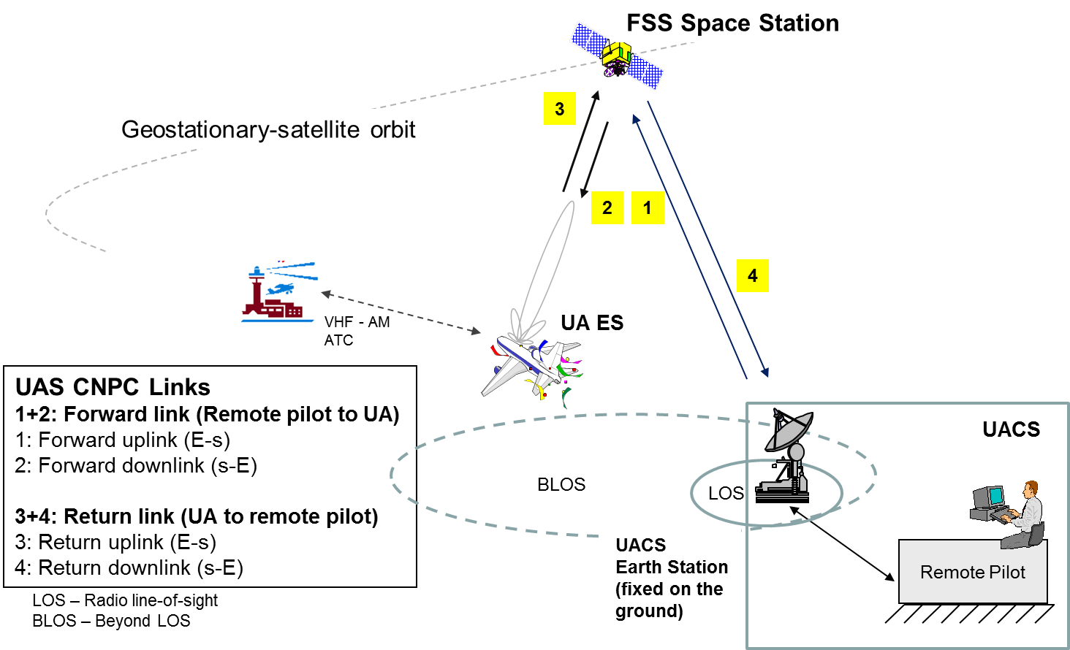

Figure 1

Elements of UAS architecture using the FSS

Annex 2 to Resolution [85A5-A15-FSS-UA-CNPC] (WRC‑15)

Protection of the fixed service and of other fixed-satellite service   
networks from UA CNPC emissions

# 1 Introduction

The fixed service is allocated by footnotes in several countries with a co-primary status to the FSS. Conditions of UA using CNPC shall be such that the fixed service is protected from any harmful interference as defined below.

# 2 Compatibility with the fixed service

NOTE − Protection measures to be added such as:

• Off-axis e.i.r.p. mask.

• Pfd mask to protect FS based on results agreed in July 2015 meeting.

• FS environment interference profile to be addressed in development of ICAO SARPs.

# 3 Protection of other fixed-satellite service networks

NOTE − Protection measures to be added such as:

• Off-axis e.i.r.p. mask.

# 4 Protection of radio astronomy and other incumbent services as appropriate

NOTE − Protection measures to be added.

______________