|  |  |  |  |  |  |  |  |  |  |  |  |  |  |  |  |  |  |  |
| --- | --- | --- | --- | --- | --- | --- | --- | --- | --- | --- | --- | --- | --- | --- | --- | --- | --- | --- |
| |  |  | | --- | --- | | **World Radiocommunication Conference (WRC-15) Geneva, 2-27 November 2015** |  | | **INTERNATIONAL TELECOMMUNICATION UNION** |  | |  |  | | **PLENARY MEETING** | **Addendum 1 to Document 4(Add.1)-E** | | **29 September 2015** | | **Original: English** | | Director, Radiocommunication Bureau | | | REPORT OF THE DIRECTOR ON THE ACTIVITIES OF THE RADIOCOMMUNICATION SECTOR | | | part 1  activities of the radiocommunication sector in the period between WRC‑12 and WRC‑15 | | | Additional information relevant to Part 1of the Director’s Report | | |

# 1 Resolution 49 (Rev.WRC‑12) – Due diligence

Paragraph 2.5.5.1 of Document CMR15/4(Add.1) is suggesting possible improvements to Resolution 49 which might include:

– The submission of due diligence information within [30] days following the bringing into use/resumption of operation of frequency assignments to a satellite network (this would allow for easier association of a real satellite/date of launch (when applicable) with the orbital location at which these assignments are brought into use).

– A formal requirement to renew the information whenever changes occur (requirement to be linked also with the suspension under No. 11.49).

|  |
| --- |
| WRC-15 might wish also to consider further generalizing, streamlining and simplifying the procedures for the registration of satellite networks by merging due diligence information requirements under Resolution 49 with notification data in, e.g. Appendix 4 of the Radio Regulations.  An example of draft texts on the update of Resolution 49 for possible consideration by the Conference is presented in Annex 1. |

# 2 Activities related to the end of the Transition period from analogue to digital broadcasting set forth by the GE06 Regional Agreement

Section 3.5 of document CMR15/4(Add.1) describes the actions undertaken by the Bureau and administrations in relation to the end of the Transition period from analogue to digital broadcasting for which the applicable Transition period ended on 17 June 2015.

That Section also indicates that the BR initiated consultations with the responsible administrations concerning their assignments to analogue broadcasting stations recorded in the Master Register in the GE06 planning area and bands.

The Bureau would like to report that on 17 June 2015 the Master Register contained 43884 analogue broadcasting assignments in the GE06 planning area and bands of 79 administrations. After consultations with the administrations concerned, the following actions were taken:

– 27 121 assignments of 57 administrations were retained in the MIFR, at the request of the responsible administrations, with favourable regulatory findings, unfavourable conformity to plan findings and on the condition that they shall not cause unacceptable interference to, nor claim protection from, any station operating in conformity with the GE06 Agreement;

– 16 763 assignments of 27 administrations were suppressed from the Master Register.

# 3 Implementation of Resolution 755 (WRC-12) related to terrestrial services

Section 3.6.8 of document CMR15/4(Add.1) describes the actions aimed at bringing the frequency assignments to stations in the fixed and mobile services in the band 21.4 – 22 GHz recorded in the MIFR in conformity with the pfd limit specified in No. **5.530A**, as required by Resolution **755 (WRC-12)**. At the time of preparation of Part 1 of the Director’s Report the relevant consultations with administrations concerned were still going on.

In relation to this activity, a total of 9128 frequency assignments recorded on behalf of 15 administrations were examined. After consultations with the responsible administrations the following actions were taken by the Bureau with respect to these assignments:

– 8719 frequency assignments of 5 administrations that were in conformity with the relevant pfd limit were retained in the Master Register with favourable regulatory findings;

– 332 frequency assignments of 7 administrations, which either did not provide with declarations concerning the conformity with the pfd limit specified in No. **5.530A** or asked to retain their non-conforming assignments, were kept in the Master Register with unfavourable regulatory findings under the conditions of No. **8.5** of the RR for information purposes;

– 77 frequency assignments of 4 administrations were suppressed at the request of the responsible administrations.

By 17 September the activities on the implementation of Resolution **755 (WRC-12)** related to terrestrial services had been completed.

# 4 Resolution 74 (Rev. WRC.03)

Section 4.3 of document CMR15/4(Add.1) describes the activities carried out by the ITU‑R Study Groups in preparation for WRC-15. Additionally, in the 2012-2015 study period, Study Group 7 prepared a report on the protection of SRS earth stations from aircraft stations in the 2 200-2 290 MHz band, which was subsequently approved as Report ITU-R SA.2276-0. This Report gives separation distances between aircraft stations and several SRS earth stations as a function of aircraft altitudes to protect the SRS earth stations. The results show that the current 500 km predetermined coordination distance given in Table 10/Annex 7/Appendix **7** of the Radio Regulations is not sufficient to protect the SRS earth stations and actually 880 km would be needed to protect them. Based on this report, ITU-R approved new Recommendation ITU-R SA.2078-0, proposing the use of 880 km as the coordination distance between SRS earth stations and aircraft stations.

In accordance with *resolves 1* of Resolution **74 (Rev. WRC-03)** this matter is brought to the attention of the Radiocommunication Assembly 2015.

In accordance with *resolves 2* of Resolution **74 (Rev. WRC-03)**, if the Radiocommunication Assembly 2015 confirms the improvements of the methods in *considering d)* for determination of the coordination area of an earth station and/or the values of technical coordination parameters which have been presented by ITU‑R, this matter will be reported in an update to the Director’s report to WRC-15.

In that case, in accordance with *invites 1* of Resolution **74 (Rev. WRC-03)**, WRC-15 would then be invited to consider the revision of Appendix **7** in light of the recommendation of the Radiocommunication Assembly 2015.

# 5 Regional Radiocommunication Seminars (RRS)

Section 6.2.2 of Document CMR15/4(Add.1) describes the implementation of Regional Radiocommunication Seminars during the period 2012-2015.

The number of participants/administrations that attended the RRS-15 Americas (last row in Table 6.2.2-1) was 73/13 as shown below:

Table 6.2.2-1

ITU Regional Radiocommunication Seminars (2013-2015)

|  |  |  |  |  |  |  |  |
| --- | --- | --- | --- | --- | --- | --- | --- |
| **Date** | **RRS** | **Place** | **Host** | **Cooperation** | **Forum  Topics** | **Languages** | **Participants/ administrations** |
| ……. |  |  |  |  |  |  |  |
| 27-31 July 2015 | **RRS-15-Americas** | San Salvador, El Salvador | Superintendencia General de Electricidad y Telecomunicaciones of El Salvador (SIGET) | COMTELCA, ITU area office for Central America | WRC15: Challenges  and opportunities for the Region  C-band registration  Unlicensed Devices Regulations | **S** | **73/13** |

The following pie-chart shows the number of countries that attended the series of WRS and/or RRS during the period 2012-2015:

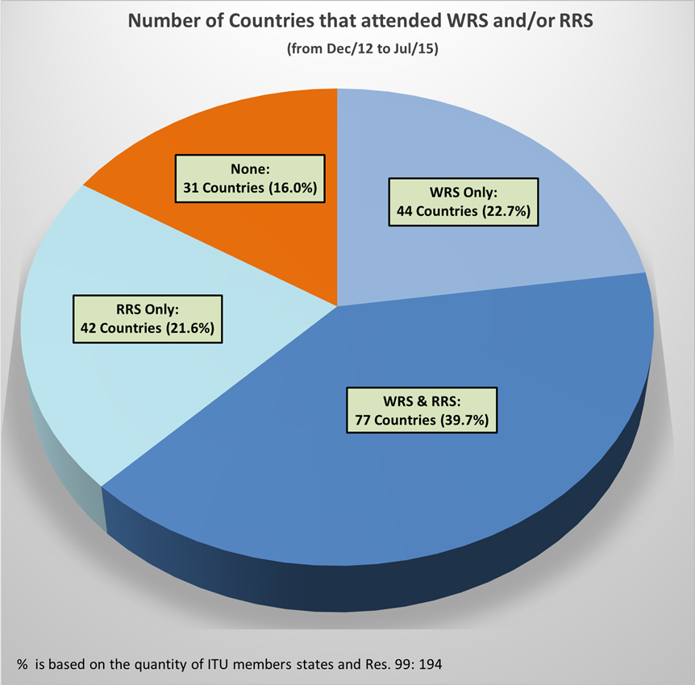

Annex

MOD RESOLUTION 49[1]1 (Rev.WRC‑15)

Administrative due diligence applicable to some   
satellite radiocommunication services

The World Radiocommunication Conference (Geneva, 2012),

considering

*a)* that Resolution 18 of the Plenipotentiary Conference (Kyoto, 1994) instructed the Director of the Radiocommunication Bureau to initiate a review of some important issues concerning international satellite network coordination and to make a preliminary report to WRC‑95 and a final report to WRC‑97;

*b)* that the Director of the Bureau provided a comprehensive report to WRC‑97, including a number of recommendations for action as soon as possible and for identifying areas requiring further study;

*c)* that one of the recommendations in the Director’s report to WRC‑97 was that administrative due diligence should be adopted as a means of addressing the problem of reservation of orbit and spectrum capacity without actual use;

*d)* that experience may need to be gained in the application of the administrative due diligence procedures adopted by WRC‑97, and that several years may be needed to see whether administrative due diligence measures produce satisfactory results;

*e)* that new regulatory approaches may need to be carefully considered in order to avoid adverse effects on networks already going through the different phases of the procedures;

*f)* that Article 44 of the Constitution sets out the basic principles for the use of the radio-frequency spectrum and the geostationary-satellite and other satellite orbits, taking into account the needs of developing countries,

considering further

*g)* that WRC‑97 decided to reduce the regulatory time-frame for bringing a satellite network into use;

*h)* that WRC‑2000 has considered the results of the implementation of the administrative due diligence procedures and prepared a report to the 2002 Plenipotentiary Conference in response to Resolution 85 (Minneapolis, 1998),

resolves

that the administrative due diligence procedure contained in Annex 1 to this Resolution shall be applied as from 22 November 1997 for a satellite network or satellite system of the fixed-satellite service, mobile-satellite service or broadcasting-satellite service for which the advance publication information under No. 9.2B, or for which the request for modifications of the Region 2 Plan under Article 4, § 4.2.1 *b)* of Appendices 30 and 30A that involve the addition of new frequencies or orbit positions, or for which the request for modifications of the Region 2 Plan under Article 4, § 4.2.1 *a)* of Appendices 30 and 30A that extend the service area to another country or countries in addition to the existing service area, or for which the request for additional uses in Regions 1 and 3 under § 4.1 of Article 4 of Appendices 30 and 30A, or for which the submission of information under supplementary provisions applicable to additional uses in the planned bands as defined in Article 2 of Appendix 30B (Section III of Article 6) has been received by the Bureau from 22 November 1997, or for which submission under Article 6 of Appendix **30B (Rev.WRC‑07)** is received on or after 17 November 2007, with the exception of submissions of new Member States seeking the acquisition of their respective national allotments[2]2 for inclusion in the Appendix **30B** Plan;

[

,]

**Reasons**: Suppression of outdated *resolves* that have already been implemented.

further resolves

that the procedures in this Resolution are in addition to the provisions under Article 9 or 11 of the Radio Regulations or Appendices 30, 30A or 30B, as applicable, and, in particular, do not affect the requirement to coordinate under those provisions (Appendices 30, 30A) in respect of extending the service area to another country or countries in addition to the existing service area,

instructs the Director of the Radiocommunication Bureau

to report to future competent world radiocommunication conferences on the results of the implementation of the administrative due diligence procedure.

ANNEX 1 TO RESOLUTION 49 (Rev.WRC‑12)

1 Any satellite network or satellite system of the fixed-satellite service, mobile-satellite service or broadcasting-satellite service with frequency assignments that are subject to coordination under Nos. **9.7**, **9.11**, **9.12**, **9.12A** and **9.13** and Resolution **33 (Rev.WRC‑03)** shall be subject to these procedures.

2 Any request for modifications of the Region 2 Plan under the relevant provisions of Article 4 of Appendices **30** and **30A** that involve the addition of new frequencies or orbit positions or for modifications of the Region 2 Plan under the relevant provisions of Article 4 of Appendices **30** and **30A** that extend the service area to another country or countries in addition to the existing service area or request for additional uses in Regions 1 and 3 under the relevant provisions of Article 4 of Appendices **30** and **30A** shall be subject to these procedures.

3 Any submission of information under Article 6 of Appendix **30B (Rev.WRC‑07)**, with the exception of submissions of new Member States seeking the acquisition of their respective national allotments[3]3 for inclusion in the Appendix **30B** Plan, shall be subject to these procedures.

4 An administration requesting coordination for a satellite network under § 1 above shall send to the Bureau within [30] days following the notified date of bringing into use under No. **11.44** or the date on which the recorded assignment is brought back into use under No. **11.49**, as appropriate , the due diligence information relating to the identity of the satellite network, the spacecraft manufacturer and the launch services provider specified in Annex 2 to this Resolution.

5 An administration requesting a modification of the Region 2 Plan or additional uses in Regions 1 and 3 under Appendices **30** and **30A** under § 2 above shall send to the Bureau within [30] days following the end of the period established as a limit to bringing into use in accordance with the relevant provisions of Article 4 of Appendix **30** and the relevant provisions of Article 4 of Appendix **30A**, the due diligence information relating to the identity of the satellite network, the spacecraft manufacturer and the launch services provider specified in Annex 2 to this Resolution.

6 An administration applying Article 6 of Appendix **30B** **(Rev.WRC‑07)** under § 3 above shall send to the Bureau within [30] days following the end of the period established as a limit to bringing into use in § 6.1 of that Article, the due diligence information relating to the identity of the satellite network, the spacecraft manufacturer and the launch services provider specified in Annex 2 to this Resolution.

7 The information to be submitted in accordance with § 4, 5 or 6 above shall be signed by an authorized official of the notifying administration or of an administration that is acting on behalf of a group of named administrations.

8 On receipt of the due diligence information under § 4, 5 or 6 above, the Bureau shall promptly examine that information for completeness. If the information is found to be complete, the Bureau shall publish the complete information in a special section of the BR IFIC within 30 days.

9 If the information is found to be incomplete, the Bureau shall immediately request the administration to submit the missing information. In all cases, the complete due diligence information shall be received by the Bureau within the appropriate time period specified in § 4, 5 or 6 above, as the case may be, relating to the date of bringing the satellite network into use.

10 Six months before expiry of the period specified in § 4, 5 or 6 above, the Bureau shall send a reminder to the responsible administration.

11 If the complete due diligence information is not received by the Bureau within the time limits specified in this Resolution, the networks covered by § 1, 2 or 3 above shall be cancelled by the Bureau. The provisional recording in the MIFR shall be deleted by the Bureau after it has informed the concerned administration. The Bureau shall publish this information in the BR IFIC.

With respect to the request for modification of the Region 2 Plan or for additional uses in Regions 1 and 3 under Appendices **30** and **30A** under § 2 above, the modification shall lapse if the due diligence information is not submitted in accordance with this Resolution.

With respect to the request for application of Article 6 of Appendix **30B (Rev.WRC‑07)** under § 3 above, the network shall also be deleted from the Appendix **30B** List. When an allotment under Appendix **30B** is converted into an assignment, the assignment shall be reinstated in the Plan in accordance with § 6.33 *c)* of Article 6 of Appendix **30B (Rev.WRC‑07)**.

12

The information submitted in accordance with § 4, 5 or 6 above shall be updated and resubmitted to the Bureau by the notifying administration not later than [3 months] after the actual commencement, or resumption, as appropriate, of use of the frequency assignments or after the end of life or relocation of the spacecraft associated with the submissions under §4, 5 or 6 above, as necessary. For satellite networks for which the information submitted in accordance with § 4, 5 or 6 has been received by the Bureau by [27 November 2015], the responsible administration shall submit to the Bureau a confirmation or an update of the due diligence information in accordance with Annex 2 to this Resolution no later than [27 March 2016]

**Reasons**: Mandatory update of the due diligence information as necessary.

13 When an administration has completely fulfilled the due diligence procedure but has not completed coordination, this does not preclude the application of No. 11.41 by that administration.

ANNEX 2 TO RESOLUTION 49 (Rev.WRC‑12)

# A Identity of the satellite network

*a)* Identity of the satellite network

*b)* Name of the administration

*c)* Country symbol

*d)* Reference to the advance publication information or to the request for modification of the Region 2 Plan or for additional uses in Regions 1 and 3 under Appendices **30** and **30A**; or reference to the information processed under Article 6 of Appendix **30B** **(Rev.WRC‑07)**

*e)* Reference to the request for coordination (not applicable for Appendices **30**, **30A** and **30B**)

*f)* Frequency band(s)

*g)* Name of the operator

*h)* Name of the satellite

*i)* Orbital characteristics.

# B Spacecraft manufacturer[4]*

*a)* Name of the spacecraft manufacturer

*b)* Date of execution of the contract

*c)* Contractual “delivery window”

*d)* Number of satellites procured.

# C Launch services provider

*a)* Name of the launch vehicle provider

*b)* Date of execution of the contract

*c)* Launch or in-orbit delivery window

*d)* Name of the launch vehicle

*e)* Name and location of the launch facility.

______________

1. 1 This Resolution does not apply to satellite networks or satellite systems of the broadcasting-satellite service in the 21.4-22 GHz band in Regions 1 and 3.
2. 2 See § 2.3 of Appendix **30B (Rev.WRC‑07)**.
3. 3 See § 2.3 of Appendix **30B (Rev.WRC‑07)**.
4. * NOTE − In cases where a contract for satellite procurement covers more than one satellite, the relevant information shall be submitted for each satellite.