Radiocommunication Study Groups
Source: Document 5A/TEMP/308 | Annex 16 to  Document 5A/844-E
Source: Document 5A/TEMP/308 | 1 June 2018
Source: Document 5A/TEMP/308 | English only
Annex 16 to Working Party 5A Chairman’s Report
WORKING DOCUMENT TOWARDS A PRELIMINARY
DRAFT NEW REPORT ITU-R M.[CDLMR]
Conventional digital land mobile radio systems

1 Scope
This Report deals with the technical and operational characteristics of conventional digital land mobile radio (CDLMR) systems that provide capabilities required for specific user groups/applications, such as governmental, mining, health, hospitality, transportations, disaster relief, industrial, manufacturing, construction, etc. This report also includes information on approaches to frequency assignments for CDLMR.
Digital Land Mobile Systems for specific applications, such as PPDR and trunked systems, are addressed in other ITU documents.
[Editor's note:
– Invite inputs for the next meeting WP 5A to bring information to the section 7 in line with this scope. Part of this discussion will be the level of detail that this document should contain, and whether there is a need to develop a separate report.]

2 Related Recommendations and Reports
Issues relating to PPDR are covered in:
Recommendation ITU-R M.2009 – Radio interface standards for use by public protection and disaster relief operations in some parts of the UHF band in accordance with Resolution 646 (Rev.WRC-012)
Recommendation ITU-R M.2015 – Frequency arrangements for public protection and disaster relief radiocommunication systems in accordance with Resolution 646 (Rev.WRC-15)
Report ITU-R M.2377 – Radiocommunication objectives and requirements for Public Protection and Disaster Relief
Report ITU-R M.2415 – Spectrum needs for Public Protection and Disaster Relief (PPDR)
Issues relating to Trunked Digital land mobile Radio systems/ for Dispatch are addressed in:
Report ITU-R M.2014 – Digital land mobile systems for dispatch traffic

[Editor notes:
– It should be discussed further where the frequency bands and channel arrangements would be included, either in this PDNR or in a separate report.
– Make clear in the body of this PDNR that IMT is covered in other documents.
– It should be change the words requirements/PLMR bands/licenses-free, as appropriate, and consider whether licensing approaches should be included in this document.]
Acronyms
LMR Land Mobile Radio
PPDR Public Protection and Disaster Relief
PLMR Private Land Mobile Radio
CTCSS Continuous Tone-Coded Squelch System
DCS Digital Code Squelch
LBT Listen before talk
CDLMR Conventional Digital Land Mobile Radio
CLMR Conventional Land Mobile Radio
Land Mobile Radio (LMR) System: Analogue or digital two-way conventional or trunked radio communications system in which two or more fixed or mobile radio stations in the land mobile service communicate on one or more frequency (ies).
Private Land Mobile Radio (PLMR or PMR) System: LMR system utilized by a closed group of users to meet specific radiocommunication requirements.
Trunked Land Mobile Radio (TLMR) System: Radiocommunications system where two or more LMR stations communicate on frequency channels assigned by a controlling station automatically from a set of defined frequencies in real time using a radiocommunication protocol.
Conventional Land Mobile Radio (CLMR) System: Radiocommunications system where two or more LMR stations communicate on a predetermined frequency channel(s), without the use of any controlling station and or control frequency channel.
Conventional Digital Land Mobile Radio (CDLMR) System: Conventional LMR system that transmits and receives using digital modulation techniques.

3 Introduction
Private land mobile radio (PLMR) communications systems have been providing two way communications for many industries for decades and are expected to continue to serve millions of businesses and industries around the world. These systems enable flexibility in deployment and can utilise limited spectrum resources to meet the needs of different users. Applications for PLMR include schools, seaports, construction sites, convention halls, factories, retailers and delivery services, etc.
PLMR systems could be trunked or conventional. Trunked PLMR systems are described in Report ITU-R M.2014.
Conventional Land Mobile Radio (CLMR) — sometimes called Private / Professional Mobile Radio (PMR) – is a mobile system that serves a closed user group and that is normally owned and operated by the same organization as its users with push-to-talk and group communications capability.

3.1 Typical System Architecture
CLMR systems can be as basic and simple as a group of users (minimum two sets) operating on an assigned frequency (or frequencies) to communicate in one-to-one or one-to-group mode of communication as show in Figure 1 below. A conventional radio system is the most basic and simplest two-way radio system for the user. Two-way radio systems can be configured in many different ways to allow for one one-to-one and one-to-many communication.
CLMR have a common functionality of one-to-one or one-to-many (group) communication by a simple Push-to-Talk. CLMR systems were developed for business users who need to communicate over limited geographical areas but are also widely used for emergency services.
CLMR systems can be categorized into two types: simplex operation for direct peer-to-peer communications; and repeater operation where repeater(s) is (are) used to extend the communication reach.
A CLMR system for simplex operation can be as basic and simple as a group of users using a common assigned frequency (or set of frequencies) to communicate as show in Figure 1 below.
Basic Simplex (Direct mode) or Simplex with Talk Around CLMR system
– There is no automated processing of the calls.
– Users simply ‘push-to-talk’ (PTT) on the channel (frequency) they have selected on their mobile or handheld terminals.
– Users have immediate access to selected channel(s) at any time and must listen for a clear channel before transmitting to avoid causing interference to another user in the group.
– The range of the basic conventional LMR system is limited by the range of the mobile terminals.
– A fixed base transmitter or repeater is used to increase the range over which users can communicate.
– Talk around mode is when a radio repeats the signal on the same channel with small delay to extend coverage or overcome a field signal obstruction.
– Simplex design (T=R).
– Pro: No infrastructure, low cost, can operate with only single frequency/pair.
– Con: No wide-area coverage, must relay messages.

Figure 1
Basic Simplex One-to-Many Group communication configuration
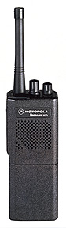
16
T=1
R=1
T=1
R=1
T=1
R=1
T=1
R=1
T=1
R=1
T=1
R=1
T=1
R=1
T=1
R=1
Figure 2
Basic conventional LMR system / One to one Direct mode or Talk Around modes of operation
T=1
R=1
T=1
R=1
T=1
R=1
Several km
Several km

The coverage of a CLMR simplex system is limited by the transmitter range of the mobile terminals used. In a CLMR Talk-Around repeater system, a mobile radio retransmits on the same frequency with a small delay to increase the range over which users can communicate.
Duplex or Simplex with fixed repeater CLMR system
A common CDLMR configuration with repeater system enables repeater to either re-transmit on the same frequency is the single site CLMR shown in Figure 3.
Figure 3
Single site CLMR repeater system
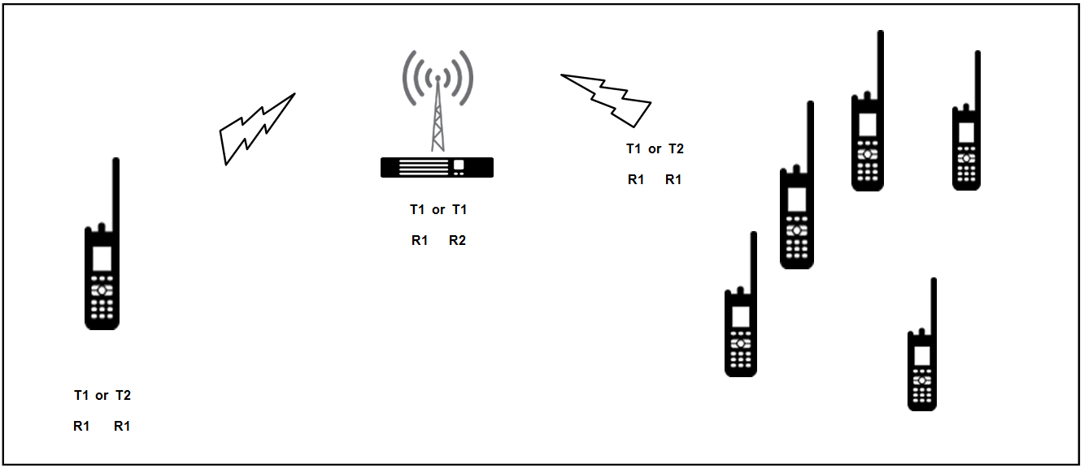
– A single-site system is defined as one site with a fixed base transmitter(s)/repeater(s).
– There is no automated processing of calls.
– Two frequencies (one pair) are required per repeater although a single frequency configuration can be used with some systems settings but is not common.
– Fixed repeater base station enables extended coverage and as higher Transmit power is used in the order of 5-20 times that of the mobile radio.
– In Simplex Mode, fixed station acts as a “repeater” and acts as a simple radio relay. Other mobile units may not hear mobile transmitter if not within range. In Direct Mode (using base station to/from mobile) half Duplex mode, other mobile units will not hear mobile transmitter even if within range (R≠T).
– Other mobile units may not hear mobile transmitter if not within range to mobile radios; receive audio re-transmitted instantly (T≠R always). Other mobile units will hear mobile transmitter.
Wide area coverage with multiple repeater sites CLMR system
In wide area coverage CDLMR deployments, multiple repeater sites are deployed to provide extended coverage. Repeaters operating independently:
– Subscribers cannot talk across RF boundaries; wide-area coverage for business, but not wide-area communications.
– Manual roaming i.e. users must know RF boundaries and manually change channels as they move from cell to cell.
– A multiple frequency broadcasting design (multicast) enables multiple repeater coverage but allows for communications across RF sites; coverage overlap is not required.
If the CLMR system grow user base or require more talk-groups (i.e. frequency channels), listen before talk becomes a cumbersome as the number of users increase, the channel occupancy mandates additional radio channels (frequencies) hence complex repeaters design to support cascaded repeater in CLMR. The complexity of analog CLMR multi-channel RF repeater site is at least double that of equivalent digital system. Trunked LMR systems employ automated processing of calls in which a group of frequencies assigned to the trunked radio system is electronically shared among a large number of users. Trunked systems use access control schemes to share channel capacity among many users. The control channel enables users to take advantage of the fact that some transmitted channels are idle at a particular time while others are busy.
From their early designs, CLMR systems have developed into 'trunked' systems.
The technique also enables multiple base stations to be connected and to provide coverage across a wider area than with a single base station. The Report ITU-R M.2014 provides the technical and operational characteristics for spectrum efficient digital trunking systems and also provides details of systems being introduced throughout the world.
While supporting the introduction of DLMR, consideration also needed to be given to the impact on the large number of existing users employing analogue technology. A two thousand and eighteen study for global installed base of analog radios indicates that there is an excess of 20 Millions subs based on analog LMR. (Source: IHS PMR report 2018)
Many administrations around the world have mandated that PLMR applicants use DLMR systems when applying for new authorizing or renewing existing ones.
For a fixed digital audio quality, digital radios provide greater usable range than analog, when all other factors are considered equal (for example, transmit power level, antenna height, receiver noise figures, IF filter bandwidths, no additional audio processing, on the analog radios, terrain, antenna combining equipment, and others).
Figure 4
Conceptual diagram showing improvements in audio quality with digital PLMR
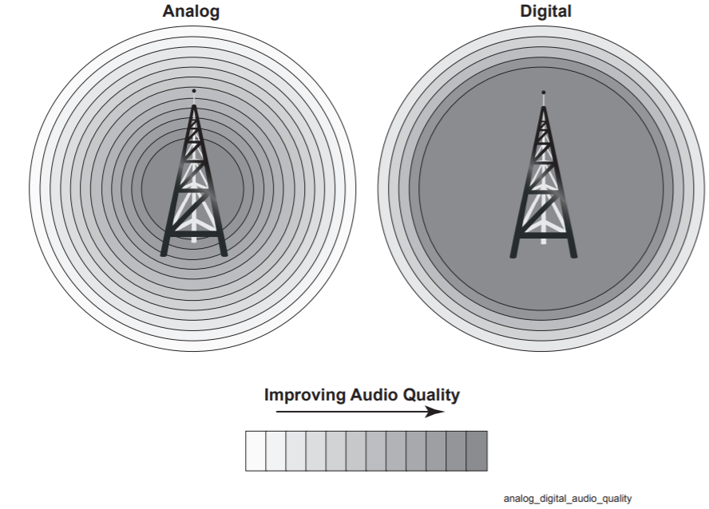
[Editor's note: To be enhanced and Complemented.]

4 General technical and operational considerations
As is the case with other mobile radiocommunication systems (e.g. mobile cellular) the; the operational requirements of professional users have evolved. In addition to spectrum efficiency, digital radio technologies provide: improved audio quality; longer battery performance; and better communication security.
In a normal analog radio, every sound that’s picked up by the microphone is transmitted. If there’s a lot of background noise, it can be very difficult to understand the message. Digital technology uses software that focuses purely on voice or data, paying no attention to the machine clatter or the crowd noise around the users. The result is exceptional voice clarity. Radio interference creates static on an analog radio and makes the conversation less intelligible. Voice gets garbled and the message must be repeated. Because a digital radio has automatic error correction, it rebuilds voice sounds and maintains the clarity of the voice, even if a signal is badly corrupted. And since speech is digitally-encoded, the users benefit from smarter capabilities, such as advanced software algorithms that can deliver clear voice in the most extreme conditions. See Figure 5 below.
Figure 5
Digital vs. Analogue
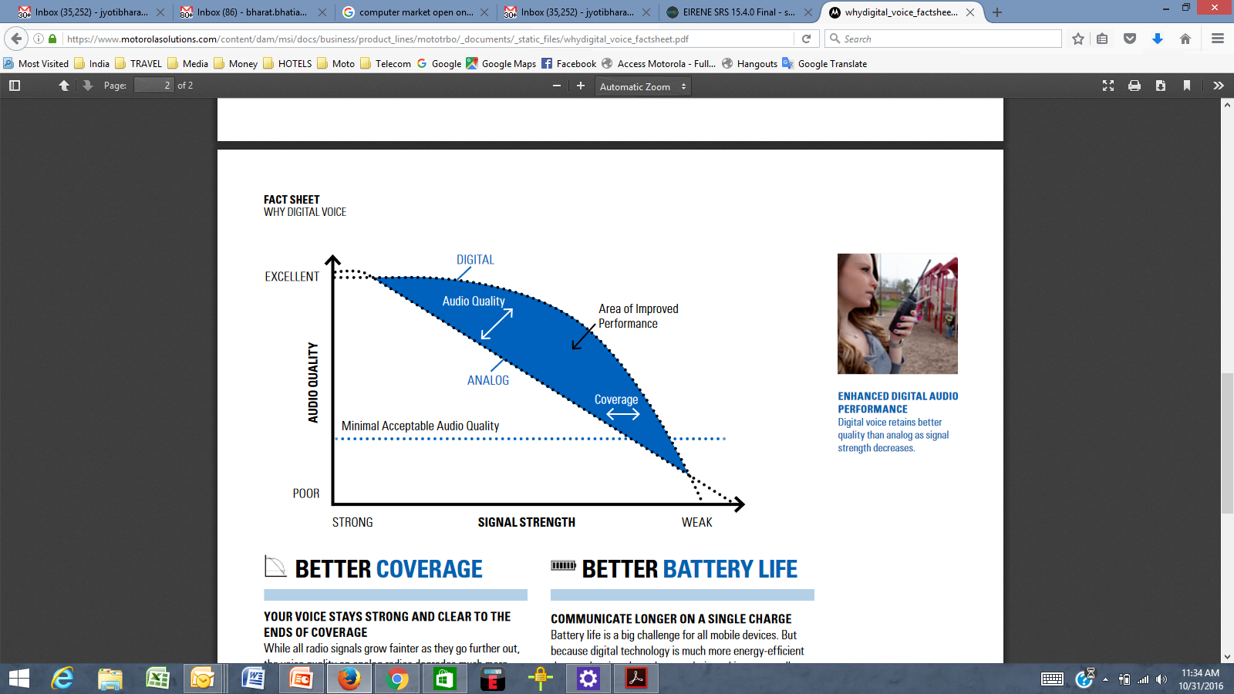
In general the underlying technologies to digital radio protocols used in CDLMR are:
– TDMA: Typically occupies a channel width of 12.5 kHz and divides each 12.5 kHz channel into two timeslots (two logical channels), with each time slot providing a separate communication path.
– FDMA: In contrast to TDMA, FDMA radio protocols provide one communication path per physical channel. For example a 6.25 kHz FDMA radio will operate in a 6.25 kHz channel and provides one communication path.
In the case of CDLMR radios employing 12.5 kHz, these radios have been specified with the intention of allowing the replacement of analog 12.5 kHz radios in existing LMR bands.
Figure 6
Example of benefits of digital over analogue LMR
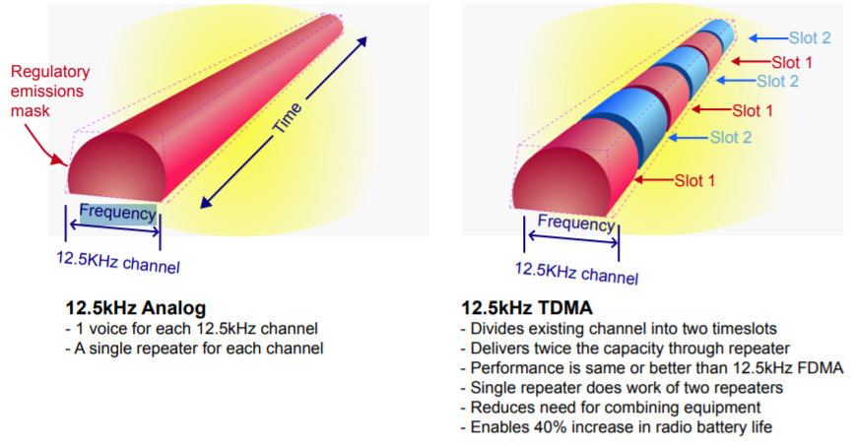

In cases where existing analogue CLMR systems are upgraded to CDLMR systems using existing channel arrangements the technical and operational considerations for CDLMR are similar to that for analogue CLMR. For CDLMR repeater systems using paired frequencies, the same channel assignment plan may be used as the frequency separation for multiple transmitters located at a site is the same.
The use of 12.5 or 6.25 kHz channels with digital technologies can provide up to 4 times the capacity compared with analog 25 kHz systems. Using similar infrastructure, CDLMR systems can be as robust and stable as analog CLMR systems while providing additional useful features such as better communication quality. Interference issues between analogue CLMR systems is the same as that between analogue and digital CLMR systems; that coexistence issues are similar between analogue to analogue, analogue to digital and digital to digital systems. Technical safeguards (such as CTCSS and channel sensing) can allow coexistence between digital and analogue LMR systems in shared simplex channels. In addition, DLMR Access Control can further increase the effectiveness of protection safeguards by limiting access to the resources of a system including radio channel resources to only authorized users.
[Editor's note: To be enhanced and complemented.]

5 Systems technical characteristics and operational features and standards

5.1 Systems technical characteristics and operational features
Operation of CDLMR radio equipment is based on open standards such as APCO P25, dPMR and DMR which are designed for dedicated use by specific organizations, or standards such as NXDN intended for general commercial use. Typical examples are the radio systems used by police forces and fire brigades.
Key features of CDLMR systems include:
– Push-To-Talk (PTT): Is a functionality that is common to all CLMR radios. It is a method in which a single button is pressed to open communication (i.e. transmit mode) and the button is released to listen (i.e. receive mode).CLMR systems are available in two modes:
• Simplex mode: A single frequency is used for transmit and receive among a talk-group, through PTT. A talk-group here is a frequency channel.
• Repeater mode: A pair of frequencies are used, one frequency is used for transmitting and the other is used for receiving. PTT ensures that only one frequency is active at a time, for mobile stations.
– Point to multi-point communications, group communications (as opposed to cell phones which are point to point communications).
– Large coverage areas.
– Closed user groups.
– Use of VHF or UHF frequency bands.
When CLMR first started the systems simply consisted of a single base station with a number of mobiles that could communicate with this single base station. These systems are still in widespread use today with taxi firms and many others using them for communication. Now facilities such as DTMF and CTCSS provide additional calling selection. Because the base station’ antenna may be mounted on a high tower, coverage may extend up to distances of fifty kilometers. This is helpful especially when there is no signal in a public cellular mobile phone. Licenses are allocated for operation on a particular channel or channels. The user can then have use of these channels to contact the mobile stations in their fleet.
Many systems operate with the remote or mobile stations being able to hear all the calls being made. This may not always be satisfactory and a system of selective calling may be needed. There are several ways of achieving this, including Dual Tone Multiple Frequency (DTMF) signalling and Continuous Tone Coded Squelch System (CTCSS).
In general narrow band frequency modulation is the chosen form of modulation, although airport services use amplitude modulation. Typically a deviation of 2.5 kHz is used for FM and this enables a channel spacing of 12.5 kHz to be implemented.

5.2 Standards
The worldwide adoption of open standards optimises economies of scale in equipment supply for many countries. Also, open standards provide increased technical robustness, as they are periodically reviewed by industry.
In general, DLMR systems using open standards helps to ensure backwards compatibility with analogue LMR.
There are a number of standards and technologies that support conventional digital PLMR applications. A short summary of three main DLMR standards are described below:

5.2.1 Project 25 (P25 or APCO-25)
P25 may be used in "talk around" mode without any intervening equipment between two or more radios, in conventional mode where two or more radios communicate through a repeater or base station without trunking or in a trunked mode where traffic is automatically assigned to one or more voice channels by a Repeater or Base Station.
P25 is a suite of standards for digital radio communications. P25 was established to address the need for common digital public safety radio communications standards for first-responders and homeland security/emergency response professionals. The P25 suite of standards involves digital Land Mobile Radio (PLMR) services for local, state/provincial and national public safety organizations and agencies. Although developed primarily for North American public safety services, P25 technology and products are not limited to public safety alone and have also been selected and deployed in other private system application, worldwide. P25-compliant systems are being increasingly adopted and deployed in many countries. Radios can communicate in analog mode with legacy radios, and in either digital or analog mode with other P25 radios. Additionally, the deployment of P25-compliant systems will allow for a high degree of equipment interoperability and compatibility. P25 standards use the proprietary Improved Multi-Band Excitation (IMBE) and Advanced Multi-Band Excitation (AMBE+2) voice codecs which were designed by Digital Voice Systems, Inc. to encode/decode the analog audio signals. The protocol supports the use of Data Encryption Standard (DES) encryption (56 bit), 2-key Triple-DES encryption, three-key Triple-DES encryption, Advanced Encryption Standard (AES) encryption at up to 256 bits keylength, RC4 (40 bits, sold by Motorola as Advanced Digital Privacy), or no encryption.

5.2.2 TETRA in Direct mode operations
TETRA is a high-performance mobile radio system which has been developed primarily for professional users such as the emergency services and public transport. The TETRA suite of mobile radio specifications provide a comprehensive radio capability encompassing trunked, non-trunked and direct mobile-to-mobile communication with a range of facilities including voice, circuit mode data, short data messages and packet mode services. TETRA supports an especially wide range of supplementary services, many of which are exclusive to TETRA.
TETRA is designed to operate in the bands below 1 GHz with 25 kHz channel bandwidth.
When operated in Non-Trunk or Direct Mode Operation (DMO), TETRA works as a DLMR enabling direct mobile-to-mobile communications, Mobile repeater outside the coverage of the network or can be used as a secure communication channel within the network coverage area.

5.2.3 DMR
Digital mobile radio (DMR) is an open digital mobile radio standard defined in the European Telecommunications Standards Institute (ETSI) Standard and used in commercial products around the world. DMR, along with P25 and TETRA are the main PLMR technologies in achieving 6.25 kHz equivalent spectrum efficiency. DMR was designed with three tiers. DMR tiers I and II (conventional) were first published in 2005, and DMR III (trunked) was published in 2012, with manufacturers producing products within a few years of each publication. The primary goal of the standard is to specify a digital system with low complexity, low cost and interoperability across brands, so radio communications purchasers are not locked into a proprietary solution. In practice, many brands have not adhered to this open standard and have introduced proprietary features that make their product offerings non-interoperable.
The DMR standard operates within the existing 12.5 kHz channel spacing used in land mobile frequency bands globally and it achieves two voice channels through two-slot TDMA technology. The standard is still under development with revisions being made regularly as more systems are deployed and discover improvements that can be made. It is very likely that further refinements will be made to the standard, which will necessitate firmware upgrades to terminals and infrastructure in the future to take advantage of these new improvements, with potential incompatibility issues arising if this is not done. DMR covers the RF range 30 MHz to 1 GHz.
Forward error correction can achieve a higher quality of voice when the receive signal is still relatively high. In practice, however, digital modulation protocols are much more susceptible to multipath interference and fail to provide service in areas where analogue FM would otherwise provide degraded but audible voice service. At a higher quality of voice, DMR outperforms analogue FM by about 11 dB. Where digital signal processing has been used to enhance the analogue FM audio quality then analogue FM generally outperforms DMR in all situations, with a typical 2-3 dB improvement for "high quality" voice and around 5 dB improvement for "lower quality" voice.[citation needed] Where digital signal processing is used to enhance analog FM audio, the overall "delivered audio quality" is also considerably better than DMR.[citation needed][ However DSP processing of analog FM audio does not remove the 12.5 kHz requirement so DMR is still more spectrally efficient.]
DMR Tier I products are for licence-exempt use in the 446 MHz band in many countries in Europe and Asia. Tier I products are specified for non-infrastructure use only without the use of repeaters. This part of the standard provides for consumer applications and low-power commercial applications, using a maximum of 0.5 watt RF power.
DMR Tier II covers licensed conventional radio systems, mobiles and hand portables operating in PMR frequency bands up to 960 MHz. The ETSI DMR Tier II standard is targeted at those users who need spectral efficiency, advanced voice features and integrated IP data services in licensed bands for high-power communications. A number of manufacturers have DMR Tier II compliant products on the market. ETSI DMR specifies two slot TDMA in 12.5 kHz channels for Tier II and III.
DMR Tier III covers trunking operation in frequency bands up to 960 MHz. Tier III supports voice and short messaging handling similar to TETRA with built-in 128 character status messaging and short messaging with up to 288 bits of data in a variety of formats. It also supports packet data service in a variety of formats, including support for IPv4 and IPv6. Tier III compliant products were launched in 2012.

5.2.4 dPMR
dPMR or digital private mobile radio, is a Common Air Interface (CAI) for digital mobile communications. dPMR is an open, non-proprietary standard that was developed by the European Telecommunications Standards Institute (ETSI) and published under the reference ETSI TS 102 658. A simplified version of the dPMR protocol intended for licence-free applications was also published by ETSI under the reference TS 102 490.
dPMR major specification:
– Access method: FDMA.
– Transmission rate: 4,800 bit/s.
– Modulation: four-level FSK.
What is significant is that dPMR achieves all this in a 6.25 kHz channel.
Because the emission mask is so tight, two 6.25 kHz dPMR signals can be used next to each other within a 12.5 kHz channel without causing interference to each other or adjacent channels. Compliance with EN301 166 at 6.25 kHz for current equipment is one measure of guarantee that interference issues are no different from at 12.5 kHz or 25 kHz. Frequency co-coordinators in the USA have even made recommendations to the FCC about setting up new 6.25 kHz systems adjacent to existing systems, outlining parameters to avoid harmful interference.
dPMR equipment complies with the relevant European standard ETSI EN 301 166 as well as the FCC emission mask applicable for operation in the US.
dPMR supports several voice coding algorithms. Class A equipment is based on AMBE+2 vocoder, Class R uses RALCWI (Robust Advanced Low Complexity Waveform Interpolation) vocoder, and Class M equipment uses manufacturer specific algorithm; equipment from different classes is not interoperable in digital mode and must revert to analog FM mode.
dPMR446 radios are licence-free products for use in the 446.1–446.2 MHz band within Europe. These are fully digital versions of PMR446 radios. dPMR446 radios comply with the ETSI TS 102 490 open standard and are limited to 500 mW RF power with fixed antennas per ECC Decision (05)12. They are ideally suited to recreational and professional users who do not need wide area coverage with base stations and repeaters. dPMR446 equipment is capable of voice, data and voice+data modes of operation. This means that dPMR446 can provide voice calls, text messaging (SMS), status and embedded data such as GPS position etc.
dPMR Mode 1 is the peer to peer mode of dPMR (without repeaters or infrastructure) but without the limitations of the licence-free counterpart. It can operate all typical licensed PMR frequency bands and without the RF power limits of dPMR446. As well as offering voice and data, dPMR446 Mode 1 also supports combined voice+data so it is possible to embed data into a voice call or automatically append it at the end of a call.
dPMR Mode 2 operations include repeaters and other infrastructure. This brings extra functionality such as analogue or digital system interfaces which can be IP based. Inclusion of repeaters and base stations means that wide area coverage is possible even more so when multiple repeaters are used. Such multiple repeaters can be managed by dynamic channel selection or they can be part of a co-channel wide area system.
dPMR Mode 3 can offer multichannel, multisite trunked radio systems. This ensures optimum use of spectrum and optimum density of radio traffic. Management of the radio system starts from the authentication of radios that wish to connect. Calls are set up by the infrastructure when both parties have responded to the call request ensuring optimum use of the radio resource. Calls may be diverted to other radios, landline numbers or even IP addresses. The infrastructure managing these beacon channels would be capable of placing a call to another radio whether that radio is using the same site or another site within the system.

5.3 Summary of Conventional DLMR systems features

 | TETRA | Project 25 Phase 2 | DMR | dPMR
Standardisation Body | ETSI | TIA | ETSI | ETSI
Trunked mode | Yes | Yes | Yes | Yes
Conventional mode | No | Yes | Yes | Yes
Conventional – Single Frequency Repeater mode | No | No | Yes | Yes
Direct Mode (Walkie Talkie) | Yes | Yes | Yes | Yes
Simulcast capability | No | Yes | Yes | Yes
Channel access | TDMA  (4-slot) | TDMA  (2-slot) | TDMA  (2-slot) | FDMA
Channel width | 25 kHz | 12.5 kHz | 12.5 kHz | 6.25 kHz
Effective (equivalent) traffic channel bandwidth | 6.25 kHz | 6.25 kHz | 6.25 kHz | 6.25 kHz
Frequency ranges that can be supported (MHz) | 350-470 | 136-869 | 70-900 | Below 1 GHz

6 Frequency bands [and channelization]

6.1 Frequency bands
PLMR utilizes various frequency bands across regions in the mobile service, subject to regional harmonization measures and national conditions.
In certain countries the frequency bands used for CLMR are 136 to 144 MHz, 146 to 174 MHz, 350 to 470 MHz, 806 to 869 MHz.

6.2 [Channel spacings and center frequencies
Channel raster or channel spacing for CLMR may be 25 kHz, 20 kHz, 12.5 kHz, 10 kHz and 6.25 kHz.
For every sub-band of above frequency bands, center frequency can be calculated as follows:
Fn = F1 + (n-1) × Channel spacing
where:
Fn: Center frequency of channel n;
F1: Center frequency of first channel;
Channel spacing: frequency difference between 2 adjacent channels;
n: channel number; n = 1, 2, … and n < (F_{higher-edge} – F_{lower-edge}) / Channel spacing.

6.3 Channel arrangements
There are two type of arrangements between two channel spacing, i.e. between 25 kHz and 12.5 kHz channels or 12.5 kHz and 6.25 kHz channels, as illustrate below:

a) Narrow channel locate in the center and the edge of wider channel
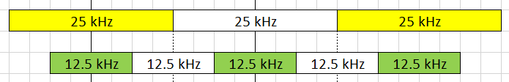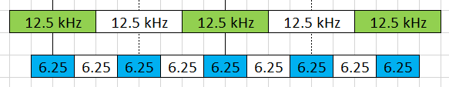
b) Two narrow channel locate inside one wider channel
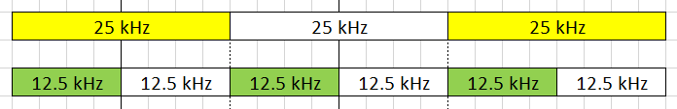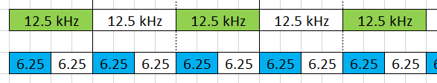
In practice, channeling arrangements for 25, 12.5 and 6.25 kHz could belong to one type or mixed between the above two types.
Figure 7
Interleaved channel plan
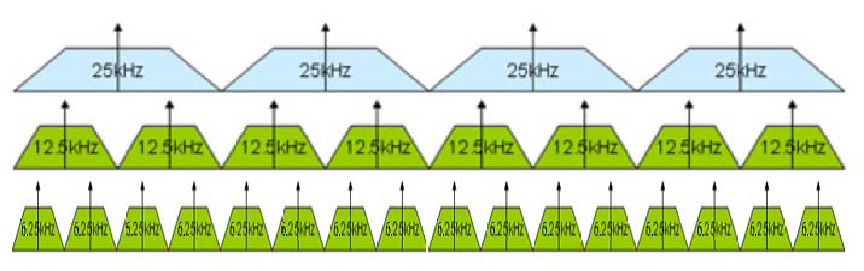
]
Example of national channelization could be provide in Annex to this Report.
Channel raster should be compatible with existing channelization and must be technology inclusive to accommodate both TDMA and FDMA technologies, and legacy analog radios (which have not yet upgraded to digital); and have a well-defined structure for channel frequency spacing. Under this the center of the channel should remain on the same repeat pattern or “on center” in the spectrum whether a licensee holds licenses with 25 kHz, 12.5 kHz, or 6.25 kHz channel bandwidths. Figure 8 below shows how 25 kHz licenses, 12.5 kHz licenses and 6.25 kHz licenses fit into this general channel structure.
FIGURE 8
Channel structure for LMR bands showing unified channel center spacing
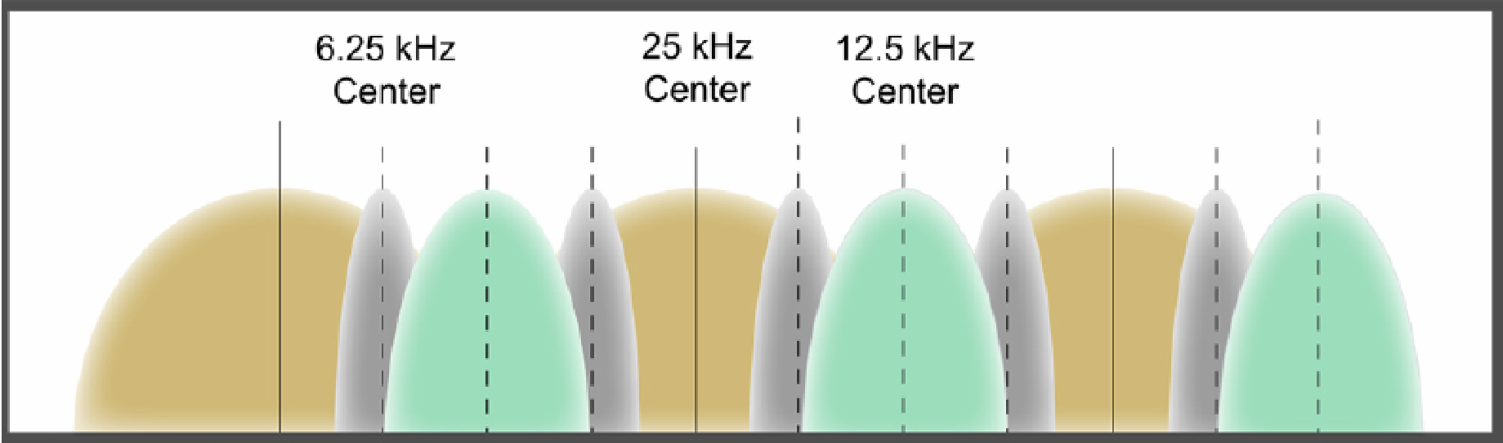
Example of national channelization are provided in Annex 1 to this Report.

7 [Aspects of coexistence
[Editor´s note: This section needs to be revised to avoid inclusion of issues related to licenses and authorisation of spectrum. This section should focus in coexistence issues regarding PLMR to facilitate sharing and efficient use of spectrum by this application.]
This section aims to deal with frequency engineering and selection for systems operating in intra-Land Mobile Radio Service scenario: methodology, criteria, practice.
Frequency selection criteria across various scenarios is considered: when a new DPLMR system share the frequency with existing PLMR systems; when existing DPLMR require additional channels; and sharing and interference analysis between PLMR system with C/I or I/N.
Further systems technical and operational characteristics of conventional and trunked land mobile systems operating in the mobile service allocations below 869 MHz to be used in sharing studies are found in Recommendation ITU-R M.1808.

7.1 Frequency engineering and selection method
The traditional method of selection of frequencies for PLMR systems is typically through an administrative method, which results in an apparatus assignment.
Apparatus assignments are typically issued on a first-come-first-served basis and it usually includes RF technical conditions, including duration and associated fees.
[The fees payable in apparatus assignments usually consists of two components:
a) Licence fee for a fixed term. The duration of the licence term varies with administrations. It ranges from one to five years.
b) Spectrum fee or spectrum management fee. The spectrum fee component usually depends on the frequency channel bandwidth and can also depend on the frequency band. Like the licence fee component the duration of the spectrum fee varies with administrations; 1 to 5 years.
Annex 1 contain examples of frequency assignment and licensing criteria/conditions.]
To operate digital LMR systems, and where frequency arrangements are based on 12.5 KHz channels, holders of 25 kHz licenses or assignments that wish to migrate to 12.5 kHz, will have to take into account whether center frequency of 12.5 KHz channels are aligned with 25 kHz channels assigned or whether it is interleaved. Selection of channel would result in a new engineering study as systems characteristics could vary and RF study is required to validate engineering assumptions used in existing systems continue. License amended to designate a new 12.5 kHz channel on the center frequency of the old higher bandwidth channel. (This is illustrated in Figure 9A below) should take limitations of RF components of system being migrated to avoid unnecessary re-engineering of cost to existing user. The license modification issued will then reflect the new 12.5 kHz emission designator.
For the licensee, a two for one channel capacity increase is gained using TDMA technology, and possible interference issues are reduced (in contrast to the increased potential for interference resulting from splitting a 25 kHz license into three adjacent 6.25 kHz channels).
FIGURE 9
Effect of using TDMA technology in an existing 12.5 KHz and 25 KHz channel
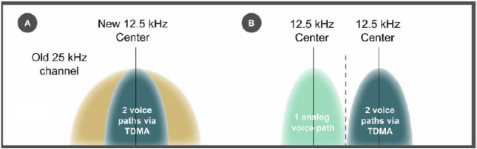
As a general practice, licensees do not require to apply for a new license to achieve 6.25 kHz spectrum efficiency or a doubling of capacity in a 12.5 kHz channel. This is true whether the licensee converts a current 25 kHz channel to a 12.5 kHz channel, or currently uses an existing 12.5 kHz channel. For example, DMR works within the existing 12.5 kHz channel mask and achieves doubling of channel capacity by the use of TDMA with only one repeater required per two virtual channels. This is illustrated in Figure 9B above.
Licenses may be issued by regulators on shared used or exclusive use basis. Spectrum fees calculations varies from country to country, some prefer calculations based on the area of coverage, others prefers calculations based on the number of repeaters and channels assigned (regardless the number of mobile and portable radios).
As with other radiocommunications services, CLMR systems can be issued an authorisation under one of several regimes. In the VHF and UHF bands, whose allocation is under the National Regulator responsibility, users must be granted an authorisation by National Regulator. Under this individual licensing system, there are four distinct schemes for spectrum use, adapted to PMR system' different needs.

7.2 Individual authorisation by allotment
An authorisation is granted for the use of a block of frequencies in a given geographical area, without specifying the location of the user base stations. The authorisation carries a protection guarantee against harmful interference. This type of authorisation does not specify in any detail how the authorised system is engineered, which the user is free to alter within the limits set by the authorisation provisions.

7.3 Individual authorisation by assignment
An authorisation is granted for the use of a frequency in a given location and under technical terms and conditions that are detailed specifically in the authorisation, which implies prior frequency coordination, site by site. The authorisation carries a protection guarantee against harmful interference. If the user wants to modify the location of the sites or the technical terms and conditions attached to its licence, the user must request permission from Regulator to make these changes.
Traditionally, CLMR systems have usually been based on some popular technical standards for the equipment, but operated under assignment and subject to National frequency management plans.
As the demands for CLMR are high, it is necessary to make effective use of the channels available. This is achieved by re-using the frequencies in different areas. Base stations must be located sufficiently far apart so that interference is not experienced, and also selective calling techniques such as CTCSS and DTMF are used to ensure that as many mobiles as possible can use a given channel.

7.4 Individual licences for shared use, with no guarantee of protection
The licence is issued for the use of frequencies on an individual, but non-exclusive basis, with no guarantee of protection from other users.

7.5 Class authorization (individual Licence-exempt)
In some channels of the identified frequency bands, which pre-allocated, a PMR system does not require a prior authorisation from National Regulator to operate: these sub-bands are subject to a system of Licence-exempt. Users can therefore employ these frequencies for free, provided they comply with the technical terms and conditions set out, which may include restrictions on the type of equipment, system or technology that can be employed in the frequency band.
CLMR licences control who can transmit where, and on what frequency, to make sure that different users do not cause interference to each other. This is especially important regarding "official" radio users such as governmental, air traffic control, emergency services, disaster relief, mining, health, hospitality, transportations, industrial, manufacturing, construction, etc. In other way, "licence free" or “licence-exempt” radios will be fine for many walkie-talkie simple users, they share limited number of frequency channels with low transmit power subjected to not causing harmful interference and cannot claim protection from harmful interference caused by the other users (e.g. licence-exempt frequencies for CLMR devices around the world, e.g. PMR446, FRS, GMRS).]

8 Analog to digital transition
When planning to introduce digital PLMR for the first time, considerations for both data and voice applications, channeling plans, type approval and regulatory requirements need to be considered and to ensure the operation of digital radio in existing (or planned) LMR frequency bands.

8.1 Digital Voice and Data
Digital PLMR systems support both voice and data services, in time or in frequency domain. Data applications in PLMR are becoming an important aspect of PLMR applications. In scenarios where analog only radio interface are included in the national PLMR requirements, PLMR systems that support both data and voice or improved voice channel will have to wait for changes to benefit from the improved channel usage or to benefit from both data and voice capabilities.

8.2 Transition analog to digital
The transition of a PLMR frequency band from analog to digital is straightforward if the existing arrangements (transmit power, channel assignment plan, channel raster, etc.) remain unchanged.
Some administration may wish to re-band an existing PLMR frequency band to use a narrower channel spacing. For example, from existing 25 kHz channel spacing to 12.5 kHz channel space. In this case the transition will include the additional step of re-banding.

8.2.1 Analog to digital transition in PLMR bands with existing channel arrangements
Digital PLMR equipment that use 25 kHz or 12.5 kHz channel can operate in existing PLMR frequency bands using existing 25 kHz or 12.5 kHz channel arrangements (transmit power, channel assignment plan, channel raster, etc.) In this transition scenario the probability of interference is no worse than for analog radio.
Below table provides a summary of which category of digital PLMR radio than can migrate in existing PLMR bands.

Existing PLMR band with | Category of digital PLMR radio that can migrate into existing PLMR band
12.5 kHz channel arrangements | 12.5 kHz digital PLMR
25 kHz channel arrangements | 25 kHz digital PLMR

As this transition only involve the upgrade of analog systems to digital PLMR systems using the same frequencies, much of the existing site infrastructure (e.g. combiner, cabling, etc.) can be re-used.

8.2.2 Analog to digital transition with re-banding from 25 kHz to 12.5 kHz channel spacing
In this transition scenario a frequency band with 25 kHz channel spacing for analog PLMR is re-banded to 12.5 kHz channel spacing for digital PLMR.
This type of transition usually implemented in phases. The following transition method consists of two phases. The first phase involves the migration of existing 25 kHz analog PLMR systems to 12.5 kHz digital PLMR systems using their existing frequency assignments. The second phase involve the retrieving of new 12.5 kHz channels with the completion 25 kHz to 12.5 kHz migration. The migration may take some time before the new channels can be retrieved and reassigned. However it provides a smooth migration without affecting systems that had upgraded to digital PLMR in the first phase.
Figure 10 below illustrates the different phases of the transition.
Figure 10
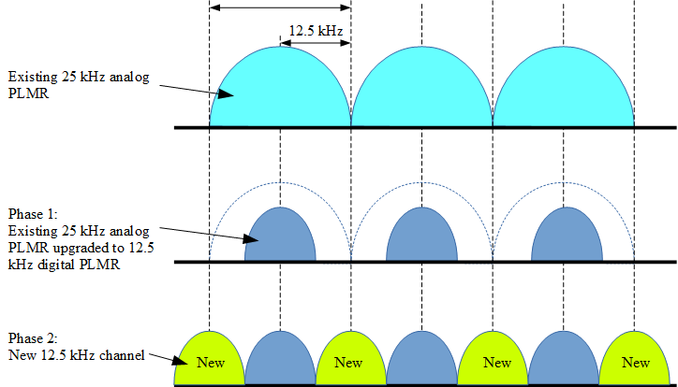

9 Interleaved and Offset Channelling Arrangements
Bands with interleaved channel plans are often suitable for the immediate introduction of DLMR systems, while bands with offset channel plans may require segmentation or transition plans.

9.1 Interleaved channel plans
Interleaved channel plans can provide for the introduction of digital services designed to operate in 12.5 kHz and 6.25 kHz channels without the need for band migrations, provided the selected technology standards are compatible with existing analogue land mobile equipment.
Figure 11
Interleaved channel plan

9.2 Offset channel plans
Analogue emissions tend to concentrate their power closer to the centre frequency and within a narrower bandwidth than the channel space assigned in the band (i.e. the effective emission bandwidth in a 25 kHz analogue LMR channel only occupies approximately 16 kHz). Since analogue LMR channels do not spread their power across the entire allocated channel space, it is possible to license narrower 12.5 kHz analogue channels (which also concentrate their power in the same way) in the offset gap between 25 kHz analogue channels, without causing harmful interference (as shown in Figure 12).
Unlike analogue emissions, digital emissions tend to spread their power across the entire channel, and therefore mixing digital and analogue emissions in offset bands can cause adjacent channel interference (from digital into analogue). Therefore, offset bands require either band segmentation or migration plans to be implemented to protect existing analogue services.
Figure 12
Offset channel plan
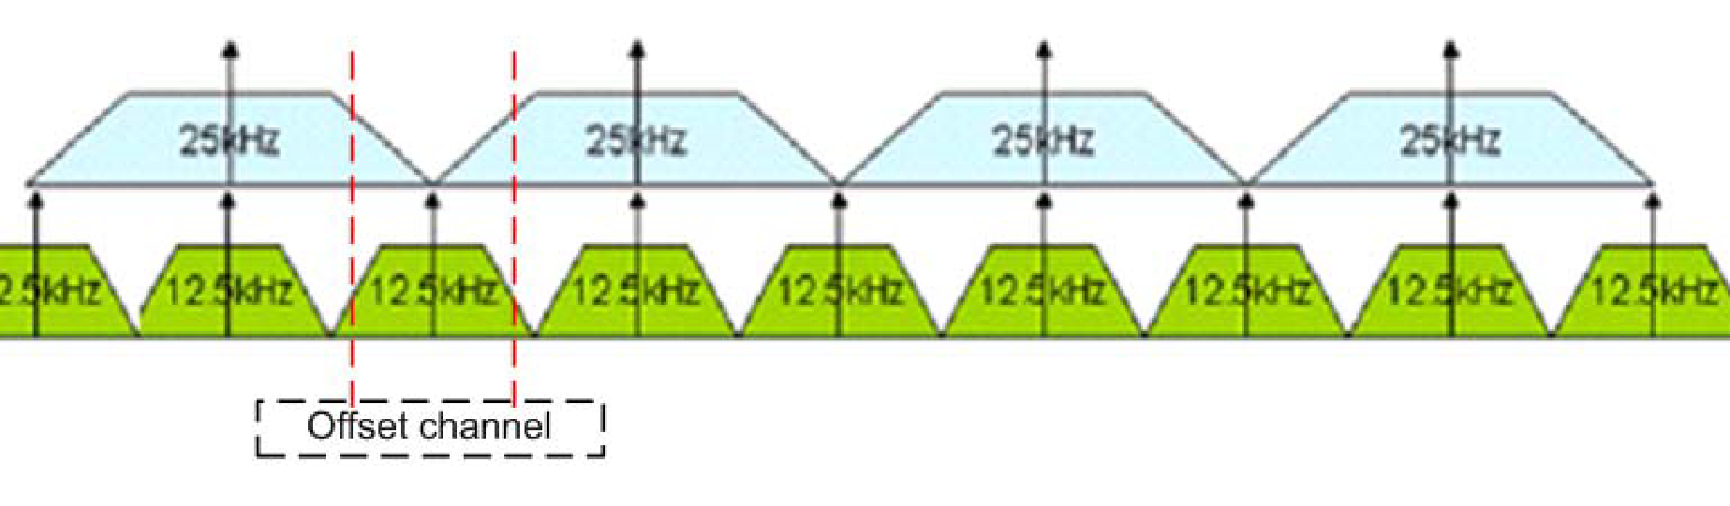
The use of transition plans is seen as an appropriate approach for offset channel plans.

ANNEX [N]
[An example of Frequency channel selection for CLMR systems

1 Introduction
Traditionally, CLMR systems have usually been based on some popular technical standards for the equipment, but operated under assignment and subject to National frequency management plans.
As the demands for CLMR are high, it is necessary to make effective use of the channels available. This is achieved by re-using the frequencies in different areas. Base stations must be located sufficiently far apart so that interference is not experienced, and also selective calling techniques such as CTCSS and DTMF are used to ensure that as many mobiles as possible can use a given channel.
Selection of a frequency channel for a CLMR system means to find a frequency channel that one DPLMR system can be used without interfere and/or be interfered with existing DPLMR systems.
One of efficient/popular method in frequency channel selection for CLMR systems is Frequency and distance separations (call F-D) method or F-D constrain. Apply the F-D constraints to assess the potential for interference between the proposed assignment and the existing systems. Intermodulation issue also be taken into consideration when assigning a frequency channel to CLMR system.
Assignment will be made to the proposed network on the channel that satisfies the F-D constraints, consistent with meeting this network’s operating frequency requirements as far as practicable.

2 Frequency bands and channeling
The frequency band 138-174 MHz in the VHF range and 406-470 MHz in UHF range are widely use around the world for CLMR. Channel spacing in those bands are 25 / 20 / 12.5 / 10 / 6.25 kHz. An example of channelization of CLMR frequency as below

No | Band (MHz) | Center frequency (MHz) | Channel number (N) | Channel spacing  (kHz)
VHF range
1 | 138-144 | 138 + 0.025 x N | 0 to 240 | 25
1 | 138-144 | 138 + 0.0125 x N | 0 to 480 | 12.5
1 | 138-144 | 138 + 0.00625 x N | 0 to 960 | 6.25
2 | 146-149.9 | 146 + 0.025 x N | 0 to 155 | 25
2 | 146-149.9 | 146 + 0.0125 x N | 0 to 310 | 12.5
2 | 146-149.9 | 146 + 0.00625 x N | 0 to 620 | 6.25
3 | 150.05-156.4875 | 150.05 + 0.025 x N | 0 to 257 | 25
3 | 150.05-156.4875 | 150.05 + 0.0125 x N | 0 to 514 | 12.5
3 | 150.05-156.4875 | 150.05 + 0.00625 x N | 0 to 1028 | 6.25
4 | 156.8375-174 | 156.850 + 0.025 x N | 0 to 686 | 25
4 | 156.8375-174 | 156.850 + 0.0125 x N | 0 to 1372 | 12.5
4 | 156.8375-174 | 156.850 + 0.00625 x N | 0 to 2744 | 6.25
UHF range
5 | 406-430 | 406 + 0.025 x N | 0 to 960 | 25
5 | 406-430 | 406 + 0.0125 x N | 0 to 1920 | 12.5
5 | 406-430 | 406 + 0.00625 x N | 0 to 3840 | 6.25
6 | 440-470 | 440 + 0.025 x N | 0 to 1200 | 25
6 | 440-470 | 440 + 0.0125 x N | 0 to 2400 | 12.5
6 | 440-470 | 440 + 0.00625 x N | 0 to 4800 | 6.25
NOTE: due to local regulation, some portions of frequency bands listed may not be available in some countries.

3 Frequency – Distance criteria

3.1 Deployment model
There are 3 popular types of CLMR deployment:
a) Type A:
– Only handheld transceivers
– Low output power: typical maximum 5W to 10 W
– Single frequency, simplex: transmit and receive in same frequency
b) Type B:
– With repeater station(s) and mobile stations
– Height output power: typical maximum 25W to 50 W
– Single frequency, simplex: transmit and receive in same frequency
c) Type C:
– With repeater stations and mobile stations
– Height output power: typical maximum 25W to 50 W
– Two frequency, semi-duplex: transmit and receive in difference frequencies

3.2 Minimum distance separation between two CLMR system type A
a) For VHF range

Δf between  new 6.25 kHz and existing | Distance separation (km)
Δf between  new 6.25 kHz and existing | Existing  6.25 kHz | Existing  12.5 kHz | Existing  25 kHz
0 kHz | 10 | 10 | 10
6.25 kHz | 1.9 | 10 | 10
12.5 kHz | 0.3 | 0.5 | 10
18.75 kHz | 0.3 | 0.3 | 0.8
25 kHz | 0.3 | 0 | 0.4
31.25 kHz | 0 | 0 | 0
37.5 kHz | 0 | 0 | 0
43.75 kHz | 0 | 0 | 0
50 kHz | 0 | 0 | 0

Δf between  new 12.5 kHz and existing | Distance separation (km)
Δf between  new 12.5 kHz and existing | Existing  6.25 kHz | Existing  12.5 kHz | Existing  25 kHz
0 kHz | 10 | 10 | 10
6.25 kHz | 10 | 10 | 10
12.5 kHz | 0.5 | 1.2 | 10
18.75 kHz | 0.3 | 0 | 1.2
25 kHz | 0 | 0 | 0.4
31.25 kHz | 0 | 0 | 0.3
37.5 kHz | 0 | 0 | 0.3
43.75 kHz | 0 | 0 | 0.3
50 kHz | 0 | 0 | 0.3

Δf between  new 25 kHz  and existing | Distance separation (km)
Δf between  new 25 kHz  and existing | Existing  6.25 kHz | Existing  12.5 kHz | Existing  25 kHz
0 kHz | 10 | 10 | 10
6.25 kHz | 10 | 10 | 10
12.5 kHz | 10 | 10 | 10
18.75 kHz | 0.8 | 1.2 | 10
25 kHz | 0.4 | 0.4 | 0.6
31.25 kHz | 0.4 | 0.4 | 0.5
37.5 kHz | 0.4 | 0.4 | 0.5
43.75 kHz | 0.4 | 0.4 | 0.5
50 kHz | 0.4 | 0.4 | 0.5

b) For UHF range

Δf between  new 6.25 kHz  and existing | Distance separation (km)
Δf between  new 6.25 kHz  and existing | Existing  6.25 kHz | Existing  12.5 kHz | Existing  25 kHz
0 kHz | 10 | 10 | 10
6.25 kHz | 1.9 | 10 | 10
12.5 kHz | 0.3 | 0.5 | 10
18.75 kHz | 0.3 | 0.3 | 0.8
25 kHz | 0.3 | 0 | 0.4
31.25 kHz | 0 | 0 | 0
37.5 kHz | 0 | 0 | 0
43.75 kHz | 0 | 0 | 0
50 kHz | 0 | 0 | 0

Δf between  new 12.5 kHz  and existing | Distance separation (km)
Δf between  new 12.5 kHz  and existing | Existing  6.25 kHz | Existing  12.5 kHz | Existing  25 kHz
0 kHz | 10 | 10 | 10
6.25 kHz | 10 | 10 | 10
12.5 kHz | 0.5 | 1.2 | 10
18.75 kHz | 0.3 | 0 | 1.2
25 kHz | 0 | 0 | 0.4
31.25 kHz | 0 | 0 | 0
37.5 kHz | 0 | 0 | 0
43.75 kHz | 0 | 0 | 0
50 kHz | 0 | 0 | 0

Δf between  new 25 kHz  and existing | Distance separation (km)
Δf between  new 25 kHz  and existing | Existing  6.25 kHz | Existing  12.5 kHz | Existing  25 kHz
0 kHz | 10 | 10 | 10
6.25 kHz | 10 | 10 | 10
12.5 kHz | 10 | 10 | 10
18.75 kHz | 0.8 | 1.2 | 10
25 kHz | 0.4 | 0.4 | 0.5
31.25 kHz | 0 | 0 | 0
37.5 kHz | 0 | 0 | 0
43.75 kHz | 0 | 0 | 0
50 kHz | 0 | 0 | 0

3.3 Minimum distance separation between two CLMR system type B
a) For VHF range

Δf between  new 6.25 kHz and existing | Distance separation (km)
Δf between  new 6.25 kHz and existing | Existing  6.25 kHz | Existing  12.5 kHz | Existing  25 kHz
0 kHz | 140 | 140 | 140
6.25 kHz | 90 | 130 | 136
12.5 kHz | 33 | 51 | 106
18.75 kHz | 33 | 30 | 64
25 kHz | 26 | 23 | 48
31.25 kHz | 17 | 15 | 47
37.5 kHz | 17 | 15 | 47
43.75 kHz | 17 | 15 | 47
50 kHz | 17 | 15 | 47

Δf between  new 12.5 kHz and existing | Distance separation (km)
Δf between  new 12.5 kHz and existing | Existing  6.25 kHz | Existing  12.5 kHz | Existing  25 kHz
0 kHz | 140 | 140 | 140
6.25 kHz | 130 | 130 | 135
12.5 kHz | 51 | 76 | 118
18.75 kHz | 30 | 22 | 76
25 kHz | 23 | 16 | 48
31.25 kHz | 15 | 8.6 | 46
37.5 kHz | 15 | 8.6 | 46
43.75 kHz | 15 | 8.6 | 46
50 kHz | 15 | 8.6 | 46

Δf between  new 25 kHz  and existing | Distance separation (km)
Δf between  new 25 kHz  and existing | Existing  6.25 kHz | Existing  12.5 kHz | Existing  25 kHz
0 kHz | 140 | 140 | 140
6.25 kHz | 136 | 135 | 135
12.5 kHz | 106 | 118 | 118
18.75 kHz | 64 | 76 | 82
25 kHz | 48 | 48 | 56
31.25 kHz | 47 | 46 | 51
37.5 kHz | 47 | 46 | 51
43.75 kHz | 47 | 46 | 51
50 kHz | 47 | 46 | 51

b) For UHF range

Δf between  new 6.25 kHz  and existing | Distance separation (km)
Δf between  new 6.25 kHz  and existing | Existing  6.25 kHz | Existing  12.5 kHz | Existing  25 kHz
0 kHz | 120 | 120 | 120
6.25 kHz | 70 | 110 | 116
12.5 kHz | 8.1 | 19 | 86
18.75 kHz | 8.1 | 7.5 | 44
25 kHz | 6.4 | 5.7 | 12
31.25 kHz | 4.1 | 3.6 | 5.1
37.5 kHz | 4.1 | 3.6 | 4.7
43.75 kHz | 4.1 | 3.6 | 4.7
50 kHz | 4.1 | 3.6 | 4.7

Δf between  new 12.5 kHz  and existing | Distance separation (km)
Δf between  new 12.5 kHz  and existing | Existing  6.25 kHz | Existing  12.5 kHz | Existing  25 kHz
0 kHz | 120 | 120 | 120
6.25 kHz | 110 | 110 | 115
12.5 kHz | 19 | 57 | 98
18.75 kHz | 7.5 | 5.4 | 56
25 kHz | 5.7 | 4.1 | 13
31.25 kHz | 3.6 | 2.1 | 4.6
37.5 kHz | 3.6 | 2.1 | 3.6
43.75 kHz | 3.6 | 2.1 | 2.4
50 kHz | 3.6 | 2.1 | 2.4

Δf between  new 25 kHz  and existing | Distance separation (km)
Δf between  new 25 kHz  and existing | Existing  6.25 kHz | Existing  12.5 kHz | Existing  25 kHz
0 kHz | 120 | 120 | 120
6.25 kHz | 116 | 115 | 115
12.5 kHz | 86 | 98 | 98
18.75 kHz | 44 | 56 | 62
25 kHz | 12 | 13 | 23
31.25 kHz | 5.1 | 4.6 | 7.9
37.5 kHz | 4.7 | 3.6 | 4.6
43.75 kHz | 4.7 | 2.4 | 2.8
50 kHz | 4.7 | 2.4 | 2.4

3.4 Minimum distance separation between two CLMR system type C
a) For VHF range

Δf between  new 6.25 kHz  and existing | Distance separation (km)
Δf between  new 6.25 kHz  and existing | Existing  6.25 kHz | Existing  12.5 kHz | Existing  25 kHz
0 kHz | 100 | 100 | 100
6.25 kHz | 52* | 86 | 94
12.5 kHz | 0 | 0 | 63
18.75 kHz | 0 | 0 | 0
25 kHz | 0 | 0 | 0
31.25 kHz | 0 | 0 | 0
37.5 kHz | 0 | 0 | 0
43.75 kHz | 0 | 0 | 0
50 kHz | 0 | 0 | 0

Δf between  new 12.5 kHz  and existing | Distance separation (km)
Δf between  new 12.5 kHz  and existing | Existing  6.25 kHz | Existing  12.5 kHz | Existing  25 kHz
0 kHz | 100 | 100 | 100
6.25 kHz | 86 | 87 | 94
12.5 kHz | 0 | 0 | 74
18.75 kHz | 0 | 0 | 47
25 kHz | 0 | 0 | 0
31.25 kHz | 0 | 0 | 0
37.5 kHz | 0 | 0 | 0
43.75 kHz | 0 | 0 | 0
50 kHz | 0 | 0 | 0

Δf between  new 25 kHz  and existing | Distance separation (km)
Δf between  new 25 kHz  and existing | Existing  6.25 kHz | Existing  12.5 kHz | Existing  25 kHz
0 kHz | 100 | 100 | 100
6.25 kHz | 94 | 94 | 94
12.5 kHz | 63 | 74 | 74
18.75 kHz | 0 | 47 | 48
25 kHz | 0 | 0 | 0
31.25 kHz | 0 | 0 | 0
37.5 kHz | 0 | 0 | 0
43.75 kHz | 0 | 0 | 0
50 kHz | 0 | 0 | 0

b) For UHF range

Δf between  new 6.25 kHz  and existing | Distance separation (km)
Δf between  new 6.25 kHz  and existing | Existing  6.25 kHz | Existing  12.5 kHz | Existing  25 kHz
0 kHz | 100 | 100 | 100
6.25 kHz | 54* | 87 | 95
12.5 kHz | 0 | 0 | 65
18.75 kHz | 0 | 0 | 0
25 kHz | 0 | 0 | 0
31.25 kHz | 0 | 0 | 0
37.5 kHz | 0 | 0 | 0
43.75 kHz | 0 | 0 | 0
50 kHz | 0 | 0 | 0

Δf between  New 12.5 kHz  and existing | Distance separation (km)
Δf between  New 12.5 kHz  and existing | Existing  6.25 kHz | Existing  12.5 kHz | Existing  25 kHz
0 kHz | 100 | 100 | 100
6.25 kHz | 87 | 88 | 94
12.5 kHz | 0 | 0 | 75
18.75 kHz | 0 | 0 | 47
25 kHz | 0 | 0 | 0
31.25 kHz | 0 | 0 | 0
37.5 kHz | 0 | 0 | 0
43.75 kHz | 0 | 0 | 0
50 kHz | 0 | 0 | 0

Δf between  new 25 kHz  and existing | Distance separation (km)
Δf between  new 25 kHz  and existing | Existing  6.25 kHz | Existing  12.5 kHz | Existing  25 kHz
0 kHz | 100 | 100 | 100
6.25 kHz | 95 | 94 | 94
12.5 kHz | 65 | 75 | 75
18.75 kHz | 0 | 47 | 49
25 kHz | 0 | 0 | 0
31.25 kHz | 0 | 0 | 0
37.5 kHz | 0 | 0 | 0
43.75 kHz | 0 | 0 | 0
50 kHz | 0 | 0 | 0

3.5 Minimum distance separation between a CLMR system type A and type B
a) For VHF range

Δf between  new 6.25 kHz  and existing | Distance separation (km)
Δf between  new 6.25 kHz  and existing | Existing  6.25 kHz | Existing  12.5 kHz | Existing  25 kHz
0 kHz | 116 | 111 | 111
6.25 kHz | 35 | 91 | 103
12.5 kHz | 4.5 | 8 | 54
18.75 kHz | 4.5 | 4.3 | 14
25 kHz | 3.9 | 3.5 | 7
31.25 kHz | 2.9 | 2.6 | 6.7
37.5 kHz | 2.9 | 2.6 | 6.7
43.75 kHz | 2.9 | 2.6 | 6.7
50 kHz | 2.9 | 2.6 | 6.7

Δf between  new 12.5 kHz  and existing | Distance separation (km)
Δf between  new 12.5 kHz  and existing | Existing  6.25 kHz | Existing  12.5 kHz | Existing  25 kHz
0 kHz | 111 | 105 | 111
6.25 kHz | 91 | 92 | 102
12.5 kHz | 8 | 23 | 70
18.75 kHz | 4.3 | 3.4 | 23
25 kHz | 3.5 | 2.8 | 7
31.25 kHz | 2.6 | 1.8 | 6.4
37.5 kHz | 2.6 | 1.8 | 5.2
43.75 kHz | 2.6 | 1.8 | 5.2
50 kHz | 2.6 | 1.8 | 5.2

Δf between  new 25 kHz  and existing | Distance separation (km)
Δf between  new 25 kHz  and existing | Existing  6.25 kHz | Existing  12.5 kHz | Existing  25 kHz
0 kHz | 111 | 111 | 111
6.25 kHz | 103 | 102 | 102
12.5 kHz | 54 | 70 | 71
18.75 kHz | 14 | 23 | 27
25 kHz | 7 | 7 | 10
31.25 kHz | 6.7 | 6.4 | 7.9
37.5 kHz | 6.7 | 6.4 | 7.8
43.75 kHz | 6.7 | 6.4 | 7.8
50 kHz | 6.7 | 6.4 | 7.8

b) For UHF range

Δf between  new 6.25 kHz  and existing | Distance separation (km)
Δf between  new 6.25 kHz  and existing | Existing  6.25 kHz | Existing  12.5 kHz | Existing  25 kHz
0 kHz | 107 | 103 | 103
6.25 kHz | 34 | 85 | 96
12.5 kHz | 4.5 | 8 | 52
18.75 kHz | 4.5 | 4.3 | 14
25 kHz | 3.9 | 3.5 | 6
31.25 kHz | 2.9 | 2.6 | 3.3
37.5 kHz | 2.9 | 2.6 | 3.1
43.75 kHz | 2.9 | 2.6 | 3.1
50 kHz | 2.9 | 2.6 | 3.1

Δf between  new 12.5 kHz  and existing | Distance separation (km)
Δf between  new 12.5 kHz  and existing | Existing  6.25 kHz | Existing  12.5 kHz | Existing  25 kHz
0 kHz | 103 | 97 | 103
6.25 kHz | 85 | 86 | 95
12.5 kHz | 8 | 23 | 67
18.75 kHz | 4.3 | 3.4 | 23
25 kHz | 3.5 | 2.8 | 6.1
31.25 kHz | 2.6 | 1.8 | 3.1
37.5 kHz | 2.6 | 1.8 | 2.6
43.75 kHz | 2.6 | 1.8 | 2
50 kHz | 2.6 | 1.8 | 2

Δf between  new 25 kHz  and existing | Distance separation (km)
Δf between  new 25 kHz  and existing | Existing  6.25 kHz | Existing  12.5 kHz | Existing  25 kHz
0 kHz | 103 | 103 | 103
6.25 kHz | 96 | 95 | 95
12.5 kHz | 52 | 67 | 68
18.75 kHz | 14 | 23 | 27
25 kHz | 6 | 6.1 | 9.2
31.25 kHz | 3.3 | 3.1 | 4.4
37.5 kHz | 3.1 | 2.6 | 3.1
43.75 kHz | 3.1 | 2 | 2.2
50 kHz | 3.1 | 2 | 2
]

[ANNEX 1]
[Editor´s note: This part is out of the scope]

1 [An example of assignment criteria based on number of mobile/portable terminals
In some administrations the utilization and licensing of frequencies for PLMR is broadly divided into two categories: shared use; and exclusive use. The licence fees and conditions, and spectrum fees are dependent on whether the frequencies are for shared use or exclusive use. For example the licence application for exclusive frequencies may include the criteria of minimum number of mobile terminals per frequency or frequency-pair and may also include justification for using a private network. Tables 1a and 1b below provide an example of an assignment criteria based on the number of mobile/portable terminals and the annual spectrum fees.
Table 1a
Assignment criteria based on number of mobile/portable terminals
Type of PLMR system | Minimum number of portable radios | Maximum permitted transmit power | Type of frequency assignment
Single Frequency | 5 | 1 Watt ERP | Shared frequency
Single Frequency | 30 | 5 Watts ERP | Shared frequency
Two Frequency | 50 | 25 Watts ERP | Exclusive frequency

Table 1b
Spectrum fee for Private PLMR
Category of frequency usage | Frequency band | Occupied bandwidth per frequency | Fee per frequency per year.
Frequency used on an exclusive basis | All PLMR frequency bands | ≤ 25 kHz | 400 units
Frequency used on a shared basis | All PLMR frequency bands | ≤ 25 kHz | 300 units

2 Assignment criteria based on light regulation for shared frequencies and based on area of coverage and popularity of frequency band for exclusive frequencies
In this example, the licensing of shared frequencies is lightly regulated. It consists of two types:
a) Simple licence: 15 frequencies are shared by licensees using hand-portable radios only.
b) Simple site licence: The operation of a base station is permitted and a pool of frequencies is shared among licensees.
A summary of the above simple licensing is given in Table 2a.
Table 2a
Simple licence using shared frequencies
Type of PLMR system | Frequencies | Maximum transmit power of devices | Licence criteria | Licence fee
Simple licence | 15 shared | 5 Watts ERP | Licensee must self-coordinate with other Simple licences. Base station use not permitted | 75 units for 5 years
Simple Site | A pool of frequencies | 2 Watts ERP for mobile station and base station | Licensee must self-coordinate with other Simple Site licences. | 75 units for 5 years

The licence criteria for exclusive frequencies is based on area of coverage and popularity of frequency band. The area of coverage can be a fixed area (e.g. 50 km square block), sub-regional (a town or city), regional (northern, southern regions) or nationwide. The licence fees are calculated using a combination of frequency width, frequency band and region/area covered. Table 2b provides an example for comparison of licence fees based on popularity of frequency bands and area of coverage.
Table 2b
Licence fees for two 12.5 kHz frequencies based on frequency band and area covered
Area | Fee for highly popular bands | Fee for medium popular bands | Fee for less popular bands
Nationwide | 9 900 | 8 250 | 3 300
50 km block within high population area | 1 185 | 990 | 395
50 km block within medium population area | 150 | 125 | 50
50 km block within low population area | 14 | 12 | 5

]

______________

Typically, 250 kHz separation for transmit-to-transmit for collocated transmitters in UHF band.
To mitigate intermodulation and near-far interference issues. Refer Recommendation ITU-R SM.337, Report ITU-R M.901-2.
The spectrum fee is displayed in unnamed currency units to provide comparison between frequencies for exclusive and shared use.

