|  |  |
| --- | --- |
| **Radiocommunication Study Groups** |  |
|  |  |
|  |  |
| Source: Document 5A/TEMP/254(Rev.1)  Subject: WRC-19 agenda item 9.1, issue 9.1.8 | **Annex 33 to  Document 5A/650-E** |
| **17 November 2017** |
| **English only** |
| Annex 33 to Working Party 5A Chairman’s Report | |
| Working Document towards a Preliminary Draft New Report ITU-R M.[non_IMT.MTC_USAGE] | |
| Technical and operational aspects of Internet of Things and Machine-to-Machine applications by systems in the Mobile Service (excluding IMT) | |

*[Editor’s note: WP 5D is also developing an IMT report on MTC/IoT. WP 5A should coordinate this effort with WP 5D in order to avoid any duplication.]*

# 1 Introduction

*[TBD]*

# 2 Scope

This report provides information on the technical and operational aspects of Machine Type Communications (MTC) including Internet of Things (IoT)/Machine to Machine (M2M) applications by systems in the Mobile Service (excluding IMT). This report also provides information on the existing and planned/future usage of Mobile Service frequency bands by IoT/M2M applications.

*[Editor’s note: The scope can be extended later based on input contributions.]*

# 3 Related documents

## 3.1 ITU documents

*[Editor’s note: check with ITU counsellor how to treat non ITU document]*

Resolution ITU-R 66 – *Studies related to wireless systems and applications for the development of the Internet of Things*

Recommendation ITU-R M.1450 – *Characteristics of broadband radio local area networks*

Recommendation ITU-R M.2002 – *Objectives, characteristics and functional requirements of wide-area sensor and/or actuator network (WASN) systems*

Recommendation ITU-R SM.1132 – *General principles and methods for sharing between radiocommunication services or between radio stations*

Recommendation ITU-R SM.1896 – *Frequency ranges for harmonization of short range devices*

Working document towards a draft new Report ITU-R M.[IMT.MTC/NB.BB.IOT/SPECTRUM]

Report ITU-R SM.2152 – *Definitions of Software Defined Radio (SDR) and Cognitive Radio System (CRS)*

Report ITU-R SM.2153 – *Technical and operating parameters and spectrum requirements for short-range devices*

Report ITU-R SM.2255 – *Technical characteristics, standards and frequency bands of operation for radio-frequency identification (RFID) and potential harmonization opportunities*

Report ITU-R SM.2351 – *Smart grid utility management systems*

## 3.2 Other references

[ETSI TR 102 889-2 V1.1.1](http://www.etsi.org/deliver/etsi_tr/102800_102899/10288902/01.01.01_60/tr_10288902v010101p.pdf) (2011-08): Electromagnetic compatibility and Radio spectrum Matters (ERM); System Reference Document; Short Range Devices (SRD); Part 2: Technical characteristics for SRD equipment for wireless industrial applications using technologies different from Ultra-Wide Band (UWB),

ECC Report 206: Compatibility studies in the band 5 725-5 875 MHz between SRD equipment for wireless industrial applications and other systems,

ERC Recommendation 74-01: Unwanted emissions in the spurious domain",

ECC Recommendation (02)05: "Unwanted emissions",

EN/IEC 61784-2:2010: "Industrial communication networks – Profiles – Part 2: Additional fieldbus profiles for real-time networks based on ISO/IEC 8802-3",

EN/IEC 62591: "Industrial communication networks – Wireless communication network and communication profiles –WirelessHART®",

IEEE 802.11-2016: "IEEE Standard for Information technology – Telecommunications and information exchange between systems - Local and metropolitan area networks – Specific requirements - Part 11: Wireless LAN Medium Access, Control (MAC) and Physical Layer, (PHY) Specifications",

IEEE 802.15.1-2005: "IEEE Standard for Information technology – Telecommunications and information exchange between systems – Local and metropolitan area networks – Specific requirements – Part 15.1: Wireless medium access control (MAC) and physical layer (PHY) specifications for wireless personal area networks (WPANs)",

IEEE 802.15.4: "IEEE Standard for Information technology – Telecommunications and information exchange between systems – Local and metropolitan area networks – Specific requirements Part 15.4: Wireless Medium Access Control (MAC) and Physical Layer (PHY) Specifications for Low‑Rate Wireless Personal Area Networks (WPANs)".

[*Editor’s note: WP 5A seeks further contributions on the framework and structure of this report. Items for consideration in this structure may include the Technical and operational aspects of M2M/IoT which may require liaising with external organizations. In addition, the M2M/IoT report being developed by WP 5D may provide an example and guidance on the framework for this report.*]

# 4 Definitions and terminology

The following definition and terms are used in the Report.

## 4.1 Definitions

*[Editor’s note: Define MTC, IoT, M2M and WIA.]*

## 4.2 Terminology

*[Editor’s note: To be completed as necessary]*

For the purpose of this report, the following terms have the meanings given below.   
However, these terms do not necessarily apply for other purposes.

End-to-end latency

Parameter for characterizing the communication service delay from an application point of view

Jitter

Variation of latency

Node

Node refers to a generic network element (e.g. a base station, an access points, radio terminals, core network element) that is involved in the related network operations.

Survival time

The survival time specifies the time an application may continue without an anticipated message.

## 4.3 Abbreviations

CEPT Conference of Postal and Telecommunications Administrations

IoT Internet of Things

LPWAN Low Power Wide Area Networks

M2M Machine-to-Machine

MTC Machine Type Communications

WIA Wireless Industrial Application

# 5 Overview of existing and possible future IoT/M2M applications

**[*Editor’s note: Need to shorten the introductory text for the information placed in the Annex*]**

### 5.1 Wireless industrial applications – WIA

[*Editor’s note: Need short text defining WIA in the context of this report.*]

Modern automation technology applications are increasingly using wireless technologies to transfer data. But, industrial automation applications require robust technologies to be used for their critical wireless communication. The advantages of wireless technologies are savings of often complex and expensive cables, cable protection and plugs, the increased mobility and flexibility as well as the wear and tear free transmission medium.

The majority of wireless systems for industrial automation applications use the bands designated for Industrial, Scientific and Medical applications (ISM) and Short Range Devices (SRDs). The main incentive for using some of these bands is their broad harmonisation and their license-exempt status.

Details of the current use, technology and related deployments can be found in Annex 1.

### 5.2 Low Power Wide Area Networks - LPWAN

*[Editor’s note: Contributions are encouraged on Low Power Wide Area Networks (LPWAN) for Machine-Type Communication and the Internet of Things. Detailed information on the current use, technology and related deployments would be placed in Annex 2]*

### 5.3 …

# 6 Technical and operational aspects of Land-Mobile Service Based radio networks and systems to support narrowband and broadband machine-type communication

*[Editor’s note: Categorisation of the technical and operational aspects within the MTC family (i.e. robustness, narrowband sensing (e.g. temperature), broadband sensing (e.g. laser based detection), massive connection capabilities etc.) needs to be address]*

*[Editor’s note: Need text explaining the link between WIA and narrowband and broadband MTC]*

*[Editor’s note: The text below could be considered for definition]*

Wireless Industrial application requires robust wireless technologies for wireless links in industrial applications. More and more communication technologies are being considered for these WIA applications, such as context information sensing technology, large quantity of terminal access technology, transmission efficiency and security technology and edge computing technology. *[Editor’s note: To check that the above WIA examples are depicted in the Annex]*

# 7 Information on the spectrum usage of MTC applications

In recent years, additional varieties of new wireless applications for MTC have continued to emerge. Users of particular applications select a suitable technology based upon a number of important metrics such as reliability, simplicity, efficiency, range of transmission and cost. Massive applications of wireless intelligent terminals can facilitate the integration of real physical world and virtual network world, and achieve interconnection between resources, information, and goods.

The below table illustrates the frequency bands used worldwide for MTC.

TABLE [XX]

Examples of frequency bands used for MTC

|  |  |
| --- | --- |
| Europe | 5 725–5 875 MHz is currently in use by a number of technologies for MTC |
|  |  |
|  |  |

# 8 Enabling and existing technologies

# 9 Deployments scenarios and architectures

# 10 Summary

Machine-type communications (MTC) currently utilise existing communication network solutions. The advantages of wireless technologies include reduced cost of complex and cables, cable protection and plugs, increased mobility and flexibility as well as access to a wear and tear free transmission medium.

The Report presents information on MTC applications including wireless industrial automation (WIA) and low power wide area networks (LPWAN). Various typical WIA applications include factory automation, process automation, audio visual interaction, remote control, mobile robotics and vehicles ranging from low latency applications (e.g. robotic arms) to reliable and secure applications (e.g. driverless autonomous transportation systems).

MTC applications are increasingly using robust wireless technologies to transfer data. This Report includes technologies already used for MTC-based on IEEE 802.11/IEEE 802.15.1 and IEEE 802.15.4. IEEE 802.11(n, ac and ax) is an important technology for WIA as devices based on 802.11 technology offer sufficient bandwidth for various applications. For WIA applications, systems typically use a nominal channel bandwidth of 20 MHz, which allows to operate multiple systems in parallel and independently.

In addition, devices and systems using technology other than IEEE 802.11 are in use for applications such as visual monitoring and video surveillance. These systems are often based on proprietary technologies operating in accordance with the applicable regulations. Due to the nature of video transmission and high bandwidth characteristics, these broadband systems occupy several MHz of spectrum.

The majority of the wireless systems addressed in this Report for MTC applications operates as short range devices (SRD) or operates in bands designated for industrial, scientific and medical (ISM) applications. The main incentive for using these bands is the broad harmonisation of their license-exempt status. For instance, in Europe, the 5 725–5 875 MHz frequency band is currently in use by the number of technologies for MTC.

**Annexes:** 2

Annex 1

Wireless industrial automation (WIA) applications

# 1 Introduction

This Annex provides information on wireless industrial automation application. This includes information on how current radio systems for wireless industrial automation, their evolution, and/or potentially new radio interface technologies and system approaches could be appropriate, taking into account the impact of the propagation characteristics related to the possible future operation of wireless industrial applications.

Wireless industrial automation applications would require appropriate consideration of the following demands:

– very low latency and high reliability machine-centric communication;

– high user density;

– maintaining high quality (e.g. robustness and low-latency real-time behaviour) at high mobility.

Furthermore the Report ITU-R M.2370-0 describes that machine to machine communication (M2M) is a growing market in future. For that reason it is necessary to consider the technical feasibility of current and future radio interfaces for wireless industrial automation application within the framework of advanced manufacturing and Industry 4.0.

There has been recent academic and industry research and development related to suitability of wireless industrial automation applications. For that reason the [ETSI TR 102889-2](http://www.etsi.org/deliver/etsi_tr/102800_102899/10288902/01.01.01_60/tr_10288902v010101p.pdf) was developed to describe the requirements of wireless industrial automation applications. Based on the ETSI TR 102889-2, CEPT utilises the frequency range from 5 725 MHz to 5 875 MHz for wireless industrial automation application. The results of compatibility studies within the frequency range can be found in ECC Report 206.

*[Editor’s note: The other relevant frequency bands could be considered later on based on input contributions.]*

# 3 Typical WIA Applications

*[Editor's note: This chapter describes typical WIA with application related requirements.]*

## 3.1 Overview

### 3.1.1 Factory Automation

Factory automation is used as synonym for discrete manufacturing where products are produced, assembled, tested or packed in many discrete steps (automotive, general consumer electronic, goods production). For factory automation, in-time deliveries of messages and high reliability (robustness) are very important to avoid interruptions in the manufacturing process. Redundancy, cyber security and functional safety are also very important for factory automation. Typically, every manufacturing step involves many sensors and actuators controlled by a single controller (e.g. Programmable Logical Controller). Many of these use wired connections which are often stressed by repeated movements and/or rotations and other harsh conditions.

Figure A1-1

Automation hierarchy in a discrete manufacturing factory plant   
with example technologies used

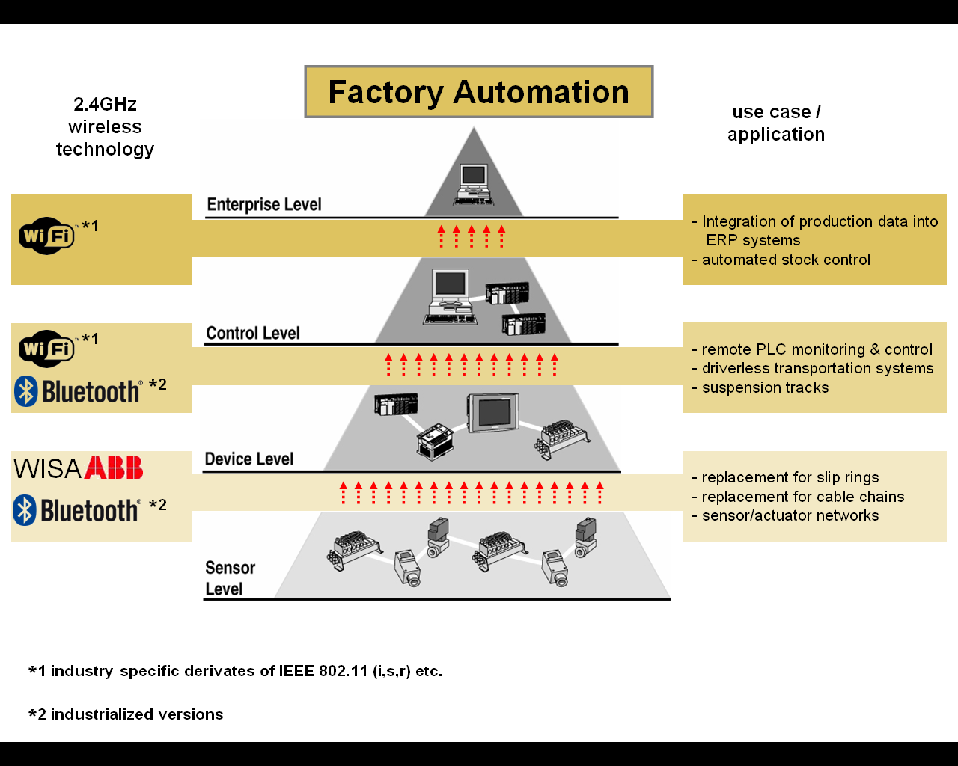

*[Editor’s note: Trademark will be removed in the drafting process]*

Today more and more devices, especially sensor and actuator nodes with relaxed requirements, are connected using wireless technology to improve productivity and increase availability compared to wired sensors/actuators at difficult locations.

Motion control is characterized by high requirements on the communications system regarding latency, reliability, and availability.

Application examples *[to be completed]*

– Automatic guided vehicles (AGV);

– Single and collaborating mobile robots;

– High-bay storage / Intra logistics;

– Portal crane;

– Assistance systems for workers and operators:

• Video cam & display (e. g. Hololense);

• Human machine interface (HMI).

### 3.1.2 Process Automation

*[Editor’s note: Process Automation: this includes applications in the higher levels of the automation hierarchy e.g. at the control or enterprise level, where the data volume rises, so throughput, security and availability becomes more important, but real–time communications requirements decrease.]*

Process automation is defined as an automation application for industrial automation processes. It is typically associated with continuous operation, with specific requirements for determinism, reliability, redundancy, cyber security, and functional safety. Process Automation is typically used for continuous production processes to produce or process large quantities or batches of a certain product (like fluids, chemical, or an "endless" product like e.g. wires, cables).

Figure A1-2

Automation hierarchy in a process plant with example technologies used

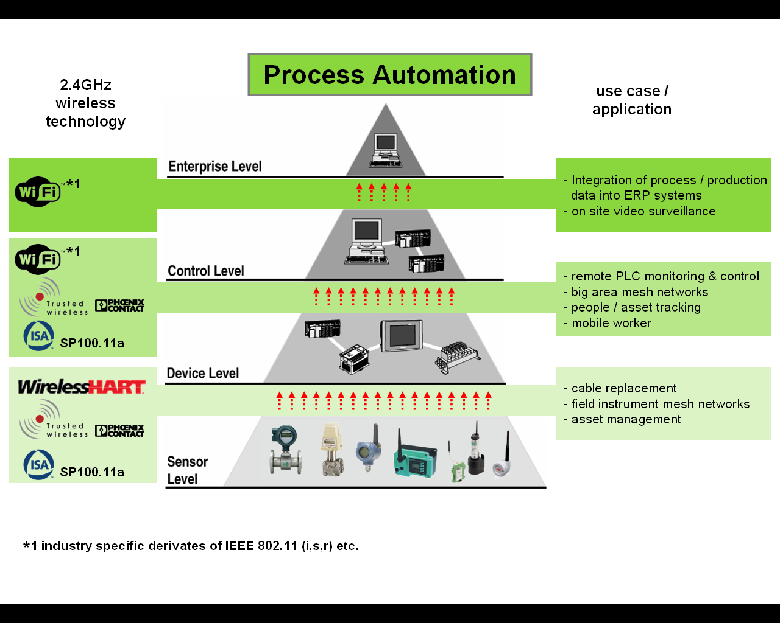

Process applications also require deterministic behaviour and therefore require low latencies in the range between 100 ms and a few seconds. Process automation can cover relatively large areas and so wide wireless transmissions ranges are required. The end nodes (sensors) in process automation applications potentially have to have a battery life of several years.

On the sensor level you can find mesh networks for field instruments, based on different wireless mesh protocols. The mesh structure helps to achieve a large range coverage with standard low power levels and to be robust. On higher levels of the automation hierarchy e.g. at the control or enterprise level, where the data volume rises (e.g. portable supervisory stations), so throughput, security and availability becomes more important, but real–time communication requirements decrease.

Process automation covers, for example, the following industries: oil & gas, refining, chemical, pharmaceutical, mining, pulp & paper, water & wastewater and steel.

Application examples *[to be completed]*

– Portable supervisory station (commissioning, maintenance);

– Environmental sensors;

– …

### 3.1.3 Audio-visual interaction

Audio-visual interaction is characterized by a human being interacting with the environment or people, or controlling a device, and relying on audio-visual feedback.

### 3.1.4 Remote control

Remote control is characterized by a device being operated remotely, either by a human or a computer.

### 3.1.5 Mobile Robotics and Vehicles

Mobile robots and vehicles are playing an increasingly important role in modern factories. This includes mobile units for taking care of the supply of items and material on the shopfloor level, such as autonomous guided vehicles (AGVs) or intelligent fork lifters, but also mobile manipulators, which may be flexibly used at different locations and possibly even facilitate a close human-machine collaboration. In general, the performance and efficiency of such mobile units can be significantly increased if they are interconnected with each other as well as the environment using a powerful wireless system. For example, relatively simple and thus inexpensive AGVs may form a larger swarm by coordinating their actions based on information exchanged between them and thus jointly realize complex tasks, such as lifting items that would be too heavy or big for one unit alone. The more reliable and the faster the connectivity is, the safer and faster the coordination can take place. If the wireless system could additionally provide a sufficiently accurate information about the current location of a mobile unit (in the range of 10‑50 cm), this could be beneficially exploited in many cases, for example for autonomous navigation or collision prevention.

## 3.2 Current applications

### 3.2.1 Low latency applications

The following applications are examples for industrial wireless application utilising extreme low latency. One of the most important reasons for wireless usage in the industry is the control of moving parts. The traditional solutions are slip rings, or cable chains.

#### 3.2.1.1 Robotic arms

Figure A1-3

Robotic arms

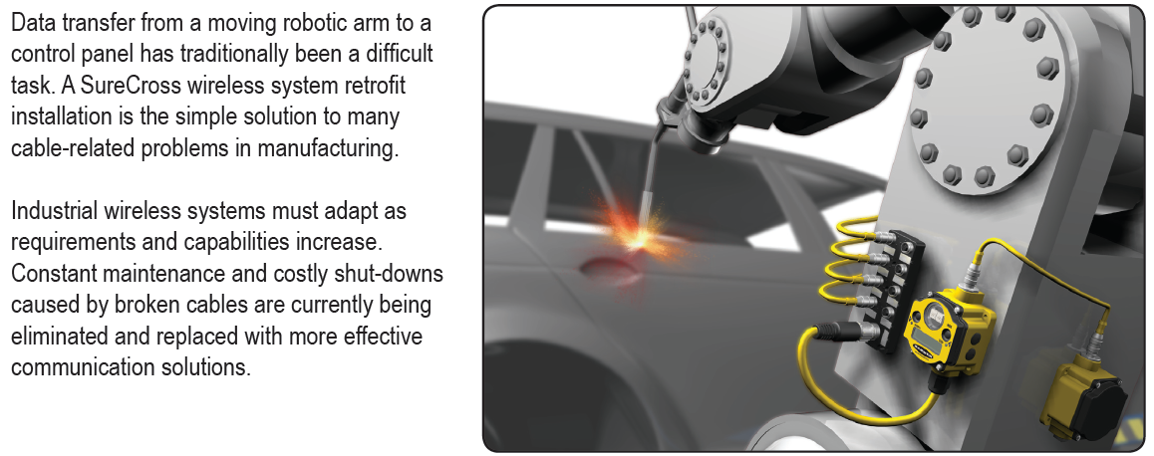

*[Editor’s note: Trademark will be removed in the drafting process]*

Figure A1-4

Cable replacement at the welding robot

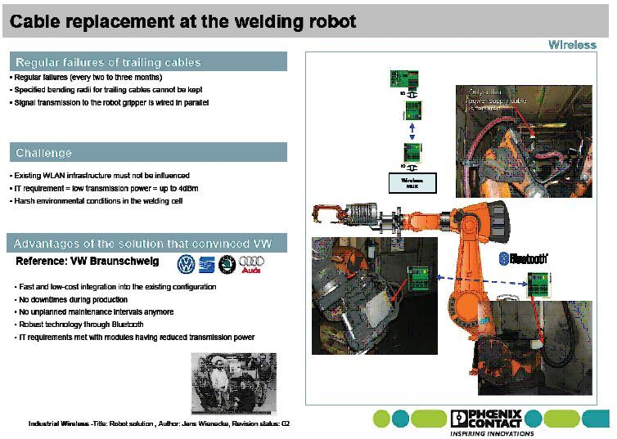

#### 3.2.1.2 Rotating tables/storages

Figure A1-5

Rotating tables/storages

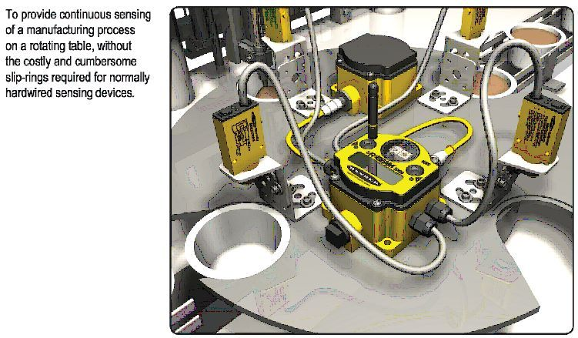

Figure A1-6

Wireless control of rotary storage

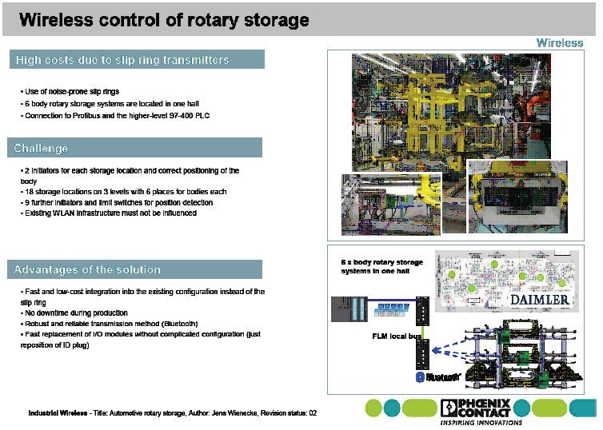

#### 3.2.1.3 Overhead conveyer systems

Figure A1-7

Overhead conveyer systems

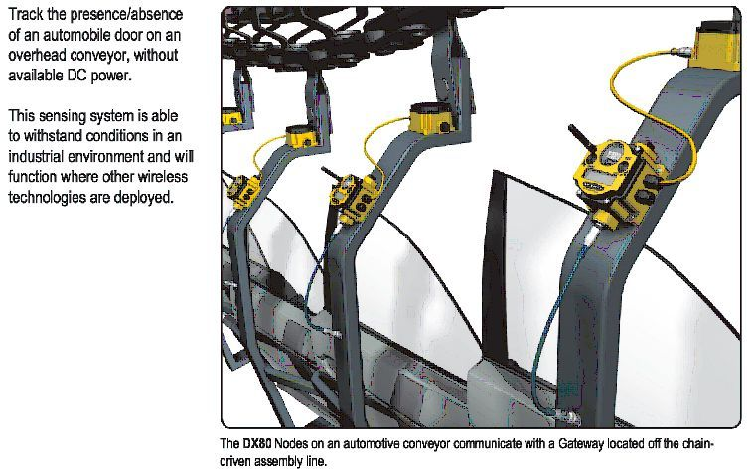

#### 3.2.1.4 Other moving parts and applications

Figure A1-8

Moving parts and applications

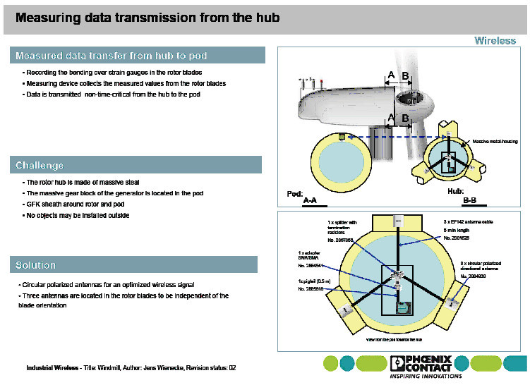

### 3.2.2 Reliable and secure applications

#### 3.2.2.1 Driverless autonomous transportation systems

Figure A1-9

Driverless autonomous transportation systems

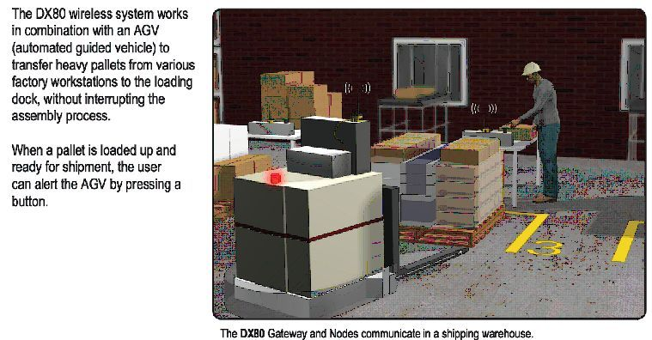

#### 3.2.2.2 Driverless autonomous transportation systems

The transportation vehicle inside a high rack warehouse needs to get a lot of information from the ERP system. In this application an industrial Bluetooth solution exchanges the data between the moving vehicle and the stationary network.

Figure A1-10

High rack warehouse

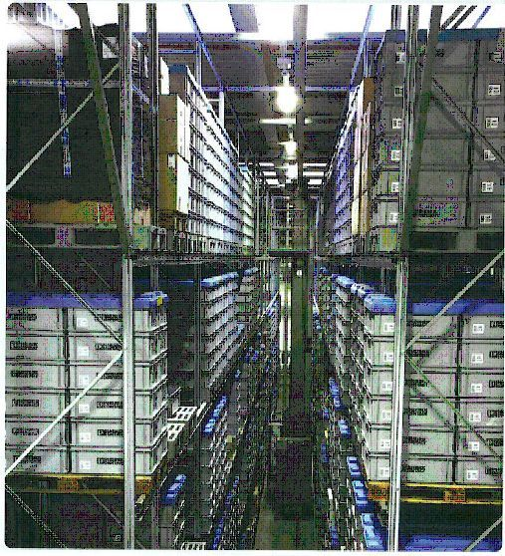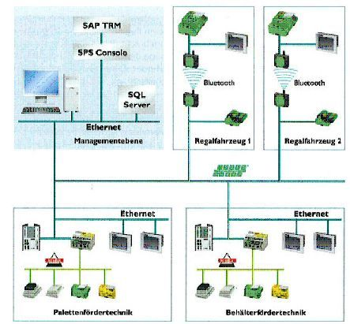

#### 3.2.2.3 Crane control

Figure A1-11

Crane control

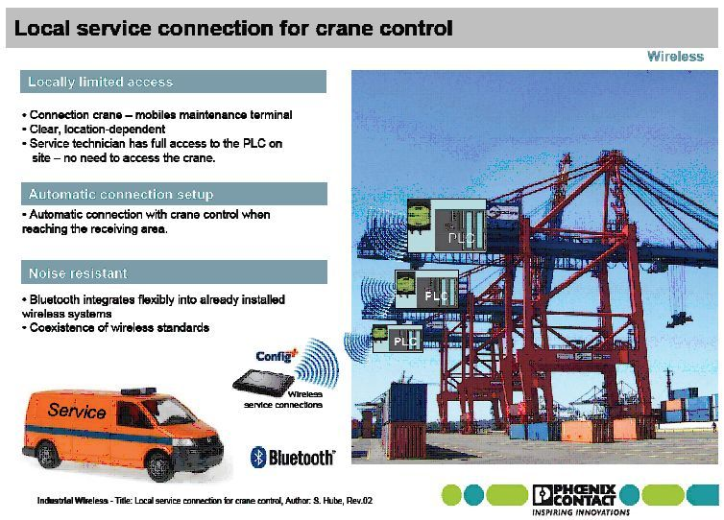

#### 3.2.2.4 Clean rooms

Figure A1-12

Clean rooms

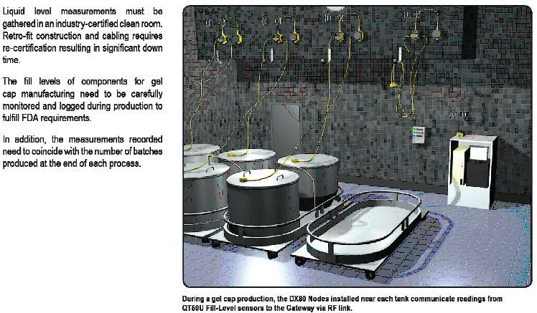

#### 3.2.2.5 Refinery

Figure A1-13

Refinery industry

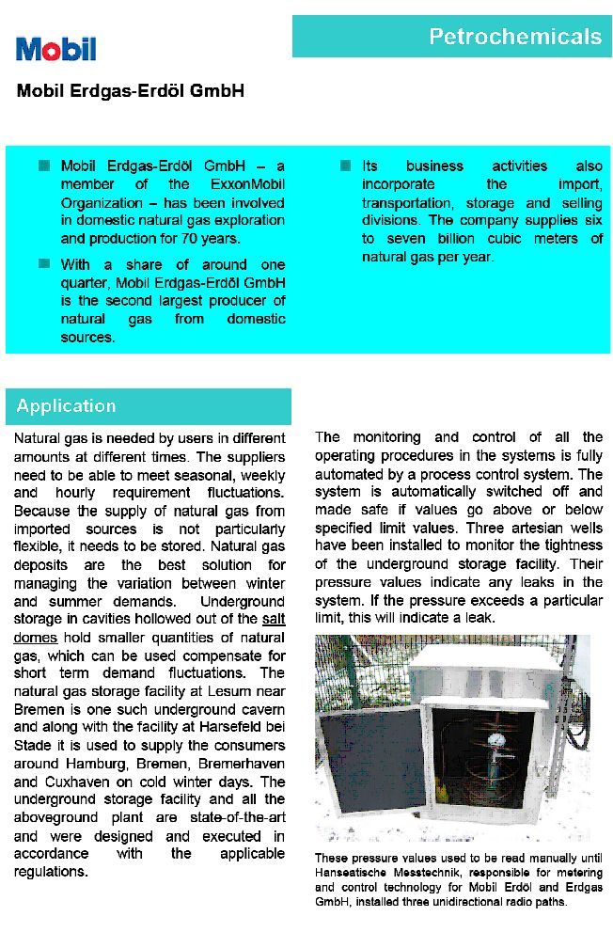

Figure A1-14

Gas production

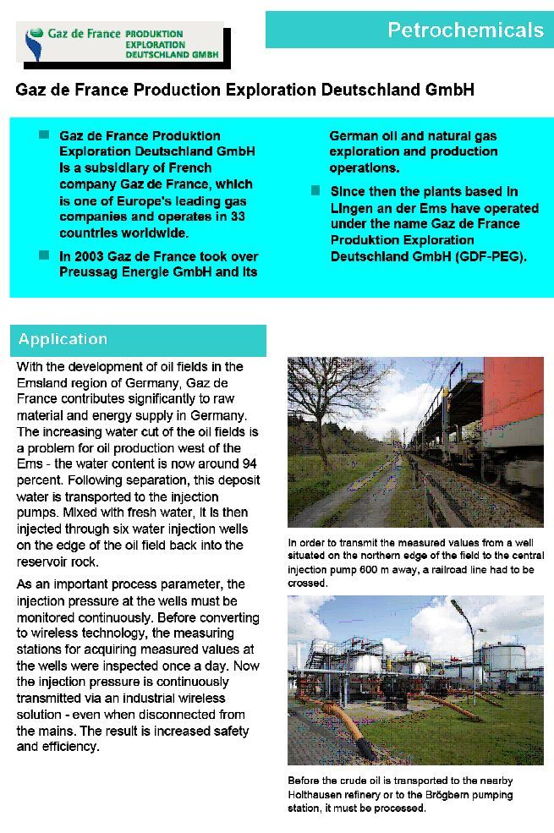

# 4 Characteristics for WIA applications

*[Editor's Note: This chapter will describe the characteristics of the WIA system operations. This would include e.g. channel models to be developed to perform radio performance simulations and the impact of radio propagation.]*

## 4.1 Operation and maintenance characteristics

### 4.1.1 Ease of use

Communication networks should be able to be planned, set up, operated, and maintained without in-depth knowledge of communication technologies and with a minimum of time effort. The communication network should provide communication services with clearly defined quality levels, which simply can be used without understanding of how these communication services are realized.

### 4.1.2 Isolation

Many applications, with different QoS requirements, will use the same network. For instance, in a manufacturing environment, industrial control will coexist with the control of autonomous vehicles, manufacturing operations management, video monitoring, building-automation, etc. The priority of these applications from a productivity and safety point of view is often different, and their network resource consumption, too. For instance, monitoring cameras in a factory hall readily surpass the needed network capacity of fire-safety applications, but connectivity for the latter absolutely has to be available at all times. In practice, vertical applications will, at a minimum, be virtually separated from each other. Also, different actors with different roles will need access to the same network. For instance, factory maintenance might be delegated to an external organization, which needs dedicated access to only the machinery it is responsible for. For an appropriate use of the infrastructure, all applications and tenants may not adversely influence each other. For instance, huge communication resource demands for autonomous vehicles may not adversely impact motion control.

### 4.1.4 Multicast

Domain multicast is required for some automation applications.

### 4.1.5 Multi-tenancy

Vertical applications increasingly need to handle different stakeholders who are using the same network for running their services. Examples are operation, maintenance, emergency response, etc. This requirement has to be supported while still assuring the communication service quality level and excluding conflicts between the stakeholders’ interests. This is especially the case if a provider network is used.

### 4.1.6 Network recovery

Not only should it be possible to isolate communication services consumed by different applications and/or tenants against each other (see isolation), but networks should also provide functionality that regulates the network recovery and reconnection of UEs in a controlled fashion. For instance, in a factory setting, after recovery from a network failure, industrial control application should be provided with communication service access before the outbound logistics applications.

### 4.1.7 Quality of service (QoS) description

Distributed industrial solutions do not stop at national or service provider borders. Therefore, a common understanding and definition of industry-grade QoS across national borders and between providers would be helpful. This is the only way to provide service guarantees beyond connectivity in an end-to-end fashion. To assure that such end-to-end services can be setup in a timely manner, fundamental industrial service / SLA profiles including the required monitoring should be available, globally accepted and offered. By so doing, long lasting negotiation periods with several network service operators and undue overhead when merging two networks can be avoided.

### 4.1.8 Service response (Negotiation of QoS levels)

Some automation applications can operate at more than one communication QoS setting. Therefore, if a certain QoS level is requested by the application but cannot be met by the network, an alternative should be proposed by the network. For instance, if the requested end-to-end latency of 10 ms cannot be guaranteed, the communication service indicates what end-to-end latency is instead feasible. The automation application has then the option to request communication services at a refined QoS level.

### 4.1.9 Service deployment time

Today, end-to-end services traversing many network domains, covering large distances or asking for specific quality properties need a long time (in the order of weeks to months) to be setup by the service provider. The reasons for this are suboptimal processes, technical inflexibilities, required manual interventions, missing suitable interfaces, etc. For remote services on demand and many other services this is not acceptable. Significantly reduced lead times of approximately several hours are needed.

### 4.1.10 Simplified certification

Industrial solutions are foreseen for international use. In many cases, certifications have to be applied before this is legally possible. This includes the certification of communication solutions, especially if these solutions leverage wireless interfaces. Region/nation-specific certification procedures which are not accepted amongst each other, are very cumbersome and expensive.   
Thus WIA systems should be able to successfully pass such certification processes.

### 4.1.11 Technology availability (long-term availability of technology and the related infrastructure)

The lifetimes of industrial solutions are typically in the range of several decades. In order to ensure continuity, any underlying communication solution has to be available throughout the whole lifetime. Therefore an availability of WIA systems (components, spare parts, and infrastructure) over at least 20 years has to be assured. In this context also backward compatibility is of major importance.

### 4.1.12 Non-standard operating conditions

The absence of low-voltage power supply can be an issue in the field, creating the need for battery- or energy-harvester-powered ultra low-power area networks with a corresponding low bandwidth. For battery powered WIA devices a lifetime of than 10 years (and more) is required.

Harsh environments, including wind and weather, vibrations, heat, dust or even hazardous gases may also be a challenge for communication equipment.

### 4.1.13 Operation of private network infrastructures

Leveraging the full potential of WIA systems can only be achieved if from the very beginning the setup and operation the wireless network infrastructures can be done also in a local and closed environment without the involvement of a 3rd party network provider and without sharing the infrastructure with other (potentially less controlled) users/applications.

The need to keep the operation of local/closed wireless networks in the responsibility of the industrial operator are mainly due to system criticality: the dependence on 3rd parties is minimized, the transparency in the level of compliance with required quality levels is intrinsically given, and responsibilities and liabilities are much easier to determine. All this leads to a significantly reduced risk for the industrial operator. In addition, maintenance strategies of the industrial solutions will be very different to the ones applied by a 3rd party network service operator.

## 4.2 Impact and challenges of radio propagation

*[Editor's note: In case of channel model, other groups in ITU-R have responsibility to develop and define the documents regarding channel model. Therefore, this section can describe the necessity to develop channel model in due course.]*

*[Editor's note 2: Consider to mention that industrial channels are typically very challenging due to lots of metal, interference, etc., but that there is currently a general lack of appropriate channel models]*

WIA applications require different propagation characteristics:

– Spectrum to cover areas also under NLOS conditions:

• Use with moving devices (example: Automatic Guided Vehicles, AGVs);

• Use with small bandwidth and good penetration of walls (e. g. sensors and actuators).

– Spectrum to cover areas under LOS inside production halls, high density of systems (see table [A1-1], Connection density for Factory automation):

• Protection of other systems outside the production halls.

## 4.3 Coverage

*[Editor's note: Coverage characteristics including propagation loss, penetration loss, attenuation and transmission distance can be described in this section.]*

See table [A1-1], column Service area

## 4.4 Mobility

*[Editor's note: Mobility characteristics including path loss and NLOS transmission can be described in this section.]*

WIA systems can be stationary or mobile, depending on the application. Mobile WIA systems can move with up to 50 km/h. Transmission conditions for moving systems can change between LOS, OLOS and NLOS very quickly.

## 4.5 Transmitter parameters

### 4.5.1 Transmitter Output Power/Radiated Power

e.i.r.p. up to [250] mW is specified.

### 4.5.2 Antenna Characteristics

No restrictions on antenna characteristics.

### 4.5.3 Bandwidth

*[Editor's note: Bandwidth characteristics to fits the requirements of WIA.]*

As different technologies are used, the typical occupied bandwidth for a single device varies between [0.1] MHz and [20] MHz. Specific applications like location tracking may even use the complete available (sub-)band.

Frequency Hopping as well as non-frequency hopping technologies are used.

## 4.6 Channel access parameters

For maximised spectrum efficiency, including sharing among all wireless industrial applications present, a spectrum sharing mechanism may be appropriate for industrial applications.

An example of that is Frequency Agility. Frequency Agility is the ability of a system to operate according to frequency or channel assignments of a centralized or distributed control mechanism, which will define the configuration of all devices within an industrial site or subarea thereof, Configurations may change over time depending on the application requirements. If non-contiguous spectrum is assigned, then the Frequency Agility feature is supposed to operate across all assigned sub-bands.

## 4.7 Other characteristics

*[Editor's note: Other characteristics can be described in this section.]*

# 5 Deployment scenarios and architectures

*[Editor’s note: This section is intended to address the different deployment scenarios and architectures for radio systems of WIA. This section would describe how those deployment scenarios and architectures could be utilized for WIA systems and how they are to be taken into account in assessing the technical feasibility of implementing WIA systems in specific bands.]*

## 5.1 Presentation of system or technology concept

Typical industrial sites are manufacturers of goods or providers at any place within the delivery chain towards these goods (e.g. oil/gas/energy producers, suppliers of parts or components of these goods up to final assembly of the goods, after- production processes such as water/waste management).

Examples of existing communication network solutions are standardized in EN/IEC 61784-2 *[reference]* and EN/IEC 62591 *[reference]* for wireless solutions for so-called PROFINET based on IEEE 802.11/IEEE 802.15.1 *[reference]* and WirelessHART (see EN/IEC 62591) based on IEEE 802.15.4 *[reference]*.

Industrial automation requires "robust" wireless technologies to be used for their wireless links in industrial applications. More and more wireless solutions are being considered nowadays for these applications.

The advantages of wireless are savings of often complex and expensive cabling, cable protection and plugs the increased mobility and flexibility as well as the wear and tear free transmission medium. These advantages are particularly high in the area of:

* Monitoring and mobile worker communication.
* Wireless sensors and actuators at moving parts.

Different functions can be mastered substantially more efficient by a wireless network of data acquisition terminals, robotic type equipment or automated guided vehicles.

For the sensor and actuator type of applications in industrial automation, the main requirement is the real time behaviour. Real time means a maximum response time defined by the type of application. E.g. on the factory floor of discrete manufacturing, very short latencies of a few ms and a very high reliability (high robustness) is necessary in order to avoid interruptions in the manufacturing process.

In higher levels of the automation hierarchy e.g. at the control or enterprise level, the data volume rises, so throughput, security and reliability becomes more important, but real–time communication requirements decrease.

To meet these requirements, both application categories require specific wireless technologies for specialised sensor/actuator networks. Some technologies being developed for these applications are listed above.

Industrial automation equipment is typically designed in a way that it is not impacted by other wireless applications present in the industrial environment. If an important wireless link would be interrupted, or not respond instantaneously, appropriate measures will take effect immediately.

To achieve the required performances for different industrial wireless applications, it is important to achieve either short latencies or high throughput, in addition to range and reliability, etc. Therefore, industrial users very much depend on the chosen technical solutions for their seamless operational procedures, i.e. a high dependability is envisaged.

In addition, the manufacturing processes require often to use more than one wireless technology simultaneously within the same area or environment. One option is to use a coexistence management system in industrial automation applications according to IEC 62657-2 [i.11] or using any other appropriate sharing mechanisms meeting the specific demands of the industrial applications.

## 5.2 Deployment scenarios

*[Editor’s note: This section is intended to describe the deployment scenarios of subdivisions of WIA system. For example: WIA system deployment in manufacturing cell, factory halls and at plant level]*

In a larger industrial plant, if a chemical or oil-/and gas industry process plant ("process automation") or e.g. an automotive discrete manufacturing plant (discrete or "factory automation"), there are and will be always many different wireless systems and technologies for different purposes in parallel to each other (partly or completely overlapping).

The subdivision of such systems into three main classes can be typically done according to table A1 into:

– cell or sub-unit automation;

Lowest control system level, can be a part of a line in an automotive plant or a normal discrete manufacturing cell or a subunit in process automation (e.g. a reactor with a local control to which sensors and actuators are connected). Typically lower range (e.g. 10 m to 30 m range) but most demanding for latency and robustness, are capable to live with fast movements, integrated antennas and many obstacles (nearly complete shielding).

• One such cell unit has one wireless system with in average 30 devices.

• Up to 10 such units/manufacturing cells can be in close proximity, so that their interference area overlaps.

• The area related local device density at 10 m range therefore is typically 10x30 devices per 10x10 m² or 0,33 to 3 devices per m² (at 30 m to 10 m range respectively).

• The cell automation data packets as such are typically quite small and have 16 octets on air (e.g. 4 octets of user data, 12 octets for addressing, control and error protection) and have to be sent every 50 ms in each direction.

– factory hall or plant sub-unit automation;

Medium Control System level, where e.g.:

a) whole production lines or moving applications (e.g. moving through a factory hall in discrete manufacturing e.g. automated guided vehicles, rail hanging power screwdrivers), or

b) whole production units in process automation:

• Larger area (e.g. 100 m x 100 m) are covered, for example, by an industrial WLAN *[ref needed]* or a mesh type technology (TDMA schemes used).

• Average of 100 devices with low latencies.

Also here the master uses a higher duty cycles and high power to cover the range without line of sight:

– Up to 5 such independent systems can be within range of each other.

– The area related local device density at 100 m range therefore is approximately 5 × 100 devices per 100 × 100 m² or 0.022 per m² at 100 m range.

– The hall/subunit automation data packets as such are typically medium size with 200 octets on air (e.g. 140 octets of user data, 60 octets for addressing, networking, control and error protection) and have to be sent every 200 ms in each direction.

– plant level automation

Control system level covering up to the whole plant, typically an industrial mesh technology:

Able to cover e.g. 1 km × 1 km but typically with mesh technology to increase robustness against typical industrial influences (moving obstacles, interference).

– One such mesh system can have up to 1 000 connected devices, but each device only having to cover a smaller range (100 m) and the mesh covers the larger distances needed, without excessive power needs.

– There may be up to 3 independent mesh networks operating in parallel in the whole plant.

Up to maximum of 50 devices within 3 clusters can be within range of each other.

– The local device density at 100 m range therefore is approximately 50 devices per 100 × 100 m² or 0,025 per m² at 100 m range.

– The plant level automation data packets are typically medium size with 105 octets on air (e.g. 50 octets of user data, 55 octets for addressing, networking, control and error protection) and have to be sent every 500 ms in each direction.

All of these 3 levels are operated in parallel (partially or completely overlapping radio area), and often by different operators and connected to different Control Systems. Each of the many wireless systems has to be allowed to switch on and off and vary the number of connected active devices and data amount transferred, depending of the needs of the many different production cells/subunits/ lines in order to maximise individually production, quality, safety and do service, troubleshooting and installation work on the productions units.

Parallel means that in most parts of the plant the three "wireless" classes have overlapping coverage, preferably in the same frequency band. This provides the opportunity for maximal flexibility of coexistence management, increasing spectrum efficiency, limited-industrial-interference, power efficiency (range) and bending/damping by obstacles.

Figure A1-15

Example of a 1 plant production with 10 production halls and 50 manufacturing cells

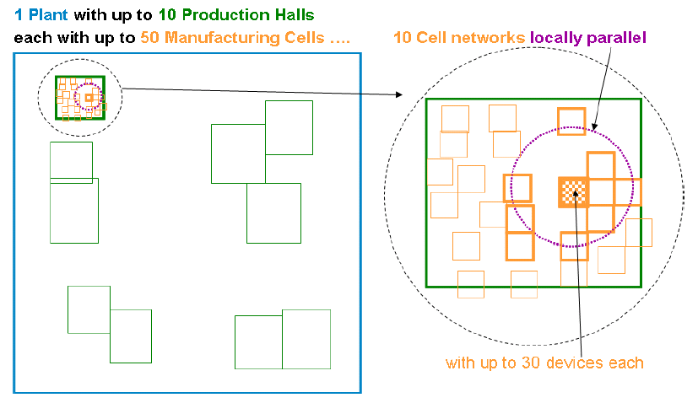

Figure A1.16

Example of hall wide networks, up to locally parallel

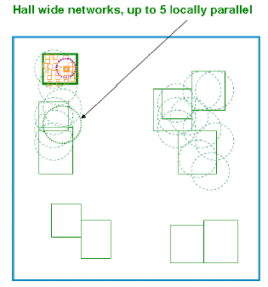

Figure A1-17

Example of plant wide networks, up to 3 parallel

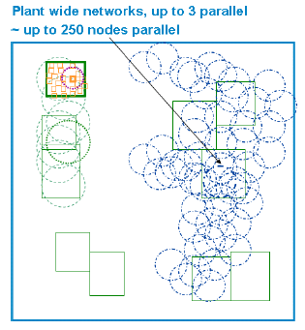

Figure A1.18

Example of a combination of 3 classes

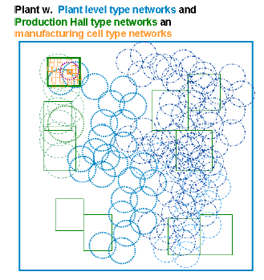

Table A1

Unit density

|  |  |  |  |
| --- | --- | --- | --- |
|  | Manufacturing cell | Factory hall | Plant level |
| Indoor/outdoor application | indoor | mostly indoor | mostly outdoor |
| Spatial dimension L×W×H [m3] | 10 × 10 × 3 | 100 × 100 × 10 | 1 000 × 1 000 × 50 |
| Number of devices (typically) | 30 | 100 | 1 000 |
| Number of parallel networks (= clusters) | 10 | 5 | 5 |
| Number of such clusters per plant | 50 | 10 | 1 |
| Min. Number of locally parallel devices | 300 | 500 | 250 |
| Network Type | Star | Star/Mesh | Mesh |
| Typical operational distance | Depends on individual use case and frequency of operation. | | |

# 6 Information on spectrum usage for WIA applications

*[Editor's note: This chapter can describe what kinds of technologies are today being implemented in bands under study in this document.]*

*[Editor’ note: Contributions are welcomed on spectrum usage in various countries/region]*

An important technology for WIA devices is IEEE 802.11, especially devices according to the amendments IEEE 802.11n, ac and ax. Devices based on this technology offer sufficient bandwidth for various applications. For this application, systems typically use a nominal channel bandwidth of 20 MHz, which allows to operate multiple systems in parallel and independently.

In addition devices and systems using other technology than IEEE 802.11, are in use, such as visual monitoring and video surveillance. Systems are often based on proprietary technology, but operate in accordance with the applicable regulation. According to the nature of video transmission and high bandwidth requirements these broadband systems occupy several MHz of spectrum.

A number of LTE based technologies are already on the market (including MulteFire) that are designed for operation in licence-exempt spectrum. MulteFire can also be deployed as stand-alone system without any link to a cellular network, making it suitable for enterprise use, with carrier bandwidths specified with 10 MHz and 20 MHz.

## 6.1 Region 1

In Europe the band 5 725–5 875 MHz is currently already in use by the number of technologies stated above. These devices conform to the current regulation for short-range devices (Decision 2017/1483/EU amending Decision 2006/771/EC, ERC Recommendation 70-03) and typically operate as non-specific short-range devices.

In Europe the transmit power of devices operating in 5 725–5 875 MHz is limited to 25 mW e.i.r.p. according to Decision 2017/1483/EU, which also limits the range and reliability and thereby also the range of possible applications. In addition, ERC Recommendation 70-03 includes the possibility to use of this frequency band for WIA applications up to 400 mW, given the implementation of appropriate spectrum access and mitigation techniques.

Today also RFID systems are being implemented in the band 5 725–5 875 MHz for identification, tracking and real-time location applications. These RFID systems use active tags transmitting with power levels up to 25 mW.

## 6.2 Region 2

*[Editor’s note: USA to check the data below]*

[In some Region 2 countries, parts of this 5 725–5 875 MHz band are open for IEEE 802.11 devices. In the USA the band 5 725–5 850 MHz, designated as U-NII-3, is made available to unlicensed devices with a transmit power of up to 1 W e.i.r.p. (FCC 13-22). This frequency range is covered by IEEE 802.11 channels 149 to 165, and vendors are offering chipsets supporting this band additionally to the traditional RLAN bands between 5 150 MHz and 5 725 MHz.]

## 6.3 Region 3

*[Editor’ note: No information available]*

Annex 2

Low Power Wide Area Networks (LPWAN) for Machine-Type Communication

# 1 Introduction

[*Editor’s note: This section should provide high-level information describing the report.*]

# 3 MTC application based on LPWAN systems

[*Editor’s note: This section should provide an overview of the main applications available and foreseen and estimates the numbers of devices to which these applications may give rise*]

A large and varied range of applications is supported by LPWAN systems.

## 3.1 Application domains for LPWAN systems

[*Editor’s note: This sub-section should highlight the main domains and sectors which can benefit from LPWAN development*.]

– Infrastructure networks & utilities

– Smart City

– Environment & Agriculture

– Industrial

– Automotive

– Logistics

– Healthcare

– Conventional Cellular Cooperation

– Home Automation

## 3.2 Example of use cases for LPWAN systems

[*Editor’s note: This sub-section should provide typical use cases with their individual characteristics*]

# 4 Technical and operational aspects of Low Power Wide Area Networks to support Machine-Type communication and the Internet of Things

## 4.1 Technical Aspects

[*Editor’s note: This section should provide information on main technologies and standards available for the development of LPWAN.*]

## 4.2 Operational aspects

[*Editor’s note: This section should provide information regarding operational aspects and typical deployment scenarios*]

# 5 Information on spectrum usage for LPWAN applications

Table 1

Example of frequency bands used for LPWAN

...

Annex X

[*Editor’s note: This is a place holder for other industry wireless applications.*]