|  |  |
| --- | --- |
| **Radiocommunication Study Groups** |  |
|  |  |
|  |  |
| Source: Documents 5A/TEMP/260(Rev.2)  Subject: Question [ITU-R 205-5/5](http://www.itu.int/pub/R-QUE-SG05.205) | **Annex 29 to**  **Document 5A/650-E** |
| **16 November 2017** |
| **English only** |
| Annex 29 to Working Party 5A Chairman’s Report | |
| WORKING DOCUMENT TOWARD A PRELIMINARY  DRAFT NEW REPORT ITU-R M.[ITS USAGE] | |
| Intelligent transport systems (ITS) usage in ITU Member States | |

TABLE OF CONTENTS

1 Scope 2

2 Background 2

3 Related documents 2

4 List of acronyms and abbreviations 3

5 Overview of ITS radiocommunication and automotive radar 4

6 Legacy ITS radiocommunication - ETC 8

7 Advanced ITS radiocommunication 23

8 Millimetre-wave automotive radar 69

9 Results of Studies 83

[Attachement: ITS Deployment parameters and numbers compared   
with CEPT ECC Report 101 [1] and current available products 84](#_Toc498514485)

1 Introduction 84

2 CEPT ECC Report 101 84

3 ITS technical and deployment parameter 84

4 FSS parameters 87

5 Conclusions 90

6 References 91

*[Editor’s note: All the texts may be addressed in future contributions to this document.]*

*[Editor’s note: Renumbering is required for the figures and tables.]*

# 1 Scope

This report addresses the usages of Intelligent Transport System (ITS) radiocommunication applications, such as vehicle to infrastructure, vehicle to vehicle, vehicle to pedestrian communications for traffic safety related and traffic efficiency applications as well as electronic tolling systems and automotive radars for collision avoidance in ITU Member states.

This report identifies current and planned usage of ITS technologies, frequency bands, status of standardization, applications and deployments in ITU Member States.

# 2 Background

*Since May 2014, Working Party 5A (WP 5A) started developing new Report ITU-R M.[ITS USAGE] Intelligent transport systems (ITS) usage in ITU Member States.*

During the WRC-15 in November 2015, WRC-19 agenda item (A.I.) 1.12 – ITS applications was approved. Under A.I. 1.12, WP 5A is responsible group to consider global or regional harmonized frequency bands, to the maximum extent possible, for the implementation of evolving ITS under existing mobile-service allocations in accordance with Resolution **237 (WRC-15)**.

To consider global or regional harmonized frequency bands for the implementation of evolving ITS, this new Report ITU-R M.[ITS USAGE] “ITS usage in ITU Member States” will be an important reference material. *To meet A.I. 1.12, new Report ITU-R M.[ITS USAGE] should be published as early as possible.*

# 3 Related documents

ITU-R Recommendations:

ITU-R M.1890 Intelligent transport systems – Guidelines and objectives

ITU-R M.1452 Millimetre wave radiocommunication systems for Intelligent Transport Systems applications

ITU-R M.1453 Intelligent Transport Systems – dedicated short-range communications at 5.8 GHz

ITU-R M.2057 Systems characteristics of automotive radars operating in the frequency band 76‑81 GHz for intelligent transport systems applications

ITU-R M.2084 Radio interface standards of vehicle-to-vehicle and vehicle-to-infrastructure communication for intelligent transport systems applications

[Working document towards a preliminary draft new~~]~~ Recommendation ITU-R M.[ITS_FRQ]: “Harmonization of frequency arrangements for Intelligent Transport Systems in the mobile service"

ITU-R Report:

ITU-R M.2228 Advanced intelligent transport systems (ITS) radiocommunication

ITU-R M.2322 Systems characteristics and compatibility of automotive radars operating in the frequency band 77.5-78 GHz for sharing studies

ITU-R F.2394 Compatibility between point-to-point applications in the fixed service operating in the 71‑76 GHz and 81‑86 GHz bands and automotive radar applications in the radiolocation service operating in the 76‑81 GHz bands

ITU-R Handbook:

Land Mobile (including Wireless Access) - Volume 4:   
 Intelligent Transport Systems

# 4 List of acronyms and abbreviations

3GPP The 3rd Generation Partnership Project

APT Asia-Pacific Telecommunity

ARIB Association of Radio Industries and Businesses (Japan)

ATIS Alliance for Telecommunications Industry Solutions (U.S.A.)

AWG APT Wireless Group

C-ITS Cooperative ITS communication

C2C- CC CAR-to-CAR Communication Consortium

CAMP Crash Avoidance Metric Partnership

CCSA China Communications Standards Association

CEN European Committee for Standardization

CEPT European Conference of Postal and Telecommunications Administrations

D2D Device-to-device

ECC Electronic Communications Committee

ETSI European Telecommunications Standards Institute

FCC Federal Communications Commission

IEEE Institute of Electrical and Electronics Engineers

IMDA Infocomm Media Development Authority (Singapore)

ISO International Organization for Standardization

ITS Intelligent Transport Systems

LTE Long Term Evolution

LTE-V2X LTE based Vehicle to Infrastructure/Vehicle/Network/Pedestrians and others

MBSFN Multicast-Broadcast Single-Frequency Network

OoC Out of coverage

PC5 [Device-to-Device Direct Link]

RLAN Radio Local Area Network

RSS Radio Standards Specification (Canada)

SC-PTM Single Cell Point To Multipoint

TIA Telecommunications Industry Association (U.S.A.)

TSAC Telecommunications Standards Advisory Committee (Singapore)

TTA Telecommunication Technology Association (Korea, (Republic of))

Uu [Link between Base Station and Device]

V2I Vehicle to Infrastructure

V2N Vehicle to Network

V2P Vehicle to Pedestrians

V2V Vehicle to Vehicle

V2X Vehicle to Infrastructure/Vehicle/Network/Pedestrians and others

WAVE Wireless Access in Vehicular Environments

WLAN Wireless Local Area Network

# 5 Overview of ITS radiocommunication and automotive radar

Since several decades ago, traffic congestion has been increasing all over the world as results of increased motorization, urbanization, population growth, and changes in population density. Congestion reduces efficiency of transportation infrastructure and increases travel time, air pollution, and fuel consumption. Interest in ITS comes from the problems caused by traffic congestion and a synergy of new information technology for simulation, real-time control, and communications networks. Namely, ITS is system to support transportation of goods and humans with information and communication technologies in order to efficiently and safely use the transport infrastructure and transport means (cars, motorcycles, bicycles, trains, planes, ships, and other)[1].

Figure 1

Communication technologies and services for ITS[2]

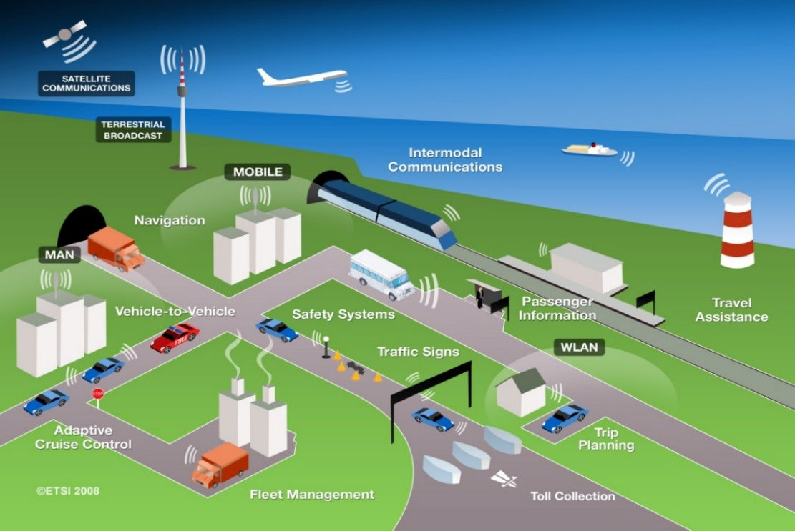

ITS have been standardized and studied in various standards development organizations. As an international level, ITU-R, ISO TC 204, and IEEE are working on developing the standards, recommendations and reports.

In Asia-Pacific, AWG is working as a regional level as well as ARIB, TTA, IMDA TSAC and other standard organizations in each country and region. In Europe, ETSI TC ITS and CEN TC278 are working as a regional level.

This report identifies current and planned usage of ITS technologies, frequency bands, status of applications and deployment in ITU Member States.

The major deployed ITS in the world were classified as electronic toll collection, automotive radar, and vehicle information & communication. In this report, we described applications overview, established standards, frequency plan, and implication in each ITS.

## 5.1 ITS radiocommunication

Electronic toll collection allows the manual in-lane toll collection process to be automated in such a way that drivers do not have to stop and pay cash at a toll booth. ETC systems improve traffic flow at toll plazas, and the level of pollution by reducing fuel consumption. In addition, allowing traffic to pass through the gate without stopping can increase road capacity by three or four times and relieve traffic congestion at the tollgate. It is also expected that ETC systems will reduce the operating costs of toll roads by replacing manual toll collection.

Since 1996, Vehicle Information and Communication System (VICS) has been used in Japan for delivering traffic and travel information to road vehicle drivers.

Nowadays, to extend beyond the existing ITS applications and to achieve traffic safety enhancement and reduce the environmental impact by the transportation sector, vehicle-to-vehicle (V2V), vehicle-to-infrastructure (V2I), infrastructure-to-vehicle (I2V) communications are studied. According to this progress, ITU-R WP 5A has developed report on advanced ITS radiocommunication[3]. In the report, legacy ITS and advanced ITS are classified by their technical characteristics as shown in Table 1, Wireless Access in Vehicular Environments (WAVE) and Continuous Access for Land Mobiles (CALM) technologies and ITS Connect could be inclusive in advanced ITS category.

### 5.1.1 Terms and definitions

*[Editor´s note: following terms and definitions should be revised in the document according to the following]*

|  |  |
| --- | --- |
| Dedicated Short Range Communication (DSRC) | **Europe:** road tolling and similar applications |
| **North America**: vehicle to vehicle and vehicle to infrastructure communication based on IEEE 802.11p / WAVE technology in 5.9 GHz, comparable to C-ITS based on IEEE 802.11p / ITS-G5 in Europe. |
| **Japan**: technology for ETC, road tolling and vehicle to infrastructure traffic information systems |
| Legacy ITS | – TTT: Transport and Traffic Telematic, mainly in Region 1, also called DSRC in Europe  • CEN DSRC tolling  • HDR DSRC tolling,  – ETC: In Japan, Korea and China  – VICS: In Japan |
| Advanced ITS | Cooperative ITS (C-ITS) building on ad hoc networks with vehicle-to-vehicle (V2V) and vehicle-to-infrastructure communication (V2I), together called vehicle-to-X (V2X), e.g.  – V2X (ETSI ITS-G5, IEEE 802.11p)  – V2X (LTE based V2X)  – V2X (WAVE, IEEE 802.11p), also called DSRC in US  – V2X (ITS Connect, ARIB STD-T109) |

It should be noted that the term DSRC has different meanings in various regions. All ITS technologies in this document are structured in the legacy ITS (already existing in the market for several years) and advanced ITS (shortly deployed or in deployment phase).

*[Editor´s note: The sentence above requires to review the document according to above definitions.]*

### 5.1.2 Technical characteristics

Table 1

Technical characteristics of legacy ITS and advanced ITS

|  |  |  |
| --- | --- | --- |
| Items | Legacy ITS | Advanced ITS |
| Technologies | TTT  ETC | **ETSI ITS-G5, IEEE 802.11p**  **WAVE, IEEE 802.11p**  **ITS Connect, ARIB STD-T109**  **LTE-V2X** |
| Vehicular networking | V2I | V2X includes V2I, V2V, V2N, V2P |
| Radio performance | Radio coverage: Max. 100 m  Data rate: ~ 4 Mbps  Packet size: ~100 bytes | Radio coverage: Max. 1 000 m  Data rate: Max. 27 Mbps  Packet size: Max. 2 kbytes  Latency: within 100 msec  within 1 000 msec for V2P |

## 5.2 Automotive radar

Automotive radar facilitates various functions that increase the driver’s safety and convenience.

Exact measurement of distance and relative speed of objects in front, beside, or behind the car allows the realization of systems which improve the driver’s ability to perceive objects during bad optical visibility or objects hidden in the blind spot during parking or changing lanes. Radar technology has proved its ability for automotive applications for several years. Automotive radar systems are of two categories according to the applications and frequency band

− Adaptive Cruise Control 'long-range radar' (usually operating at 76 GHz band). This enables a vehicle to maintain a cruising distance from a vehicle in front.

− Anti-collision 'short-range radar' (usually operating at 24 GHz and 79 GHz bands). This is being developed as part of a system to warn the driver of a pending collision, enabling avoiding action to be taken. In the event where collision is inevitable, the vehicle may prepare itself (for example by applying brakes, pre-tensioning seat belts) to minimize injury to passengers and others.

Figure x

Automotive radar

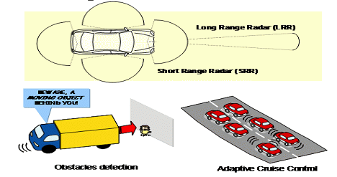

### 5.2.1 Terms and definitions

*[Editor’s note: Text to be added]*

### 5.2.2 Technical characteristics

*[Editor’s note: Text to be added]*

## 5.3 Global Navigation Satellite Systems in ITS

It is common knowledge that devices installed in cars used by motorists employ the use of satellites to pinpoint their location anywhere on the earth. There are also numerous mobile applications on smartphones, making the service more accessible, that make use of Global Navigation Satellite Systems (GNSS), together with the terrestrial network, to provide motorists real time traffic congestion information to direct these people to the most efficient, if not the most convenient, route towards their destination.

The use of satellite positioning is not only limited to motorists or in cars, but also caters to commuters. GNSS assists these people in their day-to-day travel, stating the timing of public vehicles’ departure and arrival which helps these busy people plan their schedule accordingly.

Various entities have developed several GNSS already; Europe has Galileo, USA has Global Positioning System (GPS), Russia had Global'naya Navigatsionnaya Sputnikovaya Sistema (GLONASS) and China has BeiDou Navigation Satellite System. Each of these systems is comprised of a constellation of satellites working together and transmitting signals from space to the earth which are then intercepted and utilized by receivers to determine the receiver’s precise location. In later developed devices, information on the speed and direction of travel are also indicated to the user.

Due to their wide footprints, these systems are able to provide global coverage, encompassing areas with little population not often reached by terrestrial networks. This inherent nature of satellites, together with the capability of broadcasting data, ensures that signals can be received anywhere, anytime by many, including the numerous ITS nodes.

From the simple yet essential legacy ITS applications to the advanced ITS services integrating sophisticated features brought by modernization, this ability to identify position is and will continue to be fundamental to any ITS system. Now more than ever, especially when travelling is already within an arm’s reach, this technology is undeniably indispensable.

# 6 Legacy ITS radiocommunication - ETC

*[editor´s note: DSRC should not be used, see terms and definitions above, instead ETC, TTT when Standards have the title “DSRC” add in brackets “specified for ETC, TTT”]*

## 6.1 Overview

Electronic toll collection (ETC) allows for the manual in-lane toll collection process to be automated in such a way that drivers do not have to stop and pay cash at a toll booth. ETC systems improve traffic flow at toll plazas, and the level of pollution by reducing fuel consumption. In addition, allowing traffic to pass through the gate without stopping can increase road capacity by three or four times and relieve traffic congestion at the tollgate. It is also expected that ETC systems will reduce the operating costs of toll roads by replacing manual toll collection.

There are many similar words related to ETC. In Europe, Electronic Fee Collection (EFC) is popularly used. They think that EFC covers ETC, Electronic Parking System (EPS), Electronic Road Pricing. Electronic Road Pricing is usually referred to the electronic toll collection scheme adopted in Singapore for purposes of congestion management. To avoid confusion, these terminologies need to define clearly.

In Japan, Mobile Service using DSRC with the frequency bands between 5 770 and 5 850 MHz, the applications for ETC (Electronic Toll Collection) and safe driving assistance have been widely used for daily life.

## 6.2 Technical characteristics

DSRC refers to a dedicated short range communication between a roadside infrastructure and vehicles or mobile platforms for ITS applications.

The two major components of DSRC are on-board equipment (OBE) and roadside equipment (RSE).

**On-board equipment (OBE):** OBE is installed near the dashboard or on the windshield of the vehicle, and consists of radiocommunication circuits, an application processing circuit and so on. It usually has a human-machine interface, including switches, displays and buzzer.

**Roadside equipment (RSE):** RSE is installed above or alongside the road and communicates with passing OBE by use of radio signals. RSE consists of radiocommunication circuits, an application processing circuit and so on. It usually has a link to the roadside infrastructure to exchange data.

DSRC systems operate by transmitting radio signals for the exchange of data between vehicle mounted OBE and RSE. This exchange of data demands high reliability and user privacy as it may involve financial and other transactions.

## 6.3 Frequency usage

*[Editor’s note: Text to be added]*

## 6.4 Standardization

Table [X]

Global Standard on ETC

|  |  |  |
| --- | --- | --- |
| SDO | Standard No. | Standard Title |
| ITU | ITU-R M.1453-2 | Intelligent transport systems – dedicated short range communications at 5.8 GHz |

Dedicated Short Range Communication (DSRC) refers to any short-range radiocommunication technology from a roadside infrastructure to a vehicle or a mobile platform [4]. Although DSRC can be applied to various application of ITS (e.g. parking payment, gas (fuel) payment, in-vehicle signing, traffic information, etc.), ETC is the most typical one. Table [X] shows the established DSRC standards.

## 6.5 Applications

DSRC is the use of non-voice radio techniques to transfer data over short distances between roadside and mobile radio units to perform operations related to the improvement of traffic flow, traffic safety and other intelligent transport service applications in a variety of public and commercial environments. DSRC services include vehicle control systems, traffic management systems, traveller information systems, public transportation systems, fleet management systems, emergency management systems and electronic payment services.

Figure [X]

Interrelation of DSRC with ITS communication networks

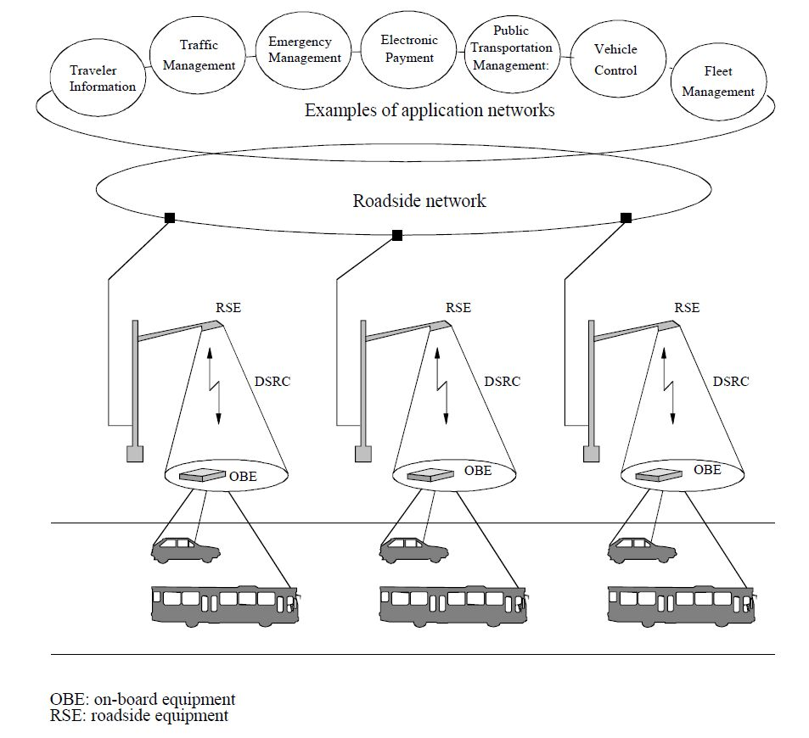

## 6.6 Region 1

In 1992, the CEPT (European Conference of Postal and Telecommunications Administrations) – ERC (European Radio communications Committee) agreed on ERC Decision (92)02 designating frequency bands for the development of a fully Integrated Road Transport system in order to improve all aspects of road transport. It was decided to designate the frequency band 5 795‑5 805 MHz on a European basis, with an additional sub-band 5 805-5 815 MHz on a national basis, to meet the requirements of multilane road junctions. The frequency bands were foreseen for initial road-to-vehicle systems, in particular for road toll systems for which requirements had emerged in a number of European countries at that time. In 2002, the Electronic Communications Committee (ECC) withdrew ERC Decision (92)02 and replaced it by ECC Decision (02)01, entering in force on 15 March 2002.

Based on the ECC Decision, standards for DSRC for ITS applications have been developed by European Committee for Standardization (CEN) and European Telecommunications Standards Institute (ETSI). A standard for the Physical Layer using Microwaves at 5.8 GHz (CEN EN 12253) describes radiocommunication and RF parameter values necessary for co-existence and interoperability of DSRC systems. This standard forms part of the DSRC family of standards consisting of four standards covering the protocol layers 1, 2 and 7 of the Open Systems Interconnection (OSI) protocol stacks and profiles for RTTT (Road Transport and Traffic Telematics) applications. All these CEN standards were approved and published in 2003 and 2004.

The harmonized ETSI standard EN 300 674-2: “Dedicated Short Range Communication (DSRC) transmission equipment (500 kbit/s / 250 kbit/s) operating in the 5.8 GHz Industrial, Scientific and Medical (ISM) band” was approved and published in 2004. This standard contains general and environmental test conditions, methods of measurements and parameter limits.

***[****Editor´s note: The following technical characteristics will be included in section 6.1 overview at a later stage]****]***

### 6.6.1 Technical characteristics

(1) Passive Backscatter Method

European DSRC systems adopt the passive backscatter (transponder) method. This method does not have an internal oscillator for generating a 5.8 GHz band radio carrier signal in the on board equipment (OBE), so it relies on the 5.8 GHz oscillator of the roadside unit with which it communicates. A detailed explanation is given in Figure [X] with a typical functional block diagram.

As the passive transponder does not have a carrier signal oscillator, when transmitting from the OBE, the roadside unit has to emit an unmodulated carrier signal continuously. The OBE receives this signal, which is fed to the transmission circuit and makes it its own carrier signal (B). The transmission data from the main processing unit modulates the output of the sub-carrier signal oscillator C and mixes it with the carrier signal from the receiver. Resultant sideband signals carrying transmission data with different frequencies (carrier signal frequency plus/minus sub carrier frequency) from the carrier signal are transmitted with the carrier signal. The sub-carrier modulation method is utilized to extend the communication zone through reduction of the carrier phase noise and to reduce the re-use distance of RSE in passive transponder system. The modulated signal from the RSE is detected in the detector and processed by the main processing unit as receiving data. The communication zone of the passive (transponder) system is very small, typically up to 10 or 20 meters in front of the RSE. To extend the communication zone to some degree, additional radio frequency amplifier D may be inserted into the transmission circuit of the transponder.

One of the significant features of the passive backscatter method is a narrow communication zone, typically up to 10 or 20 meters in front of the RSE. This characteristic, i.e. communications can only take place at a precise point, is particularly important to correctly locate the vehicle. There are many applications utilizing this characteristic such as Electronic Toll Collection (ETC), Automatic Vehicle Identification (AVI) etc. Another feature of the passive backscatter method is that the structure of the OBE is simple and results in low manufacturing costs.

Figure [X]

Typical configuration of OBE in passive backscatter method

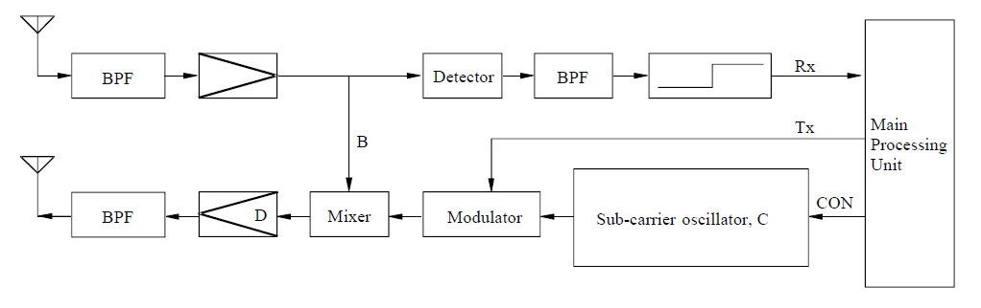

Figure [X] shows the RSE and OBE transmission timing chart and Figure [X] shows the RSE and OBE transmission spectrum in passive backscatter method.

Figure [X]

Transmission timing chart in passive backscatter method

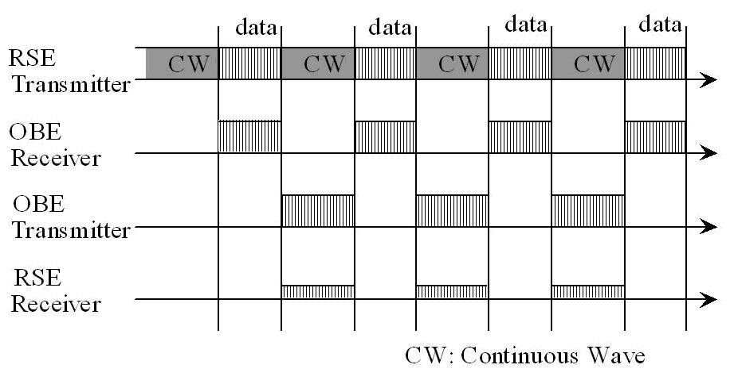

FIGURE [X]

RSE and OBE transmission spectrum in passive backscatter method

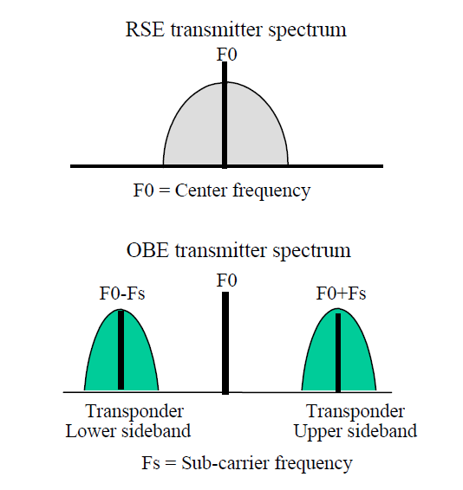

(2) Technical Characteristics of the European Backscatter Method

Technical characteristics of the European backscatter (transponder) method are shown in Table [X] which is an excerpt from Recommendation ITU-R M.1453-2. The Recommendation incorporates the “Medium data rate” European standard (CEN EN 12253) as well as the “High data rate” Italian standard into a single Recommendation.

In the European DSRC standard, the OBE supports two kinds of sub-carrier frequencies (1.5 MHz and 2.0 MHz). Selection of sub-carrier frequency depends on the profile indicated by the RSE. (1.5 MHz is recommended). Frequency spectrum of “Medium data rate” European standard is shown in Figure [X].

In the case of “High data Rate” Italian standard, the OBE uplink sub-carrier frequency is 10.7 MHz, resulting in higher uplink data transmission speed.

Frequency spectrum of the “High data rate” Italian standard is shown in Figure [X].

Figure [X]

Frequency spectrum of “Medium data rate” European standard

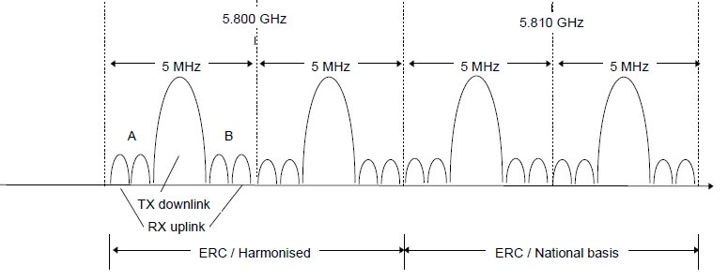

(RAST6(98)29　“Intelligent Transportation System – An ETSI View”)

Figure [X]

Frequency spectrum of “High data rate” Italian standard

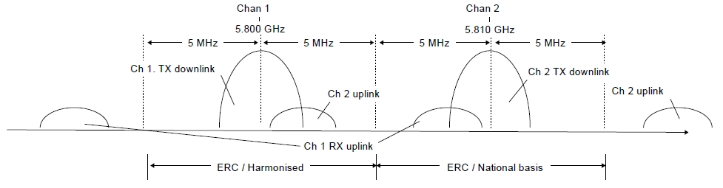

(RAST6(98)29　“Intelligent Transportation System - An ETSI View”)

Table [X]

Characteristics of backscatter (transponder) method

|  |  |  |  |
| --- | --- | --- | --- |
| Item | Technical characteristic | | |
| Medium data rate | | High data rate |
| Carrier frequencies | | 5.8 GHz band for downlink | 5.8 GHz band for downlink | |
| Sub-carrier frequencies | | 1.5 MHz/2 MHz (uplink) | 10.7 MHz (uplink) | |
| RF carrier spacing (channel separation) | | 5 MHz | 10 MHz | |
| Allowable occupied bandwidth | | Less than 5 MHz/channel | Less than 10 MHz/channel | |
| Modulation method | | ASK (downlink carrier) PSK (uplink sub-carrier) | ASK (downlink carrier) PSK (uplink sub-carrier) | |
| Data transmission speed (bit rate) | | 500 kbit/s (downlink) 250 kbit/s (uplink) | 1 Mbit/s (downlink) 1 Mbit/s (uplink) | |
| Data coding | | FM0 (downlink) NRZI (uplink) |  | |
| Communication type | | Transponder type | Transponder type | |
| Maximum e.i.r.p.(1) | | ≤ +33 dBm (downlink) ≤ –24 dBm (uplink: single sideband) | ≤ +39 dBm (downlink) ≤ –14 dBm (uplink: single sideband) | |
| (1) ERC Recommendation 70-03 specifies values of 2 W e.i.r.p. for active and 8 W e.i.r.p. for passive systems | | | | |

### 6.6.2 Frequency usage

TABLE [X]

Frequency usage for ETC in Europe

|  |  |  |  |  |
| --- | --- | --- | --- | --- |
| Country | Frequency band | Technology/ Standard | Service | Deployment or plan year |
| Europe | 5 795-5 805 MHz  [5 805-5 815 MHz] | DSRC | Electronic Toll Collection | Enacted in [19XX] |

### 6.6.3 Standardization

TABLE [X]

Standard for ETC in Europe

|  |  |  |
| --- | --- | --- |
| SDO | Standard No. | Standard Title |
| ETSI | EN 300 674 | Road Transport and Traffic Telematics (RTTT); Dedicated Short Range Communication (DSRC) transmission equipment (500 kbit/s / 250 kbit/s) operating in the 5,8 GHz Industrial, Scientific and Medical (ISM) band |
| ETSI EN 300 674-2-1 | Transport and Traffic Telematics (TTT); Dedicated Short Range Communication (DSRC) transmission equipment (500 kbit/s / 250 kbit/s) operating in the 5.8 GHz Industrial, Scientific and Medical (ISM) band; Part 2: Harmonised Standard covering the essential requirements of article 3.2 of the Directive 2014/53/EU; Sub-part 1: Road Side Units (RSU) |
| ETSI EN 300 674-2-2 | Transport and Traffic Telematics (TTT); Dedicated Short Range Communication (DSRC) transmission equipment (500 kbit/s / 250 kbit/s) operating in the 5.8 GHz Industrial, Scientific and Medical (ISM) band; Part 2: Harmonised Standard covering the essential requirements of article 3.2 of the Directive 2014/53/EU; Sub-part 2: On-Board Units (OBU) |
| TS 102 486 | Test specifications for DSRC transmission equipment |

***[****Editor´s Note: the following text related to applications to be shifted to chapter 6.1 with legacy ITS application overview over all three regions****]***

### 6.6.4 Applications

(1) General

A large number of European countries are implementing electronic toll collection (ETC) system based on DSRC technology. ETC applications are considered to be a major driving force that will create the new market for a large number of DSRC equipment which provides the versatile services for other DSRC based applications. In addition to ETC, applications such as access control, parking management and payment, traffic information and emergency warning, freight and fleet management, traffic control etc. are proposed as ITS services in Europe. These applications are expected to be implemented significantly when ETC using DSRC technology becomes widely used.

The European project DELTA (DSRC Electronics Implementation for Transportation and Automotive applications) is aiming to integrate the DSRC communication link as basic equipment in any vehicle. The following list includes such possible future ITS applications.

– In-vehicle Signing to Assist for Safe Driving (Obtaining roadside traffic and travel information)

– Parking Garage Fee Payment

– MP3 Music Download While Fuelling

– Vehicle status for car rental automatic billing

– Software Installation (Service facility installs fleet management software on the vehicle)

– Mission Planning (A fleet operator plans and downloads mission data to the vehicle)

– Floating Car Data (Acquisition of travel-related information via DSRC)

– Multimodal Transport Information (Display of public transport vehicle information)

– Vehicle Control (Adaptive automatic cruise control)

– Service subscription

– Diagnostics (Service technician diagnostics fault via DSRC).

It should be noted, that for many of these services, there are competing technologies e.g. mobile communications with satellite positioning (GNSS). However, the specific characteristics of DSRC such as high data integrity (highly reliability) and low transmission latency (real time) will make it possible for DSRC to be used for most services associated with these applications.

Typical applications utilizing favourable characteristics of passive DSRC are described below. These applications are standardized within the European Committee for Standardization (CEN).

## 6.7 Region 2

*[Editor’s note: Text to be added]*

### 6.7.1 Frequency usage

TABLE [X]

Frequency usage for ETC in North and South America

|  |  |  |  |  |
| --- | --- | --- | --- | --- |
| Country | Frequency Band | Technology/ Standard | Service | Deployment or plan Year |
| U.S.A. | 902-928 MHz, | DSRC | Electronic Toll Collection | Enacted in [19XX] |
| Canada | 902-928 MHz | [RSS 137](https://www.ic.gc.ca/eic/site/smt-gst.nsf/vwapj/rss137.pdf/$FILE/rss137.pdf) | Electronic Toll Collection | Enacted in [1999] |
| Mexico | 902-928 MHz | DSRC | Electronic Toll Collection | Enacted in [19XX] |

### 6.7.2 Standardization

Table [X]

Standard for ETC in North and South America

|  |  |  |
| --- | --- | --- |
| SDO | Standard No. | Standard Title |
|  |  |  |
|  |  |

## 6.8 Region 3

***[****Editor´s note: The following technical characteristics will be included in section 6.1 overview at a later stage]****]***

### 6.8.1 Technical characteristics

**(1) Technical Characteristics of the Japanese Active Method**

Technical characteristics of the Japanese active (transceiver) method are shown in Table X, which is also an excerpt from Recommendation ITU-R [M.1453-2](http://www.itu.int/rec/R-REC-M.1453/en). In this table there are two specifications in RF carrier spacing column. Wide spacing (10 MHz channel separation) is mainly for current ETC application with the ASK (Amplitude Shift Keying) modulation method. Narrow spacing (5 MHz channel separation) is for multiple purpose DSRC applications services with the ASK and/or QPSK (Quadrature Phase Shift Keying) modulation method. Specifications for the 5 MHz narrow spacing was replaced with 10 MHz spacing added in October 2000, when the Japanese Ministry of Posts and Telecommunications (now MIC) revised the radio law according to the proposal of the Telecommunications Technology Council on general purpose DSRC system applications. The revision was adopted by the ITU-R as the modified DSRC Recommendation ITU-R M.1453-1 in August 2002.

The maximum communication zone of DSRC is recommended to be within 30 meters to promote effective use of frequencies by reducing the re-use distance of RSE. FDD (Frequency Division Duplex) systems are also adopted to promote effective use of radio frequencies.

*[Editor´s note: title of following table uses DSRC, which might be misinterpreted in this report, consider a change of title]*

Table [X]

Characteristics of active (transceiver) method, (Dedicated Short Range) System, ETC

|  |  |
| --- | --- |
| Item | Technical characteristic |
| Carrier frequencies | 5.8 GHz band for downlink and uplink |
| RF carrier spacing (channel separation) | 5 MHz |
| Allowable occupied bandwidth | Less than 4.4 MHz |
| Modulation method | ASK, QPSK |
| Data transmission speed (bit rate) | 1 024 kbit/s/ASK, 4 096 kbit/s/QPSK |
| Data coding | Manchester coding/ASK, NRZ/QPSK |
| Duplex separation | 40 MHz in case of FDD |
| Communication type | Transceiver type |
| Maximum e.i.r.p.(1) | ≤ 30 dBm (downlink)  (For a transmission distance of 10 m or less. Power supplied to antenna ≤ 10 dBm) |
| ≤ 44.7 dBm (downlink)  (For a transmission distance of more than 10 m. Power supplied to antenna ≤ 24.77 dBm) |
| ≤ 20 dBm (uplink)  (Power supplied to antenna ≤ 10 dBm) |
| (1) European Radiocommunications Committee (ERC) Recommendation 70-03 specifies values of 2W e.i.r.p. for active and 8 W e.i.r.p. for passive systems. | |

Figure [X] shows channel arrangement of ITS applications using DSRC at 5.8 GHz band in Japan.

FIGURE [X]

Channel arrangement of DSRC for ITS applications in Japan at 5.8 GHz band



(2) Technical Characteristics of the Chinese ETC System

The Chinese ETC System adopts the active (transceiver) method. Both RSE and OBE work in 5.8 GHz band. There are two classes specified in the physical layer. Class A with ASK modulation should meet the basic requirement of ETC application. Class B with FSK modulation should meet the requirement of high speed data transmission. Technical characteristics of downlink and uplink are shown in Tables 3 and 4 respectively.

Table 3

Technical characteristics of downlink

|  |  |  |  |
| --- | --- | --- | --- |
| Item | | Class A | Class B |
| Carrier frequencies | Channel 1 | 5 830 MHz | 5 830 MHz |
| Channel 2 | 5 840 MHz | 5 840 MHz |
| Allowable occupied bandwidth | | ≤5 MHz | ≤5 MHz |
| Modulation method | | ASK | FSK |
| Data transmission speed (bit rate) | | 256 kbit/s | 1 Mbit/s |
| Data coding | | FM0 | Manchester |
| e.i.r.p. | | ≤ +33 dBm | ≤ +33 dBm |

Table 4

Technical characteristics of uplink

|  |  |  |  |
| --- | --- | --- | --- |
| Item | | Class A | Class B |
| Carrier frequencies | Channel 1 | 5 790 MHz | 5 790 MHz |
| Channel 2 | 5 800 MHz | 5 800 MHz |
| Allowable occupied bandwidth | | ≤5 MHz | ≤5 MHz |
| Modulation method | | ASK | FSK |
| Data transmission speed (bit rate) | | 512 kbit/s | 1 Mbit/s |
| Data coding | | FM0 | Manchester |
| e.i.r.p. | | ≤ +10 dBm | ≤ +10 dBm |

### 6.8.2 Frequency usage

The usage status of ETC in APT countries is shown in Table X. Many APT countries adopted ETC in frequency band of 2.4, 5.8, 5.9 and 24 GHz. For ETC in some APT countries, DSRC technology and 5.8 GHz band has been used.

Table [X]

Legacy ITS communication [- ETC] in Asia-Pacific

| Country | Frequency Band | Technology/ Standard | Application | Deployment or Plan Year |
| --- | --- | --- | --- | --- |
| Australia | 5 725-5 795 MHz,  5 815-5 875 MHz,  24-24.25 GHz | - | Electronic tolling | - |
| China | 5 725-5 850 MHz | DSRC | ETC (Electronic Toll Collection) | Enacted in 2003 |
| 2 400 – 2 483.5 MHz[1] | Exemption from Licensing Order | Electronic toll collection services | 1998 |
| Japan | 76-90 MHz  (FM multiplex broadcasting) | VICS (Vehicle Information and Communications System) | Traffic information | Enacted in 1994  (*VICS will not be available at 2 499.7 MHz after 31 March 2022.) |
| 2 499.7 MHz* (Radio beacon) |
| 5 770-5 850 MHz | ETC (Electronic Toll Collection) | Collect highway toll (Communication) | Enacted in 1997 |
| DSRC  (Dedicated Short Range Communication) | -Collect highway toll -Provide various information (Communication, Broadcast) | Enacted in 2001  (Revised 2008) |
| Korea | 5 795-5 815 MHz | DSRC/  TTA Standard  (TTAS.KO-06.0025/R1) | ETC (Electronic Toll Collection)  BIS(Bus Information System) | 2006  (Highpass Tolling) |
| Singapore | 2 350‑2 483.5 MHz | - | Electronic Road Pricing (ERP) Systems | 1998 |
| 5 855‑5 925 MHz | DSRC  (Dedicated Short Range Communication) | Next Generation Electronic Road Pricing (ERP) Systems | 2020 (estimated) |
| Thailand | 5 470-5 850 MHz | Compliance Standard:  ETSI EN 300 440-1 or FCC Part 15.247 or  FCC Part 15.249 | RFID (e.g. Electronic Toll Collection) | 2008 |
| Viet Nam | 920-923 MHz | RFID | ETC (Electronic Toll Collection) | 2016 |

### 6.8.3 Standardization

Table [X]

Standard for ETC in Asia-Pacific

|  |  |  |
| --- | --- | --- |
| SDO | Standard No. | Standard Title |
| TTA | TTAS.KO-06.0025/R1 | Standard of DSRC Radio Communication between Road-side Equipment and On-board Equipment in 5.8 GHz band |
| TTAS.KO-06.0052/R1 | Test specification for DSRC L2 at 5.8 GHz |
| TTAS.KO-06.0053/R1 | Test specification for DSRC L7 at 5.8 GHz |
| ARIB | STD-T75 | Dedicated Short Range Communication (DSRC) System |
| SAC (Standardization Administration of China) | GB/T 20851.1-2007 | Electrical toll collection – Dedicated short range communication – Part 1: Physical layer |
| GB/T 20851.2-2007 | Electrical toll collection – Dedicated short range communication – Part 2: Data link layer |
| GB/T 20851.3-2007 | Electrical toll collection – Dedicated short range communication – Part 3: Application layer |
| GB/T 20851.4-2007 | Electrical toll collection – Dedicated short range communication – Part 4: Equipment application |
| GB/T 20851.5-2007 | Electrical toll collection – Dedicated short range communication – Part 5: Test methods of the main parameters in physical layer |
| IMDA  TSAC | IMDA TS DSRC | Technical Specification for Dedicated Short-Range Communications in Intelligent Transport Systems |

*[Editor´s note: The following text referring to applications to be shifted to chapter 6.1 with legacy ITS application overview over all three regions***]**

### 6.8.4 Applications

As in Europe, Electronic toll collection (ETC) using DSRC is a forerunner of ITS applications in Japan. ETC service in Japan started in March 2001 and by the end of March 2003, the service covered approximately 900 toll gates through which 90% of expressway users pass. This indicates that the service was deployed nationwide in approximately two years. As of the end of March 2004, the number of toll gates increased to 1 300 and as of December 2005, the number of OBEs (ETC subscribers) reached ten million.

ETC in Japan, started in 2000 and the number of on-board equipment have reached 57 million out of 80 million vehicles, is used by 7.5 million vehicles every day for the payment of the tolls on 9 000 km long expressways. The amount of the payment is US$50 million a day and $20 billion a year. The penetration ratio is more than 90 % and it is one of the fundamental systems for industrial and daily living use. ETC has become an essential thing in our lives.

The ETC system is operated as the one with high communication reliability since one single passenger car payment often surpasses a couple of hundred dollars where the toll is expensive as $23 for every 100 km drive. Therefore, the system cannot be troubled due to radiocommunication interference or else, and if it happens, the toll system could lose the trust of the users and trigger opposition, and also there is a concern of rear-end collision accidents due to troubles of the gate bars.

Regarding to the safe driving assistance, various measures are being taken such as the alert of forward warning of accident or congestion at a point of frequent traffic accidents, the provision of the real time images of snow and foggy conditions, and the dissemination of emergency messages at the time of earthquake. Regarding to the provision of traffic information, the congestion and appropriate route selection information for wide area is provided, which contributes to congestion reduction.

The vehicle driving history data is collected as the big data by the vehicle probe system, and is used to make congestion countermeasures by grasping the points of accurate congestion bottlenecks and queue length based on the vehicle speed data, and also is used to analyze the data, for instance abrupt braking or steering, and to take measures to prevent accidents. The route information whether travel by a vehicle is possible or not is provided from the probe data in case of big disasters. Therefore, the 5.8 GHz DSRC greatly contributes to traffic safety in these various use cases, and more various kinds of applications, such as effective congestion countermeasures by the use of probe data, are being deployed.

Figure [X]

DSRC multiple applications being studied in Japan

1

Since 1996, Vehicle Information and Communication System (VICS) has been operating in Japan for delivering traffic and travel information to road vehicle drivers. The following nine application fields are being studied in Japan to extend applications in the vehicle. (Refer to Figure [X]):

(1) Parking lot management

(2) Gas filling station

(3) Convenience store

(4) Drive-through

(5) Logistics management

(6) Pedestrian support

(7) Specific region entry charging (Zone tolling)

(8) Information providing: semi-stationary state

(9) Information providing: high speed driving

# 7 Advanced ITS radiocommunication

## 7.1 Overview

*[Editor´s note: V2N need to be adressed]*

After the deployments of DSRC basic applications such as ETC, to extend beyond the existing ITS applications and to enhance traffic safety and reduce the environmental impact by the transportation sector, vehicle-to-vehicle (V2V), vehicle-to-infrastructure (V2I), infrastructure-to-vehicle (I2V), vehicle-to-network (V2N), vehicle-to-pedestrian (V2P) communications are studied. According to this progress, ITU-R has developed report on advanced ITS radiocommunications [8]. In the report, advanced ITS are classified by its technical characteristics as shown in Table x. V2X (WAVE), V2X (ETSI ITS-G5), V2X (ITS Connect) and LTE based V2X (LTE-V2X) technologies could be inclusive in advanced ITS category.

WAVE is a dedicated mobile radiocommunication system for providing non-voice communications among vehicles that travel on roads, rails, or other dedicated facilities; as well as between those vehicles and the transportation infrastructure. WAVE is therefore a fundamental technology for ITS communications, helping link roads, traffic and vehicles covered by ITS deployment with coordinated, interoperable information technology. This particular wireless technology could be transformational to the evolution of transportation systems, since it provides very localized, low latency communications capabilities on a peer-to-peer basis. These capabilities are intended to support the planned, as well as the still unforeseen, data needs of the evolving, more automated, future transportation system. WAVE systems specifically utilize the broadcast mode of operations as the primary means to support public benefits; and also communicate using two-way communications between vehicles and infrastructure, including the ability to provide lower priority messages related to the specific units involved in a variety of public and private transportation environments.

WAVE is being pursued in the United States “to improve traveller safety, decrease traffic congestion, facilitate the reduction of air pollution, and help to conserve vital fossil fuels”6, and as a particular focus in the United States, to reduce highway fatalities7. Although not yet widely deployed, the United States has developed multiple applications, a number of which have been tested in large-scale field tests or operated in model deployments[2]. This progress has provided the United States with extensive knowledge of these applications that contribute to transportation safety, mobility and environmental stewardship in the context of advanced ITS. The WAVE ITS applications are designed to perform operations related to the improvement of traffic safety and traffic flow, as well as other intelligent transport service applications, including enhancing transportation systems efficiencies and operations (for example, facilitating roadway freight movements or transportation management during emergency responses). The main points of focus for the US deployment of advanced ITS applications using WAVE communications include: nationwide interoperability; long-term technical stability; voluntary industry standards; and support for public benefits.

Cooperative ITS communication (C-ITS) has to be based on standardized and interoperable wireless ad-hoc communication systems. The interoperability has to be guaranteed at least in the different worldwide regions. This interoperability requirement does not imply the use of exactly the same system in all regions, e.g. C-ITS in Europe in 5.9 GHz is mainly based on IEEE 802.11p and ETSI ITS-G5, whereas the US implementation in 5.9 GHz is based on the slightly different IEEE 802.11p and WAVE system as described above. For these technologies the standards are finished, intensive testing and validation has taken place, first implementations done and deployment is planned. Most of the actual discussed systems are based on a well-established access layer (PHY-layer and MAC-layer) standardised by IEEE802 as IEEE802.11p, which is part of the IEEE802.11-2012 set of standards.

In certain countries, a frequency band in the range between 5 850‑5 925 MHz (up to 75 MHz bandwidth) has been chosen/picked as the main band of operation for the upcoming traffic-safety related C-ITS. In addition, the frequency band 63 GHz to 64 GHz has been designated for traffic safety related applications under the Mobile Service in CEPT.

Worldwide a broad range of standardisation organisation are involved in the standardisation of C‑ITS. The main actors with a strong support from the Automotive Industry are the US activities around IEEE/WAVE/SAE and the European activities around ETSI TC ITS. These activities are backed by industry consortia CAMP (Crash Avoidance Metric Partnership) in the US and the C2C‑CC (CAR-to-CAR Communication Consortium) in Europe.

The C2C-CC as an industry driven, non-profit association of 16 European vehicle manufacturers, 37 suppliers and 28 research organisations, dedicated to realise cooperative road traffic and herewith increase traffic safety, efficiency and driving comfort. The C2C-CC plays an important role in the development of European standards for C-ITS and cooperates closely on C-ITS with the CAMP consortium in the US. To align and harmonise the C-ITS roll-out in vehicles and traffic infrastructure in Europe by 2019 the consortium engages in the Amsterdam Group. This is a strategic alliance of the CAR 2 CAR Communication Consortium, the ASECAP (Association of operators of toll road infrastructures), CEDR (Conference of European Directors of Roads) and POLIS (European Cities and Regions Networking for Innovative Transport Solutions). Furthermore, the consortium actively contributes to the work of the C-ITS Deployment Platform organised by the European Commission.

The C2C-CC participated in the initial design of vehicle-to-vehicle communications technologies through the publication of a manifesto. It also helps validating the C-ITS by getting involved in FOT (Field operational tests) and ongoing cross-border C-ITS corridor projects and focusing on interoperability testing.

In 2007, the CAR 2 CAR Communication Consortium published the Manifesto on its website[3]. The document built the basis for the first interoperability demonstration shown 2008 at the Opel testside in Dudenhofen.

The document describes the C-ITS scenarios for improving safety and traffic efficiency as well as using the communication system for infotainment and other purposes. From the scenarios, the system prerequisites and constraints are derived and the system architecture developed. The architecture describes the communication principles, the individual components, the layers’ architecture and related protocols. The further chapters describe the applications, the radio and communication system as well as data security and privacy.

This document specifies the standard profile that enables interoperability of C-ITS units. The first Basic System Profile (BSP) version was released for C2C-CC internal usage by end of 2014. The latest revised BSP version will be published by sharing it with the Basic Members of the consortium by May 2016. It contains a system specification complemented by a selection of standards and parameters. It allows to test the aspects that are going to be used by “day one” applications.

ITS Connect is a dedicated mobile radiocommunication system for V2X communication[4]. The ITS Connect is based on the ARIB STD-T109 which the formal name is 700 MHz BAND INTELLIGENT TRANSPORT SYSTEMS. 755.5-764.5MHz is assigned for the ITS Connect in Japan. Therefore, the standard uses “700MHz band” and its centre frequency is 760MHz in Japan. The ITS Connect several services had been deployed in Japan from 2015[5]. Road side equipment (RSE) had been installed by the National Police Agency of Japan. From the view point of the vehicle, one of the usage of the ITS Connect (V2X communication) is a “sensor of a vehicle” for undetectable objects (other vehicles, pedestrian, and others in Non Line Of Site (NLOS)), which own on board sensors (radar, camera, lidar, and others) is difficult to sense. UHF (760MHz) band could aid receiving messages from objects in NLOS with its diffractive features. Another usage of the ITS Connect (V2I communication) could also support passing the junction safely receiving traffic signal information and vehicle location information at junction in advance. These information aids appropriate actions for vehicles, and pedestrians before arriving at the junction. In the future automated driving era, the ITS Connect (V2X communication) must be important.

Advanced ITS is also supported by 3GPP technologies and worldwide standards. 3GPP has developed specifications to enable the use of LTE mobile networks to provide connectivity between vehicles, roadside infrastructure and pedestrians inside and around the connected vehicles, i.e. targeting all initial main V2X use cases and requirements studied by 3GPP: V2V, V2P, V2I and V2N.

3GPP Release 14 specification work about LTE-V2X service, including system and radio access requirements, has been completed in March 2017 and 3GPP will freeze the specification work on release 14 in June 2017. Both PC5 (device-to-device direct link) and Uu (link between base station and device) are included, supporting transmission in existing mobile allocations up to 6 GHz. Device-to-device direct link communication without network assistance is also supported. More details can be found in Section 7.2.3 below. The LTE based V2X communication over PC5 and Uu interface can be found in Figure X

Figure X

V2X communication over LTE-PC5 interface and LTE-Uu interface

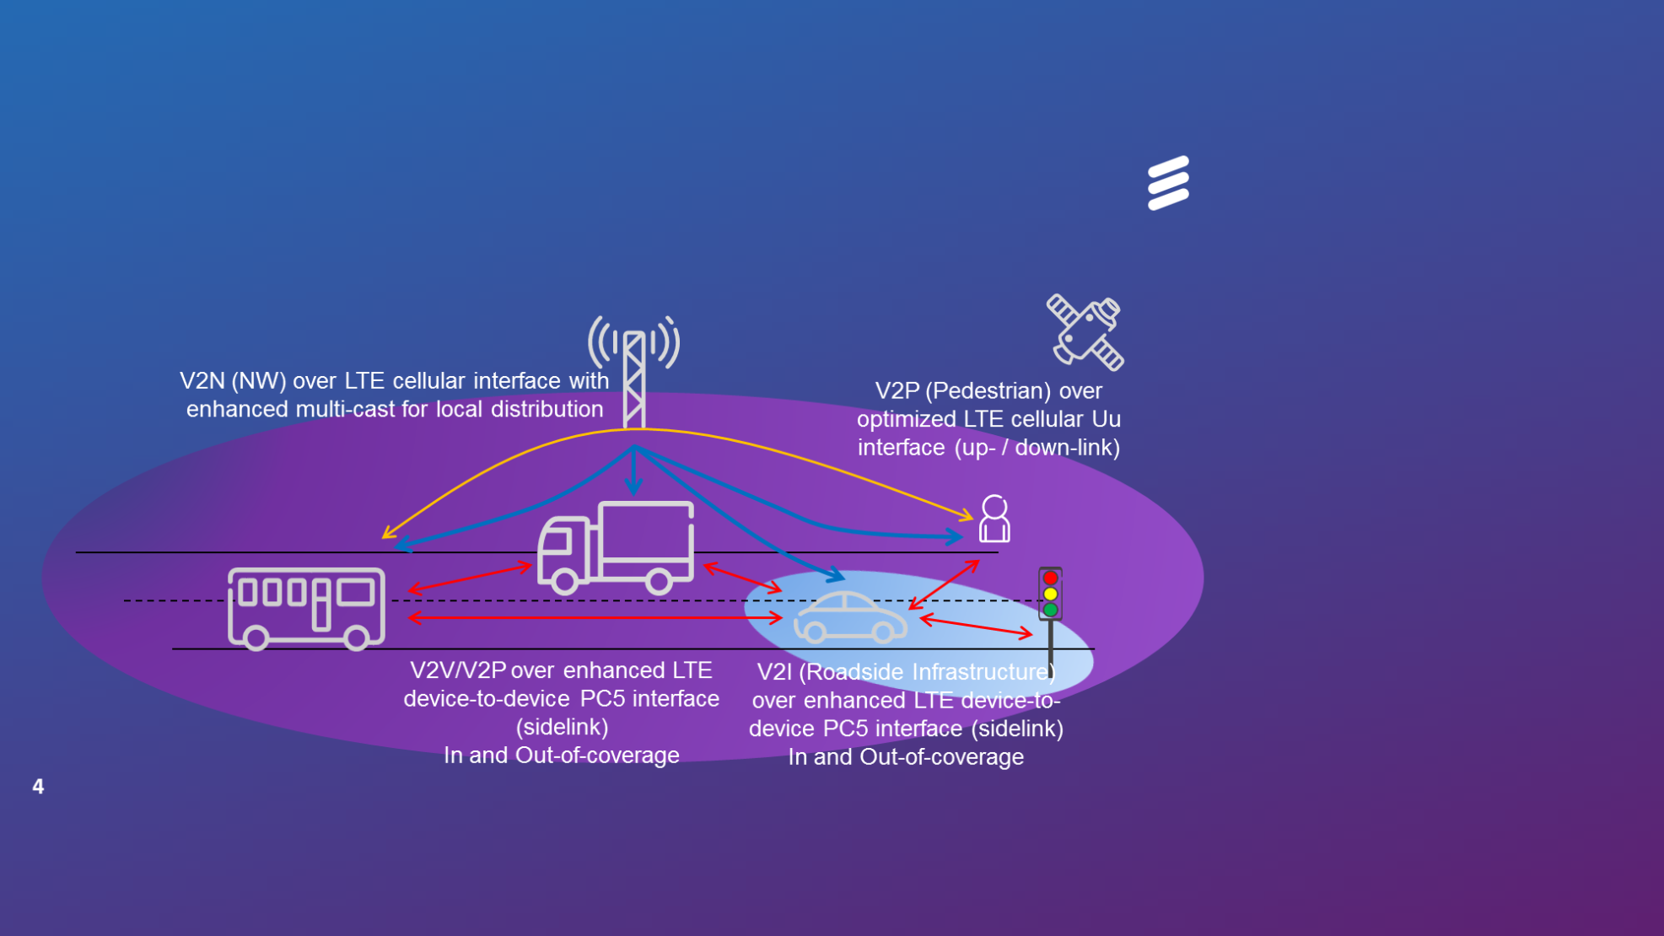

3GPP is also looking at continuously evolving the V2X services in its coming releases including 5G. Future V2X releases will support, e.g. enhanced safety use cases at high vehicle speeds, challenging road conditions with its improved reliability, extended range, lower latency, and enhanced non-line-of-sight (NLOS) capabilities. Therefore, further 3GPP V2X enhancements are expected, from Rel-15 onward.

China started to develop trials of LTE based V2X communication technology (LTE-V2X) to verify road safety and non-road safety applications from 2015.

## 7.2 Technical characteristics

### 7.2.1 Overview

Table [X]

Technical characteristic of Advanced ITS

*[Editor’s note: References are invited, columns needed for PC5, uu like the format of REC 2084, suggestion that we might delete “radio performance” row until referenced and aligned values can be agreed on]*

|  |  |  |  |  |
| --- | --- | --- | --- | --- |
| Items | V2X (WAVE) | V2X (ETSI ITS-G5) | V2X (LTE based V2X) | V2X (ITS Connect) |
| Technologies | WAVE,  IEEE 802.11p | ETSI ITS-G5  IEEE 802.11p | 3GPP LTE based V2X | ARIB STD-T109 |
| Vehicular networking | V2V, V2I, V2P | V2V, V2I, V2P | V2V, V2N, V2I, V2P | V2V, V2I, V2P |
| [Radio performance | Radio coverage: Max. 1 000 m  Data rate: Max. [27 Mbps]  Packet size: Max. 2 kbytes  Latency : within 100 msec | Radio coverage: Max. 1 000 m  Data rate: Max. 27 Mbps  Packet size: Max. 2 kbytes  Latency : within 100 msec | Radio coverage: Max. 1 000 m  Data rate: Max. 27 Mbps  Packet size: Max. 2 kbytes  Latency: within 100 msec  within 1 000 msec for V2N | Radio coverage: Max. 1 000 m  Data rate: Max. 18 Mbps  Packet size: Max. 100 bytes (from Vehicle) Max 1 500 bytes (from Infrastructure)  Latency : within 100 msec] |

Figure [X]

Vehicle information & Communication (V2V, V2I, I2V)



### 7.2.2 V2X (WAVE)

***[Editor’s note for 7.2.1 V2X:*** *It should be noted that the information contained in this WAVE section may need to be revised/updated as a result of ongoing domestic proceedings by one administration.****]***

*On-board equipment (WAVE OBE)*: The OBE consists of communications and processing equipment installed in vehicles to enable WAVE communications with other vehicles and infrastructure, and support WAVE-enabled applications. OBEs may be most effective when integrated into the vehicle and able to interface with other on-board equipment such as the vehicle’s sensor suite, anti-lock braking system, and other subsystems, allowing it to complement these existing systems.

*Roadside unit (WAVE RSU)*: A WAVE RSU is installed above or alongside the road or other infrastructure and communicates with passing OBEs by the use of radio signals. An RSU consists of radio communication circuits, an application processing circuit and related equipment. It may have data linkages to traffic management centers (TMCs) and to other roadside equipment (such as traffic signal controllers), as well as to the Internet to exchange data and to maintain security credential information.

The WAVE systems operate by transmitting radio signals for the exchange of data among vehicle-mounted OBEs, and between OBEs and infrastructure-based RSUs. By adhering to requirements set by industry standards, these systems accomplish a data exchange that ensures that data is interoperable across a wide range of device and application manufacturers. Interoperability is key to support the rapid, standardized adoption of applications that deliver critical safety related, system and operational efficiencies, and other public benefits.

Much of the information to complete the following tables comes from Std 802.11-2016[6].

The modulation used for WAVE is ‘half-clocked’ OFDM on 10 MHz channels. Below are basic OFDM transmitter and receiver block diagrams.

Transmitter and Receiver[7]

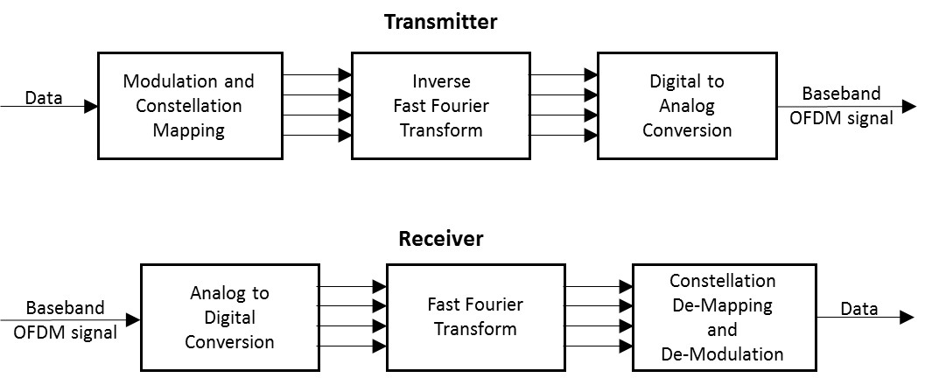

Transmitter characteristics[8]

| Parameter | Value | |
| --- | --- | --- |
| Emission 3 dB Bandwidth (MHz) | 10 MHz | |
| Power (Peak) (dBm) | 23 to 44.8 dBm e.i.r.p.[9] (Depending on Channel used, RSU or OBE[10] and government or private); also, transmissions shall use only the power necessary to support the particular application[11] | |
| Emission Spectrum  (Relative Attenuation (dB) as a Function of Frequency Offset from Center Frequency (ΔF) (MHz)) | **Attenuation** | **Δ*F*** |
| See footnote[12] | See footnote7 |
| Data Rate | 6 Mb/s[13] | |
| Modulation Parameters[14] | Modulation QPSK | Coding Rate 1/2 |
| Azimuth Off-Axis Antenna Pattern | Vehicles - omnidirectional (3600)[15]; sectorized antennas sometimes used with Infrastructure WAVE transmitter antennas | |
| Elevation Off-Axis Antenna Pattern | -6 to +10 degrees – vehicles Infrastructure – specification TBD | |
| Antenna Height (meters) | 1.5-15 m[16] | |
| Antenna Polarization | Primarily vertical (some right hand circular)[17] | |

Receiver characteristics3

| Parameter | Value |
| --- | --- |
| Receiver Sensitivity | -92 dBm minimum,  -94 dBm typical[18] |
| Receiver Selectivity | See following table on “Adjacent and Next-Adjacent Channel Rejection Receiver Characteristics” |
| Information Data Rate | 3, 4.5, 6, 9, 12, 18, 24 and 27 Mb/s (3, 6 and 12 Mb/s are mandatory)[19] |
| Antenna Characteristics | Note that the same antenna is typically used for both transmit and receive functions in WAVE systems – refer to antenna characteristics in the previous table for receiver antenna characteristics |

Adjacent and Next-Adjacent Channel Rejection Receiver Characteristics[20]

|  |  |  |  |  |  |
| --- | --- | --- | --- | --- | --- |
| Modulation | Coding Rate | Receiver Performance (dB) | | Optional Enhanced Receiver Performance (dB) | |
| Adjacent Channel Rejection | Next Adjacent Channel Rejection | Adjacent Channel Rejection | Next Adjacent Channel Rejection |
| BPSK | 1/2 | 16 | 32 | 28 | 42 |
| BPSK | 3/4 | 15 | 31 | 27 | 41 |
| QPSK | 1/2 | 13 | 29 | 25 | 39 |
| QPSK | 3/4 | 11 | 27 | 23 | 37 |
| 16-QAM | 1/2 | 8 | 24 | 20 | 34 |
| 16-QAM | 3/4 | 4 | 20 | 16 | 30 |
| 64-QAM | 2/3 | 0 | 16 | 12 | 26 |
| 64-QAM | 3/4 | –1 | 15 | 11 | 25 |

Maximum STA transmit power classification for the 5 850 – 5 925 MHz band in the United States[21]

|  |  |  |
| --- | --- | --- |
| STA transmit power classification | Maximum STA transmit power (mW) | Maximum permitted e.i.r.p. (dBm) |
| A | 1 | 23 |
| B | 10 | 33 |
| C | 100 | 33 |
| D | 760 Note that for this class higher power is permitted as long as the power level is reduced to this level at the antenna input and the emission mask specifications are met. | 33 for nongovernment  44.8 for government |

Spectrum mask data for 10 MHz channel spacing4

| STA transmit power class | Permitted power spectral density, dBr | | | | |
| --- | --- | --- | --- | --- | --- |
| ± 4.5 MHz offset (±f1) | ± 5.0 MHz offset (±f2) | ± 5.5 MHz offset (±f3) | ± 10 MHz offset (±f4) | ± 15 MHz offset (±f5) |
| Class A | 0 | –10 | –20 | –28 | –40 |
| Class B | 0 | –16 | –20 | –28 | –40 |
| Class C | 0 | –26 | –32 | –40 | –50 |
| Class D | 0 | –35 | –45 | –55 | –65 |

Transmit spectrum mask for 10 MHz OBE transmission (Class C typical)[22]

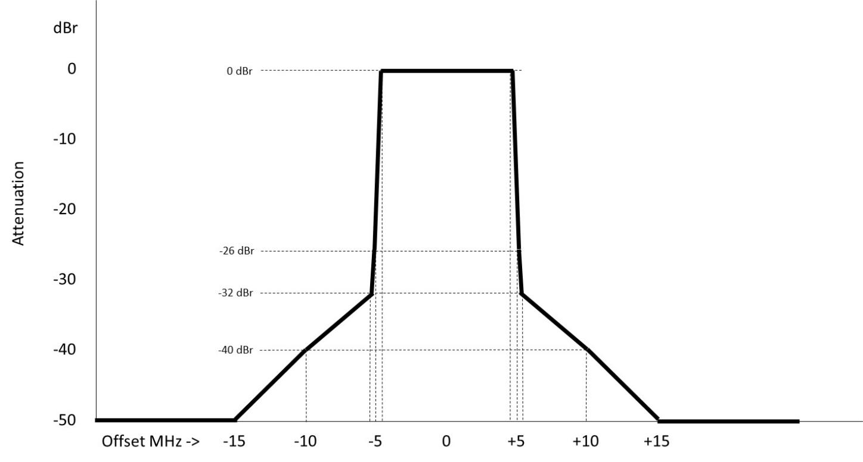

### 7.2.3 V2X (ETSI ITS-G5)

V2X (ETSI ITS-G5) has been specified in the ETSI Technical Committee ITS (Intelligent Transport Systems). The basic system is fully harmonized with the US V2X (WAVE) as described in clause 7.2.2. Similar to the WAVE system it consists of Onboard Units (OBUs) and Roadside units (RSU) as introduced in clause 7.2.2.

V2X (ETSI ITS-G5) has been developed as a full ad-hoc system not relying on any fixed network components like access points, base station or other infrastructure components. Nevertheless, the deployment of infrastructure based on the ETSI ITS-G5 standards as part of the ad-hoc network can enhance the operational capabilities by introducing infrastructure based information.

Similarly to the WAVE system, the access layer of ETSI-G5 is based on the IEEE802.11-166.

The main spectrum relevant technical characteristics of the ETSI ITS-G5 systems complies with ETSI EN 302 571 V2.1.1[23].

Table[X]

Main Transmitter characteristics,

| Parameter | Value | |
| --- | --- | --- |
| Emission 3 dB Bandwidth (MHz) | 10 MHz6 | |
| Power (Peak) (dBm) e.i.r.p. | 33 dBm23 | |
| Power spectral density dBm/MHz e.i.r.p | 23 dBm/MHz23 | |
| Data Rate | 3, 4.5, 6, 9, 12, 18, 24 and 27 Mb/s6 | |
| Modulation Parameters | Modulation:6 BPSK, QPSK, 16-QAM, 64-QAM | Coding Rate:6 ½, ¾, 2/3, |
| Azimuth Off-Axis Antenna Pattern | Vehicles - omnidirectional (3600);  sectorized antennas sometimes used with Infrastructure ETSI-ITS-G5 transmitter antennas6 | |

Table[X]

Transmitter spectrum mask for 10 MHz channel bandwidth6

|  |  |  |  |  |  |
| --- | --- | --- | --- | --- | --- |
| Carrier frequency fc (dBc) | ± 4,5 MHz  offset  (dBc) | ± 5,0 MHz  offset  (dBc) | ± 5,5 MHz  offset  (dBc) | ± 10 MHz  offset  (dBc) | ± 15 MHz  offset  (dBc) |
| 0 | 0 | ‑26 | ‑32 | ‑40 | ‑50 |

Table[X]

Receiver sensitivity6

|  |  |  |
| --- | --- | --- |
| Modulation | Coding rate | Minimum sensitivity for 10 MHz channel spacing (dBm) |
| BPSK | ½ | -85 |
| BPSK | ¾ | -84 |
| QPSK | ½ | -82 |
| QPSK | ¾ | -80 |
| 16-QAM | ½ | -77 |
| 16-QAM | ¾ | -73 |
| 64-QAM | 2/3 | -69 |
| 64-QAM | ¾ | -68 |

Table[X]

Adjacent and Next-Adjacent Channel Rejection Receiver Characteristics21

|  |  |  |  |
| --- | --- | --- | --- |
| Modulation | Coding rate | Receiver performance (dB) | |
| Adjacent channel rejection | Next adjacent channel rejection |
| BPSK | ½ | 16 | 32 |
| BPSK | ¾ | 15 | 31 |
| QPSK | ½ | 13 | 29 |
| QPSK | ¾ | 11 | 27 |
| 16-QAM | ½ | 8 | 24 |
| 16-QAM | ¾ | 4 | 20 |
| 64-QAM | 2/3 | 0 | 16 |
| 64-QAM | ¾ | –1 | 15 |

In addition to the traditional requirements for the transmitter and receiver the ETSI ITS-G5 systems specifies a protection mechanism**Error! Bookmark not defined.** for the protection of ETC systems based on CEN-DSRC operating in the band 5 795 MHz to 5 815 MHz. These mechanisms and restriction will optimize the smooth coexistence of the two systems operating in a close vicinity.

Furthermore, ETSI ITS-G5 systems have to implement a congestion control mechanism in order to guarantee a smooth operation under high channel load conditions. This mechanism has been defined in ETSI TS 103 175**Error! Bookmark not defined.**.

### 7.2.4 V2X (ITS Connect)

ITS Connect is configured using road side units (RSUs) and On-board equipment (OBE). Basic functions of ITS Connect are the following:

Conveyance and exchange of information that contributes to reduce the number of traffic accidents.

Conveyance and exchange of information that contributes to assist safe driving

Conveyance and exchange of information that contributes to smooth traffic flow

The OBE is installed in vehicle side. The OBE performs radio communication with the RSUs or other OBEs. The radio equipment of the OBE is composed of a transmitter, receiver, controller, antenna, and etc. The OBE sends vehicle information (such as position, speed, direction, and so on). The OBE receives signal from other OBE and RSUs. Then the vehicle can know the position and situation of other vehicle, and can provide adequate information or behavior to driver for assisting safe driving.

The RSU performs radio communication with OBEs or the other RSUs. The radio equipment of the RSU is composed of a transmitter, receiver, controller, antenna, and etc. The RSU is installed at roadside (mainly junction). One of the use case of Infrastructure to Vehicle (I2V) is to broadcast traffic signal information. For this use case, the RSU shall connect traffic signal control center. Another use case of I2V is to broadcast information of vehicle and pedestrian when the pedestrian crossing around junction that the RSU is installed. A sensor detects the vehicle and pedestrian, and the sensor transfers the information to the RSU.

ITS Connect uses one RF channel OFDM modulated signal. The occupied bandwidth shall be 9 MHz or less. Most OFDM parameter is same with the IEEE802.11p. The modulation and coding method is described on the Table 9. The transmission data rate shall be 5 Mb/s or more.

TABLE 9

Specification of the modulation and coding method

|  |  |
| --- | --- |
| Item | Parameter |
| Frequency band | 755.5 – 764.5 MHz (single channel) |
| Channel selection | Not required (fixed) |
| Error correction | Convolution FEC R=1/2, 3/4 |
| Modulation | BPSK/OFDM, QPSK/OFDM, 16QAM/OFDM |

The limit on secondary radiated emissions shall be as specified in Table 10 for a RSU and Table 11 for OBE.

TABLE 10

Limits of incidentally produced radiation（RSU）

|  |  |
| --- | --- |
| Frequency band | Limits of incidentally produced radiation |
| 770 MHz or less | 4 nW or less per 100 kHz bandwidth |
| More than 770 MHz and 810 MHz or less | 0.32 nW or less per 100 kHz bandwidth |
| More than 810 MHz and 1 GHz or less | 4 nW or less per 100 kHz bandwidth |
| More than 1 GHz | 4 nW or less per 1 MHz bandwidth |

TABLE 11

Limits of incidentally produced radiation（OBE）

|  |  |
| --- | --- |
| Frequency band | Limits of incidentally produced radiation |
| 1 GHz or less | 4 nW or less per 100 kHz bandwidth |
| More than 1 GHz | 4 nW or less per 1 MHz bandwidth |

Blocking characteristics of RSU and OBE are defined in Table 12 and Table 13.

TABLE 12

Blocking characteristics（RSU）

|  |  |
| --- | --- |
| Frequency band | Interference signal |
| More than 710 MHz and 748 MHz or less | -7 dBm |
| More than 773 MHz and 810 MHz or less | -7 dBm |

TABLE 13

Blocking characteristics（OBE）

|  |  |
| --- | --- |
| Frequency band | Interference signal |
| More than 710 MHz and 748 MHz or less | -21 dBm |
| More than 773 MHz and 810 MHz or less | -21 dBm |

The permissible values for unwanted emission intensity shall be as specified in Table 14 for a RSU and Table 15 for OBE.

TABLE 14

Unwanted emission intensity（RSU）

|  |  |
| --- | --- |
| Frequency band | Emission limit (average power) |
| 710 MHz or less | 2.5 µW or less per 100 kHz bandwidth |
| More than 710 MHz and 750 MHz or less | 20 nW or less per 100 kHz bandwidth |
| More than 750 MHz and 755 MHz or less | 0.1 mW or less per 100 kHz bandwidth |
| More than 765 MHz and 770 MHz or less | 0.1 mW or less per 100 kHz bandwidth |
| More than 770 MHz and 810 MHz or less | 0.32 nW or less per 100 kHz bandwidth |
| More than 810 MHz and 1 GHz or less | 2.5 µW or less per 100 kHz bandwidth |
| More than 1 GHz | 2.5 µW or less per 1 MHz bandwidth |

TABLE 15

Unwanted emission intensity（OBE）

|  |  |
| --- | --- |
| Frequency band | Emission limit (average power) |
| 710 MHz or less | 2.5 µW or less per 100 kHz bandwidth |
| More than 710 MHz and 750 MHz or less | 20 nW or less per 100 kHz bandwidth |
| More than 750 MHz and 755 MHz or less | 0.1 mW or less per 100 kHz bandwidth |
| More than 765 MHz and 770 MHz or less | 0.1 mW or less per 100 kHz bandwidth |
| More than 770 MHz and 810 MHz or less | 10 nW or less per 100 kHz bandwidth |
| More than 810 MHz and 1 GHz or less | 2.5 µW or less per 100 kHz bandwidth |
| More than 1 GHz | 2.5 µW or less per 1 MHz bandwidth |

These regulations are defied for co-existing with ITS Connect that using 755.5-764.5MHz and adjacent channel systems (LTE, Digital TV, radio mic, and so on).

Reception sensitivity is same with the IEEE802.11p. In this system, BPSK, QPSK and 16QAM of 10 MHz channel spacing shall be selected. Transmitting power for the operating frequency band shall be 10 mW or less per 1 MHz bandwidth on average.

In Japan, ITS Connect uses 755.5-764.5 MHz. The center frequency shall be 760 MHz. If the ITS Connect will be used in other country, for example, when lower than 1 GHz band will be assigned, performance of communication distance on NLOS/LOS is similar with 760 MHz, the system may be able to provide similar road safety and environmental effects.

### 7.2.5 V2X (LTE based V2X)

3GPP TSG RAN in RAN#73 completed work item “Support for V2V services based on LTE sidelink”, LTE based V2V device-to-device direct link communications are based on D2D communications defined as part of ProSe (proximity service) services in 3GPP Release-12[24] and Release-13[25]. As part of ProSe services, a new D2D interface was introduced in Release-14 and it has been enhanced for vehicular use cases, specifically addressing high speed (relative speeds up to 500 kph) and high density connection scenarios. A few fundamental modifications to LTE‑V2V PC5 have been introduced.

* Additional DMRS symbols have been added to handle the high Doppler associated with relative speeds of up to 500 kph and at high frequency (5.9 GHz ITS band being the main target).
* The arrangement of scheduling assignment and data resources are designed to enhance the system level performance under high density scenarios while meeting the low-latency requirements of V2V.

Distributed scheduling (Mode 4), which is a sensing mechanism with semi-persistent transmission , was introduced.

The 3GPP work item “LTE-based V2X services” specifies enhancements required to enable V2X services with LTE uplink and downlink, to enable LTE PC5 interface to support additional V2X services such as vehicle to pedestrian (V2P), and to support more operational scenarios for V2V services using LTE PC5. Specifically, the following are considered the main features of this work item:

* uplink and PC5 enhancement to enable eNB to quickly change semi-persistent scheduling (SPS) in adapting to a change in the V2X message generation pattern;
* introduction of shorter scheduling periods in downlink and PC5 for broadcasting V2X messages within latency requirements;
* introduction of an additional resource allocation procedure in PC5 mode 4 for power saving in pedestrian UEs;
* introduction of PC5 congestion control for operation in high traffic load;
* enhancement to PC5 synchronization for operation outside GNSS or eNB coverage; and
* support of simultaneous V2X operations over multiple carriers.

The PC5 interface for V2X supports QPSK and 16QAM in a 10 MHz or 20 MHz channel leading to a peak rate of 41.472 Mbps. The Uu interface for V2X reuses the existing LTE Uu interface, so the modulation scheme and the peak rate is the same.

As a result of this WI, the LTE radio specification supports the two LTE based V2X communication methods, both PC5 and Uu interface, illustrated in Figure X below. The interface communication supports direct link transmission when cellular network provides coverage for vehicles (in coverage), or when vehicles are out of coverage of a cellular network. LTE based V2X can support message transmission by both unicast and broadcast in Uu interface.

Figure x

V2X communication over PC5 interface and Uu interface



## 7.3 Technical and operational communications aspects

### 7.3.1 Technical Communications Aspects

***[Editor’s note:*** *It should be noted that the information contained in this section may be updated at a future meeting as a result of related ongoing United States domestic proceedings.****]***

Table [xx]

Technical Communications Aspects for Advanced ITS Applications to Support Transportation Safety-Related and Efficiency Applications[26]

|  |  |
| --- | --- |
|  | Aspect |
|  | *Interoperability aspects* |
| United States | Certification Operating Council certifies all vehicle and infrastructure safety-related communication devices[27] to ensure interoperability before being permitted to operate in the United States. |
| V2V Basic Safety Messages[28] (BSM)s are transmitted on a dedicated safety channel, which is the 10 MHz channel from 5 855 to 5 865 MHz Channel 172 under current standards[29] and regulations[30] in the United States. |
| Protection of safety-related communications is the highest priority[31]. |
|  |
| *Performance aspects* |
| Devices provide[32],[33] 300 m[34],[35],[36] range with less than 10% packet error rate anywhere along the 360 circle around the center of the vehicle 1.5 m above the ground, with line of sight and under controlled test conditions (to support V2V safety applications) |
| Objective of 10% packet error rate is for reception of basic safety messages at the edges of 300 m range. Other applications may have different objectives. |
| Reliable operation of basic safety messages and other use cases imply limits on maximum system latency[37],[38] |
| Technology designed to support appropriate scale (sufficient capabilities for each vehicle to maintain a real time dynamic state map through concurrent communications with vehicles within a communications zone transmitting basic safety messages 10 times per second)[39],[40] |
| Congestion mitigation is employed (monitor channel loading and gradually adjust parameters in congested conditions, to fully support the most likely vehicle conflict scenarios)[41] |
| Connectionless communications capabilities are supported for safety-related messages (e.g., for Basic Safety Messages and Signal Phase and Timing messages), rather than requiring point-to-point connections between devices[42],[43] |
| Non-trackability (anonymity) / appropriate level of privacy (no vehicle or individual identification for required safety-related transmissions)[44] |
| Out of network coverage range operation supported such that devices are able to operate independently of wide area network coverage[45],[46] |
| Security (trust anchor for safety-related communications that preserves anonymity; ability to remove “bad actors” from making credible safety-related transmissions)[47] |

### 7.3.2 Operational Communications Aspects

Table [xx]

Operational Communications Aspects for Advanced ITS Applications to Support Transportation Safety-Related and Efficiency Applications[48]

|  |  |
| --- | --- |
| United States | Technology is reliable, upgradable and backwards compatible to ensure typical automobile and infrastructure deployment and lifecycle time frames. |
| Does not require periodic end-user payment to utilize required safety-related applications[49] |
| Retrofit and aftermarket devices, compatible with factory-installed integrated devices, may be deployed in existing vehicle fleet according to market-driven incentives. |
| Compliant equipment deployed according to the same planning factors as other transportation infrastructure.[50] |

*[editor´s note: contributions until next meeting are invited to shorten the table in case of agreement]*

[Table [xx]

Operational Communications Aspects for Advanced ITS Applications to Support Transportation Safety-Related and Efficiency Applications in the European Union

|  |  |
| --- | --- |
| European Union | To ensure a coordinated and effective deployment of ITS within the Union as a whole, specifications, including, where appropriate, standards, defining further detailed provisions and procedures should be introduced. Before adopting any specifications, the Commission should assess their compliance with certain defined principles set out in Annex II of directive 2010/40/EU[51]. Priority should be given in the first instance to the four main areas of ITS development and deployment. Within those four areas, priority actions should be established for the development and use of specifications and standards. During further implementation of ITS the existing ITS infrastructure deployed by a particular Member State should be taken into account in terms of technological progress and financial efforts made. |
| ITS should build on interoperable systems which are based on open and public standards and available on a non-discriminatory basis to all application and service suppliers and users. Such a set of standards is developed in ETSI under a EC standardisation mandate to ETSI, CEN, CENELEC[52]. |
| PRINCIPLES FOR SPECIFICATIONS AND DEPLOYMENT OF ITS according to ITS directive51  (a) Be effective – make a tangible contribution towards solving the key challenges affecting road transportation in Europe (e.g. reducing congestion, lowering of emissions, improving energy efficiency, attaining higher levels of safety and security including vulnerable road users);  (b) Be cost-efficient – optimise the ratio of costs in relation to output with regard to meeting objectives;  (c) Be proportionate – provide, where appropriate, for different levels of achievable service quality and deployment, taking into account the local, regional, national and European specificities;  (d) Support continuity of services – ensure seamless services across the Union, in particular on the trans-European network, and where possible at its external borders, when ITS services are deployed. Continuity of services should be ensured at a level adapted to the characteristics of the transport networks linking countries with countries, and where appropriate, regions with regions and cities with rural areas;  (e) Deliver interoperability – ensure that systems and the underlying business processes have the capacity to exchange data and to share information and knowledge to enable effective ITS service delivery;  (f) Support backward compatibility – ensure, where appropriate, the capability for ITS systems to work with existing systems that share a common purpose, without hindering the development of new technologies;  (g) Respect existing national infrastructure and network characteristics – take into account the inherent differences in the transport network characteristics, in particular in the sizes of the traffic volumes and in road weather conditions;  (h) Promote equality of access – do not impede or discriminate against access to ITS applications and services by vulnerable road users;  (i) Support maturity – demonstrate, after appropriate risk assessment, the robustness of innovative ITS systems, through a sufficient level of technical development and operational exploitation;  (j) Deliver quality of timing and positioning – use of satellite-based infrastructures, or any technology providing equivalent levels of precision for the purposes of ITS applications and services that require global, continuous, accurate and guaranteed timing and positioning services;  (k) Facilitate inter-modality – take into account the coordination of various modes of transport, where appropriate, when deploying ITS;  (l) Respect coherence – take into account existing Union rules, policies and activities which are relevant in the field of ITS, in particular in the field of standardisation.] |

## 7.4 Frequency usage

### 7.4.1 Introduction

Among APT countries, Japan is using 760 MHz band and studying 5.8 GHz band for V2V and V2I communication to transmit safety related information. Also, Korea assigned 5 855‑5 925 MHz for C-ITS (V2V and V2I communications) in 2016. China is also studying spectrum related aspects on V2X (LTE based V2X) communication technology in 5.9 GHz band, where V2X communication includesV2V, V2I, V2P, V2N applications. ITS spectrum study is under developing in multiple standard organizations in China, where the study includes ITS use cases, spectrum need, and coexistence study with incumbent services. In December 2016, China has identified 5 905-5 925 MHz as LTE-V2X experiment frequency band. TIAA (Telematics Industry Application Alliance) and IMT-2020 Promotion Group work closely with vehicle manufactories, telecommunication companies, research institutions and testing institutions to start road-test and verification work of technical characteristics of LTE-V2X, including radio power, efficiency, radiation, interference, effectiveness, *etc.* in six major cities.

On the other hand, Europe is using 5 855-5 925 MHz frequency band for C-ITS (V2V and V2I communication) according to the ECC decision in 2008, and the U.S. use the frequency band 5 850-5 925 MHz for the WAVE providing ITS applications with specific channels for safety. For interoperability and global harmonization, some APT countries are (e.g. Australia, Singapore) also considering these band for cooperative ITS.

Regarding these activities, in Australia, the investigation has carefully examined the constraints created by existing and future service coordination requirements. These include, for example, the fixed-satellite service concerns over the unknown compounding effects of aggregated roadside and on-board units which could constructively interfere with the FSS, and/or raise the overall noise floor within which the FSS operates. Moreover, the need to protect intelligent transport systems may severely limit the deployment of future FSS earth stations in the band 5 850‑5 925 MHz While studies have indicated these impacts will be minimal, mitigation and appropriate licensing strategies are under consideration.

### 7.4.3 V2X (ETSI ITS-G5)

*[Editor’s note: Text to be added.]*

### 7.4.2 V2X (WAVE)

WAVE is being pursued in the United States “to improve traveller safety, decrease traffic congestion, facilitate the reduction of air pollution, and help to conserve vital fossil fuels”[53], and as a particular focus in the United States, to reduce highway fatalities[54]. In order to address the need for advanced ITS to provide these public benefits, a number of applications have been developed, with more still under development, to leverage the unique short range characteristics of WAVE. These applications include communications among vehicles and other mobile end users, as well as between mobile users and roadside infrastructure.

WAVE applications may have access to each of the seven 10 MHz channels on a dynamic assignment basis under the direction of the control channel as shown in the following table, but do not use the 20 MHz combined channels, designated as Channels 175 and 181 in the table. This band plan provides dedicated channels for crash-imminent safety-related (Channel 172) and high-powered public safety-related (Channel 184) applications[55], as well as flexible assignment of other service channels through the control channel mechanism to support the wide range of advanced ITS WAVE applications. Many applications will only partially use a particular assignable channel at a particular time and location, permitting sharing among WAVE applications on individual assignable service channels.

Safety-related applications which are not pre-assigned to the dedicated channels typically use the control channel to transmit very short, infrequent messages, or else use WAVE Service Announcements (WSA) on the control channel to indicate a service channel upon which to communicate, if those messages are less dependent upon having very low latency. Lower priority messages typically use WSAs on the control channel to be assigned to a service channel which is not fully occupied by safety-related communications at that location at that time. This flexible designation of application messages to different service channels in various locations facilitates spectral efficiency and reduces interference among WAVE applications.

Band Plan for WAVE in the United States[56]

|  |  |  |  |  |  |  |  |
| --- | --- | --- | --- | --- | --- | --- | --- |
| 5.850 GHz |  |  | |  |  | | 5.925 GHz |
|  | | CH175 | |  | CH181 | |  |
| 5 850-5 855  reserve 5 MHz | CH172  service 10 MHz | CH174  service 10 MHz | CH176  service 10 MHz | CH178  control 10 MHz | CH180  service 10 MHz | CH182  service 10 MHz | CH184  service 10 MHz |

Note – This band plan may need to be revised if regulatory changes occur as a result of ongoing regulatory proceedings in the United States.

### 7.4.4 V2X (ITS Connect)

In Japan, 755.5-764.5 MHz is assigned for ITS Connect. All RSU and OBE share one RF channel. Time slot is divided into Vehicle to Vehicle (V2V) communication periods and I2V communication periods, then RSU and OBE can share the frequency without mutual interference. Figure 9 shows the sharing mechanism. The RSUs and OBEs carry out communications normally in a cycle of 100 ms. In the Figure 9, the RSU can use gray period. If the RSU does not use all 3024 us, OBE can use the time for V2V communication.

FIGURE X

RSU transmitting periods



In order to avoid collision between OBE to OBE, CSMA/CA protocol is used.

### 7.4.5 V2X (LTE based V2X)

*[Editor´s note: Reference of usage in one member state is needed]*

[The 3GPP ITS technology, widely cited as C-V2X, is based on a similar frequency arrangement comprised of seven 10 MHz channel blocks within the frequency range 5 855-5 925 MHz. A lower 5 MHz block (5 850-5 855 MHz) is reserved for future use.

The C-V2X technology positions the safety-critical channels supporting V2V communications functionality associated with anti-collision and other safety functions in the three central channels, to minimise risk of interference from systems allocated to the adjacent spectrum segments below 5 850 MHz and above 5 925 MHz:

5850 MHz

5855 MHz

5925 MHz

5875 MHz

5905 MHz

*reserved*

Safety-critical channels

*10 MHz*

*10 MHz*

*10 MHz*

*10 MHz*

*10 MHz*

*10 MHz*

*10 MHz*

The remaining four channels (in the frequency blocks 5 855-5 875 MHz and 5 905-5 925 MHz) are designated for use by non-safety-related ITS functions.]

## 7.5 Best practice and experiences on the usage of the bands between ITS and other applications / services

*[Editor´s note: Contributions for 5 850-5 925 MHz and 63-64 GHz are invited.]*

### 7.5.1 CEPT: ITS Deployment parameters and numbers compared with CEPT ECC Report 101 [1] and current available products

During its work on harmonization for ITS, CEPT studied the situation with other users in the band 5 855 MHz to 5 925 MHz. The attachment is a comparison between the assumptions made for ECC Report 101 [1] as published in 2007 and the current and planned usage of ITS in the band.

It arrives at the following conclusions:

– The assumption taken in ECC Report 101 [1] can be seen as worst case assumption taking into account the relevant ETSI ITS set of specifications and the planned deployments scenarios in Europe. Some of the assumption concerning the TX power and the maximum average duty cycle were significantly overestimated and will lead to an additional protection margin.

– Under the review assumption even a 100% penetration with ITS devices based on IEEE 802.11p technology (i.e. ETSI ITS-G5 [12]) will not lead to an increase of the noise floor by more than 1%.

– The review on the assumptions of ECC Report 101 revealed that the taken conclusions are still valid.

### 7.5.2 China: Coexistence study LTE based V2X and Fixed-Satellite Service

*[Editor´s note: Referenced study needed for Annex or hyperlink]*

[In the year 2015, CCSA initiated and developed a technical report “Frequency requirement and coexistence study on intelligent transportation system V2V/V2I active safety application”, it was finalized in the year 2016. The report shows that the LTE based V2X system and Fixed-Satellite service could be co-existed in 5.9 GHz frequency band.]

## 7.6 Standardization, technical specifications, technical reports and ITU deliverables

Table [X]

Global Standards, technical specifications on Advanced ITS Radiocommunication

| SDO | Document Number | Title |
| --- | --- | --- |
| ASTM | E2213-03 | Standard Specification for Telecommunications and Information Exchange Between Roadside and Vehicle Systems – 5 GHz Band Dedicated Short Range Communications (DSRC) Medium Access Control (MAC) and Physical Layer (PHY) Specifications |
|  | [TS 102 637 series](http://webapp.etsi.org/WorkProgram/Frame_WorkItemList.asp?SearchPage=TRUE&butExpertSearch=++Search++&qETSI_STANDARD_TYPE=%27TS%27&qETSI_NUMBER=102+637&qTB_ID=&qINCLUDE_SUB_TB=True&includeNonActiveTB=FALSE&qWKI_REFERENCE=&qTITLE=&qSCOPE=&qCURRENT_STATE_CODE=&qSTOP_FLG=N&qSTART_CURRENT_STATUS_CODE=&qEND_CURRENT_STATUS_CODE=&qFROM_MIL_DAY=&qFROM_MIL_MONTH=&qFROM_MIL_YEAR=&qTO_MIL_DAY=&qTO_MIL_MONTH=&qTO_MIL_YEAR=&qOPERATOR_TS=&qRAPTR_NAME=&qRAPTR_ORGANISATION=&qKEYWORD_BOOLEAN=OR&qKEYWORD=&qPROJECT_BOOLEAN=OR&qPROJECT_CODE=&includeSubProjectCode=FALSE&qSTF_List=&qDIRECTIVE=&qMandate_List=&qSORT=HIGHVERSION&qREPORT_TYPE=SUMMARY&optDisplay=10&titleType=all) | Intelligent Transport Systems (ITS); Vehicular Communications; Basic Set of Applications |
| [EN 302 637-2](https://portal.etsi.org/webapp/WorkProgram/Report_WorkItem.asp?WKI_ID=37126&curItemNr=1&totalNrItems=1&optDisplay=10&qSORT=HIGHVERSION&qETSI_ALL=TRUE&SearchPage=TRUE&qETSI_NUMBER=302+637-2&qINCLUDE_SUB_TB=True&qINCLUDE_MOVED_ON=&qSTOP_FLG=&qKEYWORD_BOOLEAN) | ITS-Vehicular Communications; Basic Set of Applications; Part 2: Specification of Cooperative Awareness Basic Service. |
| [EN 302 637-3](https://portal.etsi.org/webapp/WorkProgram/Report_WorkItem.asp?WKI_ID=37127&curItemNr=1&totalNrItems=1&optDisplay=10&qSORT=HIGHVERSION&qETSI_ALL=TRUE&SearchPage=TRUE&qETSI_NUMBER=302+637-3&qINCLUDE_SUB_TB=True&qINCLUDE_MOVED_ON=&qSTOP_FLG=&qKEYWORD_BOOLEAN=&qCLUSTER_BOOLEAN=&qFREQUENCIES_BOOLEAN=&qSTOPPING_OUTDATED=&butSimple=Search&includeNonActiveTB=FALSE&includeSubProjectCode=&qREPORT_TYPE=SUMMARY) | ITS-Vehicular Communications; Basic Set of Applications; Part 3: Specifications of Decentralized Environmental Notification Basic Service. |
| [EN 302 665](http://webapp.etsi.org/WorkProgram/Frame_WorkItemList.asp?SearchPage=TRUE&butExpertSearch=++Search++&qETSI_STANDARD_TYPE=&qETSI_NUMBER=302+665&qTB_ID=&qINCLUDE_SUB_TB=True&includeNonActiveTB=FALSE&qWKI_REFERENCE=&qTITLE=&qSCOPE=&qCURRENT_STATE_CODE=&qSTOP_FLG=N&qSTART_CURRENT_STATUS_CODE=&qEND_CURRENT_STATUS_CODE=&qFROM_MIL_DAY=&qFROM_MIL_MONTH=&qFROM_MIL_YEAR=&qTO_MIL_DAY=&qTO_MIL_MONTH=&qTO_MIL_YEAR=&qOPERATOR_TS=&qRAPTR_NAME=&qRAPTR_ORGANISATION=&qKEYWORD_BOOLEAN=OR&qKEYWORD=&qPROJECT_BOOLEAN=OR&qPROJECT_CODE=&includeSubProjectCode=FALSE&qSTF_List=&qDIRECTIVE=&qMandate_List=&qSORT=HIGHVERSION&qREPORT_TYPE=SUMMARY&optDisplay=10&titleType=all) | Intelligent Transport Systems (ITS); Communications Architecture |
| [TS 102 636 series](http://webapp.etsi.org/WorkProgram/Frame_WorkItemList.asp?SearchPage=TRUE&butExpertSearch=++Search++&qETSI_STANDARD_TYPE=&qETSI_NUMBER=102+636&qTB_ID=&qINCLUDE_SUB_TB=True&includeNonActiveTB=FALSE&qWKI_REFERENCE=&qTITLE=&qSCOPE=&qCURRENT_STATE_CODE=&qSTOP_FLG=N&qSTART_CURRENT_STATUS_CODE=&qEND_CURRENT_STATUS_CODE=&qFROM_MIL_DAY=&qFROM_MIL_MONTH=&qFROM_MIL_YEAR=&qTO_MIL_DAY=&qTO_MIL_MONTH=&qTO_MIL_YEAR=&qOPERATOR_TS=&qRAPTR_NAME=&qRAPTR_ORGANISATION=&qKEYWORD_BOOLEAN=OR&qKEYWORD=&qPROJECT_BOOLEAN=OR&qPROJECT_CODE=&includeSubProjectCode=FALSE&qSTF_List=&qDIRECTIVE=&qMandate_List=&qSORT=HIGHVERSION&qREPORT_TYPE=SUMMARY&optDisplay=10&titleType=all) | Intelligent Transport Systems (ITS); Vehicular Communications; GeoNetworking; |
| [EN 302 636-4-1](https://portal.etsi.org/webapp/WorkProgram/Report_WorkItem.asp?WKI_ID=38232&curItemNr=1&totalNrItems=1&optDisplay=10&qSORT=HIGHVERSION&qETSI_ALL=TRUE&SearchPage=TRUE&qETSI_NUMBER=302+636-4-1&qINCLUDE_SUB_TB=True&qINCLUDE_MOVED_ON=&qSTOP_FLG=&qKEYWORD_BOOLEAN=&qCLUSTER_BOOLEAN=&qFREQUENCIES_BOOLEAN=&qSTOPPING_OUTDATED=&butSimple=Search&includeNonActiveTB=FALSE&includeSubProjectCode=&qREPORT_TYPE=SUMMARY) | Intelligent Transport Systems (ITS); Vehicular Communications; GeoNetworking; Part 4: Geographical Addressing and Forwarding for Point-to-Point and Point-to-Multipoint Communications; Sub-part 1: Media-Independent Functionality. |
| [TS 102 894-2](https://portal.etsi.org/webapp/WorkProgram/Report_WorkItem.asp?WKI_ID=43353&curItemNr=2&totalNrItems=3&optDisplay=10&qSORT=HIGHVERSION&qETSI_ALL=TRUE&SearchPage=TRUE&qETSI_NUMBER=102+894-2&qINCLUDE_SUB_TB=True&qINCLUDE_MOVED_ON=&qSTOP_FLG=&qKEYWORD_BOOLEAN=&qCLUSTER_BOOLEAN=&qFREQUENCIES_BOOLEAN=&qSTOPPING_OUTDATED=&butSimple=Search&includeNonActiveTB=FALSE&includeSubProjectCode=&qREPORT_TYPE=SUMMARY) | ITS-Users and applications requirements; Part 2: Applications and facilities layer common data dictionary. Dictionary of definitions used by other ETSI TC ITS standards. |
| [TS 102 890-3](https://portal.etsi.org/webapp/WorkProgram/Report_WorkItem.asp?WKI_ID=35130&curItemNr=1&totalNrItems=1&optDisplay=10&qSORT=HIGHVERSION&qETSI_ALL=TRUE&SearchPage=TRUE&qETSI_NUMBER=102+890-3&qINCLUDE_SUB_TB=True&qINCLUDE_MOVED_ON=&qSTOP_FLG=&qKEYWORD_BOOLEAN=&qCLUSTER_BOOLEAN=&qFREQUENCIES_BOOLEAN=&qSTOPPING_OUTDATED=&butSimple=Search&includeNonActiveTB=FALSE&includeSubProjectCode=&qREPORT_TYPE=SUMMARY) | ITS – Facilities layer function; facility position and time management. |
| [EN 302 895](https://portal.etsi.org/webapp/WorkProgram/Report_WorkItem.asp?WKI_ID=31914&curItemNr=1&totalNrItems=1&optDisplay=10&qSORT=HIGHVERSION&qETSI_ALL=TRUE&SearchPage=TRUE&qETSI_NUMBER=302+895&qINCLUDE_SUB_TB=True&qINCLUDE_MOVED_ON=&qSTOP_FLG=&qKEYWORD_BOOLEAN=&qCLUSTER_BOOLEAN=&qFREQUENCIES_BOOLEAN=&qSTOPPING_OUTDATED=&butSimple=Search&includeNonActiveTB=FALSE&includeSubProjectCode=&qREPORT_TYPE=SUMMARY) | Intelligent Transport Systems (ITS); Vehicular Communications; Basic Set of Applications; Local Dynamic Map (LDM) |
| [TS 101 556-1](https://portal.etsi.org/webapp/WorkProgram/Report_WorkItem.asp?WKI_ID=35131&curItemNr=1&totalNrItems=1&optDisplay=10&qSORT=HIGHVERSION&qETSI_ALL=TRUE&SearchPage=TRUE&qETSI_NUMBER=101+556-1&qINCLUDE_SUB_TB=True&qINCLUDE_MOVED_ON=&qSTOP_FLG=&qKEYWORD_BOOLEAN=&qCLUSTER_BOOLEAN=&qFREQUENCIES_BOOLEAN=&qSTOPPING_OUTDATED=&butSimple=Search&includeNonActiveTB=FALSE&includeSubProjectCode=&qREPORT_TYPE=SUMMARY) | Intelligent Transport Systems (ITS); I2V Applications; Electric Vehicle Charging Spot Notification Specification |
| [TS 101 556-2](https://portal.etsi.org/webapp/WorkProgram/Report_WorkItem.asp?WKI_ID=38839&curItemNr=1&totalNrItems=1&optDisplay=10&qSORT=HIGHVERSION&qETSI_ALL=TRUE&SearchPage=TRUE&qETSI_NUMBER=101+556-2&qINCLUDE_SUB_TB=True&qINCLUDE_MOVED_ON=&qSTOP_FLG=&qKEYWORD_BOOLEAN=&qCLUSTER_BOOLEAN=&qFREQUENCIES_BOOLEAN=&qSTOPPING_OUTDATED=&butSimple=Search&includeNonActiveTB=FALSE&includeSubProjectCode=&qREPORT_TYPE=SUMMARY) | Intelligent Transport Systems (ITS); Infrastructure to Vehicle Communication; Part 2: Communication system specification to support application requirements for Tyre Information System (TIS) and Tyre Pressure Gauge (TPG) interoperability |
| [TS 101 539-1](https://portal.etsi.org/webapp/WorkProgram/Report_WorkItem.asp?WKI_ID=35112&curItemNr=1&totalNrItems=1&optDisplay=10&qSORT=HIGHVERSION&qETSI_ALL=TRUE&SearchPage=TRUE&qETSI_NUMBER=101+539-1&qINCLUDE_SUB_TB=True&qINCLUDE_MOVED_ON=&qSTOP_FLG=&qKEYWORD_BOOLEAN=&qCLUSTER_BOOLEAN=&qFREQUENCIES_BOOLEAN=&qSTOPPING_OUTDATED=&butSimple=Search&includeNonActiveTB=FALSE&includeSubProjectCode=&qREPORT_TYPE=SUMMARY) | ITS – V2X Applications; Part 1: Road Hazard Signalling (RHS) application requirements |
| [TS 101 539-3](https://portal.etsi.org/webapp/WorkProgram/Report_WorkItem.asp?WKI_ID=35136&curItemNr=1&totalNrItems=1&optDisplay=10&qSORT=HIGHVERSION&qETSI_ALL=TRUE&SearchPage=TRUE&qETSI_NUMBER=101+539-3&qINCLUDE_SUB_TB=True&qINCLUDE_MOVED_ON=&qSTOP_FLG=&qKEYWORD_BOOLEAN=&qCLUSTER_BOOLEAN=&qFREQUENCIES_BOOLEAN=&qSTOPPING_OUTDATED=&butSimple=Search&includeNonActiveTB=FALSE&includeSubProjectCode=&qREPORT_TYPE=SUMMARY) | ITS – V2X Applications; Part 3: Longitudinal Collision Risk Warning (LCRW) application requirement specification. |
| [TS 102 792](https://portal.etsi.org/webapp/WorkProgram/Report_WorkItem.asp?WKI_ID=44131&curItemNr=1&totalNrItems=2&optDisplay=10&qSORT=HIGHVERSION&qETSI_ALL=TRUE&SearchPage=TRUE&qETSI_NUMBER=102+792&qINCLUDE_SUB_TB=True&qINCLUDE_MOVED_ON=&qSTOP_FLG=&qKEYWORD_BOOLEAN=&qCLUSTER_BOOLEAN=&qFREQUENCIES_BOOLEAN=&qSTOPPING_OUTDATED=&butSimple=Search&includeNonActiveTB=FALSE&includeSubProjectCode=&qREPORT_TYPE=SUMMARY) | Intelligent Transport Systems (ITS); Mitigation techniques to avoid interference between European CEN Dedicated Short Range Communication (CEN DSRC) tolling equipment and Intelligent Transport Systems (ITS) operating in the 5 GHz frequency range. |
| [EN 302 571](https://portal.etsi.org/webapp/WorkProgram/Report_WorkItem.asp?WKI_ID=43780&curItemNr=1&totalNrItems=3&optDisplay=10&qSORT=HIGHVERSION&qETSI_ALL=TRUE&SearchPage=TRUE&qETSI_NUMBER=302+571&qINCLUDE_SUB_TB=True&qINCLUDE_MOVED_ON=&qSTOP_FLG=&qKEYWORD_BOOLEAN=&qCLUSTER_BOOLEAN=&qFREQUENCIES_BOOLEAN=&qSTOPPING_OUTDATED=&butSimple=Search&includeNonActiveTB=FALSE&includeSubProjectCode=&qREPORT_TYPE=SUMMARY) | Intelligent Transport Systems (ITS); Radiocommunications equipment operating in the 5 855 5 925 MHz frequency band; Harmonised Standard covering the essential requirements of article 3.2 of Directive 2014/53/EU |
| [EN 302 686](https://portal.etsi.org/webapp/WorkProgram/Report_WorkItem.asp?WKI_ID=20587&curItemNr=1&totalNrItems=2&optDisplay=10&qSORT=HIGHVERSION&qETSI_ALL=TRUE&SearchPage=TRUE&qETSI_NUMBER=302+686&qINCLUDE_SUB_TB=True&qINCLUDE_MOVED_ON=&qSTOP_FLG=&qKEYWORD_BOOLEAN=&qCLUSTER_BOOLEAN=&qFREQUENCIES_BOOLEAN=&qSTOPPING_OUTDATED=&butSimple=Search&includeNonActiveTB=FALSE&includeSubProjectCode=&qREPORT_TYPE=SUMMARY) | Intelligent Transport Systems (ITS); Radiocommunications equipment operating in the 63 GHz to 64 GHz frequency band; Harmonised Standard covering the essential requirements of article 3.2 of the Directive 2014/53/EU  This standard is under revision and a final draft of the new release should be available until the end of the year 2016 |
| [EN 302 663](http://www.etsi.org/deliver/etsi_en/302600_302699/302663/01.02.01_60/en_302663v010201p.pdf) | Intelligent Transport Systems (ITS); European profile standard for the physical and medium access control layer of Intelligent Transport Systems operating in the 5 GHz frequency band |
| IEEE | IEEE 802.11-2016 | Wireless LAN Medium Access Control (MAC) and Physical Layer (PHY) Specifications |
| IEEE 1609 | Family of Standards for Wireless Access in Vehicular Environments (WAVE) |
| – IEEE 1609.0-2013 – IEEE Guide for WAVE – Architecture |
| – IEEE 1609.2-2016 – IEEE Standard for WAVE – Security Services for Applications and Management Messages |
| – IEEE 1609.3 -2016 – IEEE Standard for WAVE – Networking Services |
| – IEEE 1609.4 -2016- IEEE Standard for WAVE - Multi-Channel Operations |
| – IEEE 1609.11-2010 – IEEE Standard for WAVE – Over-the-Air Electronic Payment Data Exchange Protocol for ITS |
| – IEEE 1609.12-2016 – IEEE Standard for WAVE – Identifier Allocations |
| SAE | J2735- March, 2016 | Dedicated Short Range Communications (DSRC) Message Set Dictionary |
| J2945/1 March, 2016 | On-board System Requirements for V2V Safety Communications |
| ARIB | ARIB STD-T109 | 700 MHz Band Intelligent Transport Systems |
| 3GPP | 22 Series | TS 22.185 Service requirements for V2X services |
| 23 Series | TS 23.285 Architecture enhancements for V2X services |
| 36 Series | TS 36.101 Evolved Universal Terrestrial Radio Access (E-UTRA); User Equipment (UE) radio transmission and reception  TS 36.133 Evolved Universal Terrestrial Radio Access (E-UTRA); Requirements for support of radio resource management  TS 36.211 Evolved Universal Terrestrial Radio Access (E-UTRA); Physical Channels and Modulation  TS 36.212 Evolved Universal Terrestrial Radio Access (E-UTRA); Multiplexing and channel coding  TS 36.213 Evolved Universal Terrestrial Radio Access (E-UTRA); Physical layer procedures  TS 36.214 Evolved Universal Terrestrial Radio Access (E-UTRA); Physical layer;  *Measurements*  TS 36.300 Evolved Universal Terrestrial Radio Access (E-UTRA) and Evolved Universal Terrestrial Radio Access Network (E-UTRAN); Overall description;  *Stage 2*  TS 36.302 Evolved Universal Terrestrial Radio Access (E-UTRA); Services provided by the physical layer  TS 36.304 Evolved Universal Terrestrial Radio Access (E-UTRA); User Equipment (UE) procedures in idle mode  TS 36.306 Evolved Universal Terrestrial Radio Access (E-UTRA); User Equipment (UE) radio access capabilities  TS 36.321 Evolved Universal Terrestrial Radio Access (E-UTRA); Medium Access Control (MAC) protocol specification  TS 36.322 Evolved Universal Terrestrial Radio Access (E-UTRA); Radio Link Control (RLC) protocol specification  TS 36.323 Evolved Universal Terrestrial Radio Access (E-UTRA); Packet Data Convergence Protocol (PDCP) specification  TS 36.331 Evolved Universal Terrestrial Radio Access (E-UTRA); Radio Resource Control (RRC); Protocol specification  TS 36.413 Evolved Universal Terrestrial Radio Access Network (E-UTRAN); S1 application protocol (S1AP)  TS 36.423 Evolved Universal Terrestrial Radio Access Network (E-UTRAN); X2 application protocol (X2AP)  36.443 Evolved Universal Terrestrial Radio Access Network (E-UTRAN); M2 Application Protocol (M2AP) |

Table [X]

ITU Deliverables and technical reports on Advanced ITS Radiocommunication

|  |  |  |
| --- | --- | --- |
| SDO/ITU | Document number | Title |
| ITU | ITU-R M.1890 | Intelligent transport systems – Guidelines and objectives |
| Report ITU-R M.2228 | Advanced intelligent transport systems (ITS) radiocommunications |
| ITU-R M.2084 | Radio interface standards of vehicle-to-vehicle and vehicle-to-infrastructure communication for intelligent transport systems applications |
| ETSI | [TR 102 638](http://webapp.etsi.org/WorkProgram/Frame_WorkItemList.asp?SearchPage=TRUE&butExpertSearch=++Search++&qETSI_STANDARD_TYPE=&qETSI_NUMBER=102+638&qTB_ID=&qINCLUDE_SUB_TB=True&includeNonActiveTB=FALSE&qWKI_REFERENCE=&qTITLE=&qSCOPE=&qCURRENT_STATE_CODE=&qSTOP_FLG=N&qSTART_CURRENT_STATUS_CODE=&qEND_CURRENT_STATUS_CODE=&qFROM_MIL_DAY=&qFROM_MIL_MONTH=&qFROM_MIL_YEAR=&qTO_MIL_DAY=&qTO_MIL_MONTH=&qTO_MIL_YEAR=&qOPERATOR_TS=&qRAPTR_NAME=&qRAPTR_ORGANISATION=&qKEYWORD_BOOLEAN=OR&qKEYWORD=&qPROJECT_BOOLEAN=OR&qPROJECT_CODE=&includeSubProjectCode=FALSE&qSTF_List=&qDIRECTIVE=&qMandate_List=&qSORT=HIGHVERSION&qREPORT_TYPE=SUMMARY&optDisplay=10&titleType=all) | Intelligent Transport Systems (ITS); Vehicular Communications; Basic Set of Applications; Definitions |
| [TR 101 607](https://portal.etsi.org/webapp/WorkProgram/Report_WorkItem.asp?WKI_ID=39332&curItemNr=1&totalNrItems=1&optDisplay=10&qSORT=HIGHVERSION&qETSI_ALL=TRUE&SearchPage=TRUE&qETSI_NUMBER=101+607&qINCLUDE_SUB_TB=True&qINCLUDE_MOVED_ON=&qSTOP_FLG=&qKEYWORD_BOOLEAN=&qCLUSTER_BOOLEAN=&qFREQUENCIES_BOOLEAN=&qSTOPPING_OUTDATED=&butSimple=Search&includeNonActiveTB=FALSE&includeSubProjectCode=&qREPORT_TYPE=SUMMARY) | Intelligent Transport Systems (ITS); Cooperative ITS (C-ITS); Release 1 |
| 3GPP | TR 22.885 | Study on LTE support for Vehicle to Everything (V2X) services |
| TR 23.785 | Study on architecture enhancements for LTE support of V2X services |
| TR 36.785 | Vehicle to Vehicle (V2V) services based on LTE sidelink; User Equipment (UE) radio transmission and reception |
| TR 36.786 | V2X Services based on LTE; User Equipment (UE) radio transmission and reception |
| TR 36.885 | Study on LTE-based V2X services |

## 7.7 Applications

The following application examples are taken from US Department of Transportation’s Connected Vehicle Reference Implementation Architecture (CVRIA)[57], which also provides further definitions and reference implementation information. Several applications are already deployed in Japan since 2015 by using the ITS Connect[58]. In addition, V2X services application based on 3GPP study[59] are also included.

### 7.7.1 V2V, V2P Safety-Related Applications

*[Editor´s note: Explain V2V and V2P are included.]*

These are applications with a primary focus of enhancing safety through vehicle to vehicle communications and vehicle to pedestrian communication to address the prevention of imminent crashes, and/or mitigation of the injuries and damages that might result if a crash cannot be prevented. Since this category represents a major focus of e.g. the United States WAVE ITS development and deployment, there tend to be a large number of these applications, and they are typically in later stages of deployment than applications in the other categories.

This is not a complete listing of V2V, V2P safety-related applications, since others are also being deployed, and continuing innovation is expected.

Blind Spot Warning + Lane Change Warning[60]

This application has been operated in model deployments to warn the driver of the vehicle during a lane change attempt if the blind-spot zone into which the vehicle intends to switch is, or will soon be, occupied by another vehicle.

Control Loss Warning[61]

This application is being developed to enable a vehicle to broadcast a self-generated, control loss event to surrounding vehicles.

Do Not Pass Warning[62]

Has been operated in model deployments to warn the driver of the vehicle when a slower moving vehicle, ahead and in the same lane, cannot be safely passed.

Emergency Electronic Brake Light[63]

Has been operated in model deployments to enable a vehicle to broadcast a self-generated emergency brake event to surrounding vehicles.

Emergency Vehicle Alert[64]

Has been developed and is planned for operation in pilot deployment to alert the driver about the location of and the movement of public safety vehicles responding to an incident so the driver does not interfere with the emergency response.

Forward Collision Warning[65]

Has been operated in model deployments to warn the driver of the vehicle in case of an impending rear-end collision with another vehicle ahead in traffic.

Intersection Movement Assist[66]

Has been operated in model deployments to warn the driver of a vehicle when it is not safe to enter an intersection due to high collision probability with other vehicles at stop sign controlled and uncontrolled intersections.

Motorcycle Approaching Indication[67]

This application is intended to warn the driver of a vehicle that a motorcycle is approaching.

Situational Awareness[68]

Has been developed and is planned for installation and operation in pilot deployment to determine if the road conditions measured by other vehicles represent a potential safety hazard for the vehicle containing the application.

Wrong way driving warning59

This use case describes V2V communication used between two vehicles driving in opposite directions warning wrong way driving and trigger safer behaviour for cars in proximity.

V2V Emergency Stop59

This use case describes vehicles V2V communication used in case of emergency stop to trigger safer behaviour for other cars in proximity of the stationary vehicle.

Vulnerable Road User (VRU) Safety59

This use case describes the scenario whereby a vehicular and a pedestrian are both equipped with V2P capabilities, and the vehicle detects the pedestrian's presence and alerts the driver, if an imminent threat is present. This capability extends the safety benefit of V2X to pedestrians and other vulnerable road users, e.g. bicyclists, wheelchair users, etc.

Queue Warning[69]

A queue of vehicles on the road may pose a potential danger and cause delay of traffic, e.g. when a turning queue extends to other lanes. Using the V2I Service, the queue information can be made available to other drivers beforehand. This minimizes the likelihood of crashes and allows for mitigation actions.

### 7.7.2 V2I Safety-Related Applications

The applications in this category are targeted toward enhancing roadway safety through vehicle to/from infrastructure communications. The following examples of the V2I safety related applications provide a view of the diversity possible within this category. As in the safety related category examples, the following is not a complete listing of such applications.

Curve Speed Warning[70]

Has been operated in model deployments to allow a connected vehicle to receive information that it is approaching a curve along with the recommended speed for the curve.

Emergency Communications and Evacuation Information[71],[72]

Is being designed to broadcast emergency information from local and regional emergency response centers to vehicles from RSUs. The information may include location-specific directions for evacuation, location restrictions for entry, global emergency information, and route-specific information.

Emergency Vehicle Preemption[73]

Has been operated in model deployments to provide a very high level of priority for emergency first responder vehicles to facilitate safe and efficient movement through intersections.

End of Ramp Deceleration Warning[74],[75]

Is being deployed in a pilot deployment to warn the driver to slow down to a recommended speed as the vehicle approaches the end of a queue.

Enhanced Maintenance Decision Support System[76]

Is being developed to incorporate the additional information that can come from collecting road weather data from connected vehicles into existing Maintenance Decision Support System (MDSS) capabilities to generate improved plans and recommendations to maintenance personnel.

Incident Scene Work Zone Alerts for Drivers and Workers[77]

Has been operated in model deployments to provide warnings and alerts relating to incident zone operations. One aspect of the application is an in-vehicle messaging system that provides drivers with merging and speed guidance around an incident. Another aspect is providing in-vehicle incident scene alerts to drivers and on-scene workers.

In-Vehicle Signage[78]

Has been operated in model deployments to augment regulatory, warning, and informational signs and signals by providing information directly to drivers through in-vehicle devices.

Oversize Vehicle Warning[79]

Has been developed to use external measurements taken by the roadside infrastructure, and transmitted to the vehicle, to support in-vehicle determination of whether an alert/warning is necessary.

Pedestrian in Signalized Crosswalk Warning[80]

Has been developed and is planned for operation in pilot deployment to provide to the connected vehicle information from the infrastructure that indicates the possible presence of pedestrians in a crosswalk at a signalized intersection.

Railroad Crossing Violation Warning[81]

Is being developed to alert and/or warn drivers who are approaching an at-grade railroad crossing if they are on a crash-imminent trajectory to collide with a crossing or approaching train.

Red Light Violation Warning[82]

Has been operated in field tests and is planned for operation in pilot deployment to enable a connected vehicle approaching an instrumented signalized intersection to receive information regarding the signal timing and geometry of the intersection.

Reduced Speed Zone Warning / Lane Closure[83]

Has been developed and is planned for operation in pilot deployment ~~Is being deployed~~ to provide connected vehicles which are approaching a reduced speed zone with information on the zone's posted speed limit and/or if the lane is closed or shifted.

Restricted Lane Warnings[84]

Are being developed to provide the connected vehicle with travel lane restrictions, such as if the lane is restricted to high occupancy vehicles, transit, or public safety vehicles, or has defined eco‑lane criteria.

Roadside Lighting[85]

This application is being developed to use the presence of vehicles based on V2I communications as an input to control of roadside lighting systems.

Stop Sign Gap Assist[86]

Is being developed to improve safety at non-signalized intersections by helping drivers on a minor road stopped at an intersection understand the state of activities associated with that intersection by providing a warning of unsafe gaps on the major road.

Stop Sign Violation Warning[87]

Is being developed to improve safety at intersections with posted stop signs by providing warnings to the driver approaching an unsignalized intersection.

Transit Vehicle at Station/Stop Warnings[88]

Is being developed to inform nearby vehicles of the presence of a transit vehicle at a station or stop and to indicate the intention of the transit vehicle in terms of pulling into or out of a station/stop.

Vehicle Turning Right in Front of a Transit Vehicle[89]

Has been operated in model deployments to determine the movement of vehicles near to a transit vehicle stopped at a transit stop and provide an indication to the transit vehicle operator that a nearby vehicle is pulling in front of the transit vehicle to make a right turn.

V2I Emergency Stop59

This use case describes V2I communication where a Service RSU notifies vehicles in vicinity in case of emergency stop to trigger safer behaviour

### 7.7.3 Transportation System Efficiency and Operations Applications

These applications are designed to improve the flow of traffic and generally support the efficient operation of the transportation system. The following subsections provide selected examples of mobility applications.

Cooperative Adaptive Cruise Control[90]

Is being developed to provide an evolutionary advancement of conventional cruise control systems and adaptive cruise control (ACC) systems by utilizing V2V communication to automatically synchronize the movements of many vehicles within a platoon.

Intelligent Traffic Signal System[91]

Has been operated in model deployments to use both vehicle location and movement information from connected vehicles as well as infrastructure measurement of non-equipped vehicles to improve the operations of traffic signal control systems.

#### 7.7.3.3 Intermittent Bus Lanes[92]

Is being developed to provide dedicated bus lanes during peak demand times to enhance transit operations mobility.

#### 7.7.3.4 Pedestrian Mobility[93]

Has been developed and is planned for operation in pilot deployment to integrate traffic and pedestrian information from roadside or intersection detectors and new forms of data from wirelessly connected, pedestrian (or bicyclist) carried mobile devices (nomadic devices) to provide input to dynamic pedestrian signals or to inform pedestrians when to cross and how to remain aligned with the crosswalk based on real-time Signal Phase and Timing (SPaT) and MAP information.

#### 7.7.3.5 Performance Monitoring and Planning[94]

Has been operated in model deployments to use information collected from connected vehicles to support operational functions, including performance monitoring, transportation planning, condition monitoring, safety analyses, and research.

#### 7.7.3.6 Speed Harmonization[95]

Is being developed to determine speed recommendations based on traffic conditions and weather information. Recommendations can be regulatory (e.g. variable speed limits) or advisory in order to change traffic speed on links that approach areas of traffic congestion that affect flow.

#### 7.7.8.7 Traffic Flow Optimisation59

This use case describes vehicles V2N (Vehicle to Network) communication to a centralised ITS server referred here to as “entity” to optimize traffic flow when approaching intersections. This use case addresses the situation when approaching the vehicle has to stop even though there are no other cars around at an intersection or has to slow down because of explicit traffic lights signal absence.

Transit Signal Priority[96]

Has been operated in model deployments to use V2I communications to allow a transit vehicle to request a priority at one or a series of intersections.

Variable Speed Limits for Weather-Responsive Traffic Management[97]

Is being developed to provide real-time, location-specific information on appropriate speeds for current conditions and to warn drivers of imminent road conditions.

Vehicle Data for Traffic Operations[98]

Is being developed to use information obtained from vehicles in the network to support traffic operations, including incident detection and the implementation of localized operational strategies.

### 7.5.4 Environment Applications

The environment category includes applications that are designed to support environmental sustainability for the transportation system. From protecting the air quality within a sensitive zone, to ensuring the smallest environmental footprint for a connected vehicle to pass through an intersection, the example environment applications presented below illustrate the wide range of opportunities to use ITS technology to reduce the environmental impact of the transportation system.

Eco-Approach and Departure at Signalized Intersections[99]

Has been developed to use wireless data communications sent from a roadside equipment (RSU) unit to connected vehicles to encourage "green" approaches to and departures from signalized intersections.

Eco-Speed Harmonization[100]

Is being developed to determine eco-speed limits based on traffic conditions, weather information, greenhouse gas emissions, and criteria pollutant information.

Low Emissions Zone Management[101]

Is being developed to support the operation of a low emissions zone that is responsive to real-time traffic and environmental conditions. Low emissions zones are geographic areas that seek to restrict or deter access by specific categories of high-polluting vehicles into the area to improve the air quality within the geographic area.

Spot Weather Impact Warning[102],[103]

Is being deployed in a pilot deployment to enable localized road condition information, such as fog or icy roads, to be broadcast from a roadside unit and received by a connected vehicle.

### 7.5.5 Core Services

DSRC applications rely upon a set of core services that support the cooperative and interoperable nature of the independently-operated applications and technologies that communicate and share information as well as independently authenticate devices before accepting data.

Core Authorization[104]

Has been operated in model deployments to manage the authorization mechanisms to define roles, responsibilities and permissions for other connected vehicle applications. This allows system administrators to establish operational environments where different connected vehicle system users may have different capabilities. For instance, certain vehicle elements may be authorized to request signal priority, while those without those permissions would not.

Location and Time[105]

Is being developed to show the external systems and their interfaces to provide accurate location and time to connected vehicle devices and systems.

Security and Credentials Management[106]

Has been operated in model deployments to ensure trusted communications between mobile devices and other mobile devices or roadside devices and to protect data they handle from unauthorized access.

### 7.7.6 Non-Priority Communications[107], such as E-Commerce and Infotainment

ITS in the 5.9 GHz band might also have numerous commercial applications. Below are a few applications envisioned for ITS in this band.

Wireless Advertising[108]

The Wireless Advertising application would provide businesses and other entities located near a roadway the opportunity to deliver advertisements to the occupants of a passing vehicle. The application could restrict the recipients of these advertisements to only certain motorists to maximize the relevance of these advertisements to consumers.

Vehicle to Infrastructure Internet Connection[109]

ITS spectrum and technologies could be used to provide Internet access to occupants of a moving vehicle by transmitting data to a network of roadside units or, potentially, using a vehicle to vehicle mesh network.

Drive-Thru Payments[110]

The Drive-Thru Payments application would allow motorists to automatically pay for goods and services purchased from within the vehicle, such as at the “drive-thru” window of a restaurant.

Vehicle to Vehicle Messaging[111]

If an occupant notices any problem (e.g. flat tire, missing gas cap, open trunk, etc.), it can send a message to the corresponding vehicle. The message could be chosen from a list of pre-defined or customized messages.

### 7.7.7 Other Applications

The main intention of this category is to provide public benefits by supporting the safe and efficient operation of the overall transportation system. The other applications category may also include proprietary or commercial applications, but at a lower priority level.

Border Management Systems[112]

Have been developed to provide international border registration, pre-processing and border inspection capabilities.

Electric Charging Stations Management[113]

Is being developed to provide an exchange of information between vehicle and charging station to manage the charging operation.

Integrated Multi-Modal Electronic Payment[114]

Has been developed to use connected vehicle roadside and vehicle systems to provide the electronic payment capability for toll systems, parking systems, and other areas requiring electronic payments.

Road Weather Information for Maintenance and Fleet Management Systems[115]

This application is being developed to be either a stand-alone application or as an adjunct to the Enhanced-MDSS. The data collected can be used by maintenance or fleet dispatchers to monitor the status of the maintenance operations, or the data can be used as an input to the Enhanced‑MDSS application.

Smart Roadside Initiative[116]

Is being developed to improve the efficiency and safety of the Nation's roadways by providing for the exchange of important safety related and operational information regarding commercial vehicles.

Automated Parking System59

The Automated Parking System (APS) contains a database which provides real-time information to vehicles in a metropolitan area on availability of parking spots, be it on the street or in public parking garages. Connected vehicles help maintain the real-time database of the occupancy of parking spaces, which can be accessed by means of smartphones and connected vehicles. APS allows a driver to reserve an available parking space, be guided to it via a navigation application, and make a hands-free payment for parking.

[In addition, V2X services application based on 3GPP study[117] are also included.]

## 7.8 Options for Deployment and Operations

Current and planned commercial and pilot deployment and operation in Europe:

The Car2Car-Communication Consortium (C2C-CC[118]) was founded in 2002 to collectively develop safety related information exchange and therefor developed a detailed expertise in the short-range road safety related information exchange, C-ITS requirements and ETSI ITS-G5 communications.

The C-Roads[119] Platform brings together road authorities and operators currently covering 16 Member States (Austria, Belgium, Czech Republic, Denmark, Finland, France, Germany, Hungary, Ireland, Italy, Portugal, Slovenia, Spain, Sweden, The Netherlands, Luxembourg, UK as well as Norway, Switzerland and Australia).

The objective of these European Member States is to realize the safe travel goal as expressed in the EU transport policy and reduce the amount of accidents via available ITS technologies that have been already tested and demonstrated on large scale. The aim of the C-Roads platform is to realize this road safety goal at a European level by aligning specifications for cooperative intelligent transport systems (C-ITS) to ensure European interoperability. A rapid deployment of harmonised C-ITS services is key to this objective. C-Roads Member States are focused at realizing flawless operation of C-ITS services cross border today and are building the foundations for connected and automated vehicles.

The C-Roads platform and its contributing Member States follow the European strategy (COM(2016) 766[120]), the European declaration of Amsterdam, and the European C-ITS deployment platform recommendations. Current deployments of C-ITS are based on available communication technologies IEEE802.11p/ETSI ITS-G5 as well as 3G and 4G cellular standards. In this combination, the short range communication technology ETSI ITS-G5 (as demonstrated in SCOOP and the C-ITS corridor) complements long range 3G/4G cellular communication (as demonstrated in NordicWay). This is shown in figure 1.

Today ETSI ITS-G5 equipment is available in the market, and is implemented and operational in both Vehicular On-Board Units (OBU) and Road Site Systems (RSU). Just in France, Original Equipment Manufacturer OEM[121] 1 deliveres 1000 passenger vehicles into the market, with first vehicles delivered in 2017 (France only). OEM 2 will upgrade its vehicle´s series with ETSI ITS-G5 (about 1000) selling to the market. Authorities and others will retrofit another 1000 vehicles. These vehicles are equipped with dual channel ETSI ITS-G5 systems using two of the ETSI ITS G5A channels[122] (i.e. 5 875 to 5 885 MHz with IEEE channel number 176 and 5 895 MHz to 5 905 MHz with IEEE channel number 180) (Figure below) in the Scoop@F project. OEM 3[123] will introduce ETSI ITS-G5 equipment in mass market model before summer 2019 and in strong consensus the C2C-CC published[124] their commitment to start deploying C‑ITS services in serial vehicles based on ETSI ITS-G5 technology. Many, mostly dual channel, ETSI ITS-G5 infrastructural systems have been installed in various European Member States, and an increasing number of Member States follow the European Hybrid Communication interoperability approach as agreed at the C-ROADS Platform. Austria has started to deploy ETSI ITS-G5 in 2016. From 2018, onwards 300 km of roads will be equipped with ETSI ITS-G5 (ASFINAG[125], Eco-AT[126]). Deployment in France, England, the Netherlands, Norway and Sweden also started in 2016 based on country projects, Germany and Slovenia are equipped in 2017, and Hungary was already implementing ETSI ITS-G5 in 2016. Other C-ROAD Member States will follow in 2018 (C-ROADS).The basic use cases, as defined in the ETSI TR 102 638, realize their information exchange by the simple CAM and DENM messages which are exchanged on channel 180. Additionally, based on the obligated PKI support, channel 176 is used for certificate exchange via ETSI ITS-G5.

Figure [X]

C-ITS channels used by ETSI ITS-G5 in Europe, status 2017, with corresponding IEEE channel number66)

Figure [X]

Short and long range communication complement each other[127]

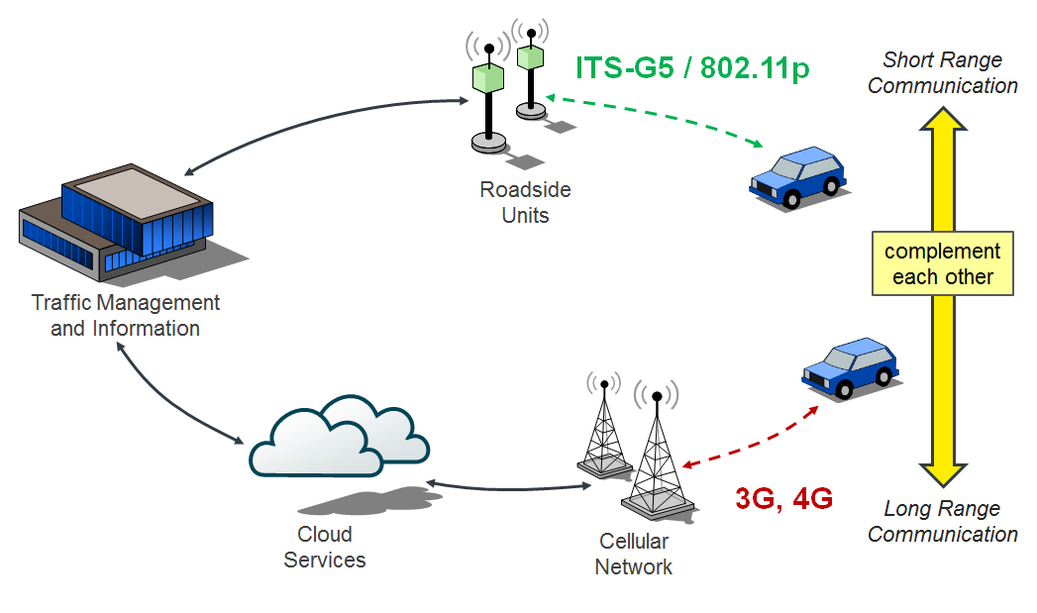

The European ITS Strategy as defined in the COM(2016) 766, a milestone towards cooperative, connected and automated mobility, is focused on the deployment of C-ITS services based on the existing ITS-G5 short-range communication for the tactical traffic safety related and efficiency related information exchange as proven in the many projects over the last 20 years. The C-ROADS Platform Member States are committed to follow the COM(2016) 766 European ITS strategy and the Declaration of Amsterdam[128]. The C-ROADS Member States are focused to deploy C-ITS applications based on the Hybrid Communication environment as agreed in the EU C-ITS platform Final Report phase 1 from 2016[129]. To accomplish this the C-ROADS Platform and the C2C-CC have agreed a Memorandum of Understanding (MoU[130]) to ensure the required European Interoperability.

Beside the commitment to start deploying ETSI ITS-G5 in 2019 by C2C-CC OEM’s, the motorcycle companies’ OEM’s expect to follow the vehicle, specifically for the realisation of ITS‑G5 in their products, have organized themselves in the Motorcycle Consortium[131] and expressed to follow the car OEM’s in the C2C-CC with the realisation of ETSI ITS-G5. OEM 4 (world wide) and OEM 3123 (in Europe) officially announce their commitments to implement this technology and Score@F members have equipped products sold into the market and expects that this will be followed by others. Six truck OEMs (OEM 5, OEM 6, OEM 7, OEM 8, OEM 9, and OEM 10) have expressed to realize platooning based on ETSI ITS-G5 communication equipment. The Truck manufacturers are expecting to use multiple ETSI ITS-G5 channels as they need a higher CAM rate of up to 30Hz and additional platooning management information exchange.

*[Editor´s note: The following description explains the situation in Australia.]*

[Responsibility for deployment and operation of ITS in use today already varies between countries, and even between cities/states. Some ITS are deployed and operated by government agencies, while others are deployed and operated by other entities, including public and private road/freeway operators, commercial service providers, franchisees, and others. As more advanced ITS are deployed, involving greater functionality, wider coverage, an expanding variety of connected data servers, and offering a growing range of other applications and information, the approach to deployment and operations will become more complex, involve greater capital commitments, and therefore likely to involve consideration of alternative deployment options.

While the low-latency needs of emerging Advanced ITS functionality associated with safety and collision-avoidance will very likely rely on localized radiocommunications links – V2V and V2I involving direct communications and/or relay via roadside units (RSUs) – the broader city-wide and nationwide V2X functionality will necessarily require a ubiquitous wide-area backhaul ‘fabric’ to reliably interconnect all of the data servers, control centres, and other information sources involved in the future of transportation. Some of these data servers and control centres will be owned/operated by government agencies (roads & traffic authorities), but others will be operated by private transport/roads operators, applications/information providers and other service-provider entities. Increasing innovation will likely see many of the connected systems owned and operated by commercial enterprises offering new pay-as-you-go and subscription-based services, including everything from navigation/guidance, valet/concierge, traffic and convenience information services, to augmented driving and even driverless vehicle services.

In that context, the ubiquitous wide-area backhaul may also potentially be provided by non‑government entities. In all likelihood, we will see a range of ownership/deployment and operation arrangements implemented within cities, across multiple cities, and even nationwide, in the future ITS environment – roadside units, ubiquitous broadband wireless network, data-servers, control centres, information centres, guidance/navigation, driverless services, and many more:

Figure X

Example of multiple service providers in the future ITS environment

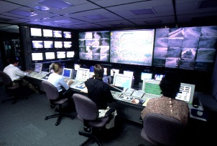

*Ubiquitous BB wireless network*

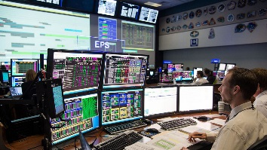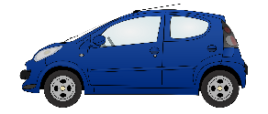

*5.8 GHz*

***RSU***

*5.8 GHz*

***Service Provider E***

***Service Provider A***

***Service Provider B***

***Service Provider D***

***Service Provider C***

***Service Provider F***

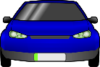

*5.8 GHz*

]

## 7.9 Region 1

*[Editor’s note: Text to be added]*

### 7.9.1 Frequency usage

In Europe, the band 5 855-5 925 MHz has been identified specifically to road safety and traffic efficiency based on the existing Mobile Service allocation in the band:

* The European Commission has harmonised the band 5 875-5 905 MHz for traffic safety‑and traffic efficiency related applications in the European Union via the legally binding Commission Decision 2008/671/EC (2008).
* The CEPT harmonisation is applied by the ECC via ECC Decision (08)01 from 2008, which additionally indicates that CEPT administrations shall consider the designation of the frequency sub-band 5 905-5 925 MHz for an extension of ITS spectrum.
* ECC also recommends, via ECC Recommendation (08)01[132] from 2008, that CEPT administrations should make the frequency band 5 855-5 875 MHz available for traffic non-safety applications.

The above regulatory measures from the ECC refer to the ETSI Harmonized Standard EN 302 571[133] and defines requirements for operation of ITS equipment in 5 855-5 925 MHz, covering the essential requirements of article 3.2 of the Radio Equipment Directive (2014/53/EU). According to ECC DEC (08)01 and ECC REC (08)01, equipment complying with EN 302 571 are exempt from individual licensing for operating in this band.

Table [X]

Frequency Usage for Advanced ITS Radiocommunication in Region 1

| Countries or Group | Frequency band | Technology/ System | Service | Deployment or plan year |
| --- | --- | --- | --- | --- |
| CEPT | 5 855-5 875 MHz | Vehicle to Vehicle and Vehicle to/from Infrastructure communications system | Non-safety information  (Communications) |  |
| CEPT | 5 875-5 905 MHz | Vehicle to Vehicle and Vehicle to/from Infrastructure communications system | Safety-related information (communications) | Deployment of infrastructure in some member states since 2016119, deployment of vehicles in 2019 |
| CEPT | 5 905-5 925 MHz | Vehicle to Vehicle and Vehicle to/from Infrastructure communications system | Future ITS usage, regulation in update process |  |

### 7.9.2 Standardization

*[Editor´s note: duplicated entries can be deleted and instead a reference can refer to chapter 7.6*

*]*

Table [X]

Standards, technical Specifications for Advanced ITS Radiocommunication in Europe

|  |  |  |
| --- | --- | --- |
| SDO | Standard No. | Standard Title |
| ETSI | [TS 102 637 series](http://webapp.etsi.org/WorkProgram/Frame_WorkItemList.asp?SearchPage=TRUE&butExpertSearch=++Search++&qETSI_STANDARD_TYPE=%27TS%27&qETSI_NUMBER=102+637&qTB_ID=&qINCLUDE_SUB_TB=True&includeNonActiveTB=FALSE&qWKI_REFERENCE=&qTITLE=&qSCOPE=&qCURRENT_STATE_CODE=&qSTOP_FLG=N&qSTART_CURRENT_STATUS_CODE=&qEND_CURRENT_STATUS_CODE=&qFROM_MIL_DAY=&qFROM_MIL_MONTH=&qFROM_MIL_YEAR=&qTO_MIL_DAY=&qTO_MIL_MONTH=&qTO_MIL_YEAR=&qOPERATOR_TS=&qRAPTR_NAME=&qRAPTR_ORGANISATION=&qKEYWORD_BOOLEAN=OR&qKEYWORD=&qPROJECT_BOOLEAN=OR&qPROJECT_CODE=&includeSubProjectCode=FALSE&qSTF_List=&qDIRECTIVE=&qMandate_List=&qSORT=HIGHVERSION&qREPORT_TYPE=SUMMARY&optDisplay=10&titleType=all) | Intelligent Transport Systems (ITS); Vehicular Communications; Basic Set of Applications |
| [EN 302 637-2](https://portal.etsi.org/webapp/WorkProgram/Report_WorkItem.asp?WKI_ID=37126&curItemNr=1&totalNrItems=1&optDisplay=10&qSORT=HIGHVERSION&qETSI_ALL=TRUE&SearchPage=TRUE&qETSI_NUMBER=302+637-2&qINCLUDE_SUB_TB=True&qINCLUDE_MOVED_ON=&qSTOP_FLG=&qKEYWORD_BOOLEAN) | ITS-Vehicular Communications; Basic Set of Applications; Part 2: Specification of Cooperative Awareness Basic Service. |
| [EN 302 637-3](https://portal.etsi.org/webapp/WorkProgram/Report_WorkItem.asp?WKI_ID=37127&curItemNr=1&totalNrItems=1&optDisplay=10&qSORT=HIGHVERSION&qETSI_ALL=TRUE&SearchPage=TRUE&qETSI_NUMBER=302+637-3&qINCLUDE_SUB_TB=True&qINCLUDE_MOVED_ON=&qSTOP_FLG=&qKEYWORD_BOOLEAN=&qCLUSTER_BOOLEAN=&qFREQUENCIES_BOOLEAN=&qSTOPPING_OUTDATED=&butSimple=Search&includeNonActiveTB=FALSE&includeSubProjectCode=&qREPORT_TYPE=SUMMARY) | ITS-Vehicular Communications; Basic Set of Applications; Part 3: Specifications of Decentralized Environmental Notification Basic Service. |
| [EN 302 665](http://webapp.etsi.org/WorkProgram/Frame_WorkItemList.asp?SearchPage=TRUE&butExpertSearch=++Search++&qETSI_STANDARD_TYPE=&qETSI_NUMBER=302+665&qTB_ID=&qINCLUDE_SUB_TB=True&includeNonActiveTB=FALSE&qWKI_REFERENCE=&qTITLE=&qSCOPE=&qCURRENT_STATE_CODE=&qSTOP_FLG=N&qSTART_CURRENT_STATUS_CODE=&qEND_CURRENT_STATUS_CODE=&qFROM_MIL_DAY=&qFROM_MIL_MONTH=&qFROM_MIL_YEAR=&qTO_MIL_DAY=&qTO_MIL_MONTH=&qTO_MIL_YEAR=&qOPERATOR_TS=&qRAPTR_NAME=&qRAPTR_ORGANISATION=&qKEYWORD_BOOLEAN=OR&qKEYWORD=&qPROJECT_BOOLEAN=OR&qPROJECT_CODE=&includeSubProjectCode=FALSE&qSTF_List=&qDIRECTIVE=&qMandate_List=&qSORT=HIGHVERSION&qREPORT_TYPE=SUMMARY&optDisplay=10&titleType=all) | Intelligent Transport Systems (ITS); Communications Architecture |
| [TS 102 636 series](http://webapp.etsi.org/WorkProgram/Frame_WorkItemList.asp?SearchPage=TRUE&butExpertSearch=++Search++&qETSI_STANDARD_TYPE=&qETSI_NUMBER=102+636&qTB_ID=&qINCLUDE_SUB_TB=True&includeNonActiveTB=FALSE&qWKI_REFERENCE=&qTITLE=&qSCOPE=&qCURRENT_STATE_CODE=&qSTOP_FLG=N&qSTART_CURRENT_STATUS_CODE=&qEND_CURRENT_STATUS_CODE=&qFROM_MIL_DAY=&qFROM_MIL_MONTH=&qFROM_MIL_YEAR=&qTO_MIL_DAY=&qTO_MIL_MONTH=&qTO_MIL_YEAR=&qOPERATOR_TS=&qRAPTR_NAME=&qRAPTR_ORGANISATION=&qKEYWORD_BOOLEAN=OR&qKEYWORD=&qPROJECT_BOOLEAN=OR&qPROJECT_CODE=&includeSubProjectCode=FALSE&qSTF_List=&qDIRECTIVE=&qMandate_List=&qSORT=HIGHVERSION&qREPORT_TYPE=SUMMARY&optDisplay=10&titleType=all) | Intelligent Transport Systems (ITS); Vehicular Communications; GeoNetworking; |
| [EN 302 636-4-1](https://portal.etsi.org/webapp/WorkProgram/Report_WorkItem.asp?WKI_ID=38232&curItemNr=1&totalNrItems=1&optDisplay=10&qSORT=HIGHVERSION&qETSI_ALL=TRUE&SearchPage=TRUE&qETSI_NUMBER=302+636-4-1&qINCLUDE_SUB_TB=True&qINCLUDE_MOVED_ON=&qSTOP_FLG=&qKEYWORD_BOOLEAN=&qCLUSTER_BOOLEAN=&qFREQUENCIES_BOOLEAN=&qSTOPPING_OUTDATED=&butSimple=Search&includeNonActiveTB=FALSE&includeSubProjectCode=&qREPORT_TYPE=SUMMARY) | Intelligent Transport Systems (ITS); Vehicular Communications; GeoNetworking; Part 4: Geographical Addressing and Forwarding for Point-to-Point and Point-to-Multipoint Communications; Sub-part 1: Media-Independent Functionality. |
|  |  |
| [TS 102 894-2](https://portal.etsi.org/webapp/WorkProgram/Report_WorkItem.asp?WKI_ID=43353&curItemNr=2&totalNrItems=3&optDisplay=10&qSORT=HIGHVERSION&qETSI_ALL=TRUE&SearchPage=TRUE&qETSI_NUMBER=102+894-2&qINCLUDE_SUB_TB=True&qINCLUDE_MOVED_ON=&qSTOP_FLG=&qKEYWORD_BOOLEAN=&qCLUSTER_BOOLEAN=&qFREQUENCIES_BOOLEAN=&qSTOPPING_OUTDATED=&butSimple=Search&includeNonActiveTB=FALSE&includeSubProjectCode=&qREPORT_TYPE=SUMMARY) | ITS-Users and applications requirements; Part 2: Applications and facilities layer common data dictionary. Dictionary of definitions used by other ETSI TC ITS standards. |
| [TS 102 890-3](https://portal.etsi.org/webapp/WorkProgram/Report_WorkItem.asp?WKI_ID=35130&curItemNr=1&totalNrItems=1&optDisplay=10&qSORT=HIGHVERSION&qETSI_ALL=TRUE&SearchPage=TRUE&qETSI_NUMBER=102+890-3&qINCLUDE_SUB_TB=True&qINCLUDE_MOVED_ON=&qSTOP_FLG=&qKEYWORD_BOOLEAN=&qCLUSTER_BOOLEAN=&qFREQUENCIES_BOOLEAN=&qSTOPPING_OUTDATED=&butSimple=Search&includeNonActiveTB=FALSE&includeSubProjectCode=&qREPORT_TYPE=SUMMARY) | ITS – Facilities layer function; facility position and time management. |
| [EN 302 895](https://portal.etsi.org/webapp/WorkProgram/Report_WorkItem.asp?WKI_ID=31914&curItemNr=1&totalNrItems=1&optDisplay=10&qSORT=HIGHVERSION&qETSI_ALL=TRUE&SearchPage=TRUE&qETSI_NUMBER=302+895&qINCLUDE_SUB_TB=True&qINCLUDE_MOVED_ON=&qSTOP_FLG=&qKEYWORD_BOOLEAN=&qCLUSTER_BOOLEAN=&qFREQUENCIES_BOOLEAN=&qSTOPPING_OUTDATED=&butSimple=Search&includeNonActiveTB=FALSE&includeSubProjectCode=&qREPORT_TYPE=SUMMARY) | Intelligent Transport Systems (ITS); Vehicular Communications; Basic Set of Applications; Local Dynamic Map (LDM) |
| [TS 101 556-1](https://portal.etsi.org/webapp/WorkProgram/Report_WorkItem.asp?WKI_ID=35131&curItemNr=1&totalNrItems=1&optDisplay=10&qSORT=HIGHVERSION&qETSI_ALL=TRUE&SearchPage=TRUE&qETSI_NUMBER=101+556-1&qINCLUDE_SUB_TB=True&qINCLUDE_MOVED_ON=&qSTOP_FLG=&qKEYWORD_BOOLEAN=&qCLUSTER_BOOLEAN=&qFREQUENCIES_BOOLEAN=&qSTOPPING_OUTDATED=&butSimple=Search&includeNonActiveTB=FALSE&includeSubProjectCode=&qREPORT_TYPE=SUMMARY) | Intelligent Transport Systems (ITS); I2V Applications; Electric Vehicle Charging Spot Notification Specification |
| [TS 101 556-2](https://portal.etsi.org/webapp/WorkProgram/Report_WorkItem.asp?WKI_ID=38839&curItemNr=1&totalNrItems=1&optDisplay=10&qSORT=HIGHVERSION&qETSI_ALL=TRUE&SearchPage=TRUE&qETSI_NUMBER=101+556-2&qINCLUDE_SUB_TB=True&qINCLUDE_MOVED_ON=&qSTOP_FLG=&qKEYWORD_BOOLEAN=&qCLUSTER_BOOLEAN=&qFREQUENCIES_BOOLEAN=&qSTOPPING_OUTDATED=&butSimple=Search&includeNonActiveTB=FALSE&includeSubProjectCode=&qREPORT_TYPE=SUMMARY) | Intelligent Transport Systems (ITS); Infrastructure to Vehicle Communication; Part 2: Communication system specification to support application requirements for Tyre Information System (TIS) and Tyre Pressure Gauge (TPG) interoperability |
| [TS 101 539-1](https://portal.etsi.org/webapp/WorkProgram/Report_WorkItem.asp?WKI_ID=35112&curItemNr=1&totalNrItems=1&optDisplay=10&qSORT=HIGHVERSION&qETSI_ALL=TRUE&SearchPage=TRUE&qETSI_NUMBER=101+539-1&qINCLUDE_SUB_TB=True&qINCLUDE_MOVED_ON=&qSTOP_FLG=&qKEYWORD_BOOLEAN=&qCLUSTER_BOOLEAN=&qFREQUENCIES_BOOLEAN=&qSTOPPING_OUTDATED=&butSimple=Search&includeNonActiveTB=FALSE&includeSubProjectCode=&qREPORT_TYPE=SUMMARY) | ITS – V2X Applications; Part 1: Road Hazard Signalling (RHS) application requirements |
| [TS 101 539-3](https://portal.etsi.org/webapp/WorkProgram/Report_WorkItem.asp?WKI_ID=35136&curItemNr=1&totalNrItems=1&optDisplay=10&qSORT=HIGHVERSION&qETSI_ALL=TRUE&SearchPage=TRUE&qETSI_NUMBER=101+539-3&qINCLUDE_SUB_TB=True&qINCLUDE_MOVED_ON=&qSTOP_FLG=&qKEYWORD_BOOLEAN=&qCLUSTER_BOOLEAN=&qFREQUENCIES_BOOLEAN=&qSTOPPING_OUTDATED=&butSimple=Search&includeNonActiveTB=FALSE&includeSubProjectCode=&qREPORT_TYPE=SUMMARY) | ITS – V2X Applications; Part 3: Longitudinal Collision Risk Warning (LCRW) application requirement specification. |
| [TS 102 792](https://portal.etsi.org/webapp/WorkProgram/Report_WorkItem.asp?WKI_ID=44131&curItemNr=1&totalNrItems=2&optDisplay=10&qSORT=HIGHVERSION&qETSI_ALL=TRUE&SearchPage=TRUE&qETSI_NUMBER=102+792&qINCLUDE_SUB_TB=True&qINCLUDE_MOVED_ON=&qSTOP_FLG=&qKEYWORD_BOOLEAN=&qCLUSTER_BOOLEAN=&qFREQUENCIES_BOOLEAN=&qSTOPPING_OUTDATED=&butSimple=Search&includeNonActiveTB=FALSE&includeSubProjectCode=&qREPORT_TYPE=SUMMARY) | Intelligent Transport Systems (ITS); Mitigation techniques to avoid interference between European CEN Dedicated Short Range Communication (CEN DSRC) tolling equipment and Intelligent Transport Systems (ITS) operating in the 5 GHz frequency range. |
| [EN 302 571](https://portal.etsi.org/webapp/WorkProgram/Report_WorkItem.asp?WKI_ID=43780&curItemNr=1&totalNrItems=3&optDisplay=10&qSORT=HIGHVERSION&qETSI_ALL=TRUE&SearchPage=TRUE&qETSI_NUMBER=302+571&qINCLUDE_SUB_TB=True&qINCLUDE_MOVED_ON=&qSTOP_FLG=&qKEYWORD_BOOLEAN=&qCLUSTER_BOOLEAN=&qFREQUENCIES_BOOLEAN=&qSTOPPING_OUTDATED=&butSimple=Search&includeNonActiveTB=FALSE&includeSubProjectCode=&qREPORT_TYPE=SUMMARY) | Intelligent Transport Systems (ITS); Radiocommunications equipment operating in the 5 855 5 925 MHz frequency band; Harmonised Standard covering the essential requirements of article 3.2 of Directive 2014/53/EU |
| [EN 302 686](https://portal.etsi.org/webapp/WorkProgram/Report_WorkItem.asp?WKI_ID=20587&curItemNr=1&totalNrItems=2&optDisplay=10&qSORT=HIGHVERSION&qETSI_ALL=TRUE&SearchPage=TRUE&qETSI_NUMBER=302+686&qINCLUDE_SUB_TB=True&qINCLUDE_MOVED_ON=&qSTOP_FLG=&qKEYWORD_BOOLEAN=&qCLUSTER_BOOLEAN=&qFREQUENCIES_BOOLEAN=&qSTOPPING_OUTDATED=&butSimple=Search&includeNonActiveTB=FALSE&includeSubProjectCode=&qREPORT_TYPE=SUMMARY) | Intelligent Transport Systems (ITS); Radiocommunications equipment operating in the 63 GHz to 64 GHz frequency band; Harmonised Standard covering the essential requirements of article 3.2 of the Directive 2014/53/EU  This standard is under revision and a final draft of the new release should be available until the end of the year 2016 |
| [EN 302 663](http://www.etsi.org/deliver/etsi_en/302600_302699/302663/01.02.01_60/en_302663v010201p.pdf) | Intelligent Transport Systems (ITS); European profile standard for the physical and medium access control layer of Intelligent Transport Systems operating in the 5 GHz frequency band |

## 7.10 Region 2

*[Editor’s note: Text to be added]*

### 7.10.1 Frequency usage

Table [X]

Frequency Usage for Advanced ITS Radiocommunication in Region 2

| Country | Frequency band | Technology/ System | Service | Deployment or plan year |
| --- | --- | --- | --- | --- |
| United States | 5,850-5,925 MHz | Vehicle to Vehicle and Vehicle to/from Infrastructure communications system | Safety-related, mobility and environmental information  (Communications) | Model deployment – 2012[134]; Early Operational Deployments - 2016[135],[136]; Pilot Deployments – 2017[137] |

Note: as noted above, there are a number of regulatory proceedings underway in the U.S., the results of which could alter the frequency usage for advanced ITS in the United States.

### 7.10.2 Standardization

*[Editor´s note: duplicated entries can be deleted and instead a reference can refer to chapter 7.6]*

Table [X]

Standards for Advanced ITS Radiocommunication in the United States

|  |  |  |
| --- | --- | --- |
| SDO | Standard No. | Standard Title |
| ASTM | E2213-03 | Standard Specification for Telecommunications and Information Exchange Between Roadside and Vehicle Systems – 5 GHz Band Dedicated Short Range Communications (DSRC) Medium Access Control (MAC) and Physical Layer (PHY) Specifications |
| IEEE | IEEE 802.11-2016 | Wireless LAN Medium Access Control (MAC) and Physical Layer (PHY) Specifications |
| IEEE 1609.0-2013 | IEEE Guide for WAVE – Architecture |
| IEEE 1609.2 -2016 | IEEE Standard for WAVE – Security Services for Applications and Management Messages |
| IEEE 1609.3 -2016 | IEEE Standard for WAVE – Networking Services |
| IEEE 1609.4 -2016 | IEEE Standard for WAVE – Multi-Channel Operations |
| IEEE 1609.11-2010 | IEEE Standard for WAVE – Over-the-Air Electronic Payment Data Exchange Protocol for ITS |
| IEEE 1609.12-2016 | IEEE Standard for WAVE – Identifier Allocations |
| SAE | SAE J2735 March, 2016 | Dedicated Short Range Communications (DSRC) Message Set Dictionary |
| SAE J2945/1 March, 2016 | On-board System Requirements for V2V Safety Communications |

## 7.11 Region 3

### 7.11.1 Technical Characteristics

#### Technical characteristics in Korea

V2X communication technology has been developed for vehicle safety and Cooperative ITS applications.

In the Republic of Korea, the frequency band is 5 855-5 925 MHz for C-ITS (V2V and V2I communications) and can use 7 radio frequency channel with 10MHz channel bandwidth. In channel operation, control channel uses 5 895-5 905 MHz radio cannel and the other 6 radio channel can be used for service channel. Also, the each RF channel has 20dBm in radio transmit power level.

TABLE X

Radio channel assignment for ITS in Korea

|  |  |  |
| --- | --- | --- |
| Channel Number | Frequency Band(MHz) | Channel Usage |
| 1 | 5 855 - 5 865 | Service Channel |
| 2 | 5 865 - 5 875 | Service Channel |
| 3 | 5 875 - 5 885 | Service Channel |
| 4 | 5 885 - 5 895 | Service Channel |
| 5 | 5 895 - 5 905 | Control Channel |
| 6 | 5 905 - 5 915 | Service Channel |
| 7 | 5 915 - 5 925 | Service Channel |

Technical characteristics in Singapore

The frequency band 5 855-5 925 MHz for ITS applications is split into channels with a bandwidth of 10 MHz per channel. The ITS service channelling arrangements and the RF transmit power could be found below.

TABLE X

Singapore its service channel allocation

|  |  |  |
| --- | --- | --- |
|  | Channel type | Frequency range  [MHz] |
| Non-Safety related | Service Channel | 5 855 to 5 865 |
| Service Channel | 5 865 to 5 875 |
| Traffic/Safety related | Service Channel | 5 875 to 5 885 |
| Control Channel | 5 885 to 5 895 |
| Service Channel | 5 895 to 5 905 |
| Service Channel | 5 905 to 5 915 |
| Service Channel | 5 915 to 5 925 |

Typical RF power limit of up to 33 dBm EIRP for traffic/safety related channels and 20 dBm EIRP for non-safety related channels.

#### Technical characteristics in Japan

The frequency band 5 770-5 850 MHz for ITS applications (Refer to ITU-R M.1453-2, 2005) is split into channels with a carrier frequency spacing of 5 MHz.

The maximum transmission power for roadside equipment (RSE) should be less than 44.7 dBm e.i.r.p. The maximum transmission power for on-board equipment (OBE) should be less than 20 dBm e.i.r.p.

Table X shows channel arrangement of ITS applications using DSRC at 5.8 GHz band in Japan.

Table X

Channel arrangement for its applications at 5 770-5 850 MHz band in Japan

|  |  |
| --- | --- |
|  | Carrier Frequency  [MHz] |
| Road Side Equipment Channel | 5 775 |
| 5 780 |
| 5 785 |
| 5 790 |
| 5 795 |
| 5 800 |
| 5 805 |
| On-Board Equipment Channel | 5 815 |
| 5 820 |
| 5 825 |
| 5 830 |
| 5 835 |
| 5 840 |
| 5 845 |

### 7.11.2 Frequency usage

Table [X]

Frequency usage on Advanced ITS Radiocommunication in Asia-Pacific

| Country | frequency band | Technology | Application | Status |
| --- | --- | --- | --- | --- |
| Japan | 5 770 - 5 850 MHz | V2V/V2I communication | Safety related information | Guidelines for field experiment in 2007 (revised 2013) |
| 755.5 - 764.5 MHz band | Enacted in 2011 (revised 2013) |
| Korea | 5 855 - 5 925 MHz | V2V/V2I communication | Vehicle Safety Related  C-ITS | Enacted in 2016 |
| China | 5 905 - 5 925 MHz | LTE based V2X | V2X communication | Field  Experiment in 2017 |
| Singapore | 5 855 - 5 925 MHz | V2V/V2I | Traffic/Safety Related Information | Enacted in 2017 |

### 7.11.3 Standardization

*[Editor´s note: Duplicated entries can be deleted and instead a reference can refer to Chapter 7.6]*

Table [X]

Standards, Technical Specifications, Guidelines on Advanced ITS Radiocommunication in Asia-Pacific

|  |  |  |
| --- | --- | --- |
| SDO | Standard No. | Standard Title |
| TTA | TTAS.KO-06.0175/R1 | Vehicle Communication System Stage1: Requirements |
| TTAS.KO-06.0193/R1 | Vehicle Communication SystemStage2: Architecture |
| TTAS.KO-06.0216/R1 | Vehicle Communication System Stage3 : PHY/MAC |
| TTAS.KO-06.0234/R1 | Vehicle Communication System State 3 : Networking |
| TTAK.KO-06.0242/R1 | Vehicle Communication System Stage3 : Application Protocol Interface |
| TTAK KO-06.0344 | In-Vehicle Signage System for Vehicle Safety Guidance Stage 1: Requirements |
| TTAK KO-06.0344-Part2 | In-Vehicle Signage System for Vehicle Safety Guidance Stage 2: Data Exchange |
| ITS Info-communications Forum | ITS FORUM GUIDELINES | - ITS FORUM RC-008 Operation Management Guideline for Driver Assistance Communications System  - ITS FORUM RC-009 Security Guideline for Driver Assistance Communications System  - ITS FORUM RC-010 700MHz BAND INTELLIGENT TRANSPORT SYSTEMS ‐ Extended Functions Guideline  - ITS FORUM RC-013 700MHz BAND INTELLIGENT TRANSPORT SYSTEMS‐ Experimental Guideline for Inter‐vehicle Communication Messages |
| ITS Connect Promotion Consortium | ITS Connect TD-001 | ITS Connect TD-001 Inter-vehicle Communication Message Specifications |
| ARIB | STD T109 | 700 MHz Band Intelligent Transport System |
| CCSA | 2015-1616T-YD | General technical requirements of LTE-based vehicular communication |
| 2016-1853T-YD | Technical requirements of air interface of LTE-based vehicular communication |
| IMDA TSAC | IMDA TS DSRC | Technical Specification for Dedicated Short-Range Communications in Intelligent Transport Systems |

# 8 Millimetre-wave automotive radar

## 8.1 Overview

The millimetre-wave band of the electromagnetic spectrum corresponds to radio band frequencies of 30 GHz to 275 GHz (wavelength from 10 mm to 1 mm). Millimetre waves’ high frequency realizes small equipment size including the compact high gain antenna which makes this technology well suited for vehicular use. Particularly in radar system, the millimetre wave can easily create a narrow beam that is desirable to discriminate small distant objects.

Sensor technologies for monitoring and identifying objects in the proximity of vehicles are the most important safety-related base technologies for developing systems that will accommodate this purpose. Various types of sensors have been studied and developed, and through this research and development, it has become clear that a Radio Detection and Ranging (RADAR) using radio waves is suitable for this objective.

International efforts has been taken to make harmonized frequency ranges available for automotive radar applications.

WRC-15, allocated the frequency range 77.5-78 GHz to Radio Location Service (RLS) on a co- primary service under agenda item 1.18 (RR 5.559B).

The frequency band 76‑81 GHz band is for short-range high-resolution automotive radar applications. This radar can be used for variety of applications, such as reduce number of fatalities and traffic accidents.

Automotive radar sensors operating in In the frequency band 76-81 GHz, provide additional functions that contribute to enhanced road safety for vehicle passengers and other vulnerable road users .. Evolving demands related to automotive safety applications, including the reduction of traffic fatalities and accidents require a range resolution for automotive radar systems leading to a necessary bandwidth of up to 4 to 5 GHz. These high resolution automotive radars will be key sensors for autonomous driving vehicles.

In Europe, Ultra Wide Band (UWB) Short Range Radar (SRR) operating at 24 GHz (22-29 GHz) was considered to be a key technology for the rapid and cost-effective introduction of many intelligent vehicle safety related systems. In January 2005, the European Commission decided on the temporaray time‑limited (until 1 July 2013) use of the 24 GHz range radio spectrum band for the ultra-wide band part of short-range vehicle radar equipment as outlined in ECC /DEC (04)10 The decision was revised and the final deadline was set to 2018.

In parallel it was decided that in future SRR equipment is intended to operate in the frequency band 79 GHz (77-81 GHz) on a permanent base, see ECC/DEC/(04)03. When the temporary allocation for 24 GHz automotive radar was implemented, based on the conducted studies it was concluded that incumbent users operating in the 24 GHz band would increasingly suffer from significant levels of harmful interference if a certain level of penetration of vehicles using the 24 GHz range radio spectrum band for UWB short-range radars was to be exceeded.

According to CEPT (European Conference of Postal and Telecommunications Administrations), the sharing between earth exploration satellite services and UWB short-range vehicle radar could only be feasible on a temporary basis, based on the at that time foreseen low penetration rate for 24 GHz automotive radars.

In contrast to the above, 24.05-24.25 GHz ISM band automotive radars can be used worldwide without any time limitation.

China identified 77-81 GHz for experiment frequency band of millimetre-wave vehicular radar in December 2016. Laboratory test and road-test were launched in four major cities of China to verify technical characteristics, including electromagnetic compatibility and radio frequency matters, interference, and radar performance in typical scenarios, etc.

It is expected that in the near future further administrations will decide to implement the WRC-15 decision of automotive radars.

## 8.2 Technical characteristics

(1) Low Power Automotive Radar at 24 GHz

Today the frequency allocation for automotive radar application is in a rebuilding phase. Due to technological and commercial constraints, the frequency allocation for these safety related applications has been done in the beginning of the last decade in the range of 24 GHz. In Europe, e.g. an allocation for the 24 GHz UWB band (21.65–26.65 GHz) has been done as an intermediate solution due to the incompatibility with the Radio Astronomy Service, EESS, the Fixed Service and military applications. Therefore, the cut-off date of 1st July 2013 has been defined. In July 2011, the ECC extended the cut-off date ( for sensors with reduced frequency range of 24,25‑26,65 GHz) until 1st January 2018 by ECC decision 04(10) to allow the car manufacturers a seamless implementation of 79 GHz technology. The technological evolution during the last years led to the fact that with a similar effort a higher performance can be reached today.

It is to be noted, that the 24 GHz ISM band (24.05-24.25 GHz) plays an import role, especially for affordable vehicles. As this band is an ISM band and globally harmonized, 24.05-24.25 GHz ISM band automotive radars can be used worldwide without any time limitation.

(2) High Resolution Short Range Automotive Radar operating at 79 GHz (77-81 GHz)

The 77-81 GHz band has already been implemented for this kind of automotive radar applications in many countries. It is expected that further countries will implement the WRC-2015 decision on 79 GHz automotive radars in the near future.

The 77-81 GHz band has been designated by CEPT in July 2004 (ECC/DEC/(04)03) for automotive radar applications. Also, the European Commission has adopted the decision 2004/545/EC on the harmonization of radio spectrum in the 79 GHz (77-81 GHz) range for the use of automotive radar. The harmonized standard EN 302 264 has been adopted by ETSI for short-range radar (SRR) operating in the 77-81 GHz band.

In March 2010, the Ministry of Internal Affairs and Communications (MIC) in Japan has started a study group in the Information and Communications Council for the introduction of high-resolution radar in the 77-81 GHz frequency band for national use. As a result of this activity the 78-81 GHz band was allocated to automotive radar in [2013]

In October 2010, the Russian Federation identified the 77-81 GHz band for automotive radar.

(3) Ultra Wide Band (UWB) Radar

Generally UWB is defined as the radio signal whose fractional bandwidth is greater than 20% of the centre frequency or the 10 dB bandwidth occupies 500 MHz or more of spectrum.

UWB technology originally employed very narrow or short duration pulses that result in very large or wideband transmission bandwidths (refer to Figure [X], “UWB monocycle time and frequency domains”). For automotive radar, the pulsed-UWB technique is replaced step-by-step by very wideband frequency chirps (Frequency-modulated continuous-wave = FMCW or pulse compression radar) without the need for short duration pulses. With appropriate technical standards, UWB devices can operate using spectrum occupied by existing radio services without causing interference, thereby permitting scarce spectrum resources to be used more efficiently.

Figure [X]

UWB monocycle time and frequency domains   
(UWB, "A possible area for standards", GSC 8 Presentation by FCC.)

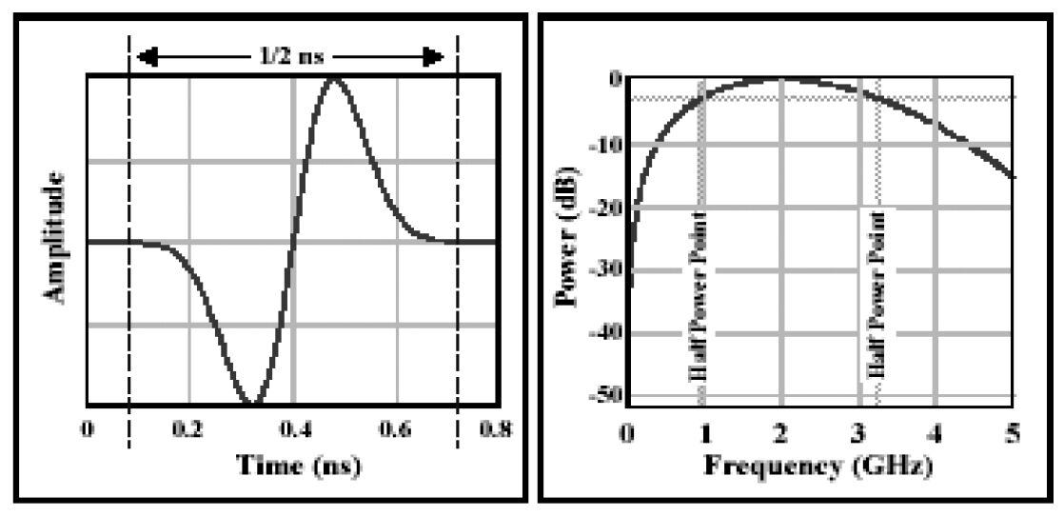

(4) Vehicle mounted radar

Regarding functional and safety requirements, the automotive radar systems operating in the 76‑81 GHz band can be separated in two categories:

– **Category 1**: Adaptive Cruise Control (ACC) and Collision Avoidance (CA) radar, for measurement ranges up to 300 metres. For these applications, a maximum continuous bandwidth of 1 GHz is required. Such radars are considered to add additional comfort functions for the driver, giving support for more stress-free driving.

– **Category 2**: Sensors for high resolution applications such as Blind Spot Detection (BSD), Lane-Change Assist (LCA) and Rear-Traffic-Crossing-Alert (RTCA), detection of pedestrians and bicycles in close proximity to a vehicle, for measurement ranges up to 100 metres. For these high resolution applications, a necessary bandwidth of 4 GHz is required. Such radars directly add to the passive and active safety of a vehicle and are therefore an essential benefit towards improved traffic safety.

Depending on the number of radar sensors and their mounting position on the vehicle it is possible to detect objects in sectors or even the complete surrounding of a car. The sensor signals are the basis not only for driver assistance systems like ACC but also for a broad variety of automotive applications of active and passive safety.

Systems for monitoring the proximity to vehicles will play an important role in ensuring driving safety. High resolution automotive radars will be a key sensor technology for autonomous driving vehicles. With its resistance to bad weather and dirt, automotive radar is suitable for vehicles driven in severe conditions.

Figure [X] shows the configuration of automotive radar.

Figure [X]

Configuration of automotive radar



Subsystems are as follows:

*– Antenna/RF unit*

This part consists of a transmitting antenna, a receiving antenna, receiving equipment and transmission equipment. Signal modulations, conversions to high frequencies, radio‑wave transmission, and radio‑wave reception are handled in this part. This part could be equipped with several antennas and could perform beam scanning.

*– Signal processing unit*

This unit renders distance and speed by calculating signals handed over from the RF unit. Rendering of average distance and speed, and mitigation of interference are sometimes handled here. When the antenna performs beam scanning, this unit calculates the direction of detected objects.

*– Recognition unit*

This unit can select and arrange the most wanted or necessary data depending on the needs of each system. For example, the unit will recognize the most relevant objects, and can judge whether the vehicle in front is in lane. The unit occasionally averages figures gathered, filters interference, and enhances measuring accuracy and reliability of data by tracking objects and by data fusion with data from other sensors.

(5) Radar for road incident detection system[138]

Incident detection service deployed in Korea enables drivers in vehicles to receive real-time information for unexpected road situation (obstacle, stopped and wrong way vehicle, frozen-road etc.) through real-time and automatic detection system using radar sensors to prevent unexpected accidents. It also provides traffic information within 1 km from radar sensor. It supports driver in heavy rains and foggy weather to receive real–time information by incident detection system.

FIGURE X

Incident detection service

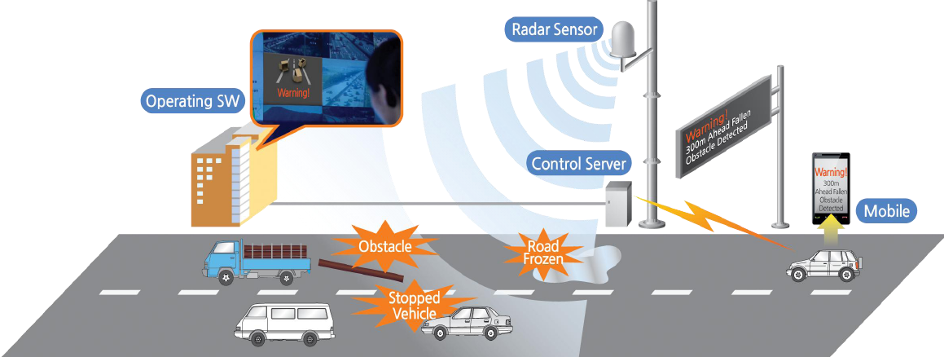

Characteristics of 34 GHz incident detection radar are given in Table [X].

*[Editor´s note: This frequency usage should be included in the frequency usage table]*

TABLE [X]

Road radar system

| Characteristic (Parameter) | Value |
| --- | --- |
| **Operational characteristics** | |
| Application/Service | Road Incident Detection System |
| Typical installation | Road Side Pole(or gantry) |
| **Technical characteristics** | |
| Max. range | 1 000 m |
| Frequency range | 34.275-34.875 GHz |
| Specified bandwidth (typical) | Up to 600 MHz |
| Peak Power (e.i.r.p) | Up to +55 dBm |
| Mean Power (e.i.r.p) | Up to +45 dBm |

(6) Radar for Cooperative driving support

In Japan, a cooperative driving support system is developed and deployed for intersection safety. The system consists of the millimetre-wave radar as a roadside sensor to detect pedestrians, cyclists, and vehicles entering an intersection. The roadside sensor typically mounted at approximately the same height as traffic signals that have a wide field of view. The system also alerts motorists to potential hazards by using the ITS radio communication.

FIGURE X

Cooperative driving support

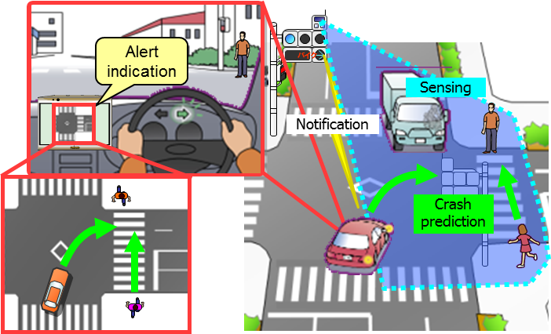

## 8.3 Frequency usage

(1) Automotive Radar at 77 GHz band

Several millimetre-wave bands are considered for vehicular radar. The 76-77 GHz band has already been designated by the Federal Communications Commission (FCC) in the United States of America and by the Ministry of Internal Affairs and Communications (MIC) in Japan for these purposes.

Up to October 2017 in the United States, vehicular radars operating in the 76-77 GHz band are regulated according to FCC 47 part 15.253 and as part 15 device; may not cause harmful interference and must accept interference that may be caused by the operation of an authorized radio system, by another intentional or unintentional radiator, by industrial, scientific and medical (ISM) equipment, or by an incidental radiator. In October 2017 FCC implemented a new rule for automotive radars under part 95M.

In European spectrum requirements for Road Transport and Traffic Telematics (RTTT), ETSI has adopted European standards for automotive radar operating in the 76-77 GHz band (ETSI EN 301 091) in Europe, this band is covered under the short range device decision: as latest version 2017/1483/EU.

In Japan, the 76-77 GHz band is designated for this kind of application (ARIB STD-T48).

(2) High Resolution Automotive Radar at 79 GHz band

The industries are trying to seek globally or regionally harmonized frequency allocations for new automotive radar technologies. The following frequency bands are allocated to radio location service on a primary basis which are designated for use by automotive radar applications: The rationale for separating these applications into two different frequency bands is given in ECC Report 56, which reveals, that sharing studies have concluded that sharing is not achievable between Category 1 and Category 2 if operated in a common frequency band.

– 76 GHz to 77 GHz Long Range Radar (LRR) > 150 meter

– 77 GHz to 81 GHz Short Range Radar (SRR) < 150 meter (high resolution).

The rationale for separating these applications into two different frequency bands is given in ECC Report 56, which reveals, that sharing studies have concluded that sharing is not achievable between LRR and SRR if operated in a common frequency band.

*[Editor´s note: following table should summarize the frequency usage equal in all 3 regions]*

Table [X]

Global frequency usage for millimetre-wave automotive radar

|  | 76 to 77 GHz | | | 77 to 81 GHz | | |
| --- | --- | --- | --- | --- | --- | --- |
|  | Recommendation | Standard | Report/Notes | Recommendation | Standard | Report/Notes |
| ITU-R | M.1452-2 |  | SM.2067 | M.1452-2 |  |  |
| M.2057 |  |  | M.2057 |  |  |

In Japan, the 77-81 GHz band is also designated for safety related applications (ARIB STD-T111).

## 8.4 Standardization

Table [X]

Global standard for millimetre-wave automotive radar

|  |  |  |  |
| --- | --- | --- | --- |
| SDO | Standard No. | | Standard title |
| ITU | Recommendation | ITU-R M.1452 | Millimetre wave radiocommunication systems for intelligent transport system applications |
| ITU-R M.2057 | Systems characteristics of automotive radars operating in the frequency band 76-81 GHz for intelligent transport systems applications |
| Report | ITU-R M.2322 | Systems Characteristics and Compatibility of Automotive Radars Operating in the 77.5-78 GHz Band for Sharing Studies |
| ITU-R F.2394 | Compatibility between point-to-point applications in the fixed service operating in the 71-76 GHz and 81-86 GHz bands and automotive radar applications in the radiolocation service operating in the 76-81 GHz bands |

## 8.5 Applications

Today’s automotive radar systems, operating in the millimetre wave, are of two categories according to the measurement ranges and bandwidth:

– Category 1: Adaptive Cruise Control (ACC) and collision avoidance radar (CA), operating in the band 76-77 GHz, for measurement ranges up to 300 m.

– Category 2 “Short-range” radar for applications such as Blind Spot Detection (BSD), Lane-Change Assist (LCA), and Rear-Traffic-Crossing-Alert (RTCA), operating in the band 77‑81 GHz for measurement ranges up to 100 m.

FIGURE [X]

Automotive radar applications

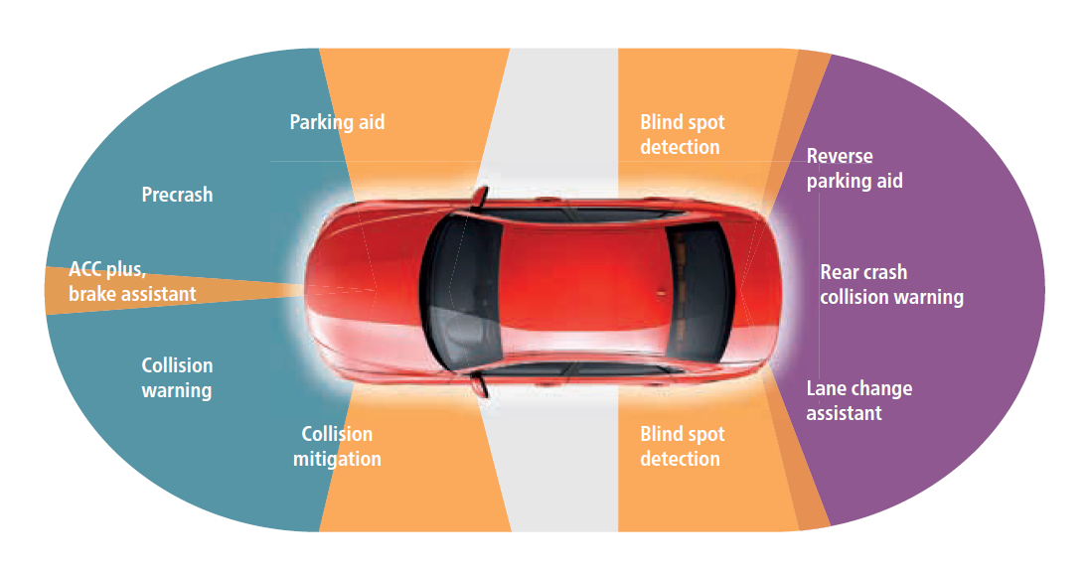

## 8.6 Region 1

76-81 GHz range for various automotive radar applications. In Europe, the 76-77 GHz frequency band was designated for vehicular and infrastructure radar systems in ERC Recommendation 70-03. This frequency band is used by long range radars for ground based vehicle and infrastructure systems.

In order to support industry developments of the general and specific SRR technology within the 79 GHz range, the frequency band 77-81 GHz was designated for SRR automotive applications in ECC Decision (04)03.

European Commission also designated these bands for automotive radar applications in 2004 and 2005 by means of following EC Decisions:

2004/545/EC: Harmonisation of radio spectrum in the 79 GHz range (77-81 GHz) for the use of automotive short-range radar equipment in the Community as the permanent frequency range for the Europe wide implementation of SRR.

2017/1483/EU: Amending Decision 2006/771/EC on harmonisation of the radio spectrum for use by short-range devices which covers the 76-77 GHz range.

### 8.6.1 Frequency usage

Table [X]

Frequency usage for millimetre-wave automotive radar in Europe

|  | 24,05 to 24,25 GHz ISM | | 76 to 77 GHz | | | 77 to 81 GHz | | |
| --- | --- | --- | --- | --- | --- | --- | --- | --- |
|  | Regulation | Standard | Regulation | Standard | Report/Notes | Regulation | Standard | Report/ Notes |
| Europe  - CEP, EU | ERC/REC 70-03  Annex 5  COMMISSION IMPLEMENTING DECISION 2013/752/EU | ETSI EN 302 858 (2013-07) | -ERC/REC 70-03   Annex 5  -ECC/DEC/(02)01  COMMISSION IMPLEMENTING DECISION  2017/1483/EU | ETSI EN 301 091-1 (2006-11) | CEPT Reports 35, 36, and 37 | - 2004/545/EC  -ERC/REC 70-03  Annexes 5 & 13  ECC/DEC/(04)03 | ETSI EN 302 264-1 (2009-04) | - ECC/REP 056  - Partly: CEPT Report 003  - CEPT Reports 46 &37 |
| - Russia | SFMC Decision No. 07-20-03-001 Annex 7 |  | SFMC Decision No. 07-20-03-001 Annex 7 |  | Appendix 1  Resolution of State Radio Frequency Committee No. 10-09-03 of 29 October 2010 | SFMC Decision No. 07-20-03-001 Annex 7 |  | Appendix 1  Resolution of State Radio Frequency Committee No. 10-09-03 of 29 October 2010 |
| Gulf States (e.g. Saudi Arabia,  Oman) |  | CITC Technical Specification  Document Number: RI054  (Rev 2) | CITC | CITC Technical Specification  Document Number: RI049  (Rev 2) |  | 77-82 GHz -SRR Decision of TRA No 133/2008 of 28-Oct-08 |  |  |

### 

### 8.6.2 Standardization

Table [X]

Standards for millimetre-wave automotive radar in Europe

|  |  |  |
| --- | --- | --- |
| SDO | Standard No. | Standard Title |
| ETSI | TR 101 983 | Radio equipment to be used in the 76 GHz to 77 GHz band; System Reference Document for Short-Range Radar to be fitted on road infrastructure |
| EN 301 091 parts 1-2 | Short Range Devices; Road Transport and Traffic Telematics (RTTT); Radar equipment operating in the 76 GHz to 77 GHz range; |
| EN 302 258 parts 1-2 | Short Range Devices; Road Transport and Traffic Telematics (RTTT);  Radar equipment operating in the 24,05 GHz to 24,25 GHz or 24,05 GHz to 24,50 GHz range ; |
| EN 302 288 parts 1-2 | Short Range Devices; Road Transport and Traffic Telematics (RTTT); Short range radar equipment operating in the 24 GHz range; |
| EN 302 264 parts 1-2 | Short Range Devices, Road Transport and Traffic Telematics (RTTT); Short Range Radar equipment operating in the 77 GHz to 81 GHz band |

## 8.7 Region 2

*Region 2 covers the Americas, including Greenland, and some of the eastern Pacific Islands.*

The frequency ranges:

– 24 GHz ISM (24.05-24.25 GHz),

– 24 GHz UWB (22-29 GHz) and

– 76-77 GHz

are implemented in most of the Region 2 countries already for various automotive radar applications.

The relevant standards are

– US: FCC part 15 PART 15—RADIO FREQUENCY DEVICES

– Canada: Industry Canada Spectrum Management and Telecommunications Radio Standards Specification (RSS 210, RSS310, RSS251)

– Brazil: ANATEL Resolution 506 (currently under revision)

• American National Standard of Procedures for Compliance Testing of Unlicensed Wireless Devices, ANSI C63.10-2013

In USA, since October 2017 automotive radars operating in the frequency band 76-81 GHz are covered under Part 95 M that reflects the co-primary status.

In addition there is a 24 GHz UWB regulation in several Region 2 countries (including USA, Canada).

### 8.7.1 Frequency usage

Table [X]

Frequency usage for millimetre-wave vehicular radar in North and South America

|  |  |  |  |  |  |  |  |  |
| --- | --- | --- | --- | --- | --- | --- | --- | --- |
|  | 24,05 to 24,25 GHz | | 76 to 77 GHz | | | 77 to 81 GHz | | |
|  | Regulation | Standard | Regulation | Standard | Report/ Notes | Regulation | Standard | Report /Notes |
| U.S.A. | FCC Part 15/15.249 |  | FCC Part 15/15.253 |  |  | Planned (NPRM FCC15-16) |  |  |
| Canada |  | RSS-310 | Spectrum Utilization Policies SP-47 GHz | [RSS 251](https://www.ic.gc.ca/eic/site/smt-gst.nsf/vwapj/RSS-251-issue1.pdf/$FILE/RSS-251-issue1.pdf) |  |  |  |  |
| Mexico | [Cofetel usually accepts FCC regulation] |  | [Cofetel usually accepts FCC regulation] |  |  |  |  |  |
| Brazil | ANATEL resolution No.506 |  | ANATELresolution No.506 |  |  |  |  |  |

### 8.7.2 Standardization

Table [X]

Standards on millimetre-wave vehicular radar in North and South America

|  |  |  |
| --- | --- | --- |
| SDO | Standard No. | Standard Title |
|  | ANSI C63.10-2013 |  |
|  | FCC part 15.249 | FCC part 15 PART 15—RADIO FREQUENCY DEVICES  Operation within the bands 902–928, MHz, 2 400–2 483.5 MHz, 5 725‑5 875 MHz, and 24.0–24.25 GHz. |
|  | FCC part 15.252 | FCC part 15 PART 15—RADIO FREQUENCY DEVICES  15.252 Operation of wideband vehicular radar systems within the bands 16.2–17.7 GHz and 23.12–29.0 GHz. |
|  | FCC part 95M | FCC part 15 PART 15—RADIO FREQUENCY DEVICES  15.253 Operation within the bands 46.7–46.9 GHz and 76.0–77.0 GHz. |
|  | FCC part 15.515 | FCC part 15 PART 15—RADIO FREQUENCY DEVICES  15.515 Technical requirements for vehicular radar systems. |

## 8.8 Region 3

In some APT countries, frequency bands of 24, 60, 76 and 79 GHz have been used. For global harmonization of ITS, APT countries like Australia are considering European activities which use 79 GHz as a permanent band. Also, Hong Kong, China opened the 79 GHz band for automotive radar systems utilizing ultra-wideband technology in January 2017.

Based on the result of WRC-15, Japan has allocated 77-81 GHz band for short-range high-resolution radar in January 2017.

### 8.8.1 Frequency usage

Table [X]

Frequency usage on millimetre-wave automotive radar in Asia-Pacific

|  | 24.05 to 24.25 GHz ISM | | 76 to 77 GHz | | | 77 to 81 GHz | | |
| --- | --- | --- | --- | --- | --- | --- | --- | --- |
|  | Regulation | Standard | Regulation | Standard | Report/Notes | Regulation | Standard | Report/Notes |
| Korea, Republic of |  | Article 103 | Rules on Radio Equipment (Article **29** Paragraph 9) (2013-01-03)” | Technical Standards for Radio Equipment  (RRL Notification 2006-84 (2006.8.23)) |  |  |  |  |
| China | Technical Specification for Micropower (Short Distance) Radio Equipments of Category G |  | Technical Specification for Micropower (Short Distance) Radio Equipments, part XIV |  |  |  |  |  |
| Japan | ARIB STD-T73 1.1 |  | Ordinance Regulating Radio Equipment Notification of MIC (643-1997) |  |  | Ordinance Regulating Radio Equipment, Notification of MIC (4432012) |  |  |
| Singapore |  |  | IMDA Technical Specification Short Range Devices | IMDA TS SRD |  | IMDA Technical Specification Ultra-Wideband (UWB) Devices | IMDA TS UWB |  |
| Thailand | [Technical Standard of telecommunication device and equipment  Radar based Telecommunication device in vehicle (Vehicle Radar)  Section 2.1.1] | Vehicle Radar Standard NBTC 1011-2557  Section 2.1.1 | [NTC TS 1011-2549] | Vehicle Radar Standard NBTC 1011-2557  Section 2.1.3 |  |  |  |  |

### 8.8.2 Standardization

TABLE [X]

Standards on millimetre-wave automotive radar in Asia-Pacific

|  |  |  |
| --- | --- | --- |
| SDO | Standard No. | Standard Title |
| ARIB | STD-T48 | Millimeter-Wave Radar Equipment for Specified Low Power Radio Station |
| STD-T111 | 79 GHz Band High-Resolution Radar |
| IMDA  TSAC | IMDA TS SRD |  |
| IMDA TS UWB |  |

*[Editor´s note: Shift this table to chapter 8.8.1 Frequency usage]*

Table [X]

Usage status of automotive radar in Asia-Pacific

| Country | Frequency band | Technology/ Standard | Application | deployment or plan year |
| --- | --- | --- | --- | --- |
| Australia | 22-26.5 GHz | Radiocommunications (Low Interference Potential Devices) Class Licence 2015 | Section 66  Ultra-wideband short-range vehicle radar systems transmitters | - |
| 24.0-24.25 GHz | Section 66  Radiodetermination transmitters |  |
| 76-77 GHz | Long-range vehicle radar (intelligent cruise control)  Section 69  Radiodetermination transmitters |  |
| 77 – 81 GHz | Section 70  Radiodetermination transmitters |  |
| China | 24.00-24.25 GHz | Notice on Promulgation of the Technical Specification for Micropower (Short Distance) Radio Equipments | Vehicular range radar | Enacted in 2005 |
| 76-77 GHz |
| 24.25-26.65 GHz | Ministry of Industry and IT, Notice regarding 24GHz frequency band short range automotive radar | Vehicular range radar | Enacted in 2012 |
| 77-81 GHz | Radar | Vehicular range radar | Field  Experiment in 2017 |
| 76-77 GHz[139] | HKCA1075  Exemption from Licensing Order | Vehicular radar systems | 2005 |
| 77-81 GHz139 | 2017 |
| Japan |  | Quasi-millimetre wave system | Environmental recognition (Obstacle detection) |  |
| 24.0-24.25 GHz | Enacted in 2010 |
| 24.25-29 GHz |
| 60-61 GHz | Millimeter wave system | Enacted in 1995 |
| 76-77 GHz | Enacted in 1997  (Occupied band width: 500 MHz)  Revised in 2015  (Occupied band width: 1 GHz) |
| 77-81 GHz | Enacted in 2012 for 78-81 GHz.  Revised in 2017 for inclusion above 77 GHz. |
| Korea |  | Radar |  |  |
| 24.25-26.65 GHz | Vehicular collision avoidance radar | 2012  (The device for “Automotive radar” can be installed until 31st Dec. 2021 and this can be used until lifetime of this device.) |
| 76-77 GHz | 2008 |
| 77 – 81 GHz | 2016 |
| Singapore |  |  |  |  |
|  |  |  |  |
| 76-77 GHz | Radar  IMDA TS SRD | Short-range radar systems such as automatic cruise control and collision warning systems for vehicle | 2002 |
| 77-81 GHz | Radar  IMDA TS UWB | Vehicular Radar | 2008 |
| Thailand | 5725–5 875 MHz | - | Radar application | Regulation adopted in 2007 |
| 24.05–24.25 GHz | Vehicle Radar Standard NBTC 1011-2557- | Vehicle Radar application | Regulation adopted in 2007 |
| 24.25-26.65 GHz | Vehicle Radar Standard NBTC 1011-2557 | Vehicle Radar application | Regulation adopted in 2014 |
| 76-81 GHz |  | Radar application | Regulation adopted in 2007 |
| 76-77 GHz | Compliance Standard: FCC Part 15.253 or EN 301 091-1 | Vehicle radar application | Regulation adopted in 2006 |
| Viet Nam | 76-77 GHz | Radar | Vehicular Radar | 2012 |
| 77-81 GHz | Radar | Vehicular Radar | 2016 |

# 9 Results of Studies

ITS attract many people’s interest because it could improve the safety of road traffic, ensure smoother traffic, reduce environmental burdens, and stimulate regional economic activity, etc. From the APT survey results (already included in this ITS usage report), major deployed ITS in APT countries were classified as electronic toll collection and vehicle information, communication and automotive radar. As the importance of car safety is increasing, cooperative system is widely considered for international deployment. In addition to Europe and North America, some countries in Asia-Pacific region, frequency band 5 855-5 925 MHz was assigned for cooperative systems and many development project was performed toward deployment of autonomous driving vehicles in near future. Regarding these activities, administrations should study the optimal frequency spectrum for cooperative systems and try to reach regional/international harmonization of spectrum arrangements, which is the target of WRC‑19 agenda item 1.12 – ITS Applications. Regarding short-range high-resolution radar, additional spectrum of 77.5-78 GHz has been allocated for 79 GHz band radar under WRC-15 agenda item 1.18. The 79 GHz band radar can be used spectrum up to 5 GHz bandwidth (76‑77 GHz and 77-81 GHz) to give much higher resolution for radar.

References

[1] ETSI EN 302 665 V1.1.1, “Intelligent Transport Systems (ITS); Communications Architecture” (2010-09)

[2] <http://www.etsi.org/website/Technologies/IntelligentTransportSystems.aspx>

[3] Report ITU-R M.2228, “Advanced Intelligent Transport Systems (ITS) radiocommunication”

[4] Recommendation ITU-R M.1453, “Intelligent Transport Systems – dedicated short‑range communications at 5.8 GHz”

[5] [APT/AWG/REP-18 [(Rev.2)](http://www.aptsec.org/sites/default/files/2016/09/AWG-20-TMP-44_ITS_USAGE_Consolidated_R2_clear.docx)] “The usage of intelligent transport systems in APT Countries”

ATTACHEMENT

[*Editor’s Note: This attachment has not been agreed in the meeting and further discussion is necessary to decide if this belongs to this ITU-R Report.*]

[*Editor’s Note: This entire attachment is in [ ]. Need to discuss whether or not this attachment is out of scope of this Report in next WP5A meeting.*]

[ITS Deployment parameters and numbers compared with CEPT ECC Report 101 [1] and current available products

# 1 Introduction

In this document, the technical parameter relevant for the [coexistence investigation] between IEEE802.11p based ITS like ETSI ITS-G5 and IEEE WAVE in the band 5 855-5 925 MHz and FSS systems are reviewed. The focus of the evaluation is on potential interference effects of ITS into a FSS earth-to-space segment. The actual deployment parameters visible in the year 2017 in the European Union of an ETSI ITS-G5 based ITS are compared to the parameters considered in 2007 in the CEPT ECC Report 101 [1]. In addition, these deployment parameters can be used for further coexistence consideration in adjacent bands, if necessary.

The ITS parameters considered here are based on ETSI ITS standards based on IEEE802.11 technologies and the corresponding deployment scenarios actually envisaged in Europe.

# 2 CEPT ECC Report 101

The ECC Report 101 [1] has been developed in response to a request from ETSI for the designation of spectrum for Intelligent Transport Systems (ITS) around 5.9 GHz, specifically in the band 5 855‑5 925 MHz. Compatibility studies were conducted between these systems and the existing services and applications in the band and in adjacent bands. As a main conclusion ECC Report 101 pointed out, that under the given assumptions for the deployment of ITS and FSS, no harmful interference will be generated towards FSS system in the earth-to-space segment.

As a result of the investigation documented in ECC Report 101 the band 5 875-5 905 MHz has been designated in an ECC decision [2] for safety related ITS and the band 5 855-5 875 MHz has been designated in a ECC recommendation [3] for other ITS application.

Similarly, the parameters for reception of ITS as assumed in the ECC Report 101 are still representative of the current and planned ITS systems.

# 3 ITS technical and deployment parameter

## 3.1 Transmitting elements

In table 1 the main ITS parameters relevant for coexistence investigation towards FSS are listed. Beside the parameters already known in 2007 at the time of the preparation of the ECC Report 101 additional mitigation factors and techniques are mentioned in the table.

Table 1

ETSI ITS-G5 Parameter comparison ECC Report 101 and actual implementations (Transmitter)

|  |  |  |
| --- | --- | --- |
| Parameters | Values in ECC Report 101 | Actual values for ETSI ITS-G5 systems (IEEE802.11p) |
| Max. TX power e.i.r.p | 33 dBm or 23 dBm/MHz | Max. 33 dBm or 23 dBm/MHz  (typical 23 dBm; 13 dBm/MHz based on known implementations) |
| Bandwidth | 10 MHz | 10 MHz |
| Duty cycle | 2%  equation (8) ECC Report 101 [1] | maximum average 1%,  typical well below |
| Activity time per day | 2 h | 1 h [4] |
| Number of vehicles in Europe | 300 Mio | 303 Mio (EU28) [5] |
| Power control | 30 dB/ mitigation factor 3dB | 30 dB |
| Additional mitigation factors | ---- | Decentralized congestion control (DCC) |
| Antenna pattern | ITU-R F.1336 [6] | ITU-R F.1336 [6] |

The world-wide number of deployed passenger cars is given by statistics from the “Organisation Internationale des Constructeurs d’Automobiles” (OICA; <http://www.oica.net/)>. In table 2 the figures for the year 2015 for Europe are given. In addition, the assumptions included in ECC Report 101 are added in the table.

Table 2

Number of all vehicles in use in Europe 2015 in thousand units [7] including the figures considered in ECC Report 101 [1]

|  |  |  |
| --- | --- | --- |
| REGIONS/COUNTRIES | 2015 | Assumptions ECC Report 101 |
| EUROPE | 387.519 | --- |
| EU28 + EFTA | 302.582 | --- |
| EU15 + EFTA | 250.037 | 214.489 (without EFTA) |
| Austria | 5.202 | 4.335 |
| Belgium | 6.426 | 5.330 |
| Denmark | 2.838 | 2.301 |
| Finland | 2.708 | 2.506 |
| France | 38.652 | 35.144 |
| Germany | 48.427 | 48.225 |
| Greece | 6.205 | 4.765 |
| Iceland | 262 | N/A |
| Ireland | 2.316 | 1.681 |
| Italy | 42.242 | 37.682 |
| Luxembourg | 423 | N/A |
| Netherlands | 9.395 | 7.894 |
| Norway | 3.183 | N/A |
| Portugal | 5.872 | 5.140 |
| Spain | 27.463 | 23.048 |
| Sweden | 5.279 | 4.466 |
| Switzerland | 4.924 | N/A |
| United Kingdom | 38.220 | 31.971 |

The number of vehicles in each country is the basis for the calculation of the interference effects. In addition, the activity factor *AF* of vehicles (time fraction of vehicle use), the penetration rate *R*P of ITS equipped vehicles and the duty cycle *dc* of an ITS device needs to be take into account.

### 3.1.1 Activity Factor *AF*

The worst-case activity factor assume in ECC Report 101 is 8%. That means, the assumption is that in the worst case 8% of all registered vehicles are travelling simultaneously on the road in Europe. This assumption have been extracted from the average usage time of 1h per day (confirmed in [4]) and the density distribution included in the ECC Report 101. This figure is a worst-case situation assuming the same travel behaviour over a day all over Europe. This would lead to an overall maximum number of simultaneously travelling cars in EU15 plus EFTA of 20 Mio (8% of 250 Mio vehicles) vehicles.

### 3.1.2 Duty Cycle *dc*

In the actual implementation and specification of ITS based on the ETSI ITS-G5 set of standard an average maximum duty cycle of 1% can be assumed. This figure has also been taken into account in the newest compatibility investigation on CEPT level [8]. The overall average will be significantly below this value especially due to the decentralized congestion control (DCC) mechanism implemented in the ETSI ITS-G5 system [9]. The DCC mechanism will automatically reduce the duty cycle of each individual device in case of a channel congestion situation. Thus, in case of very dense traffic the individual duty cycle of the ITS devices can be reduced down to 1 message per second (*dc* =0,1%).

In real non-congested traffic situation, the duty cycle can reach 1% for high speed low density traffic ( > 130km/h; see CAM generation rules [10]) with some peaks at up to 2,5% for additional event driven messages (DENM [11], very low deployment probability).

In ECC Report 101 the duty cycle of a device has been calculated based of a geographic distribution leading to a value of 2% (equation (8) in ECC Report 101 [1]). This value was higher than the actual assumed values in real implementations.

### 3.1.3 Summary

Considering the given figure above the number of simultaneously active ITS devices relevant for the calculation of the aggregated interference effect onto a FSS systems can be derived *N*ITS_Sim:

*N*ITS_Sim = *N* * *R*p * *dc* * *AF*,

where *N* is the overall number of vehicles in Europe (see table 2), *R*p is the penetration rate of ITS, *dc* is the maximum average duty cycle and *AF* is the activity factor.

Taking into account a penetration rate of 50%, a duty cycle of 1% (see table 2 and clause Duty Cycle in this document, lower than in ECC Report 101) and a worst-case activity factor of 8% (same like in ECC Report 101) *N*ITS_Sim can be calculated to 100 000 simultaneously active ITS devices in Europe. Taking a penetration rate of 100% this value would reach 200 000 simultaneously active ITS devices.

These values are below the allowed limits calculated in ECC Report 101 [1] for an e.i.r.p. TX power of 33 dBm given in table 5 for the 9 considered satellite systems.

## 3.2 Receiving elements

In order to analyse the interference which ITS could receive from FSS earth stations, the ITS receiving characteristics are defined by the following parameters, comparing assumptions made in the ECC Report 101 and the current and planned usage of ITS in the band.

|  |  |  |
| --- | --- | --- |
| Parameters | Values in ECC Report 101 | Actual values for ETSI ITS-G5 systems (IEEE802.11p) |
| Frequency stability | 1 ppm | 20 ppm |
| Modulation scheme | BPSK  QPSK  16QAM  64QAM | BPSK  QPSK  16QAM  64QAM |
| Data rates | 3/4.5 /6/9/ 12/18 /24/27 Mbit/s | 3/4.5 /6/9/ 12/18 /24/27 Mbit/s |
| Communication mode | Half-duplex, broadcast | Broadcast |
| Receiver bandwidth | 10 MHz | 10 MHz |
| Receiver sensitivity | -82 dBm | -85 dBm |
| Antenna gain | 8 dBi | 0 dBi |
| Receiver sensitivity at antenna input | -100 dBm/MHz | -95 dBm/MHz |
| C/I | 6 dB | 6 dB |
| Allowable Interfering Power at receiver antenna input | -106 dBm/MHz | -101 dBm/MHz |

# 4 FSS parameters

The satellites considered in the ECC Report 101 calculation are given in Table 3.

Table 3

Derivation of acceptable aggregate e.i.r.p. from interferers in the satellite beam

|  |  |  |  |  |  |  |  |
| --- | --- | --- | --- | --- | --- | --- | --- |
| Satellite | Satellite orbital position | Receiver Gain,  *Gsat* (dBi) | Satellite Receiving System Noise Temperature *Tsat* (K) | Aggregate e.i.r.p.  dB(W Hz-1)  from ITS for ΔTsat/Tsat=1% | Satellite Name | Administration | Beam |
| A | 5o West | 34 | 773 | -54.1 | TELECOM-2B | Fr | MET |
| B | 14o West | 26.5 | 1200 | -44.7 | EXPRESS-2 | RUS | ZER |
| C | 31.5o West | 32.8 | 700 | -53.3 | INTELSAT8 | USA | 9Z3 |
| D | 3o East | 34 | 773 | -54.1 | TELECOM-2C | Fr | MET |
| E | 18o West | 32.8 | 700 | -53.3 | INTELSAT8 | USA | 9Z3 |
| F | 53o East | 26.5 | 1200 | -44.7 | EXPRESS-5 | RUS | ZER |
| G | 59.5o East | 34 | 1200 | -52.2 | No longer existing |  |  |
| H | 66o East | 34.7 | 700 | -55.2 | INTELSAT9 | USA | 9Z1 |
| I | 359o East | 32.8 | 700 | -53.3 | INTELSAT8 | USA | 9Z3 |

## 4.1 Deployment of ITS devices

ITS devices are spread in each of the main city of the EU15 countries taking into account the ITS antenna discrimination in the elevation plane in the direction of the chosen satellite.

Table 4 provides the elevation angles from most countries in Europe to the satellites listed in Table 3, using the latitude and longitude of a representative city in each country.

Table 4

Latitude/Longitude of representative cities in European countries & Elevation Angle in degrees to the satellites given in Table 3

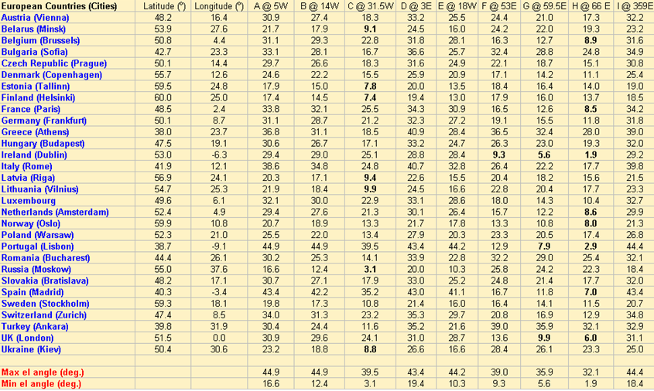

One can consider that propagation losses and discrimination angle would be quite the same for all location in a same country. Spreading ITS devices in a given country does not bring any significant impact. Otherwise, some little variations could be observed from one country to another.

Figure 1

Example, Impact of ITS location within Europe for the satellite A



Satellite footprints are given by available figures on the ITU MIFR. One could access to these data with the ITU GIMS software.

The e.i.r.p. of each ITS device in the direction of satellite was calculated by deriving the transmit power from the on-axis e.i.r.p. and then adding the gain (in dBi) in the elevation plane for the appropriate elevation angle from the country being considered.

The effects of power control (TPC factor), activity ratio (duty cycle) are then taken into account to improve the total amount of ITS devices in CEPT countries.

No changes in the actual deployment of the satellites are assumed.

## 4.2 Results in ECC Report 101

Table 5 summarises results for Satellites A to I except G given in table 3. The shown values are the greatest amount of ITS devices that can be deployed in the whole EU15 area. These results are obtained using the assumptions outlined in ECC Report 101 [1].

One has to recall that the results of the first two rows stands for the number of ITS devices which can be implemented on board vehicles, the next two for the number of active devices which means ITS devices able to transmit something and the last two for the number of ITS devices which can transmit simultaneously. All these figures are relating to a single channel (10 MHz bandwidth), a duty cycle of 2% and a TX power of 33dBm during the peak hour of traffic density leading to an activity factor of 8%.

Table 5

Maximum number of ITS devices (Class C) in Europe to meet ∆Tsat/Tsat noise temperature thresholds for Satellites A to I in ECC Report 101[1]

|  |  |  |  |  |  |  |
| --- | --- | --- | --- | --- | --- | --- |
|  | Max # of ITS in satellite beam (millions)  per 10 MHz channel | | Max # of ACTIVE ITS in satellite beam (millions)  per 10 MHz channel | | Max # of ACTIVE ITS in satellite beam (millions)  per 10 MHz channel simultaneously in use | |
| e.i.r.p. = 33 dBm  (OBU Gmax=5dBi)  *dc* = 2% (Equation (8) [1]) | | e.i.r.p. = 33 dBm  (OBU Gmax=5dBi)  *dc* = 2% (Equation (8) [1]) | | e.i.r.p. = 33 dBm  (OBU Gmax=5dBi)  *dc* = 2% (Equation (8) [1]) | |
| Satellite |  |  |  |  |  |  |
| A | >300 | >300 | >30 | >30 | >0.6 | >0.6 |
| B | >300 | >300 | >30 | >30 | >0.6 | >0.6 |
| C | >300 | >300 | >30 | >30 | >0.6 | >0.6 |
| D | 195 | >300 | 19.3 | >30 | 0.4 | >0.6 |
| E | >300 | >300 | >30 | >30 | >0.6 | >0.6 |
| F | >300 | >300 | >30 | >30 | >0.6 | >0.6 |
| G | NA | NA | NA | NA | NA | NA |
| H | >300 | >300 | >30 | >30 | >0.6 | >0.6 |
| I | 128 | >300 | 12.6 | >30 | 0.26 | >0.6 |

One has to recall that an additional propagation loss (up to 5 dB) is considered if elevation angle of the satellite from the ITS device is lower than 20°.

ECC Report 101 conclusions are still valid with respect to the interference from FSS earth station into the ITS receivers. This means that the interference that FSS earth stations can create into the ITS receivers may require adopting separation distances between FSS earth stations and ITS receivers, as deemed necessary. The size of the zone around the FSS transmitting earth station, where the interference received by ITS exceeds the interference criterion, varies up to about 9 km. As those distances cannot be guaranteed when dealing with mobile devices, ITS systems operate on the basis of not claiming protection from the FSS earth stations. Therefore, ITS systems are designed in such a way to ensure they can operate facing the interference generated by FSS earth stations.

# 5 Conclusions

The assumption taken in ECC Report 101 [1] can be seen as worst case assumption taking into account the relevant ETSI ITS set of specifications and the planned deployments scenarios in Europe. Some of the assumption concerning the TX power and the maximum average duty cycle were significantly overestimated and will lead to an additional protection margin.

Under the review assumption even a 100% penetration with ITS devices based on IEEE802.11p technology (i.e. ETSI ITS-G5 [12] ) will not lead to an increase of the noise floor by more than 1%.

The review on the assumptions of ECC Report 101 revealed that the conclusions are still valid. Current and planned ITS usage will follow the principle of non-interference/non-protection in the band 5 855 MHz to 5 925 MHz.

# 6 References

[1] ECC Report 101, “Compatibility studies in the band 5 855‑5 925 MHz between Intelligent Transport Systems (ITS) and other systems,” Bern, 2007.

[2] ECC Decision (08)01, “The harmonised use of the 5 875-5 925 MHz frequency band for Intelligent Transport Systems (ITS),” 2015.

[3] ECC Recommendation (08)01, “Use of the band 5 855-5 875 MHz for Intelligent Transport Systems (ITS),” 2015.

[4] J. Bates and D. Leibling, “Spaced Out Perspectives on parking policy,” *RAC Found.*, no. July, p. 132, 2012.

[5] ACEA, “THE AUTOMOBILE INDUSTRY POCKET GUIDE 2017 / 2018,” Brussels, 2017.

[6] Recommendation ITU-R F.1336-4, “Reference radiation patterns of omnidirectional, sectoral and other antennas for the fixed and mobile services for use in sharing studies in the frequency range from 400 MHz to about 70 GHz,” 2014.

[7] Organisation Internationale des Constructeurs d’Automobiles” (OICA), “World-Wide Passenger cars in use - 2015.” 2015.

[8] ECC Report 228, “Compatibility studies between Intelligent Transport Systems (ITS) in the band 5 855-5 925 MHz and other systems in adjacent bands,” 2015.

[9] ETSI TS 102 687 V1.1.1, “Intelligent Transport Systems (ITS); Decentralized Congestion Control Mechanisms for Intelligent Transport Systems operating in the 5 GHz range,” 2011.

[10] ETSI EN 302 637-2 V1.3.2, “Intelligent Transport Systems (ITS) - Vehicular Communications - Basic Set of Applications - Part 2 : Specification of Cooperative Awareness Basic Service**,**” 2014.

[11] ETSI EN 302 637-3 V1.2.2, “Intelligent Transport Systems (ITS); Vehicular Communications ; Part 3 : Specifications of Decentralized,” 2014.

[12] ETSI EN 302 663 V1.2.1, “EN302663 Access layer specification for in the 5 GHz frequency band,” 2013

]

______________

1. This frequency usage is for Hong Kong, China.
2. "Collaborative Connected Vehicle Research Update" (<http://www.its.dot.gov/presentations/pdf/V2V_Collaborative_Research_MikeLukuc2013.pdf>) at 10-12; “Safety Pilot Model Deployment: Lessons Learned and Recommendations for Future Connected Vehicle Activities” (<http://ntl.bts.gov/lib/59000/59300/59361/FHWA-JPO-16-363.pdf>) at 11-12; “CV Applications Already Deployed by Responding Agencies” (<http://transops.s3.amazonaws.com/uploaded_files/V2I%20DC%20TWG%201%20-%20January%2028%2C%202016%20Webinar%20Slides%20V3.pptx>) at 30; “Maricopa County Department of Transportation (MCDOT) SMARTDriveSM Program” (<http://www.mcdot.maricopa.gov/business/connected-vehicles.aspx>); “Connected Vehicle Pilot Deployment Program Phase 1: Concept of Operations (ConOps) - New York City” (<http://ntl.bts.gov/lib/59000/59300/59360/FHWA-JPO-16-299.pdf>) at 36; “Connected Vehicle Pilot Deployment Program: ICF/Wyoming Concept of Operations” (<http://www.its.dot.gov/pilots/pdf/ICF_ConOpsWebinar_02042016.pdf>) at 34.
3. <https://www.car-2-car.org/index.php?id=31>
4. <https://www.itsconnect-pc.org/en/about_its_connect/>
5. <http://newsroom.toyota.co.jp/en/detail/9676551/>
6. IEEE Std 802.11TM-2016, IEEE Standard for Information technology - Telecommunications and information exchange between systems - Local and metropolitan area networks - Specific requirements Part 11: Wireless LAN Medium Access Control (MAC) and Physical Layer (PHY) Specifications.
7. USDOT diagram based upon Std 802.11-2016 and generic OFDM principles.
8. Based upon information from IEEE Std 802.11TM-2016, IEEE Standard for Information technology - Telecommunications and information exchange between systems - Local and metropolitan area networks - Specific requirements: Part 11: Wireless LAN Medium Access Control (MAC) and Physical Layer (PHY) Specifications, 47 CFR [B9], Part 90, Sections 90.371–383, ASTM E2213 – 03 (as noted), SAE J2945TM/1 MAR2016, On-Board System Requirements for V2V Safety Communications, and field experience.
9. 47 CFR, Part 90, Section 90.377.
10. Portable, hand-carried OBEs are limited to 1.0 mW maximum output power – 47 CFR, Part 95, Subpart E, Section 95.639.
11. Note that for OBEs transmitting Basic Safety Messages (BSM)s on the dedicated V2V safety channel, the requirement is for maximum e.i.r.p. of 20 dBm - SAE J2945TM/1 MAR2016 (Table 21).
12. Per IEEE Std 802.11-2016, §17.3.9.3, p. 2305: Spectrum mask for 10 MHz channels, the transmitted spectral density shall have a 0 dBr bandwidth not exceeding 9 MHz and shall not exceed the spectrum mask created using the permitted power spectral density.
13. Society of Automotive Engineers (SAE), Surface Vehicle Standard, J2945™/1, March 2016, § 6.3.2 p. 57 and § 7, Table 21, p. 77.
14. For vehicles transmitting BSMs on the dedicated V2V safety channel, 6 Mbps data rate applies and IEEE Std 802.11-2016 (Table 17-4, p. 2285) specifies modulation-dependent parameters as shown.
15. Society of Automotive Engineers (SAE), Surface Vehicle Standard, J2945™/1, March 2016, § 6.4.1 p. 71.
16. 47 CFR [B9], Part 90, Sections 90.371–383: “A Road Side Unit (RSU) may employ an antenna with a height exceeding 8 meters but not exceeding 15 meters provided the e.i.r.p. specified in the table below is reduced by a factor of 20 log (Ht/8) in dB where Ht is the height of the radiation center of the antenna in meters above the roadway bed surface. The e.i.r.p. is measured as the maximum e.i.r.p. toward the horizon or horizontal, whichever is greater, of the gain associated with the main or center of the transmission beam. The RSU antenna height shall not exceed 15 meters above the roadway bed surface.
17. ASTM E2213 – 03: Standard Specification for Telecommunications and Information Exchange Between Roadside and Vehicle Systems — 5 GHz Band Dedicated Short Range Communications (DSRC) Medium Access Control (MAC) and Physical Layer (PHY) Specifications
18. SAE J2945/1, § 6.4.2, p. 73, and § 7, Table 21, p. 79.
19. IEEE Std 802.11-2016, Table 17-16, p. 2303.
20. Based upon information from IEEE Std 802.11TM-2016, IEEE Standard for Information technology – Telecommunications and information exchange between systems – Local and metropolitan area networks – Specific requirements Part 11: Wireless LAN Medium Access Control (MAC) and Physical Layer (PHY) Specifications; at pages 2310-2311.
21. IEEE Std 802.11TM-2016, IEEE Standard for Information technology – Telecommunications and information exchange between systems – Local and metropolitan area networks – Specific requirements Part 11: Wireless LAN Medium Access Control (MAC) and Physical Layer (PHY) Specifications; Annex D.
22. USDOT diagram based upon Std 802.11-2016, § 17.3.9.3, p. 2305 and D.2.2, p. 3271.
23. ETSI EN 302 571 V2.1.1: “Intelligent Transport Systems (ITS); Radiocommunications equipment operating in the 5 855 MHz to 5 925 MHz frequency band; Harmonised Standard covering the essential requirements of article 3.2 of Directive 2014/53/EU,” 2017.
24. 3GPP RP-142043, Revised Work Item Description: LTE Device to Device Proximity Services.
25. 3GPP RP-150441, Revised WI: Enhanced LTE Device to Device Proximity Services.
26. <https://www.fhwa.dot.gov/fastact/factsheets/itsprogramfs.cfm>.
27. See: <https://github.com/certificationoperatingcouncil/COC_TestSpecs>.
28. SAE J2945/1 March, 2016, 5.1.1, page 27.
29. SAE J2945/1, §7, Table 21, p. 79.
30. FCC Memorandum Opinion and Order “Amendment of the Commission’s Rules Regarding Dedicated Short-Range Communication Services in the 5.850-5.925 GHz Band (5.9 GHz Band),” WT Docket No. 01-90 of “Amendment of Parts 2 and 90 of the Commission's Rules to Allocate the 5.850-5.925 GHz Band to the Mobile Service for Dedicated Short Range Communications of Intelligent Transportation Services,” ET Docket No. 98-95, FCC 06-110, released July 26, 2006, § 1, p. 3, and § 17, pages 12-13.
31. FCC Memorandum Opinion and Order “Amendment of the Commission’s Rules Regarding Dedicated Short-Range Communication Services in the 5.850-5.925 GHz Band (5.9 GHz Band),” WT Docket No. 01-90 of “Amendment of Parts 2 and 90 of the Commission's Rules to Allocate the 5.850-5.925 GHz Band to the Mobile Service for Dedicated Short Range Communications of Intelligent Transportation Services,” ET Docket No. 98-95, FCC 06-110, released July 26, 2006, Appendix A.5.d, p. 24.
32. <http://media.cadillac.com/media/us/en/cadillac/news.detail.html/content/Pages/news/us/en/2017/mar/0309-v2v.html>.
33. <http://www.motortrend.com/news/2017-cadillac-cts-now-standard-v2v-technology/>+.
34. Society of Automotive Engineers (SAE), Surface Vehicle Standard, J2735™/1, March 2016, § 4.2, p. 27 “*The range of the system is generally considered to be line-of-sight distances of less than 1 000 meters.*” Also § 11.10, p. 263, ”*As an example, a traffic flow monitoring application may desire lane information extending back 1000 meters from the stop line, while the needs of a vehicle safety application may be served by a smaller span of perhaps 300 meters*”.
35. SAE J2945/1, § 7, p. 79.
36. The applications tested in the Safety Pilot Model Deployment assumed vehicles were transmitting basic safety messages at the 300 m range. The Do-Not-Pass-Warning (DNPW) may require the longest communication range for effective operation because it addresses a crash scenario where two vehicles approach each other head-on. Using the target range of 300 m, two vehicles approaching at 60 mph would be afforded approximately 5.6 seconds for the DNPW application to detect the crash scenario and issue a warning. Based on this information, 300 m range should be sufficient for the anticipated safety applications.
37. SAE J2945/1, § 6.3.6.4, p. 60; §6.3.8, p. 65-67; and § 7, and Table 21, p. 77.
38. DOT HS 812 014: “Vehicle-to-Vehicle Communications: Readiness of V2V Technology for Application”, August, 2014; p. 98.
39. SAE J2945/1, § 5.1.1, p. 27; § 6.3.1, p. 56; § 6.3.8, p. 65-67; and § 7, Table 21, p. 78.
40. DOT HS 812 014: “Vehicle-to-Vehicle Communications: Readiness of V2V Technology for Application”, August, 2014; p. 96-97, p. 108-110.
41. SAE J2945/1, § 5.1.1, p. 27; § 6.3.8, p. 65-67; and Appendix A.8, pages 114-116.
42. SAE J2945/1, § 5.1.1, p. 27.
43. DOT HS 812 014: “Vehicle-to-Vehicle Communications: Readiness of V2V Technology for Application”, August, 2014; p. 98.
44. SAE J2945/1, § 5.1.3.5, p28
45. <https://www.qualcomm.com/documents/ihs-technology-whitepaper-cellular-vehicle-everything-c-v2x-connectivity>, p. 1.
46. <http://www.phonearena.com/news/Carrier-coverage-claims-What-does-covering-X-percentage-of-Americans-really-mean_id64143>
47. SAE J2945/1, § 5.1.3, p. 28 and § 6.5, p. 73-77.
48. <https://www.fhwa.dot.gov/fastact/factsheets/itsprogramfs.cfm>.
49. DOT HS 812 014: “Vehicle-to-Vehicle Communications: Readiness of V2V Technology for Application”, August, 2014; p. 256.
50. FHWA-JPO-16-421: “Connected Vehicle Impacts on Transportation Planning-Desk Reference”, June 2016 (available online at <https://ntl.bts.gov/lib/60000/60200/60241/FHWA-JPO-16-421.pdf>).
51. Directive 2010/40/EU of the European Parliament and of the Council of 7 July 2010 on the framework for the deployment of Intelligent Transport Systems in the field of road transport and for interfaces with other modes of transport  
    <http://eur-lex.europa.eu/eli/dir/2010/40/oj>
52. European Commission, 10 2009, M/453: “EN standardisation mandate addressed to CEN, CENELEC and ETSI in the field of information and communication technologies to support the interoperability of co-operative systems for intelligent transport in the European Community”
53. FCC Report and Order, October 1999, ET Docket No. 98-95.
54. Press Release, U.S. Transportation Secretary Mineta Announces Opening of Crash-Preventing “Intelligent Intersection” Test Facility (June 24, 2003) (<http://www.its.dot.gov/press/fhw2003.htm>).
55. FCC 06-110; MEMORANDUM OPINION AND ORDER; July 2006; ET Docket No. 98-95.
56. FCC 03-324 REPORT AND ORDER, December 2003, ET Docket No. 98-95.
57. <http://www.iteris.com/cvria/html/applications/applications.html>.
58. <https://www.itsconnect-pc.org/en/about_its_connect/service.html>
59. 3GPP TR 22.885 Study on LTE support for Vehicle to Everything (V2X) services.
60. <http://local.iteris.com/cvria/html/applications/app7.html#tab-3>.
61. <http://local.iteris.com/cvria/html/applications/app11.html#tab-3>.
62. <http://local.iteris.com/cvria/html/applications/app16.html#tab-3>.
63. <http://local.iteris.com/cvria/html/applications/app23.html#tab-3>.
64. <http://local.iteris.com/cvria/html/applications/app29.html#tab-3>.
65. <http://local.iteris.com/cvria/html/applications/app31.html#tab-3>.
66. <http://local.iteris.com/cvria/html/applications/app36.html#tab-3>.
67. <http://local.iteris.com/cvria/html/applications/app116.html#tab-3>.
68. <http://local.iteris.com/cvria/html/applications/app62.html#tab-3>.
69. <http://local.iteris.com/cvria/html/applications/app52.html#tab-3>.
70. <http://local.iteris.com/cvria/html/applications/app13.html#tab-3>
71. <https://www.cvp.nyc/emergency-communications-and-evacuation-information>
72. <http://www.nyc.gov/html/dot/html/pr2016/pr16-094.shtml>
73. <http://local.iteris.com/cvria/html/applications/app24.html#tab-3>
74. <https://www.tampacvpilot.com/wp-content/uploads/2017/03/2672-Tampa-Connected-Vehicle-Pilot-Fact-Sheet-20170331-rgb.pdf>
75. <http://www.govtech.com/fs/Tampa-Bay-Fla-Seeks-Toll-Road-Drivers-to-Volunteer-for-its-Connected-Vehicle-Study.html>
76. <http://local.iteris.com/cvria/html/applications/app25.html#tab-3>
77. <http://local.iteris.com/cvria/html/applications/app38.html#tab-3>
78. <http://local.iteris.com/cvria/html/applications/app115.html#tab-3>
79. <http://local.iteris.com/cvria/html/applications/app48.html#tab-3>
80. <http://local.iteris.com/cvria/html/applications/app51.html#tab-3>
81. <http://local.iteris.com/cvria/html/applications/app53.html#tab-3>
82. <http://local.iteris.com/cvria/html/applications/app57.html#tab-3>
83. <http://local.iteris.com/cvria/html/applications/app60.html#tab-3>
84. <http://local.iteris.com/cvria/html/applications/app58.html#tab-3>
85. <http://local.iteris.com/cvria/html/applications/app99.html#tab-3>
86. <http://local.iteris.com/cvria/html/applications/app70.html#tab-3>
87. <http://local.iteris.com/cvria/html/applications/app71.html#tab-3>
88. <http://local.iteris.com/cvria/html/applications/app82.html#tab-3>
89. <http://local.iteris.com/cvria/html/applications/app81.html#tab-3>
90. <http://local.iteris.com/cvria/html/applications/app8.html#tab-3>
91. <http://local.iteris.com/cvria/html/applications/app43.html#tab-3>
92. <http://local.iteris.com/cvria/html/applications/app35.html#tab-3>
93. <http://local.iteris.com/cvria/html/applications/app50.html#tab-3>
94. <http://local.iteris.com/cvria/html/applications/app88.html#tab-3>
95. <http://local.iteris.com/cvria/html/applications/app68.html#tab-3>
96. <http://local.iteris.com/cvria/html/applications/app79.html#tab-3>
97. <http://local.iteris.com/cvria/html/applications/app85.html#tab-3>
98. <http://local.iteris.com/cvria/html/applications/app87.html#tab-3>
99. <http://local.iteris.com/cvria/html/applications/app66.html#tab-3>
100. <http://local.iteris.com/cvria/html/applications/app97.html#tab-3>
101. <http://local.iteris.com/cvria/html/applications/app19.html#tab-3>
102. <https://wydotcvp.wyoroad.info/>
103. <http://www.traffictechnologytoday.com/news.php?NewsID=81573>
104. <http://local.iteris.com/cvria/html/applications/app12.html#tab-3>
105. <http://local.iteris.com/cvria/html/applications/app108.html#tab-3>
106. <http://local.iteris.com/cvria/html/applications/app63.html#tab-3>
107. Other applications may also be non-priority communications depending on how they are deployed, the entity that deployed them, and other considerations. *See* 47 CFR, Section 90.377.
108. *See, e.g.*, GM Global Technology Operations, Inc., *Using V2X In-Network Message Distribution and Processing protocols to Enable Geo-Service Advertisement Applications*, U.S. Patent Appl. No. 12/415,756 (filed 31 Mar. 2009), <https://www.google.com/patents/US20100250346>; Mitsubishi Denki Kabushiki Kaisha, *Vehicle-Roadside Service Providing System*, U.S. Patent No. 6,768,934 (issued 27 July 2004), <http://www.google.com/patents/US6768934>.
109. *See, e.g.*,Comments of Oakland County Michigan at 5, ET Docket No. 13-49 (filed 5 July 2016).
110. NAT’L HIGHWAY TRAFFIC & SAFETY ADMIN., Vehicle Safety Communications Project Task 3 Final Report—Identify Intelligent Vehicle Safety Applications Enabled by DSRC at 14 (Mar. 2005) (“NHTSA DSRC Applications Report”), <https://www.nhtsa.gov/DOT/NHTSA/NRD/Multimedia/PDFs/Crash%20Avoidance/2005/CAMP3scr.pdf>; Presentation by Jinhua Guo, Director of Vehicular Networking Systems Research Lab, University of Michigan-Dearborn, 2006 US Army VI Winter Workshop, *Vehicle Safety Communications in DSRC* at 25 (2006); see also Jinhua Guo and Nathan Balon, University of Michigan – Dearborn, *Vehicular Ad Hoc Networks and Dedicated Short-Range Communication* at 18 (26 June 2006), <http://nathanbalon.net/projects/cis695/vanet_chapter.pdf>; GM Global Technology Operations, LLC, *Vehicular Wireless Payment Authorization Method*, U.S. Patent Appl. No. 12/631,680 (filed 4 Dec. 2009), <https://www.google.com/patents/US20110136429>; Henry Bzeih, Kia Motors America, *Safety Applications in a Connected Vehicle* at 13, <http://www.in-vehicle-infotainment-summit.com/media/downloads/42-day-2-henry-bzeih-kia-connected-car.pdf> (last accessed 24 June 2016).
111. NHTSA DSRC Applications Report at 34.
112. <http://local.iteris.com/cvria/html/applications/app5.html#tab-3>
113. <http://local.iteris.com/cvria/html/applications/app22.html#tab-3>
114. <http://local.iteris.com/cvria/html/applications/app37.html#tab-3>
115. <http://local.iteris.com/cvria/html/applications/app41.html#tab-3>
116. <http://local.iteris.com/cvria/html/applications/app94.html#tab-3>
117. 3GPP TR 22.885 Study on LTE support for Vehicle to Everything (V2X) services.
118. 21 OEMs, 39 Suppliers and additional development members
119. <https://www.c-roads.eu/platform.html>
120. <https://ec.europa.eu/energy/sites/ener/files/documents/1_en_act_part1_v5.pdf>
121. OEM is here the vehicle manufacturer.
122. EN 302 663, Table 3.
123. [https://www.volkswagenag.com/en/news/2017/06/pwlan.html#](https://www.volkswagenag.com/en/news/2017/06/pwlan.html)
124. <https://www.car-2-car.org/index.php?eID=tx_nawsecuredl&u=0&g=0&t=1510698932&hash=94c3a14630805b58a47027100699c3829ee8e417&file=fileadmin/downloads/PDFs/C2C-CC_Press_Information_on_EC_Masterplan_final.pdf>
125. <https://www.asfinag.at>
126. <http://www.eco-at.info/>
127. Source: <https://www.c-roads.eu/fileadmin/user_upload/media/Dokumente/C-Roads_Position_paper_on_59GHz_final.pdf>
128. <https://www.government.nl/topics/mobility-public-transport-and-road-safety/question-and-answer/what-is-the-declaration-of-amsterdam-on-selfdriving-and-connected-vehicles>
129. <https://ec.europa.eu/transport/sites/transport/files/themes/its/doc/c-its-platform-final-report-january-2016.pdf>
130. MOU between C2C-CC and the C-ROADS project:   
     <https://www.car-2-car.org/index.php?eID=tx_nawsecuredl&u=0&g=0&t=1510698932&hash=f35f83f8bcff26ea64b5acc9cafc2832d08fa8e1&file=fileadmin/downloads/PDFs/C-ITS_Cooperation_between_C2C-CC_and_C-Roads_Platform.pdf>
131. <http://www.cmc-info.net>
132. <http://www.erodocdb.dk/Docs/doc98/official/pdf/REC0801.PDF>
133. <http://www.etsi.org/deliver/etsi_en/302500_302599/302571/02.00.00_20/en_302571v020000a.pdf>
134. <https://www.nhtsa.gov/sites/nhtsa.dot.gov/files/812171-safetypilotmodeldeploydeltestcondrtmrep.pdf>.
135. <http://corporatenews.pressroom.toyota.com/releases/toyota-umtri-largest-connected-car-proving-ground.htm>.
136. <http://www.aztech.org/projects/connected-vehicles-research.htm>.
137. <http://www.its.dot.gov/factsheets/JPO_cvPilot.htm>.
138. Technical regulation on radio equipment without license: [Enforcement 2017.9.1] [Ministry of Science and ICT, Republic Korea, Notice 2017-10, 2017.9.1, Revision]; Article number 7 Radio equipment without license: Radar for detection of road information. The technical regulation is revised whenever necessary, therefore its number indicated may be changeable
139. This frequency usage is for Hong Kong, China.