|  |  |
| --- | --- |
| **Radiocommunication Study Groups** |  |
|  |  |
|  |  |
| Source: Document 5A/TEMP/237 | **Annex 24 to**  **Document 5A/650-E** |
| **20 November 2017** |
| **English only** |
| Annex 24 to Working Party 5A Chairman’s Report | |
| WORKING DOCUMENT TOWARDS A PRELIMINARY DRAFT NEW  REPORT ITU-R M.[RLAN SHARING 5 250-5 350 MHz] | |
| Sharing and compatibility studies of WAS/RLAN in the 5 250-5 350 MHz frequency range | |

*[Editor’s Note: This document is a compilation of material presented in contributions submitted to May and November 2016, and the May and November 2017 WP 5A meetings (see Source Indication below) that the submitting administrations requested to be considered in developing this document. The content of this document need to be supported by corresponding sharing studies. The material contained in this document has not been agreed by WP 5A. The material if agreed could be used to satisfy the objective of agenda item 1.16.]*

# 1 Introduction

This Report includes the sharing and compatibilities studies of WAS/RLAN in the 5 250‑5 350 MHz frequency range.

It is intended to represent the response to *invites ITU-R* *c)* of Resolution **239 (WRC‑15)** under WRC-19 agenda item 1.16.

# 2 Overall view of allocations in the 5 250-5 350 MHz range

| **Allocation to services** | | | **Expected studies** |
| --- | --- | --- | --- |
| **Region 1** | **Region 2** | **Region 3** |
| **5** **250-5** **255** EARTH EXPLORATION-SATELLITE (active)  MOBILE except aeronautical mobile 5.446A 5.447F  RADIOLOCATION  SPACE RESEARCH 5.447D  5.447E 5.448 5.448A | | | Coexistence between WAS/RLAN outdoor operations and EESS (active), Radiolocation and SRS (active) |
| **5 255-5** **350** EARTH EXPLORATION-SATELLITE (active)  MOBILE except aeronautical mobile 5.446A 5.447F  RADIOLOCATION  SPACE RESEARCH (active)  5.447E 5.448 5.448A | | |

# 3 Assumptions on technical and operational elements for the sharing and compatibility of WAS/RLAN with other services

## 3.1 Technical and operational characteristics of the WAS/RLAN operating in the 5 250- 5 350 MHz ranges

[Editor’ Note: The text below needs to be modified after finalization of the document Report ITU-R M.[RLAN REQ-PAR]]

[Option 1

[RUS [5A/196](https://www.itu.int/md/R15-WP5A-C-0196/en)]

Technical and operational characteristics of RLANs are presented in Recommendation ITU-R M.1450 «Characteristics of broadband radio local area networks». In accordance with this Recommendation in the territory of USA and Canada e.i.r.p. of RLANs operating in the frequency band 5 250–5 350 MHz is 250 mW conducted (-6 dBW). At the same time RLANs operating in the territory of Europe, and in numerous Region 3 countries including Australia, are restricted to an e.i.r.p. of 200 mW (-7 dBW) in the frequency bands 5 250-5 350 MHz and.

e.i.r.p. spectral densities specified in Recommendation ITU-R М.1450 shows that it addresses RLANs having carrier bandwidth of 20 MHz. However taking in account the achievements in RLANs development such as IEEE standard 802.11ac, the considered Report includes analysis of networks having carrier bandwidth of both 20 MHz and 160 MHz.

[UK and ESA [5A/246](https://www.itu.int/md/R15-WP5A-C-0246/en), [96](https://www.itu.int/md/R15-WP5A-C-0096/en)]

Option 2

### 3.1.1 Characteristics of RLAN in 5 250-5 350 MHz Band

]

## 3.2 Technical and operational characteristics of the Earth Exploration Satellite service operating in the frequency ranges 5 250-5 350 MHz

[7C 5A/[204](https://www.itu.int/md/R15-WP5A-C-0204/en)]

The band 5 250-5 570 MHz, allocated to EESS (active) on a primary basis, is currently used by many Administrations operating EESS (active) sensors and is planned to be used by a number of additional sensors. Typically, this band is used by the following type of sensors:

– Synthetic aperture radars (SAR) with operations typically limited to the 5 350‑5 470 MHz band.

– Altimeters with operations typically covering the whole 5 250-5 570 MHz band.

– Scatterometers with small bandwidths and operations typically within the 5 250‑5 350 MHz band or the 5 350-5 470 MHz band.

Studies under WRC-15 AI 1.1 mainly focused on SAR missions, however all types of EESS (active) sensors require relevant protection. Therefore, all mitigation techniques to be studied have to assess protection of all existing and planned SAR, altimeters and scatterometers sensors. Each sensor type has different technical characteristics. Within each sensor type, however, the characteristics present similar modes of operation.

The table in Annex 1 provides a non-exhaustive listing of existing and planned EESS (active) systems known to date and Annex 2 provides detailed characteristics of some of these EESS (active) systems.

Prior studies included in Annex 35 to Document [4-5-6-7/715](http://www.itu.int/md/R12-JTG4567-C-0715/en) (Chairman’s Report) depicted substantial negative margins for EESS (active) SAR systems, while additional studies are needed for altimeters and scatterometers. However, one can envision similar results as those found with SARs, since aggregate interference from RLANs to EESS (active) is mainly controlled by the sensors antenna gain and the number of active RLANs within the sensor footprint. Altimeters and scatterometers present lower antenna gain but, by direct effect, larger footprint and hence higher number of active RLAN to be considered in the aggregation calculations.

In case more detailed dynamic studies with altimeters and scatterometers were found necessary, the relevant EESS (active) protection criteria to be used for these sensors (from Recommendation ITU‑R RS.1166-4) are given below, together with the SAR interference criteria:

Table 3.1

|  |  |  |  |  |
| --- | --- | --- | --- | --- |
| Sensor type | Interference criteria | | Data availability criteria (%) | |
| Performance degradation | *I*/*N* (dB) | Systematic | Random |
| Scatterometer | 8% degradation in measurement of normalized radar backscatter to deduce wind speeds | –5 | 99 | 95 |
| Altimeter | 4% degradation in height noise | –3 | 99 | 95 |
| Synthetic Aperture Radar | 10% degradation of standard deviation of pixel power | -6 | 99 | 95 |

*Note*: Since interference is most likely to be produced by an aggregation of RLAN interferers, it would be related to population densities and interference would hence more than likely be systematic. The percentage of data availability to be used in the RLAN case is therefore 99%.

## 3.3 Technical and operational characteristics of the Radiolocation service operating in the 5 250-5 350 MHz

[UK 5A/[246](https://www.itu.int/md/R15-WP5A-C-0246/en)]

*Editor’s Note: Individual Radar highlighted in the tables below may operate across one of the sub bands in the 5GHz range or across more than one of these sub bands. In addition, some of the radar highlighted in the tables below may already covered by the existing mitigation techniques in Recommendation ITU-R M.1652-1. Future drafts should make the usage situation across the bands clearer and which radar are already covered by the existing mitigation techniques shown in Recommendation ITU-R M.1652-1*

### 3.3.1 Technical characteristics of Radiolocation systems operating in 5 250‑5 350 MHz band

[RUS 5A/[398](https://www.itu.int/md/R15-WP5A-C-0398/en)]

[Editor’s Note: make sure the relevant section of CPM text is consistent with the text below.]

The technical characteristics of the radiodetermination radars operating in the frequency band 5 250−5 850  MHz are given in Recommendations ITU-R М.1638-1 “Characteristics of and protection criteria for sharing studies for radiolocation (except ground based meteorological radars) and aeronautical radionavigation radars operating in the frequency bands between 5 250 and 5 850 MHz” and M.[1849-1](http://www.itu.int/rec/R-REC-M.1849/en) “Technical and operational aspects of ground-based meteorological radars”.

Analysis of Recommendation ITU-R [M.1638-1](http://www.itu.int/rec/R-REC-M.1638/en) showed that radars operating in separate bands of the considered frequency range are airborne and ground based. Table 3.2 below provides the technical parameters of airborne radars from this Recommendation used in the compatibility studies.

TABLE 3.2

Technical parameters and protection criteria of airborne radars operating   
in the frequency band 5 250-5 350 MHz

|  |  |  |  |
| --- | --- | --- | --- |
| Radar | | Radar No. 8 | Radar No. 9 |
| Band, MHz | | 5300 | 5 250-5 725 |
| Antenna gain, dB | | 26 | 40 |
| Noise figure, dB | | 4.9 | 3.5 |
| Intermediate frequency band, MHz | | 90 | 1 |
| I/N, dB | | -10 | -10 |
| Тn, К | | 606 | 359 |
| Рadd noise, dBW | | -121 | -143 |
| Iadd, dBW |  | -131 | -153 |

The technical characteristics of ground based radars to be used in the compatibility studies are given in Table 3.3.

TABLE 3.3

Technical parameters and protection criteria of ground based radars operating   
in the frequency band 5 250-5 350 MHZ

|  |  |  |  |  |  |  |  |
| --- | --- | --- | --- | --- | --- | --- | --- |
| Radar | Radar 1 | Radar 6 | Radar 10 | Radar 11 | Radar 19 | Radar 21 | Radar 23 |
| Band, MHz | 5 300 | 5 300 | 5 250-5 875 | 5 250-5 350 | 5 300-5 700 | 5 300-5 750 | 5 250-5 850 |
| Antenna gain, dB | 38.3 | 28 | 33 | 16 | 44.5 | 44.5 | 31.5 |
| Noise figure, dB | 6 | 5 | 3 | 10 | 3 | 3 | 13 |
| Intermediate frequency band, MHz | 1.0 | 1.5 | 11.0 | 11.0 | 0.75 | 0.8 | 5 |
| I/N, dB | -6 | -6 | -6 | -6 | -6 | -6 | -6 |
| Тn, К | 865 | 627 | 289 | 2610 | 289 | 289 | 5496 |
| Рnoise, dBW | -139 | -139 | -134 | -124 | -145 | -145 | -124 |
| Iadd, dBW | -145 | -145 | -140 | -130 | -151 | -151 | -130 |

The protection criteria for each considered radar are not given in Recommendation ITU-R М.1638‑1. This Recommendation notes that:” An increase of noise power spectral density of about 1 dB for the radiolocation radars except ground based meteorological radar would constitute significant degradation. Such an increase corresponds to an (*I* + *N* )/*N* ratio of 1.26, or an *I*/*N* ratio of about −6 dB. For the radionavigation service and meteorological[1] radars considering the safety‑of-life function, an increase of about 0.5 dB would constitute significant degradation. Such an increase corresponds to an *I* /*N* ratio of about –10 dB.” Therefore the interference-to-noise ratio (I/N) of minus 6 dB used as the protection criteria for the radiolocation radars is given in Tables 1 and 2.

The interference-to-noise ratio (I/N) assumed in this study is of minus 10 dB used as the protection criteria for the meteorological radars described in Table 3.4.

In accordance with Recommendation ITU -R М.1849-1 6 types of meteorological radars operate in the frequency band 5 250-5 350 MHz. The technical characteristics and protection criteria are given in Table 3.4.

TABLE 3.4

Technical parameters and protection criteria of ground based meteorological radars operating   
in the frequency band 5 250-5 350 MHZ

|  |  |  |  |  |  |  |
| --- | --- | --- | --- | --- | --- | --- |
| Radar | Radar 1 | Radar 4 | Radar 8 | Radar 11 | Radar 12 | Radar13 |
| Band, MHz | 5 300-5 700 | 5 300-5 700 | 5 250-5 725 | 5 250-5 350 | 5 330-5 370 | 5 250-5 370 |
| Antenna gain,dB | 39 | 40 | 45 | 45 | 45 | 50 |
| Noise figure, dB | 7 | 3 | 3 | 1.2 | 1.9 | 1 |
| Intermediate frequency band, MHz | 0.5 | 0.6 | 10 | 1.6 | 1.4 | 1.4 |
| I/N, dB | -10 | -10 | -10 | -10 | -10 | -10 |
| Тn, К | 1163 | 289 | 289 | 92 | 159 | 75 |
| Рnoise, dBW | -141 | -146 | -134 | -147 | -145 | -148 |
| Iadd, dBW | -151 | -156 | -144 | -157 | -155 | -158 |

# 4 Sharing studies per service

## 4.1 Sharing and compatibility of Earth exploration satellite versus WAS/RLAN in the band 5 250-5 350 MHz

[ESA/EUMETSAT 5A/96, 97]

The sharing and compatibility studies between WAS/RLAN and EESS (active) systems concern different type of sensors operating in different portions of the 5 250-5 570 MHz band:

− Synthetic aperture radars (SAR) in the 5 350-5 470 MHz band.

− Altimeters covering the whole 5 250-5 570 MHz band.

− Scatterometers with small bandwidths in the 5 250-5 350 MHz band or the 5 350‑5 470 MHz band.

According to Resolution **239 (WRC-15)**, the issues to be addressed in relation to EESS (active) are twofold:

[Editor’s Note: *Resolution* ***229 (Rev.WRC-12)*** *states that administrations are requested to take appropriate measures that will result in the predominant number of stations in the mobile service being operated in an indoor environment. Furthermore, stations in the mobile service that are permitted to be used outdoors in 5 250-5 350 MHz shall comply with eirp elevation masks in Resolution 229, however, administrations may exercise some flexibility in adopting other mitigation techniques to achieve an equivalent level of protection to incumbent services*.]

− In the 5 250-5 350 MHz band, to study the possibility of enabling expanded outdoor WAS/RLAN operations including possible associated conditions (see *invites ITU-R c)).* This implies studies with Altimeter and scatterometer sensors.

− In the 5 350-5 470 MHz band, to study whether additional mitigation techniques would provide coexistence between WAS/RLAN systems and EESS (active) (see *invites ITU‑R d))* This implies studies with Altimeter, SAR and scatterometer sensors.

### 4.1.1 Determination of the number of RLAN overlapping EESS bandwidths and bandwidth factors

As a first step to address sharing between RLAN and EESS (active) at 5 250-5 570 MHz, it is necessary to calculate the number of RLAN overlapping the EESS bandwidth and bandwidth factors based on the method proposed by the U.S. administration and widely agreed in JTG 4-5-6-7 (see Annex D of Annex 35 to Document [4-5-6-7/704](http://www.itu.int/md/R12-JTG4567-C-0704/en)).

For reference, section 4.1.1.1 presents the calculations undertook during previous study period for the EESS (active) SAR sensor with a 100 MHz bandwidth as used in corresponding studies.

Sections 4.1.1.2 and 4.1.1.3 address the EESS (active) altimeter and scatterometers sensors, respectively, and provide consistent calculations to take into account the different sensor bandwidth of 320 MHz and 2 MHz.

#### 4.1.1.1 SAR sensor with 100 MHz bandwidth

The overlapping of the EESS (active) SAR bandwidth on the RLAN channel plan is described below:

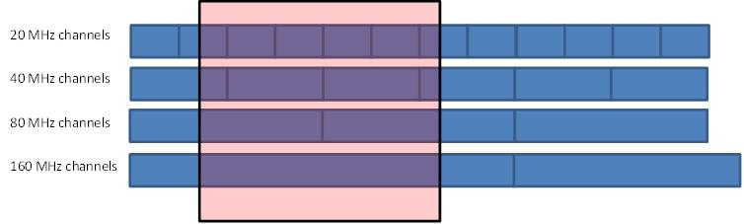

On this basis, for the so-called “Sim city” (with 5.25 M inhabitants), the calculation of the number of RLAN overlapping the EESS (active) bandwidth and the bandwidth factor is made as follows (for RLAN density option D1):



These calculation leads to the following basic assumptions that were used for sharing studies with SAR sensor:

* Number of RLAN overlapping the EESS (bandwidth) = **11279**
* Corresponding RLAN density per inhabitant = **0.0021**
* Average bandwidth factor per overlapping RLAN = -**1.94 dB**

Similarly, for RLAN density options D2-low and D2-high, the calculation of the number of RLAN overlapping the EESS (active) bandwidth is made as follows (noting that the bandwidth factor remains similar):





These calculation leads to the following basic assumptions that were used for sharing studies with SAR sensor:

* Number of RLAN overlapping the EESS (bandwidth) = **21000 (D2-low)** and **210000 (D2‑high)**
* Corresponding RLAN density per inhabitant = **0.004 (D2-low)** and **0.04 (D2-high)**

**Summary for SAR sensor:**

|  |  |  |  |
| --- | --- | --- | --- |
| **RLAN density option** | **Nb of RLAN overlapping the 100 MHz EESS bandwidth** | **Nb of RLAN per inhabitant (density) overlapping the 100 MHz EESS bandwidth** | **Average bandwidth factor** |
| **D1** | 11279 | 0.0021 | -1.94 dB |
| **D2-low** | 21000 | 0.004 | -1.94 dB |
| **D2-high** | 210000 | 0.04 | -1.94 dB |

#### 4.1.1.2 Altimeter sensor with 320 MHz bandwidth

The overlapping of the EESS (active) altimeter bandwidth on the RLAN channel plan is described below:

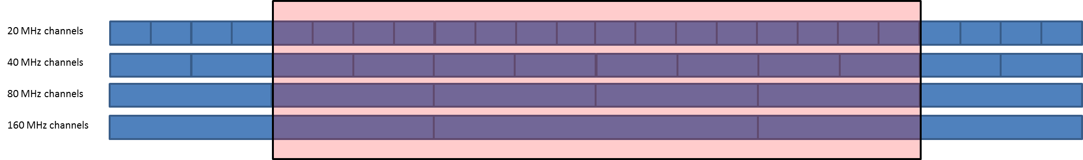

On this basis, for the so-called “Sim city” (with 5.25 M inhabitants), the calculation of the number of RLAN overlapping the EESS (active) bandwidth and the bandwidth factor is made as follows (for RLAN density option D1):



These calculation leads to the following basic assumptions for sharing studies:

* Number of RLAN overlapping the EESS (bandwidth) = **25297**
* Corresponding RLAN density per inhabitant = **0.0048**
* Average bandwidth factor per overlapping RLAN = -**0.4 dB**

Similarly, for RLAN density option options D2-low and D2-high, the calculation of the number of RLAN overlapping the EESS (active) bandwidth is made as follows (noting that the bandwidth factor remains similar):





These calculation leads to the following basic assumptions for sharing studies:

* Number of RLAN overlapping the EESS (bandwidth) = **47103 (D2-low)** and **471021 (D2‑high)**
* Corresponding RLAN density per inhabitant = **0.00897 (D2-low)** and **0.0897 (D2-high)**

**Summary for Altimeter sensor:**

|  |  |  |  |
| --- | --- | --- | --- |
| **RLAN density option** | **Nb of RLAN overlapping the 320 MHz EESS bandwidth** | **Nb of RLAN per inhabitant (density) overlapping the 320 MHz EESS bandwidth** | **Average bandwidth factor** |
| **D1** | 25297 | 0.0048 | -0.4 dB |
| **D2-low** | 47103 | 0.00897 | -0.4 dB |
| **D2-high** | 471021 | 0.0897 | -0.4 dB |

#### 4.1.1.3 Scatterometer sensor with 2 MHz bandwidth

The overlapping of the EESS (active) scatterometer bandwidth on the RLAN channel plan is described below:

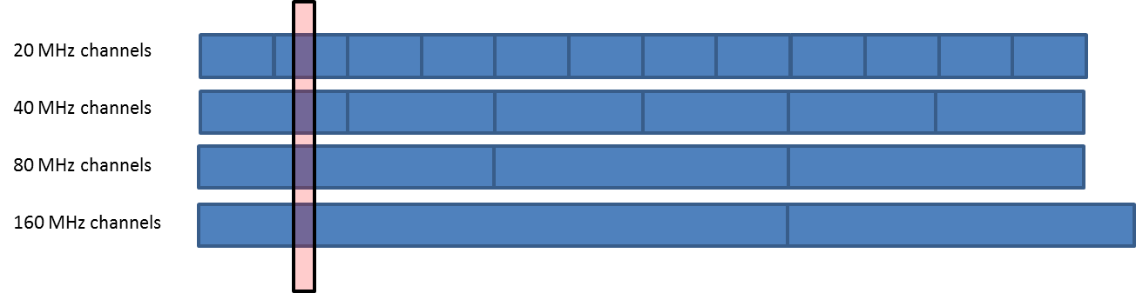

On this basis, for the so-called “Sim city” (with 5.25 M inhabitants), the calculation of the number of RLAN overlapping the EESS (active) bandwidth and the bandwidth factor is made as follows (for RLAN density option D1):



These calculation leads to the following basic assumptions for sharing studies:

– Number of RLAN overlapping the EESS (bandwidth) = 5 786

– Corresponding RLAN density per inhabitant = 0.0011

– Average bandwidth factor per overlapping RLAN = -16.03 dB

Similarly, for RLAN density option options D2-low and D2-high, the calculation of the number of RLAN overlapping the EESS (active) bandwidth is made as follows (noting that the bandwidth factor remains similar):





These calculation leads to the following basic assumptions for sharing studies:

– Number of RLAN overlapping the EESS (bandwidth) = 10 773 (D2-low) and 107 722 (D2-high).

– Corresponding RLAN density per inhabitant = 0.0021 (D2-low) and 0.021 (D2-high).

Summary for SCA sensor:

|  |  |  |  |
| --- | --- | --- | --- |
| **RLAN density option** | **Nb of RLAN overlapping the 2 MHz EESS bandwidth** | **Nb of RLAN per inhabitant (density) overlapping the 2 MHz EESS bandwidth** | **Average bandwidth factor** |
| **D1** | 5786 | 0.0011 | -16.03 dB |
| **D2-low** | 10773 | 0.0021 | -16.03 dB |
| **D2-high** | 107722 | 0.021 | -16.03 dB |

### 4.1.2 Sharing and compatibility studies with EESS (active) in the 5 250-5 350 MHz band

#### 4.1.2.1 Altimeter case

Detailed sharing studies between WAS/RLAN and EESS (active) altimeters sensors are presented in Annex 3, based on the ESA Sentinel-3 SRAL sensor.

It provides static and dynamic analysis taking into account similar assumptions and ranges of RLAN 5 GHz parameters (e.g. antenna gain discrimination, devices densities, outdoor ratio, building attenuation) than those considered for analysis made for SAR sensors during previous study period.

These studies provide results for “indoor type” WAS/RLAN (limited to WiFi case) deployment and hence representative of the current situation in the 5 250-5 350 MHz band.

Similar studies addressing “outdoor type” WAS/RLAN deployment taking into account both WiFi and LAA/LTE cases are to be performed.

#### 4.1.2.2 Scatterometer case

Detailed sharing studies between WAS/RLAN and EESS (active) scatterometers sensors are presented in Annex 4, based on the EUMETSAT EPS-SG SCAsensor.

It provides static and dynamic analysis taking into account similar assumptions and ranges of RLAN 5 GHz parameters (e.g. antenna gain discrimination, devices densities, outdoor ratio, building attenuation) than those considered for analysis made for SAR sensors during previous study period.

These studies provide results for “indoor type” WAS/RLAN (limited to WiFi case) deployment and hence representative of the current situation in the 5 250-5 350 MHz band.

Similar studies addressing “outdoor type” WAS/RLAN deployment taking into account both WiFi and LAA/LTE cases are to be performed.

#### 4.1.2.3 Consideration of potential RLAN mitigation techniques

TBD

## 4.2 Sharing and compatibility of Radiolocation with WAS/RLAN in the 5 250‑5 350 MHz

[RUS 5A/[398](https://www.itu.int/md/R15-WP5A-C-0398/en)]

To assess the impact of outdoor WAS/RLAN systems operation in the frequency band 5 250‑5 350 MHz the required separation distances are defined for protection of radars from indoor and outdoor WAS/RLAN systems emissions and the obtained results are compared.

To estimate compatibility with air-borne radars RLAN transmitter effective e.i.r.p. was defined by the following equation:

 (1)

EIRP loss due to propagation in the walls was estimated using the following formula:

, dBW; (1a)

where

σ - additional attenuation, dB.

Then the receiver thermal noise level was estimated for each of the Radars considered using the following equations:

 ° К, (2)

 dBW, (3)

where

*k* - Boltzmann constant;

NF - radar receiver noise figure;

 - radar receiver IF operational pass-band.

Maximum permissible noise power at the receiver front end was assessed such as:

, dBW. (4)

WPs 3K and 3M informed WP 5A that the appropriate propagation model to use for studies between airborne platforms and terrestrial stations is Recommendation ITU-R P.528. In considering sharing proposals, it may be viewed as useful to estimate the maximum density and/or the maximum e.i.r.p. of the WAS/RLAN stations that could potentially be authorized. For this purpose, within the line-of-sight range in an open environment without obstruction, an approximate procedure using the method in Recommendation ITU-R P.525 to calculate the expected free-space basic transmission loss might be utilized. Recommendation ITU-R P.528 uses median basic transmission loss estimates that are congruent with Recommendation ITU-R P.525 under these conditions. More detailed and precise analysis would, of course, require use of Recommendation ITU-R P.528, especially in the beyond-line-of-sight range.

A free space propagation model was used to estimate interference to air-borne radars. In that case a separation distance *R* required for radiodetermination radar protection was estimated in the following way:

, (5)

where

 - radar antenna gain, dB;

λ – operational bandwidth, m.

Estimation of interference to ground-based radars used a propagation model, presented in Recommendation ITU-R Р.452.

When considering a case of multi-source interference from several RLAN transmitters the aggregate interference level at the ground-based radar receiver front end was calculated as:

, (6)

where:

 - aggregate interference level at the radar receiver front end, dBW;

 - interference level produced by the *i*-th RLAN transmitter at the radar receiver front end;

*N* – number of interference sources under consideration.

### 4.2.1 Assessment of outdoor WAS/RLAN systems operation consequences for air-borne radiodetermination radars in the frequency band 5 250-5 350 MHz

Interference from RLAN transmitters to operation of air-borne radiolocation stations was estimated using the scenario presented in Figure 4.1 addressing air-borne radars of type 8 and 9 (Recommendation ITU-R [М.1638-1](http://www.itu.int/rec/R-REC-M.1638/en)).

FIGuRE 4.1

Interference scenario for air-borne receivers



The acceptable interference power levels at the receiver front end were calculated for those radars using equations (2) – (4) above. The calculated values are shown in Table 4.1. They were used for determination of the required protection distances ensuring interference free operation of the Radars in case of indoor and outdoor deployment of single RLAN systems.

The estimations assumed an aircraft flying at 10 km altitude (Н=10 000 m). Interference to operation of the air-borne radar was caused by RLAN transmitters deployed indoor and outdoor at the height of 14 m, 20 m and 26 m. Estimation of interference from RLAN transmitters used a free space propagation model, described in Recommendation ITU-R Р.525. To take propagation loss in the walls into account in equation (4) additional propagation loss, σ, equal to 20 dB was assumed. Multi-source interference was taken into account using equation (6).

Table 4.1 presents calculation results for separation distance required for protecting the air-borne radars from single indoor and outdoor RLAN transmitters.

table 4.1

Separation distances (km) required for protecting the air-bore radars from indoor   
and outdoor operating RLANs

|  |  |  |  |  |
| --- | --- | --- | --- | --- |
|  | *EIRPeff=-7 dBW, σ=20 dB* | | *EIRPeff=-7 dBW, σ=0 dB* | |
| ΔFRLAN, MHz | 20 | 160 | 20 | 160 |
| Radar 8 | 14 | 11 | 145 | 109 |
| Radar 9 | 200 | 71 | >RLOS | >RLOS |

* RLOS – line-of-sight distance of 420 km for a typical flight altitude of 12 000 m without refraction consideration

Analysis of the results presented in Table 4.1 shows that in case of using the outdoor WAS/RLAN systems the required protection distance would increase significantly compared with that for indoor WAS/RLAN systems. Such usage of even single outdoor WAS/RLAN systems could result in the required protection distances exceeding LOS distance for radars of certain types.

Besides, the required protection distances were estimated for a case of three indoor RLAN transmitters simultaneously operating in one building. The results are shown in Table 4.2.

table 4.2

Separation distances (km) required for protecting air-borne radars from three indoor and outdoor RLAN

|  |  |  |  |  |
| --- | --- | --- | --- | --- |
|  | *EIRPeff=-7 dBW, σ=20 dB* | | *EIRPeff=-7 dBW, σ=0 dB* | |
| ΔFRLAN, MHz | 20 | 160 | 20 | 160 |
| Radar 8 | 25 | 19 | 249 | 187 |
| Radar 9 | 344 | 122 | >RLOS | >RLOS |

Analysis of the results presented in Table 4.2 shows that the protection distances required for protecting air-borne radars could increase significantly in case of minor (as compared with the above case) increase in number of outdoor WAS/RLAN systems.

The results so obtained allow drawing the conclusions that it would be extremely difficult to provide compatibility of outdoor WAS/RLAN systems with air-borne radars without employing additional interference mitigation techniques.

### 4.2.2 Assessment of consequences of outdoor WAS/RLAN systems operation in the frequency band 5 250-5 350 MHz to ground-based radiodetermination radars

Protection distances for the ground-based radiodetermination radars operating in the frequency bands considered were estimated on the basis of assumed interference scenario depicted in Figure 4.2.

figure 4.2

Interference scenario for ground-based radar receivers



Interference was estimated using a free space propagation model described in Recommendation ITU-R Р.452-16. The assumed height of RLANs transmitters was 14 m, 20 m and 26 m. Propagation loss in walls were considered using expression (1a). Attenuation in walls was assumed as 20 dB. The assumed radar antenna height above the ground level was 20 m. Multi-source interference was taken into account using equation (6).

Table 4.3 presents minimum estimated separation distances required for protection of ground‑based radiodetermination radars from a single-source interference caused by indoor RLAN transmitters. In addition the calculations were conducted assuming a case of multi-source interference caused by three simultaneously operating indoor RLAN transmitters deployed in the same building.

TABLE 4.3

Separation distances (km) required for protecting ground-based radiolocation radars from indoor RLAN

|  |  |  |  |  |  |  |  |  |
| --- | --- | --- | --- | --- | --- | --- | --- | --- |
| **RLAN spectrum width** | **20 MHz** | | | | **160 MHz** | | | |
| RLAN transmitter  altitude, m | 14 | 20 | 26 | Σ | 14 | 20 | 26 | Σ |
| Radar 1 | 27 | 30 | 33 | 34 | 21 | 24 | 26 | 28 |
| Radar 6 | 22 | 24 | 26 | 28 | 10 | 10 | 10 | 17 |
| Radar 11 | <5 | <5 | <5 | 6 | <5 | <5 | <5 | <5 |
| Radar 19 | 35 | 38 | 41 | 43 | 28 | 31 | 34 | 36 |
| Radar 21 | 35 | 38 | 41 | 43 | 28 | 32 | 34 | 36 |
| Radar 23 | 15 | 15 | 15 | 21 | 5 | 5 | 5 | 8 |

Analysis of estimation results reflected in Table 4.3 shows that the required protection distance in case of deploying indoor WAS/RLAN systems will not exceed 43 km. This value of protection distance is required only for two types of the radars addressed in case of the aggregate interference from RLAN systems using a signal of 20 MHz in width.

Table 4.4 presents minimum estimated separation distances required for protection of ground‑based radiodetermination radars from a single-source and aggregate interference caused by outdoor RLAN transmitters. Estimations were conducted using equation (2) for every mode of RLAN operation. The estimation assumed the height of RLAN transmitters to be 14 m, 20 m and 26 m.

TABLE 4.4

Separation distances (km) required for protecting ground-based radiolocation and radionavigation radars   
from outdoor deployed RLANs

|  |  |  |  |  |  |  |  |  |
| --- | --- | --- | --- | --- | --- | --- | --- | --- |
| **RLAN spectrum width** | **20 MHz** | | | | **160 MHz** | | | |
| RLAN transmitter  altitude, m | 14 | 20 | 26 | Σ | 14 | 20 | 26 | Σ |
| Radar 1 | 43 | 46 | 49 | 51 | 35 | 38 | 41 | 43 |
| Radar 6 | 35 | 39 | 42 | 44 | 28 | 32 | 34 | 36 |
| Radar 10 | 47 | 50 | 53 | 55 | 38 | 41 | 44 | 46 |
| Radar 11 | 23 | 26 | 28 | 29 | 12 | 14 | 14 | 21 |
| Radar 19 | 54 | 57 | 59 | 62 | 45 | 48 | 51 | 53 |
| Radar 21 | 54 | 57 | 60 | 63 | 45 | 48 | 51 | 53 |
| Radar 23 | 31 | 34 | 37 | 38 | 24 | 28 | 31 | 38 |

Analysis of the estimation results described in Table 4.4 shows that assuming outdoor RLAN transmitters the separation distances required for protecting relevant radars would be of several dozen km even for RLANs using data transfer channel of 160 MHz. For example, for radar 21 and a RLAN transmitter using a data channel of 20 MHz passband and deployed at a height of 26 m the estimated distance was 60 km. In case of aggregate interference caused from three RLANs the protection distance would increase to 63 km. The obtained results would also provide for drawing a conclusion that compatibility of outdoor WAS/RLAN systems with ground-based radars would be extremely difficult to provide without implementation of additional interference mitigation techniques.

### 4.2.3 Assessment of consequences of outdoor WAS/RLAN systems operation in the frequency band 5 250-5 350 MHz to ground-based meteorological radars

Protection distances for the ground-based meteorological radars operating in the frequency bands considered were also estimated in line with the interference scenario depicted in Figure 4.2. The estimation used a free space propagation model described in Recommendation ITU-R Р.452-16. The assumed height of RLANs transmitters was 14 m, 20 m and 26 m. Propagation loss in walls were considered using expression (1a). Attenuation in walls was assumed as 20 dB. The assumed radar antenna height above the ground level was 20 m. Multi-source interference was taken into account using equation (6).

Table 4.5 presents minimum estimated separation distances required for protection of ground‑based meteorological radars from a single-source interference caused by indoor RLAN transmitters. Table 4.5 also reflects results of estimation assuming multi-source interference caused by three simultaneously operating indoor RLAN transmitters deployed in the same building.

TABLE 4.5

Separation distances (km) required for protecting ground-based meteorological radars   
from indoor deployed RLANS

|  |  |  |  |  |  |  |  |  |
| --- | --- | --- | --- | --- | --- | --- | --- | --- |
| RLAN spectrum width | 20 MHz | | | | 160 MHz | | | |
| RLAN transmitter  altitude, m | 14 | 20 | 26 | Σ | 14 | 20 | 26 | Σ |
| Radar 1 | 29 | 33 | 36 | 37 | 24 | 27 | 29 | 31 |
| Radar 4 | 34 | 38 | 41 | 43 | 28 | 31 | 34 | 36 |
| Radar 8 | 39 | 42 | 45 | 48 | 32 | 35 | 37 | 39 |
| Radar 11 | 44 | 47 | 49 | 52 | 36 | 39 | 42 | 44 |
| Radar 12 | 41 | 44 | 47 | 49 | 33 | 36 | 39 | 41 |
| Radar 13 | 47 | 50 | 53 | 56 | 39 | 42 | 44 | 46 |

Analysis of the estimation results described in Table 4.5 shows that providing protection for major number of radars would require separation distances of several dozen kilometers.

Table 4.6 reflects minimum separation distances required for protecting ground-based radiodetermination radars from single-source interference caused by outdoor RLAN transmitters. Estimations referred to the addressed modes of RLAN operation were performed using expression (2). The assumed height of RLANs transmitters was 14 m, 20 m and 26 m. Estimations also addressed a case associated with multi-source interference caused be three simultaneously operating indoor RLAN transmitters deployed in the same building at the height of 14 m, 20 m and 26 m.

TABLE 4.6

Separation distances (km) required for protecting ground-based meteorological radars   
from outdoor deployed RLANS

|  |  |  |  |  |  |  |  |  |
| --- | --- | --- | --- | --- | --- | --- | --- | --- |
| **RLAN spectrum width** | **20 MHz** | | | | **160 MHz** | | | |
| RLAN transmitter  altitude, m | 14 | 20 | 26 | Σ | 14 | 20 | 26 | Σ |
| Radar 1 | 46 | 49 | 51 | 54 | 38 | 41 | 44 | 49 |
| Radar 4 | 54 | 56 | 59 | 62 | 44 | 47 | 50 | 52 |
| Radar 8 | 60 | 62 | 65 | 68 | 50 | 53 | 55 | 59 |
| Radar 11 | 66 | 69 | 71 | 76 | 55 | 58 | 60 | 64 |
| Radar 12 | 63 | 66 | 69 | 72 | 53 | 55 | 58 | 61 |
| Radar 13 | 75 | 77 | 79 | 83 | 62 | 65 | 68 | 71 |

Analysis of the estimation results described in Table 4.6 shows that absence of additional loss associated with emission propagation in walls would result in significant increase of separation distances required for protecting meteorological radars as compared with the case of indoor WAS/RLAN systems. The obtained results also allow to conclude that it would be extremely difficult to provide compatibility of outdoor WAS/RLAN systems with ground-based radars without additional usage of interference mitigation techniques.

# 5 Conclusions of sharing and compatibility studies per service

## 5.1 General considerations

## 5.2 Sharing and compatibility results in the band 5 250-5 350 MHz

### [USA 5A/381]

Some administrations permit RLANs to share with incumbent services in the 5 250- 5 350 MHz band. RLAN devices operating in this band utilizing Dynamic Frequency Selection (DFS), which monitors the spectrum transmissions from incumbent radars and changes channels to avoid them when they are detected. One administration has improved compliance measurement procedures to improve DFS testing for radar detection and eliminate certain outdated performance tests including:

* *DFS Security*: Required devices to be designed to prohibit software changes that would allow users to disable the DFS functionality.
* *DFS Sensing Bandwidth:* Modified rules to require devices to sense for radar signals at 100 percent of their emissions bandwidth in the 5 250-5 350 MHz band. This requirement is applicable to all DFS and as such provides an additional security layer to protect the Terminal Doppler Weather Radar (TDWR) from any possible harmful interference from co-channel RLANS.
* *Sensing Threshold:* Revised the DFS sensing procedures by introducing a Power Spectral Density (PSD) limit for devices that meet the requirements for a relaxed sensing threshold. Modified rules to require that devices operate with both an e.i.r.p. of less than 200 mW (23 dBm), and an e.i.r.p. spectral density of less than 10 dBm/MHz (10 mW/MHz), in order to use the relaxed sensing detection threshold of -62 dBm. Devices that do not meet the proposed e.i.r.p. and e.i.r.p. spectral density requirements must use the -64 dBm sensing threshold. This change further enhances protection for radars from co-channel interference by reducing both the range and the in-band spectral density of the RLAN devices that use the relaxed sensing threshold.
* *Bin 1 Waveforms:* RLAN devices are certified using a testing regime that considers how the equipment responds to sample waveforms that simulate typical parameters that are used by radars that operate in these bands. The radar parameters are divided up into several “bins,” each representing a different category of radar system.
* *Channel Spreading:* Modified rules to eliminate the requirement that the DFS process provide a uniform spreading of the loading over all of the available channels and revised Compliance Measurement Procedures to remove the channel spreading requirement.
* *Channel Loading:* Revised Compliance Measurement Procedures to indicate the general requirement that DFS functionality be tested using a method and level of channel loading that is representative of the data types used by the RLAN device without specifying that the system testing be performed with an MPEG test file that streams full motion video at 30 frames per second for channel loading.

[RUS 5A/[398](https://www.itu.int/md/R15-WP5A-C-0398/en)]

Results of the conducted studies allow to make the following conclusions:

Sharing of the outdoor WAS/RLAN systems operating in the frequency band 5 250-5 350 MHz having the current characteristics with airborne and terrestrial radars is unfeasible;

– operation of outdoor WAS/RLAN systems in the frequency band 5 250-5 350 MHz would require development of effective measures of reducing interference caused by them to operation of air-borne and ground-based radars. The reduction of e.i.r.p values of WAS/RLAN transmitters approximately by 20 dB while increasing the receiver sensitivity can be considered as the effective method for reducing interference. Such e.i.r.p reduction allows to compensate increase of interference to radiodetermination radars caused by significant reduction of propagation loss due to the absence of additional fading in the walls.

It would be impossible to make decision on feasibility of employing WAS/RLAN systems in the addressed frequency band without development and implementation of such measures.

[7C 5A/[204](https://www.itu.int/md/R15-WP5A-C-0204/en)]

ANNEX 1

List of current and planned EESS (active) systems in the 5 GHz range (non-exhaustive)

***Note****: This table has been derived to the best knowledge of the delegates attending the Space Frequency Coordination Group (SFCG) and WP 7C and should hence only be used as informative document since no guarantee can be offered that it fully covers all the existing and planned missions with sensors operating in the 5 GHz range.*

| **Administration** | **Satellite** | **Sensor type** | **# Sats** | **Apogee/ Perigee (km/km)** | **Inclination (°)** | **Sat. Nb** | **Date of launch (Month and year)** | **Mission Duration** | **RAAN (°)** | **Argument of perigee (°)** | **True Anomaly (°)** | **EPOCH** |
| --- | --- | --- | --- | --- | --- | --- | --- | --- | --- | --- | --- | --- |
| Canada | RADARSAT-2C | SAR | 1 | 789 | 98.6 | 1 | 12/2007 | 7 years  (design life)  Still operational | 173.5 | 90.0 | 38.8 | 15166.23953944 |
| RADARSAT-3B | SAR | 6 | 617/586 | 97.7 | 1 | 07/2018 | 7 years  (design life) Operational system, will be renewed | 250.8 | 90.0 | 120° separation | Not launched |
| 2 | 07/2018 | 7 years  (design life)  Operational system, will be renewed | 250.8 | 90.0 | Not launched |
| 3 | 07/2018 | 7 years  (design life)  Operational system, will be renewed | 250.8 | 90.0 | Not launched |
| 4 | Planned  2022 | 7 years  (design life) Operational system, will be renewed | 250.8 | 90.0 | TBD | Not launched |
| 5 | Planned  2022 | 7 years  (design life)  Operational system, will be renewed | 250.8 | 90.0 | TBD | Not launched |
| 6 | Planned  2022 | 7 years  (design life)  Operational system, will be renewed | 250.8 | 90.0 | TBD | Not launched |
| China | HY-2 | Altimeter and scatterometer | 1 | 963 | 99.34 | 1 | 08/2011 | 3 years  (design life)  Still operational | 253.7 | 54.1 | 306 | 17043.685370 |
| FY-3-A | Scatterometer | 1 | 854/818 | 98.75 |  |  | | | | | |
| 1 | Planned  11/2018 | no limit in time | 314.17 | 0 | 0 | Not launched |
|  |  | | | | | |
|  |  | | | | | |
| GC-3 | SAR | 1 | 755 | 98.4 | 1 | 08/2016 | 8 years  (design life)  Operational system, will be renewed | 128.11 | 0 | 202.12 | 30-04-2016  07:14:26.77 UTC |
| France  USA | SWOT | Altimeter | 1 | 890.582  **(Note 1)** | 78 | 1 | Planned  10/2020 | 3 years (design lifetime) | 22.36 | 90.0 | 270.12 (LAN) | Not launched |
| France  EUMETSAT  USA | JASON2/OSTM  /USOCEAN  **(Note 2)** | Altimeter | 1 | 1336 | 66 | 1 | 06/2008 | 6-10 years | 306.05 | 266.33 | 156.34 | 2016  272.15638603 |
| JASON3/OSTM  /USOCEAN | Altimeter | 1 | 1336 | 66 | 1 | 01/2016 | 6-10 years | 305.6 | 265.85 | 94.16 | 2016  272.53411538 |
| ESA | SENTINEL-1 | SAR | 4 | 701.2/684.5 | 98.183 | 1 | 04/2014 | Up to 12 years | 263.78 | 80.27 | 279.86 | 14/09/2016  04 :33 :48 |
| 2 | 04/2016 | Up to 12 years | 263.30 | 80.37 | 279.77 | 13/09/2016  21 :08 :45 |
| 3 | Planned  2021 | Up to 12 years | 263.XX | 80.XX | TBD | Not launched |
| 4 | Planned  2022 | Up to 12 years | 263.XX | 80.XX | TBD | Not launched |
| SENTINEL-3 | Altimeter | 4 | 808.1/791.5 | 98.6 | 1 | 02/2016 | Up to 12 years | 323.58 | 105.7 | 254.43 | 14/09/2016  04 :45 :07 |
| 2 | Planned  2017 | Up to 12 years | 323.XX | 105.XX | Expected 120° from Satellite #1 | Not launched |
| 3 | Planned  2023 | Up to 12 years | 323.XX | 105.XX | TBD | Not launched |
| 4 | Planned  2024 | Up to 12 years | 323.XX | 105.XX | TBD | Not launched |
| EUMETSAT | SENTINEL-6  (Jason-CS) | Altimeter | 2 | 1336 | 66 | 1 | Planned  2020 | 6-10 years | 306 | 90 | 180° separation | Not launched |
| 2 | Planned  2025 | 6-10 years | 306 | 90 | Not launched |
| ASCAT | Scatterometer | 3 | 832 | 98.7 | 1 | 10/2006 | 10-14 years | 330.19 | 157.1 | 203.07 (mean anomaly) | 2016  272.71848113 |
| 2 | 09/2012 | 10-14 years | 330.65 | 157.03 | 320.85 (mean anomaly) | 2016  272.63852887 |
| 3 | Planned  2018 | 10-14 years | 330.XX | 157.XX | TBD | Not launched |
| SCA | Scatterometer | 3 | 832 | 98.7 | 1 | Planned  2021 | 10-14 years | 62.4731+0.98564735 x (Nb Julian days from 1/1/2000) | 90 | 120° separation | Not launched |
| 2 | Planned  2023 | 10-14 years | 90 | Not launched |
| 3 | Planned  2029 | 10-14 years | 90 | Not launched |
| India | RISAT | SAR | 1 | 536.38 | 97.6 | 1 | TBD | TBD | TBD | TBD | TBD | TBD |
| Russia |  |  |  |  |  |  |  | | | | | |
| MINI-RSA  (on-board ISS) | SAR | 1 | 400.6/409.6 | 51.64 | 1 | Planned  4Q 2017 | Up to 7 years | 258.95 | 17.78 | 124.40 | 29.09.16 07:56:33 GMT+2 |
| GEO-IK-2  **(Note 3)** | Altimeter | 3 | 1000 | 99.4 | 1 | 06/2016 | no limit in time | TBD | TBD | TBD | TBD |
| 2 | Planned  2017 | no limit in time | TBD | TBD | TBD | TBD |
| 3 | TBD | no limit in time | TBD | TBD | TBD | TBD |

|  |  |  |
| --- | --- | --- |
| TOTAL | Altimeters | 13 |
| Scatterometers | 8 |
| SAR | 14 |
| TOTAL | 35 |

**Note 1**: Only 21-day repeat science orbit (890.6 km altitude) is shown; the 1-day repeat “fast-sampling orbit” has a 857.2 km altitude orbit.

**Note 2**: starting the week of 3 October 2016 Jason-2 will be moved to an 'interleaved' orbit, ~160° different from Jason-3, to split the ground track and separate them by about 1/2 of the repeat cycle (5 of the ~10 days). The inclination and altitude will be the same, but not the phase.

**Note 3**: Satellites of the constellation use different orbital planes, which are separated by 120°.

[7C 5A/[38](https://www.itu.int/md/R15-WP5A-C-0038/en)]

ANNEX 2

Detailed characteristics of EESS (active) systems

Several types of synthetic aperture radars (SAR), altimeters, and scatterometers are identified as EESS (active) missions in the frequency bands between 5 150 MHz and 5 925 MHz to be studied under agenda item 1.16. Typical characteristics for EESS (active) sensors are shown in Table 1 for frequency overlaps that should be considered in sharing studies within these bands. The actual mission names as well the generic names which will be used in the final recommendation are provided in the table. It should be noted that the service area for most of these active sensors is global.

Table 1

Typical parameters of EESS (active) sensors in the 5 250-5 570 MHz band

| Mission/Sensor | SAR-D1  (Sentinel- 1 (CSAR)) | SAR-D2 (ASAR) | SAR-D3 (RISAT-1) | SAR-D4 (Radarsat-2) | SAR-D5 (Radarsat-3 (RCM)) | SAR-D6 (Radarsat Next Generation (RNG)) | SAR-D7 (GC-3) |
| --- | --- | --- | --- | --- | --- | --- | --- |
| Sensor type | SAR | SAR | SAR | SAR | SAR | SAR | SAR |
| Type of orbit | Circular SSO | SSO, circular | SSO | Near circular | Near circular | Near circular | Near circular |
| Altitude, km | 693 | 764 | 536 | 792-813 | 586.9-615.2 | 586.9-615.2 | 755 |
| Inclination, deg | 98.18 | 98.6 | 97 | 98.6 | 97.74 | 97.74 | 98.4 |
| Ascending Node LST | 18:00/6:00[2] | 10:30 | 6:00 | 6:00 | 6:00 | 6:00 | 18:00 |
| Repeat period, days | 12 | 35 | 13 | 24 | 12 | 12 | 29 |
| Antenna type | Phase array | Phase array | Planar Phased Array | Planar Phased Array | Planar Phased Array | Planar Phased Array | Planar Phased Array |
| Number of beams | 1 | 1 | 1 | 1 | 1 | 1 | 1 |
| Antenna Size/diameter | 12.3 m × 0.8 m | 10 m × 1.3 m | 10 m × 3 m | 15 m × 1.5 m | 6.88 m × .37 m | 6.88 m × 1.37 m | 15m× 1.232m |
| Antenna Pk Xmt Gain, dBi | 43.5 to 45.3 | 40 to 45 | 35 | 49[3] | 453 | 453 | 48 |
| Antenna Pk Rcv Gain, dBi | 43.5 to 44.8 | 40 to 45 | 35 | 493 | 453 | 453 | 48 |
| Polarization | V, H | H, V | Linear H,V | HH, HV, VH, VV | HH, VV, HV, VH, CH, CV | HH, VV, HV, VH, CH, CV | HH, HV, VH, VV |
| Antenna beam look angle, deg | 20-47[4] | 15-45 | 10-45 | 9-50 | 16-51 | 16-53 | 10-60 |
| Antenna beam azimuth angle, deg | 90 | 90 | 90 | 0 | 0 | 0 | 0 |
| Antenna elev. beamwidth, deg | 6 to 8 | 2.5 | 4.6 | 1.88 (for focused beam) | 2.05 (for focused beam) | 2.05 (for focused beam) | 2.288 |
| Antenna az. beamwidth, deg | 0.3 | 0.3 | 1.4 | 0.19 | 0.42(for focused beam) | 0.42(for focused beam) | 0.188 |
| Swath width (km) | 20-410 | 10-405 | 10-225 | 18-500 | 20-500 | 20-500 | 10~650 |
| RF center frequency, MHz | 5 405 | 5 331 | 5 350 | 5 405 | 5 405 | 5 405 | 5 400 |
| RF bandwidth, MHz | 100 | 16 | 18.75-75 | 11.6, 17.3, 30, 50, 100 | 14-100 | 14-300 | 2-240 |
| Transmit Pk pwr, W | 4 140 | 2 500 | 4 000 | 2 400 or  3 700 | 1 490 | 1 990 | 15 360 |
| Transmit Ave. pwr, W | 370 | 200 | 260 | 300 | 180 | 240 | 1 900 |
| Pulsewidth, μsec | 5 to 53 | 16 to 41 | 2 0 | 21,42 | 10 to 50 | 10 to 50 | 15 to 50 |
| Pulse Repetition Frequency (PRF) Hz | 1 450-2 000 | 1 600‑2 100 | 3 250 | 1 000-2 800 | 2 000-7 000 | 2 000-7 000 | 1 100-4 500 |
| Chirp rate, MHz/μsec | 0.34-3.75 | 0.39 | 0.937-3.75 | 0.27 to 2.38 | 0.14 to 10 | 0.14 to 10 | 0.13 to 6.85 |
| Transmit duty cycle, % | 0.5-9.0 depending on ops mode | 8.61 | 6.5 | Variable, max 8% | Variable, max 12% | Variable, max 12% | Variable, max 20% |
| e.i.r.p. ave, dBW | 70 (for 9% duty cycle) | 68.0 | 68 | Approx. 73[5] | 67.67 | 69.0 | Approx. 80.7 |
| e.i.r.p. peak, dBW | 80 | 78.0 | 71.0 | 83.5[6] | 76.7 | 78.0 | 89.8 |
| System Noise figure, dB | 3.2 | 4.5 | 5.8 | 6 | 6 | 6 | 4 |

| Mission/Sensor | ALT-D1 (JASON-2/3 SSALT, POSEIDON-3/3B) (Note 3) | ALT-D2  (Sentinel 3 SRAL) (Note 1 & 3) | ALT-D3 (HY-2A)  (Note 3) | ALT-D4 (Sentinel-6 POSEIDON-4)  (Notes 1, 2  & 3) | ALT-D5  (SWOT)  (Note 3) |
| --- | --- | --- | --- | --- | --- |
| Sensor type | Altimeter | Altimeter | Altimeter | Altimeter | Altimeter |
| Type of orbit | NSS | Circular, SSO | SSO | NSS | NSS |
| Altitude, km | 1336 | 814 | 963 | 1 336 | 890 |
| Inclination, deg | 66 | 98.65 | 99.3 | 66 | 78 |
| Ascending Node LST | NSS | 22:00 | 06:00 | NSS | NSS |
| Repeat period, days | 10 | 27 | 14 | 10 | 21 |
| Antenna type | Parabolic reflector | Parabolic reflector | Parabolic reflector | Parabolic reflector | Parabolic reflector |
| Number of beams | 1 | 1 | 1 | 1 | 1 |
| Antenna Size/diameter | 1.2 m | 1.2 m | 1.4 m | 1.2 m | 1.2 m |
| Antenna Pk Xmt Gain, dBi | 32 | 34.5 | 35; 43 | 33.5 | 32 |
| Antenna Pk Rcv Gain, dBi | 32 | 34.5 | 35; 43 | 33.5 | 32 |
| Polarization | linear | linear | linear VV | linear | linear |
| Azimuth scan rate, rpm | 0 | 0 | 0 | 0 | 0 |
| Antenna beam look angle, deg | 0 | 0 | 0 | 0 | 0 |
| Antenna beam azimuth angle, deg | 0 | 0 | 0 | 0 | 0 |
| Antenna elev. beamwidth, deg | 3.4 | 3.4 | 2.3 | 3.4 | 3.4 |
| Antenna az. beamwidth, deg | 3.4 | 3.4 | 2.3 | 3.4 | 3.4 |
| Swath width (km) | 79.4 | 48.4 | 38.7 | 97 | 52.9 |
| RF center frequency, MHz | 5 300 | 5 410 | 5 250 | 5 410 | 5 300 |
| RF bandwidth, MHz | 100, 320 | 320 | 160 | 320 | 100, 320 |
| Transmit Pk pwr, W | 17 | 32 | 20 | 25 | 17 |
| Transmit Ave. pwr, W | 0.51 | 0.4 (LRM), 0.25 (SAR) | 8.2 | <2 | 0.51 |
| Pulsewidth, μsec | 106.0 | 49 | 102.4 | 32 | 106.0 |
| Pulse Repetition Frequency (PRF) Hz | 300 | 275 (LRM), 157 (SAR) | 670 | 2 060-9 280 | 300 |
| Chirp rate, MHz/μsec | 0.9, 3.0 | 6.5 | 1.56 | 9.69 | 0.9, 3.0 |
| Transmit duty cycle, % | 3.1 | 1.5 (LRM),  0.7 (SAR) | 40.96 | 30 | 3.1 |
| e.i.r.p. ave, dBW | 29.5 | 30.8 (LRM), 28.4 (SAR) | 44.1 | 36.51 | 29.5 |
| e.i.r.p. peak, dBW | 44.8 | 49.5 | 48 | 47.47 | 44.8 |
| System Noise figure, dB | 4.45 | 3.8 | 3.5 | 3.5 | 4.45 |

Note 1 − Dual frequency radar altimeter (C/Ku Band) which performs measurements either in low resolution mode (LRM) or synthetic aperture radar mode (Nadir-SAR). LRM mode is the conventional altimeter pulse limited mode with interleaved C/Ku Band pulses, while Nadir-SAR mode is the high along track resolution mode based on SAR processing. The system is a two-satellite constellation.

Note 2 – The Poseidon-4 altimeter of Sentinel-6 is an evolution of the Poseidon-3/3B, SIRAL and SRAL altimeters of the Jason-3, CryoSat-2 and Sentinel-3 satellites, respectively.

Note 3 - It should be noted that EESS (active) altimeters may experience the influence from land backscatter (main lobe or side lobes), oceanic surface having anomalous profiles or other unwanted reflections (mispointing errors for example). It is therefore usually agreed to use the value of 2 times the 3 dB beamwidth as a typical value for the reflected area.

Table 1 (*continued*)

| Mission/Sensor | SCAT-D1 (Metop-A,B,C ASCAT) | SCAT-D2 (Metop-SG SCA) |
| --- | --- | --- |
| Sensor type | Scatterometer | Scatterometer |
| Type of orbit | SSO | SSO |
| Altitude, km | 832 | 832 |
| Inclination, deg | 98.7 | 98.7 |
| Ascending Node LST | 21:30 | 21:30 |
| Repeat period, days | 29 | 29 |
| Antenna type | Six fan beam‑antennas (slotted WG arrays) | Six fan beam‑antennas  (slotted WG arrays) |
| Number of beams | 6 | 6 |
| Antenna Size/diameter | 2.251 m x 0.337 m (mid),  3.003 m x 0.253 m (side) | 2.757 m x 0.315 m (mid), 3.02 m x 0.315 m (side) |
| Antenna Pk Xmt Gain, dBi | 24-32 | 23-31[7] |
| Antenna Pk Rcv Gain, dBi | 24-32 | 23-31 |
| Polarization | linear VV for all beams | linear VV for all 6 beams + VH/HV and linear HH for the 2 mid‑beams |
| Azimuth scan rate, rpm | 0 | 0 |
| Antenna beam look angle, deg | 22-45.6 (mid beams)  29.5-53.4 (side beams) | 17.5-45.5 (mid beams)  24-54 (side beams) |
| Antenna beam azimuth angle, deg | 45, 90, 135, 225, 270, 315 | 45, 90, 135, 225, 270, 315 |
| Antenna elev. beamwidth, deg | 23.6 (mid beams)  23.9 (side beams) | 28 (mid beams)  30 (side beams) |
| Antenna az. beamwidth, deg | 1.5 (mid beams)  1.2 (side beams) | 1.3 |
| Swath width (km) | 550 on each side of the orbit plane | 665 on each side of the orbit plane |
| RF center frequency, MHz | 5 255 | 5 355 |
| RF bandwidth, MHz | 0.5 | 2 |
| Transmit Pk pwr, W | 120 | 2 512 |
| Transmit Ave. pwr, W | 29 (mid beams)  36.5 (side beams) | 92 |
| Pulsewidth, μsec | 10 000 | 1 000 |
| Pulse Repetition Frequency (PRF) Hz | 28.259 | 32 |
| Chirp rate, MHz/μsec | 0.00002 | 0.00002 |
| Transmit duty cycle, % | 28.29 | 3.68 |
| e.i.r.p. ave, dBW | 39 - 47 | 42-50 |
| e.i.r.p. peak, dBW | 53 | 57-65 |
| System Noise figure, dB | 3.0 | 3.5 |

[ESA 5A/[96](https://www.itu.int/md/R15-WP5A-C-0096/en)]

ANNEX 3

Sharing studies between RLANs and EESS (active) Altimeter sensor

(Sentinel-3 SRAL sensor)

# 1 Introduction/Background

The present Annex addresses sharing between WAS/RLAN and EESS (active) altimeters sensors, based on the ESA Sentinel-3 SRAL sensor.

It provides static and dynamic analysis taking into account similar assumptions and ranges of RLAN 5 GHz parameters in 5 250-5 570 MHz (e.g. antenna gain discrimination, devices densities, outdoor ratio, building attenuation) than those considered for analysis made for SAR sensors and given in Document [4-5-6-7/664](http://www.itu.int/md/R12-JTG4567-C-0664/en) (ESA).

# 2 Technical characteristics

## 2.1 EESS (active)

### 2.1.1 Parameters

The EESS (active) parameters and interference criteria used in the present studies are those provided by WP 7C to WP 5A in their liaison statement in Document [5A/38](http://www.itu.int/md/R15-WP5A-C-0038/en).

Table 1 gives the technical parameters for the SRAL sensor on board Sentinel-3 satellites being developed by ESA for the Copernicus program of the European Commission.

Table 1

|  |  |
| --- | --- |
| Parameter | Sentinel-3 SRAL |
| Sensor type | ALTIMETER |
| Orbital altitude (km) | 800 |
| Orbital inclination (degrees) | 98.65 |
| RF centre frequency (MHz) | 5 410 |
| Peak radiated power (W) | 32 (at ant input) |
| Polarisation | Linear |
| Antenna type | Parabolic reflector 1.2 m |
| Antenna gain (dBi) | 34.5 |
| Antenna pattern steering capability | No |
| Antenna pattern | Based on F.699 |
| Antenna orientation (degrees from nadir) | Nadir (altimeter) |
| Receiver noise figure (dB) | 3.8 |
| Pulse/Receiver bandwidth (MHz) | 320 |
| Noise power (dBW) | –115 |
| Service area | Global |
| Footprint (km2) | 1 840 |

Concerning the polarisation, it is to be noted that Sentinel-3 SRAL makes use of a dual linearly polarised antenna. **Therefore no polarisation discrimination advantage can be taken into account.**

The antenna pattern used for SRAL is based on Recommendation ITU-R F.699.

### 2.1.2 Protection criteria

The relevant protection criteria is given in Table 2, taken from Recommendation ITU-R RS.1166-4. Even if RLANs are nomadic/mobile by nature, their very high density implies that the interference will be systematic. The relevant percentage of data availability, corresponding to the percentage of time, is therefore 99% (see Document [5A/38](http://www.itu.int/md/R15-WP5A-C-0038/en))

Table 2

|  |  |  |  |  |
| --- | --- | --- | --- | --- |
| Sensor type | Interference criteria | | Data availability criteria (%) | |
| Performance degradation | *I*/*N* (dB) | Systematic | Random |
| Altimeter | 4% degradation in height noise | –3 | 99 | 95 |

For the SRAL instrument, the protection criteria calculated over a 320 MHz bandwidth is   
–118.1 dBW (-88.1 dBm) not to be exceeded more than 1% of the time.

This criteria is applied over data acquisition periods of time when the sensor is operating over the measurement area of interest (as per Recommendation ITU-R RS.1166-4).

## 2.2 Mobile service (WAS/RLAN)

RLAN parameters used in the present studies are those agreed in the previous study period and given in the preliminary draft new Report ITU-R RS.[EESS RLAN 5 GHz] (see Annex 35 to Document [4-5-6-7/715](http://www.itu.int/md/R12-JTG4567-C-0715/en) (Chairman’s Report)):

– e.i.r.p. distribution:

|  |  |  |  |  |
| --- | --- | --- | --- | --- |
| RLAN e.i.r.p. Level | 200 mW (Omni-Directional) | 80 mW (Omni-Directional) | 50 mW (Omni-Directional) | 25 mW (Omni-Directional) |
| RLAN Device Percentage | 19% | 27% | 15% | 39% |

Note: Such distribution corresponds to a 19 dBm average e.i.r.p.

– Indoor/outdoor:

Outdoor ratio: 5% (RLAN devices are assumed to be indoors only, based on the requirement to help facilitate coexistence. For the purposes of sharing studies, 5% of the devices should be modelled without building attenuation)

– Channel Bandwidth distribution:

|  |  |  |  |  |
| --- | --- | --- | --- | --- |
| Channel bandwidth | 20 MHz | 40 MHz | 80 MHz | 160 MHz |
| RLAN Device Percentage | 10% | 25% | 50% | 15% |

– Bandwidth factor:

The bandwidth factor (BWF) used in this document is derived taking into account the positioning of an EESS (active) 100 MHz bandwidth over the RLAN raster/channel plan, as shown below.

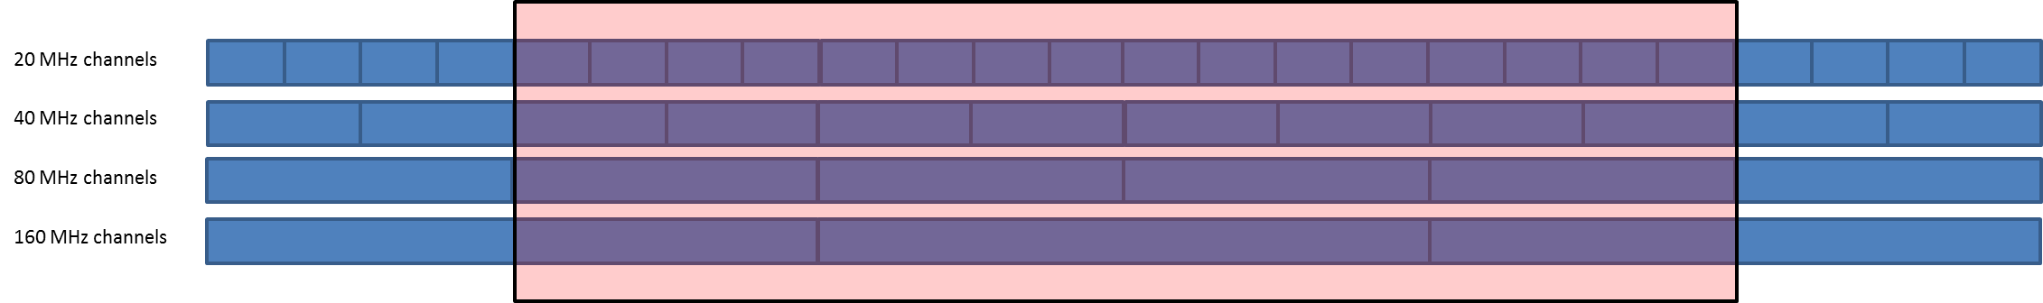

On this basis, the following bandwidth factors are considered (see details in Annex 2):

• 160 MHz (15% of RLANs): 1 channel overlaps fully overlaps the EESS bandwidth and 2 overlap by 80 MHz.

– BWF = 0 dB for 1/3 of cases

– BWF = 10 *log(80/160) = - 3 dB for 2/3 of cases

This represent an average BWF = -1.76 dB

• 80 MHz (50% of RLANS): 4 channels fully overlaps the EESS bandwidth. No bandwidth factor is applied.

• 40 MHz (25% of RLANS): 8 channels fully overlaps the EESS bandwidth. No bandwidth factor is applied.

• 20 MHz (10% of RLANS): 16 channels fully overlaps the EESS bandwidth. No bandwidth factor is applied.

Overall, considering all bandwidth, this represent an average BWF = - 0.4 dB

– Propagation conditions:

• building attenuation with a Gaussian distribution (17 dB + 7 dB) truncated at 1 dB, as described in the figure below:

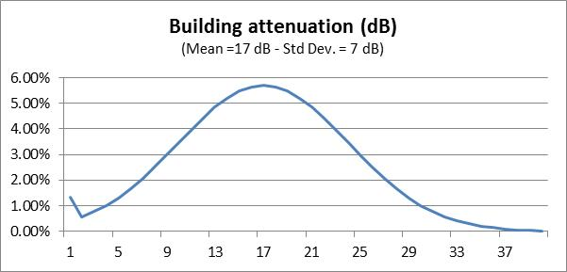

Note: when used to calculate aggregate interference from multiple sources (as in the present case), the impact of this distribution is similar to the one leading from a 12 dB average attenuation.

• Angular clutter loss model from Recommendation ITU-R P.452 associated with RLAN heights distributions and specific parameters for Urban, Suburban and Rural environments. The antenna heights are randomly selected using a uniform probability distribution from the set of floor heights at 3 meter steps. It should be noted that due to the EESS (active) geometry (Nadir) this model leads to no attenuation.



Antenna height

|  |  |
| --- | --- |
| **RLAN deployment region** | **Antenna height (metres)** |
| Urban | 1.5 to 28.5 |
| Suburban | 1.5, 4.5 |
| Rural | 1.5, 4.5 |

– Antenna gain/discrimination (Omnidirectional in azimuth for all scenarios)

• Option A1: Omnidirectional in elevation with 0 dBi gain.

• Option A3: An average 4 dB antenna discrimination is applied to the e.i.r.p. level distribution above in the direction of the satellite Omnidirectional in elevation with 0 dBi gain.

Note: since Option A3 is proposing a fixed discrimination of 4 dB, corresponding results can therefore be extrapolated by shifting by 4 dB the results obtained with Option A1 (0 dBi).

– Number of active RLAN:

• Option D1: 11 279 active devices per 100 MHz channel per 5.25 million inhabitants (so-called “Sim City” with 5.25 M inhabitants).

• Option D2: from 0.004 (D2-low) to 0.04 (D2-high) per 100 MHz channel per inhabitant.

Extrapolation of these numbers from a 100 MHz bandwidth to a 320 MHz bandwidth is detailed in Annex 2 and leads to the following figures:

• Option D1: 25297 active devices per 320 MHz channel per 5.25 million inhabitants (Sim City), i.e. a density of 0.0048 RLAN per inhabitant.

• Option D2-Low: 47103 active devices per 320 MHz channel per 5.25 million inhabitants (Sim City), i.e. a density of 0.00897 RLAN per inhabitant.

• Option D2-High: 471021 active devices per 320 MHz channel per 5.25 million inhabitants (Sim City), i.e. a density of 0.0897 RLAN per inhabitant.

These factors lead to the following number of active RLAN to be considered over the French territory (with a population of 66 M inh.), Dutch territory (with a population of 16.8 M inh.) and the UK territory (with a population of 63.3 M inh.):

|  |  |  |  |  |
| --- | --- | --- | --- | --- |
|  | Nb of active RLAN per inhabitant | Nb of active RLAN over France  (in 320 MHz) | Nb of active RLAN over NL  (in 320 MHz) | Nb of active RLAN over UK  (in 320 MHz) |
| Option D1 | 0.0048 per inh. | 318 019 | 80 950 | 305 009 |
| Option D2 | Low (0.00897 per inh.) | 592 142 | 150 727 | 567 918 |
| High (0.0897 per inh.) | 5 921 422 | 1 507 271 | 5 679 182 |

Detailed deployment assumptions are described in the analysis sections.

# 3 Analysis

Analyses based on static and dynamic methodologies have been used to address the compatibility between WAS/RLAN and EESS (active) altimeter in the 5 GHz range:

– Section 3.1: static analyses.

– Section 3.2: dynamic analyses based on existing population densities.

– Section 3.3: consideration of some additional parameters proposed in PDN Report ITU‑R RS.[EESS RLAN 5 GHz].

## 3.1 Static analyses

### 3.1.1 Single entry static analysis

The following Table 4 provides calculation of the impact of 1 single outdoor RLAN on EESS (active) sensors described in Table 1 above.

Table 4

|  |  |
| --- | --- |
| Parameter | Sentinel-3 SRAL |
| Frequency (MHz) | 5 410 |
| Orbital altitude (km) | 800 |
| Off Nadir Angle (°) | 0 |
| Slant path distance (km) | 800 |
| Free Space losses (dB) | 165.2 |
| EESS antenna gain (dBi) | 34.5 |
| **EESS protection criteria (dBm/320 MHz)** | **–88.1** |
| RLAN EIRP (dBm) | 23 |
| **Interference from 1 outdoor RLAN (dBm)** | **–107.7** |
| Margin for 1 outdoor RLAN (dB) | 19.6 |
| **Nb of outdoor RLAN in the EESS footprint to reach the protection criteria** | **91** |

This calculation shows that 91 outdoor RLANs within the 1840 km² EESS (active) footprint transmitting with the full e.i.r.p. of 200 mW are sufficient to interfere with an EESS (active) system.

**This represents a maximum density of less than 0.05 RLAN / km².**

### 3.1.2 Static analysis based on EESS (active) footprint shape

The following analysis provides calculation of the aggregate RLAN impact on EESS (active) considering the so-called ‘Sim City” (circular based) with the footprint shape of the EESS (active) system (with a radius of 24.2 km), as shown on the Figure 1 below.

Figure 1

RLAN deployment and EESS (active) footprint

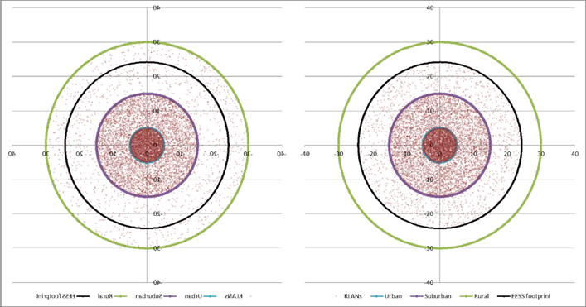

In this case, the percentage of RLAN within the EESS (active) footprint (as on the right figure) can be calculated as in Table 5 below.

Table 5

|  |  |  |  |  |
| --- | --- | --- | --- | --- |
|  | Distance (km) | Area (km²) | Area enclosed in EESS footprint (km²) | Ratio of RLAN within the EESS footprint |
| Urban | 5 | 79 | 79 | 100% |
| Suburban | 15 | 628 | 628 | 100% |
| Rural | 30 | 2 121 | 1133 | 53% |

To consider potential interference from RLAN deployment on EESS (active) sensor, one can therefore use these percentages to determine the total number of RLAN in the EESS (active) footprint, for both density Option D1 (total of 25297 RLAN within the overall city for 5.25 M inhabitants), the low edge of Density Option D2 (47102 RLAN) and the upper edge of Density Option D2 (471022 RLAN) as given in Table 6 below.

Table 6

|  |  |  |  |  |  |
| --- | --- | --- | --- | --- | --- |
|  | Ratio of RLAN within the EESS footprint | Ratio of RLAN in each city area (based on model agreed in JTG) | Nb of active RLAN in EESS footprint (Option D1) | Nb of active RLAN in EESS footprint (Option D2-low) | Nb of active RLAN in EESS footprint (D2-high) |
| Total Nb of RLAN in city |  | **100%** | 25297 | 47102 | 471022 |
| Urban | 100% | 35.5% | 8978 | 16718 | 167176 |
| Suburban | 100% | 53.3% | 13488 | 25115 | 251148 |
| Rural | 53% | 11.2% | 1512 | 2816 | 28159 |
| **Total Nb of RLAN in EESS footprint** |  |  | **23979** | **44648** | **446482** |

On this basis, the following Table 7 provides calculation of interference for the “EESS (active) footprint shape scenario” for the Sentinel-3 SRAL.

Table 7

|  |  |  |  |
| --- | --- | --- | --- |
| Parameter | Sentinel-3 SRAL with RLAN Density Option D1 | Sentinel-3 SRAL with RLAN Density Option D2-low | Sentinel-3 SRAL with RLAN Density Option D2-high |
| Frequency (MHz) | 5410 | 5410 | 5410 |
| Orbital altitude (km) | 800 | 800 | 800 |
| Off Nadir Angle (°) | 0 | 0 | 0 |
| Slant path distance (km) | 800 | 800 | 800 |
| Free Space losses (dB) | 165.2 | 165.2 | 165.2 |
| EESS antenna gain (dBi) | 34.5 | 34.5 | 34.5 |
| Average RLAN EIRP (dBm) (including average BWF) | 18.6 | 18.6 | 18.6 |
| **Interference from 1 RLAN (dBm)** | **-112.1** | **-112.1** | **-112.1** |
| Nb of RLAN (see table 6 above) | **23979** | **44648** | **446482** |
| Nb of outdoor RLAN (5%) | **1199 (=30.8 dB)** | **2232 (=33.5 dB)** | **22324 (=43.5 dB)** |
| Nb of indoor RLAN | **22780 (=43.6 dB)** | **42416 (=46.3 dB)** | **424158 (=56.3 dB)** |
| Average indoor/outdoor attenuation (dB) | 12 | 12 | 12 |
| Interference from outdoor RLAN (dBm/320 MHz) | -81.3 | -78.6 | -68.6 |
| Interference from indoor RLAN (dBm/320 MHz) | -80.5 | -77.8 | -67.8 |
| **TOTAL INTERFERENCE (dBm/320 MHz)** | **-77.9** | **-75.2** | **-65.2** |
| EESS protection criteria (dBm/320 MHz) | -88.1 | -88.1 | -88.1 |
| **Exceeding = Negative Margin (dB) with antenna Option A1** | **10.2** | **12.9** | **22.9** |

This Table shows that, when considering the “footprint shape” scenario, (with RLAN antenna Option A1), the RLAN deployment **exceeds the EESS (active) protection criteria from 10.2 dB (with Density Option D1) to 22.9 dB (with Density Option D2-high).**

As a summary, the following Table 8 provides the level of interference in excess considering all different RLAN density scenarios and antenna options.

Table 8

Level of interference in excess (static analysis)

|  |  |  |
| --- | --- | --- |
| Scenario | Sentinel-3 SRAL | |
| RLAN Antenna | Antenna Option A1 | Antenna Option A3 (= A1 –4 dB) |
| **JTG Option D1** | 10.2 dB | 6.2 dB |
| **JTG Option D2-low** | 12.9 dB | 8.9 dB |
| **JTG Option D2-high** | 22.9 dB | 18.9 dB |

These calculations therefore show that when considering the “footprint shape” scenario, the RLAN deployment **largely exceeds the EESS (active) protection up to 22.9 dB** and allow to show there is no compatibility between RLAN and EESS (active) altimeters sensors in the 5 GHz range.

## 3.2 Dynamic analyses

### 3.2.1 RLAN deployment

The dynamic analysis have been considered over France (550 000 km² and 66 M inhabitants) on the one hand and over a more restricted area covering the Paris metropolitan area (a square of 10 000 km² and approximately 10.2 M inhabitants) on the other hand.

Some calculations have also been made considering the Netherlands (41 530 km² and 16.8 M inhabitants).

Other simulations have been considered over the UK (244 000 km² and 63.3 M inhabitants) on the one hand and over a more restricted area covering the London metropolitan area (a square of 10 000 km² and approximately 12.9 M inhabitants) on the other hand.

These simulations are properly reflecting the real scenarios, with real population distributions.

Over these areas, different scenarios related to the number of active RLAN were considered as in Table 9 below:

Table 9

Scenarios considered for the dynamic analysis

|  |  |  |  |  |  |  |
| --- | --- | --- | --- | --- | --- | --- |
|  | Nb of active RLAN per inhabitant | Nb of active RLAN over France  (in 320 MHz) | Nb of active RLAN over Paris Metro (in 320 MHz) | Nb of active RLAN over NL  (in 320 MHz) | Nb of active RLAN over UK  (in 320 MHz) | Nb of active RLAN over London Metro (in 320 MHz) |
| Option D1 | 0.0048 per inh. | 318 019 | 49 148 | 80 950 | 305 009 | 62 158 |
| Option D2 | Low (0.00897 per inh.) | 592 142 | 91 513 | 150 727 | 567 918 | 115 737 |
| High (0.0897 per inh.) | 5 921 422 | 915 129 | 1 507 271 | 5 679 182 | 1 157 369 |

These active RLAN have been deployed following the population densities, as depicted in Figure 2 below.

An EESS (active) measurement area has been defined around France, with an area of about 1 000 000 km² (blue square on Figure 2A), around Paris with an area of 10 000 km² (blue square on Figure 2B), around the Netherlands with an area of about 120 000 km² (blue square on Figure 2C), around the UK, with an area of about 700 000 km² (blue square on Figure 2D) and around London with an area of 10 000 km².

Figure 2a

RLAN deployment and measurement area over France (592 142 RLANs for D2-low)

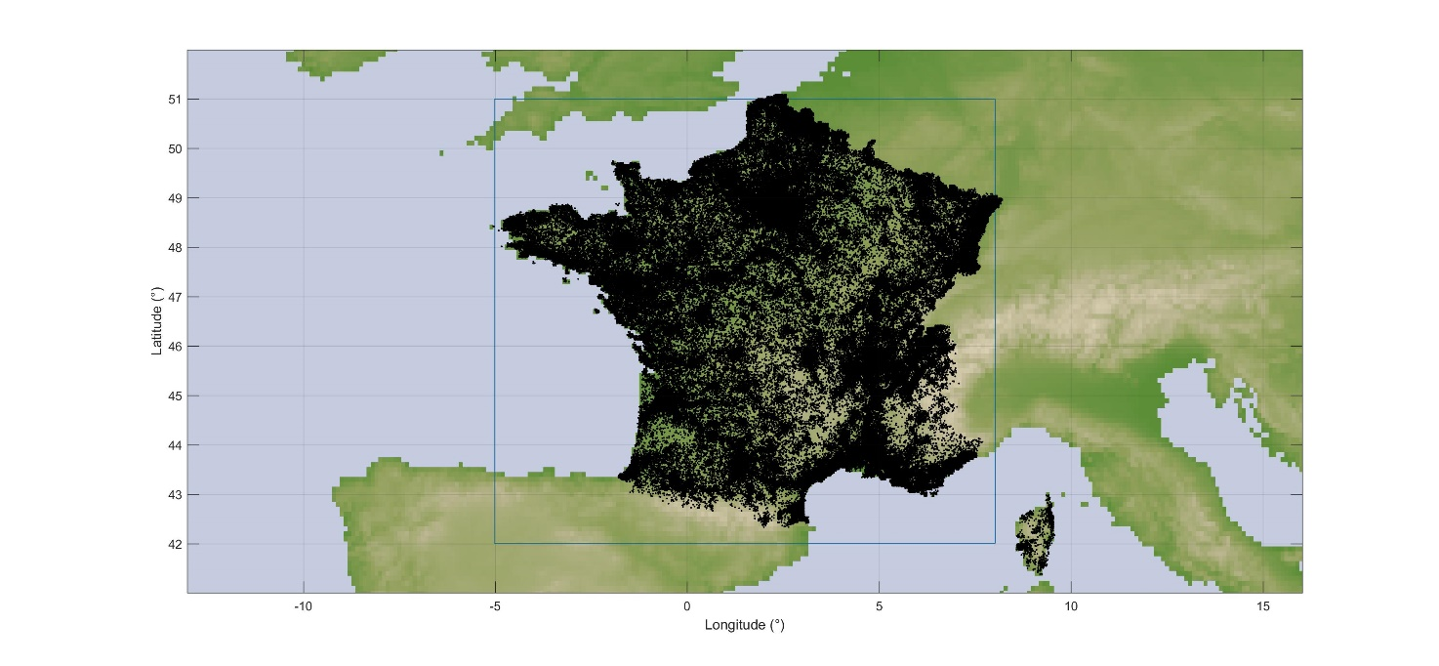

Figure 2B

RLAN deployment and measurements area over Paris metropolitan (91 513 RLANs for D2-low)

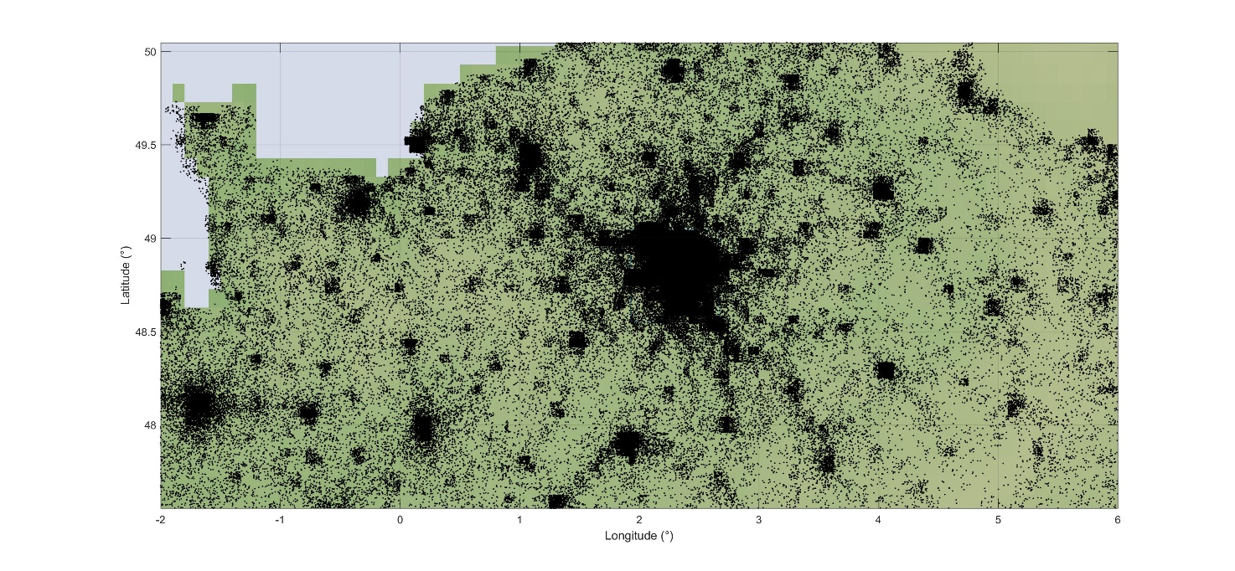

Figure 2C

RLAN deployment and measurements area over the Netherlands (150 727 RLANs for D2-low)

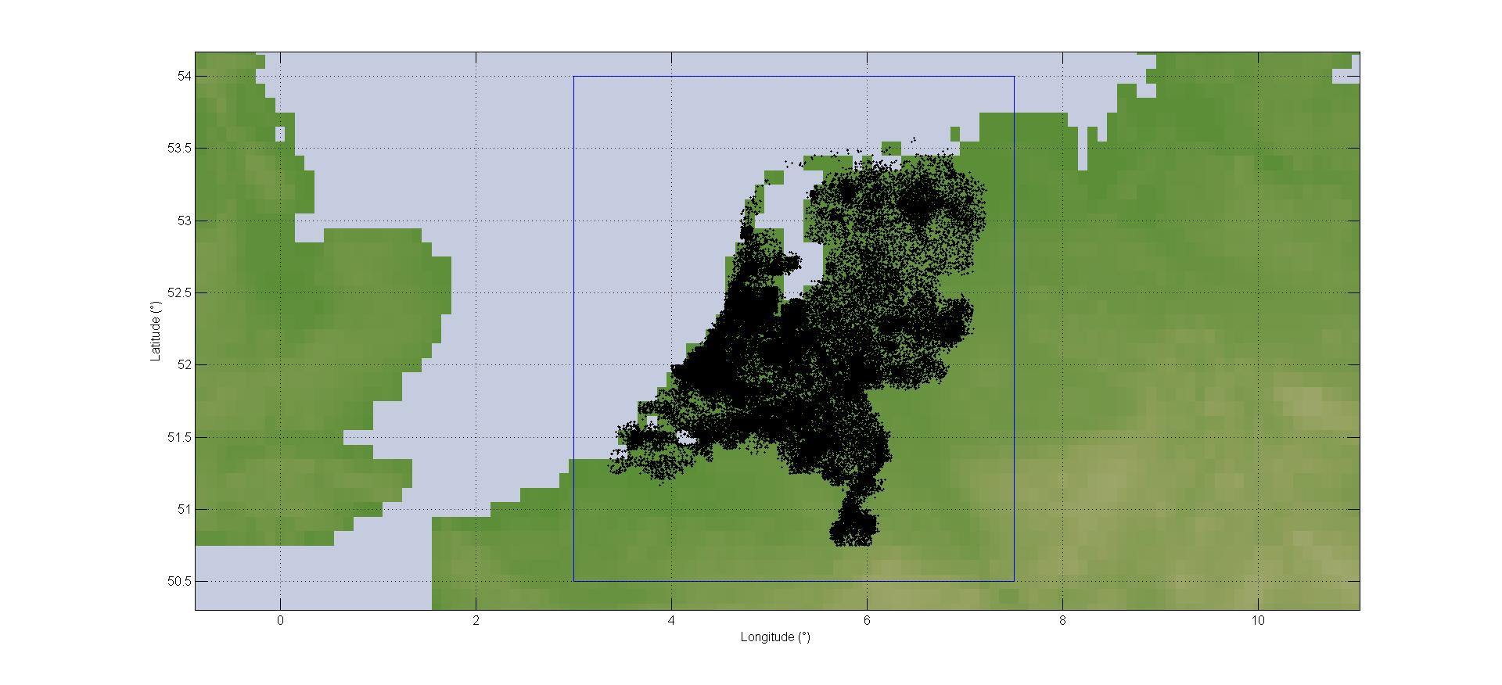

Figure 2D

RLAN deployment and measurements area over the UK (567 918 RLANs for D2-low)

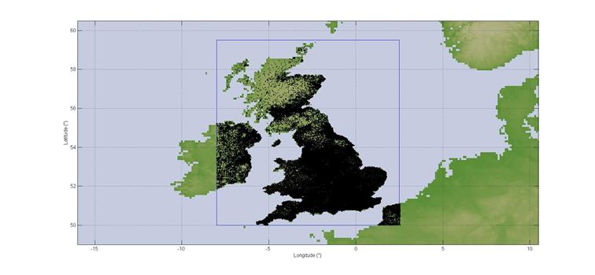

### 3.2.2 Dynamic analyses conditions

Simulations have been run for the SRAL sensor on board Sentinel-3 with a **time step of 1 second and for a period of 30 days**.

At each step of the simulation (i.e. corresponding to 1 s dynamic of the EESS satellite), the interference to the EESS (active) sensor from each RLAN in visibility is calculated (taking into account the EESS antenna pattern to determine the relative gain), hence leading to an aggregate interference.

The percentage of time of interference is calculated with reference to the measurement area, which means that only the time steps when the sensor antenna boresight is within the blue area are retained for the calculation of the percentage of time of interference.

Then, compiling the aggregate interference over the whole steps of the simulations allows to deriving the interference distribution that will be compared to the EESS (active) protection criteria.

The SRAL sensor has been considered with an antenna pointing at nadir with a payload active 100% of the time.

### 3.2.3 Dynamic analyses results over France

On this basis, Figure 3 gives the cumulative distribution function of interference for deployment of 592 142 RLANs over France (Option D2-low) and antenna Option A1.

Figure 3

Interference for Sentinel-3 (Over France – options A1 and D2-low)

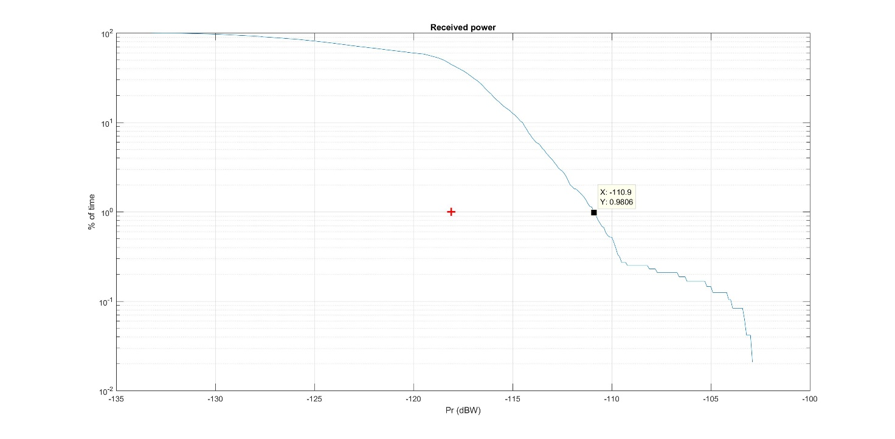

It can be seen that the EESS (active) protection criterion **is exceeded by 7.1 dB (–110.9 dBW)**.

It can also be seen that the interference level corresponding to the protection criteria is exceeded for more than 30% of the time. The situation is also depicted on Figure 4 below showing in red the interfered portion of images (vs the non-interfered in white).

Figure 4

Interfered portion of images (in red) vs non-interfered (in white) (Over France – options A1 and D2-low)

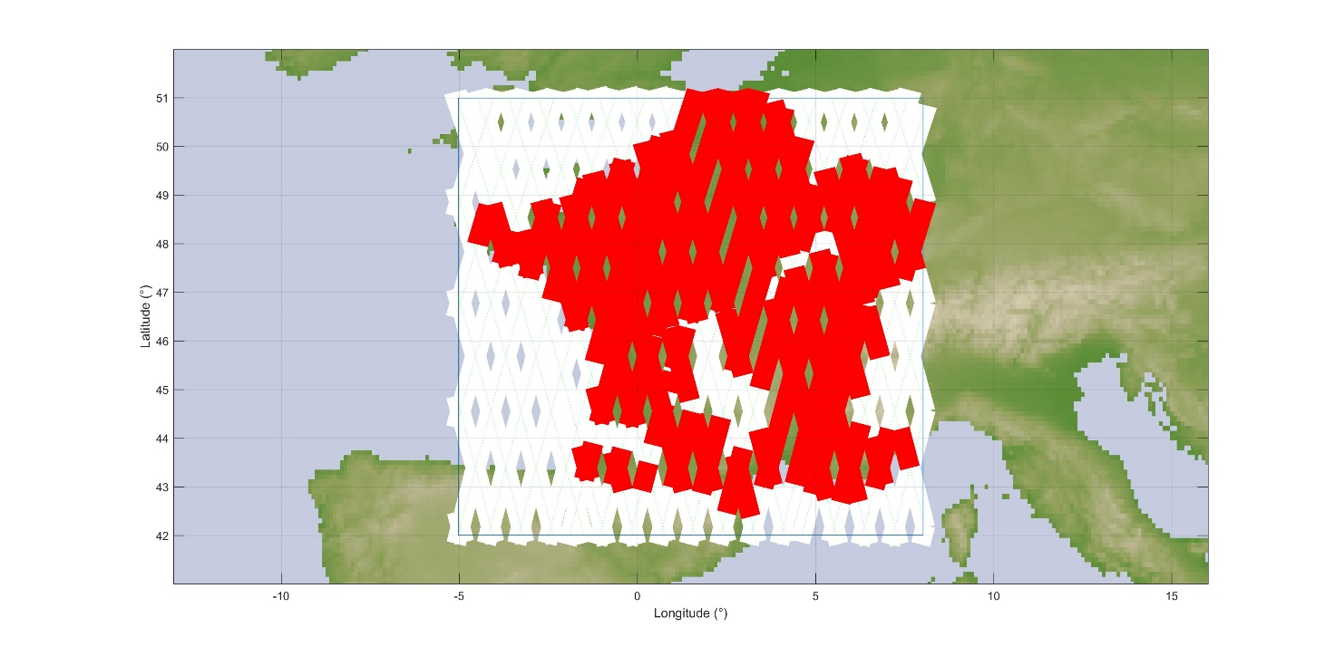

In addition, Figure 5 gives the cumulative distribution function of interference for deployment of 318 019 RLANs over France (Option D1) and antenna Option A1.

Figure 5

Interference for Sentinel-3 (Over France – options A1 and D1)

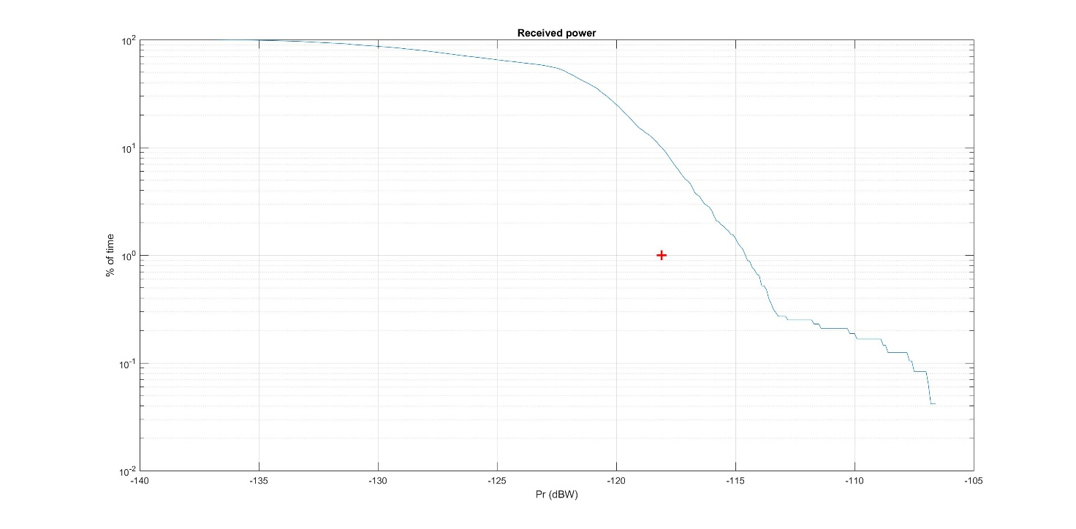

It can be seen that the EESS (active) protection criterion **is exceeded by 3.4 dB (–114.6 dBW)**.

It can also be seen that the interference level corresponding to the protection criteria is exceeded for more than 10% of the time. The situation is also depicted on Figure 6 below showing in red the interfered portion of images (vs the non-interfered in white).

Figure 6

Interfered portion of images (in red) vs non-interfered (in white) (Over France – options A1 and D1)

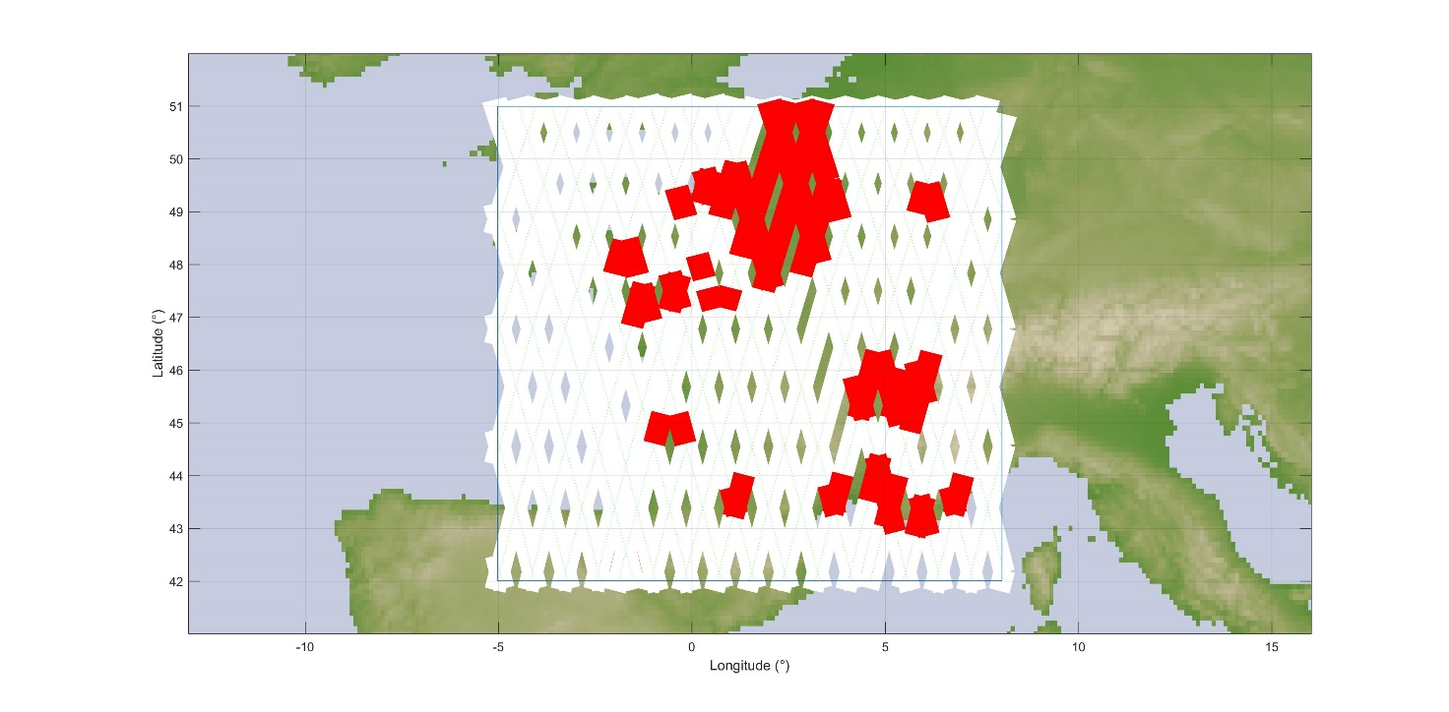

It appears obvious that in these situations, the Sentinel-3 sensor will be totally ineffective over most land and coastal areas, in particular all urban and suburban areas.

Finally, Table 10 provides the levels of interference in excess for the 3 RLAN density options (D1, D2-low and D2-High) and antenna Options A1 and A3.

Table 10

Interference in excess (over France)

|  |  |  |  |  |
| --- | --- | --- | --- | --- |
| Scenario | Active RLAN density (Nb per inhabitant per 320 MHz) | Nb of active RLAN over France  (in 320 MHz) | Interference in excess for antenna  Option A1 | Extrapolated for antenna Option A3  (A1 – 4 dB) |
| JTG Option D1 | 0.0048 | 318 019 | **3.4 dB** | **-0.6 dB** |
| JTG Option D2-low | 0.00897 | 592 142 | **7.1 dB** | **3.1 dB** |
| JTG Option D2-high  (D2-Low +10 dB) | 0.0897 | 5 921 422 | **17.1 dB** | **13.1 dB** |

### 3.2.4 Dynamic analyses results over Paris metropolitan

Under the same principle, the following Figure 7 gives the cumulative distribution functions of interference corresponding to a deployment of 592 142 RLANs over France, including 91 513 RLANs over Paris metropolitan area (Option D2-low) and antenna Option A1.

Figure 7

Interference for Sentinel-3 (Over Paris Metro – options A1 and D2-low)

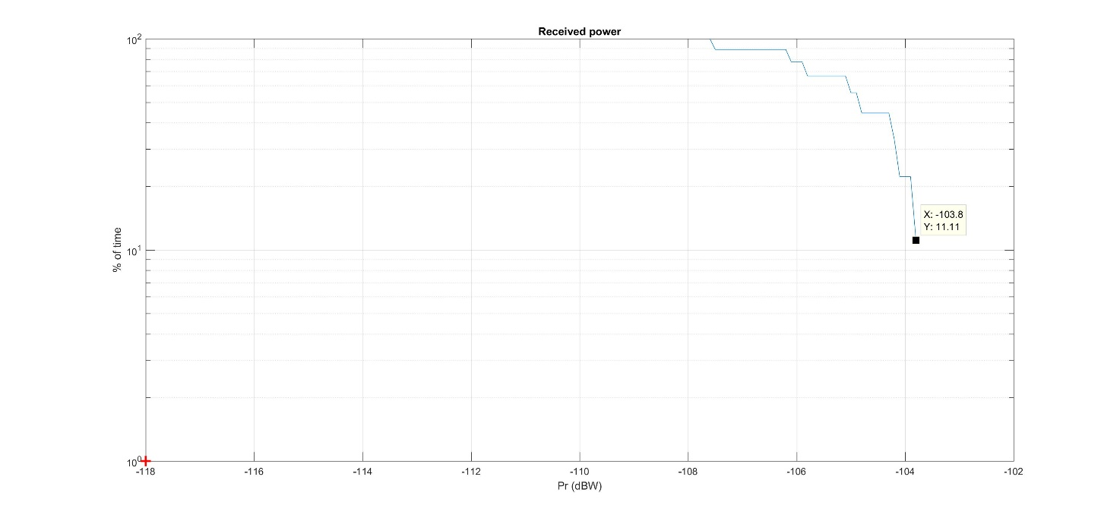

It can be seen that the EESS (active) protection criterion **is largely exceeded by 14.2 dB   
(–103.8 dBW)**. (The interference level corresponding to the protection criteria **is exceeded for 100 % of the time.**)

Similarly, the following Figure 8 gives the cumulative distribution functions of interference corresponding to a deployment of 318 019 RLANs over France, including 49 148 RLANs over Paris metropolitan area (Option D1) and antenna Option A1.

Figure 8

Interference for Sentinel-3 (Over Paris Metro – options A1 and D1)

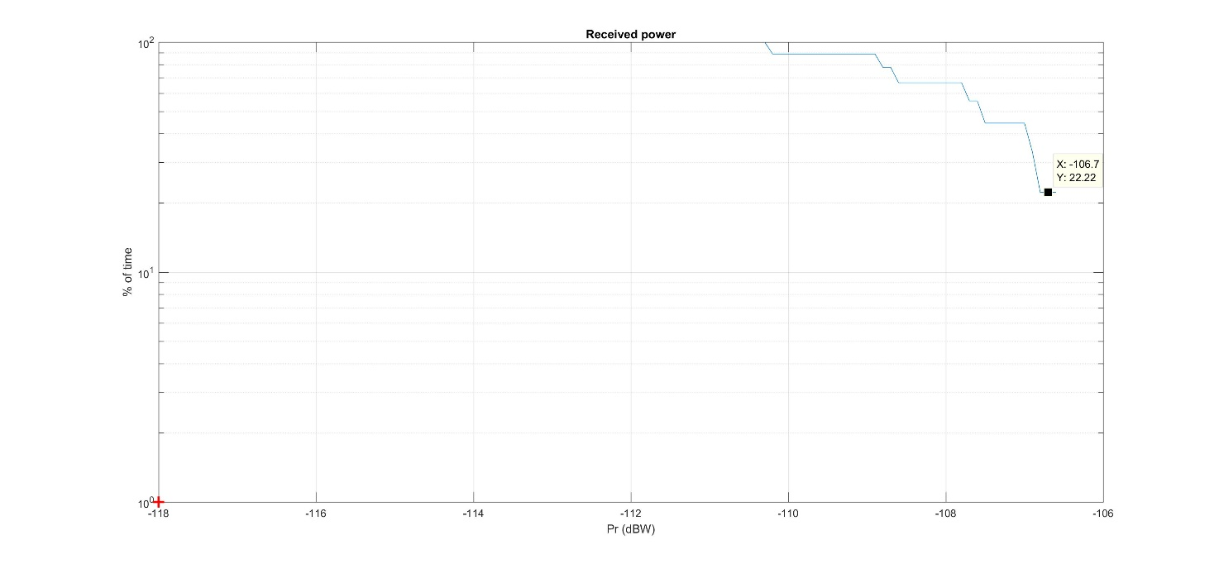

It can be seen that the EESS (active) protection criterion **is largely exceeded by 11.3 dB   
(–106.7 dBW)**. (The interference level corresponding to the protection criteria **is exceeded 100 % of the time.**)

Finally, Table 11 provides the levels of interference in excess for the 3 RLAN density options (D1, D2-low and D2-High) and antenna Options A1 and A3.

Table 11

Interference in excess (over Paris metropolitan)

|  |  |  |  |  |
| --- | --- | --- | --- | --- |
| Scenario | Active RLAN density (Nb per inhabitant per 320 MHz) | Nb of active RLAN over Paris Metro (in 320 MHz) | Interference in excess for antenna  Option A1 | Extrapolated for antenna Option A3  (A1 – 4 dB) |
| JTG Option D1 | 0.0048 | 49 148 | **11.3 dB** | **7.3 dB** |
| JTG Option D2-low | 0.00897 | 91 513 | **14.2 dB** | **10.2 dB** |
| JTG Option D2-high  (D2-Low +10 dB) | 0.0897 | 915 129 | **24.2 dB** | **20.2 dB** |

### 3.2.5 Dynamic analyses results over the Netherlands

Under the same principle, the following Figure 9 gives the cumulative distribution functions of interference corresponding to a deployment of 150 727 RLANs over the Netherlands (Option D2‑low) and antenna Option A1.

Figure 9

Interference for Sentinel-3 (Over the Netherlands – options A1 and D2-low)

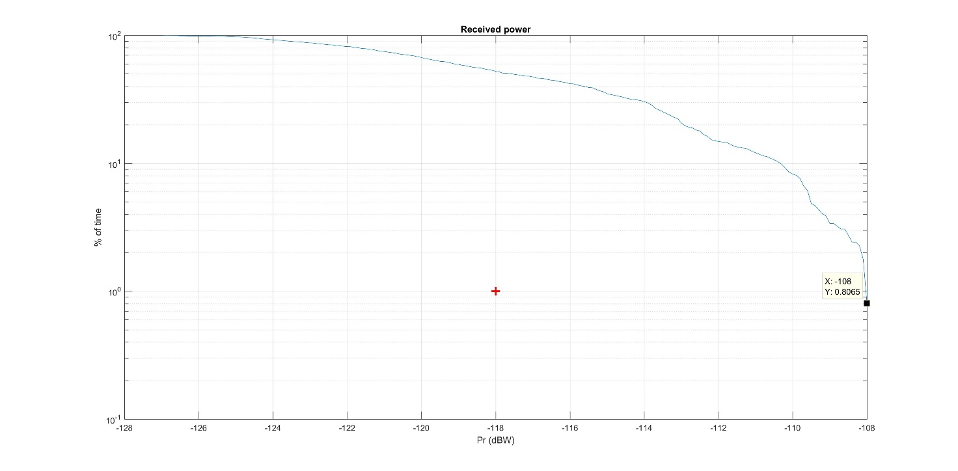

It can be seen that the EESS (active) protection criterion **is largely exceeded by 10 dB   
(–-108 dBW)**.

It can also be seen that the interference level corresponding to the protection criteria is exceeded for more than 50% of the time. The situation is also depicted on Figure 10 below showing in red the interfered portion of images (vs the non-interfered in white).

Figure 10

Interfered portion of images (in red) vs non-interfered (in white)   
(Over the Netherlands – options A1 and D2-low)

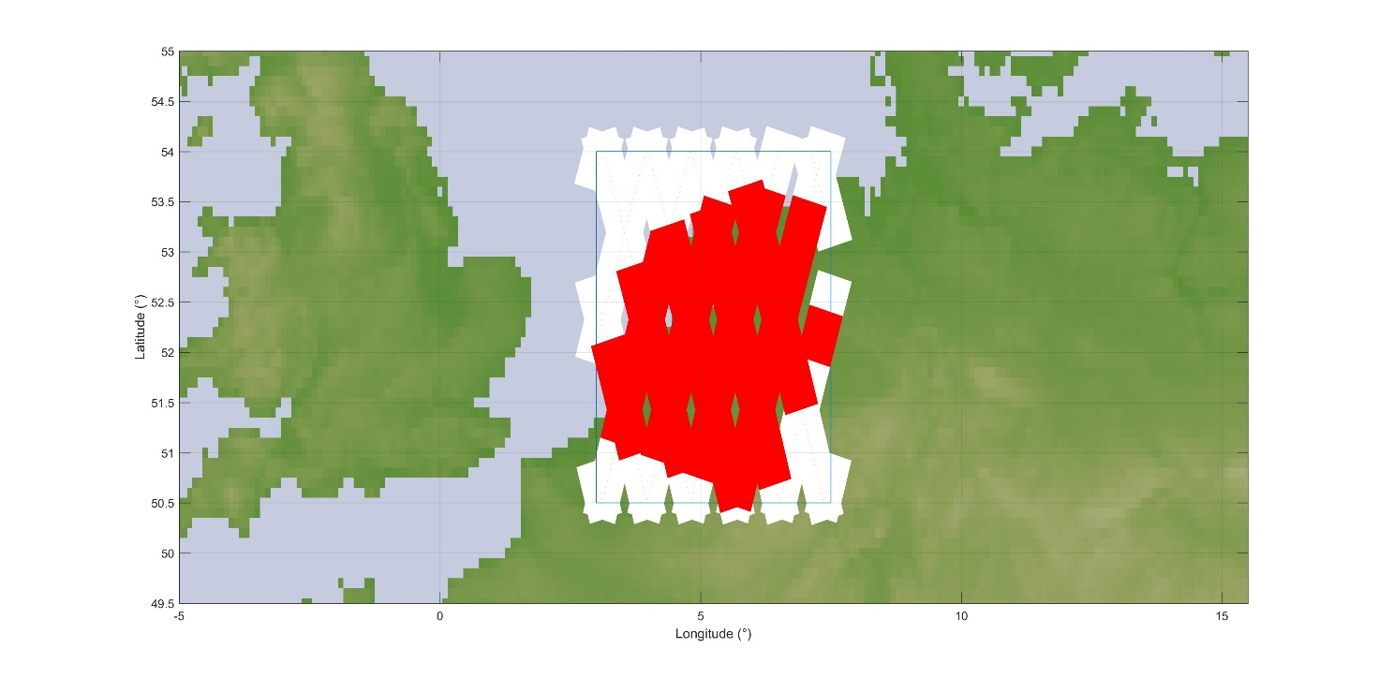

It appears obvious that in this situation (150 727 active RLAN corresponding to 0.00897 active RLAN per inh.), the Sentinel-3 sensor will be totally ineffective over the Netherlands.

Finally, Table 12 provides the levels of interference in excess for the 3 RLAN density options (D1, D2-low and D2-High) and antenna Options A1 and A3.

Table 12

Interference in excess (over the Netherlands)

|  |  |  |  |  |
| --- | --- | --- | --- | --- |
| Scenario | Active RLAN density (Nb per inhabitant per 320 MHz) | Nb of active RLAN over the Netherlands (in 320 MHz) | Interference in excess for antenna  Option A1 | Extrapolated for antenna Option A3  (A1 – 4 dB) |
| JTG Option D1 (D2-Low –3 dB) | 0.0048 | 80 950 | **7 dB** | **3 dB** |
| JTG Option D2-low | 0.00897 | 150 727 | **10 dB** | **6 dB** |
| JTG Option D2-high  (D2-Low +10 dB) | 0.0897 | 1 507 270 | **20 dB** | **16 dB** |

### 3.2.6 Dynamic analyses results over the UK

Figure 11 gives the cumulative distribution function of interference for deployment of 567 918 RLANs over the United Kingdom (Option D2-low) and antenna Option A1.

Figure 11

Interference for Sentinel-3 (Over the UK – options A1 and D2-low)

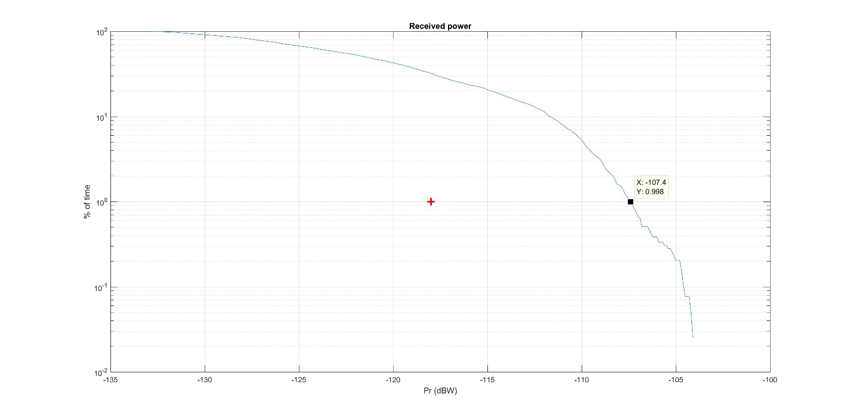

It can be seen that the EESS (active) protection criterion **is exceeded by 10.6 dB (–-107.4 dBW)**.

It can also be seen that the interference level corresponding to the protection criteria is exceeded for more than 30% of the time. The situation is also depicted on Figure 12 below showing in red the interfered portion of images (vs the non-interfered in white).

Figure 12

Interfered portion of images (in red) vs non-interfered (in white)   
(Over the UK – options A1 and D2-low)

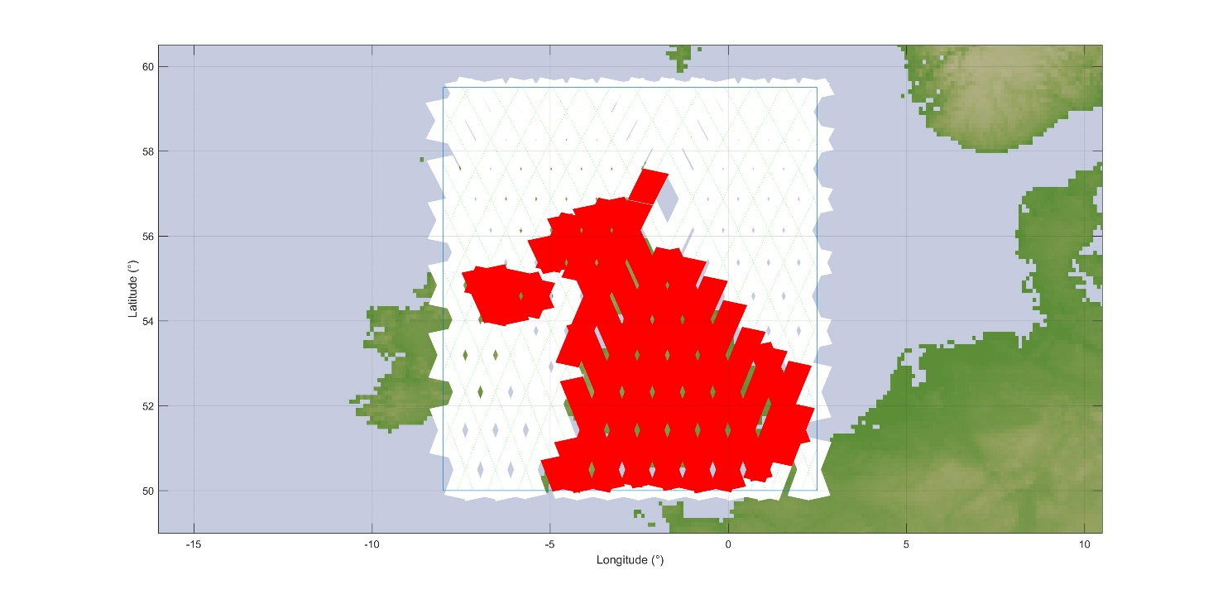

In addition, Figure 13 gives the cumulative distribution function of interference for deployment of 305 009 RLANs over the UK (Option D1) and antenna Option A1.

Figure 13

Interference for Sentinel-3 (Over the UK – options A1 and D1)

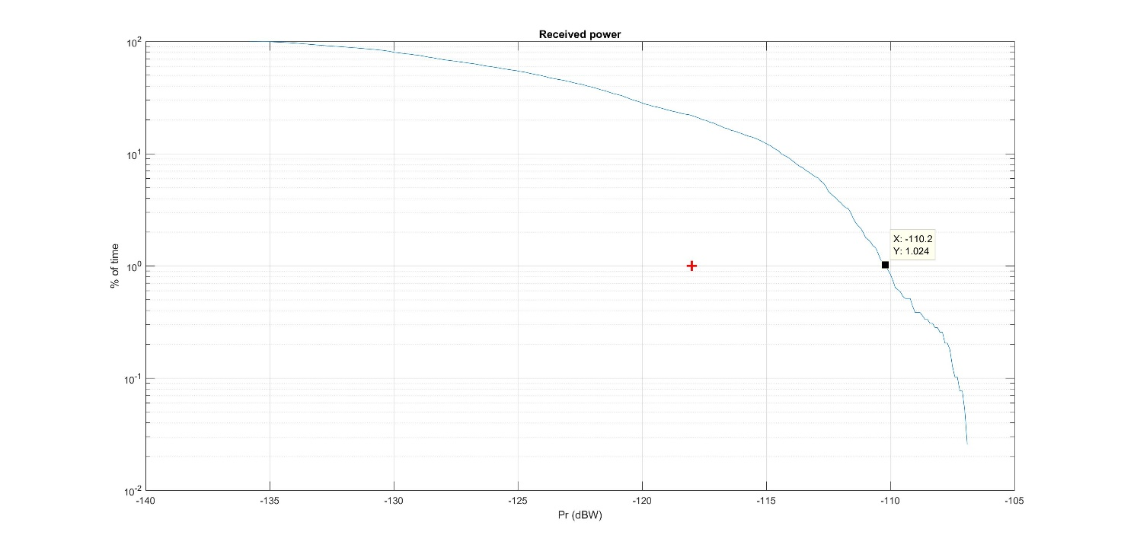

It can be seen that the EESS (active) protection criterion **is largely exceeded by 7.8 dB   
(–110.2 dBW)**.

It can also be seen that the interference level corresponding to the protection criteria is exceeded for more than 20% of the time. The situation is also depicted on Figure 14 below showing in red the interfered portion of images (vs the non-interfered in white).

Figure 14

Interfered portion of images (in red) vs non-interfered (in white)   
(Over the UK – JTG options A1 and D1)

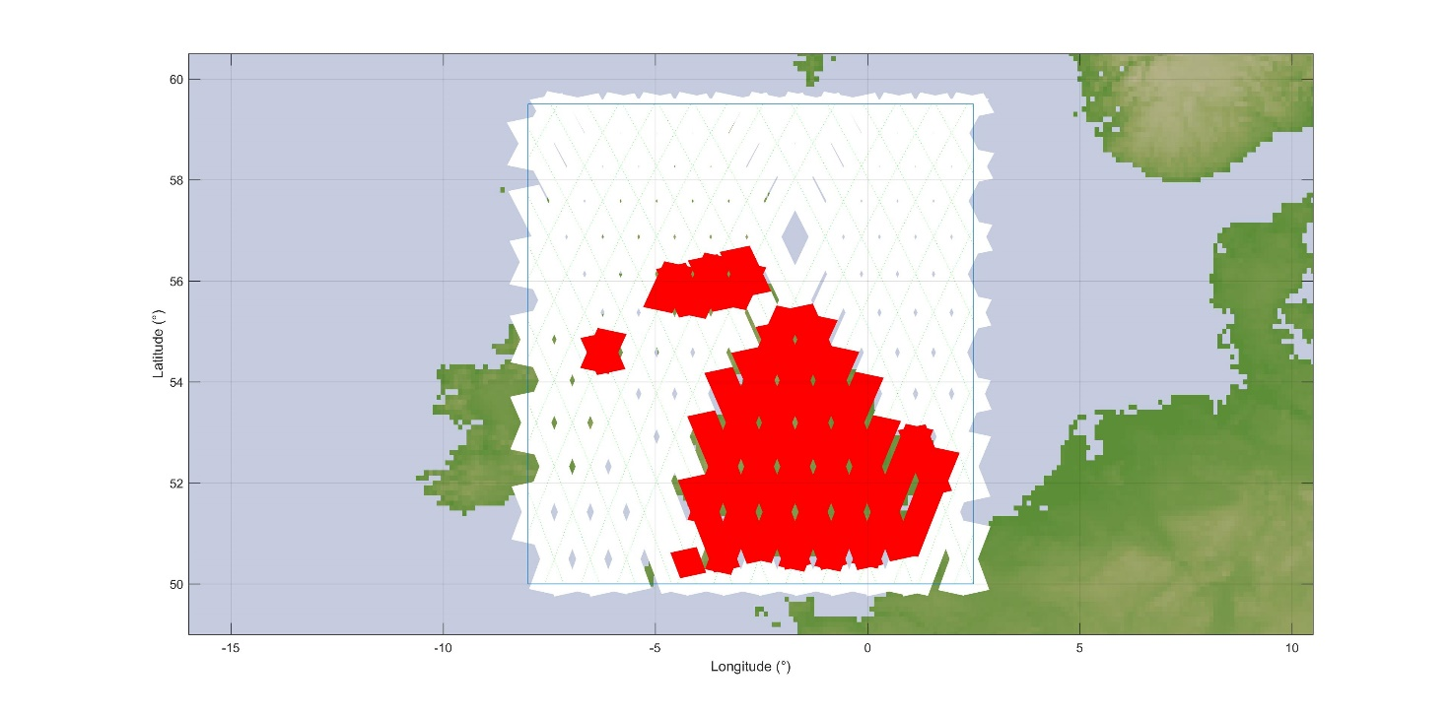

It appears obvious that in these situations, the Sentinel-3 sensor will be totally ineffective over most land and coastal areas, in particular all urban and suburban areas.

Finally, Table 13 provides the levels of interference in excess for the 3 RLAN density options (D1, D2-low and D2-High) and antenna Options A1 and A3.

Table 13

Interference in excess (over the UK)

|  |  |  |  |  |
| --- | --- | --- | --- | --- |
| Scenario | Active RLAN density (Nb per inhabitant per 320 MHz) | Nb of active RLAN over the UK (in 320 MHz) | Interference in excess for antenna  Option A1 | Extrapolated for antenna Option A3 (A1 – 4 dB) |
| JTG Option D1 | 0.0048 | 305 009 | **7.8 dB** | **3.8 dB** |
| JTG Option D2-low | 0.00897 | 567 918 | **10.6 dB** | **6.6 dB** |
| JTG Option D2-high (D2-Low +10 dB) | 0.0897 | 5 679 180 | **20.6 dB** | **16.6 dB** |

### 3.2.7 Dynamic analyses results over London metropolitan

Figure 15 gives the cumulative distribution functions of interference corresponding to a deployment of 567 918 RLANs over the UK, including 115 737 RLANs over London metropolitan area (Option D2-low) and antenna Option A1.

Figure 15

Interference for Sentinel-3 (Over London Metro – options A1 and D2-low)

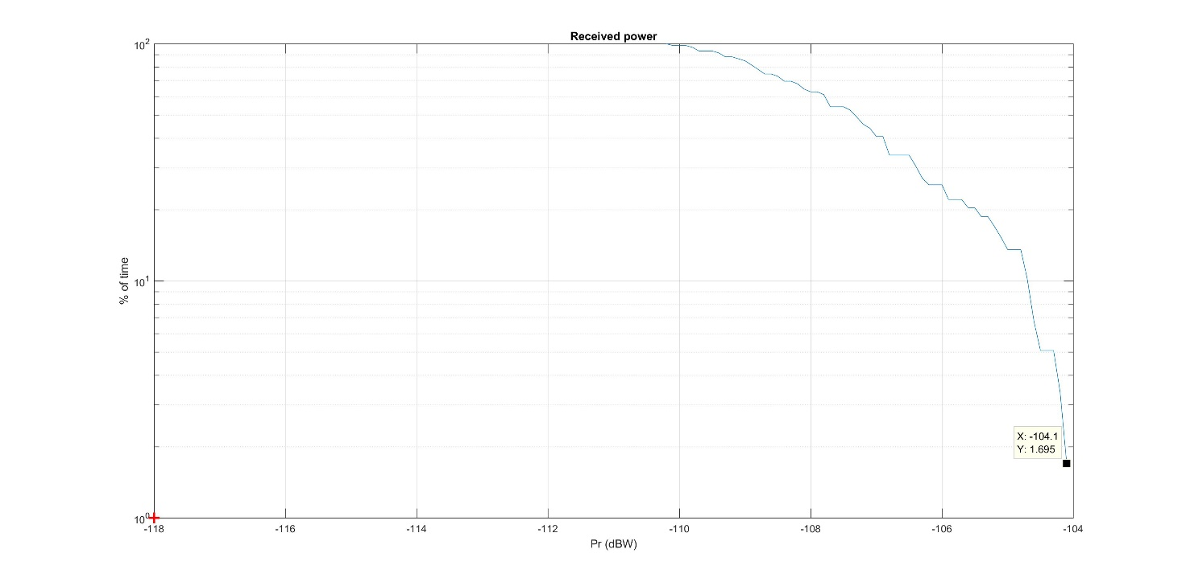

It can be seen that the EESS (active) protection criterion **is largely exceeded by 16.6 dB   
(–104.1 dBW)**.

It can also be seen that the interference level corresponding to **the protection criteria is exceeded for 100% of the time**.

Finally, Table 14 provides the levels of interference in excess for the 3 RLAN density options (D1, D2-low and D2-High) and antenna Options A1 and A3.

Table 14

Interference in excess (over London metropolitan)

|  |  |  |  |  |
| --- | --- | --- | --- | --- |
| Scenario | Active RLAN density (Nb per inhabitant per 320 MHz) | Nb of active RLAN over London Metro (in 320 MHz) | Interference in excess for antenna Option A1 | Extrapolated for antenna Option A3 (A1 –4 dB) |
| JTG Option D1 (D2-Low –3 dB) | 0.0048 | 62 158 | **13.6 dB** | **9.6 dB** |
| JTG Option D2-low | 0.00897 | 115 737 | **16.6 dB** | **12.6 dB** |
| JTG Option D2-high (D2-Low +10 dB) | 0.0897 | 1 157 369 | **26.6 dB** | **22.6 dB** |

### 3.2.8 Dynamic analyses – Summary of results

The results of the dynamic analysis over France are given below (see Table 10 above):

|  |  |  |  |  |
| --- | --- | --- | --- | --- |
| Scenario | Active RLAN density (Nb per inhabitant per 320 MHz) | Nb of active RLAN over France (in 320 MHz) | Interference in excess for antenna  Option A1 | Extrapolated for antenna Option A3  (A1 – 4 dB) |
| JTG Option D1 | 0.0048 | 318 019 | **3.4 dB** | **-0.6 dB** |
| JTG Option D2-low | 0.00897 | 592 142 | **7.1 dB** | **3.1 dB** |
| JTG Option D2-high  (D2-Low +10 dB) | 0.0897 | 5 921 422 | **17.1 dB** | **13.1 dB** |

The results of the dynamic analysis over Paris Metropolitan are given below (see Table 11 above):

|  |  |  |  |  |
| --- | --- | --- | --- | --- |
| Scenario | Active RLAN density (Nb per inhabitant per 320 MHz) | Nb of active RLAN over Paris Metro (in 320 MHz) | Interference in excess for antenna  Option A1 | Extrapolated for antenna Option A3  (A1 – 4 dB) |
| JTG Option D1 | 0.0048 | 49 148 | **11.3 dB** | **7.3 dB** |
| JTG Option D2-low | 0.00897 | 91 513 | **14.2 dB** | **10.2 dB** |
| JTG Option D2-high  (D2-Low +10 dB) | 0.0897 | 915 129 | **24.2 dB** | **20.2 dB** |

The results of the dynamic analysis over the Netherlands are given below (see Table 12 above):

|  |  |  |  |  |
| --- | --- | --- | --- | --- |
| Scenario | Active RLAN density (Nb per inhabitant per 320 MHz) | Nb of active RLAN over the Netherlands (in 320 MHz) | Interference in excess for antenna  Option A1 | Extrapolated for antenna Option A3  (A1 – 4 dB) |
| JTG Option D1 (D2-Low –3 dB) | 0.0048 | 80 950 | **7 dB** | **3 dB** |
| JTG Option D2-low | 0.00897 | 150 727 | **10 dB** | **6 dB** |
| JTG Option D2-high  (D2-Low +10 dB) | 0.0897 | 1 507 270 | **20 dB** | **16 dB** |

The results of the dynamic analysis over the UK are given below (see Table 13 above):

|  |  |  |  |  |
| --- | --- | --- | --- | --- |
| Scenario | Active RLAN density (Nb per inhabitant per 320 MHz) | Nb of active RLAN over the UK (in 320 MHz) | Interference in excess for antenna  Option A1 | Extrapolated for antenna Option A3 (A1 – 4 dB) |
| JTG Option D1 | 0.0048 | 305 009 | **7.8 dB** | **3.8 dB** |
| JTG Option D2-low | 0.00897 | 567 918 | **10.6 dB** | **6.6 dB** |
| JTG Option D2-high (D2-Low +10 dB) | 0.0897 | 5 679 180 | **20.6 dB** | **16.6 dB** |

The results of the dynamic analysis over London Metropolitan are given below (see Table 14 above):

|  |  |  |  |  |
| --- | --- | --- | --- | --- |
| Scenario | Active RLAN density (Nb per inhabitant per 320 MHz) | Nb of active RLAN over London Metro (in 320 MHz) | Interference in excess for antenna Option A1 | Extrapolated for antenna Option A3 (A1 –4 dB) |
| JTG Option D1 (D2-Low –3 dB) | 0.0048 | 62 158 | **13.6 dB** | **9.6 dB** |
| JTG Option D2-low | 0.00897 | 115 737 | **16.6 dB** | **12.6 dB** |
| JTG Option D2-high (D2-Low +10 dB) | 0.0897 | 1 157 369 | **26.6 dB** | **22.6 dB** |

Overall, in all cases, the above dynamic analyses confirm the result of static analyses, presenting interference largely exceeding EESS (active) protection criteria and allow to show that **there is no compatibility between RLAN and EESS (active) in the 5 GHz range.**

## 3.3 consideration of some additional parameters

In addition to the RLAN parameters given in section 2 above, PDN Report ITU-R RS.[EESS RLAN 5 GHz] mentions different parametric assumptions as follows:

– Outdoor ratio: consider 2% and 10% in addition to the agreed 5%.

– Indoor/outdoor attenuation: consider a fixed 17 dB in additional to the agreed “Gaussian 17 dB +-7 dB standard deviation”.

As expressed in Document [4-5-6-7/664](http://www.itu.int/md/R12-JTG4567-C-0664/en), and validated by dynamic simulations, the impact of these parametric parameters can be calculated as follows:

Aresult = 10 log(Or + (1-Or)10(-IOa/10)

where:

Aresult = resulting attenuation

Or = Outdoor ratio

IOa = Indoor/outdoor attenuation.

On this basis, the following Table 21 provides the corresponding results:

Table 21

Calculated attenuations due to the parametric parameters

|  |  |  |  |
| --- | --- | --- | --- |
|  | Outdoor ratio | | |
| Indoor/outdoor attenuation | 2% | 5% | 10% |
| Gaussian 17 dB + -7 dB (resulting in 12 dB) | 10.9  (-1.3) | 9.6  (0) | 8.0  (+1.6) |
| Fixed 17dB | 14.0  (-4.4) | 11.6  (-2) | 9.3  (+0.3) |

Note: The figures in brackets ( x) represent the difference compared to the JTG  
agreed scenario (in Red: 5% Outdoor ratio and “Gaussian 17 dB + -7 dB”)

It can therefore be seen that the potential impact of the parametric assumptions mentioned in JTG ranges **from a potential decrease of the interference of 4.4 dB up to an increase by 1.5 dB and will therefore not change the overall negative conclusions in previous sections**.

# 4 Summary

Under all scenarios and simulation methodologies (static and dynamic), the analyses show that RLAN deployment in 5 250-5 570 MHz within the 5 GHz range would create large interference in the SRAL sensor on board the Sentinel-3 satellite.

The static analyses presented above indicate that:

– the maximum density of outdoor RLANs (transmitting with the full e.i.r.p. of 200 mW) within the 1840 km² EESS (active) is less than 0.05 RLAN / km² (see section 3.1.1)

– Depending on the scenario (different number of active RLAN (D1 and D2) and RLAN antenna A1 and A3), the interference to the EESS (active) sensor will be **in excess of the relevant protection criteria by 6.2 to 22.9 dB** (see section 3.1.2)

The dynamic analyses presented above indicate that, depending on the scenario (different number of active RLAN (D1 and D2) and RLAN antenna A1 and A3), the interference to the EESS (active) sensor will be **in excess of the relevant protection criteria by** (for 0.0048 to 0.0897 active RLAN per inhabitant, respectively):

• **-0.6 to 17.1 dB** (case over France) *(see section 3.2.3)*

• **7.3. to 24.2 dB** (case over Paris metropolitan) *(see section 3.2.4)*

• **3 to 20 dB** (case over the Netherlands) *(see section 3.2.5)*

• **3.8 to 20.6 dB** (case over the UK) *(see section 3.2.6)*

• **9.6 to 26.6 dB** (case over London metropolitan) *(see section 3.2.7)*.

It has to be highlighted that these analyses were not considering a number of assumptions that would further increase these negative margins, such as an additional **apportionment factor of the protection criteria** (since the band is already shared with terrestrial radars). ESA stresses that this apportionment factor has not been introduced in the analysis given the already large negative results obtained under the assumption that no other services could generate interference to EESS (active).

Further, some assumptions related to RLAN remains unclear or unresolved and could also increase the potential interference to EESS (active). This covers in particular the possibilities given to a single RLAN to make use of multiple channels transmission (by means of either orthogonal transmissions or MIMO technique) or to concatenate multiple small channels to provide wider bandwidth with higher power. Such questioning also relates to other applications than RLAN since opening a band to RLAN, low power and unlicensed by nature, will drive the use of different applications such as SRDs, M2M, … (similarly to the current situation in the 2.4 GHz band) or LAA-LTE. Consideration of these additional applications would need to be taken into account.

**Overall, this document demonstrates and confirms that RLANs cannot share with EESS (active) in 5 250-5 570 MHz within the 5 GHz range, confirming that sharing between RLAN and EESS (active) in the 5 GHz range may only be feasible if additional RLAN mitigation measures are implemented.**

[EUMETSAT 5A/[97](https://www.itu.int/md/R15-WP5A-C-0097/en)]

ANNEX 4

Sharing studies between RLANs and EESS (active) scatterometer sensor  
(SCA sensor)

# 1 Introduction/Background

The present Annex addresses sharing between WAS/RLAN and EESS (active) scatterometers sensors, based on the EUMETSAT SCA sensor.

It provides static and dynamic analysis taking into account similar assumptions and ranges of RLAN 5 GHz parameters (e.g. antenna gain discrimination, devices densities, outdoor ratio, building attenuation) than those considered for analysis made for SAR sensors and given in Document [4-5-6-7/664](http://www.itu.int/md/R12-JTG4567-C-0664/en) (ESA).

# 2 Technical characteristics

## 2.1 EESS (active)

### 2.1.1 Parameters

The EESS (active) parameters and interference criteria used in the present studies are those provided by WP 7C to WP 5A in their liaison statement in Document [5A/38](http://www.itu.int/md/R15-WP5A-C-0038/en).

Table 1 gives the technical parameters for the SCA sensor on board EPS-SG satellites being developed by EUMETSAT.

Table 1

| Parameter | EPS-SG SCA |
| --- | --- |
| Sensor type | SCATTEROMETER |
| Orbital altitude (km) | 832 |
| Orbital inclination (degrees) | 98.7 |
| RF centre frequency (MHz) | 5 355 |
| Peak radiated power (W) | 2512 peak (92 average) |
| Polarisation | VV+VH |
| Antenna type | 6 x fan beam antennas (2 mid-beams at +- 90° azimuths and 4 side-beams at +-45° azimuth and +-135° azimuth) |
| Antenna gain (dBi) | 27-30 for mid-beams  23-31 for side-beams |
| Antenna pattern steering capability | No |
| Antenna pattern | See Below |
| Antenna orientation (degrees from nadir) | 17.5-45.5 (mid beams)  24-54 (side beams) |
| Receiver noise figure (dB) | 3.5 |
| Pulse/Receiver bandwidth (MHz) | 2 |
| Noise power (dBW) | –138 |
| Service area | Global |
| Footprint (km2) | 12 400 km² for mid-beams  21 000 km² for side-beams |

Concerning the polarisation, it is to be noted that EPS-SG SCA makes use of a dual linearly polarised antenna. Thus, no polarisation discrimination advantage can be taken into account.

### 2.1.2 Antenna pattern

The SCA antenna system is composed of 6 fan-beam antennas (with 1° aperture).

– 4 x SIDE-beams at 45°, 135°, 225° and 315° (with an antenna beam look angle from nadir ranging 24° to 54°).

– 2 x MID-beams at 90° and 270° (with an antenna beam look angle from nadir ranging 17.5° to 45.5°).

Corresponding footprints are synthetised on Figure 1 below.

Figure 1

SCA footprints

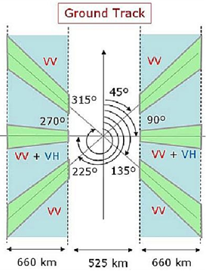

The antenna pattern model for sharing analysis is given as follows.

G = max(Gmin ; Gver+Ghor);

with:

Ghor = 10 x log (sinc(coefH.sin(Az))²)

coefH = 40

Az = Azimuth angle taken from the pointing angle of the antenna (in radians)

Gver = linear extrapolation from Table 2 (for MID and SIDE beam) with Elevation angle in degrees

Gmin = –10

Note: The cardinal sinc function is here used in its form: $sinc\left(x\right)=\frac{sin⁡(πx)}{πx}$

Table 2

**Specific antenna gain for linear extrapolation**

*Note: the elevation angles are given with reference (0°) at satellite Nadir*



The antenna pattern representation for each beam type (MID and SIDE) are given on Figures 1A, 1B, 2A and 2B for both vertical (at 0° azimuth) and horizontal (at elevation corresponding to the maximum gain, i.e. 45° (MID) and 55° (SIDE).

Figure 1A

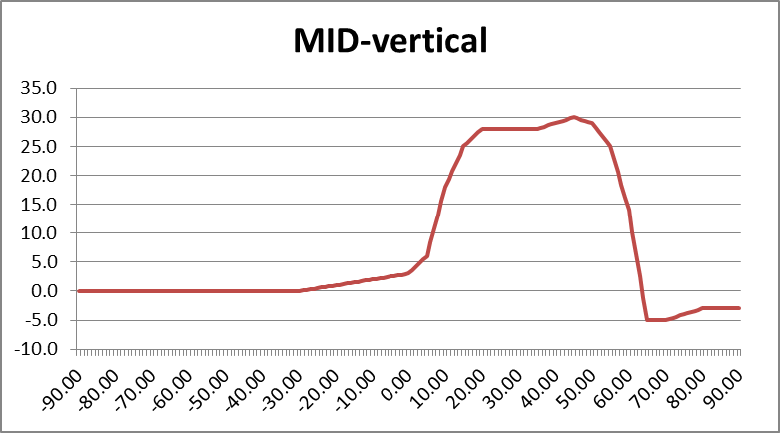

Figure 2B

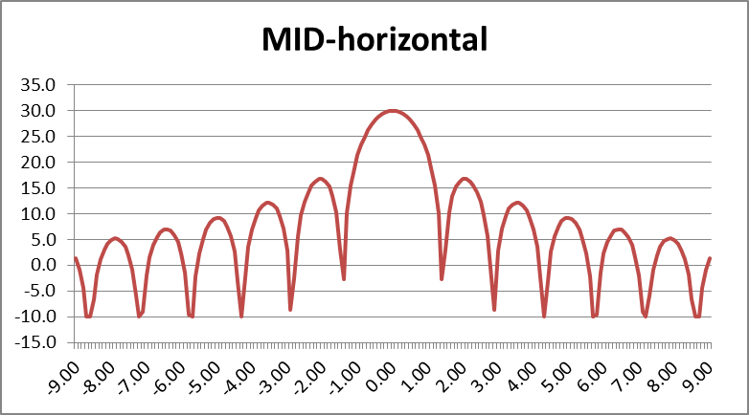

Figure 2A

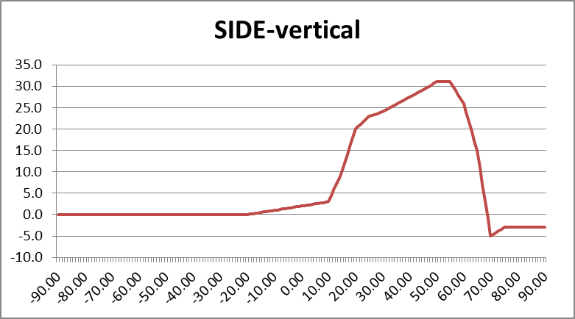

Figure 2B

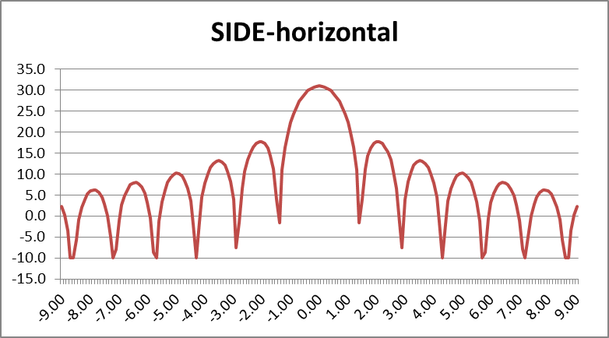

### 2.1.3 Protection criteria

The relevant protection criteria is given in Table 3, taken from Recommendation ITU-R RS.1166-4. Even if RLANs are nomadic/mobile by nature, their very high density implies that the interference will be systematic. The relevant percentage of data availability, corresponding to the percentage of time, is therefore 99% (see Document [5A/38](http://www.itu.int/md/R15-WP5A-C-0038/en))

Table 3

|  |  |  |  |  |
| --- | --- | --- | --- | --- |
| Sensor type | Interference criteria | | Data availability criteria (%) | |
| Performance degradation | *I*/*N* (dB) | Systematic | Random |
| Scatterometer | 8% degradation in measurement of normalized radar backscatter to deduce wind speeds | –5 | 99 | 95 |

For the SCA instrument, the protection criteria calculated over a 2 MHz bandwidth is –143 dBW  
(-113 dBm) not to be exceeded more than 1% of the time.

This criteria is applied over data acquisition periods of time when the sensor is operating over the measurement area of interest (as per Recommendation ITU-R RS.1166-4).

## 2.2 Mobile service (WAS/RLAN)

RLAN parameters used in the present studies are those agreed in the previous study period and given in the preliminary draft new Report ITU-R RS.[EESS RLAN 5 GHz] (see Annex 35 to Document 4-5-6-7/715 (Chairman’s Report)):

– e.i.r.p. distribution:

|  |  |  |  |  |
| --- | --- | --- | --- | --- |
| RLAN e.i.r.p. Level | 200 mW (Omni-Directional) | 80 mW (Omni-Directional) | 50 mW (Omni-Directional) | 25 mW (Omni-Directional) |
| RLAN Device Percentage | 19% | 27% | 15% | 39% |

Note: Such distribution corresponds to a 19 dBm average e.i.r.p.

– Indoor/outdoor:

Outdoor ratio: 5% (RLAN devices are assumed to be indoors only, based on the requirement to help facilitate coexistence. For the purposes of sharing studies, 5% of the devices should be modelled without building attenuation)

– Channel Bandwidth distribution:

|  |  |  |  |  |
| --- | --- | --- | --- | --- |
| Channel bandwidth | 20 MHz | 40 MHz | 80 MHz | 160 MHz |
| RLAN Device Percentage | 10% | 25% | 50% | 15% |

– Bandwidth factor:

The bandwidth factor (BWF) used in this document is derived taking into account the positioning of an EESS (active) 2 MHz bandwidth over the RLAN raster/channel plan, as shown below.



On this basis, the following bandwidth factors are considered (see details in Annex 2):

• 160 MHz (15% of RLANs): 1 channel overlaps by 2 MHz.

– BWF = 10 *log(2/160) = -19 dB

• 80 MHz (50% of RLANS): 1 channel overlaps by 2 MHz.

– BWF = 10 *log(2/80) = -16 dB

• 40 MHz (25% of RLANS): 1 channel overlaps by 2 MHz.

– BWF = 10 *log(2/40) = -13 dB

• 20 MHz (10% of RLANS): 1 channel overlaps by 2 MHz.

– BWF = 10 *log(2/20) = -10 dB

Overall, considering all bandwidth, this represent an average BWF = -16 dB

– Propagation conditions:

• building attenuation with a Gaussian distribution (17 dB + 7 dB) truncated at 1 dB, as described in the figure below:



Note: when used to calculate aggregate interference from multiple sources (as in the present case), the impact of this distribution is similar to the one leading from a 12 dB average attenuation.

• Angular clutter loss model from Recommendation ITU-R P.452 associated with RLAN heights distributions and specific parameters for Urban, Suburban and Rural environments. The antenna heights are randomly selected using a uniform probability distribution from the set of floor heights at 3 meter steps. It should be noted that due to the EESS (active) geometry this model leads to no attenuation.



Antenna height

|  |  |
| --- | --- |
| **RLAN deployment region** | **Antenna height (metres)** |
| Urban | 1.5 to 28.5 |
| Suburban | 1.5, 4.5 |
| Rural | 1.5, 4.5 |

– Antenna gain/discrimination (Omnidirectional in azimuth for all scenarios)

• Option A1: Omnidirectional in elevation with 0 dBi gain

• Option A3: An average 4 dB antenna discrimination is applied to the e.i.r.p. level distribution above in the direction of the satellite Omnidirectional in elevation with 0 dBi gain

Note: since Option A3 is proposing a fixed discrimination of 4 dB, corresponding results can therefore be extrapolated by shifting by 4 dB the results obtained with Option A1 (0 dBi).

– Number of active RLAN:

• Option D1: 11 279 active devices per 100 MHz channel per 5.25 million inhabitants (so-called “Sim City” with 5.25 M inhabitants).

• Option D2: from 0.004 (D2-low) to 0.04 (D2-high) per 100 MHz channel per inhabitant.

Extrapolation of these numbers from a 100 MHz bandwidth to a 2 MHz bandwidth is detailed in Annex 2 and leads to the following figures:

• Option D1: 5786 active devices per 2 MHz channel per 5.25 million inhabitants (Sim City), i.e. a density of 0.0011 RLAN per inhabitant.

• Option D2-Low: 10773 active devices per 2 MHz channel per 5.25 million inhabitants (Sim City), i.e. a density of 0.0021 RLAN per inhabitant.

• Option D2-High: 107722 active devices per 2 MHz channel per 5.25 million inhabitants (Sim City), i.e. a density of 0.021 RLAN per inhabitant.

These factors lead to the following number of active RLAN to be considered over the French territory (with a population of 66 M inh.) and the UK territory (with a population of 63.3 M inh.):

|  |  |  |  |
| --- | --- | --- | --- |
|  | Nb of active RLAN per inhabitant | Nb of active RLAN over France  (in 2 MHz) | Nb of active RLAN over UK  (in 2 MHz) |
| Option D1 | 0.0011 per inh. | 72 738 | 69 763 |
| Option D2 | Low (0.0021 per inh.) | 135 432 | 129 892 |
| High (0.021 per inh.) | 1 354 319 | 1 298 916 |

Detailed deployment assumptions are described in the analysis sections.

# 3 Analysis

Analyses based on static and dynamic methodologies have been used to address the compatibility between WAS/RLAN and EESS (active) altimeter in the 5 GHz range:

– Section 3.1: static analyses.

– Section 3.2: dynamic analyses based on existing population densities.

## 3.1 Static analyses

### 3.1.1 Single entry static analysis

The following Table 4 provides calculation of the impact of 1 single outdoor RLAN on EESS (active) SCA sensor, for both MID and SIDE beams described in Table 1 above.

Table 4

| Parameter | SCA  SIDE beam | SCA  MID beam |
| --- | --- | --- |
| Frequency (MHz) | 5355 | 5355 |
| Orbital altitude (km) | 832 | 832 |
| Off Nadir Angle (°) (at center beam) | 39 | 31.5 |
| Slant path distance (km) | 1121 | 1001 |
| Free Space losses (dB) | 168.0 | 167.0 |
| EESS antenna gain (dBi)(average over footprint) | 27.1 | 27.5 |
| **EESS protection criteria (dBm/2 MHz)** | **–113** | **–113** |
| RLAN EIRP (dBm) | 23 | 23 |
| Bandwidth factor for 20 MHz RLAN (dB) | 10 | 10 |
| **Interference from 1 outdoor RLAN (dBm)** | **-127.9** | **-126.5** |
| Margin for 1 outdoor RLAN (dB) | 14.9 | 13.5 |
| **Nb of outdoor RLAN in the EESS footprint to reach the protection criteria** | **31** | **23** |

This calculations shows that, for the a SIDE beam, 31 outdoor RLANs transmitting with the full e.i.r.p. of 200 mW within the 21 000 km² footprint are sufficient to interfere with the SCA sensor.

Similarly, for the a MID beam, 23 outdoor RLANs transmitting with the full e.i.r.p. of 200 mW within the 12 400 km² footprint are sufficient to interfere with the SCA sensor.

This represents a maximum density of 0.0015 and 0.0018 RLAN / km², respectively.

### 3.1.2 Static analysis based on EESS (active) footprint shape

The following analysis provides calculation of the aggregate RLAN impact on EESS (active) considering the so-called ‘Sim City” (circular based) with the footprint shape of the EESS (active) system, as shown on the Figure 3 below.

Figure 3

RLAN deployment and EESS (active) footprint

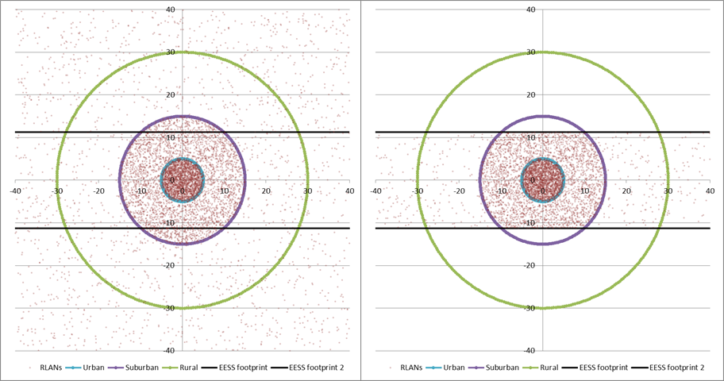

Considering the size of the EESS (active) scatterometer footprints (with lengths of 660 km (MID beam) and 930 km (SIDE beam)), they largely extend out of the circular based RLAN deployment and limiting calculation to this deployment only would artificially limit the interference. To avoid this, the portion of the EESS (active) scatterometer footprints outside of the circular based “Sim city” have been considered covering rural areas.

In this case, the percentage of RLAN within the EESS (active) footprint (as on the right figure) can be calculated as in Tables 5A and 5B below (considering footprint widths at center footprint of 18.9 km (MID beam) and 22.6 km (SIDE beam)).

Table 5A

|  |  |  |  |  |
| --- | --- | --- | --- | --- |
| SIDE  beam | Distance (km) | Area (km²) | Area enclosed in EESS footprint (km²) | Ratio of RLAN within the EESS footprint |
| Urban | 5 | 79 | 79 | 100% |
| Suburban | 15 | 628 | 527 | 84% |
| Rural | 30 | 2 121 | 715 | 34% |
| Rural (outside the city) |  |  | 19 680 |  |

Table 5B

|  |  |  |  |  |
| --- | --- | --- | --- | --- |
| MID  beam | Distance (km) | Area (km²) | Area enclosed in EESS footprint (km²) | Ratio of RLAN within the EESS footprint |
| Urban | 5 | 79 | 79 | 100% |
| Suburban | 15 | 628 | 447 | 71% |
| Rural | 30 | 2 121 | 586 | 28% |
| Rural (outside the city) |  |  | 11 288 |  |

To consider potential interference from RLAN deployment on EESS (active) sensor, one can therefore use these percentages to determine the total number of RLAN in the EESS (active) footprint, for both density Option D1 (total of 25297 RLAN within the overall city for 5.25 M inhabitants), the low edge of Density Option D2 (47102 RLAN) and the upper edge of Density Option D2 (471022 RLAN) as given in Tables 6A and 6B below.

Table 6A

|  |  |  |  |  |  |
| --- | --- | --- | --- | --- | --- |
| SIDE  beam | Ratio of RLAN within the EESS footprint | Ratio of RLAN in each city area (based on model agreed in JTG) | Nb of active RLAN in EESS footprint (Option D1) | Nb of active RLAN in EESS footprint (Option D2-low) | Nb of active RLAN in EESS footprint (D2-high) |
| Total Nb of RLAN in city |  | **100%** | 5785 | 10773 | 107722 |
| Urban | 100% | 35.5% | 2053 | 3824 | 38233 |
| Suburban | 84% | 53.3% | 2589 | 4821 | 48204 |
| Rural | 34% | 11.2% | 218 | 406 | 4061 |
| Rural (outside the city)* |  |  | 6006 | 11185 | 111851 |
| **Total Nb of RLAN in EESS footprint** |  |  | **10866** | **20236** | **202349** |

* RLAN density of 0.31/km² (D1), 0.57/km² (D2-low) and 5.68/km² (D2-high)

Table 6B

|  |  |  |  |  |  |
| --- | --- | --- | --- | --- | --- |
| MID | Ratio of RLAN within the EESS footprint | Ratio of RLAN in each city area (based on model agreed in JTG) | Nb of active RLAN in EESS footprint (Option D1) | Nb of active RLAN in EESS footprint (Option D2-low) | Nb of active RLAN in EESS footprint (D2-high) |
| Total Nb of RLAN in city |  | **100%** | 5785 | 10773 | 107722 |
| Urban | 100% | 35.5% | 2053 | 3824 | 38233 |
| Suburban | 71% | 53.3% | 2195 | 4088 | 40877 |
| Rural | 28% | 11.2% | 179 | 333 | 3333 |
| Rural (outside the city)* |  |  | 3445 | 6416 | 64156 |
| **Total Nb of RLAN in EESS footprint** |  |  | **7873** | **14660** | **146598** |

* RLAN density of 0.31/km² (D1), 0.57/km² (D2-low) and 5.68/km² (D2-high)

On this basis, the following Tables 7A and 7B provides calculation of interference for the “EESS (active) footprint shape scenario” for the EPS-SG SCA instrument for both SIDE and MID beams.

Table 7A (SIDE BEAM)

|  |  |  |  |
| --- | --- | --- | --- |
| Parameter | EPS-SG SCA (SIDE beam) with RLAN Density Option D1 | EPS-SG SCA (SIDE beam) with RLAN Density Option D2-low | EPS-SG SCA (SIDE beam) with RLAN Density Option D2-high |
| Frequency (MHz) | 5355 | 5355 | 5355 |
| Orbital altitude (km) | 832 | 832 | 832 |
| Off Nadir Angle (°) (at center beam) | 39 | 39 | 39 |
| Slant path distance (km) (at center beam) | 1121 | 1121 | 1121 |
| Free Space losses (dB) (at center beam) | 168.0 | 168.0 | 168.0 |
| EESS antenna gain (dBi) (average over footprint) | 27.1 | 27.1 | 27.1 |
| Average RLAN EIRP (dBm) (including average BWF) | 3 | 3 | 3 |
| **Interference from 1 RLAN (dBm)** | **-137.9** | **-137.9** | **-137.9** |
| Nb of RLAN (see table 6A above) | **10866** | **20236** | **202349** |
| Nb of outdoor RLAN (5%) | **543 (=27.2 dB)** | **1012 (=30.1 dB)** | **10117 (=40.1 dB)** |
| Nb of indoor RLAN | **10323 (=40.1 dB)** | **19224 (=42.8 dB)** | **192231 (=52.8 dB)** |
| Average indoor/outdoor attenuation (dB) | 12 | 12 | 12 |
| Interference from outdoor RLAN (dBm/2 MHz) | -110.6 | -107.9 | -97.9 |
| Interference from indoor RLAN (dBm/2 MHz) | -109.8 | -107.1 | -97.1 |
| **TOTAL INTERFERENCE (dBm/2 MHz)** | **-107.1** | **-104.4** | **-94.4** |
| EESS protection criteria (dBm/2 MHz) | -113.0 | -113.0 | -113.0 |
| **Exceeding = Negative Margin (dB) with antenna Option A1** | **5.9** | **8.6** | **18.6** |

Table 7B (MID BEAM)

| Parameter | EPS-SG SCA (MID beam) with RLAN Density Option D1 | EPS-SG SCA (MID beam) with RLAN Density Option D2-low | EPS-SG SCA (MID beam) with RLAN Density Option D2-high |
| --- | --- | --- | --- |
| Frequency (MHz) | 5355 | 5355 | 5355 |
| Orbital altitude (km) | 832 | 832 | 832 |
| Off Nadir Angle (°) (at center beam) | 31.5 | 31.5 | 31.5 |
| Slant path distance (km) (at center beam) | 1001 | 1001 | 1001 |
| Free Space losses (dB) (at center beam) | 167.0 | 167.0 | 167.0 |
| EESS antenna gain (dBi) (average over footprint) | 27.5 | 27.5 | 27.5 |
| Average RLAN EIRP (dBm) (including average BWF) | 3 | 3 | 3 |
| **Interference from 1 RLAN (dBm)** | **-136.5** | **-136.5** | **-136.5** |
| Nb of RLAN (see table 6B above) | 7873 | 14660 | 146598 |
| Nb of outdoor RLAN (5%) | **394 (=26 dB)** | **733 (=28.7 dB)** | **7330 (=38.7 dB)** |
| Nb of indoor RLAN | **7479 (=38.7 dB)** | **13927 (=41.4 dB)** | **139268 (=51.4 dB)** |
| Average indoor/outdoor attenuation (dB) | 12 | 12 | 12 |
| Interference from outdoor RLAN (dBm/2 MHz) | -110.6 | -107.9 | -97.9 |
| Interference from indoor RLAN (dBm/2 MHz) | -109.8 | -107.1 | -97.1 |
| **TOTAL INTERFERENCE (dBm/2 MHz)** | **-107.2** | **-104.5** | **-94.5** |
| EESS protection criteria (dBm/2 MHz) | -113.0 | -113.0 | -113.0 |
| **Exceeding = Negative Margin (dB) with antenna Option A1** | **5.8** | **8.5** | **18.5** |

This Tables shows that, when considering the “footprint shape” scenario, (with RLAN antenna Option A1), the RLAN deployment exceeds the EESS (active) protection criteria from 5.8 dB (with Density Option D1) to 18.6 dB (with Density Option D2-high).

As a summary, the following Table 8 provides the level of interference in excess considering all different RLAN density scenarios and antenna options.

Table 8

Level of interference in excess (static analysis)

|  |  |  |  |  |
| --- | --- | --- | --- | --- |
| Scenario | EPS-SG SCA (SIDE beam) | | EPS-SG SCA (MID beam) | |
| RLAN Antenna | Antenna Option A1 | Antenna Option A3 (= A1 –4 dB) | Antenna Option A1 | Antenna Option A3 (= A1 –4 dB) |
| **JTG Option D1** | 5.9 dB | 1.9 dB | 5.8 dB | 1.8 dB |
| **JTG Option D2-low** | 8.6 dB | 4.6 dB | 8.5 dB | 4.5 dB |
| **JTG Option D2-high** | 18.6 dB | 14.6 dB | 18.5 dB | 14.5 dB |

These calculations therefore show that when considering the “footprint shape” scenario, the RLAN deployment largely exceeds the EESS (active) protection up to 18.6 dB and allow to show there is no compatibility between RLAN and EESS (active) scatterometer sensors in the 5 GHz range.

## 3.2 Dynamic analyses

### 3.2.1 RLAN deployment

The dynamic analysis have been considered over France (550 000 km² and 66 M inhabitants) on the one hand and over a more restricted area covering the Paris metropolitan area (a square of 10 000 km² and approximately 10.2 M inhabitants) on the other hand.

Other simulations have been considered over the UK (244 000 km² and 63.3 M inhabitants) on the one hand and over a more restricted area covering the London metropolitan area (a square of 10 000 km² and approximately 12.9 M inhabitants) on the other hand.

These simulations are properly reflecting the real scenarios, with real population distributions.

Over these areas, different scenarios related to the number of active RLAN were considered as outlined in Table 9 below:

Table 9

Scenarios considered for the dynamic analysis

|  |  |  |  |  |  |
| --- | --- | --- | --- | --- | --- |
|  | Nb of active RLAN per inhabitant | Nb of active RLAN over France  (in 2 MHz) | Nb of active RLAN over Paris Metro (in 2 MHz) | Nb of active RLAN over UK  (in 2 MHz) | Nb of active RLAN over London Metro (in 2 MHz) |
| Option D1 | 0.0011 per inh. | 72 738 | 11 241 | 69 763 | 14 217 |
| Option D2 | Low (0.0021 per inh.) | 135 432 | 20 930 | 129 892 | 26 471 |
| High (0.021 per inh.) | 1 354 319 | 209 304 | 1 298 916 | 264 708 |

These active RLAN have been deployed following the population densities, as depicted in Figure 2 below.

An EESS (active) measurement area has been defined around France, with an area of about 1 000 000 km² (blue square on Figure 4A), around Paris with an area of 10 000 km² (blue square on Figure 4B), around the Netherlands with an area of about 120 000 km² (blue square on Figure 4C), around the UK, with an area of about 700 000 km² (blue square on Figure 4D) and around London with an area of 10 000 km².

Figure 4a

RLAN deployment and measurement area over France (135 432 RLANs for D2-low)



Figure 4B

RLAN deployment and measurements area over Paris metropolitan (20 930 RLANs for D2-low)



Figure 4C

RLAN deployment and measurements area over the Netherlands (34 474 RLANs for D2-low)



Figure 4D

RLAN deployment and measurements area over the UK (129 892 RLANs for D2-low)



### 3.2.2 Dynamic analyses conditions

Simulations have been run for the EPS-SG SCA sensor (MID beam) with a time step of 1 second and for a period of 30 days.

At each step of the simulation (i.e. corresponding to 1 s dynamic of the EESS satellite), the interference to the EESS (active) sensor from each RLAN in visibility is calculated (taking into account the EESS antenna pattern to determine the relative gain), hence leading to an aggregate interference.

The percentage of time of interference is calculated with reference to the measurement area, which means that only the time steps when the sensor antenna boresight is within the blue area are retained for the calculation of the percentage of time of interference.

Then, compiling the aggregate interference over the whole steps of the simulations allows to deriving the interference distribution that will be compared to the EESS (active) protection criteria.

The SCA sensor has been considered with a payload active 100% of the time.

### 3.2.3 Dynamic analyses results over France

On this basis, Figure 5 gives the cumulative distribution function of interference for deployment of 135 432 RLANs over France (Option D2-low) and antenna Option A1.

Figure 5

Interference for SCA (MID beam) (Over France – options A1 and D2-low)

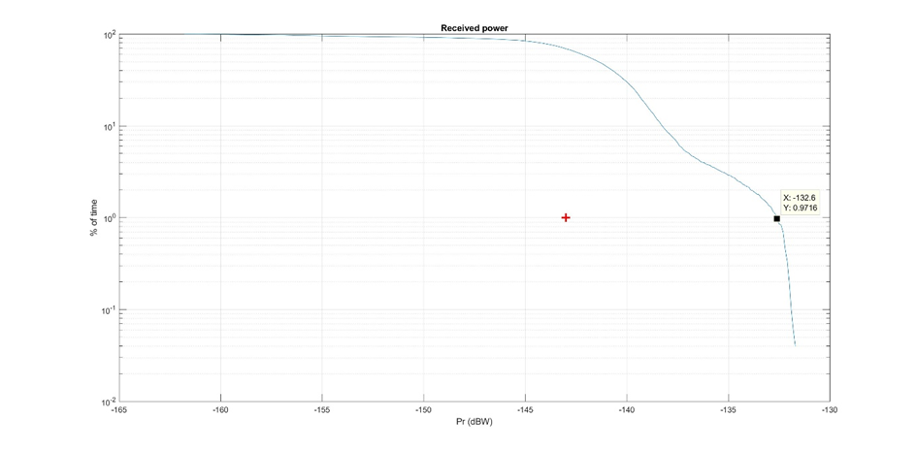

It can be seen that the EESS (active) protection criterion is exceeded by 10.2 dB (–132.8 dBW).

It can also be seen that the interference level corresponding to the protection criteria is exceeded for more than 70% of the time. The situation is also depicted on Figure 6 below showing in red the interfered portion of images (vs the non-interfered in white).

Figure 6

Interfered portion of images (in red) vs non-interfered (in white) (Over France – options A1 and D2-low)

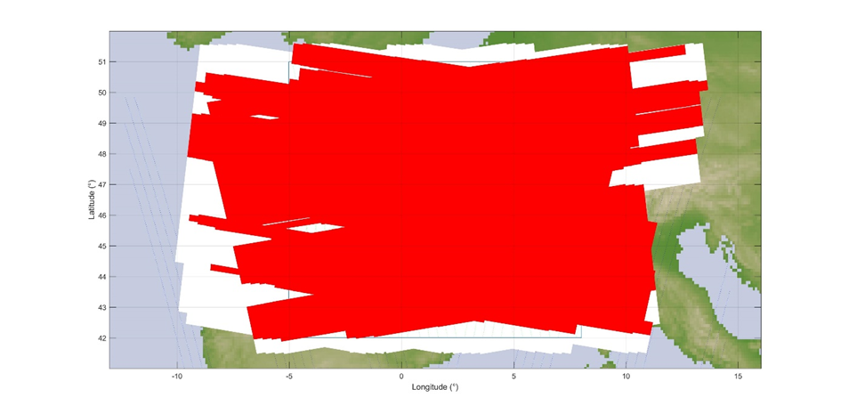

In addition, Figure 7 gives the cumulative distribution function of interference for deployment of 72 738 RLANs over France (Option D1) and antenna Option A1.

Figure 7

Interference for SCA (MID beam) (Over France – options A1 and D1)

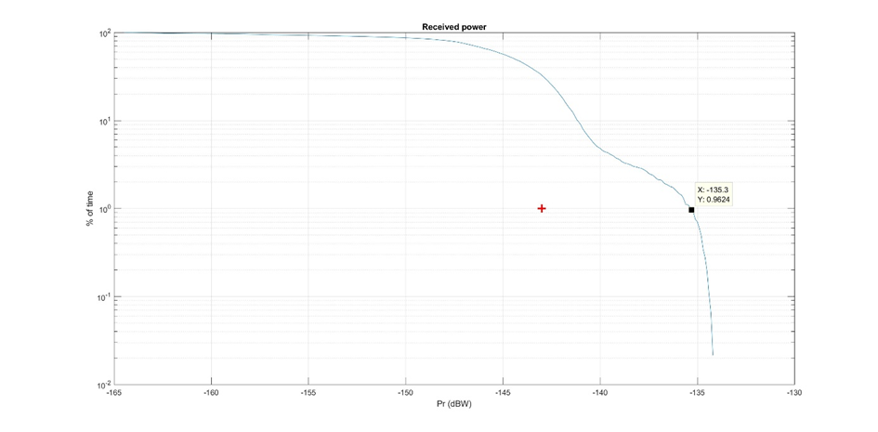

It can be seen that the EESS (active) protection criterion is exceeded by 7.7 dB (–135.3 dBW).

It can also be seen that the interference level corresponding to the protection criteria is exceeded for more than 40% of the time. The situation is also depicted on Figure 8 below showing in red the interfered portion of images (vs the non-interfered in white).

Figure 8

Interfered portion of images (in red) vs non-interfered (in white) (Over France – options A1 and D1)



It appears obvious that in these situations, the SCA sensor will be totally ineffective over most land and coastal areas, in particular all urban and suburban areas.

Finally, Table 10 provides the levels of interference in excess for the 3 RLAN density options (D1, D2-low and D2-High) and antenna Options A1 and A3.

Table 10

Interference in excess (over France)

|  |  |  |  |  |
| --- | --- | --- | --- | --- |
| Scenario | Active RLAN density (Nb per inhabitant per 2 MHz) | Nb of active RLAN over France (in 2 MHz) | Interference in excess for antenna Option A1 | Extrapolated for antenna Option A3  (A1 – 4 dB) |
| JTG Option D1 | 0.0011 | 72 738 | **7.7 dB** | **3.7 dB** |
| JTG Option D2-low | 0.0021 | 135 432 | **10.2 dB** | **6.2 dB** |
| JTG Option D2-high  (D2-Low +10 dB) | 0.021 | 1 354 319 | **20.2 dB** | **16.2 dB** |

### 3.2.4 Dynamic analyses results over Paris metropolitan

Under the same principle, the following Figure 9 gives the cumulative distribution functions of interference corresponding to a deployment of 135 432 RLANs over France, including 20 930 RLANs over Paris metropolitan area (Option D2-low) and antenna Option A1.

Figure 9

Interference for SCA (MID beam) (Over Paris Metro – options A1 and D2-low)

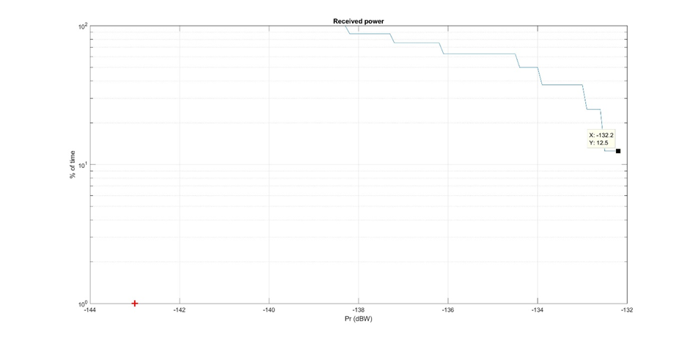

It can be seen that the EESS (active) protection criterion is largely exceeded by 10.8 dB  
(–132.2 dBW). (The interference level corresponding to the protection criteria is exceeded for 100 % of the time.)

Similarly, the following Figure 10 gives the cumulative distribution functions of interference corresponding to a deployment of 72 738 RLANs over France, including 11 241 RLANs over Paris metropolitan area (Option D1) and antenna Option A1.

Figure 10

Interference for SCA (MID beam) (Over Paris Metro – options A1 and D1)

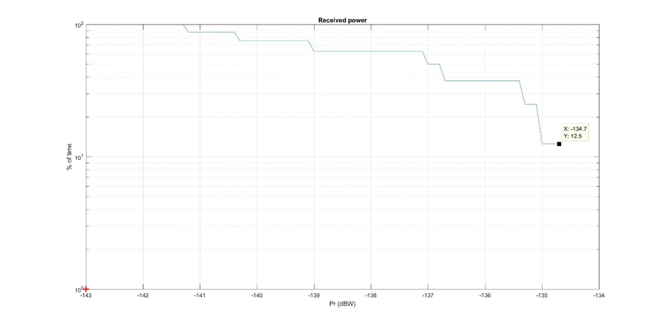

It can be seen that the EESS (active) protection criterion is largely exceeded by 8.3 dB   
(–134.7 dBW). (The interference level corresponding to the protection criteria is exceeded 100 % of the time.)

Finally, Table 11 provides the levels of interference in excess for the 3 RLAN density options  
(D1, D2-low and D2-High) and antenna Options A1 and A3.

Table 11

Interference in excess (over Paris metropolitan)

|  |  |  |  |  |
| --- | --- | --- | --- | --- |
| Scenario | Active RLAN density (Nb per inhabitant per 2 MHz) | Nb of active RLAN over Paris Metro  (in 2 MHz) | Interference in excess for antenna Option A1 | Extrapolated for antenna Option A3 (A1 – 4 dB) |
| JTG Option D1 | 0.0011 | 11 241 | **8.3 dB** | **4.3 dB** |
| JTG Option D2-low | 0.0021 | 20 930 | **10.8 dB** | **6.8 dB** |
| JTG Option D2-high  (D2-Low +10 dB) | 0.021 | 209 304 | **20.8 dB** | **16.8 dB** |

### 3.2.5 Dynamic analyses results over the UK

Figure 11 gives the cumulative distribution function of interference for deployment of 129 892 RLANs over the United Kingdom (Option D2-low) and antenna Option A1.

Figure 11

Interference for SCA (MID beam) (Over the UK – options A1 and D2-low)

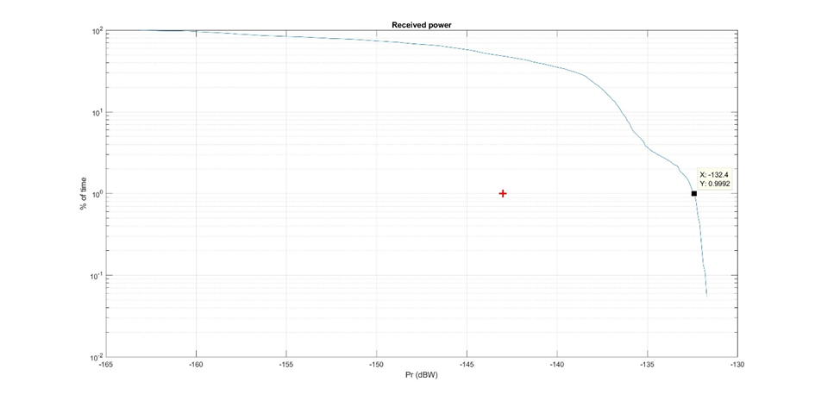

It can be seen that the EESS (active) protection criterion **is exceeded by 10.6 dB (–-132.4 dBW)**.

It can also be seen that the interference level corresponding to the protection criteria is exceeded for more than 40% of the time. The situation is also depicted on Figure 12 below showing in red the interfered portion of images (vs the non-interfered in white).

Figure 12

Interfered portion of images (in red) vs non-interfered (in white) (Over the UK – options A1 and D2-low)

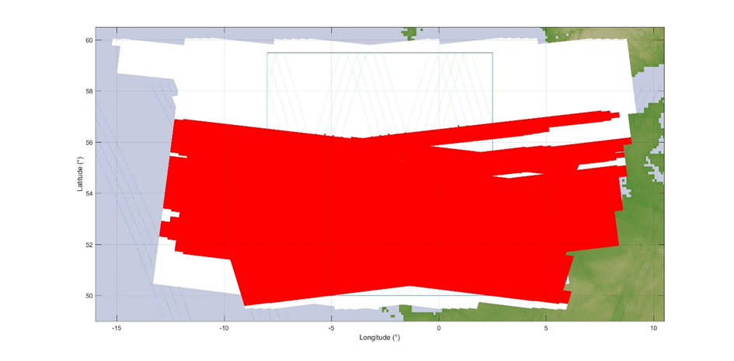

In addition, Figure 13 gives the cumulative distribution function of interference for deployment of 69 763 RLANs over the UK (Option D1) and antenna Option A1.

Figure 13

Interference for SCA (MID beam) (Over the UK – options A1 and D1)

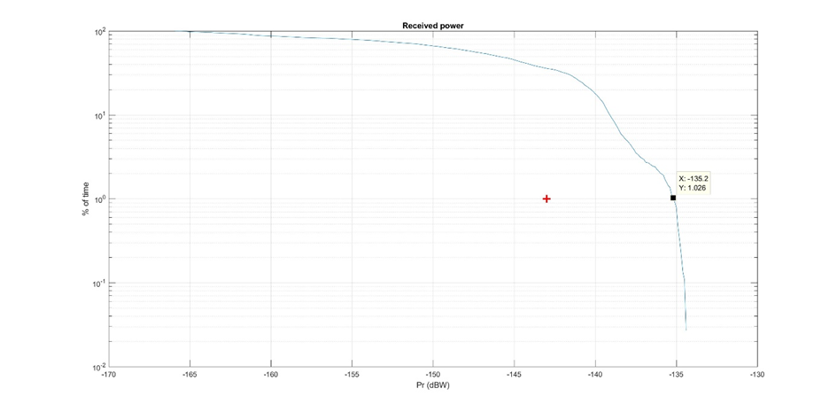

It can be seen that the EESS (active) protection criterion is largely exceeded by 7.8 dB   
(–135.2 dBW).

It can also be seen that the interference level corresponding to the protection criteria is exceeded for more than 30% of the time. The situation is also depicted on Figure 14 below showing in red the interfered portion of images (vs the non-interfered in white).

Figure 14

Interfered portion of images (in red) vs non-interfered (in white) (Over the UK – JTG options A1 and D1)

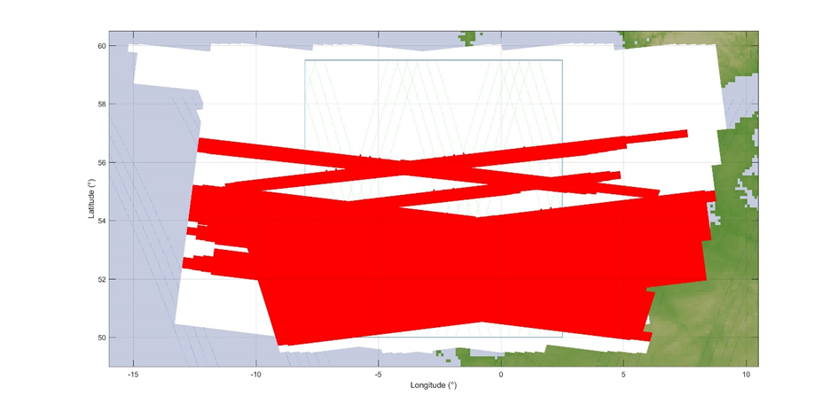

It appears obvious that in these situations, the SCA (MID beam) sensor will be totally ineffective over most land and coastal areas, in particular all urban and suburban areas.

Finally, Table 12 provides the levels of interference in excess for the 3 RLAN density options (D1, D2-low and D2-High) and antenna Options A1 and A3.

Table 12

Interference in excess (over the UK)

|  |  |  |  |  |
| --- | --- | --- | --- | --- |
| Scenario | Active RLAN density (Nb per inhabitant per 2 MHz) | Nb of active RLAN over the UK (in 2 MHz) | Interference in excess for antenna  Option A1 | Extrapolated for antenna Option A3 (A1 – 4 dB) |
| JTG Option D1 | 0.0011 | 69 763 | **7.8 dB** | **3.8 dB** |
| JTG Option D2-low | 0.0021 | 129 892 | **10.6 dB** | **6.6 dB** |
| JTG Option D2-high (D2-Low +10 dB) | 0.021 | 1 298 916 | **20.6 dB** | **16.6 dB** |

### 3.2.6 Dynamic analyses results over London metropolitan

Figure 15 gives the cumulative distribution functions of interference corresponding to a deployment of 129 892 RLANs over the UK, including 26 471 RLANs over London metropolitan area (Option D2-low) and antenna Option A1.

Figure 15

Interference for SCA (MID beam) (Over London Metro – options A1 and D2-low)

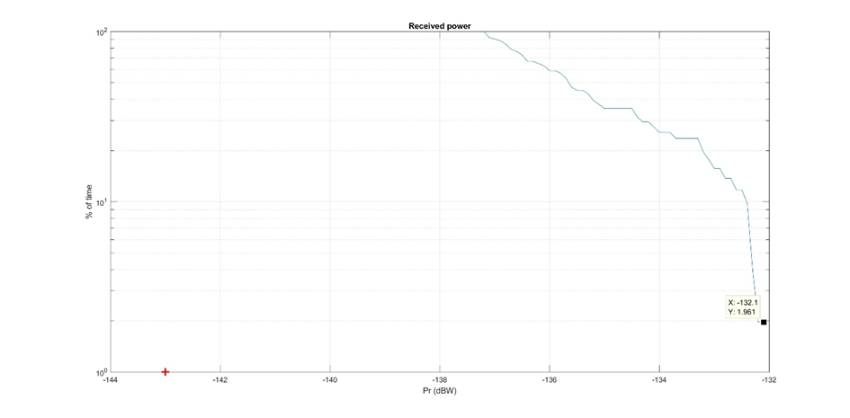

It can be seen that the EESS (active) protection criterion **is largely exceeded by 10.9 dB   
(–132.1 dBW)**.

It can also be seen that the interference level corresponding to **the protection criteria is exceeded for 100% of the time**.

Finally, Table 13 provides the levels of interference in excess for the 3 RLAN density options (D1, D2-low and D2-High) and antenna Options A1 and A3.

Table 13

Interference in excess (over London metropolitan)

|  |  |  |  |  |
| --- | --- | --- | --- | --- |
| Scenario | Active RLAN density (Nb per inhabitant per  2 MHz) | Nb of active RLAN over London Metro (in 2 MHz) | Interference in excess for antenna Option A1 | Extrapolated for antenna Option A3 (A1 –4 dB) |
| JTG Option D1 (D2-Low –3 dB) | 0.0011 | 14 217 | **7.9 dB** | **3.9 dB** |
| JTG Option D2-low | 0.0021 | 26 471 | **10.9 dB** | **6.9 dB** |
| JTG Option D2-high (D2-Low +10 dB) | 0.021 | 264 708 | **20.9 dB** | **16.9 dB** |

### 3.2.7 Dynamic analyses – Summary of results

The results of the dynamic analysis over France are given below (see Table 10 above):

|  |  |  |  |  |
| --- | --- | --- | --- | --- |
| Scenario | Active RLAN density (Nb per inhabitant per  2 MHz) | Nb of active RLAN over France (in 2 MHz) | Interference in excess for antenna  Option A1 | Extrapolated for antenna Option A3  (A1 – 4 dB) |
| JTG Option D1 | 0.0011 | 72 738 | **7.7 dB** | **3.7 dB** |
| JTG Option D2-low | 0.0021 | 135 432 | **10.2 dB** | **6.2 dB** |
| JTG Option D2-high  (D2-Low +10 dB) | 0.021 | 1 354 319 | **20.2 dB** | **16.2 dB** |

The results of the dynamic analysis over Paris Metropolitan are given below (see Table 11 above):

|  |  |  |  |  |
| --- | --- | --- | --- | --- |
| Scenario | Active RLAN density (Nb per inhabitant per 2 MHz) | Nb of active RLAN over Paris Metro (in 2 MHz) | Interference in excess for antenna  Option A1 | Extrapolated for antenna Option A3  (A1 – 4 dB) |
| JTG Option D1 | 0.0011 | 11 241 | **8.3 dB** | **4.3 dB** |
| JTG Option D2-low | 0.0021 | 20 930 | **10.8 dB** | **6.8 dB** |
| JTG Option D2-high  (D2-Low +10 dB) | 0.021 | 209 304 | **20.8 dB** | **16.8 dB** |

The results of the dynamic analysis over the UK are given below (see Table 12 above):

|  |  |  |  |  |
| --- | --- | --- | --- | --- |
| Scenario | Active RLAN density (Nb per inhabitant per  2 MHz) | Nb of active RLAN over the UK (in 2 MHz) | Interference in excess for antenna  Option A1 | Extrapolated for antenna Option A3 (A1 – 4 dB) |
| JTG Option D1 | 0.0011 | 69 763 | **7.8 dB** | **3.8 dB** |
| JTG Option D2-low | 0.0021 | 129 892 | **10.6 dB** | **6.6 dB** |
| JTG Option D2-high (D2-Low +10 dB) | 0.021 | 1 298 916 | **20.6 dB** | **16.6 dB** |

The results of the dynamic analysis over London Metropolitan are given below (see Table 13 above):

|  |  |  |  |  |
| --- | --- | --- | --- | --- |
| Scenario | Active RLAN density (Nb per inhabitant per  2 MHz) | Nb of active RLAN over London Metro (in 2 MHz) | Interference in excess for antenna Option A1 | Extrapolated for antenna Option A3 (A1 –4 dB) |
| JTG Option D1 (D2-Low –3 dB) | 0.0011 | 14 217 | **7.9 dB** | **3.9 dB** |
| JTG Option D2-low | 0.0021 | 26 471 | **10.9 dB** | **6.9 dB** |
| JTG Option D2-high (D2-Low +10 dB) | 0.021 | 264 708 | **20.9 dB** | **16.9 dB** |

Overall, in all cases, the above dynamic analyses confirm the result of static analyses, presenting interference largely exceeding EESS (active) protection criteria and allow to show that there is no compatibility between RLAN and EESS (active) in the 5 GHz range.

# 4 Summary

Under all scenarios and simulation methodologies (static and dynamic), the analyses show that RLAN deployment in 5 250-5 570 MHz within the 5 GHz range would create large interference in the SCA sensor on board the EPS-SG satellites.

The static analyses presented above indicate that:

– the maximum allowed density of outdoor RLANs (transmitting with the full e.i.r.p. of 200 mW) within the 12 400 km² (MID beam) and 21000 km² (SIDE beam) EESS (active) is 0.0015 and 0.0018 RLAN / km², respectively (see section 3.1.1)

– Depending on the scenario (different number of active RLAN (D1 and D2) and RLAN antenna A1 and A3), the interference to the EESS (active) sensor will be in excess of the relevant protection criteria by 1.8 to 18.6 dB (see section 3.1.2)

The dynamic analyses presented above indicate that, depending on the scenario (different number of active RLAN (D1 and D2) and RLAN antenna A1 and A3), the interference to the EESS (active) sensor will be in excess of the relevant protection criteria by (for 0.0011 to 0.021 active RLAN per inhabitant, respectively)**:**

• 3.7 to 20.2 dB (case over France) *(see section 3.3.3)*

• 4.3 to 20.8 dB (case over Paris metropolitan) *(see section 3.3.4)*

• 3.8 to 20.6 dB (case over the UK) *(see section 3.3.5)*

• 3.9 to 20.9 dB (case over London metropolitan) *(see section 3.3.6)*.

It has to be highlighted that these analyses were not considering a number of assumptions that would further increase these negative margins, such as an additional apportionment factor of the protection criteria (since the band is already shared with terrestrial radars). EUMETSAT stresses that this apportionment factor has not been introduced in the analysis given the already large negative results obtained under the assumption that no other services could generate additional interference to EESS (active).

Further, some assumptions related to RLAN remains unclear or unresolved and could also increase the potential interference to EESS (active). This covers in particular the possibilities given to a single RLAN to make use of multiple channels transmission (by means of either orthogonal transmissions or MIMO technique) or to concatenate multiple small channels to provide wider bandwidth with higher power. Such questioning also relates to other applications than RLAN since opening a band to RLAN, low power and unlicensed by nature, will drive the use of different applications such as SRDs, M2M, … (similarly to the current situation in the 2.4 GHz band) or LAA-LTE. Thus, consideration of these additional applications would need to be taken into account.

Overall, this document demonstrates and confirms again that RLANs cannot share with EESS (active) in 5 250-5 570 MHz within the 5 GHz range, confirming that sharing between RLAN and EESS (active) in the 5 GHz range may only be feasible if additional RLAN mitigation measures are implemented.

List of References

1. EC Mandate to CEPT to study and identify harmonised compatibility and sharing conditions for Wireless Access Systems including Radio Local Area Networks in the bands 5 350-5 470 MHz and 5 725-5 925 MHz ('WAS/RLAN extension bands') for the provision of wireless broadband services, September 2013
2. ECC Decision (04)08: "Harmonised use of 5 GHz for the implementation of WAS/RLANs "
3. WRC Resolution 229 (WRC-03): "Use of the bands 5 150-5 250, 5 250-5 350 MHz and 5 470-5 725 MHz by the mobile service for the implementation of Wireless Access Systems including Radio Local Area Networks"
4. ERC Report 67: "Study of the Frequency sharing between HIPERLANs and MSS feeder links in the 5 GHz band"
5. ERC Report 72: " Compatibility studies related to the possible extension band for HIPERLAN at 5 GHz"
6. ETSI EN 301 893: " Broadband Radio Access Networks (BRAN); 5 GHz high performance RLAN; Harmonized EN covering the essential requirements of Article 3.2 of the R&TTE Directive"
7. EC Decision 2005/513/EC complemented by EC Decision 2007/90/EC
8. Recommendation ITU-R M.1739: "Protection criteria for wireless access systems, including radio local area networks, operating in the mobile service in accordance with Resolution 229 (WRC-03) in the bands 5 150-5 250 MHz, 5 250-5 350 MHz and 5 470‑5 725 MHz"
9. ERC Report 25: "The European table of frequency allocations and applications in the frequency range 8.3 kHz to 3000 GHz"
10. EC Decision 2008/671/EC: "Commission Decision of 5 August 2008 on the harmonised use of radio spectrum in the 5 875-5 905 MHz frequency band for safety related applications of Intelligent Transport Systems (ITS)"
11. ECC Decision (08)01: " ECC Decision of 14 March 2008 on the harmonised use of the 5 875-5 925 MHz frequency band for Intelligent Transport Systems (ITS)"
12. ECC Recommendation (08)01: " Use of the band 5 855-5 875 MHz for Intelligent Transport Systems"
13. ECC Report 101: "Compatibility studies in the band 5 855-5 925 MHz between Intelligent Transport Systems (ITS) and other systems"
14. ECC Decision (12)04: " ECC Decision of 2 November 2012 on the withdrawal of ECC Decision (02)01. For national implementation issues related to the withdrawn Decision, check EFIS"
15. ERC Recommendation 70-03: " Relating to the use of Short Range Devices (SRD)"
16. ETSI EN 300 674: "Electromagnetic compatibility and Radio spectrum Matters (ERM); Road Transport and Traffic Telematics (RTTT); Dedicated Short Range Communication (DSRC) transmission equipment (500 kbit/s / 250 kbit/s) operating in the 5,8 GHz Industrial, Scientific and Medical (ISM) band; Part 1: General characteristics and test methods for Road Side Units (RSU) and On-Board Units (OBU)"
17. CENELEC EN 12253: "" Road transport and traffic telematics - Dedicated short-range communication - Physical layer using microwave at 5.8 GHz"
18. ECC Report 68: "Compatibility studies in the band 5 725-5 875 MHz between Fixed Wireless Access (FWA) systems and other systems"
19. ITU-R Recommendation P.452: "Prediction procedure for the evaluation of interference between stations on the surface of the Earth at frequencies above about 0.1 GHz"
20. EC Decision 2006/771/EC: "Commission Decision of 9 November 2006 on the harmonisation of the radio spectrum for use by short-range devices"
21. IARU Region-1 VHF Managers Handbook
22. Recommendation ITU-R M.1732-1: "Characteristics of systems operating in the amateur and amateur-satellite services for use in sharing studies"
23. ECC Report 210: "Compatibility/sharing studies related to Broadband Direct-Air-to-Ground Communications (DA2GC) in the frequency bands 5 855-5 875 MHz, 2 400‑2 483.5 MHz and 3 400-3 600 MHz"
24. ETSI TR 101 599: "Electromagnetic compatibility and Radio spectrum matters (ERM) System Reference Document (SRDoc); Broadband Direct-Air-to-Ground Communications System employing beamforming antennas, operating in the 2,4 GHz and 5,8 GHz bands"
25. ETSI TR 103 108: "Electromagnetic compatibility and Radio spectrum Matters (ERM); System Reference document (SRdoc); Broadband Direct-Air-to-Ground Communications System operating in the 5,855 GHz to 5,875 GHz band using 3G technology"
26. ECC Report 206: "Compatibility studies in the band 5 725-5 875 MHz between SRD equipment for wireless industrial applications and other systems"
27. IEEE 802.11-2012: "Wireless LAN Medium Access Control (MAC) and Physical Layer (PHY) Specifications"
28. ETSI EN 302 571 V1.2.2 (2011-10): "Intelligent Transport Systems (ITS); Radiocommunications equipment operating in the 5 855 MHz to 5 925 MHz frequency band; Harmonized EN covering the essential requirements of article 3.2 of the R&TTE Directive"
29. Recommendation ITU-R SM.329: "Unwanted emissions in the spurious domain"
30. ERC Recommendation 74-01: "Unwanted Emissions in the Spurious Domain"
31. Recommendation ITU-R F.1336-3: "Reference radiation patterns of omnidirectional, sectoral and other antennas for the fixed and mobile service for use in sharing studies in the frequency range from 400 MHz to about 70 GHz"
32. ETSI ES 200 674-1 V2.4.1 (2013-05): “Technical characteristics and test methods for High Data Rate (HDR) data transmission equipment operating in the 5,8 GHz Industrial, Scientific and Medical (ISM) band”
33. NTIA 5 GHz report, January 2013, “Evaluation of the 5 350-5 470 MHz and 5 850‑5 925 MHz bands pursuant to section 6406(b) of the middle class tax relief and job creation act of 2012
34. ETSI TR 102 960: "Intelligent Transport Systems (ITS); Mitigation techniques to avoid interference between European CEN Dedicated Short Range Communication (RTTT DSRC) equipment and Intelligent Transport Systems (ITS) operating in the 5 GHz frequency range; Evaluation of mitigation methods and techniques"

1. ETSI TS 102 792: "Intelligent Transport Systems (ITS); Mitigation techniques to avoid interference between European CEN Dedicated Short Range Communication (CEN DSRC) equipment and Intelligent Transport Systems (ITS) operating in the 5 GHz frequency range"
2. <http://www.statistiques-mondiales.com/union_europeenne.htm>
3. <http://appsso.eurostat.ec.europa.eu/nui/show.do?dataset=lfst_hhnhtych&lang=en>
4. <https://www.ssb.no/en/befolkning/statistikker/familie/aar/2014-12-12>
5. <http://www.bfs.admin.ch/>
6. <http://appsso.eurostat.ec.europa.eu/nui/show.do?dataset=bd_9ac_l_form_r2&lang=en>
7. 3GPP TR 36.889: Feasibility Study on Licensed-Assisted Access to Unlicensed Spectrum, <http://www.3gpp.org/DynaReport/36889.htm>
8. CEPT Report 57 : "Compatibility and sharing conditions for WAS/RLAN in the bands 5 350-5 470 MHz and 5 725-5 925 MHz"
9. ECC Report 181 on improving spectrum efficiency in SRD bands
10. JRC study on RLAN deployment and device densities: <http://www.cept.org/Documents/se-24/25709/SE24(15)070R0_WI52_number-of-RLAN-JRC>
11. JRC study on in-home RLAN coverage and number of RLAN APs per household: <http://www.cept.org/Documents/se-24/25805/SE24(15)089R0_WI52_Further-considerations-on-WLAN-indoor-coverage>
12. JRC measurements of 802.11ac RLAN APs operating in the 5 GHz band: <http://www.cept.org/Documents/se-24/24051/SE24(15)042R0_WI52_JRC_5GHZ_RLAN-_measurements>
13. ECC Report 244 “Compatibility studies related to RLANs in the 5 725-5 925 MHz band”

1. The protection criteria for ground-based meteorological radars is found in Recommendation ITU‑R M.1849.
2. This system is a two-satellites constellation.
3. Lower gain can be used for the wider beams.
4. Antenna beam “incident angles”.
5. Average e.i.r.p. over a pulse repetition interval.
6. Max e.i.r.p. during pulse transmission.
7. Antenna gain varies depending on antenna location (mid or side), and incident angle.