|  |  |
| --- | --- |
| **Radiocommunication Study Groups** |  |
|  |  |
|  |  |
| Source: Document 5A/TEMP/182(Rev.1)  Subject: Question [ITU-R 205-5/5](http://www.itu.int/pub/R-QUE-SG05.205) | **Annex 37 to**  **Document 5A/469-E** |
| **13 June 2017** |
| **English only** |
| Annex 37 to Working Party 5A Chairman’s Report | |
| proposed outline for revision of Land Mobile Handbook – vol. 4 – INTELLIGENT Transport Systems | |
|  | |

# 1 Introduction

At its meeting in May 2015, ITU-R Working Party 5A (WP 5A) decided to update the ITS handbook to include the recent ITS related communication technology and applications. There was steady advancement in radio communication technology and application among countries. The important advancement would be V2X communication technology and applications such as Cooperative ITS, vehicle safety and automated vehicle driving.

ITS handbook needs to include the existing and new advancement in ITS communication and applications. Also it needs to provide a good reference to help to understand ITS communication and applications in the level of worldwide industry. Specially, ITS services and system architecture, radio communication technology and frequency assignment, standard information will be important and valuable information.

# 2 Proposal

The current handbook includes DSRC, cellular and broadcasting, millimeter radar technology. And it provides information on radio frequency allocation, application system and services in European countries, USA, Japan and Korea, and other Asian countries. Now it seems to be the collected information from European countries, USA and Asian countries and it needs to be written to be easily understood by re-organizing the overall contents and chapter assignment. We propose the contents and chapter assignment on ITS handbook as follows.

– The Overall Contents:

• ITS service category and user service

• ITS system architecture

• Radio communication technology: DSRC, Dedicated V2X (700 MHz, 5.9 GHz), LTE based V2X, broadcasting, vehicle radar and road radar

• Radio frequency assignment

• International and national standard.

– The Chapters assignment of Revised ITS handbook:

• Chapter 1. Introduction

It covers the objective and background, contents of ITS handbook.

• Chapter 2. ITS user services

This defines service concept, service category and service name. ITS services will be categorized from the view of radio technologies as follows:

– P2V (Person to Vehicle) communication type: pedestrian warning, vehicle warning.

– P2C (Personal to Centre) communication type: traffic information based navigation, Ka Kao-Taxi.

– V2I (Vehicle to Infrastructure) communication type: electronic toll collection.

– V2C (Vehicle to Center) communication type: Bus Information Service (BIS), e-call, VICS in Japan.

– V2V communication type with vehicle sensors: emergency brake warning, intersection collision warning, Cooperative ACC.

– V2I communication type with road sensors: intersection pedestrian warning, incident detection warning, road work warning.

– V2X (V2V/V2I) mixed communication type with vehicle/road sensors: automated driving, Automated valet parking.

Figure 1

ITS System Configuration

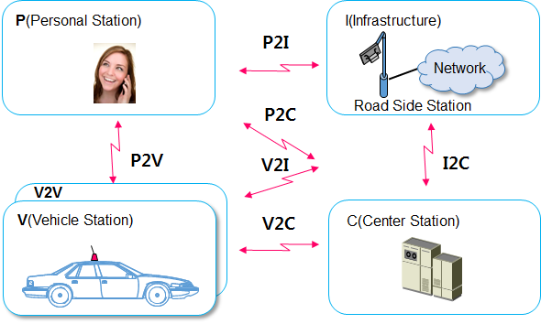

• Chapter 3. ITS system architecture

This describes system configuration and function entities, and the relationship among functional entities. It consists of personal station, vehicle station, Infrastructure (road side station and network), and center station.

• Chapter 4. Radio technologies for ITS system

This describes DSRC, Dedicated V2X, LTE based V2X, broadcasting, millimeter wave vehicle radar and road radar to use radio spectrum for ITS system. This chapter describes the technical requirements and characteristics of radio technologies for ITS system

• Chapter 5. Radio frequency assignment for ITS system

This describes radio frequency assignment for the radio technologies for ITS applications. The below table is example of the radio frequency assignment.

|  |  |
| --- | --- |
| Radio Technologies for ITS | Frequency Assignment |
| DSRC | 900 MHz (only Region 2), 2.4 GHz, 5.8 GHz |
| Dedicated V2X | 760 MHz, 5.9 GHz |
| LTE based V2X | T.B.D. |
| FM Broadcasting | 74-90 MHz |
| Vehicle Radar | 5.8 GHz, 24 GHz, 60 GHz, 76 GHz, 79 GHz |
| Road Radar | 34 GHz |

• Chapter 6. International and national standard for ITS system

This describes international standard and national standard to use the radio technologies for ITS applications. IEEE, ETSI, ARIB, CCSA, TSAC, TTA, 3GPP and ISO standard will be introduced.

• Annex: The usage of ITS from EU, USA, Japan, China, Singapore, Thailand, Korea and other countries

This describes the summary on service overview, frequency assignment and standard listed in the table format. Template will be provided to the members and contributed.