|  |  |
| --- | --- |
| **Radiocommunication Study Groups** |  |
|  |  |
|  |  |
| Source: Documents 5A/TEMP/180(Rev.1)  Subject: Question [ITU-R 205-5/5](http://www.itu.int/pub/R-QUE-SG05.205) | **Annex 32 to Document 5A/469-E** |
| **13 June 2017** |
| **English only** |
| Annex 32 to Working Party 5A Chairman’s Report | |
| |  | | --- | | WORKING DOCUMENT TOWARD A PRELIMINARY  DRAFT NEW REPORT ITU-R M.[ITS USAGE] | | Intelligent transport systems (ITS) usage in ITU Member States | | |

TABLE OF CONTENTS

1 Scope 3

2 Background 3

3 Related documents 3

4 List of acronyms and abbreviations 4

5 Overview of ITS radiocommunication and automotive radar 5

5.1 ITS radiocommunication 6

5.2 Automotive radar 7

6 Legacy ITS radiocommunication – ETC 8

6.1 Overview 8

6.2 Technical characteristics 8

6.3 Frequency usage 9

6.4 Standardization 9

6.5 Applications 9

6.6 Region 1 10

6.7 Region 2 16

6.8 Region 3 16

7 Advanced ITS radiocommunication 24

7.1 Overview 24

7.2 Technical characteristics 27

7.3 Technical and operational communications aspects 35

7.4 Frequency usage 38

[7.5 Best practice and experiences on the usage of the bands between ITS and   
other applications / services 39](#_Toc484072587)

7.6 Standardization, technical specifications, technical reports and ITU deliverables 40

7.7 Applications 42

7.8 Options for Deployment and Operations 50

7.9 Region 1 51

7.10 Region 2 51

7.11 Region 3 53

8 Millimetre-wave automotive radar 53

8.1 Overview 54

8.2 Technical characteristics 54

8.3 Frequency usage 58

8.4 Standardization 59

8.5 Applications 60

8.6 Region 1 60

8.7 Region 2 62

8.8 Region 3 63

9 Results of Studies 67

*[Editor’s note: All the texts may be addressed in future contributions to this document.]*

*[Editor’s note: Renumbering is required for the figures and tables.]*

# 1 Scope

This report addresses the usages of Intelligent Transport System (ITS) radiocommunication applications, such as vehicle to infrastructure, vehicle to vehicle, vehicle to pedestrian communications for traffic safety related and traffic efficiency applications as well as electronic tolling systems and automotive radars for collision avoidance in ITU Member states.

This report identifies current and planned usage of ITS technologies, frequency bands, status of standardization, applications and deployments in ITU Member States.

# 2 Background

Asia-Pacific Telecommunity (APT) published APT Report on “The usage of intelligent transport systems in APT Countries” [Revision 1 ([APT/AWG/REP-18](http://www.aptsec.org/sites/default/files/2016/09/AWG-20-TMP-44_ITS_USAGE_Consolidated_R2_clear.docx)).

*Since May 2014, Working Party 5A (WP 5A) started developing new Report ITU-R M.[ITS USAGE] Intelligent transport systems (ITS) usage in ITU Member States.*

During the WRC-15 in November 2015, WRC-19 agenda item (A.I.) 1.12 – ITS applications was approved. Under A.I. 1.12, WP 5A is responsible group to consider global or regional harmonized frequency bands, to the maximum extent possible, for the implementation of evolving ITS under existing mobile-service allocations in accordance with Resolution **237 (WRC-15)**.

To consider global or regional harmonized frequency bands for the implementation of evolving ITS, this new Report ITU-R M.[ITS USAGE] “ITS usage in ITU Member States” will be an important reference material. *To meet A.I. 1.12, new Report ITU-R M.[ITS USAGE] should be published as early as possible.*

# 3 Related documents

ITU-R Recommendations

ITU-R M.1890 Intelligent transport systems – Guidelines and objectives

ITU-R M.1452 Millimetre wave radiocommunication systems for Intelligent Transport Systems applications

ITU-R M.1453 Intelligent Transport Systems – dedicated short-range communications at 5.8 GHz

ITU-R M.2057 Systems characteristics of automotive radars operating in the frequency band 76-81 GHz for intelligent transport systems applications

ITU-R M.2084 Radio interface standards of vehicle-to-vehicle and vehicle-to-infrastructure communication for intelligent transport systems applications

ITU-R Report

ITU-R M.2228 Advanced intelligent transport systems (ITS) radiocommunication

ITU-R M.2322 Systems characteristics and compatibility of automotive radars operating in the frequency band 77.5-78 GHz for sharing studies

ITU-R F.2394 Compatibility between point-to-point applications in the fixed service operating in the 71-76 GHz and 81-86 GHz bands and automotive radar applications in the radiolocation service operating in the 76-81 GHz bands

ITU-R Handbook

Land Mobile (including Wireless Access) - Volume 4:   
 Intelligent Transport Systems

# 4 List of acronyms and abbreviations

3GPP The 3rd Generation Partnership Project

APT Asia-Pacific Telecommunity

ARIB Association of Radio Industries and Businesses (Japan)

ATIS Alliance for Telecommunications Industry Solutions (U.S.A.)

AWG APT Wireless Group

C-ITS Cooperative ITS communication

C2C- CC CAR-to-CAR Communication Consortium

CAMP Crash Avoidance Metric Partnership

CCSA China Communications Standards Association

CEN European Committee for Standardization

CEPT European Conference of Postal and Telecommunications Administrations

D2D Device-to-device

ECC Electronic Communications Committee

ETSI European Telecommunications Standards Institute

FCC Federal Communications Commission

IEEE Institute of Electrical and Electronics Engineers

IMDA Infocomm Media Development Authority (Singapore)

ISO International Organization for Standardization

ITS Intelligent Transport Systems

LTE Long Term Evolution

LTE-V2X LTE based Vehicle to Infrastructure/Vehicle/Network/Pedestrians and others

MBSFN Multicast-Broadcast Single-Frequency Network

OoC Out of coverage

PC5 [Device-to-Device Direct Link]

RLAN Radio Local Area Network

RSS Radio Standards Specification (Canada)

SC-PTM Single Cell Point To Multipoint

TIA Telecommunications Industry Association (U.S.A.)

TSAC Telecommunications Standards Advisory Committee (Singapore)

TTA Telecommunication Technology Association (Korea, (Republic of))

Uu [Link between Base Station and Device]

V2I Vehicle to Infrastructure

V2N Vehicle to Network

V2P Vehicle to Pedestrians

V2V Vehicle to Vehicle

V2X Vehicle to Infrastructure/Vehicle/Network/Pedestrians and others

WAVE Wireless Access in Vehicular Environments

WLAN Wireless Local Area Network

# 5 Overview of ITS radiocommunication and automotive radar

Since several decades ago, traffic congestion has been increasing all over the world as results of increased motorization, urbanization, population growth, and changes in population density. Congestion reduces efficiency of transportation infrastructure and increases travel time, air pollution, and fuel consumption. Interest in ITS comes from the problems caused by traffic congestion and a synergy of new information technology for simulation, real-time control, and communications networks. Namely, ITS is systems to support transportation of goods and humans with information and communication technologies in order to efficiently and safely use the transport infrastructure and transport means (cars, trains, planes, ships)[1].

Figure 1

Communication technologies and services for ITS[2]

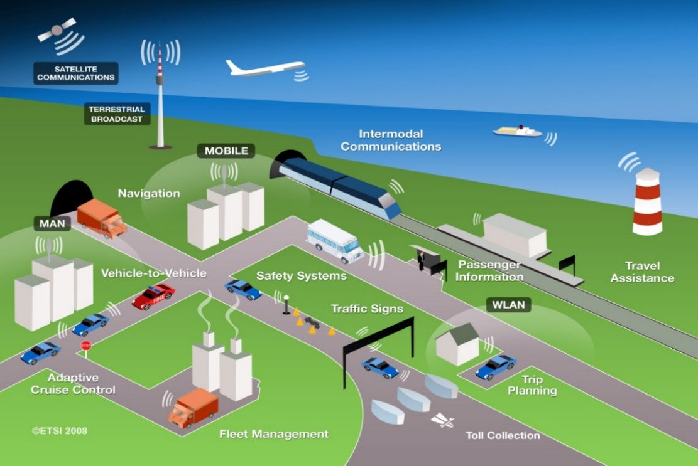

ITS have been standardized and studied in various standards development organizations. As an international level, ITU-R, ISO TC 204, and IEEE are working on developing the standards, recommendations and reports.

In Asia-Pacific, AWG is working as a regional level as well as ARIB, TTA, IMDA TSAC and other standard organizations in each countries and regions. In Europe, ETSI TC ITS and CEN TC278 are working as a regional level.

This report identifies current and planned usage of ITS technologies, frequency bands, status of applications and deployment in ITU Member States.

The major deployed ITS in the world were classified as electronic toll collection, automotive radar, and vehicle information & communication. In this report, we described applications overview, established standards, frequency plan, and implication in each ITS.

## 5.1 ITS radiocommunication

Electronic toll collection allows the manual in-lane toll collection process to be automated in such a way that drivers do not have to stop and pay cash at a toll booth. ETC systems improve traffic flow at toll plazas, and the level of pollution by reducing fuel consumption. In addition, allowing traffic to pass through the gate without stopping can increase road capacity by three or four times and relieve traffic congestion at the tollgate. It is also expected that ETC systems will reduce the operating costs of toll roads by replacing manual toll collection.

Since 1994, Vehicle Information and Communication System (VICS) has been using in Japan for delivering traffic and travel information to road vehicle drivers.

Nowadays, to extend beyond the existing ITS applications and to achieve traffic safety enhancement and reduce the environmental impact by the transportation sector, vehicle to vehicle (V2V), vehicle to infrastructure (V2I), infrastructure to vehicle (I2V) communications are studied. According to this progress, ITU-R WP 5A has developed report on advanced ITS radiocommunication[3]. In the report, legacy ITS and advanced ITS are classified by its technical characteristics as shown in Table x, Wireless Access in Vehicular Environments (WAVE) and Continuous Access for Land Mobiles (CALM) technologies could be inclusive in advanced ITS category.

### 5.1.1 Terms and definitions

*[Editor´s note: following terms and definitions should be revised in the document according to the following]*

|  |  |
| --- | --- |
| Dedicated Short Range Communication (DSRC) | **Europe:** road tolling and similar applications |
| **North America**: vehicle to vehicle and vehicle to infrastructure communication based on IEEE 802.11p / WAVE technology in 5.9 GHz, comparable to C-ITS based on IEEE 802.11p / ITS-G5 in Europe. |
| **Japan**: technology for ETC, road tolling and vehicle to infrastructure traffic information systems |
| Legacy ITS | – TTT: Transport and Traffic Telematic, mainly in Region 1, also called DSRC in Europe  • CEN DSRC tolling  • HDR DSRC tolling,  – ETC: In Japan, Korea and China  – VICS: In Japan |
| Advanced ITS | Cooperative ITS (C-ITS) building on ad hoc networks with vehicle to vehicle (V2V) and vehicle to infrastructure communication (V2I), together called vehicle to X (V2X), e.g.  – V2X (ETSI ITS-G5, IEEE 802.11p)  – V2X (LTE based V2X)  – V2X (WAVE, IEEE 802.11p), also called DSRC in US |

It should be noted that the term DSRC has different meanings in various regions. All ITS technologies in this document are structured in the legacy ITS (already existing in the market for several years) and advanced ITS (shortly deployed or in deployment phase).

*[Editor´s note: The sentence above requires to review the document according to above definitions.]*

### 5.1.2 Technical characteristics

Table 1

Technical characteristic of legacy ITS and advanced ITS

|  |  |  |
| --- | --- | --- |
| Items | Legacy ITS | Advanced ITS |
| Technologies | TTT  ETC | **ETSI ITS-G5, IEEE 802.11p**  **WAVE, IEEE 802.11p**  **LTE-V2X** |
| Vehicular networking | V2I | V2X includes V2I, V2V, V2N, V2P |
| Radio performance | Radio coverage: Max. 100 m  Data rate: ~ 4 Mbps  Packet size: ~100 bytes | Radio coverage: Max. 1 000 m  Data rate: Max. 27 Mbps  Packet size: Max. 2 kbytes  Latency: within 100 msec  within 1 000 msec for V2P |

## 5.2 Automotive radar

Automotive radar facilitates various functions that increase the driver’s safety and convenience.

Exact measurement of distance and relative speed of objects in front, beside, or behind the car allows the realization of systems which improve the driver’s ability to perceive objects during bad optical visibility or objects hidden in the blind spot during parking or changing lanes. Radar technology has proved its ability for automotive applications for several years. Automotive radar systems are of two categories according to the applications and frequency band

− Adaptive Cruise Control 'long-range radar' (usually operating at 76 GHz band). This enables a vehicle to maintain a cruising distance from a vehicle in front.

− Anti-collision 'short-range radar' (usually operating at 24 GHz and 79 GHz bands). This is being developed as part of a system to warn the driver of a pending collision, enabling avoiding action to be taken. In the event where collision is inevitable, the vehicle may prepare itself (for example by applying brakes, pre-tensioning seat belts) to minimize injury to passengers and others.

Figure x

Automotive radar

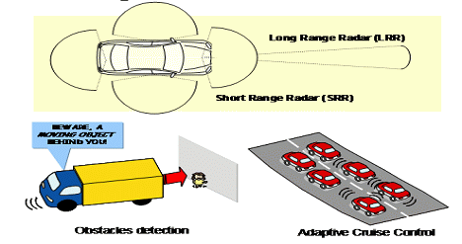

### 5.2.1 Terms and definitions

*[Editor’s note: Text to be added]*

### 5.2.2 Technical characteristics

*[Editor’s note: Text to be added]*

# 6 Legacy ITS radiocommunication - ETC

## 6.1 Overview

Electronic toll collection (ETC) allows for the manual in-lane toll collection process to be automated in such a way that drivers do not have to stop and pay cash at a toll booth. ETC systems improve traffic flow at toll plazas, and the level of pollution by reducing fuel consumption. In addition, allowing traffic to pass through the gate without stopping can increase road capacity by three or four times and relieve traffic congestion at the tollgate. It is also expected that ETC systems will reduce the operating costs of toll roads by replacing manual toll collection.

There are many similar words related to ETC. In Europe, Electronic Fee Collection (EFC) is popularly used. They think that EFC covers ETC, Electronic Parking System (EPS), Electronic Road Pricing. Electronic Road Pricing is usually referred to the electronic toll collection scheme adopted in Singapore for purposes of congestion management. To avoid confusion, these terminologies need to define clearly.

In Japan, Mobile Service using DSRC with the frequency bands between 5 770 and 5 850 MHz, the applications for ETC (Electronic Toll Collection) and safe driving assistance have been widely used for daily life.

## 6.2 Technical characteristics

DSRC refers to a dedicated short range communication between a roadside infrastructure and vehicles or mobile platforms for ITS applications.

The two major components of DSRC are on-board equipment (OBE) and roadside equipment (RSE).

**On-board equipment (OBE):** OBE is installed near the dashboard or on the windshield of the vehicle, and consists of radiocommunication circuits, an application processing circuit and so on. It usually has a human-machine interface, including switches, displays and buzzer.

**Roadside equipment (RSE):** RSE is installed above or alongside the road and communicates with passing OBE by use of radio signals. RSE consists of radiocommunication circuits, an application processing circuit and so on. It usually has a link to the roadside infrastructure to exchange data.

DSRC systems operate by transmitting radio signals for the exchange of data between vehicle mounted OBE and RSE. This exchange of data demands high reliability and user privacy as it may involve financial and other transactions.

## 6.3 Frequency usage

*[Editor’s note: Text to be added]*

## 6.4 Standardization

Table [X]

Global Standard on ETC

|  |  |  |
| --- | --- | --- |
| SDO | Standard No. | Standard Title |
| ITU | ITU-R M.1453-2 | Intelligent transport systems – dedicated short range communications at 5.8 GHz |

Dedicated Short Range Communication (DSRC) refers to any short-range radiocommunication technology from a roadside infrastructure to a vehicle or a mobile platform [4]. Although DSRC can be applied to various application of ITS (e.g. parking payment, gas (fuel) payment, in-vehicle signing, traffic information, etc.), ETC is the most typical one. Table [X] shows the established DSRC standards.

## 6.5 Applications

DSRC is the use of non-voice radio techniques to transfer data over short distances between roadside and mobile radio units to perform operations related to the improvement of traffic flow, traffic safety and other intelligent transport service applications in a variety of public and commercial environments. DSRC services include vehicle control systems, traffic management systems, traveller information systems, public transportation systems, fleet management systems, emergency management systems and electronic payment services.

Figure [X]

Interrelation of DSRC with ITS communication networks

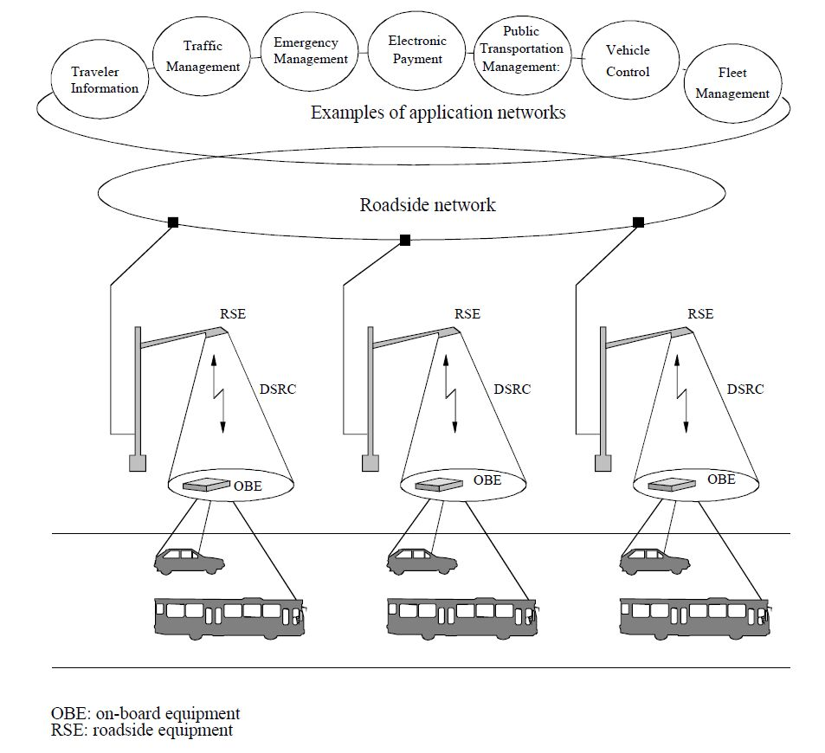

## 6.6 Region 1

In 1992, the CEPT (European Conference of Postal and Telecommunications Administrations) – ERC (European Radio communications Committee) agreed on ERC Decision (92)02 designating frequency bands for the development of a fully Integrated Road Transport system in order to improve all aspects of road transport. It was decided to designate the frequency band 5 795‑5 805 MHz on a European basis, with an additional sub-band 5 805-5 815 MHz on a national basis, to meet the requirements of multilane road junctions. The frequency bands were foreseen for initial road-to-vehicle systems, in particular for road toll systems for which requirements had emerged in a number of European countries at that time. In 2002, the Electronic Communications Committee (ECC) withdrew ERC Decision (92)02 and replaced it by ECC Decision (02)01, entering in force on 15 March 2002.

Based on the ECC Decision, standards for DSRC for ITS applications have been developed by European Committee for Standardization (CEN) and European Telecommunications Standards Institute (ETSI). A standard for the Physical Layer using Microwaves at 5.8 GHz (CEN EN 12253) describes radiocommunication and RF parameter values necessary for co-existence and interoperability of DSRC systems. This standard forms part of the DSRC family of standards consisting of four standards covering the protocol layers 1, 2 and 7 of the Open Systems Interconnection (OSI) protocol stacks and profiles for RTTT (Road Transport and Traffic Telematics) applications. All these CEN standards were approved and published in 2003 and 2004.

The harmonized ETSI standard EN 300 674-2: “Dedicated Short Range Communication (DSRC) transmission equipment (500 kbit/s / 250 kbit/s) operating in the 5.8 GHz Industrial, Scientific and Medical (ISM) band” was approved and published in 2004. This standard contains general and environmental test conditions, methods of measurements and parameter limits.

The use of this harmonized ETSI standard gives a presumption of conformity to article 3 of the Directive 1999/5/EC of the European Parliament and of the (R&TTE Directive).

***[****Editor´s note: The following technical characteristics will be included in section 6.1 overview at a later stage]****]***

Technical characteristics

(1) Passive Backscatter Method

European DSRC systems adopt the passive backscatter (transponder) method. This method does not have an internal oscillator for generating a 5.8 GHz band radio carrier signal in the on board equipment (OBE), so it relies on the 5.8 GHz oscillator of the roadside unit with which it communicates. A detailed explanation is given in Figure 4.3 with a typical functional block diagram.

As the passive transponder does not have a carrier signal oscillator, when transmitting from the OBE, the roadside unit has to emit an unmodulated carrier signal continuously. The OBE receives this signal, which is fed to the transmission circuit and makes it its own carrier signal (B). The transmission data from the main processing unit modulates the output of the sub-carrier signal oscillator C and mixes it with the carrier signal from the receiver. Resultant sideband signals carrying transmission data with different frequencies (carrier signal frequency plus/minus sub carrier frequency) from the carrier signal are transmitted with the carrier signal. The sub-carrier modulation method is utilized to extend the communication zone through reduction of the carrier phase noise and to reduce the re-use distance of RSE in passive transponder system. The modulated signal from the RSE is detected in the detector and processed by the main processing unit as receiving data. The communication zone of the passive (transponder) system is very small, typically up to 10 or 20 meters in front of the RSE. To extend the communication zone to some degree, additional radio frequency amplifier D may be inserted into the transmission circuit of the transponder.

One of the significant features of the passive backscatter method is a narrow communication zone, typically up to 10 or 20 meters in front of the RSE. This characteristic, i.e. communications can only take place at a precise point, is particularly important to correctly locate the vehicle. There are many applications utilizing this characteristic such as Electronic Toll Collection (ETC), Automatic Vehicle Identification (AVI) etc. Another feature of the passive backscatter method is that the structure of the OBE is simple and results in low manufacturing costs.

Figure [X]

Typical configuration of OBE in passive backscatter method

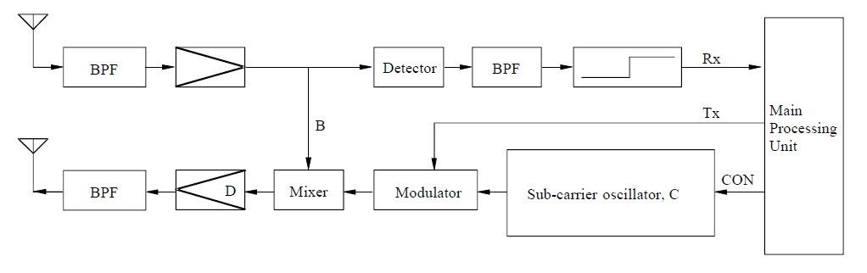

Figure [X] shows the RSE and OBE transmission timing chart and Figure [X] shows the RSE and OBE transmission spectrum in passive backscatter method.

Figure [X]

Transmission timing chart in passive backscatter method

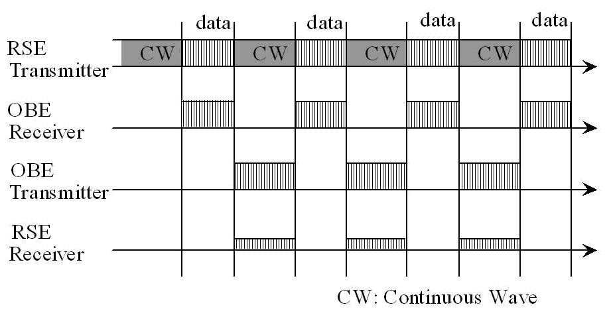

FIGURE [X]

RSE and OBE transmission spectrum in passive backscatter method

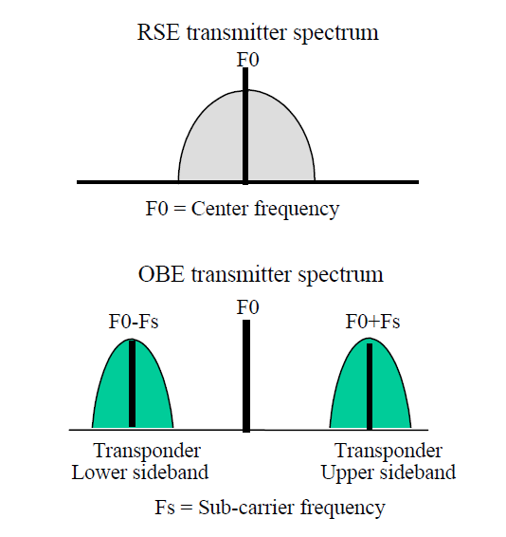

(2) Technical Characteristics of the European Backscatter Method

Technical characteristics of the European backscatter (transponder) method are shown in Table [X] which is an excerpt from Recommendation ITU-R M.1453-2. The Recommendation incorporates the “Medium data rate” European standard (CEN EN 12253) as well as the “High data rate” Italian standard into a single Recommendation.

In the European DSRC standard, the OBE supports two kinds of sub-carrier frequencies (1.5 MHz and 2.0 MHz). Selection of sub-carrier frequency depends on the profile indicated by the RSE. (1.5 MHz is recommended). Frequency spectrum of “Medium data rate” European standard is shown in Figure [X].

In the case of “High data Rate” Italian standard, the OBE uplink sub-carrier frequency is 10.7 MHz, resulting in higher uplink data transmission speed.

Frequency spectrum of the “High data rate” Italian standard is shown in Figure [X].

Figure [X]

Frequency spectrum of “Medium data rate” European standard

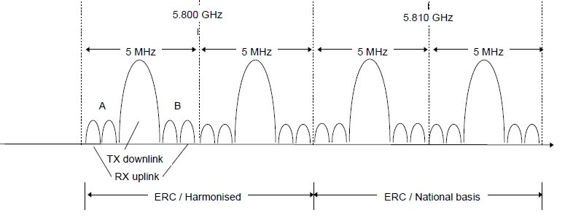

(RAST6(98)29　“Intelligent Transportation System – An ETSI View”)

Figure [X]

Frequency spectrum of “High data rate” Italian standard

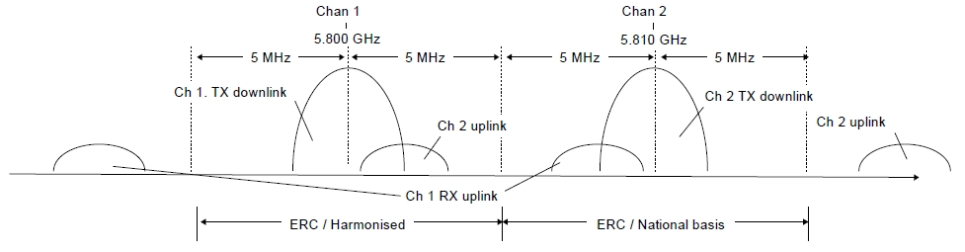

(RAST6(98)29　“Intelligent Transportation System - An ETSI View”)

Table [X]

Characteristics of backscatter (transponder) method

|  |  |  |  |
| --- | --- | --- | --- |
| Item | Technical characteristic | | |
| Medium data rate | | High data rate |
| Carrier frequencies | | 5.8 GHz band for downlink | 5.8 GHz band for downlink | |
| Sub-carrier frequencies | | 1.5 MHz/2 MHz (uplink) | 10.7 MHz (uplink) | |
| RF carrier spacing (channel separation) | | 5 MHz | 10 MHz | |
| Allowable occupied bandwidth | | Less than 5 MHz/channel | Less than 10 MHz/channel | |
| Modulation method | | ASK (downlink carrier) PSK (uplink sub-carrier) | ASK (downlink carrier) PSK (uplink sub-carrier) | |
| Data transmission speed (bit rate) | | 500 kbit/s (downlink) 250 kbit/s (uplink) | 1 Mbit/s (downlink) 1 Mbit/s (uplink) | |
| Data coding | | FM0 (downlink) NRZI (uplink) |  | |
| Communication type | | Transponder type | Transponder type | |
| Maximum e.i.r.p.(1) | | ≤ +33 dBm (downlink) ≤ –24 dBm (uplink: single sideband) | ≤ +39 dBm (downlink) ≤ –14 dBm (uplink: single sideband) | |
| (1) ERC Recommendation 70-03 specifies values of 2 W e.i.r.p. for active and 8 W e.i.r.p. for passive systems | | | | |

### 6.6.1 Frequency usage

TABLE [X]

Frequency usage for ETC in Europe

|  |  |  |  |  |
| --- | --- | --- | --- | --- |
| Country | Frequency band | Technology/ Standard | Service | Deployment or plan year |
| Europe | 5 795-5 805 MHz  [5 805-5 815 MHz] | DSRC | Electronic Toll Collection | Enacted in [19XX] |

### 6.6.2 Standardization

TABLE [X]

Standard for ETC in Europe

|  |  |  |
| --- | --- | --- |
| SDO | Standard No. | Standard Title |
| ETSI | EN 300 674 | Road Transport and Traffic Telematics (RTTT); Dedicated Short Range Communication (DSRC) transmission equipment (500 kbit/s / 250 kbit/s) operating in the 5,8 GHz Industrial, Scientific and Medical (ISM) band |
| ETSI EN 300 674-2-1 | Transport and Traffic Telematics (TTT); Dedicated Short Range Communication (DSRC) transmission equipment (500 kbit/s / 250 kbit/s) operating in the 5.8 GHz Industrial, Scientific and Medical (ISM) band; Part 2: Harmonised Standard covering the essential requirements of article 3.2 of the Directive 2014/53/EU; Sub-part 1: Road Side Units (RSU) |
| ETSI EN 300 674-2-2 | Transport and Traffic Telematics (TTT); Dedicated Short Range Communication (DSRC) transmission equipment (500 kbit/s / 250 kbit/s) operating in the 5.8 GHz Industrial, Scientific and Medical (ISM) band; Part 2: Harmonised Standard covering the essential requirements of article 3.2 of the Directive 2014/53/EU; Sub-part 2: On-Board Units (OBU) |
| TS 102 486 | Test specifications for DSRC transmission equipment |

***[****Editor´s Note: the following text related to applications to be shifted to chapter 6.1 with legacy ITS application overview over all three regions****]***

Applications

(1) General

A large number of European countries are implementing electronic toll collection (ETC) system based on DSRC technology. ETC applications are considered to be a major driving force that will create the new market for a large number of DSRC equipment which provides the versatile services for other DSRC based applications. In addition to ETC, applications such as access control, parking management and payment, traffic information and emergency warning, freight and fleet management, traffic control etc. are proposed as ITS services in Europe. These applications are expected to be implemented significantly when ETC using DSRC technology becomes widely used.

The European project DELTA (DSRC Electronics Implementation for Transportation and Automotive applications) is aiming to integrate the DSRC communication link as basic equipment in any vehicle. The following list includes such possible future ITS applications.

– In-vehicle Signing to Assist for Safe Driving (Obtaining roadside traffic and travel information)

– Parking Garage Fee Payment

– MP3 Music Download While Fuelling

– Vehicle status for car rental automatic billing

– Software Installation (Service facility installs fleet management software on the vehicle)

– Mission Planning (A fleet operator plans and downloads mission data to the vehicle)

– Floating Car Data (Acquisition of travel-related information via DSRC)

– Multimodal Transport Information (Display of public transport vehicle information)

– Vehicle Control (Adaptive automatic cruise control)

– Service subscription

– Diagnostics (Service technician diagnostics fault via DSRC).

It should be noted, that for many of these services, there are competing technologies e.g. mobile communications with satellite positioning (GNSS). However, the specific characteristics of DSRC such as high data integrity (highly reliability) and low transmission latency (real time) will make it possible for DSRC to be used for most services associated with these applications.

Typical applications utilizing favourable characteristics of passive DSRC are described below. These applications are standardized within the European Committee for Standardization (CEN).

## 6.7 Region 2

*[Editor’s note: Text to be added]*

### 6.7.1 Frequency usage

TABLE [X]

Frequency usage for ETC in North and South America

|  |  |  |  |  |
| --- | --- | --- | --- | --- |
| Country | Frequency Band | Technology/ Standard | Service | Deployment or plan Year |
| U.S.A. | 902-928 MHz, | DSRC | Electronic Toll Collection | Enacted in [19XX] |
| Canada | 902-928 MHz | [RSS 137](https://www.ic.gc.ca/eic/site/smt-gst.nsf/vwapj/rss137.pdf/$FILE/rss137.pdf) | Electronic Toll Collection | Enacted in [1999] |
| Mexico | 902-928 MHz | DSRC | Electronic Toll Collection | Enacted in [19XX] |

### 6.7.2 Standardization

Table [X]

Standard for ETC in North and South America

|  |  |  |
| --- | --- | --- |
| SDO | Standard No. | Standard Title |
|  |  |  |
|  |  |

## 6.8 Region 3

***[****Editor´s note: The following technical characteristics will be included in section 6.1 overview at a later stage]****]***

Technical characteristics

(1) Active (transceiver) method

The Japanese DSRC System adopts the active (transceiver) method. For the active (transceiver) method, the on-board equipment (OBE) is equipped with the same functions as roadside equipment (RSE) which is equipped with devices necessary for radiocommunication. More specifically, both RSE and OBE incorporate a 5.8 GHz band carrier frequency oscillator and have the same functionality for radio transmission. Figure [X] shows a typical block diagram for the OBE’s radio circuitry. The upper half of Figure [X] is the receiver, the lower half is the transmitter and the processing unit is to the right. The transmission and reception antennas may be shared. The OBE in the active (transceiver) method receives radio signals from the RSE with the antenna on the upper left. Each signal received passes through each functional block and is processed by the main processing unit as reception data. The transmission signal from the OBE is the 5.8 GHz band carrier signal from oscillator A modulated with transmission data. The signal is sent from the antenna on the bottomleft.

The active (transceiver) method can easily realize small or large communication zones by controlling the directivity of transmission antenna. Figure [X] shows examples of flexible communication zones forming in the typical configuration of the ETC gate. The footprint (communication zone) of an ETC antenna is very small (typically 3 m x 4 m). On the other hand, a large footprint of up to 30 meters in length can be realized by approach antenna for information dissemination. The Bit Error Rate (BER) within the footprints is very low (Less than 10-6). The main feature of the active (transceiver) method is a flexible zone forming, in addition to large volumes of information to be communicated with high reliability. These characteristics are indispensable for various ITS application services using DSRC.

Figure [X]

Typical configuration of OBE in active transceiver [ASK] method

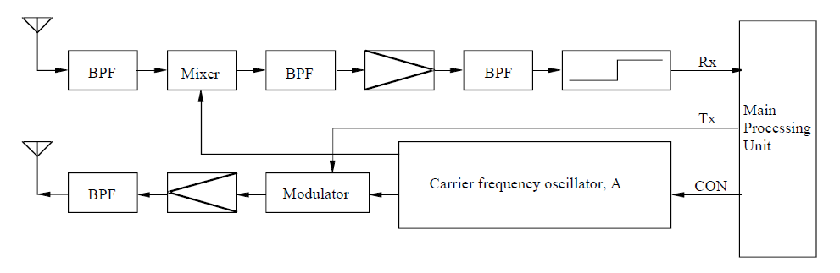

Figure [X]

Examples of DSRC antenna footprints in typical ETC toll gate

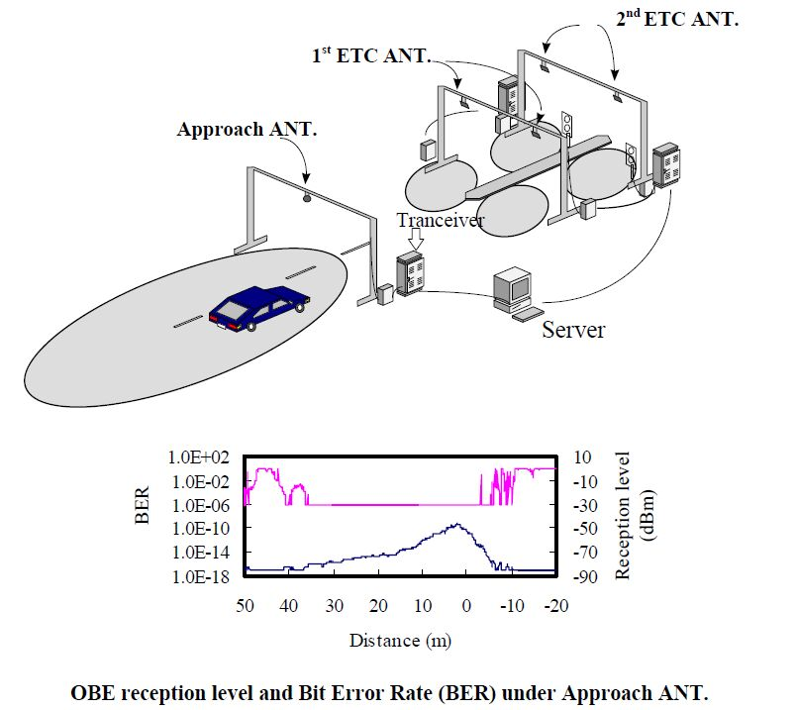

(2) Technical Characteristics of the Japanese Active Method

Technical characteristics of the Japanese active (transceiver) method are shown in Table 4.2, which is also an excerpt from Recommendation ITU-R [M.1453-2](http://www.itu.int/rec/R-REC-M.1453/en). In this table there are two specifications in RF carrier spacing column. Wide spacing (10 MHz channel separation) is mainly for current ETC application with the ASK (Amplitude Shift Keying) modulation method. Narrow spacing (5 MHz channel separation) is for multiple purpose DSRC application services with the ASK and/or QPSK (Quadrature Phase Shift Keying) modulation method. Specifications for the 5 MHz narrow spacing was replaced with 10 MHz spacing added in October 2000, when the Japanese Ministry of Posts and Telecommunications (now MIC) revised the radio law according to the proposal of the Telecommunications Technology Council on general purpose DSRC system applications. The revision was adopted by the ITU-R as the modified DSRC Recommendation ITU-R M.1453-1 in August 2002.

The maximum communication zone of DSRC is recommended to be within 30 meters to promote effective use of frequencies by reducing the re-use distance of RSE. FDD (Frequency Division Duplex) systems are also adopted to promote effective use of radio frequencies.

Figure [X] shows channel arrangement of ITS applications using DSRC at 5.8 GHz band in Japan.

Table [X]

Characteristics of active (transceiver) method

|  |  |
| --- | --- |
| Item | Technical characteristic |
| Carrier frequencies | 5.8 GHz band for downlink and uplink |
| RF carrier spacing (channel separation) | 5 MHz |
| Allowable occupied bandwidth | Less than 4.4 MHz |
| Modulation method | ASK, QPSK |
| Data transmission speed (bit rate) | 1 024 kbit/s/ASK, 4 096 kbit/s/QPSK |
| Data coding | Manchester coding/ASK, NRZ/QPSK |
| Duplex separation | 40 MHz in case of FDD |
| Communication type | Transceiver type |
| Maximum e.i.r.p.(1) | ≤ 30 dBm (downlink)  (For a transmission distance of 10 m or less. Power supplied to antenna ≤ 10 dBm) |
| ≤ 44.7 dBm (downlink)  (For a transmission distance of more than 10 m. Power supplied to antenna ≤ 24.77 dBm) |
| ≤ 20 dBm (uplink)  (Power supplied to antenna ≤ 10 dBm) |
| (1) European Radiocommunications Committee (ERC) Recommendation 70-03 specifies values of 2W e.i.r.p. for active and 8 W e.i.r.p. for passive systems. | |

FIGURE [X]

Channel arrangement of DSRC for ITS applications in Japan at 5.8 GHz band



(3) Technical Characteristics of the Chinese ETC System

The Chinese ETC System adopts the active (transceiver) method. Both RSE and OBE work in 5.8 GHz band. There are two classes specified in the physical layer. Class A with ASK modulation should meet the basic requirement of ETC application. Class B with FSK modulation should meet the requirement of high speed data transmission. Technical characteristics of downlink and uplink are shown in Tables 3 and 4, respectively.

Table 3

Technical characteristics of downlink

|  |  |  |  |
| --- | --- | --- | --- |
| Item | | Class A | Class B |
| Carrier frequencies | Channel 1 | 5 830 MHz | 5 830 MHz |
| Channel 2 | 5 840 MHz | 5 840 MHz |
| Allowable occupied bandwidth | | ≤5 MHz | ≤5 MHz |
| Modulation method | | ASK | FSK |
| Data transmission speed (bit rate) | | 256 kbit/s | 1 Mbit/s |
| Data coding | | FM0 | Manchester |
| e.i.r.p. | | ≤ +33 dBm | ≤ +33 dBm |

Table 4

Technical characteristics of uplink

|  |  |  |  |
| --- | --- | --- | --- |
| Item | | Class A | Class B |
| Carrier frequencies | Channel 1 | 5 790 MHz | 5 790 MHz |
| Channel 2 | 5 800 MHz | 5 800 MHz |
| Allowable occupied bandwidth | | ≤5 MHz | ≤5 MHz |
| Modulation method | | ASK | FSK |
| Data transmission speed (bit rate) | | 512 kbit/s | 1 Mbit/s |
| Data coding | | FM0 | Manchester |
| e.i.r.p. | | ≤ +10 dBm | ≤ +10 dBm |

### 6.8.1 Frequency usage

The usage status of ETC in APT countries is shown in Table X. Many APT countries adopted ETC in frequency band of 2.4, 5.8, 5.9 and 24 GHz. For ETC in some APT countries, DSRC technology and 5.8 GHz band has been used.

Table [X]

Legacy ITS communication [- ETC] in Asia-Pacific

| Country | Frequency band | Technology/ Standard | Application | Deployment or plan year |
| --- | --- | --- | --- | --- |
| Australia | 5 725-5 795 MHz,  5 815-5 875 MHz,  24-24.25 GHz | - | Electronic tolling | - |
| China | 5 725-5 850 MHz | DSRC | ETC (Electronic Toll Collection) | Enacted in 2003 |
| 2 400 – 2 483.5 MHz[1] | Exemption from Licensing Order | Electronic toll collection services | 1998 |
| Japan | 76-90 MHz  (FM multiplex broadcasting) | VICS (Vehicle Information and Communications System) | Traffic information | Enacted in 1994  (*VICS will not be available at 2 499.7 MHz after 31 March 2022.) |
| 2 499.7 MHz* (Radio beacon) |
| 5 770-5 850 MHz | ETC (Electronic Toll Collection) | Collect highway toll (Communication) | Enacted in 1997 |
| DSRC  (Dedicated Short Range Communication) | -Collect highway toll -Provide various information (Communication, Broadcast) | Enacted in 2001  (Revised 2008) |
| Korea | 5 795-5 815 MHz | DSRC/  TTA Standard  (TTAS.KO-06.0025/R1) | ETC (Electronic Toll Collection)  BIS(Bus Information System) | 2006  (Highpass Tolling) |
| Singapore | 2 350‑2 483.5 MHz | - | Electronic Road Pricing (ERP) Systems | 1998 |
| 5 855‑5 925 MHz | DSRC  (Dedicated Short Range Communication) | Next Generation Electronic Road Pricing (ERP) Systems | 2020 (estimated) |
| Thailand | 5 470-5 850 MHz | Compliance Standard:  ETSI EN 300 440-1 or FCC Part 15.247 or  FCC Part 15.249 | RFID (e.g. Electronic Toll Collection) | 2008 |
| Viet Nam | 920-923 MHz | RFID | ETC (Electronic Toll Collection) | 2016 |

### 6.8.2 Standardization

Table [X]

Standard for ETC in Asia-Pacific

|  |  |  |
| --- | --- | --- |
| SDO | Standard No. | Standard Title |
| TTA | TTAS.KO-06.0025/R1 | Standard of DSRC Radio Communication between Road-side Equipment and On-board Equipment in 5.8 GHz band |
| TTAS.KO-06.0052/R1 | Test specification for DSRC L2 at 5.8 GHz |
| TTAS.KO-06.0053/R1 | Test specification for DSRC L7 at 5.8 GHz |
| ARIB | STD-T75 | Dedicated Short Range Communication (DSRC) System |
| SAC (Standardization Administration of China) | GB/T 20851.1-2007 | Electrical toll collection – Dedicated short range communication – Part 1: Physical layer |
| GB/T 20851.2-2007 | Electrical toll collection – Dedicated short range communication – Part 2: Data link layer |
| GB/T 20851.3-2007 | Electrical toll collection – Dedicated short range communication – Part 3: Application layer |
| GB/T 20851.4-2007 | Electrical toll collection – Dedicated short range communication – Part 4: Equipment application |
| GB/T 20851.5-2007 | Electrical toll collection – Dedicated short range communication – Part 5: Test methods of the main parameters in physical layer |
| IMDA  TSAC | IMDA TS DSRC | Technical Specification for Dedicated Short-Range Communications in Intelligent Transport Systems |

*[Editor´s note: The following text referring to applications to be shifted to chapter 6.1 with legacy ITS application overview over all three regions***]**

### 6.8.3 Applications

As in Europe, Electronic toll collection (ETC) using DSRC is a forerunner of ITS applications in Japan. ETC service in Japan started in March 2001 and by the end of March 2003, the service covered approximately 900 toll gates through which 90% of expressway users pass. This indicates that the service was deployed nationwide in approximately two years. As of the end of March 2004, the number of toll gates increased to 1 300 and as of December 2005, the number of OBEs (ETC subscribers) reached ten million.

ETC in Japan, started in 2000 and the number of on-board equipment have reached 57 million out of 80 million vehicles, is used by 7.5 million vehicles every day for the payment of the tolls on 9 000 km long expressways. The amount of the payment is US$50 million a day and $20 billion a year. The penetration ratio is more than 90 % and it is one of the fundamental systems for industrial and daily living use. ETC has become an essential thing in our lives.

The ETC system is operated as the one with high communication reliability since one single passenger car payment often surpasses a couple of hundred dollars where the toll is expensive as $23 for every 100 km drive. Therefore, the system cannot be troubled due to radiocommunication interference or else, and if it happens, the toll system could lose the trust of the users and trigger opposition, and also there is a concern of rear-end collision accidents due to troubles of the gate bars.

Regarding to the safe driving assistance, various measures are being taken such as the alert of forward warning of accident or congestion at a point of frequent traffic accidents, the provision of the real time images of snow and foggy conditions, and the dissemination of emergency messages at the time of earthquake. Regarding to the provision of traffic information, the congestion and appropriate route selection information for wide area is provided, which contributes to congestion reduction.

The vehicle driving history data is collected as the big data by the vehicle probe system, and is used to make congestion countermeasures by grasping the points of accurate congestion bottlenecks and queue length based on the vehicle speed data, and also is used to analyze the data, for instance abrupt braking or steering, and to take measures to prevent accidents. The route information whether travel by a vehicle is possible or not is provided from the probe data in case of big disasters. Therefore, the 5.8 GHz DSRC greatly contributes to traffic safety in these various use cases, and more various kinds of applications, such as effective congestion countermeasures by the use of probe data, are being deployed.

Figure [X]

DSRC multiple applications being studied in Japan

1

Since 1996, Vehicle Information and Communication System (VICS) has been operating in Japan for delivering traffic and travel information to road vehicle drivers. The following nine application fields are being studied in Japan to extend applications in the vehicle. (Refer to Figure [X]):

(1) Parking lot management

(2) Gas filling station

(3) Convenience store

(4) Drive-through

(5) Logistics management

(6) Pedestrian support

(7) Specific region entry charging (Zone tolling)

(8) Information providing: semi-stationary state

(9) Information providing: high speed

# 7 Advanced ITS radiocommunication

## 7.1 Overview

After the deployments of DSRC basic applications such as ETC, to extend beyond the existing ITS applications and to enhance traffic safety and reduce the environmental impact by the transportation sector, vehicle to vehicle (V2V), vehicle to infrastructure (V2I), infrastructure to vehicle (I2V), vehicle to network (V2N), vehicle to pedestrian (V2P) communications are studied. According to this progress, ITU-R WP 5A has developed report on advanced ITS radiocommunications [8]. In the report, legacy ITS and advanced ITS are classified by its technical characteristics as shown in Table x. V2X (WAVE), V2X (ETSI ITS-G5) and LTE based V2X (LTE-V2X) technologies could be inclusive in advanced ITS category.

WAVE is a dedicated mobile radiocommunication system for providing non-voice communications among vehicles that travel on roads, rails, or other dedicated facilities; as well as between those vehicles and the transportation infrastructure. WAVE is therefore a fundamental technology for ITS communications, helping link roads, traffic and vehicles covered by ITS deployment with coordinated, interoperable information technology. This particular wireless technology could be transformational to the evolution of transportation systems, since it provides very localized, low latency communications capabilities on a peer-to-peer basis. These capabilities are intended to support the planned, as well as the still unforeseen, data needs of the evolving, more automated, future transportation system. WAVE systems specifically utilize the broadcast mode of operations as the primary means to support public benefits; and also communicate using two-way communications between vehicles and infrastructure, including the ability to provide lower priority messages related to the specific units involved in a variety of public and private transportation environments.

WAVE is being pursued in the United States “to improve traveller safety, decrease traffic congestion, facilitate the reduction of air pollution, and help to conserve vital fossil fuels”6, and as a particular focus in the United States, to reduce highway fatalities7. Although not yet widely deployed, the United States has developed multiple applications, a number of which have been tested in large-scale field tests or operated in model deployments[2]. This progress has provided the United States with extensive knowledge of these applications that contribute to transportation safety, mobility and environmental stewardship in the context of advanced ITS. The WAVE ITS applications are designed to perform operations related to the improvement of traffic safety and traffic flow, as well as other intelligent transport service applications, including enhancing transportation systems efficiencies and operations (for example, facilitating roadway freight movements or transportation management during emergency responses). The main points of focus for the US deployment of advanced ITS applications using WAVE communications include: nationwide interoperability; long-term technical stability; voluntary industry standards; and support for public benefits.

Cooperative ITS communication (C-ITS) has to be based on standardized and interoperable wireless ad-hoc communication systems. The interoperability has to be guaranteed at least in the different worldwide regions. This interoperability requirement does not imply the use of exactly the same system in all regions, e.g. C-ITS in Europe in 5.9 GHz is mainly based on IEEE 802.11p and ETSI ITS-G5, whereas the US implementation in 5.9 GHz is based on the slightly different IEEE 802.11p and WAVE system as described above. For these technologies the standards are finished, intensive testing and validation has taken place, first implementations done and deployment is planned. [Other systems e.g. based on LTE-direct are in an early development stage.] Most of the actual discussed systems are based on a well-established access layer (PHY-layer and MAC-layer) standardised by IEEE802 as IEEE802.11p, which is part of the IEEE802.11-2012 set of standards.

In most countries, a frequency band in the range between 5 850‑5 925 MHz (up to 75 MHz bandwidth) has been chosen/picked as the main band of operation for the upcoming traffic-safety related C-ITS. In addition, the frequency band 63 GHz to 64 GHz has been designated for traffic safety related applications under the Mobile Service in CEPT.

Worldwide a broad range of standardisation organisation are involved in the standardisation of C‑ITS. The main actors with a strong support from the Automotive Industry are the US activities around IEEE/WAVE/SAE and the European activities around ETSI TC ITS. These activities are backed by industry consortia CAMP (Crash Avoidance Metric Partnership) in the US and the C2C‑CC (CAR-to-CAR Communication Consortium) in Europe.

The C2C-CC as an industry driven, non-profit association of 16 European vehicle manufacturers, 37 suppliers and 28 research organisations, dedicated to realise cooperative road traffic and herewith increase traffic safety, efficiency and driving comfort. The C2C-CC plays an important role in the development of European standards for C-ITS and cooperates closely on C-ITS with the CAMP consortium in the US. To align and harmonising the C-ITS roll-out in vehicles and traffic infrastructure in Europe by 2019 the consortium engages in the Amsterdam Group. This is a strategic alliance of the CAR 2 CAR Communication Consortium, the ASECAP (Association of operators of toll road infrastructures), CEDR (Conference of European Directors of Roads) and POLIS (European Cities and Regions Networking for Innovative Transport Solutions). Furthermore, the consortium actively contributes to the work of the C-ITS Deployment Platform organised by the European Commission.

The C2C-CC participated in the initial design of vehicle to vehicle communications technologies through the publication of a manifesto. It also helps validating the C-ITS by getting involved in FOT (Field operational tests) and ongoing cross-border C-ITS corridor projects and focusing on interoperability testing.

In 2007 the CAR 2 CAR Communication Consortium published the Manifesto on its website[3]. The document built the basis for the first interoperability demonstration shown 2008 at the Opel testside in Dudenhofen.

The document describes the C-ITS scenarios for improving safety and traffic efficiency as well as using the communication system for infotainment and other purposes. From the scenarios, the system prerequisites and constraints are derived and the system architecture developed. The architecture describes the communication principles, the individual components, the layers’ architecture and related protocols. The further chapters describe the applications, the radio and communication system as well as data security and privacy.

This document specifies the standard profile that enables interoperability of C-ITS units. The first Basic System Profile (BSP) version was released for C2C-CC internal usage by end of 2014. The latest revised BSP version will be published by sharing it with the Basic Members of the consortium by May 2016. It contains a system specification complemented by a selection of standards and parameters. It allows to test the aspects that are going to be used by “day one” applications.

Advanced ITS is also supported by 3GPP technologies and worldwide standards. 3GPP has developed specifications to enable the use of LTE mobile networks to provide connectivity between vehicles, roadside infrastructure and pedestrians inside and around the connected vehicles, i.e. targeting all initial main V2X use cases and requirements studied by 3GPP: V2V, V2P, V2I and V2N.

3GPP Release 14 specification work about LTE-based V2X service, including system and radio access requirements, has been completed in March 2017 and 3GPP will freeze the specification work on release 14 in June 2017. Both PC5 (device-to-device direct link) and Uu (link between base station and device) are included, supporting transmission in existing mobile allocations up to 6 GHz. Device-to-device direct link communication without network assistance is also supported. More details can be found in section 7.2.3 below. The LTE based V2X communication over PC5 and Uu interface can be found in Figure X

Figure X

V2X communication over LTE-PC5 interface and LTE-Uu interface

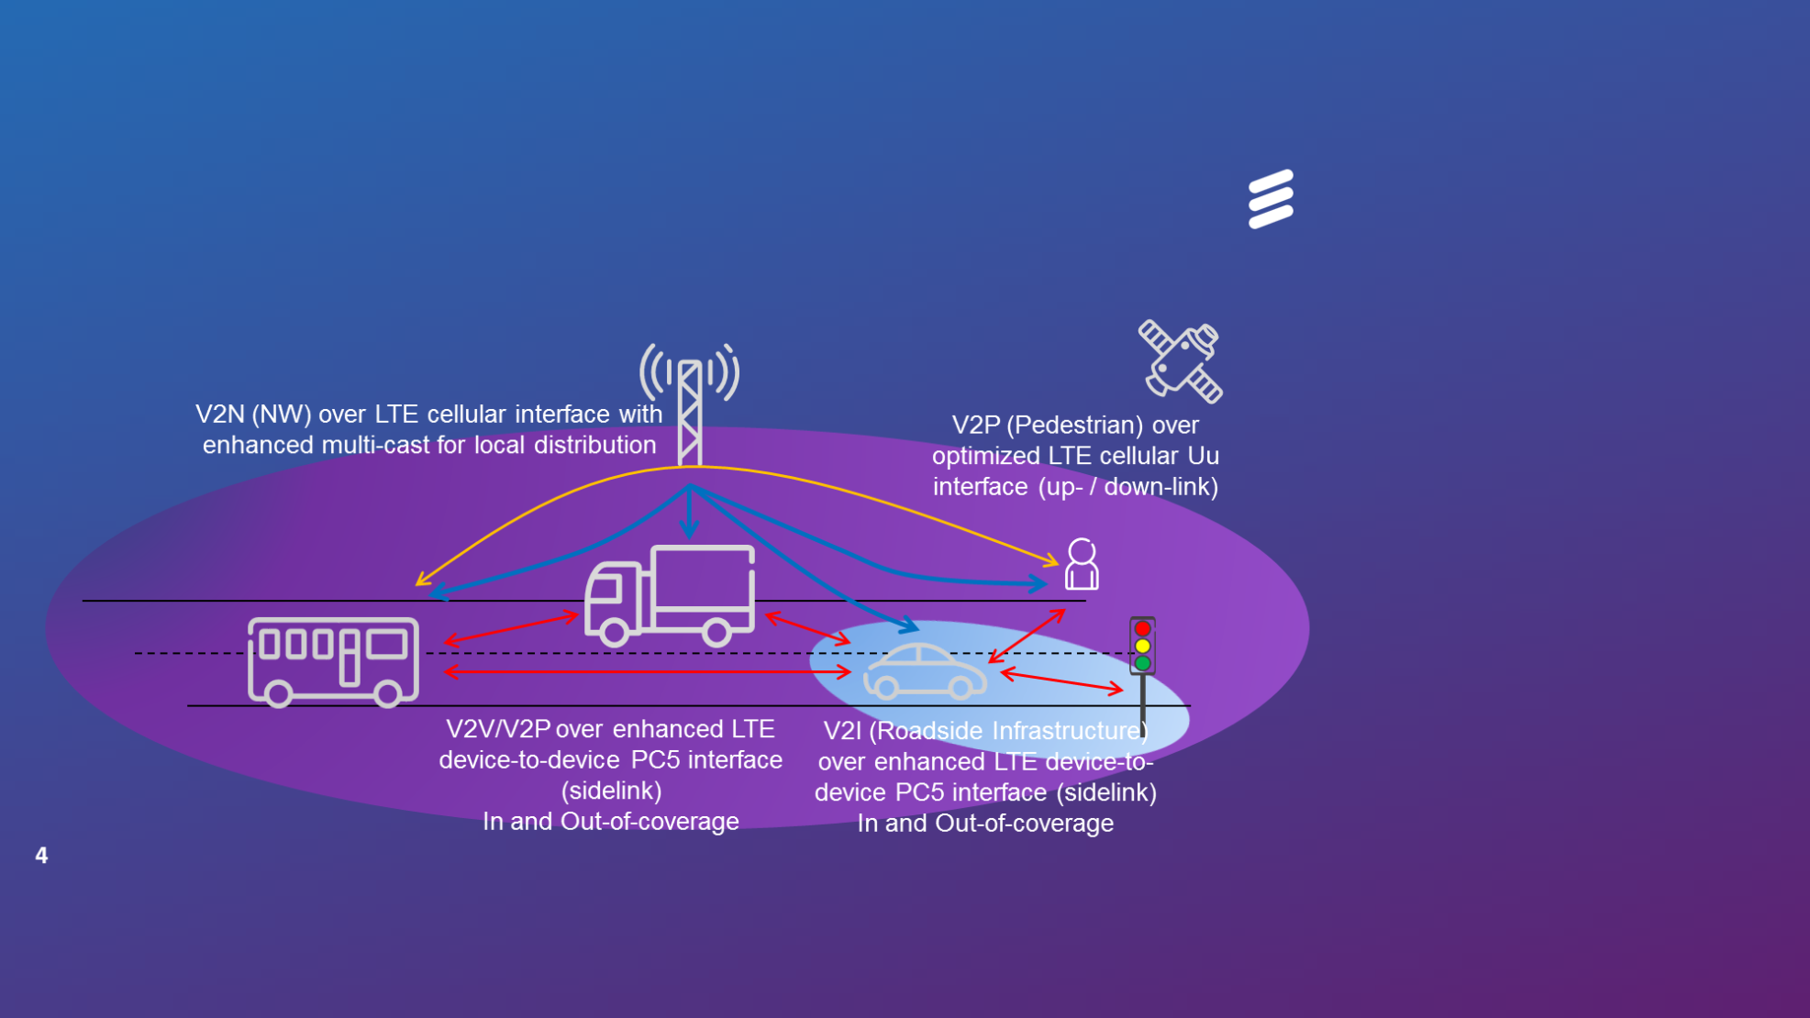

3GPP is also looking at continuously evolving the V2X services in its coming releases including 5G. Future V2X releases will support, e.g. enhanced safety use cases at high vehicle speeds, challenging road conditions with its improved reliability, extended range, lower latency, and enhanced non-line-of-sight (NLOS) capabilities. Therefore, further 3GPP V2X enhancements are expected, from Rel-15 onward.

China started to develop trials of LTE based V2X communication technology (LTE-V2X) to verify road safety and non-road safety applications from 2015.

## 7.2 Technical characteristics

Table [X]

Technical characteristic of Advanced ITS

|  |  |  |  |
| --- | --- | --- | --- |
| Items | V2X (WAVE) | V2X (ETSI ITS-G5) | V2X (LTE based V2X) |
| Technologies | WAVE,  IEEE 802.11p | ETSI ITS-G5  IEEE 802.11p | 3GPP LTE based V2X |
| Vehicular networking | V2V, V2I, V2P | V2V, V2I, V2P | V2V, V2N, V2I, V2P |
| Radio performance | Radio coverage: Max. 1 000 m  Data rate: Max. 27 Mbps  Packet size: Max. 2 kbytes  Latency : within 100 msec | Radio coverage: Max. 1 000 m  Data rate: Max. 27 Mbps  Packet size: Max. 2 kbytes  Latency : within 100 msec | Radio coverage: Max. 1 000 m  Data rate: Max. 27 Mbps  Packet size: Max. 2 kbytes  Latency: within 100 msec  within 1 000 msec for V2N |

Figure [X]

Vehicle information & Communication (V2V, V2I, I2V)



### 7.2.1 V2X (WAVE)

[changes from US]

***[Editor’s note for 7.2.1 V2X:*** *It should be noted that the information contained in this WAVE section may need to be revised/updated as a result of ongoing domestic proceedings by one administration.****]***

*On-board equipment (WAVE OBE)*: The OBE consists of communications and processing equipment installed in vehicles to enable WAVE communications with other vehicles and infrastructure, and support WAVE-enabled applications. OBEs may be most effective when integrated into the vehicle and able to interface with other on-board equipment such as the vehicle’s sensor suite, anti-lock braking system, and other subsystems, allowing it to complement these existing systems.

*Roadside unit (WAVE RSU)*: A WAVE RSU is installed above or alongside the road or other infrastructure and communicates with passing OBEs by the use of radio signals. An RSU consists of radio communication circuits, an application processing circuit and related equipment. It may have data linkages to traffic management centers (TMCs) and to other roadside equipment (such as traffic signal controllers), as well as to the Internet to exchange data and to maintain security credential information.

The WAVE systems operate by transmitting radio signals for the exchange of data among vehicle-mounted OBEs, and between OBEs and infrastructure-based RSUs. By adhering to requirements set by industry standards, these systems accomplish a data exchange that ensures that data is interoperable across a wide range of device and application manufacturers. Interoperability is key to support the rapid, standardized adoption of applications that deliver critical safety related, system and operational efficiencies, and other public benefits.

Much of the information to complete the following tables comes from Std 802.11-2016[4].

The modulation used for WAVE is ‘half-clocked’ OFDM on 10 MHz channels. Below are basic OFDM transmitter and receiver block diagrams.

Transmitter and Receiver[5]

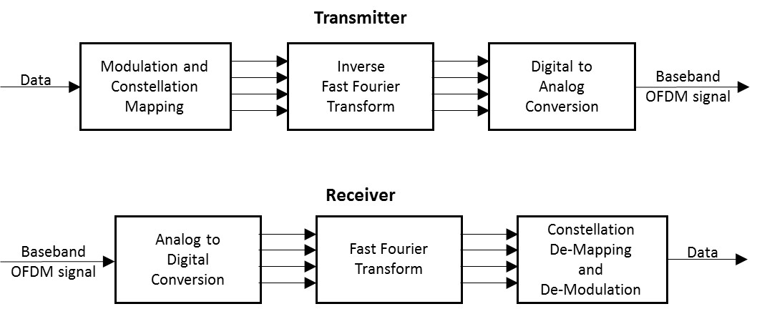

Transmitter characteristics[6]

| Parameter | Value | |
| --- | --- | --- |
| Emission 3 dB Bandwidth (MHz) | 10 MHz | |
| Power (Peak) (dBm) | 23 to 44.8 dBm e.i.r.p.[7] (Depending on Channel used, RSU or OBE[8] and government or private); also, transmissions shall use only the power necessary to support the particular application[9] | |
| Emission Spectrum  (Relative Attenuation (dB) as a Function of Frequency Offset from Center Frequency (ΔF) (MHz)) | **Attenuation** | **Δ*F*** |
| See footnote[10] | See footnote7 |
| Data Rate | 6 Mb/s[11] | |
| Modulation Parameters[12] | Modulation QPSK | Coding Rate 1/2 |
| Azimuth Off-Axis Antenna Pattern | Vehicles - omnidirectional (3600)[13]; sectorized antennas sometimes used with Infrastructure WAVE transmitter antennas | |
| Elevation Off-Axis Antenna Pattern | -6 to +10 degrees – vehicles Infrastructure – specification TBD | |
| Antenna Height (meters) | 1.5-15 m[14] | |
| Antenna Polarization | Primarily vertical (some right hand circular)[15] | |

Receiver characteristics3

| Parameter | Value |
| --- | --- |
| Receiver Sensitivity | -92 dBm minimum,  -94 dBm typical[16] |
| Receiver Selectivity | See following table on “Adjacent and Next-Adjacent Channel Rejection Receiver Characteristics” |
| Information Data Rate | 3, 4.5, 6, 9, 12, 18, 24 and 27 Mb/s (3, 6 and 12 Mb/s are mandatory)[17] |
| Antenna Characteristics | Note that the same antenna is typically used for both transmit and receive functions in WAVE systems – refer to antenna characteristics in the previous table for receiver antenna characteristics |

Adjacent and Next-Adjacent Channel Rejection Receiver Characteristics[18]

|  |  |  |  |  |  |
| --- | --- | --- | --- | --- | --- |
| Modulation | Coding rate | Receiver performance (dB) | | Optional enhanced receiver performance (dB) | |
| Adjacent channel rejection | Next adjacent channel rejection | Adjacent channel rejection | Next adjacent channel rejection |
| BPSK | 1/2 | 16 | 32 | 28 | 42 |
| BPSK | 3/4 | 15 | 31 | 27 | 41 |
| QPSK | 1/2 | 13 | 29 | 25 | 39 |
| QPSK | 3/4 | 11 | 27 | 23 | 37 |
| 16-QAM | 1/2 | 8 | 24 | 20 | 34 |
| 16-QAM | 3/4 | 4 | 20 | 16 | 30 |
| 64-QAM | 2/3 | 0 | 16 | 12 | 26 |
| 64-QAM | 3/4 | –1 | 15 | 11 | 25 |

Maximum STA transmit power classification for the 5.85–5.925 GHz band in the United States[19]

|  |  |  |
| --- | --- | --- |
| STA transmit power classification | Maximum STA transmit power (mW) | Maximum permitted e.i.r.p. (dBm) |
| A | 1 | 23 |
| B | 10 | 33 |
| C | 100 | 33 |
| D | 760 Note that for this class higher power is permitted as long as the power level is reduced to this level at the antenna input and the emission mask specifications are met. | 33 for nongovernment  44.8 for government |

Spectrum mask data for 10 MHz channel spacing4

| STA transmit power class | Permitted power spectral density, dBr | | | | |
| --- | --- | --- | --- | --- | --- |
| ± 4.5 MHz offset (±f1) | ± 5.0 MHz offset (±f2) | ± 5.5 MHz offset (±f3) | ± 10 MHz offset (±f4) | ± 15 MHz offset (±f5) |
| Class A | 0 | –10 | –20 | –28 | –40 |
| Class B | 0 | –16 | –20 | –28 | –40 |
| Class C | 0 | –26 | –32 | –40 | –50 |
| Class D | 0 | –35 | –45 | –55 | –65 |

Transmit spectrum mask for 10 MHz OBE transmission (Class C typical)[20]

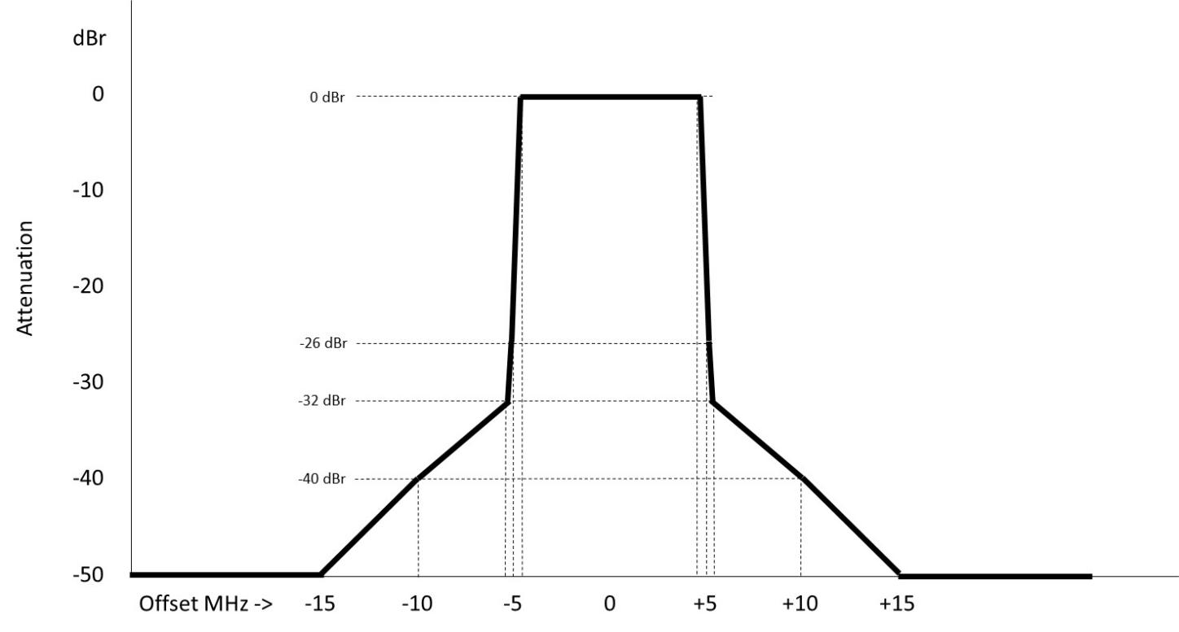

*[changes from US]*

### 7.2.2 V2X (ETSI ITS-G5)

*[Editor’s note: Text to be added]*

### 7.2.3 V2X (LTE based V2X)

3GPP TSG RAN in RAN#73 completed work item “Support for V2V services based on LTE sidelink”, LTE based V2V device-to-device direct link communications are based on D2D communications defined as part of ProSe (proximity service) services in 3GPP Release-12[21] and Release-13[22]. As part of ProSe services, a new D2D interface was introduced in Release-14 and it has been enhanced for vehicular use cases, specifically addressing high speed (relative speeds up to 500 kph) and high density.A few fundamental modifications to LTE-V2V PC5 have been introduced.

– Additional DMRS symbols have been added to handle the high Doppler associated with relative speeds of up to 500 kph and at high frequency (5.9 GHz ITS band being the main target).

– The arrangement of scheduling assignment and data resources are designed to enhance the system level performance under high density while meeting the latency requirements of V2V.

Distributed scheduling (Mode 4) a sensing with semi-persistent transmission based mechanism was introduced.

3GPP work item “LTE-based V2X services” specifies enhancements required to enable V2X services with LTE uplink and downlink, to enable LTE PC5 interface using PC5 to support additional V2X services such as vehicle to pedestrian (V2P), and to support more operational scenarios for V2V services using LTE PC5. To be specific, it is considered the following as the main features:

– Uplink and PC5 enhancement to enable eNB to quickly change semi-persistent scheduling (SPS) in adaptation to a change in the V2X message generation pattern.

– Introduction of shorter scheduling periods in downlink and PC5 for broadcasting V2X messages within latency requirements.

– Introduction of an additional resource allocation procedure in PC5 mode 4 for power saving in pedestrian UEs.

– Introduction of PC5 congestion control for operation in high traffic load.

– Enhancement to PC5 synchronization for operation outside GNSS or eNB coverage.

– Support of simultaneous V2X operations over multiple carriers.

PC5 interface for V2X supports QPSK and 16QAM in a 10 MHz or 20 MHz channel leading to a peak rate of 41.472 Mbps. Uu interface for V2X reuses the existing LTE Uu interface, so the modulation scheme and the peak rate is the same. As a result of this WI, the LTE radio specification supports the two LTE based V2X communication methods, both PC5 and Uu interface, illustrated in Figure x. PC5 interface communication supports direct link transmission when cellular network provides coverage for vehicles (in coverage), or when vehicles are out of coverage of cellular network. LTE based V2X can support message transmission by both unicast and broadcast in Uu interface.

Figure x

V2X communication over PC5 interface and Uu interface



## 7.3 Technical and operational communications aspects

### 7.3.1 Technical Communications Aspects

***[Editor’s note:*** *It should be noted that the information contained in this section may be updated at a future meeting as a result of related ongoing United States domestic proceedings.****]***

Table [xx]

Technical Communications Aspects for Advanced ITS Applications to Support Transportation Safety-Related and Efficiency Applications[23]

|  |  |
| --- | --- |
|  | Aspect |
|  | *Interoperability aspects* |
| United States | Certification Operating Council certifies all vehicle and infrastructure safety-related communication devices[24] to ensure interoperability before being permitted to operate in the United States. |
| V2V Basic Safety Messages[25] (BSM)s are transmitted on a dedicated safety channel, which is the 10 MHz channel from 5 855 to 5 865 MHz Channel 172 under current standards[26] and regulations[27] in the United States. |
| Protection of safety-related communications is the highest priority[28]. |
|  |
| *Performance aspects* |
| Devices provide[29],[30] 300 m[31],[32],[33] range with less than 10% packet error rate anywhere along the 360 circle around the center of the vehicle 1.5 m above the ground, with line of sight and under controlled test conditions (to support V2V safety applications) |
| Objective of 10% packet error rate is for reception of basic safety messages at the edges of 300 m range. Other applications may have different objectives. |
| Reliable operation of basic safety messages and other use cases imply limits on maximum system latency[34],[35] |
| Technology designed to support appropriate scale (sufficient capabilities for each vehicle to maintain a real time dynamic state map through concurrent communications with vehicles within a communications zone transmitting basic safety messages 10 times per second)[36],[37] |
| Congestion mitigation is employed (monitor channel loading and gradually adjust parameters in congested conditions, to fully support the most likely vehicle conflict scenarios)[38] |
| Connectionless communications capabilities are supported for safety-related messages (e.g., for Basic Safety Messages and Signal Phase and Timing messages), rather than requiring point-to-point connections between devices[39],[40] |
| Non-trackability (anonymity) / appropriate level of privacy (no vehicle or individual identification for required safety-related transmissions)[41] |
| Out of network coverage range operation supported such that devices are able to operate independently of wide area network coverage[42],[43] |
| Security (trust anchor for safety-related communications that preserves anonymity; ability to remove “bad actors” from making credible safety-related transmissions)[44] |

### 7.3.2 Operational Communications Aspects

Table [xx]

Operational Communications Aspects for Advanced ITS Applications to Support Transportation Safety-Related and Efficiency Applications[45]

|  |  |
| --- | --- |
| United States | Technology is reliable, upgradable and backwards compatible to ensure typical automobile and infrastructure deployment and lifecycle time frames. |
| Does not require periodic end-user payment to utilize required safety-related applications[46] |
| Retrofit and aftermarket devices, compatible with factory-installed integrated devices, may be deployed in existing vehicle fleet according to market-driven incentives. |
| Compliant equipment deployed according to the same planning factors as other transportation infrastructure.[47] |

## 7.4 Frequency usage

Among APT countries, Japan is using 760 MHz band and studying 5.8 GHz band for V2V and V2I communication to transmit safety related information. Also, Korea assigned 5 855-5 925 MHz for C-ITS (V2V and V2I communications) in 2016. China is also studying spectrum related aspects on V2X (LTE based V2X) communication technology in 5.9 GHz band, where V2X communication includesV2V, V2I, V2P, V2N applications. ITS spectrum study is under developing in multiple standard organizations in China, where the study includes ITS use cases, spectrum need, and coexistence study with incumbent services. In December 2016, China has identified 5 905-5 925 MHz as LTE-V2X experiment frequency band. TIAA (Telematics Industry Application Alliance) and IMT-2020 Promotion Group work closely with vehicle manufactories, telecommunication companies, research institutions and testing institutions to start road-test and verification work of technical characteristics of LTE-V2X, including radio power, efficiency, radiation, interference, effectiveness, *etc.* in six major cities.

On the other hand, Europe plans to use of the 5 855-5 925 MHz frequency band for C-ITS (V2V and V2I communication) according to the ECC decision in 2008, and the U.S. use the frequency band 5 850-5 925 MHz for the WAVE providing ITS applications with specific channels for safety. For interoperability and global harmonization, some APT countries are (e.g. Australia, Singapore) also considering these band for cooperative ITS.

Regards these activities, in Australia, the investigation has carefully examined the constraints created by existing and future service coordination requirements. These include, for example, the fixed-satellite service concerns over the unknown compounding effects of aggregated roadside and onboard units which could constructively interfere with the FSS, and/or raise the overall noise floor within which the FSS operates. Moreover, the need to protect intelligent transport systems may severely limit the deployment of future FSS earth stations in the band 5 850-5 925 MHz While studies have indicated these impacts will be minimal, mitigation and appropriate licensing strategies are under consideration.

### 7.4.1 V2X (WAVE)

WAVE is being pursued in the United States “to improve traveller safety, decrease traffic congestion, facilitate the reduction of air pollution, and help to conserve vital fossil fuels”[48], and as a particular focus in the United States, to reduce highway fatalities[49]. In order to address the need for advanced ITS to provide these public benefits, a number of applications have been developed, with more still under development, to leverage the unique short range characteristics of WAVE. These applications include communications among vehicles and other mobile end users, as well as between mobile users and roadside infrastructure.

WAVE applications may have access to each of the seven 10 MHz channels on a dynamic assignment basis under the direction of the control channel as shown in the following table, but do not use the 20 MHz combined channels, designated as Channels 175 and 181 in the table. This band plan provides dedicated channels for crash-imminent safety-related (Channel 172) and high-powered public safety-related (Channel 184) applications[50], as well as flexible assignment of other service channels through the control channel mechanism to support the wide range of advanced ITS WAVE applications. Many applications will only partially use a particular assignable channel at a particular time and location, permitting sharing among WAVE applications on individual assignable service channels.

Safety-related applications which are not pre-assigned to the dedicated channels typically use the control channel to transmit very short, infrequent messages, or else use WAVE Service Announcements (WSA) on the control channel to indicate a service channel upon which to communicate, if those messages are less dependent upon having very low latency. Lower priority messages typically use WSAs on the control channel to be assigned to a service channel which is not fully occupied by safety-related communications at that location at that time. This flexible designation of application messages to different service channels in various locations facilitates spectral efficiency and reduces interference among WAVE applications.

Band Plan for WAVE in the United States[51]

|  |  |  |  |  |  |  |  |
| --- | --- | --- | --- | --- | --- | --- | --- |
| 5.850 GHz |  |  | |  |  | | 5.925 GHz |
|  | | CH175 | |  | CH181 | |  |
| 5 850-5 855  reserve 5 MHz | CH172  service 10 MHz | CH174  service 10 MHz | CH176  service 10 MHz | CH178  control 10 MHz | CH180  service 10 MHz | CH182  service 10 MHz | CH184  service 10 MHz |

Note – This band plan may need to be revised if regulatory changes occur as a result of ongoing regulatory proceedings in the United States.

### 7.4.2 V2X (ETSI ITS-G5)

*[Editor’s note: Text to be added.]*

## 7.5 Best practice and experiences on the usage of the bands between ITS and other applications / services

*[Editor´s note: Contributions for 5 850-5 925 MHz and 63-64 GHz are invited.]*

## 7.6 Standardization, technical specifications, technical reports and ITU deliverables

Table [X]

Global Standards, technical specifications on Advanced ITS Radiocommunication

| SDO | Document Number | Title |
| --- | --- | --- |
| ASTM | E2213-03 | Standard Specification for Telecommunications and Information Exchange Between Roadside and Vehicle Systems – 5 GHz Band Dedicated Short Range Communications (DSRC) Medium Access Control (MAC) and Physical Layer (PHY) Specifications |
|  | [TS 102 637 series](http://webapp.etsi.org/WorkProgram/Frame_WorkItemList.asp?SearchPage=TRUE&butExpertSearch=++Search++&qETSI_STANDARD_TYPE=%27TS%27&qETSI_NUMBER=102+637&qTB_ID=&qINCLUDE_SUB_TB=True&includeNonActiveTB=FALSE&qWKI_REFERENCE=&qTITLE=&qSCOPE=&qCURRENT_STATE_CODE=&qSTOP_FLG=N&qSTART_CURRENT_STATUS_CODE=&qEND_CURRENT_STATUS_CODE=&qFROM_MIL_DAY=&qFROM_MIL_MONTH=&qFROM_MIL_YEAR=&qTO_MIL_DAY=&qTO_MIL_MONTH=&qTO_MIL_YEAR=&qOPERATOR_TS=&qRAPTR_NAME=&qRAPTR_ORGANISATION=&qKEYWORD_BOOLEAN=OR&qKEYWORD=&qPROJECT_BOOLEAN=OR&qPROJECT_CODE=&includeSubProjectCode=FALSE&qSTF_List=&qDIRECTIVE=&qMandate_List=&qSORT=HIGHVERSION&qREPORT_TYPE=SUMMARY&optDisplay=10&titleType=all) | Intelligent Transport Systems (ITS); Vehicular Communications; Basic Set of Applications |
| [EN 302 637-2](https://portal.etsi.org/webapp/WorkProgram/Report_WorkItem.asp?WKI_ID=37126&curItemNr=1&totalNrItems=1&optDisplay=10&qSORT=HIGHVERSION&qETSI_ALL=TRUE&SearchPage=TRUE&qETSI_NUMBER=302+637-2&qINCLUDE_SUB_TB=True&qINCLUDE_MOVED_ON=&qSTOP_FLG=&qKEYWORD_BOOLEAN) | ITS-Vehicular Communications; Basic Set of Applications; Part 2: Specification of Cooperative Awareness Basic Service. |
| [EN 302 637-3](https://portal.etsi.org/webapp/WorkProgram/Report_WorkItem.asp?WKI_ID=37127&curItemNr=1&totalNrItems=1&optDisplay=10&qSORT=HIGHVERSION&qETSI_ALL=TRUE&SearchPage=TRUE&qETSI_NUMBER=302+637-3&qINCLUDE_SUB_TB=True&qINCLUDE_MOVED_ON=&qSTOP_FLG=&qKEYWORD_BOOLEAN=&qCLUSTER_BOOLEAN=&qFREQUENCIES_BOOLEAN=&qSTOPPING_OUTDATED=&butSimple=Search&includeNonActiveTB=FALSE&includeSubProjectCode=&qREPORT_TYPE=SUMMARY) | ITS-Vehicular Communications; Basic Set of Applications; Part 3: Specifications of Decentralized Environmental Notification Basic Service. |
| [EN 302 665](http://webapp.etsi.org/WorkProgram/Frame_WorkItemList.asp?SearchPage=TRUE&butExpertSearch=++Search++&qETSI_STANDARD_TYPE=&qETSI_NUMBER=302+665&qTB_ID=&qINCLUDE_SUB_TB=True&includeNonActiveTB=FALSE&qWKI_REFERENCE=&qTITLE=&qSCOPE=&qCURRENT_STATE_CODE=&qSTOP_FLG=N&qSTART_CURRENT_STATUS_CODE=&qEND_CURRENT_STATUS_CODE=&qFROM_MIL_DAY=&qFROM_MIL_MONTH=&qFROM_MIL_YEAR=&qTO_MIL_DAY=&qTO_MIL_MONTH=&qTO_MIL_YEAR=&qOPERATOR_TS=&qRAPTR_NAME=&qRAPTR_ORGANISATION=&qKEYWORD_BOOLEAN=OR&qKEYWORD=&qPROJECT_BOOLEAN=OR&qPROJECT_CODE=&includeSubProjectCode=FALSE&qSTF_List=&qDIRECTIVE=&qMandate_List=&qSORT=HIGHVERSION&qREPORT_TYPE=SUMMARY&optDisplay=10&titleType=all) | Intelligent Transport Systems (ITS); Communications Architecture |
| [TS 102 636 series](http://webapp.etsi.org/WorkProgram/Frame_WorkItemList.asp?SearchPage=TRUE&butExpertSearch=++Search++&qETSI_STANDARD_TYPE=&qETSI_NUMBER=102+636&qTB_ID=&qINCLUDE_SUB_TB=True&includeNonActiveTB=FALSE&qWKI_REFERENCE=&qTITLE=&qSCOPE=&qCURRENT_STATE_CODE=&qSTOP_FLG=N&qSTART_CURRENT_STATUS_CODE=&qEND_CURRENT_STATUS_CODE=&qFROM_MIL_DAY=&qFROM_MIL_MONTH=&qFROM_MIL_YEAR=&qTO_MIL_DAY=&qTO_MIL_MONTH=&qTO_MIL_YEAR=&qOPERATOR_TS=&qRAPTR_NAME=&qRAPTR_ORGANISATION=&qKEYWORD_BOOLEAN=OR&qKEYWORD=&qPROJECT_BOOLEAN=OR&qPROJECT_CODE=&includeSubProjectCode=FALSE&qSTF_List=&qDIRECTIVE=&qMandate_List=&qSORT=HIGHVERSION&qREPORT_TYPE=SUMMARY&optDisplay=10&titleType=all) | Intelligent Transport Systems (ITS); Vehicular Communications; GeoNetworking; |
| [EN 302 636-4-1](https://portal.etsi.org/webapp/WorkProgram/Report_WorkItem.asp?WKI_ID=38232&curItemNr=1&totalNrItems=1&optDisplay=10&qSORT=HIGHVERSION&qETSI_ALL=TRUE&SearchPage=TRUE&qETSI_NUMBER=302+636-4-1&qINCLUDE_SUB_TB=True&qINCLUDE_MOVED_ON=&qSTOP_FLG=&qKEYWORD_BOOLEAN=&qCLUSTER_BOOLEAN=&qFREQUENCIES_BOOLEAN=&qSTOPPING_OUTDATED=&butSimple=Search&includeNonActiveTB=FALSE&includeSubProjectCode=&qREPORT_TYPE=SUMMARY) | Intelligent Transport Systems (ITS); Vehicular Communications; GeoNetworking; Part 4: Geographical Addressing and Forwarding for Point-to-Point and Point-to-Multipoint Communications; Sub-part 1: Media-Independent Functionality. |
|  |  |
| [TS 102 894-2](https://portal.etsi.org/webapp/WorkProgram/Report_WorkItem.asp?WKI_ID=43353&curItemNr=2&totalNrItems=3&optDisplay=10&qSORT=HIGHVERSION&qETSI_ALL=TRUE&SearchPage=TRUE&qETSI_NUMBER=102+894-2&qINCLUDE_SUB_TB=True&qINCLUDE_MOVED_ON=&qSTOP_FLG=&qKEYWORD_BOOLEAN=&qCLUSTER_BOOLEAN=&qFREQUENCIES_BOOLEAN=&qSTOPPING_OUTDATED=&butSimple=Search&includeNonActiveTB=FALSE&includeSubProjectCode=&qREPORT_TYPE=SUMMARY) | ITS-Users and applications requirements; Part 2: Applications and facilities layer common data dictionary. Dictionary of definitions used by other ETSI TC ITS standards. |
| [TS 102 890-3](https://portal.etsi.org/webapp/WorkProgram/Report_WorkItem.asp?WKI_ID=35130&curItemNr=1&totalNrItems=1&optDisplay=10&qSORT=HIGHVERSION&qETSI_ALL=TRUE&SearchPage=TRUE&qETSI_NUMBER=102+890-3&qINCLUDE_SUB_TB=True&qINCLUDE_MOVED_ON=&qSTOP_FLG=&qKEYWORD_BOOLEAN=&qCLUSTER_BOOLEAN=&qFREQUENCIES_BOOLEAN=&qSTOPPING_OUTDATED=&butSimple=Search&includeNonActiveTB=FALSE&includeSubProjectCode=&qREPORT_TYPE=SUMMARY) | ITS – Facilities layer function; facility position and time management. |
| [EN 302 895](https://portal.etsi.org/webapp/WorkProgram/Report_WorkItem.asp?WKI_ID=31914&curItemNr=1&totalNrItems=1&optDisplay=10&qSORT=HIGHVERSION&qETSI_ALL=TRUE&SearchPage=TRUE&qETSI_NUMBER=302+895&qINCLUDE_SUB_TB=True&qINCLUDE_MOVED_ON=&qSTOP_FLG=&qKEYWORD_BOOLEAN=&qCLUSTER_BOOLEAN=&qFREQUENCIES_BOOLEAN=&qSTOPPING_OUTDATED=&butSimple=Search&includeNonActiveTB=FALSE&includeSubProjectCode=&qREPORT_TYPE=SUMMARY) | Intelligent Transport Systems (ITS); Vehicular Communications; Basic Set of Applications; Local Dynamic Map (LDM) |
| [TS 101 556-1](https://portal.etsi.org/webapp/WorkProgram/Report_WorkItem.asp?WKI_ID=35131&curItemNr=1&totalNrItems=1&optDisplay=10&qSORT=HIGHVERSION&qETSI_ALL=TRUE&SearchPage=TRUE&qETSI_NUMBER=101+556-1&qINCLUDE_SUB_TB=True&qINCLUDE_MOVED_ON=&qSTOP_FLG=&qKEYWORD_BOOLEAN=&qCLUSTER_BOOLEAN=&qFREQUENCIES_BOOLEAN=&qSTOPPING_OUTDATED=&butSimple=Search&includeNonActiveTB=FALSE&includeSubProjectCode=&qREPORT_TYPE=SUMMARY) | Intelligent Transport Systems (ITS); I2V Applications; Electric Vehicle Charging Spot Notification Specification |
| [TS 101 556-2](https://portal.etsi.org/webapp/WorkProgram/Report_WorkItem.asp?WKI_ID=38839&curItemNr=1&totalNrItems=1&optDisplay=10&qSORT=HIGHVERSION&qETSI_ALL=TRUE&SearchPage=TRUE&qETSI_NUMBER=101+556-2&qINCLUDE_SUB_TB=True&qINCLUDE_MOVED_ON=&qSTOP_FLG=&qKEYWORD_BOOLEAN=&qCLUSTER_BOOLEAN=&qFREQUENCIES_BOOLEAN=&qSTOPPING_OUTDATED=&butSimple=Search&includeNonActiveTB=FALSE&includeSubProjectCode=&qREPORT_TYPE=SUMMARY) | Intelligent Transport Systems (ITS); Infrastructure to Vehicle Communication; Part 2: Communication system specification to support application requirements for Tyre Information System (TIS) and Tyre Pressure Gauge (TPG) interoperability |
| [TS 101 539-1](https://portal.etsi.org/webapp/WorkProgram/Report_WorkItem.asp?WKI_ID=35112&curItemNr=1&totalNrItems=1&optDisplay=10&qSORT=HIGHVERSION&qETSI_ALL=TRUE&SearchPage=TRUE&qETSI_NUMBER=101+539-1&qINCLUDE_SUB_TB=True&qINCLUDE_MOVED_ON=&qSTOP_FLG=&qKEYWORD_BOOLEAN=&qCLUSTER_BOOLEAN=&qFREQUENCIES_BOOLEAN=&qSTOPPING_OUTDATED=&butSimple=Search&includeNonActiveTB=FALSE&includeSubProjectCode=&qREPORT_TYPE=SUMMARY) | ITS – V2X Applications; Part 1: Road Hazard Signalling (RHS) application requirements |
| [TS 101 539-3](https://portal.etsi.org/webapp/WorkProgram/Report_WorkItem.asp?WKI_ID=35136&curItemNr=1&totalNrItems=1&optDisplay=10&qSORT=HIGHVERSION&qETSI_ALL=TRUE&SearchPage=TRUE&qETSI_NUMBER=101+539-3&qINCLUDE_SUB_TB=True&qINCLUDE_MOVED_ON=&qSTOP_FLG=&qKEYWORD_BOOLEAN=&qCLUSTER_BOOLEAN=&qFREQUENCIES_BOOLEAN=&qSTOPPING_OUTDATED=&butSimple=Search&includeNonActiveTB=FALSE&includeSubProjectCode=&qREPORT_TYPE=SUMMARY) | ITS – V2X Applications; Part 3: Longitudinal Collision Risk Warning (LCRW) application requirement specification. |
| [TS 102 792](https://portal.etsi.org/webapp/WorkProgram/Report_WorkItem.asp?WKI_ID=44131&curItemNr=1&totalNrItems=2&optDisplay=10&qSORT=HIGHVERSION&qETSI_ALL=TRUE&SearchPage=TRUE&qETSI_NUMBER=102+792&qINCLUDE_SUB_TB=True&qINCLUDE_MOVED_ON=&qSTOP_FLG=&qKEYWORD_BOOLEAN=&qCLUSTER_BOOLEAN=&qFREQUENCIES_BOOLEAN=&qSTOPPING_OUTDATED=&butSimple=Search&includeNonActiveTB=FALSE&includeSubProjectCode=&qREPORT_TYPE=SUMMARY) | Intelligent Transport Systems (ITS); Mitigation techniques to avoid interference between European CEN Dedicated Short Range Communication (CEN DSRC) tolling equipment and Intelligent Transport Systems (ITS) operating in the 5 GHz frequency range. |
| [EN 302 571](https://portal.etsi.org/webapp/WorkProgram/Report_WorkItem.asp?WKI_ID=43780&curItemNr=1&totalNrItems=3&optDisplay=10&qSORT=HIGHVERSION&qETSI_ALL=TRUE&SearchPage=TRUE&qETSI_NUMBER=302+571&qINCLUDE_SUB_TB=True&qINCLUDE_MOVED_ON=&qSTOP_FLG=&qKEYWORD_BOOLEAN=&qCLUSTER_BOOLEAN=&qFREQUENCIES_BOOLEAN=&qSTOPPING_OUTDATED=&butSimple=Search&includeNonActiveTB=FALSE&includeSubProjectCode=&qREPORT_TYPE=SUMMARY) | Intelligent Transport Systems (ITS); Radiocommunications equipment operating in the 5 855 5 925 MHz frequency band; Harmonised Standard covering the essential requirements of article 3.2 of Directive 2014/53/EU |
| [EN 302 686](https://portal.etsi.org/webapp/WorkProgram/Report_WorkItem.asp?WKI_ID=20587&curItemNr=1&totalNrItems=2&optDisplay=10&qSORT=HIGHVERSION&qETSI_ALL=TRUE&SearchPage=TRUE&qETSI_NUMBER=302+686&qINCLUDE_SUB_TB=True&qINCLUDE_MOVED_ON=&qSTOP_FLG=&qKEYWORD_BOOLEAN=&qCLUSTER_BOOLEAN=&qFREQUENCIES_BOOLEAN=&qSTOPPING_OUTDATED=&butSimple=Search&includeNonActiveTB=FALSE&includeSubProjectCode=&qREPORT_TYPE=SUMMARY) | Intelligent Transport Systems (ITS); Radiocommunications equipment operating in the 63 GHz to 64 GHz frequency band; Harmonised Standard covering the essential requirements of article 3.2 of the Directive 2014/53/EU  This standard is under revision and a final draft of the new release should be available until the end of the year 2016 |
| [ES 202 663](http://webapp.etsi.org/WorkProgram/Frame_WorkItemList.asp?SearchPage=TRUE&butExpertSearch=++Search++&qETSI_STANDARD_TYPE=&qETSI_NUMBER=202+663+&qTB_ID=&qINCLUDE_SUB_TB=True&includeNonActiveTB=FALSE&qWKI_REFERENCE=&qTITLE=&qSCOPE=&qCURRENT_STATE_CODE=&qSTOP_FLG=N&qSTART_CURRENT_STATUS_CODE=&qEND_CURRENT_STATUS_CODE=&qFROM_MIL_DAY=&qFROM_MIL_MONTH=&qFROM_MIL_YEAR=&qTO_MIL_DAY=&qTO_MIL_MONTH=&qTO_MIL_YEAR=&qOPERATOR_TS=&qRAPTR_NAME=&qRAPTR_ORGANISATION=&qKEYWORD_BOOLEAN=OR&qKEYWORD=&qPROJECT_BOOLEAN=OR&qPROJECT_CODE=&includeSubProjectCode=FALSE&qSTF_List=&qDIRECTIVE=&qMandate_List=&qSORT=HIGHVERSION&qREPORT_TYPE=SUMMARY&optDisplay=10&titleType=all) | Intelligent Transport Systems (ITS); European profile standard for the physical and medium access control layer of Intelligent Transport Systems operating in the 5 GHz frequency band |
| IEEE | IEEE 802.11-2016 | Wireless LAN Medium Access Control (MAC) and Physical Layer (PHY) Specifications |
| IEEE 1609 | Family of Standards for Wireless Access in Vehicular Environments (WAVE) |
| – IEEE 1609.0-2013 – IEEE Guide for WAVE – Architecture |
| – IEEE 1609.2-2016 – IEEE Standard for WAVE – Security Services for Applications and Management Messages |
| – IEEE 1609.3 -2016 – IEEE Standard for WAVE – Networking Services |
|  |
|  |
| – IEEE 1609.4 -2016- IEEE Standard for WAVE - Multi-Channel Operations |
|  |
| – IEEE 1609.11-2010 – IEEE Standard for WAVE – Over-the-Air Electronic Payment Data Exchange Protocol for ITS |
| – IEEE 1609.12-2016 – IEEE Standard for WAVE – Identifier Allocations |
| SAE | SAE J2735 March, 2016 | Dedicated Short Range Communications (DSRC) Message Set Dictionary |
| SAE J2945/1 March, 2016 | On-board System Requirements for V2V Safety Communications |
| 3GPP | 22 Series | TS 22.185 Service requirements for V2X services |
| 23 Series | TS 23.285 Architecture enhancements for V2X services |
| 36 Series | TS 36.101 Evolved Universal Terrestrial Radio Access (E-UTRA); User Equipment (UE) radio transmission and reception  TS 36.133 Evolved Universal Terrestrial Radio Access (E-UTRA); Requirements for support of radio resource management  TS 36.211 Evolved Universal Terrestrial Radio Access (E-UTRA); Physical Channels and Modulation  TS 36.212 Evolved Universal Terrestrial Radio Access (E-UTRA); Multiplexing and channel coding  TS 36.213 Evolved Universal Terrestrial Radio Access (E-UTRA); Physical layer procedures  TS 36.214 Evolved Universal Terrestrial Radio Access (E-UTRA); Physical layer;  *Measurements*  TS 36.300 Evolved Universal Terrestrial Radio Access (E-UTRA) and Evolved Universal Terrestrial Radio Access Network (E-UTRAN); Overall description;  *Stage 2*  TS 36.302 Evolved Universal Terrestrial Radio Access (E-UTRA); Services provided by the physical layer  TS 36.304 Evolved Universal Terrestrial Radio Access (E-UTRA); User Equipment (UE) procedures in idle mode  TS 36.306 Evolved Universal Terrestrial Radio Access (E-UTRA); User Equipment (UE) radio access capabilities  TS 36.321 Evolved Universal Terrestrial Radio Access (E-UTRA); Medium Access Control (MAC) protocol specification  TS 36.322 Evolved Universal Terrestrial Radio Access (E-UTRA); Radio Link Control (RLC) protocol specification  TS 36.323 Evolved Universal Terrestrial Radio Access (E-UTRA); Packet Data Convergence Protocol (PDCP) specification  TS 36.331 Evolved Universal Terrestrial Radio Access (E-UTRA); Radio Resource Control (RRC); Protocol specification  TS 36.413 Evolved Universal Terrestrial Radio Access Network (E-UTRAN); S1 application protocol (S1AP)  TS 36.423 Evolved Universal Terrestrial Radio Access Network (E-UTRAN); X2 application protocol (X2AP)  36.443 Evolved Universal Terrestrial Radio Access Network (E-UTRAN); M2 Application Protocol (M2AP) |

Table [X]

ITU Deliverables and technical reports on Advanced ITS Radiocommunication

|  |  |  |
| --- | --- | --- |
| SDO/  ITU | Document number | Title |
| ITU | ITU-R M.1890 | Intelligent transport systems – Guidelines and objectives |
| Report ITU-R M.2228 | Advanced intelligent transport systems (ITS) radiocommunications |
| ITU-R M.2084 | Radio interface standards of vehicle-to-vehicle and vehicle-to-infrastructure communication for intelligent transport systems applications |
| ETSI | [TR 102 638](http://webapp.etsi.org/WorkProgram/Frame_WorkItemList.asp?SearchPage=TRUE&butExpertSearch=++Search++&qETSI_STANDARD_TYPE=&qETSI_NUMBER=102+638&qTB_ID=&qINCLUDE_SUB_TB=True&includeNonActiveTB=FALSE&qWKI_REFERENCE=&qTITLE=&qSCOPE=&qCURRENT_STATE_CODE=&qSTOP_FLG=N&qSTART_CURRENT_STATUS_CODE=&qEND_CURRENT_STATUS_CODE=&qFROM_MIL_DAY=&qFROM_MIL_MONTH=&qFROM_MIL_YEAR=&qTO_MIL_DAY=&qTO_MIL_MONTH=&qTO_MIL_YEAR=&qOPERATOR_TS=&qRAPTR_NAME=&qRAPTR_ORGANISATION=&qKEYWORD_BOOLEAN=OR&qKEYWORD=&qPROJECT_BOOLEAN=OR&qPROJECT_CODE=&includeSubProjectCode=FALSE&qSTF_List=&qDIRECTIVE=&qMandate_List=&qSORT=HIGHVERSION&qREPORT_TYPE=SUMMARY&optDisplay=10&titleType=all) | Intelligent Transport Systems (ITS); Vehicular Communications; Basic Set of Applications; Definitions |
| [TR 101 607](https://portal.etsi.org/webapp/WorkProgram/Report_WorkItem.asp?WKI_ID=39332&curItemNr=1&totalNrItems=1&optDisplay=10&qSORT=HIGHVERSION&qETSI_ALL=TRUE&SearchPage=TRUE&qETSI_NUMBER=101+607&qINCLUDE_SUB_TB=True&qINCLUDE_MOVED_ON=&qSTOP_FLG=&qKEYWORD_BOOLEAN=&qCLUSTER_BOOLEAN=&qFREQUENCIES_BOOLEAN=&qSTOPPING_OUTDATED=&butSimple=Search&includeNonActiveTB=FALSE&includeSubProjectCode=&qREPORT_TYPE=SUMMARY) | Intelligent Transport Systems (ITS); Cooperative ITS (C-ITS); Release 1 |
| 3GPP | TR 22.885 | Study on LTE support for Vehicle to Everything (V2X) services |
| TR 23.785 | Study on architecture enhancements for LTE support of V2X services |
| TR 36.785 | Vehicle to Vehicle (V2V) services based on LTE sidelink; User Equipment (UE) radio transmission and reception |
| TR 36.786 | V2X Services based on LTE; User Equipment (UE) radio transmission and reception |
| TR 36.885 | Study on LTE-based V2X services |

## 7.7 Applications

*[Editor’s note: the chapter includes applications from different regions, text need to be adapted]*

The following application examples are taken from US Department of Transportation’s Connected Vehicle Reference Implementation Architecture (CVRIA)[52], which also provides further definitions and reference implementation information. In general, the WAVE ITS applications in the United States may be grouped into general categories that apply to transportation operations on a day‑to‑day basis, although there are no strict boundaries between the categories and overlaps among categories are common. There is also a category for core services that are the foundation for data exchange, interoperability, security, and privacy. The following subsections provide application examples within a selection of these categories.

### 7.7.1 V2V, V2P Safety-Related Applications

*[Editor´s note: Explain V2V and V2P are included.]*

These are applications with a primary focus of enhancing safety through vehicle to vehicle communications and vehicle to pedestrian communication to address the prevention of imminent crashes, and/or mitigation of the injuries and damages that might result if a crash cannot be prevented. Since this category represents a major focus of e.g. the United States WAVE ITS development and deployment, there tend to be a large number of these applications, and they are typically in later stages of deployment than applications in the other categories.

This is not a complete listing of V2V, V2P safety-related applications, since others are also being deployed, and continuing innovation is expected.

Blind Spot Warning + Lane Change Warning11

This application has been operated in model deployments to warn the driver of the vehicle during a lane change attempt if the blind-spot zone into which the vehicle intends to switch is, or will soon be, occupied by another vehicle.

Control Loss Warning11

This application is being developed to enable a vehicle to broadcast a self-generated, control loss event to surrounding vehicles.

Do Not Pass Warning11

Has been operated in model deployments to warn the driver of the vehicle when a slower moving vehicle, ahead and in the same lane, cannot be safely passed.

Emergency Electronic Brake Light11

Has been operated in model deployments to enable a vehicle to broadcast a self-generated emergency brake event to surrounding vehicles.

Emergency Vehicle Alert11

Has been developed and is planned for operation in pilot deployment to alert the driver about the location of and the movement of public safety vehicles responding to an incident so the driver does not interfere with the emergency response.

Forward Collision Warning11

Has been operated in model deployments to warn the driver of the vehicle in case of an impending rear-end collision with another vehicle ahead in traffic.

Intersection Movement Assist11

Has been operated in model deployments to warn the driver of a vehicle when it is not safe to enter an intersection due to high collision probability with other vehicles at stop sign controlled and uncontrolled intersections.

Motorcycle Approaching Indication11

This application is intended to warn the driver of a vehicle that a motorcycle is approaching.

Situational Awareness11

Has been developed and is planned for installation and operation in pilot deployment to determine if the road conditions measured by other vehicles represent a potential safety hazard for the vehicle containing the application.

Wrong way driving warning13

This use case describes V2V communication used between two vehicles driving in opposite directions warning wrong way driving and trigger safer behaviour for cars in proximity.

V2V Emergency Stop13

This use case describes vehicles V2V communication used in case of emergency stop to trigger safer behaviour for other cars in proximity of the stationary vehicle.

Vulnerable Road User (VRU) Safety13

This use case describes the scenario whereby a vehicular and a pedestrian are both equipped with V2P capabilities, and the vehicle detects the pedestrian's presence and alerts the driver, if an imminent threat is present. This capability extends the safety benefit of V2X to pedestrians and other vulnerable road users, e.g. bicyclists, wheelchair users, etc.

Queue Warning13

A queue of vehicles on the road may pose a potential danger and cause delay of traffic, e.g. when a turning queue extends to other lanes. Using the V2I Service, the queue information can be made available to other drivers beforehand. This minimizes the likelihood of crashes and allows for mitigation actions.

### 7.7.2 V2I Safety-Related Applications

The applications in this category are targeted toward enhancing roadway safety through vehicle to/from infrastructure communications. The following examples of the V2I safety related applications provide a view of the diversity possible within this category. As in the safety related category examples, the following is not a complete listing of such applications.

Curve Speed Warning11

Has been operated in model deployments to allow a connected vehicle to receive information that it is approaching a curve along with the recommended speed for the curve.

Emergency Vehicle Preemption11

Has been operated in model deployments to provide a very high level of priority for emergency first responder vehicles to facilitate safe and efficient movement through intersections.

Enhanced Maintenance Decision Support System11

Is being developed to incorporate the additional information that can come from collecting road weather data from connected vehicles into existing Maintenance Decision Support System (MDSS) capabilities to generate improved plans and recommendations to maintenance personnel.

Incident Scene Work Zone Alerts for Drivers and Workers11

Has been operated in model deployments to provide warnings and alerts relating to incident zone operations. One aspect of the application is an in-vehicle messaging system that provides drivers with merging and speed guidance around an incident. Another aspect is providing in-vehicle incident scene alerts to drivers and on-scene workers.

In-Vehicle Signage11

Has been operated in model deployments to augment regulatory, warning, and informational signs and signals by providing information directly to drivers through in-vehicle devices.

Oversize Vehicle Warning11

Has been developed to use external measurements taken by the roadside infrastructure, and transmitted to the vehicle, to support in-vehicle determination of whether an alert/warning is necessary.

Pedestrian in Signalized Crosswalk Warning11

Has been developed and is planned for operation in pilot deployment to provide to the connected vehicle information from the infrastructure that indicates the possible presence of pedestrians in a crosswalk at a signalized intersection.

Railroad Crossing Violation Warning11

Is being developed to alert and/or warn drivers who are approaching an at-grade railroad crossing if they are on a crash-imminent trajectory to collide with a crossing or approaching train.

Red Light Violation Warning11

Has been operated in field tests and is planned for operation in pilot deployment to enable a connected vehicle approaching an instrumented signalized intersection to receive information regarding the signal timing and geometry of the intersection.

Reduced Speed Zone Warning / Lane Closure11

Has been developed and is planned for operation in pilot deployment ~~Is being deployed~~ to provide connected vehicles which are approaching a reduced speed zone with information on the zone's posted speed limit and/or if the lane is closed or shifted.

Restricted Lane Warnings11

Are being developed to provide the connected vehicle with travel lane restrictions, such as if the lane is restricted to high occupancy vehicles, transit, or public safety vehicles, or has defined eco‑lane criteria.

Roadside Lighting11

This application is being developed to use the presence of vehicles based on V2I communications as an input to control of roadside lighting systems.

Stop Sign Gap Assist11

Is being developed to improve safety at non-signalized intersections by helping drivers on a minor road stopped at an intersection understand the state of activities associated with that intersection by providing a warning of unsafe gaps on the major road.

Stop Sign Violation Warning11

Is being developed to improve safety at intersections with posted stop signs by providing warnings to the driver approaching an unsignalized intersection.

Transit Vehicle at Station/Stop Warnings11

Is being developed to inform nearby vehicles of the presence of a transit vehicle at a station or stop and to indicate the intention of the transit vehicle in terms of pulling into or out of a station/stop.

Vehicle Turning Right in Front of a Transit Vehicle11

Has been operated in model deployments to determine the movement of vehicles near to a transit vehicle stopped at a transit stop and provide an indication to the transit vehicle operator that a nearby vehicle is pulling in front of the transit vehicle to make a right turn.

V2I Emergency Stop13

This use case describes V2I communication where a Service RSU notifies vehicles in vicinity in case of emergency stop to trigger safer behaviour

### 7.7.3 Transportation System Efficiency and Operations Applications

These applications are designed to improve the flow of traffic and generally support the efficient operation of the transportation system. The following subsections provide selected examples of mobility applications.

Cooperative Adaptive Cruise Control11

Is being developed to provide an evolutionary advancement of conventional cruise control systems and adaptive cruise control (ACC) systems by utilizing V2V communication to automatically synchronize the movements of many vehicles within a platoon.

Intelligent Traffic Signal System11

Has been operated in model deployments to use both vehicle location and movement information from connected vehicles as well as infrastructure measurement of non-equipped vehicles to improve the operations of traffic signal control systems.

#### 7.7.3.3 Intermittent Bus Lanes11

Is being developed to provide dedicated bus lanes during peak demand times to enhance transit operations mobility.

#### 7.7.3.4 Pedestrian Mobility11

Has been developed and is planned for operation in pilot deployment to integrate traffic and pedestrian information from roadside or intersection detectors and new forms of data from wirelessly connected, pedestrian (or bicyclist) carried mobile devices (nomadic devices) to provide input to dynamic pedestrian signals or to inform pedestrians when to cross and how to remain aligned with the crosswalk based on real-time Signal Phase and Timing (SPaT) and MAP information.

#### 7.7.3.5 Performance Monitoring and Planning11

Has been operated in model deployments to use information collected from connected vehicles to support operational functions, including performance monitoring, transportation planning, condition monitoring, safety analyses, and research.

#### 7.7.3.6 Speed Harmonization11

Is being developed to determine speed recommendations based on traffic conditions and weather information. Recommendations can be regulatory (e.g. variable speed limits) or advisory in order to change traffic speed on links that approach areas of traffic congestion that affect flow.

#### 7.7.8.7 Traffic Flow Optimisation13

This use case describes vehicles V2N (Vehicle to Network) communication to a centralised ITS server referred here to as “entity” to optimize traffic flow when approaching intersections. This use case addresses the situation when approaching the vehicle has to stop even though there are no other cars around at an intersection or has to slow down because of explicit traffic lights signal absence.

Transit Signal Priority11

Has been operated in model deployments to use V2I communications to allow a transit vehicle to request a priority at one or a series of intersections.

Variable Speed Limits for Weather-Responsive Traffic Management11

Is being developed to provide real-time, location-specific information on appropriate speeds for current conditions and to warn drivers of imminent road conditions.

Vehicle Data for Traffic Operations11

Is being developed to use information obtained from vehicles in the network to support traffic operations, including incident detection and the implementation of localized operational strategies.

### 7.5.4 Environment Applications

The environment category includes applications that are designed to support environmental sustainability for the transportation system. From protecting the air quality within a sensitive zone, to ensuring the smallest environmental footprint for a connected vehicle to pass through an intersection, the example environment applications presented below illustrate the wide range of opportunities to use ITS technology to reduce the environmental impact of the transportation system.

Eco-Approach and Departure at Signalized Intersections11

Has been developed to use wireless data communications sent from a roadside equipment (RSU) unit to connected vehicles to encourage "green" approaches to and departures from signalized intersections.

Eco-Speed Harmonization11

Is being developed to determine eco-speed limits based on traffic conditions, weather information, greenhouse gas emissions, and criteria pollutant information.

Low Emissions Zone Management11

Is being developed to support the operation of a low emissions zone that is responsive to real-time traffic and environmental conditions. Low emissions zones are geographic areas that seek to restrict or deter access by specific categories of high-polluting vehicles into the area to improve the air quality within the geographic area.

### 7.5.5 Core Services

DSRC applications rely upon a set of core services that support the cooperative and interoperable nature of the independently-operated applications and technologies that communicate and share information as well as independently authenticate devices before accepting data.

Core Authorization11

Has been operated in model deployments to manage the authorization mechanisms to define roles, responsibilities and permissions for other connected vehicle applications. This allows system administrators to establish operational environments where different connected vehicle system users may have different capabilities. For instance, certain vehicle elements may be authorized to request signal priority, while those without those permissions would not.

Location and Time11

Is being developed to show the external systems and their interfaces to provide accurate location and time to connected vehicle devices and systems.

Security and Credentials Management11

Has been operated in model deployments to ensure trusted communications between mobile devices and other mobile devices or roadside devices and to protect data they handle from unauthorized access.

### 7.7.6 Non-Priority Communications[53], such as E-Commerce and Infotainment

ITS in the 5.9 GHz band might also have numerous commercial applications. Below are a few applications envisioned for ITS in this band.

Wireless Advertising[54]

The Wireless Advertising application would provide businesses and other entities located near a roadway the opportunity to deliver advertisements to the occupants of a passing vehicle. The application could restrict the recipients of these advertisements to only certain motorists to maximize the relevance of these advertisements to consumers.

Vehicle to Infrastructure Internet Connection[55]

ITS spectrum and technologies could be used to provide Internet access to occupants of a moving vehicle by transmitting data to a network of roadside units or, potentially, using a vehicle to vehicle mesh network.

Drive-Thru Payments[56]

The Drive-Thru Payments application would allow motorists to automatically pay for goods and services purchased from within the vehicle, such as at the “drive-thru” window of a restaurant.

Vehicle to Vehicle Messaging[57]

If an occupant notices any problem (e.g. flat tire, missing gas cap, open trunk, etc.), it can send a message to the corresponding vehicle. The message could be chosen from a list of pre-defined or customized messages.

### 7.7.7 Other Applications

The main intention of this category is to provide public benefits by supporting the safe and efficient operation of the overall transportation system. The other applications category may also include proprietary or commercial applications, but at a lower priority level.

Border Management Systems11

Have been developed to provide international border registration, pre-processing and border inspection capabilities.

Electric Charging Stations Management11

Is being developed to provide an exchange of information between vehicle and charging station to manage the charging operation.

Integrated Multi-Modal Electronic Payment11

Has been developed to use connected vehicle roadside and vehicle systems to provide the electronic payment capability for toll systems, parking systems, and other areas requiring electronic payments.

Road Weather Information for Maintenance and Fleet Management Systems11

This application is being developed to be either a stand-alone application or as an adjunct to the Enhanced-MDSS. The data collected can be used by maintenance or fleet dispatchers to monitor the status of the maintenance operations, or the data can be used as an input to the Enhanced-MDSS application.

Smart Roadside Initiative11

Is being developed to improve the efficiency and safety of the Nation's roadways by providing for the exchange of important safety related and operational information regarding commercial vehicles.

Automated Parking System13

The Automated Parking System (APS) contains a database which provides real-time information to vehicles in a metropolitan area on availability of parking spots, be it on the street or in public parking garages. Connected vehicles help maintain the real-time database of the occupancy of parking spaces, which can be accessed by means of smartphones and connected vehicles. APS allows a driver to reserve an available parking space, be guided to it via a navigation application, and make a hands-free payment for parking.

[In addition, V2X services application based on 3GPP study[58] are also included.]

## 7.8 Options for Deployment and Operations

*[Editor´s note: The following description explains the situation in Australia.]*

[Responsibility for deployment and operation of ITS in use today already varies between countries, and even between cities/states. Some ITS are deployed and operated by government agencies, while others are deployed and operated by other entities, including public and private road/freeway operators, commercial service providers, franchisees, and others. As more advanced ITS are deployed, involving greater functionality, wider coverage, an expanding variety of connected data servers, and offering a growing range of other applications and information, the approach to deployment and operations will become more complex, involve greater capital commitments, and therefore likely to involve consideration of alternative deployment options.

While the low-latency needs of emerging Advanced ITS functionality associated with safety and collision-avoidance will very likely rely on localized radiocommunications links – V2V and V2I involving direct communications and/or relay via roadside units (RSUs) – the broader city-wide and nationwide V2X functionality will necessarily require a ubiquitous wide-area backhaul ‘fabric’ to reliably interconnect all of the data servers, control centres, and other information sources involved in the future of transportation. Some of these data servers and control centres will be owned/operated by government agencies (roads & traffic authorities), but others will be operated by private transport/roads operators, applications/information providers and other service-provider entities. Increasing innovation will likely see many of the connected systems owned and operated by commercial enterprises offering new pay-as-you-go and subscription-based services, including everything from navigation/guidance, valet/concierge, traffic and convenience information services, to augmented driving and even driverless vehicle services.

In that context, the ubiquitous wide-area backhaul may also potentially be provided by non-government entities. In all likelihood, we will see a range of ownership/deployment and operation arrangements implemented within cities, across multiple cities, and even nationwide, in the future ITS environment – roadside units, ubiquitous broadband wireless network, data-servers, control centres, information centres, guidance/navigation, driverless services, and many more:

Figure X

Example of multiple service providers in the future ITS environment

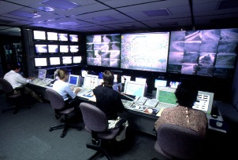

*Ubiquitous BB wireless network*

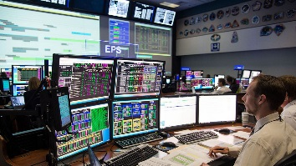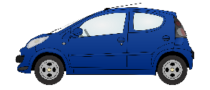

*5.8 GHz*

***RSU***

*5.8 GHz*

***Service Provider E***

***Service Provider A***

***Service Provider B***

***Service Provider D***

***Service Provider C***

***Service Provider F***

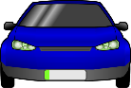

*5.8 GHz*

]

## 7.9 Region 1

*[Editor’s note: Text to be added]*

### 7.9.1 Frequency usage

### 7.9.2 Standardization

## 7.10 Region 2

*[Editor’s note: Text to be added]*

### 7.10.1 Frequency usage

Table [X]

Frequency Usage for Advanced ITS Radiocommunication in Region 2

| Country | Frequency band | Technology/ System | Service | Deployment or plan year |
| --- | --- | --- | --- | --- |
| United States | 5,850-5,925 MHz | Vehicle to Vehicle and Vehicle to/from Infrastructure communications system | Safety-related, mobility and environmental information  (Communications) | Model deployment – 2012[59]; Early Operational Deployments - 2016[60],[61]; Pilot Deployments – 2017[62] |

Note: as noted above, there are a number of regulatory proceedings underway in the U.S., the results of which could alter the frequency usage for advanced ITS in the United States.

### 7.10.2 Standardization

Table [X]

Standards for Advanced ITS Radiocommunication in the United States

|  |  |  |
| --- | --- | --- |
| SDO | Standard No. | Standard Title |
| ASTM | E2213-03 | Standard Specification for Telecommunications and Information Exchange Between Roadside and Vehicle Systems – 5 GHz Band Dedicated Short Range Communications (DSRC) Medium Access Control (MAC) and Physical Layer (PHY) Specifications |
| IEEE | IEEE 802.11-2016 | Wireless LAN Medium Access Control (MAC) and Physical Layer (PHY) Specifications |
| IEEE 1609.0-2013 | IEEE Guide for WAVE – Architecture |
| IEEE 1609.2 -2016 | IEEE Standard for WAVE – Security Services for Applications and Management Messages |
| IEEE 1609.3 -2016 | IEEE Standard for WAVE – Networking Services |
| IEEE 1609.4 -2016 | IEEE Standard for WAVE – Multi-Channel Operations |
| IEEE 1609.11-2010 | IEEE Standard for WAVE – Over-the-Air Electronic Payment Data Exchange Protocol for ITS |
| IEEE 1609.12-2016 | IEEE Standard for WAVE – Identifier Allocations |
| SAE | SAE J2735 March, 2016 | Dedicated Short Range Communications (DSRC) Message Set Dictionary |
| SAE J2945/1 March, 2016 | On-board System Requirements for V2V Safety Communications |

## 7.11 Region 3

### 7.11.1 Frequency usage

Table [X]

Frequency usage on Advanced ITS Radiocommunication in Asia-Pacific

| Country | frequency band | Technology | Application | Status |
| --- | --- | --- | --- | --- |
| Japan | 5 770-5 850 MHz | V2V/V2I communication | Safety related information | Guidelines for field experiment in 2007 (revised 2013) |
| 755.5-764.5 MHz band | Enacted in 2011 (revised 2013) |
| Korea | 5 855-5 925 MHz | V2V/V2I communication | Vehicle Safety Related  C-ITS | Enacted in 2016 |
| China | 5 905- 5 925 MHz | LTE based V2X | V2X communication | Field  Experiment in 2017 |
| Singapore | 5 855-5 925 MHz | V2V/V2I | Traffic/Safety Related Information | Enacted in 2017 |

### 7.11.2 Standardization

Table [X]

Standards on Advanced ITS Radiocommunication in Asia-Pacific

|  |  |  |
| --- | --- | --- |
| SDO | Standard No. | Standard Title |
| TTA | TTAS.KO-06.0175/R1 | Vehicle Communication System Stage1: Requirements |
| TTAS.KO-06.0193/R1 | Vehicle Communication SystemStage2: Architecture |
| TTAS.KO-06.0216/R1 | Vehicle Communication System Stage3 : PHY/MAC |
| TTAS.KO-06.0234/R1 | Vehicle Communication System State 3 : Networking |
| TTAK.KO-06.0242/R1 | Vehicle Communication System Stage3 : Application Protocol Interface |
| TTAK KO-06.0344 | In-Vehicle Signage System for Vehicle Safety Guidance Stage 1: Requirements |
| TTAK KO-06.0344-Part2 | In-Vehicle Signage System for Vehicle Safety Guidance Stage 2: Data Exchange |
| ARIB | STD-T109 | 700 MHz Band Intelligent Transport Systems |
| CCSA | TBD | TBD |
| IMDA TSAC | IMDA TS DSRC | Technical Specification for Dedicated Short-Range Communications in Intelligent Transport Systems |

# 8 Millimetre-wave automotive radar

*[Editor´s note: This chapter needs to be updated]*

## 8.1 Overview

*[AP: Update from APT]*

The millimetre-wave band of the electromagnetic spectrum corresponds to radio band frequencies of 30 GHz to 275 GHz (wavelength from 10 mm to 1 mm). Millimetre waves’ high frequency realizes small equipment size including the compact high gain antenna suited for vehicular use. Particularly in radar system, the millimetre wave can easily create a narrow beam that is desirable to discriminate small distant objects.

Sensor technologies for monitoring and identifying objects near vehicles are the most important safety-related base technologies for developing systems that will accommodate this purpose. Various types of sensors have been studied and developed, and through this research and development, it has become clear that a Radio Detection and Ranging (RADAR) using radio waves is suitable for this objective. An international effort to regulate radar for automotive applications have been conducted for ensuring stable radar operations and effective use of frequency resources.

During WRC-15, 77.5-78 GHz spectrum allocation has been approved for Radio Location Service (RLS) as primary service under agenda item 1.18. 79 GHz band radar can be operated at 76‑81 GHz band for short-range high-resolution radar applications. This radar can be used for variety of applications, such as reduce number of fatalities and traffic accidents.

The frequency bands in the 76-81 GHz range are allocated to the radiolocation service on a primary basis. Many administrations designated these bands for automotive radar as one application of the radiolocation service. In the frequency band 76-81 GHz, radar systems in support of enhanced road safety are operated. Evolving demands related to automotive safety applications, including the reduction of traffic fatalities and accidents require a range resolution for automotive radar systems leading to a necessary bandwidth of up to 4 to 5 GHz.

In Europe, Ultra wide band (UWB) short range radar (SRR) operating at 24 GHz (22-29 GHz) is considered to be a key technology for the rapid and cost-effective introduction of many intelligent vehicle safety related systems. In January 2005, the European Commission decided on the time‑limited (until 1 July 2013) use of the 24 GHz range radio spectrum band for the ultra-wide band part of short-range vehicle radar equipment. After this deadline SRR equipment is intended to operate in the frequency band 79 GHz (77-81 GHz) on a permanent base, see ECC/DEC/(04)03. Applications operating around the 24 GHz band would increasingly suffer significant levels of harmful interference if a certain level of penetration of vehicles using the 24 GHz range radio spectrum band for short-range radars was to be exceeded. According to CEPT (European Conference of Postal and Telecommunications Administrations), the sharing between earth exploration satellite services and short-range vehicle radar could only be feasible on a temporary basis.

In contrast to the above, 24.05-24.25 GHz ISM band automotive radars can be used worldwide without any time limitation.

China identified 77-81 GHz for experiment frequency band of millimeter-wave vehicular radar in December 2016. Laboratory test and road-test were launched in four major cities of China to verify technical characteristics, including electromagnetic compatibility and radio frequency matters, interference, and radar performance in typical scenarios, etc.

## 8.2 Technical characteristics

*[AP: Update from Germany]*

(1) Low Power Automotive Radar at 24 GHz and 76 GHz

Today the frequency allocation for automotive radar application is in a rebuilding phase. Due to technological and commercial constraints, the frequency allocation for these safety related applications has been done in the beginning of the last decade in the range of 24 GHz. In Europe, e.g. an allocation for the 24 GHz UWB band (21.65–26.65 GHz) has been done as an intermediate solution due to the incompatibility with the Radio Astronomy Service, EESS, the Fixed Service and military applications. Therefore, the cut-off date of 1st July 2013 has been defined. In July 2011, the ECC extended the cut-off date ( for sensors with reduced frequency range of 24,25‑26,65 GHz) until 1st January 2018 by ECC decision 04(10) to allow the car manufacturers a seamless implementation of 79 GHz technology. The technological evolution during the last years led to the fact that with a similar effort a higher performance can be reached today.

In addition to the 24 GHz UWB band (with a time-limited allocation in Europe), the 24 GHz ISM band (24.05-24.25 GHz) plays an import role, especially for affordable vehicles. As this band is an ISM band and globally harmonized, 24.05-24.25 GHz ISM band automotive radars can be used worldwide without any time limitation.

(2) High Resolution Short Range Automotive Radar at 79 GHz

High resolution automotive radar applications require bandwidths up to 4 GHz. The 77-81 GHz band has been under consideration for this kind of automotive radar applications in many countries.

The 77-81 GHz band has been designated by CEPT in July 2004 (ECC/DEC/(04)03) for automotive radar applications. Also, the European Commission has adopted the decision 2004/545/EC on the harmonization of radio spectrum in the 79 GHz (77-81 GHz) range for the use of automotive radar. The harmonized standard EN 302 264 has been adopted by ETSI for short-range radar (SRR) operating in the 77-81 GHz band.

In March 2010, the Ministry of Internal Affairs and Communications (MIC) in Japan has started a study group in the Information and Communications Council for the introduction of high-resolution radar in the 77-81 GHz frequency band for national use.

In October 2010, the Russian Federation identified the 77-81 GHz band for automotive radar.

Recently, in connection with the worldwide primary allocation of the 77.5-78.0 GHz to radio location service, for use by automotive radars; many more countries are implementing high resolution short range radar in the entire 77-81 GHz band in order to provide 4 GHz bandwidth.

(3) Ultra Wide Band (UWB) Radar

GenerallyUWB is defined as the radio signal whose fractional bandwidth is greater than 20% of the centre frequency or the 10 dB bandwidth occupies 500 MHz or more of spectrum.

UWB technology originally employed very narrow or short duration pulses that result in very large or wideband transmission bandwidths (refer to Figure [X], “UWB monocycle time and frequency domains”). For automotive radar, the pulsed-UWB technique is replaced step-by-step by very wideband frequency chirps (Frequency-modulated continuous-wave = FMCW or pulse compression radar) without the need for short duration pulses. With appropriate technical standards, UWB devices can operate using spectrum occupied by existing radio services without causing interference, thereby permitting scarce spectrum resources to be used more efficiently.

Figure [X]

UWB monocycle time and frequency domains   
(UWB, "A possible area for standards", GSC 8 Presentation by FCC.)

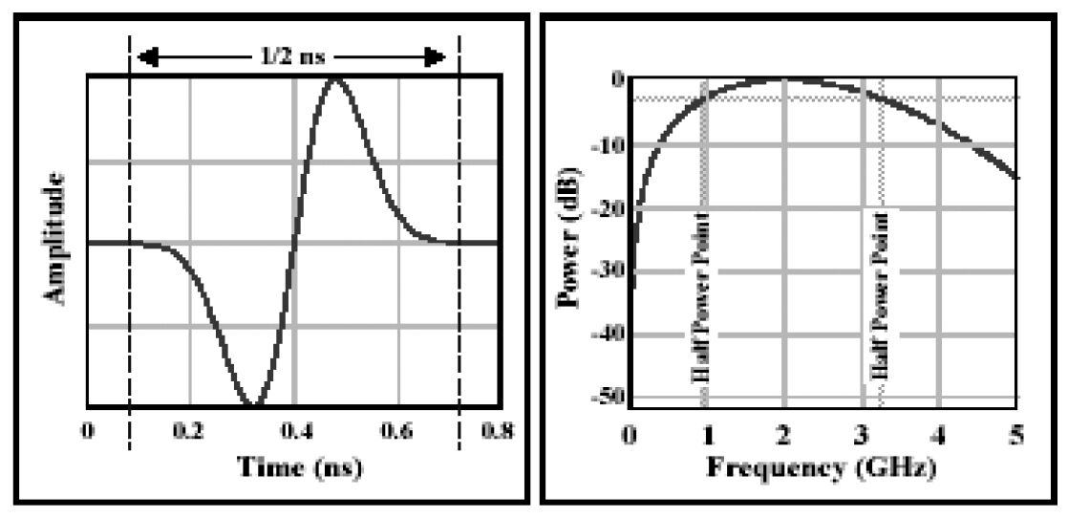

[AP: Update from APT]

(4) Vehicle mounted radar

Regarding functional and safety requirements, the automotive radar systems operating in the 76‑81 GHz band can be separated in two categories:

– **Category 1**: Adaptive Cruise Control (ACC) and Collision Avoidance (CA) radar, for measurement ranges up to 250 metres. For these applications, a maximum continuous bandwidth of 1 GHz is required. Such radars are considered to add additional comfort functions for the driver, giving support for more stress-free driving.

– **Category 2**: Sensors for high resolution applications such as Blind Spot Detection (BSD), Lane-Change Assist (LCA) and Rear-Traffic-Crossing-Alert (RTCA), detection of pedestrians and bicycles in close proximity to a vehicle, for measurement ranges up to 100 metres. For these high resolution applications, a necessary bandwidth of 4 GHz is required. Such radars directly add to the passive and active safety of a vehicle and are therefore an essential benefit towards improved traffic safety.

Depending on the number of radar sensors and their position it is possible to detect objects in sectors or even the complete surrounding of a car. The sensor signals are the basis not only for driver assistance systems like ACC but also for a broad variety of automotive applications of active and passive safety.

Systems for monitoring the proximity to vehicles will play an important role in ensuring driving safety. With its resistance to bad weather and dirt, automotive radar is suitable for vehicles driven in severe conditions.

Figure [X] shows the configuration of automotive radar.

Figure [X]

Configuration of automotive radar



Subsystems are as follows:

*– Antenna/RF unit*

This part consists of a transmitting antenna, a receiving antenna, receiving equipment and transmission equipment. Signal modulations, conversions to high frequencies, radio‑wave transmission, and radio‑wave reception are handled in this part. This part could be equipped with several antennas and could perform beam scanning.

*– Signal processing unit*

This unit renders distance and speed by calculating signals handed over from the RF unit. Rendering of average distance and speed, and mitigation of interference are sometimes handled here. When the antenna performs beam scanning, this unit calculates the direction of detected objects.

*– Recognition unit*

This unit can select and arrange the most wanted or necessary data depending on the needs of each system. For example, the unit will recognize the most relevant objects, and can judge whether the vehicle in front is in lane. The unit occasionally averages figures gathered, filters interference, and enhances measuring accuracy and reliability of data by tracking objects and by data fusion with data from other sensors.

*[AP: Update from APT]*

(5) Radar for road incident detection system

Incident detection service deployed in Korea enables drivers in vehicles to receive real-time information for unexpected road situation (obstacle, stopped and wrong way vehicle, frozen-road etc.) through real-time and automatic detection system using radar sensors to prevent unexpected accidents. It also provides traffic information within 1 km from radar sensor. It supports driver in heavy rains and foggy weather to receive real–time information by incident detection system.

FIGURE X

Incident detection service

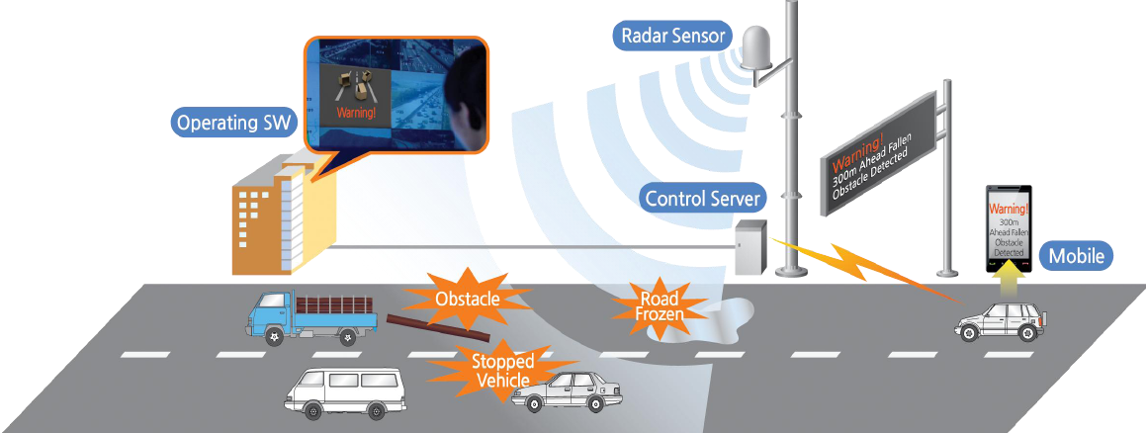

(6) Radar for Cooperative driving support

In Japan, a cooperative driving support system is developed and deployed for intersection safety. The system consists of the millimetre wave radar as a roadside sensor to detect pedestrians, cyclists, and vehicles entering an intersection. The roadside sensor typically mounted at approximately the same height as traffic signals that have a wide field of view. The system also alerts motorists to potential hazards by using the ITS radio communication.

FIGURE X

Driving support

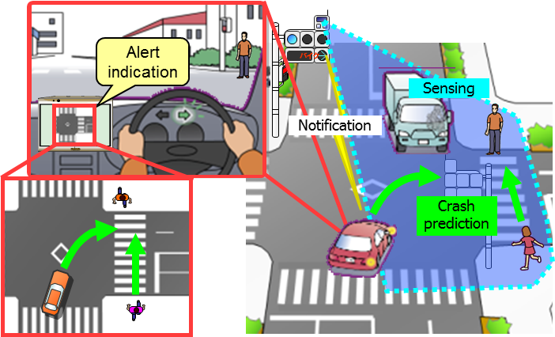

## 8.3 Frequency usage

*[AP: Update from APT]*

(1) Automotive Radar at 77 GHz band

Several millimeter wave bands are considered for vehicular radar. The 76-77 GHz band has already been designated by the Federal Communications Commission (FCC) in the United States of America and by the Ministry of Internal Affairs and Communications (MIC) in Japan for these purposes. In the United States, vehicular radars operating in the 76-77 GHz band are regulated according to FCC 47 part 15.253 and as part 15 device; may not cause harmful interference and must accept interference that may be caused by the operation of an authorized radio system, by another intentional or unintentional radiator, by industrial, scientific and medical (ISM) equipment, or by an incidental radiator. Furthermore, in accordance with European spectrum requirements for Road Transport and Traffic Telematics (RTTT), ETSI has adopted European standards for automotive radar operating in the 76-77 GHz band (ETSI EN 301 091) and ECC adopted a decision (ECC/DEC/(02)01) on the frequency bands to be designated for the coordinated introduction of RTTT, including the band 76-77 GHz. In Japan, the 76-77 GHz band is designated for this kind of application (ARIB STD-T48).

*[AP: Update from Germany]*

(2) High Resolution Automotive Radar at 79 GHz band

The industries are trying to seek globally or regionally harmonized frequency allocations for new automotive radar technologies. The following frequency bands are allocated to radio location service on a primary basis which are designated for use by automotive radar applications: The rationale for separating these applications into two different frequency bands is given in ECC Report 56, which reveals, that sharing studies have concluded that sharing is not achievable between Category 1 and Category 2 if operated in a common frequency band.

– 76 GHz to 77 GHz Long Range Radar (LRR) > 150 meter

– 77 GHz to 81 GHz Short Range Radar (SRR) < 150 meter (high resolution).

The rationale for separating these applications into two different frequency bands is given in ECC Report 56, which reveals, that sharing studies have concluded that sharing is not achievable between LRR and SRR if operated in a common frequency band.

In addition, the 24 GHz ISM band allocation (24.05-24.25 GHz) will continue to be available for automotive radar as a globally harmonized ISM band without any time limitation.

*[AP: Update from APT]*

Table [X]

Global frequency usage for millimetre-wave automotive radar

|  | 76 to 77 GHz | | | 77 to 81 GHz | | |
| --- | --- | --- | --- | --- | --- | --- |
|  | Recommendation | Standard | Report/Notes | Recommendation | Standard | Report/Notes |
| ITU-R | M.1452-2 |  | SM.2067 | M.1452-2 |  |  |
| M.2057 |  |  | M.2057 |  |  |

Today the frequency allocation for automotive radar application is in a rebuilding phase. Due to technological and commercial constraints the frequency allocation for these safety related applications has been done in the beginning of the last decade in the range of 24 GHz. In Europe e.g. this allocation has been done as an intermediate solution due to the incompatibility with the Radio Astronomy Service, EESS, the Fixed Service and military applications. Therefore, CEPT concluded that the band 77-81 GHz should be considered as the only globally harmonized frequency band for automotive radars. The 77-81 GHz band has been designated by CEPT in July 2004 (ECC/DEC/(04)03) for automotive radar. The European Commission has adopted the decision 2004/545/EC on the harmonization of radio spectrum in the 79 GHz range for the use of automotive radar. The harmonized standard EN 302 264 has been adopted by ETSI for SRR operating in the 77‑81 GHz band.

During WRC-15, 77.5-78 GHz spectrum allocation has been approved for RLS as primary service under agenda item 1.18. After that, 76-81 GHz can be used for short-range high resolution radar. This radar will be contributed to autonomous driving vehicles as a key sensor equipment.

In Japan, the 77-81 GHz band is also designated for these safety related applications (ARIB STD-T111).

## 8.4 Standardization

Table [X]

Global standard for millimetre-wave automotive radar

*[AP: Update from APT]*

|  |  |  |  |
| --- | --- | --- | --- |
| SDO | Standard No. | | Standard title |
| ITU | Recommendation | ITU-R M.1452 | Millimetre wave radiocommunication systems for intelligent transport system applications |
| ITU-R M.2057 | Systems characteristics of automotive radars operating in the frequency band 76-81 GHz for intelligent transport systems applications |
| Report | ITU-R M.2322 | Systems Characteristics and Compatibility of Automotive Radars Operating in the 77.5-78 GHz Band for Sharing Studies |
| ITU-R F.2394 | Compatibility between point-to-point applications in the fixed service operating in the 71-76 GHz and 81-86 GHz bands and automotive radar applications in the radiolocation service operating in the 76-81 GHz bands |

## 8.5 Applications

*[Editor’s note: Text to be added]*

[AP: Update from Germany]

Today’s automotive radar systems, operating in the millimetre wave, are of two categories according to the measurement ranges and bandwidth:

– Category 1: Adaptive Cruise Control (ACC) and collision avoidance radar (CA), operating in the band 76-77 GHz, for measurement ranges up to 300 m.

– Category 2 “Short-range” radar for applications such as Blind Spot Detection (BSD), Lane-Change Assist (LCA), and Rear-Traffic-Crossing-Alert (RTCA), operating in the band 77‑81 GHz for measurement ranges up to 100 m.

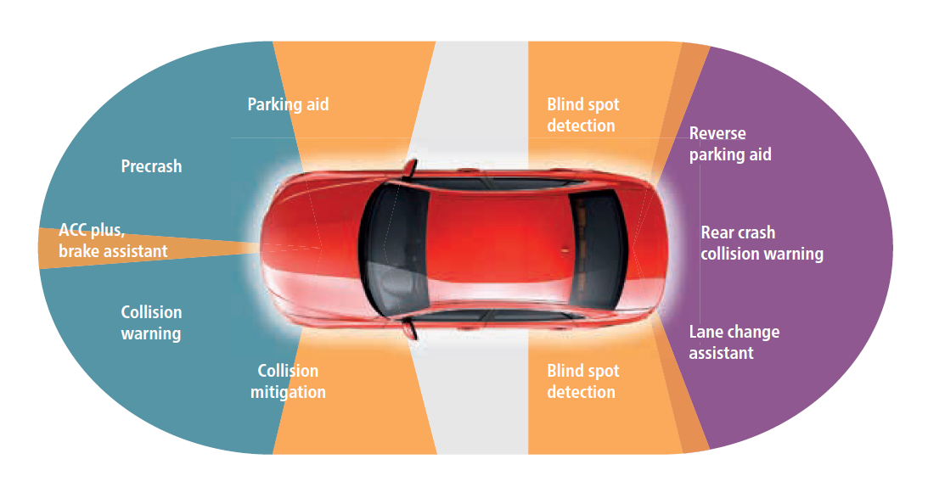

## 8.6 Region 1

*[AP: Update from Germany]*

76-81 GHz range for various automotive radar applications. In Europe, the 76-77 GHz frequency band was designated for vehicular and infrastructure radar systems in ERC Recommendation 70-03. This frequency band is used by long range radars for ground based vehicle and infrastructure systems.

In order to support industry developments of the general and specific SRR technology within the   
79 GHz range, the frequency band 77-81 GHz was designated for SRR automotive applications in ERC Recommendation 70-03 and in ECC Decision (04)03.

European Commission also designated these bands for automotive radar applications in 2004 and 2005 by means of following EC Decisions:

2004/545/EC: Harmonisation of radio spectrum in the 79 GHz range (77-81 GHz) for the use of automotive short-range radar equipment in the Community as the permanent frequency range for the Europewide implementation of SRR.

2013/752/EU: Amending Decision 2006/771/EC on harmonisation of the radio spectrum for use by short-range devices which covers the 76-77 GHz range.

### 8.6.1 Frequency usage

*[AP: Update from Germany]*

Table [X]

Frequency usage for millimetre-wave automotive radar in Europe

|  | 24,05 to 24,25 GHz ISM | | 76 to 77 GHz | | | 77 to 81 GHz | | |
| --- | --- | --- | --- | --- | --- | --- | --- | --- |
|  | Regulation | Standard | Regulation | Standard | Report/Notes | Regulation | Standard | Report/ Notes |
| Europe  - CEP, EU | ERC/REC 70-03  Annex 5  COMMISSION IMPLEMENTING DECISION 2013/752/EU | ETSI EN 302 858 (2013-07) | -ERC/REC 70-03   Annex 5  -ECC/DEC/(02)01  COMMISSION IMPLEMENTING DECISION  2013/752/EU | ETSI EN 301 091-1 (2006-11) | CEPT Reports 35, 36, and 37 | - 2004/545/EC  -ERC/REC 70-03  Annexes 5 & 13  ECC/DEC/(04)03 | ETSI EN 302 264-1 (2009-04) | - ECC/REP 056  - Partly: CEPT Report 003  - CEPT Reports 46 &37 |
| - Russia | SFMC Decision No. 07-20-03-001 Annex 7 |  | SFMC Decision No. 07-20-03-001 Annex 7 |  | Appendix 1  Resolution of State Radio Frequency Committee No. 10-09-03 of 29 October 2010 | SFMC Decision No. 07-20-03-001 Annex 7 |  | Appendix 1  Resolution of State Radio Frequency Committee No. 10-09-03 of 29 October 2010 |
| Gulf States (e.g. Saudi Arabia,  Oman) |  | CITC Technical Specification  Document Number: RI054  (Rev 2) | CITC | CITC Technical Specification  Document Number: RI049  (Rev 2) |  | 77-82 GHz -SRR Decision of TRA No 133/2008 of 28-Oct-08 |  |  |

### 8.6.2 Standardization

*[AP: Update from Germany]*

Table [X]

Standards for millimetre-wave automotive radar in Europe

|  |  |  |
| --- | --- | --- |
| SDO | Standard No. | Standard Title |
| ETSI | TR 101 983 | Radio equipment to be used in the 76 GHz to 77 GHz band; System Reference Document for Short-Range Radar to be fitted on road infrastructure |
| EN 301 091 parts 1-2 | Short Range Devices; Road Transport and Traffic Telematics (RTTT); Radar equipment operating in the 76 GHz to 77 GHz range; |
| EN 302 258 parts 1-2 | Short Range Devices; Road Transport and Traffic Telematics (RTTT);  Radar equipment operating in the 24,05 GHz to 24,25 GHz or 24,05 GHz to 24,50 GHz range ; |
| EN 302 288 parts 1-2 | Short Range Devices; Road Transport and Traffic Telematics (RTTT); Short range radar equipment operating in the 24 GHz range; |
| EN 302 264 parts 1-2 | Short Range Devices, Road Transport and Traffic Telematics (RTTT); Short Range Radar equipment operating in the 77 GHz to 81 GHz band |

## 8.7 Region 2

*[AP: Update from Germany]*

*Region 2 covers the Americas, including Greenland, and some of the eastern Pacific Islands.*

The frequency ranges:

– 24 GHz ISM (24.05-24.25 GHz),

– 24 GHz UWB (22-29 GHz) and

– 76-77 GHz

are implemented in most of the Region 2 countries already for various automotive radar applications.

The relevant standards are

– US: FCC part 15 PART 15—RADIO FREQUENCY DEVICES

– Canada: Industry Canada Spectrum Management and Telecommunications Radio Standards Specification (RSS 210, RSS310, RSS251)

– Brazil: ANATEL Resolution 506 (currently under revision)

• American National Standard of Procedures for Compliance Testing of Unlicensed Wireless Devices, ANSI C63.10-2013

The allocation of the 77-81 GHz frequency range in the US is currently under implementation by FCC (*NOTICE OF PROPOSED RULEMAKING AND RECONSIDERATION ORDER FCC, 15-16 Adopted: February 3, 2015 Released: February 5, 201)*

*It is interesting to note, that the FCC – in this notice of proposed rulemaking - plans to move vehicular radar from FCC part 15 to FCC part 90 or 95 in order to provide a higher protection status for these important safety applications.*

*In addition there is a 24 GHz UWB regulation in several Region 2 countries (including USA, Canada).*

### 8.7.1 Frequency usage

*[AP: Update from Germany]*

Table [X]

Frequency usage for millimetre-wave vehicular radar in North and South America

|  |  |  |  |  |  |  |  |  |
| --- | --- | --- | --- | --- | --- | --- | --- | --- |
|  | 24,05 to 24,25 GHz | | 76 to 77 GHz | | | 77 to 81 GHz | | |
|  | Regulation | Standard | Regulation | Standard | Report/ Notes | Regulation | Standard | Report /Notes |
| U.S.A. | FCC Part 15/15.249 |  | FCC Part 15/15.253 |  |  | Planned (NPRM FCC15-16) |  |  |
| Canada |  | RSS-310 | Spectrum Utilization Policies SP-47 GHz | [RSS 251](https://www.ic.gc.ca/eic/site/smt-gst.nsf/vwapj/RSS-251-issue1.pdf/$FILE/RSS-251-issue1.pdf) |  |  |  |  |
| Mexico | Cofetel usually accepts FCC regulation |  | Cofetel usually accepts FCC regulation |  |  |  |  |  |
| Brazil | ANATEL resolution No.506 |  | ANATELresolution No.506 |  |  |  |  |  |

### 8.7.2 Standardization

*[AP: Update from Germany]*

Table [X]

Standards on millimetre-wave vehicular radar in North and South America

|  |  |  |
| --- | --- | --- |
| SDO | Standard No. | Standard Title |
|  | ANSI C63.10-2013 |  |
|  | FCC part 15.249 | FCC part 15 PART 15—RADIO FREQUENCY DEVICES  Operation within the bands 902–928, MHz, 2 400–2 483.5 MHz, 5 725– 5 875 MHz, and 24.0–24.25 GHz. |
|  | FCC part 15.252 | FCC part 15 PART 15—RADIO FREQUENCY DEVICES  15.252 Operation of wideband vehicular radar systems within the bands 16.2–17.7 GHz and 23.12–29.0 GHz. |
|  | FCC part 15.253 | FCC part 15 PART 15—RADIO FREQUENCY DEVICES  15.253 Operation within the bands 46.7–46.9 GHz and 76.0–77.0 GHz. |
|  | FCC part 15.515 | FCC part 15 PART 15—RADIO FREQUENCY DEVICES  15.515 Technical requirements for vehicular radar systems. |

## 8.8 Region 3

***[****Editor´s note: The following technical characteristics will be included in section 8.1 overview at a later stage]****]***

Technical characteristics

*[Editor’s note: Text to be added]*

(1) Incident detection radar

Characteristics of 34 GHz incident detection radar are given in Table x.

TABLE X

Road radar system

| Characteristic (Parameter) | Value |
| --- | --- |
| **Operational characteristics** | |
| Application/Service | Road Incident Detection System |
| Typical installation | Road Side Pole(or gantry) |
| **Technical characteristics** | |
| Max. range | 1 000 m |
| Frequency range | 34.275-34.875 GHz |
| Specified bandwidth (typical) | Up to 600 MHz |
| Peak Power (e.i.r.p) | Up to +55 dBm |
| Mean Power (e.i.r.p) | Up to +45 dBm |

### 8.8.1 Frequency usage

*[AP: Update from APT]*

In some APT countries, frequency bands of 24, 60, 76 and 79 GHz have been used. For global harmonization of ITS, APT countries like Australia are considering European activities which use 79 GHz as a permanent band. Also, Hong Kong, China opened the 79 GHz band for automotive radar systems utilizing ultra-wideband technology in January 2017.

Based on the result of WRC-15, Japan has allocated 77-81 GHz band for short-range high-resolution radar in January 2017.

Table [X]

Frequency usage on millimetre-wave automotive radar in Asia-Pacific

*[AP: Update from Germany/APT]*

|  | 24.05 to 24.25 GHz ISM | | 76 to 77 GHz | | | 77 to 81 GHz | | |
| --- | --- | --- | --- | --- | --- | --- | --- | --- |
|  | Regulation | Standard | Regulation | Standard | Report/Notes | Regulation | Standard | Report/Notes |
| Korea, Republic of |  | Article 103 | Rules on Radio Equipment (Article **29** Paragraph 9) (2013-01-03)” | Technical Standards for Radio Equipment  (RRL Notification 2006-84 (2006.8.23)) |  |  |  |  |
| China | Technical Specification for Micropower (Short Distance) Radio Equipments of Category G |  | Technical Specification for Micropower (Short Distance) Radio Equipments, part XIV |  |  |  |  |  |
| Japan | ARIB STD-T73 1.1 |  | Ordinance Regulating Radio Equipment Notification of MIC (643-1997) |  |  | Ordinance Regulating Radio Equipment, Notification of MIC (4432012) |  |  |
| Singapore |  |  | IMDA Technical Specification Short Range Devices | IMDA TS SRD |  | IMDA Technical Specification Ultra-Wideband (UWB) Devices | IMDA TS UWB |  |
| Thailand | [Technical Standard of telecommunication device and equipment  Radar based Telecommunication device in vehicle (Vehicle Radar)  Section 2.1.1] | Vehicle Radar Standard NBTC 1011-2557  Section 2.1.1 | [NTC TS 1011-2549] | Vehicle Radar Standard NBTC 1011-2557  Section 2.1.3 |  |  |  |  |

### 8.8.2 Standardization

*[AP: Update from APT]*

TABLE [X]

Standards on millimetre-wave automotive radar in Asia-Pacific

|  |  |  |
| --- | --- | --- |
| SDO | Standard No. | Standard Title |
| ARIB | STD-T48 | Millimeter-Wave Radar Equipment for Specified Low Power Radio Station |
| STD-T111 | 79 GHz Band High-Resolution Radar |
| IMDA  TSAC | IMDA TS SRD |  |
| IMDA TS UWB |  |

*[Editor´s note: Applications to be shifted to 8.1 overview].*

Applications

Table [X]

Usage status of automotive radar in Asia-Pacific

*[AP: Update from Germany/APT]*

| Country | Frequency band | Technology/ Standard | Application | deployment or plan year |
| --- | --- | --- | --- | --- |
| Australia | 22-26.5 GHz | Radiocommunications (Low Interference Potential Devices) Class Licence 2015 | Section 66  Ultra-wideband short-range vehicle radar systems transmitters | - |
| 24.0-24.25 GHz | Section 66  Radiodetermination transmitters |  |
| 76-77 GHz | Long-range vehicle radar (intelligent cruise control)  Section 69  Radiodetermination transmitters |  |
| 77 – 81 GHz | Section 70  Radiodetermination transmitters |  |
| China | 24.00-24.25 GHz | Notice on Promulgation of the Technical Specification for Micropower (Short Distance) Radio Equipments | Vehicular range radar | Enacted in 2005 |
| 76-77 GHz |
| 24.25-26.65 GHz | Minstry of Industry and IT, Notice regarding 24GHz frequency band short range automotive radar | Vehicular range radar | Enacted in 2012 |
| 77-81 GHz | Radar | Vehicular range radar | Field  Experiment in 2017 |
| 76-77 GHz[63] | HKCA1075  Exemption from Licensing Order | Vehicular radar systems | 2005 |
| 77-81 GHz63 | 2017 |
| Japan | 22-24.25 GHz* | Quasi-millimetre wave system | Environmental recognition (Obstacle detection) | Enacted in 2010  (*The use of these frequency bands is allowed only until 31 December 2016. However, this limitation is eased by stations of UWB radio systems in existence on this date.) |
| 24.0-24.25 GHz |
| 24.25-29 GHz |
| 60-61 GHz | Millimeter wave system | Enacted in 1995 |
| 76-77 GHz | Enacted in 1997  (Occupied band width: 500 MHz)  Revised in 2015  (Occupied band width: 1 GHz) |
| 77-81 GHz | Enacted in 2012 for 78-81 GHz.  Revised in 2017 for inclusion above 77 GHz. |
| Korea | 24.05-24.25 GHz | Radar | Detect obstacles (Sensor) |  |
| 76-77 GHz | Vehicular collision avoidance radar | 2008 |
| 24.25-26.65 GHz | Radar | Vehicular collision avoidance radar | 2012 |
| Singapore | 76-77 GHz | Radar  IMDA TS SRD | Short-range radar systems such as automatic cruise control and collision warning systems for vehicle | 2002 |
| 77-81 GHz | Radar  IMDA TS UWB | Vehicular Radar | 2008 |
| Thailand | 5725–5 875 MHz | - | Radar application | Regulation adopted in 2007 |
| 24.05–24.25 GHz | Vehicle Radar Standard NBTC 1011-2557- | Vehicle Radar application | Regulation adopted in 2007 |
| 24.25-26.65 GHz | Vehicle Radar Standard NBTC 1011-2557 | Vehicle Radar application | Regulation adopted in 2014 |
| 76-81 GHz |  | Radar application | Regulation adopted in 2007 |
| 76-77 GHz | Compliance Standard: FCC Part 15.253 or EN 301 091-1 | Vehicle radar application | Regulation adopted in 2006 |
| Viet Nam | 76-77 GHz | Radar | Vehicular Radar | 2012 |
| 77-81 GHz | Radar | Vehicular Radar | 2016 |

# 9 Results of Studies

ITS attract many people’s interest because it could improve the safety of road traffic, ensure smoother traffic, reduce environmental burdens, and stimulate regional economic activity, etc. From the APT survey results (already included in this ITS usage report), major deployed ITS in APT countries were classified as electronic toll collection and vehicle information, communication and automotive radar. As the importance of car safety is increasing, cooperative system is widely considered for international deployment. In addition to Europe and North America, some countries in Asia-Pacific region, frequency band 5 855-5 925 MHz was assigned for cooperative systems and many development project was performed toward deployment of autonomous driving vehicles in near future. Regarding these activities, administrations should study the optimal frequency spectrum for cooperative systems and try to reach regional/international harmonization of spectrum arrangements, which is the target of WRC‑19 agenda item 1.12 – ITS Applications. Regarding short-range high-resolution radar, additional spectrum of 77.5-78 GHz has been allocated for 79 GHz band radar under WRC-15 agenda item 1.18. The 79 GHz band radar can be used spectrum up to 5 GHz bandwidth (76‑77 GHz and 77-81 GHz) to give much higher resolution for radar.

References

[1] ETSI EN 302 665 V1.1.1, “Intelligent Transport Systems (ITS); Communications Architecture” (2010-09)

[2] <http://www.etsi.org/website/Technologies/IntelligentTransportSystems.aspx>

[3] Report ITU-R M.2228, “Advanced Intelligent Transport Systems (ITS) radiocommunication”

[4] Recommendation ITU-R M.1453, “Intelligent Transport Systems – dedicated short‑range communications at 5.8 GHz”

[5] [APT/AWG/REP-18 [ (Rev.2)](http://www.aptsec.org/sites/default/files/2016/09/AWG-20-TMP-44_ITS_USAGE_Consolidated_R2_clear.docx)] “The usage of intelligent transport systems in APT Countries”

1. This frequency usage is for Hong Kong, China.
2. "Collaborative Connected Vehicle Research Update" (<http://www.its.dot.gov/presentations/pdf/V2V_Collaborative_Research_MikeLukuc2013.pdf>) at 10-12; “Safety Pilot Model Deployment: Lessons Learned and Recommendations for Future Connected Vehicle Activities” (<http://ntl.bts.gov/lib/59000/59300/59361/FHWA-JPO-16-363.pdf>) at 11-12; “CV Applications Already Deployed by Responding Agencies” (<http://transops.s3.amazonaws.com/uploaded_files/V2I%20DC%20TWG%201%20-%20January%2028%2C%202016%20Webinar%20Slides%20V3.pptx>) at 30; “Maricopa County Department of Transportation (MCDOT) SMARTDriveSM Program” (<http://www.mcdot.maricopa.gov/business/connected-vehicles.aspx>); “Connected Vehicle Pilot Deployment Program Phase 1: Concept of Operations (ConOps) - New York City” (<http://ntl.bts.gov/lib/59000/59300/59360/FHWA-JPO-16-299.pdf>) at 36; “Connected Vehicle Pilot Deployment Program: ICF/Wyoming Concept of Operations” (<http://www.its.dot.gov/pilots/pdf/ICF_ConOpsWebinar_02042016.pdf>) at 34.
3. <https://www.car-2-car.org/index.php?id=31>.
4. IEEE Std 802.11TM-2016, IEEE Standard for Information technology - Telecommunications and information exchange between systems - Local and metropolitan area networks - Specific requirements Part 11: Wireless LAN Medium Access Control (MAC) and Physical Layer (PHY) Specifications.
5. USDOT diagram based upon Std 802.11-2016 and generic OFDM principles.
6. Based upon information from IEEE Std 802.11TM-2016, IEEE Standard for Information technology - Telecommunications and information exchange between systems - Local and metropolitan area networks - Specific requirements: Part 11: Wireless LAN Medium Access Control (MAC) and Physical Layer (PHY) Specifications, 47 CFR [B9], Part 90, Sections 90.371–383, ASTM E2213 – 03 (as noted), SAE J2945TM/1 MAR2016, On-Board System Requirements for V2V Safety Communications, and field experience.
7. 47 CFR, Part 90, Section 90.377.
8. Portable, hand-carried OBEs are limited to 1.0 mW maximum output power – 47 CFR, Part 95, Subpart E, Section 95.639.
9. Note that for OBEs transmitting Basic Safety Messages (BSM)s on the dedicated V2V safety channel, the requirement is for maximum e.i.r.p. of 20 dBm - SAE J2945TM/1 MAR2016 (Table 21).
10. Per IEEE Std 802.11-2016, §17.3.9.3, p. 2305: Spectrum mask for 10 MHz channels, the transmitted spectral density shall have a 0 dBr bandwidth not exceeding 9 MHz and shall not exceed the spectrum mask created using the permitted power spectral density.
11. Society of Automotive Engineers (SAE), Surface Vehicle Standard, J2945™/1, March 2016, § 6.3.2 p. 57 and § 7, Table 21, p. 77.
12. For vehicles transmitting BSMs on the dedicated V2V safety channel, 6 Mbps data rate applies and IEEE Std 802.11-2016 (Table 17-4, p. 2285) specifies modulation-dependent parameters as shown.
13. Society of Automotive Engineers (SAE), Surface Vehicle Standard, J2945™/1, March 2016, § 6.4.1 p. 71.
14. 47 CFR [B9], Part 90, Sections 90.371–383: “A Road Side Unit (RSU) may employ an antenna with a height exceeding 8 meters but not exceeding 15 meters provided the e.i.r.p. specified in the table below is reduced by a factor of 20 log (Ht/8) in dB where Ht is the height of the radiation center of the antenna in meters above the roadway bed surface. The e.i.r.p. is measured as the maximum e.i.r.p. toward the horizon or horizontal, whichever is greater, of the gain associated with the main or center of the transmission beam. The RSU antenna height shall not exceed 15 meters above the roadway bed surface.
15. ASTM E2213 – 03: Standard Specification for Telecommunications and Information Exchange Between Roadside and Vehicle Systems — 5 GHz Band Dedicated Short Range Communications (DSRC) Medium Access Control (MAC) and Physical Layer (PHY) Specifications
16. SAE J2945/1, § 6.4.2, p. 73, and § 7, Table 21, p. 79.
17. IEEE Std 802.11-2016, Table 17-16, p. 2303.
18. Based upon information from IEEE Std 802.11TM-2016, IEEE Standard for Information technology – Telecommunications and information exchange between systems – Local and metropolitan area networks – Specific requirements Part 11: Wireless LAN Medium Access Control (MAC) and Physical Layer (PHY) Specifications; at pages 2310-2311.
19. IEEE Std 802.11TM-2016, IEEE Standard for Information technology – Telecommunications and information exchange between systems – Local and metropolitan area networks – Specific requirements Part 11: Wireless LAN Medium Access Control (MAC) and Physical Layer (PHY) Specifications; Annex D.
20. USDOT diagram based upon Std 802.11-2016, § 17.3.9.3, p. 2305 and D.2.2, p. 3271.
21. 3GPP RP-142043, Revised Work Item Description: LTE Device to Device Proximity Services.
22. 3GPP RP-150441, Revised WI: Enhanced LTE Device to Device Proximity Services.
23. <https://www.fhwa.dot.gov/fastact/factsheets/itsprogramfs.cfm>.
24. See: <https://github.com/certificationoperatingcouncil/COC_TestSpecs>.
25. SAE J2945/1 March, 2016, 5.1.1, page 27.
26. SAE J2945/1, §7, Table 21, p. 79.
27. FCC Memorandum Opinion and Order “Amendment of the Commission’s Rules Regarding Dedicated Short-Range Communication Services in the 5.850-5.925 GHz Band (5.9 GHz Band),” WT Docket No. 01-90 of “Amendment of Parts 2 and 90 of the Commission's Rules to Allocate the 5.850-5.925 GHz Band to the Mobile Service for Dedicated Short Range Communications of Intelligent Transportation Services,” ET Docket No. 98-95, FCC 06-110, released July 26, 2006, § 1, p. 3, and § 17, pages 12-13.
28. FCC Memorandum Opinion and Order “Amendment of the Commission’s Rules Regarding Dedicated Short-Range Communication Services in the 5.850-5.925 GHz Band (5.9 GHz Band),” WT Docket No. 01-90 of “Amendment of Parts 2 and 90 of the Commission's Rules to Allocate the 5.850-5.925 GHz Band to the Mobile Service for Dedicated Short Range Communications of Intelligent Transportation Services,” ET Docket No. 98-95, FCC 06-110, released July 26, 2006, Appendix A.5.d, p. 24.
29. <http://media.cadillac.com/media/us/en/cadillac/news.detail.html/content/Pages/news/us/en/2017/mar/0309-v2v.html>.
30. <http://www.motortrend.com/news/2017-cadillac-cts-now-standard-v2v-technology/>+.
31. Society of Automotive Engineers (SAE), Surface Vehicle Standard, J2735™/1, March 2016, § 4.2, p. 27 “*The range of the system is generally considered to be line-of-sight distances of less than 1 000 meters.*” Also § 11.10, p. 263, ”*As an example, a traffic flow monitoring application may desire lane information extending back 1000 meters from the stop line, while the needs of a vehicle safety application may be served by a smaller span of perhaps 300 meters*”.
32. SAE J2945/1, § 7, p. 79.
33. The applications tested in the Safety Pilot Model Deployment assumed vehicles were transmitting basic safety messages at the 300 m range. The Do-Not-Pass-Warning (DNPW) may require the longest communication range for effective operation because it addresses a crash scenario where two vehicles approach each other head-on. Using the target range of 300 m, two vehicles approaching at 60 mph would be afforded approximately 5.6 seconds for the DNPW application to detect the crash scenario and issue a warning. Based on this information, 300 m range should be sufficient for the anticipated safety applications.
34. SAE J2945/1, § 6.3.6.4, p. 60; §6.3.8, p. 65-67; and § 7, and Table 21, p. 77.
35. DOT HS 812 014: “Vehicle-to-Vehicle Communications: Readiness of V2V Technology for Application”, August, 2014; p. 98.
36. SAE J2945/1, § 5.1.1, p. 27; § 6.3.1, p. 56; § 6.3.8, p. 65-67; and § 7, Table 21, p. 78.
37. DOT HS 812 014: “Vehicle-to-Vehicle Communications: Readiness of V2V Technology for Application”, August, 2014; p. 96-97, p. 108-110.
38. SAE J2945/1, § 5.1.1, p. 27; § 6.3.8, p. 65-67; and Appendix A.8, pages 114-116.
39. SAE J2945/1, § 5.1.1, p. 27.
40. DOT HS 812 014: “Vehicle-to-Vehicle Communications: Readiness of V2V Technology for Application”, August, 2014; p. 98.
41. SAE J2945/1, § 5.1.3.5, p28
42. <https://www.qualcomm.com/documents/ihs-technology-whitepaper-cellular-vehicle-everything-c-v2x-connectivity>, p. 1.
43. <http://www.phonearena.com/news/Carrier-coverage-claims-What-does-covering-X-percentage-of-Americans-really-mean_id64143>
44. SAE J2945/1, § 5.1.3, p. 28 and § 6.5, p. 73-77.
45. <https://www.fhwa.dot.gov/fastact/factsheets/itsprogramfs.cfm>.
46. DOT HS 812 014: “Vehicle-to-Vehicle Communications: Readiness of V2V Technology for Application”, August, 2014; p. 256.
47. FHWA-JPO-16-421: “Connected Vehicle Impacts on Transportation Planning-Desk Reference”, June 2016 (available online at <https://ntl.bts.gov/lib/60000/60200/60241/FHWA-JPO-16-421.pdf>).
48. FCC Report and Order, October 1999, ET Docket No. 98-95.
49. Press Release, U.S. Transportation Secretary Mineta Announces Opening of Crash-Preventing “Intelligent Intersection” Test Facility (June 24, 2003) (<http://www.its.dot.gov/press/fhw2003.htm>).
50. FCC 06-110; MEMORANDUM OPINION AND ORDER; July 2006; ET Docket No. 98-95.
51. FCC 03-324 REPORT AND ORDER, December 2003, ET Docket No. 98-95.
52. <http://www.iteris.com/cvria/html/applications/applications.html>.
53. Other applications may also be non-priority communications depending on how they are deployed, the entity that deployed them, and other considerations. *See* 47 CFR, Section 90.377.
54. *See, e.g.*, GM Global Technology Operations, Inc., *Using V2X In-Network Message Distribution and Processing protocols to Enable Geo-Service Advertisement Applications*, U.S. Patent Appl. No. 12/415,756 (filed 31 Mar. 2009), <https://www.google.com/patents/US20100250346>; Mitsubishi Denki Kabushiki Kaisha, *Vehicle-Roadside Service Providing System*, U.S. Patent No. 6,768,934 (issued 27 July 2004), <http://www.google.com/patents/US6768934>.
55. *See, e.g.*,Comments of Oakland County Michigan at 5, ET Docket No. 13-49 (filed 5 July 2016).
56. NAT’L HIGHWAY TRAFFIC & SAFETY ADMIN., Vehicle Safety Communications Project Task 3 Final Report—Identify Intelligent Vehicle Safety Applications Enabled by DSRC at 14 (Mar. 2005) (“NHTSA DSRC Applications Report”), <https://www.nhtsa.gov/DOT/NHTSA/NRD/Multimedia/PDFs/Crash%20Avoidance/2005/CAMP3scr.pdf>; Presentation by Jinhua Guo, Director of Vehicular Networking Systems Research Lab, University of Michigan-Dearborn, 2006 US Army VI Winter Workshop, *Vehicle Safety Communications in DSRC* at 25 (2006); see also Jinhua Guo and Nathan Balon, University of Michigan – Dearborn, *Vehicular Ad Hoc Networks and Dedicated Short-Range Communication* at 18 (26 June 2006), <http://nathanbalon.net/projects/cis695/vanet_chapter.pdf>; GM Global Technology Operations, LLC, *Vehicular Wireless Payment Authorization Method*, U.S. Patent Appl. No. 12/631,680 (filed 4 Dec. 2009), <https://www.google.com/patents/US20110136429>; Henry Bzeih, Kia Motors America, *Safety Applications in a Connected Vehicle* at 13, http://www.in-vehicle-infotainment-summit.com/media/downloads/42-day-2-henry-bzeih-kia-connected-car.pdf (last accessed 24 June 2016).
57. NHTSA DSRC Applications Report at 34.
58. 3GPP TR 22.885 Study on LTE support for Vehicle to Everything (V2X) services.
59. https://www.nhtsa.gov/sites/nhtsa.dot.gov/files/812171-safetypilotmodeldeploydeltestcondrtmrep.pdf.
60. http://corporatenews.pressroom.toyota.com/releases/toyota-umtri-largest-connected-car-proving-ground.htm.
61. http://www.aztech.org/projects/connected-vehicles-research.htm.
62. http://www.its.dot.gov/factsheets/JPO_cvPilot.htm.
63. This frequency usage is for Hong Kong, China.