

|  |  |  |
| --- | --- | --- |
|  | | |
|  | | |
| 2.4 and 5 GHz Wi‑Fi Airborne Measurements over Northampton | | |
| Additional evidence for coexistence studies between Wi‑Fi and satellites at 5 GHz | | |
|  |  | |
|  | | Research Document |
| Publication date: | | **V1.5 12/04/2016** |

Contents

|  |  |  |
| --- | --- | --- |
| Section |  | Page |

1 Executive Summary 1

2 New Observations and Comparison with Previous Measurements 3

|  |  |  |
| --- | --- | --- |
| Annex |  | Page |

1 Airborne Measurement Specification 10

2 Airborne Measurement Data 13

3 High Level Summary of UK/Europe 5 GHz RLAN & BFWA Regulations 17

1. Section 1
   1. Executive Summary
      1. Purpose

We are providing new evidence for coexistence studies between satellites and Wi‑Fi at 5 GHz. In this work and previous work we have sought to present airborne measurements of aggregate Wi‑Fi emissions and develop a methodology to relate these measurements to the coexistence models being developed by SE24. We believe that we can draw two main conclusions from these new results: that we can measure both 2.4 and 5 GHz aggregate Wi‑Fi emissions from the air; and that the difference between Wi‑Fi signal strength at 2.4 GHz and 5 GHz is broadly in line with our predictions in our previous submission to SE24 in December 2015. We believe that these results should be recorded in an annex to the working document for the next ECC report.

* + 1. Summary of Analysis

In our previous work we presented measurements of aggregate 2.4 GHz Wi‑Fi emissions from an aircraft over central London and rural and suburban areas to the west of London on two separate days. We modified the SE24 5 GHz Wi‑Fi / satellite coexistence model so we could compare the values it produced with our 2.4 GHz airborne measurements. We found that the measured Wi-Fi aggregate emissions were towards the more optimistic values predicted by the modified SE24 model and some 20 dB lower than those predicted by the most pessimistic case. We believe that this implied that the more “optimistic” Wi‑Fi aggregate emissions cases under consideration by SE24 at 5 GHz are the ones closest to reality as illustrated in Figure 1 below.

For our new measurements we flew an aircraft over Northampton in order to measure both 2.4 and 5 GHz aggregate Wi-Fi emissions and verify our prediction that 5 GHz aggregate Wi‑Fi emissions might be around 13 dB lower than those at 2.4 GHz. The difference between the two bands is accounted for by a number of different factors including the greater propagation loss at 5 GHz and the lower density of 5 GHz Wi‑Fi devices today. Our new measurements show that the difference between the two bands is just over 14 dB, proving that our prediction was about right and that 5 GHz aggregate Wi‑Fi emissions might even be slightly lower than we previously predicted.

We have used a different measurement setup for our new measurements so the measured values at 2.4 GHz are not directly comparable, but we expected our new measurements to give higher results because we used higher gain, directional antennas whereas our previous measurements used an approximately omnidirectional antenna.



Figure 1: Summary of the results from our previous report alongside our new measurements. The modelled values span a range using optimistic, pessimistic and more “central” input assumptions

* + 1. Conclusions and Further Work
       1. We have shown that airborne measurements can be used to measure aggregate Wi‑Fi emissions at both 2.4 and 5 GHz and that these measurements can then be used to inform the models used for coexistence studies with satellites. We believe that both of our sets of measurements show that the range of results produced by the SE24 coexistence modelling is currently overly pessimistic and we would like the model to be updated in light of this new evidence.

1. Section 2
   1. New Observations and Comparison with Previous Measurements
      1. This work provides new evidence for international studies and builds on the measurements we took last year
         1. In this report we present our new measurements of aggregate 2.4 GHz and 5 GHz Wi‑Fi aggregate emissions from an aircraft over Northampton which we carried out to fulfil two main objectives. Firstly, we wanted to understand whether we could measure aggregate 5 GHz Wi‑Fi emissions from an aircraft because our modified version of the SE24 model predicted that measured values might be very close to the noise floor of our measurement equipment. Secondly, we wanted to verify the prediction of our previous work that aggregate Wi‑Fi emissions at 5 GHz might be some 13 dB lower than those at 2.4 GHz.
         2. We submitted our previous work to SE24 in December 2015[1] which analysed the airborne measurements of aggregate 2.4 GHz Wi‑Fi emissions that we had taken over central London and areas to the west of London. Whilst the Wi‑Fi coexistence studies with satellites are at 5 GHz, we measured 2.4 GHz because we believe the 2.4 GHz band is already saturated in London and the south-east of the UK and so these measurements are a reasonable proxy for what emissions at 5 GHz might look like in the future when use of the band has matured.
         3. In our previous work we observed aggregate Wi‑Fi emissions in the 2.4 GHz band from less than 100 m above the ground all the way up to 7 km. We knew that Wi‑Fi was the dominant source of emissions at 2.4 GHz because we could see the distinctive Wi‑Fi channelling and the “non-overlapping” channels 1, 6 and 11 were clearly visible. Aggregate Wi‑Fi power varied along our flight path with almost 10 dB difference between more rural and suburban areas and the peak power we measured over central London.
         4. Our previous results showed that the measured aggregate 2.4 GHz Wi‑Fi emissions were towards the more “optimistic” end of the range of the values predicted by the SE24 model. We inferred from this that the more “optimistic” input assumptions to the SE24 Wi‑Fi aggregate emissions model might be closest to reality at both 2.4 and 5 GHz.
         5. In the rest of this section we discuss our measurement methodology and then take a high-level look at the data we recorded at 2.4 and 5 GHz. We then compare the power levels measured in 2.4 and 5 GHz Wi‑Fi channels and show that the difference between the two is similar to that predicted in our previous work. Finally we discuss what improvements could be made if future measurement campaigns are commissioned.
      2. We took measurements from an aircraft over Northampton

See Annex 1

We took six measurements over Northampton at an altitude of 4 300 ft (~1.3 km); using three antennas to measure both the Wi‑Fi frequency bands. For the first four measurements we flew in “orbits” around the outskirts of Northampton and pointing the antenna out of the window towards the centre of Northampton. We used both a horn antenna and a panel antenna to compare their performance. For the final two measurements we used an antenna pointing directly down mounted in the radome at the front of the aircraft. For these measurements we made three passes directly over the centre of Northampton. We discuss some of the differences between our new measurements and previous work below and give full details of our measurement setup and schedule in Annex 1. The differences in measurement methodology between our previous measurements and our new measurements means that the absolute values at 2.4 GHz are not directly relatable so we restrict our further analysis to discussing the relative difference between 2.4 and 5 GHz power levels.

|  |  |  |
| --- | --- | --- |
|  |  | ***Whilst our new measurements are similar to those presented in our previous work, there are four main differences we should take into account*** |
| **Our new measurements used directional antennas** |  | We previously used an approximately omnidirectional antenna, but we used directional antennas (~13 dBi) for our new measurements because we predicted in our previous work that 5 GHz aggregate Wi‑Fi emissions might be very close to the noise floor of our measurement equipment and some antenna gain could help us pull the wanted signal up out of the noise. We also wanted to use directional antennas to see to what extent we could measure Wi‑Fi emissions from different elevation angles and the practical constraints on what could be done. |
| **Our new measurements used antennas mounted inside  the aircraft** |  | In our previous measurements we used a pressurised King Air light aircraft with an externally mounted “shark fin” antenna, but for these new measurements we used an unpressurised Piper Navajo. We needed to use an unpressurised aircraft for two reasons: firstly so that we could use an aircraft with large windows which would give our antennas an unobstructed view of the ground; and secondly so that we could run cabling to the radome at the front of the aircraft. |
| **We took measurements over Northampton instead  of London** |  | Using an unpressurised aircraft limited us to an altitude of less than 10 000 ft. (~3 km) which meant that measurements over London would not be possible because London is a controlled airspace and extremely busy below around 12 000 ft. We chose Northampton (pop. 200 000) as a substitute because it was the nearest large city to the airfield with airspace which we could access reliably. |
| **Our new measurements were at a lower altitude than our previous measurements** |  | In our previous measurements we flew at 22 800 ft. (~7 km) over London whereas for our new measurements we flew at 4 300 ft. (~1.3 km) over Northampton. Our pilot informed us that this would be the easiest altitude to maintain for a long period of time over Northampton with a low risk of having to change altitude during the measurements. |

* + 1. We observed Wi‑Fi activity which was in line with our expectations in both bands

See Annexes 2 and 3

### At 2.4 GHz we saw similar results to our previous study

In Annex 2.2 we can see that 2.4 GHz Wi‑Fi emissions dominate with channels 1, 6 and 11, the “non-overlapping” channels, clearly visible and a slight bias towards use of channel 1. Once again, faint narrowband uses are visible at the extreme edges of the 2.4 GHz band which might be from technologies like Bluetooth. The power level remains fairly stable during our “orbital” measurements around Northampton and is fairly similar between the three passes directly over Northampton.

We measured -73.5 dBm mean power in channel 1 (2 401 to 2 423 MHz) using the panel antenna which is some 6 dB above the level we previously measured over central London and 11 dB above our previous measurements to the west of London. This might be about what we would expect because our Northampton measurements were taken using a directional antenna with a gain of 13 dBi whereas our previous measurements used an approximately omnidirectional antenna. Our Northampton measurements are not a full 13 dB higher than either of these previous measurements because there will have been some additional loss through the window of the aircraft and our footprint is smaller (because of the directional antenna) and so fewer Wi‑Fi devices will illuminating our antenna leading to lower “aggregation gain”.

The measurements we took from the antenna in the radome were around 4 dB lower at 2.4 GHz than those measured using the panel antenna from the window of the aircraft. We have already calibrated to the antenna port, so this difference is not accounted for by cable loss. We have also only taken the mean values whilst over Northampton and disregarded the measurements taken over the countryside so these do not pull the mean down. We believe that there might be three possible explanations for these lower power measurements:

|  |  |  |
| --- | --- | --- |
| **This might be because there was greater loss through the radome …** | 1 | It might be that the loss through the radome is greater than that through the window of the aircraft. Our antenna was pointing directly down and might have been partially obscured by some of the lighting equipment and landing gear, though we did our best to position the antenna so as to minimise this loss. |
| **… or because the smaller footprint lead to lower aggregation gain …** | 2 | An antenna at a lower elevation angle will have a bigger footprint than an antenna at a high elevation angle. The antenna in the radome was pointing directly down (~90°) whilst the antennas pointed out of the window were at a lower elevation angle (~30°). The smaller footprint of the antenna in the radome means that might be illuminated by fewer Wi-Fi devices at any one time and so the “aggregation gain” will be lower. |
| **… or because of greater Wi‑Fi antenna discrimination  towards the sky** | 3 | We might expect the Wi‑Fi power at higher elevation angles to be lower than that measured at lower elevation angles because of greater antenna discrimination. However, we might also expect Wi‑Fi signals at low elevation angles to be attenuated by clutter so it is hard to individually isolate these two effects. |

If there were future measurement work, then the uncertainties associated with the first two of these factors could be reduced through good calibration of the measurement antennas.

### Wi‑Fi was just about measureable at 5 GHz, but was very close to the noise floor

In Annex 2.3 we can just about see the 19 distinct 20 MHz Wi‑Fi channels in 5 150 to 5 350 and 5 470 to 5 725 MHz from the measurements out of the window of the aircraft. The power levels for these 5 GHz Wi‑Fi channels are much lower than the 2.4 GHz Wi‑Fi channels and very close to the noise floor of our measurement equipment, as predicted by the SE24 modelling. We were unable to measure aggregate Wi‑Fi emissions at 5 GHz using the antenna in the radome of the aircraft and we discuss some of the reasons why at the end of this section.

The power in the four non-DFS channels (5 150 to 5 250 MHz) is slightly higher than that in the other channels. We expected this from our discussions with manufacturers and Wi‑Fi network operators who have told us that the lack of DFS restriction makes these channels more attractive than the DFS restricted channels. Our measurements are very close to the noise floor, so it is difficult to quantify the difference in emissions, but a recent study[2] showed that the activity in these four channels might be around three times higher (four to five decibels) than the DFS-enabled channels.

There are some brief events in the Wi‑Fi channels where the power level in a channel appears to rise by a few decibels above trend before swiftly returning to the trend. In 5 600 to 5 650 MHz we see a number of narrowband events which are likely to be emissions from weather radars. The wider bandwidth events in the other Wi‑Fi channels might be where we have briefly flown across the boresight of a slightly higher gain Wi‑Fi antenna, but these events are very brief and the measurements are very close to the noise floor so it is difficult to be certain.

5 725 to 5 850 MHz is used for broadband fixed wireless access (BFWA) and ISM in the UK. We observed some lower power, broadband signals in this band which might be BFWA for urban connectivity, backhaul for CCTV cameras, for example. We also observed some higher power narrowband signals which might be microwave heating or industrial automation from some of the industrial plants around Northampton including the Brackmills Industrial Estate[3] and the Carlsberg brewery[4].

As expected, we observed only a small amount of activity above 5 850 MHz and no activity in the range 5 350 to 5 470 MHz or below 5 150 MHz. This suggests that the regulations are well observed and that there is negligible non-compliance rate.

Unfortunately, the 5 GHz Wi‑Fi power levels were too weak to be detected using the antenna mounted in the radome of the aircraft. This is likely to be as a result of the same factors reducing the Wi‑Fi signal measured at 2.4 GHz as discussed above. The additional cabling required to connect the antenna in the aircraft radome to our FSW spectrum analyser reduced our measurement sensitivity and raised the noise floor by around 3 dB at 5 GHz once calibrated to the antenna port. Only some of the brief higher power broadband events are visible as well as the higher power narrowband weather radars at 5.6 GHz and ISM applications at 5.8 GHz.

* + 1. These observations verify the delta between 2.4 and 5 GHz Wi‑Fi emissions that we predicted in our previous analysis



Figure 2: Mean signal (circle) and noise floor (line) measurements calibrated to the measurement antenna port for each of the six tests. We have shown the power in the first channel in the 2.4 and 5 GHz bands; Ch1 (2 401 to 2 423 MHz) and Ch36 (5 170 to 5 190 MHz)

In both the 2.4 and 5 GHz bands the first channel had the greatest activity and we compare these above in Figure 2. As you can see, all of the measurements at 2.4 GHz are well above the noise floor, whilst the 5 GHz measurements are very close to the noise floor, only two or three decibels above it.

The panel antenna has the same gain at 2.4 and 5 GHz (13 dBi) so we can compare the measurements made through the window directly and calculate that the 5 GHz Wi‑Fi emissions were some 14.5 dB lower than 2.4 GHz Wi‑Fi signals. This is similar to the 13 dB difference we predicted using the modelling in our previous report. Full details of the factors accounting for this difference are given in our previous report1 and include the greater propagation loss at 5 GHz (for example around 7 dB extra loss in free space and 6 dB greater building penetration loss for indoor devices) and the lower density of 5 GHz Wi‑Fi devices today (accounting for around 3 dB lower aggregate emissions, assuming all Wi‑Fi access points today support 2.4 GHz but only 51% are dual band).

We should, however, take some care when comparing these numbers:

|  |  |  |
| --- | --- | --- |
| **Our 5 GHz measurements might be hard to replicate and repeat** | 1 | Our measured 5 GHz measurements are very close to the noise floor and small amounts of loss can make the band unmeasurable. This means that small errors of losses could have a big impact on the results and also make them hard to repeat and replicate in future. |
| **Ch36 is low power and indoor-only which means the model tends to  *over* predict emissions by 5 dB …**  *See Annex 3* | 2 | We measured the strongest 5 GHz Wi­‑Fi signals in channel 36 which follows Lower 5 GHz (L5) rules rather than Upper 5 GHz (U5) rules as used in the SE24 model. The main differences are that the L5 device EIRP limit (200 mW) is lower than the U5 (1 W) and that the L5 band is indoor-only whereas the U5 band has no such indoor restriction.  We can modify the SE24 model to assume that no Wi‑Fi device will be over 200 mW EIRP and that all devices will be indoor (with a zero infringement rate). In this case, the predicted aggregate Wi‑Fi emissions fall by 5 dB. |
| **… but this is cancelled out by the higher activity factor in Ch36 which causes the model to also *under* predict emissions by 5 dB** | 3 | However, we also observed that activity was biased towards the non-DFS channels (5 150 to 5 250 MHz) so the modelling assumptions that channel loading is spread equally across all channels no longer holds. This means that the modelling might tend to under-estimate the power in non-DFS channels. As discussed previously in this report, one recent study showed that activity might be three times higher in the non-DFS channels which is equivalent to about a 5 dB increase in emissions. |

In our previous analysis of our measurements over London we did not consider clutter because the dominant Wi‑Fi emissions vector was at a fairly high elevation angle (within a few kilometres of the spot beneath the aircraft). However, our new measurements over Northampton from the window of the aircraft were at a fairly low elevation angle, approximately 30°, so we needed to see whether we now needed to take clutter into account. We used the clutter equations from propagation model P.452 and noticed that clutter is insensitive to frequency above 1 GHz, so we believe that this was not a significant factor in the measured differences between 2.4 and 5 GHz aggregate Wi‑Fi emissions.

Whilst it is possible to compare the relative levels of 2.4 and 5 GHz and how they relate to our previous modelling predictions, it is not possible to compare the absolute levels. As discussed previously in this report, our antenna setup was quite different to our previous measurement campaign over London in order to capture data at both 2.4 and 5 GHz. However, as we have also already discussed, the 2.4 GHz measurements we took over Northampton are broadly in line with what we would expect given our previous results over London. If there were future measurement work, then good calibration of the measurement antennas would allow for direct comparison of absolute power levels.

* + 1. This work shows airborne measurements of 5 GHz Wi‑Fi are possible and could be improved further in future campaigns
       1. In this report we showed that 5 GHz Wi‑Fi was measurable from the air and that the difference between 2.4 and 5 GHz Wi‑Fi aggregate emissions was similar to that which we predicted in our previous report. We therefore believe that we have shown in this work and our previous work that these measured values can be related to the modelling and used to verify aggregate Wi‑Fi emissions models for coexistence studies with satellites. If there were to be further measurements, we believe that future campaigns could improve upon our work in three main ways:
       2. First and foremost, antenna mounting and calibration would be crucial for future airborne measurements. Antenna calibration allows you to confirm the footprint of your measurements which is essential for referring measurements to the Wi‑Fi aggregate emissions models, as we showed in our previous report. Calibration is also necessary for comparing measured values from different measurement platforms, which will be important if different groups decide to continue and build on our work.
       3. Secondly, our measurements at 5 GHz were very close to the noise floor so improving the measurement sensitivity would make it easier to reliably replicate and repeat these airborne measurements. In Figure 2 we show that our measurement noise floor referred to the antenna port was about 11 dB above thermal noise for the measurements out of the window and about 14 dB above thermal noise for measurements from the aircraft radome. Less than 5 dB of this noise figure was from the FSW spectrum analyser with the rest coming from connectors, cabling and filters. You might be able to claw back five to ten decibels of sensitivity by using an LNA attached directly to the port of each antenna. However, you would need to see how possible this might be in an aircraft where space is constrained, the power supply is limited and safety rules limit where active devices can used.
       4. Thirdly, flying over more locations across the UK and Europe would give greater confidence that the measurements were representative of different national Wi‑Fi deployments scenarios. Measurements over larger cities where we anticipate there will already be high levels of 5 GHz Wi‑Fi activity are likely to give the clearest evidence of aggregate Wi‑Fi emissions, though larger cities tend to have airports and restricted airspace, as is the case for London as we discussed earlier.

1. Annex 1
   1. Airborne Measurement Specification
      * 1. In this annex we show the planning behind the airborne measurements. First we look at the equipment setup and then the measurement schedule which describes what we want to measure, what the measurements are intended to show and how the measurements are related to one another. Finally we discuss in more detail the geometries associated with the each of the measurements.
      1. Equipment Setup

Hand-held flat-panel antenna   
AND horn antenna



2.4 & 5 GHz Filters

FSW

Nose-mounted Flat-panel antenna

Low-loss cabling

* + - 1. Horn[5] and panel antennas[6] used pointing out the window from within the aircraft.
      2. Panel antenna in nose radome6.
      3. The horn antenna had a gain of 11 dBi at 2.4 GHz and 13 dBi at 5 GHz. The panel antennas had a gain of 13 dBi at both 2.4 and 5 GHz.
      4. As before, the antennas were connected to a Rohde & Schwarz FSW spectrum analyser inside the aircraft taking one RMS power scan every 10 to 12 seconds. We also used a mini-circuits ZFBP-2400 (2300 – 2500 MHz) filter to reduce the risk of overload from aeronautical transmitters on the aircraft itself for the 2.4 GHz measurements and a 5 GHz filter for the measurements at 5 GHz.
    1. Measurements Schedule

|  |  |  |  |  |  |  |
| --- | --- | --- | --- | --- | --- | --- |
| Meas. ID | Location | Antenna | BP Filter | Scan Range | Question | Objective |
| 1 | Side-Window Flying ALONGSIDE an urban area  **Antenna Swap** | Horn Handheld | 5 GHz  **Change Scan Range** | 5 GHz (long) 5 150 to 5 925 MHz | Can we measure 5 GHz Wi‑Fi at low elevation angles? | The “can we measure …” questions allow us to reduce the risk that our measurement equipment is not sensitive enough for the measurements we want to take in future trials. |
| 2 | Side-Window Flying ALONGSIDE an urban area | Flat Panel Sucker-pads / Handheld  **Filter Swap & Change Scan Range** | 5 GHz | 5 GHz (short) 5 150 to 5 850 MHz | Is a flat panel antenna good enough to measure 5 GHz Wi‑Fi at low elevation angles? | Flat panel antennas might be used in future trials because they could be easier to mount on the outside of an aircraft than measurement horns. These measurements allow is to assess the suitability of flat panel antennas for possible future trials. |
| 3 | Side-Window Flying ALONGSIDE an urban area  **Antenna Swap** | Flat Panel Sucker-pads / Handheld | 2.4 GHz | 2.4 GHz 2 390 to 2 490 MHz | How do the 5 GHz measurements above (#2) compare with the same taken at 2.4 GHz? | We have already taken airborne measurements of Wi‑Fi at 2.4 GHz but using a different aircraft and an approximately omnidirectional antenna. New measurements at 2.4 GHz will allow direct comparison with the values we will collect at 5 GHz so we can understand the difference in emissions today. |
| 4 | Side-Window Flying ALONGSIDE an urban area  **Antenna Swap** | Horn Handheld | 2.4 GHz | 2.4 GHz 2 390 to 2 490 MHz | How do the 5 GHz measurements above (#1) compare with the same taken at 2.4 GHz? |
| 5 | Nose Flying OVER an urban area | Flat Panel Secured before take-off  **Filter Swap & Change Scan Range** | 2.4 GHz | 2.4 GHz 2 390 to 2 490 MHz | How do the 5 GHz measurements below (#6) compare with the same taken at 2.4 GHz? | If possible, we also want to carry out the same measurements as above but looking directly beneath the aircraft, through a radar dome in the nose of the aircraft. We are unlikely to be able to use the horn for this test due to space constraints, but the flat-panel antenna could be attached in the nose before take-off. |
| 6 | Nose Flying OVER an urban area | Flat Panel Secured before take-off | 5 GHz | 5 GHz (short) 5 150 to 5 850 MHz | Can we measure 5 GHz Wi‑Fi at high elevation angles, directly below the aircraft? |

* + 1. Flight Path Planning

In the measurement schedule (see previous page) we are interested in aggregate interference from urban areas in two geometries:

|  |  |  |
| --- | --- | --- |
| Flying alongside an urban areaGround distance from urban area  = approx. 1.7 × the altitude | 1 | Four of the measurements will be with the antennas pointing out of the window of the aircraft at an urban area. We are most interested in taking measurements at a declination angle of approximately 30° so the aircraft should pass the urban area at a ground separation of roughly one-and-half to twice the altitude of the aircraft. If possible, this should be in an approximate “orbital” around the urban area. For each of the four measurements we might want to make sure that we get at least ten minutes of “good data”. |
| Flying over an urban area | 2 | Two of the measurements will be with the antenna in the nose of the aircraft pointing directly down. For these we will want to fly directly over the urban area. For each of the two measurements we want to fly over the urban area three times in order to demonstrate (short term) repeatability. |

1. Annex 2
   1. Airborne Measurement Data
      * 1. In this annex we first show the route we flew over Northampton; both the “orbitals” for the measurements using the antennas pointing out of the window and the passes we made directly over the city for measurements using the antenna in the radome. These measurements were all taken as a height of 4 300 ft (~1.3 km) above ground level on the afternoon of 13 January 2016.
        2. Secondly we show spectrograms of the 2.4 and 5 GHz measured data. For each of the measurements pointing the antenna out of the window we recorded just over ten minutes of data whilst flying in an “orbital” around Northampton and pointing the antenna towards the centre of the city. For each of the measurements using the antenna mounted in the radome we made three passes over the centre of Northampton. All measurements have been calibrated to the antenna plane and you can see that the longer cabling required for the antenna in the radome has resulted in reduced sensitivity for those measurements when compared to the greater sensitivity for the measurements we took with the antennas pointing out of the window.
      1. Flight path over and around Northampton on the afternoon of 13 January 2016
         1. 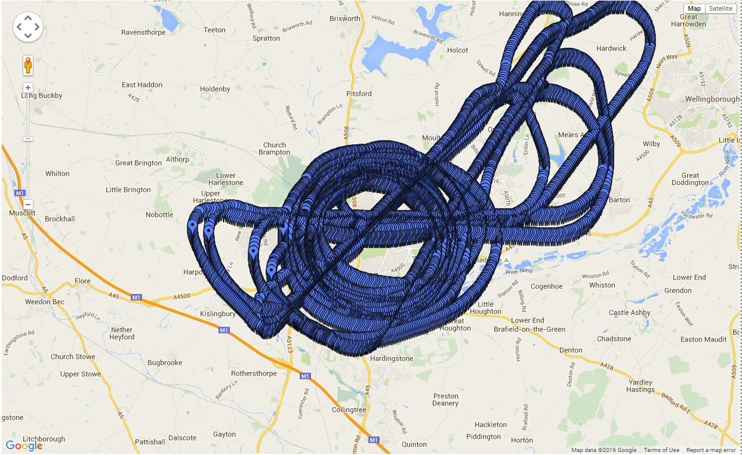
      2. Spectrograms of the measured 2.4 GHz data calibrated to the antenna port

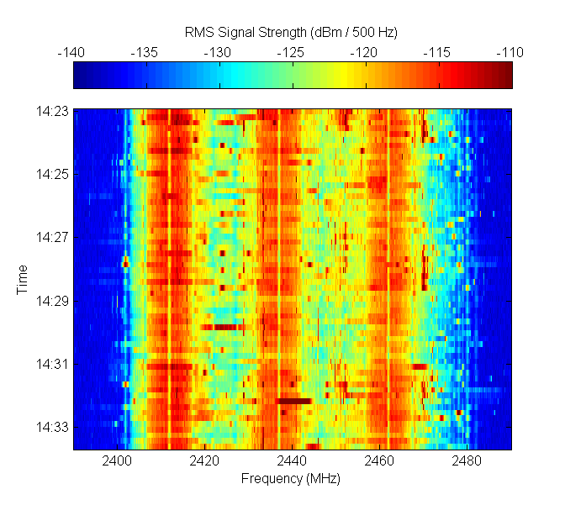

Horn out of window

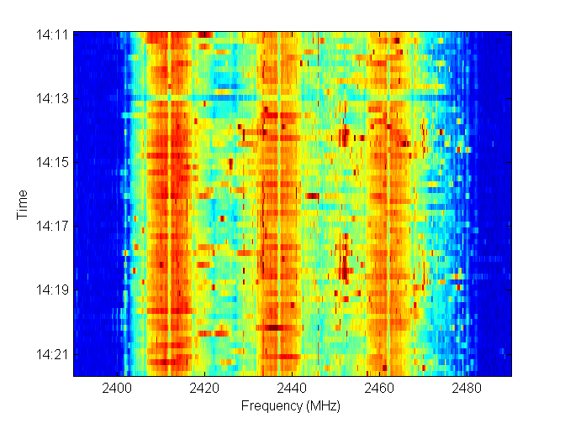

Panel out of window

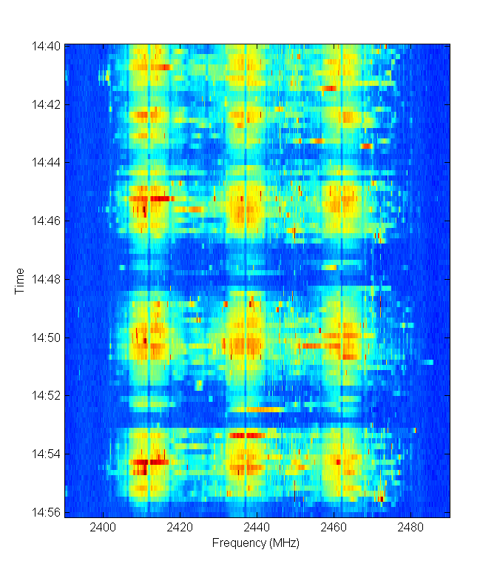

Panel in radome

* + 1. Spectrograms of the measured 5 GHz data calibrated to the antenna port

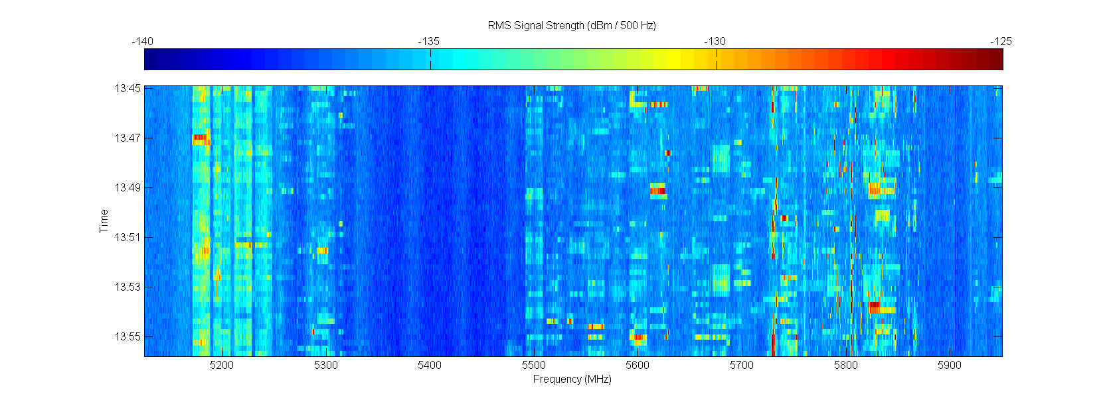

Horn out of window

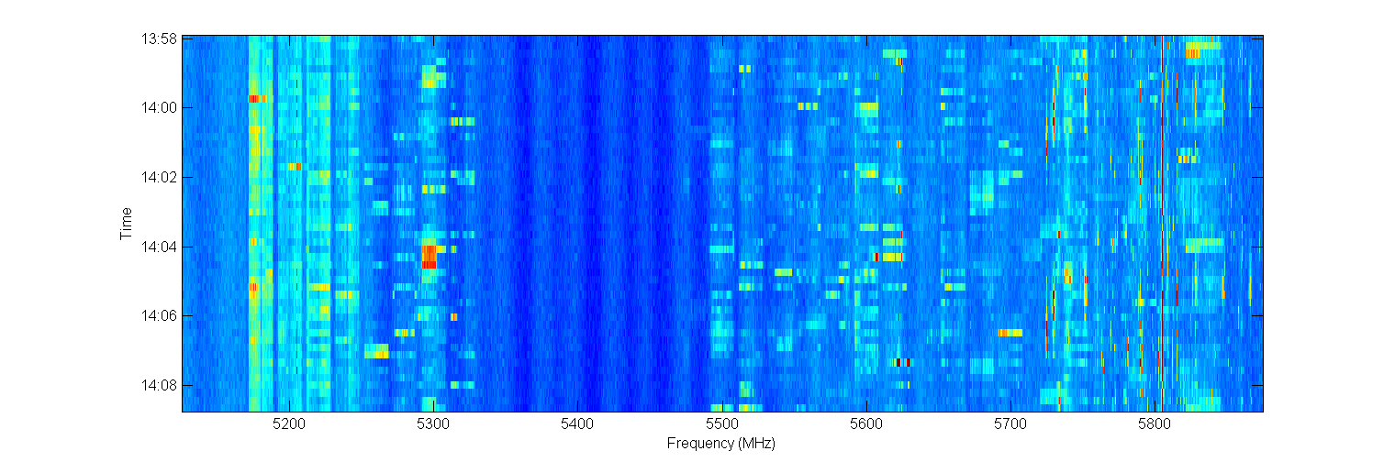

Panel out of window

* + - 1. 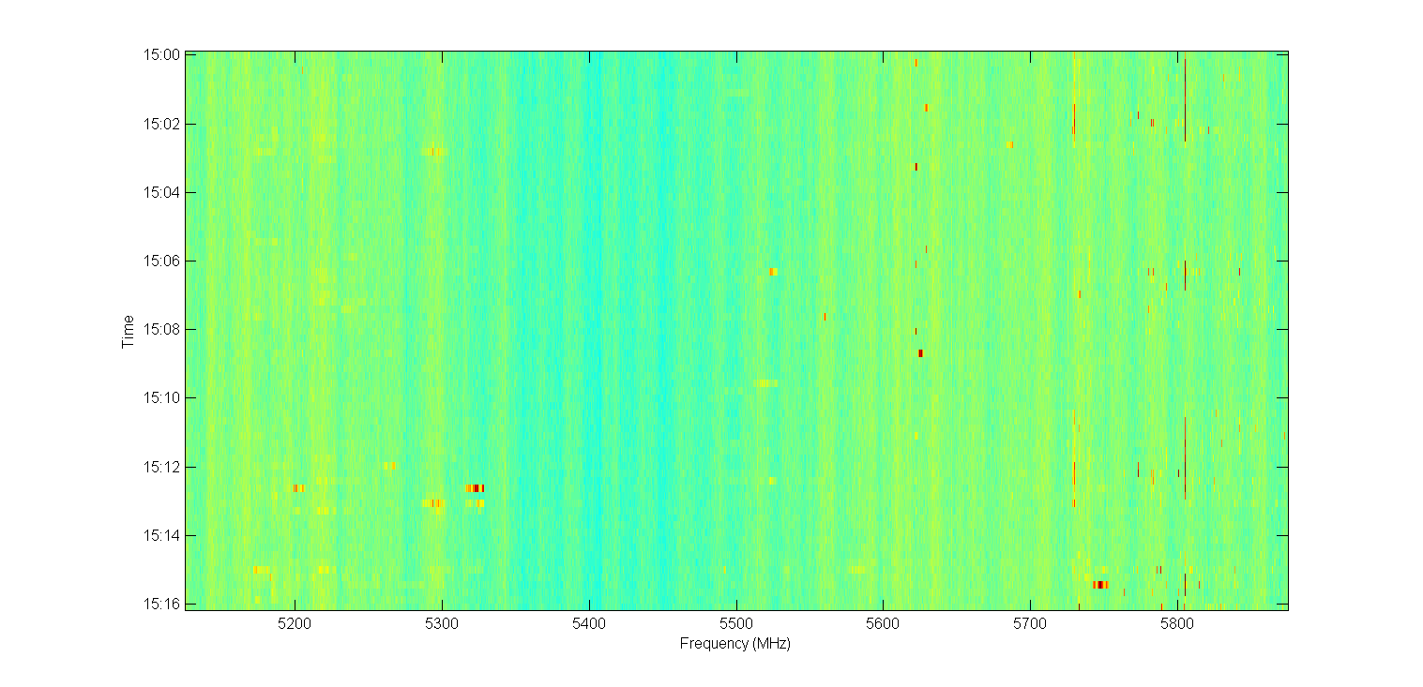

Panel in radome

1. Annex 3
   1. High Level Summary of UK/Europe 5 GHz RLAN & BFWA Regulations

In this Annex we provide a simple on-one-page summary of the current UK / European RLAN and BFWA regulations. These were derived from the ETSI standards[7],[8] as referenced in the UK interface requirements[9],[10].



|  |  |  |  |  |  |  |  |
| --- | --- | --- | --- | --- | --- | --- | --- |
| *Frequency Range* | 5 150 to 5 250 MHz | 5 250 to 5 350 MHz | 5 470 to 5 725 MHz | | 5 725 to 5 850 MHz | |  |
| *Condition of Operation* | Indoor only Fixed and Mobile | | Indoor and Outdoor  Fixed and Mobile | | Indoor and Outdoor Fixed only | |  |
| *Licensing Condition* | License Exempt | | | | Light Licensed  5 795 to 5 815 MHz shall not be used (to protect RTTT) | |  |
| *Max. Conducted Power* | N/A (EIRP condition only) | | | | 1.00 | | *W* |
| *Max. EIRP* | 0.20  0.01 | 0.20  0.01  without TPC:  100 mW (5 mW / MHz) | 1.00  0.05  without TPC:  500 mW (25 mW / MHz) | | 4.00  0.20  Skyward emissions restriction* | | *W*  *W / MHz* |
| *Tx Power Reduction (dBm‑by‑dBi) required when antenna exceeds …* | N/A (EIRP condition only) | | | | > 6 | | dBi |
| *Out-of-band EIRP emissions limit* | 1 000 to 5 150 MHz:  5 350 to 5 470 MHz:  5 725 to 26 000 MHz: | | | -30  -30  -30 | 1 000 to 5 725 MHz:  5 875 to 26 500 MHz: | -30  -30 | dBm / MHz |
| *Dynamic Frequency Selection required?* | **No** | **Yes,** for master device | | | **Yes**, for ALL BFWA devices as specified in ETSI EN 302 502 | |  |
| **No**, for slave device under control of a master | | |
| *Transmit Power Control  required?* | **No** | **Yes**, RLANs must be able to reduce EIRP < 50 mW | **Yes**, RLANs must be able to reduce EIRP < 250 mW | | **Yes**, ALL BFWA must be able to reduce EIRP < 250 mW | |  |
| **No**, for RLANs w/ EIRP < 100 mW | **No**, for RLANs w/ EIRP < 500 mW | |

* The EIRP spectral density of the transmitter emissions should not exceed the following values for the elevation angle θ (degrees) above the local horizontal plane (of the Earth):

For sectorised (e.g. P-MP Central or Base Station) and Omni-directional deployments:

−7 dB(W/MHz) for 0° ≤ θ <4°

−2.2 - (1.2*θ) dB(W/MHz) for 4° ≤ θ ≤ 15°

−18.4 - (0.15*θ) dB(W/MHz) for θ > 15°

For P-MP Customer Terminal Station and P-P deployments:

−7 dB(W/MHz) for 0° ≤ θ <8°

−2.68 -(0.54*θ) dB(W/MHz) for 8° ≤ θ < 32°

−20 dB(W/MHz) for 32° ≤ θ ≤50°

−10 - (0.2*θ) dB(W/MHz) for θ > 50°

1. “2.4 GHz Wi‑Fi Airborne Measurements - Submission to SE24 for coexistence studies between Wi Fi and satellites at 5 GHz”, Ofcom, 02/12/2015,

   <http://www.cept.org/Documents/se-24/28001/SE24(15)166R0_WI52_Ofcom_24_GHz-_Airborne_Meas_ove-r_London>
2. Figure 3-9: 5 GHz channel utilisation in central London, “Future Use of License Exempt Spectrum”, Plum Consulting, July 2015,

   <http://www.plumconsulting.co.uk/pdfs/Plum_July_2015_Future_use_of_Licence_Exempt_Radio_Spectrum.pdf>
3. The Brackmills Industrial Estate is home to many large companies including the UK logistics arms of Panasonic and Coca-Cola and smaller high-tech manufacturers,

   <http://www.brackmillsindustrialestate.co.uk/explore-brackmills-industrial-estate-northampton>
4. The Carlsberg brewery in Northampton was the first brewery that Carlsberg established outside of Denmark, <http://www.carlsberggroup.com/Company/heritage/Pages/Exportingandexpanding.aspx>
5. “BBHA 9120 D - Double Ridged Broadband Horn Antenna”, Schwarzbeck,

   <http://www.schwarzbeck.de/en/antennas/broadband-horn-antennas/double-ridged-horn-antenna/404-bbha-9120-d-double-ridged-broadband-horn-antenna.html>
6. “Panel WiFi Antenna”, Tupavco,

   <http://www.network-equipment.com/panel-wifi-antenna-24ghz5ghz-58ghz-range-13dbi-dual-bandmulti-band-outdoor-directional-wireless-antenna-2400-25005150-5850mhz-tp542>
7. ETSI EN 301 893 V1.8.1 (2015-03), “Broadband Radio Access Networks (BRAN); 5 GHz high performance RLAN; Harmonized EN covering the essential requirements of article 3.2 of the R&TTE Directive”,

   <http://www.etsi.org/deliver/etsi_en/301800_301899/301893/01.08.01_60/en_301893v010801p.pdf>
8. ETSI EN 302 502 V1.2.1 (2008-07), “Broadband Radio Access Networks (BRAN); 5,8 GHz fixed broadband data transmitting systems; Harmonized EN covering the essential requirements of article 3.2 of the R&TTE Directive”, <https://www.etsi.org/deliver/etsi_en/302500_302599/302502/01.02.01_60/en_302502v010201p.pdf>
9. UK Interface Requirement 2006, “Wireless Access Systems (WAS) including RLANs operating in the 5150-

   5725 MHz band”, Ofcom, November 2006,

   <http://stakeholders.ofcom.org.uk/binaries/spectrum/spectrum-policy-area/spectrum-management/research-guidelines-tech-info/interface-requirements/uk2006.pdf>
10. UK Interface Requirement 2007, “Fixed Broadband Services operating in the 5725-5850 MHz band”, Ofcom, May 2007,

    <http://stakeholders.ofcom.org.uk/binaries/spectrum/spectrum-policy-area/spectrum-management/research-guidelines-tech-info/interface-requirements/uk_interface_2007.pdf>