|  |  |
| --- | --- |
| **Radiocommunication Study Groups** |  |
|  |  |
|  |  |
| Source: Document 5A/TEMP/153(Rev.1) | **Annex 15 to  Document 5A/469-E** |
| **12 June 2017** |
| **English only** |
| Annex 15 to Working Party 5A Chairman’s Report | |
| WORKING DOCUMENT TOWARDS A PRELIMINARY  DRAFT NEW REPORT ITU-R M.[CDLMR] | |
| Conventional digital land mobile radio systems | |

# 1 Scope

This Report deals with the technical and operational characteristics and frequency assignment criteria of conventional[1] digital land mobile radio systems that provide capabilities required for specific user groups/applications, such as governmental, mining, health, hospitality, transportations, disaster relief, industrial, manufacturing, construction, etc.

Issues relating to PPDR are covered in Report [ITU-R M.2009](http://www.itu.int/pub/R-REP-M.2009), Report [ITU-R M.2377](http://www.itu.int/pub/R-REP-M.2377) and Recommendation [ITU-R M.2015](http://www.itu.int/rec/R-REC-M.2015/en).

*Editor notes:*

*– Keep in mind to make appropriate references to other specific docs related to PPDR and Machine to Machine communications.*

*– It should be discussed further where the frequency bands and channel arrangements would be included, either in this PDNR or in a separate report.*

*– Make clear in the body of this PDNR that IMT is covered in other documents.*

– *Based on the discussions in the WP 5A November meeting, the scope of the report DLMSA is limited to DPLMR.*

– *Review and make reference to documents related to disaster relief*

Acronyms

LMR Land Mobile Radio

PPDR Public Protection and Disaster Relief

PLMR Private Land Mobile Radio

CTCSS Continuous Tone-Coded Squelch System

DCS Digital Code Squeltch

LBT Listen before talk

**Private Land Mobile Radios (PLMR).** In this report, PLMR are land mobile stations that are utilized by closed groups of users to meet their own specific radiocommunication requirements.

**Conventional Land Mobile Radio System:**  Radiocommunication system where two or more radio terminals communicate on a single fixed frequency which is pre-determined.

NOTE 1: In some cases conventional radios incorporate multiple predetermined frequencies in the same terminal but the radio operates only on one selected frequency at a time.

NOTE 2: Conventional repeaters, which are also part of conventional LMR systems, receive on one frequency and transmit on the same or another frequency.

NOTE 3: Conventional LMR does not use any central control station to assign the frequencies automatically in real time.

NOTE 4: Conventional radios can be analogue or digital.

# 2 Introduction

Private land mobile radios have been providing two way communications for many industries for decades and continue to empower millions of businesses and industries around the world. From schools to seaports, construction sites to convention halls, factories to delivery services, they are synonymous with reliability, durability and convenience.

*Editor´s note: It is necessary to develop some paragraph regarding to the analog to digital transition.*

In the recent years, private land mobile Radios have been transitioning from analog to digital to meet the needs of greater spectrum efficiency. Digital land mobile radios are highly bandwidth-efficient and can accommodate two completely separate “channels” in one 12.5 kHz channel making more efficient use of precious radio spectrum. Digital land mobile radios therefore provide double the capacity of existing 12.5 kHz channel and enable many more people to communicate in the same spectrum.

Many administrations around the world have therefore mandated the use of digital private land mobile radios when authorizing any new licenses and that new designs of two-way radios must be based on digital standards.

*Editor's note [Provide reference to the national regulation of specific countries]*

In addition, digital private land mobile radios offer many advantages over analog, including improved voice quality with greater coverage, better privacy, better battery life and more. In a normal analog radio, every sound that’s picked up by the microphone is transmitted. If there’s a lot of background noise, it can be very difficult to understand the message. Digital technology uses software that focuses purely on voice or data, paying no attention to the machine clatter or the crowd noise around the users. The result is exceptional voice clarity. Radio interference creates static on an analog radio and makes the conversation less intelligible. Voice gets garbled and the message must be repeated. Because a digital radio has automatic error correction, it rebuilds voice sounds and maintains the clarity of the voice, even if a signal is badly corrupted. And since speech is digitally-encoded, the users benefit from smarter capabilities, such as advanced software algorithms that can deliver clear voice in the most extreme conditions. See figure 1 below.

*Editor´s note: The above information could be used in the item 7.*

Figure 1

Conceptual diagram showing improvements in audio quality with digital PLMR

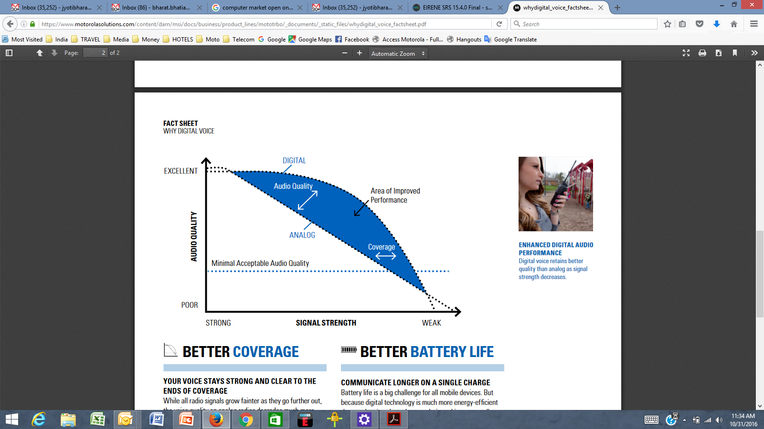

# 3 General technical and operational considerations

A more efficient usage of the existing PLMR spectrums could be achieved with the systematic utilization of 12.5 kHz and 6.25 kHz channel spacing together with digital modulation. The use of 12.5 or 6.25 kHz channels with digital technologies can provide up to 4 times the capacity compared with traditional 25 kHz system. With the same infrastructure, digital PLMR can work as robustly and stable as analogue PLMR systems but provides additional useful features as well as better communication quality. Interference between analogue systems is the same situation as between analogue and digital system. It means that the coexistence issue is not different among analogue vs analogue, analogue vs digital and digital vs digital systems. In addition, CTCSS, DCS and listen before talk (LBT) functions could be ways to mitigate the congestion of CDLMR spectrum.

*Editor´s note: To be enhanced and complemented*

# 4 Systems technical characteristics and operational features and standards

## 4.1 Systems technical characteristics and operational features

## 4.2 Standards

There are a number of standards and technologies that support digital PLMR applications. A short summary of three main DLMR standards are described below:

### 4.2.1 Project 25 (P25 or APCO-25)

P25 may be used in "talk around" mode without any intervening equipment between two radios, in conventional mode where two radios communicate through a repeater or base station without trunking or in a trunked mode where traffic is automatically assigned to one or more voice channels by a Repeater or Base Station.

P25 is a suite of standards for digital radio communications. P25 was established to address the need for common digital public safety radio communications standards for first-responders and homeland security/emergency response professionals. The P25 suite of standards involves digital Land Mobile Radio (LMR) services for local, state/provincial and national public safety organizations and agencies. Although developed primarily for North American public safety services, P25 technology and products are not limited to public safety alone and have also been selected and deployed in other private system application, worldwide. P25-compliant systems are being increasingly adopted and deployed in many countries. Radios can communicate in analog mode with legacy radios, and in either digital or analog mode with other P25 radios. Additionally, the deployment of P25-compliant systems will allow for a high degree of equipment interoperability and compatibility. P25 standards use the proprietary Improved Multi-Band Excitation (IMBE) and Advanced Multi-Band Excitation (AMBE+2) voice codecs which were designed by Digital Voice Systems, Inc. to encode/decode the analog audio signals. The protocol supports the use of Data Encryption Standard (DES) encryption (56 bit), 2-key Triple-DES encryption, three-key   
Triple-DES encryption, Advanced Encryption Standard (AES) encryption at up to 256 bits keylength, RC4 (40 bits, sold by Motorola as Advanced Digital Privacy), or no encryption.

### 4.2.2 DMR

Digital mobile radio (DMR) is an open digital mobile radio standard defined in the European Telecommunications Standards Institute (ETSI) Standard and used in commercial products around the world. DMR, along with P25 and TETRA are the main LMR technologies in achieving  
 6.25 kHz equivalent bandwidth. DMR was designed with three tiers. DMR tiers I and II (conventional) were first published in 2005, and DMR III (trunked) was published in 2012, with manufacturers producing products within a few years of each publication. The primary goal of the standard is to specify a digital system with low complexity, low cost and interoperability across brands, so radio communications purchasers are not locked into a proprietary solution. In practice, many brands have not adhered to this open standard and have introduced proprietary features that make their product offerings non-interoperable.

The DMR standard operates within the existing 12.5 kHz channel spacing used in land mobile frequency bands globally, but achieves two voice channels through two-slot TDMA technology. The standards are still under development with revisions being made regularly as more systems are deployed and discover improvements that can be made. It is very likely that further refinements will be made to the standard, which will necessitate firmware upgrades to terminals and infrastructure in the future to take advantage of these new improvements, with potential incompatibility issues arising if this is not done. DMR covers the RF range 30 MHz to 1 GHz.

The DMR Association and manufacturers often claim that DMR has superior coverage performance to analogue FM. Forward error correction can achieve a higher quality of voice when the receive signal is still relatively high. In practice, however, digital modulation protocols are much more susceptible to multipath interference and fail to provide service in areas where analogue FM would otherwise provide degraded but audible voice service. At a higher quality of voice, DMR outperforms analogue FM by about 11 dB. Where digital signal processing has been used to enhance the analogue FM audio quality then analogue FM generally outperforms DMR in all situations, with a typical 2-3 dB improvement for "high quality" voice and around 5 dB improvement for "lower quality" voice.[citation needed] Where digital signal processing is used to enhance analog FM audio, the overall "delivered audio quality" is also considerably better than DMR.[citation needed] However DSP processing of analog FM audio does not remove the 12.5 kHz requirement so DMR is still more spectrally efficient.

DMR Tier I products are for licence-free use in the 446 MHz band in many countries in Europe and Asia. Tier I products are specified for non-infrastructure use only without the use of repeaters. This part of the standard provides for consumer applications and low-power commercial applications, using a maximum of 0.5 watt RF power.

DMR Tier II covers licensed conventional radio systems, mobiles and hand portables operating in PMR frequency bands up to 960 MHz. The ETSI DMR Tier II standard is targeted at those users who need spectral efficiency, advanced voice features and integrated IP data services in licensed bands for high-power communications. A number of manufacturers have DMR Tier II compliant products on the market. ETSI DMR specifies two slot TDMA in 12.5 kHz channels for Tier II and III.

DMR Tier III covers trunking operation in frequency bands up to 960 MHz. Tier III supports voice and short messaging handling similar to TETRA with built-in 128 character status messaging and short messaging with up to 288 bits of data in a variety of formats. It also supports packet data service in a variety of formats, including support for IPv4 and IPv6. Tier III compliant products were launched in 2012.

dPMR and DMR are two major digital technologies for DPLMR, DMR system is a two time-slot TDMA while dPMR is a FDMA system. Both standards use 4 FSK modulation variants (DMR using 9 600 bps in 12.5 kHz channels and dPMR uses 4 800 bps in 6.25 kHz channels) and voice digitally coded with error correction at 3 600 bps. There major operation modes (peer to peer, infrastructure and trunk communication) are supported by DMR and dPMR.

*Editor´s note: To be enhanced and complemented*

# 5 Frequency bands

## 5.1

PLMR utilizes various frequency bands across regions in the mobile service, subject to provisions in the Radio Regulations, regional harmonization measures and national conditions[2].

*Editor´s note: To be enhanced and complemented*

# 6 Channelization

[Channel raster should be compatible with existing channelization and must be technology inclusive. Example of national channelization could be provide in Annex to this Report].

*Editor´s note: To be enhanced and complemented*

# 7 Frequency assignment

[This section aims to deal with frequency assignment for systems operating in intra-Land Mobile Radio Service scenario: methodology, criteria, practice.

E.g. Frequency assignment criteria: when a new DPLMR system will share the frequency with existing PLMR systems; when existing DPLMR require additional channels; do the interference analysis between PLMR system with *C/I* or *I/N*]

## 7.1 Assignment method and criteria

*[TBD]*

## 7.2 Licence-exempt frequencies

PLMR licences control who can transmit where, and on what frequency, to make sure that different users do not cause interference to each other. This is especially important regarding "official" radio users such as governmental, air traffic control, emergency services, disaster relief, mining, health, hospitality, transportations, industrial, manufacturing, construction, etc. In other way, "licence free" or “licence-exempt” radios will be fine for many walkie-talkie simple users, they share limited number of frequency channels with low transmit power subjected to not causing harmful interference and cannot claim protection from harmful interference caused by the other users.  
(e.g. licence-exempt frequencies for PLMR devices around the world, e.g. PMR446, FRS)

# 8 Analog to digital transition

When planning to introduce digital PLMR for the first time, considerations for both data and voice, spectrum channeling plans, type approval and regulatory requirements need to be considered and to ensure the operation of digital radio in existing (or planned) LMR frequency bands.

## 8.1 Digital Voice and Data

Digital PLMR systems support both voice and data services, in time or in frequency domain. Data applications in PLMR are becoming an important aspect of PLMR applications. In scenarios where analog only radio interface are included in the national PLMR requirements, PLMR systems that support both data and voice or improved voice channel will have to wait for changes to benefit from the improved channel usage or to benefit from both data and voice capabilities.

## 8.2 Spectrum

Digital radio equipment that use 25 kHz and 12.5 kHz can operate in existing LMR frequency bands using existing channel arrangements (transmit power, channel assignment plan, channel raster, etc.).

1. Trunked Digital land mobile Radio systems are addressed in Report ITU-R M.2014.  
   
2. For example, in some countries the following bands are used for PLMR: 136 to 144 MHz, 148 to 174 MHz, 350 to 470 MHz, 806 to 869 MHz.