|  |  |  |  |
| --- | --- | --- | --- |
|  | **Radiocommunication Study Groups** | |  |
| **INTERNATIONAL TELECOMMUNICATION UNION** | |  | |
|  | |  | |
| Source: Document 5A/TEMP/24(Rev.1)  Subject: Question [ITU-R 205-5/5](http://www.itu.int/pub/R-QUE-SG05.205) | | **Annex 29 to Document 5A/114-E** | |
| **24 May 2016** | |
| **English only** | |
| Annex 29 to Working Party 5A Chairman’s Report | | | |
| Working document toward a preliminary DRAFT new  report ITU-R M.[ITS usage] | | | |
| Intelligent transport systems (ITS) usage in ITU Member States | | | |

(Question ITU-R 205-5/5)

Table of Contents

1 Scope 3

2 Background 3

3 Related documents 3

4 List of acronyms and abbreviations 3

5 Overview of ITS radio communication and vehicular radar 4

5.1 Terms and definitions 5

5.2 Technical characteristics 5

6 [Legacy] ITS radio communication 6

6.1 Overview 6

6.2 Frequency usage 6

6.3 Standardization 6

6.4 Applications 6

6.5 Region 1 7

6.5.1 Frequency usage 12

6.5.2 Standardization 12

6.6 Region 2 13

6.6.1 Frequency usage 13

6.6.2 Standardization 13

6.7 Region 3 13

6.7.1 Frequency usage 16

6.7.2 Standardization 18

7 Advanced ITS radio communication 20

7.1 Overview 20

7.2 Technical characteristics 20

7.3 Frequency usage 21

7.4 Standardization 22

7.5 Applications 22

7.6 Region 1 22

7.6.1 Frequency usage 22

7.6.2 Standardization 22

7.7 Region 2 22

7.7.1 Frequency usage 23

7.7.2 Standardization 23

7.8 Region 3 23

7.8.1 Frequency usage 23

7.8.2 Standardization 23

8 Millimetre-wave vehicular and road radar 24

8.1 Overview 24

8.2 Technical characteristics 24

8.3 Frequency usage 26

8.4 Standardization 26

8.5 Applications 27

8.6 Region 1 27

8.6.1 Frequency usage 27

8.6.2 Standardization 27

8.7 Region 2 27

8.7.1 Frequency usage 28

8.7.2 Standardization 28

8.8 Region 3 28

8.8.1 Frequency usage 29

8.8.2 Standardization 30

9 Conclusions 31

*[Editor’s note: All the texts may be addressed in future contributions to this document.]*

*[Editor’s note: Renumbering is required for the figures and tables.]*

# 1 Scope

This report addresses the usages of ITS radiocommunication applications, such as vehicle to infrastructure, vehicle to vehicle, vehicle to pedestrian communications for road safety applications and vehicular radars for collision avoidance in ITU Member states.

# 2 Background

Asia-Pacific Telecommunity (APT) already published an APT Report on “The usage of intelligent transport systems in APT Countries” Revision 1 (APT/AWG/REP-18 (Rev.1)) which APT contributed to WP 5A in May 2013 (Document 5A/223).

# 3 Related documents

ITU-R Recommendations:

ITU-R M.1890 Intelligent transport systems – Guidelines and objectives

ITU-R M.1452 Millimetre wave radiocommunication systems for Intelligent Transport Systems applications

ITU-R M.1453 Intelligent Transport Systems – dedicated short-range communications at 5.8 GHz

ITU-R M.2057 Systems characteristics of automotive radars operating in the frequency band 76-81 GHz for intelligent transport systems applications

ITU-R Report:

ITU-R M.2228 Advanced intelligent transport systems (ITS) radiocommunication

ITU-R M.2322 Systems characteristics and compatibility of automotive radars operating in the frequency band 77.5-78 GHz for sharing studies

ITU-R Handbook:

Land Mobile (including Wireless Access) - Volume 4:   
 Intelligent Transport Systems

# 4 List of acronyms and abbreviations

APT Asia-Pacific Telecommunity

ARIB Association of Radio Industries and Businesses

ATIS Alliance for Telecommunications Industry Solutions

AWG APT Wireless Group

CEN European Committee for Standardization

CEPT European Conference of Postal and Telecommunications Administrations

ECC Electronic Communications Committee

ETSI European Telecommunications Standards Institute

FCC Federal Communications Commission

IEEE Institute of Electrical and Electronics Engineers

ISO International Organization for Standardization

ITS Intelligent Transport Systems

RLAN Radio Local Area Network

TIA Telecommunications Industry Association

TTA Telecommunication Technology Association

WLAN Wireless Local Area Network

# 5 Overview of ITS radio communication and vehicular radar

Since several decades ago, traffic congestion has been increasing all over the world as a result of increased motorization, urbanization, population growth, and changes in population density. Congestion reduces efficiency of transportation infrastructure and increases travel time, air pollution, and fuel consumption. Interest in Intelligent Transport Systems (ITS) comes from the problems caused by traffic congestion and a synergy of new information technology for simulation, real-time control, and communications networks. Namely, ITS is systems to support transportation of goods and humans with information and communication technologies in order to efficiently and safely use the transport infrastructure and transport means (cars, trains, planes, ships)[1].

Figure 1

Communication technologies and services for ITS[2]

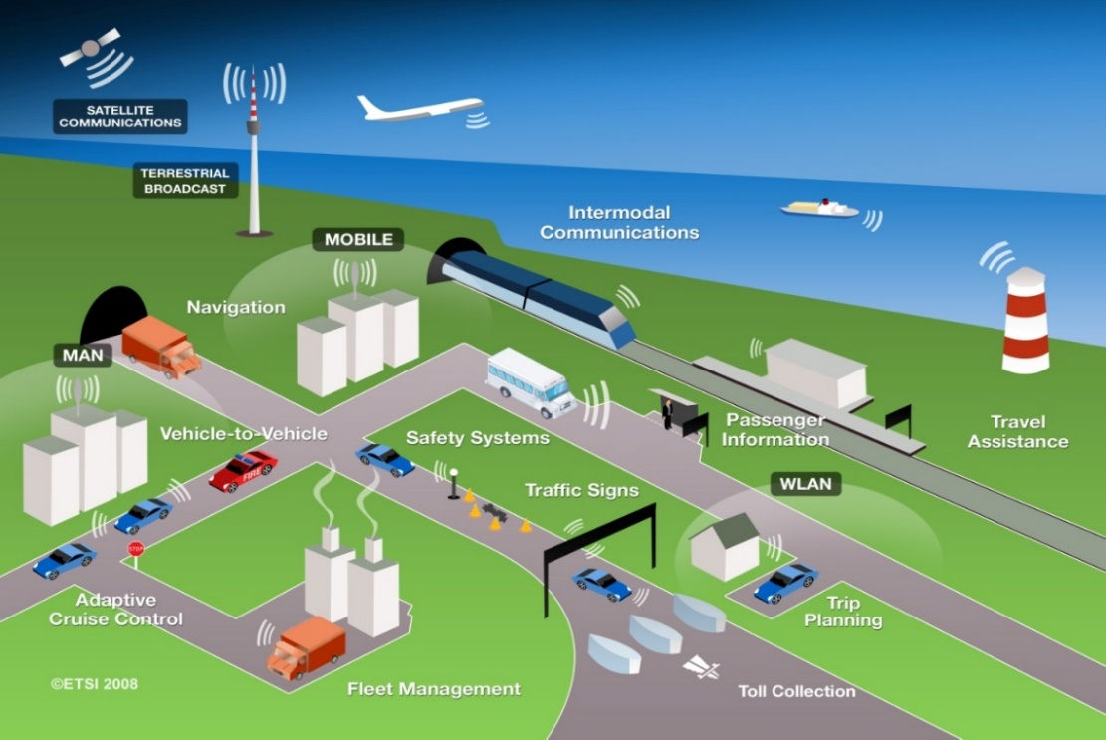

ITS have been standardized and studied in various standards development organizations. As an international level, ITU-R ISO TC 204, and IEEE are working on developing the standards and recommendations.

In Asia-Pacific, AWG is working as a regional level as well as ARIB, TTA and other standard organizations in each countries and regions. In Europe, ETSI TC ITS and CEN TC278 are working as a regional level.

This Report identifies current and planned usage of ITS technologies, frequency bands, status of services deployment in ITU Member States.

Based on the major deployed ITS systems in the world were classified as electronic toll collection, vehicular radar, and vehicle information & communication. In this report, we described service overview, established standards, frequency plan, and implication in each ITS system.

## 5.1 Terms and definitions

*[Editor’s note: Text to be added]*

*[Editor´s note: following terms and definitions should be revised in the document according to the following]*

|  |  |
| --- | --- |
| Dedicated Short Range Communication (DSRC) | **Europe:** road tolling and similar applications |
| **North America**:vehicle-to-vehicle and vehicle –to-infrastructure communication based on IEEE 802.11p / WAVE technology in 5.9 GHz, comparable to C-ITS based on IEEE 802.11p / ITS-G5 in Europe. |
| **Japan**: technology for ETC, road tolling and vehicle-to-infrastructure traffic information systems |
| legacy ITS | * TTT: Transport and Traffic Telematic, mainly in Region 1, also called DSRC in Europe   + CEN DSRC tolling   + HDR DSRC tolling, * ETC: also called DSRC in Japan |
| advanced ITS | cooperative ITS (C-ITS) building on ad hoc networks with vehicle-to-vehicle (V2V) and vehicle-to-infrastructure communication (V2I), together called vehicle-to-X (V2X), e.g.   * + V2X (ETSI ITS-G5, IEEE 802.11p)   + V2X (LTE)   + V2X (WAVE, IEEE 802.11p), also called DSRC in US |

The term DSRC has different meanings in the regions. Therefore the term DSRC is not used in this report. Instead all ITS technologies in this document are structured in the legacy ITS (already existing in the market for several years) and advanced ITS (shortly deployed or in deployment phase).

*[Editor´s note: the sentence above requires to review the document according to above definitions.]*

## 5.2 Technical characteristics

dTable 1

Technical characteristic of [legacy] ITS and advanced ITS

|  |  |  |
| --- | --- | --- |
| Items | [legacy] ITS | Advanced ITS (WAVE, ETSI ITS-G5, etc.) |
| Vehicular networking | V2I | V2I, V2V, V2N |
| Radio performance | Radio coverage: Max. 100 m  Data rate: ~ 4 Mbps  Packet size: ~100 bytes | Radio coverage: Max. 1 000 m  Data rate: Max. 27 Mbps  Packet size: Max. 2 kbytes  Latency: within 100 msec |

# 6 [Legacy] ITS radio communication

## 6.1 Overview

Electronic toll collection (ETC) allows for the manual in-lane toll collection process to be automated in such a way that drivers do not have to stop and pay cash at a toll booth. ETC systems improve traffic flow at toll plazas, and the level of pollution by reducing fuel consumption. In addition, allowing traffic to pass through the gate without stopping can increase road capacity by three or four times and relieve traffic congestion at the tollgate. It is also expected that ETC systems will reduce the operating costs of toll roads by replacing manual toll collection.

There are many similar words related to ETC. In Europe, Electronic Fee Collection (EFC) is popularly used. They think that EFC covers ETC, Electronic Parking System (EPS), Electronic Road Pricing. Electronic Road Pricing is usually referred to the electronic toll collection scheme adopted in Singapore for purposes of congestion pricing. To avoid confusion, these terminologies need to be clearly defined.

## 6.2 Frequency usage

*[Editor’s note: Text to be added]*

## 6.3 Standardization

Table [X]

Global Standard on ETC

|  |  |  |
| --- | --- | --- |
| SDO | Standard No. | Standard Title |
| ITU | ITU-R M.1453-2 | Intelligent transport systems – dedicated short range communications at 5.8 GHz |

Dedicated Short Range Communication (DSRC) refers to any short-range radiocommunication technology from a roadside infrastructure to a vehicle or a mobile platform [4]. Although DSRC can be applied to various application of ITS (e.g. parking payment, gas (fuel) payment, in-vehicle signing, traffic information, etc), ETC is the most typical one. Table 1 shows the established DSRC standards.

## 6.4 Applications

DSRC is the use of non-voice radio techniques to transfer data over short distances between roadside and mobile radio units to perform operations related to the improvement of traffic flow, traffic safety and other intelligent transport service applications in a variety of public and commercial environments. DSRC services include vehicle control systems, traffic management systems, traveller information systems, public transportation systems, fleet management systems, emergency management systems and electronic payment services.

Figure [X]

Interrelation of DSRC with ITS communication networks

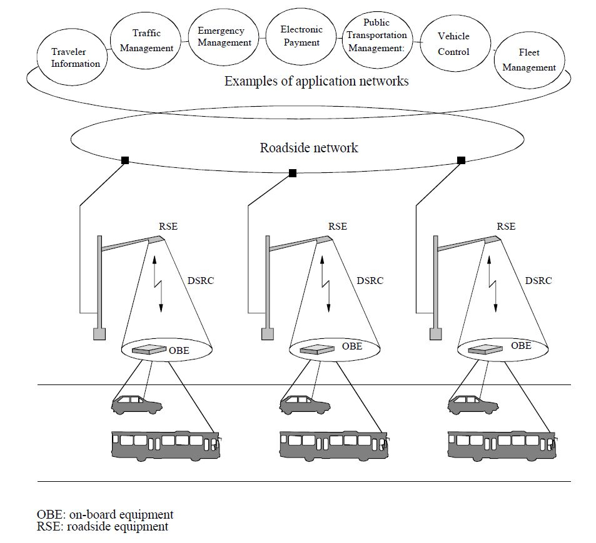

## 6.5 Region 1

In 1992, the CEPT (European Conference of Postal and Telecommunications Administrations) – ERC (European Radio communications Committee) agreed on ERC Decision (92)02 designating frequency bands for the development of a fully Integrated Road Transport system in order to improve all aspects of road transport. It was decided to designate the frequency band 5 795‑5 805 MHz on a European basis, with an additional sub-band 5 805-5 815 MHz on a national basis, to meet the requirements of multilane road junctions. The frequency bands were foreseen for initial road-to-vehicle systems, in particular for road toll systems for which requirements had emerged in a number of European countries at that time. In 2002, the Electronic Communications Committee (ECC) withdrew ERC Decision (92)02 and replaced it by ECC Decision (02)01, entering in force on 15 March 2002.

Based on the ECC Decision, standards for DSRC for ITS applications have been developed by European Committee for Standardization (CEN) and European Telecommunications Standards Institute (ETSI). A standard for the Physical Layer using Microwaves at 5.8 GHz (CEN EN 12253) describes radiocommunication and RF parameter values necessary for co-existence and interoperability of DSRC systems. This standard forms part of the DSRC family of standards consisting of four standards covering the protocol layers 1, 2 and 7 of the Open Systems Interconnection (OSI) protocol stacks and profiles for RTTT (Road Transport and Traffic Telematics) applications. All these CEN standards were approved and published in 2003 and 2004.

The harmonized ETSI standard EN 300 674-2: “Dedicated Short Range Communication (DSRC) transmission equipment (500 kbit/s / 250 kbit/s) operating in the 5.8 GHz Industrial, Scientific and Medical (ISM) band” was approved and published in 2004. This standard contains general and environmental test conditions, methods of measurements and parameter limits.

The use of this harmonized ETSI standard gives a presumption of conformity to article 3 of the Directive 1999/5/EC of the European Parliament and of the (R&TTE Directive).

***[****Editor´s Note: The following technical characteristics will be included in section 6.1 overview at a later stage]****]***

**Technical characteristics**

(1) Passive Backscatter Method

European DSRC systems adopt the passive backscatter (transponder) method. This method does not have an internal oscillator for generating a 5.8 GHz band radio carrier signal in the on board equipment (OBE), so it relies on the 5.8 GHz oscillator of the roadside unit with which it communicates. A detailed explanation is given in Figure 4.3 with a typical functional block diagram.

As the passive transponder does not have a carrier signal oscillator, when transmitting from the OBE, the roadside unit has to emit an unmodulated carrier signal continuously. The OBE receives this signal, which is fed to the transmission circuit and makes it its own carrier signal (B). The transmission data from the main processing unit modulates the output of the sub-carrier signal oscillator C and mixes it with the carrier signal from the receiver. Resultant sideband signals carrying transmission data with different frequencies (carrier signal frequency plus/minus sub carrier frequency) from the carrier signal are transmitted with the carrier signal. The sub-carrier modulation method is utilized to extend the communication zone through reduction of the carrier phase noise and to reduce the re-use distance of RSE in passive transponder system. The modulated signal from the RSE is detected in the detector and processed by the main processing unit as receiving data. The communication zone of the passive (transponder) system is very small, typically up to 10 or 20 meters in front of the RSE. To extend the communication zone to some degree, additional radio frequency amplifier D may be inserted into the transmission circuit of the transponder.

One of the significant features of the passive backscatter method is a narrow communication zone, typically up to 10 or 20 meters in front of the RSE. This characteristic, i.e. communications can only take place at a precise point, is particularly important to correctly locate the vehicle. There are many applications utilizing this characteristic such as Electronic Toll Collection (ETC), Automatic Vehicle Identification (AVI) etc. Another feature of the passive backscatter method is that the structure of the OBE is simple and results in low manufacturing costs.

Figure [X]

Typical configuration of OBE in passive backscatter method

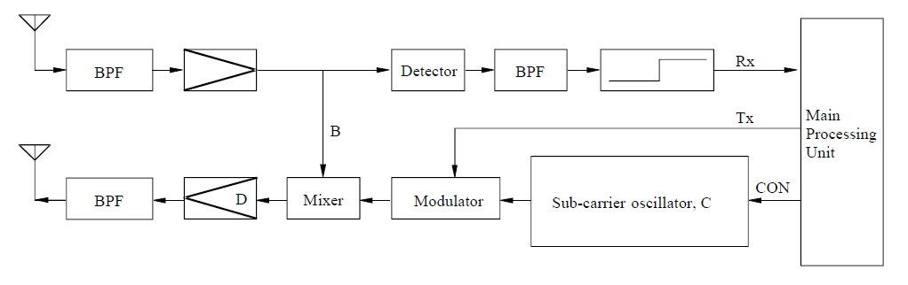

Figure [X] shows the RSE and OBE transmission timing chart and Figure [X] shows the RSE and OBE transmission spectrum in passive backscatter method.

Figure [X]

Transmission timing chart in passive backscatter method

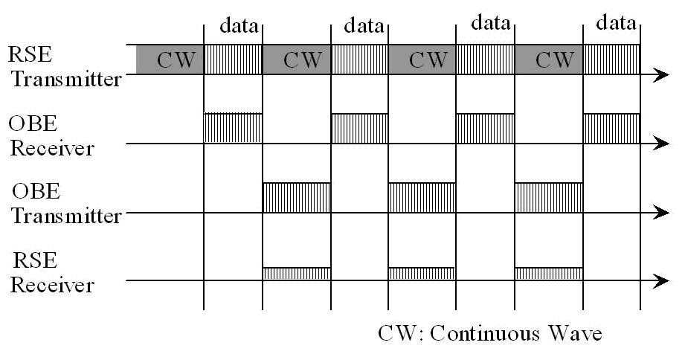

FIGURE [X]

RSE and OBE transmission spectrum in passive backscatter method

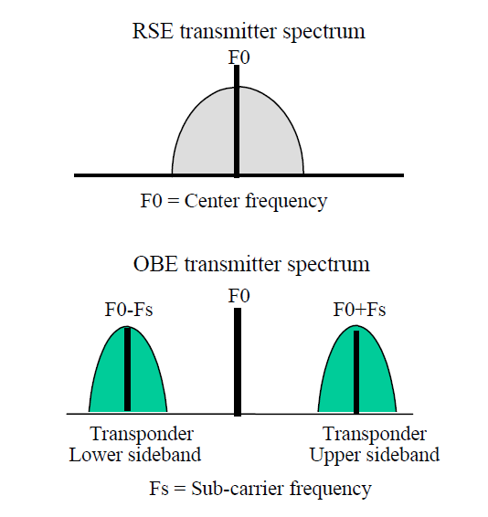

(2) Technical Characteristics of the European Backscatter Method

Technical characteristics of the European backscatter (transponder) method are shown in Table [X] which is an excerpt from Recommendation ITU-R M.1453-2. The Recommendation incorporates the “Medium data rate” European standard (CEN EN 12253) as well as the “High data rate” Italian standard into a single Recommendation.

In the European DSRC standard, the OBE supports two kinds of sub-carrier frequencies (1.5 MHz and 2.0 MHz). Selection of sub-carrier frequency depends on the profile indicated by the RSE. (1.5 MHz is recommended). Frequency spectrum of “Medium data rate” European standard is shown in Figure [X].

In the case of “High data Rate” Italian standard, the OBE uplink sub-carrier frequency is 10.7 MHz, resulting in higher uplink data transmission speed.

Frequency spectrum of the “High data rate” Italian standard is shown in Figure [X].

Figure [X]

Frequency spectrum of “Medium data rate” European standard

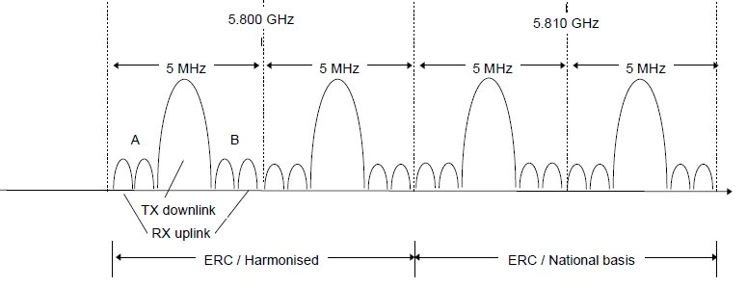

(RAST6(98)29　“Intelligent Transportation System – An ETSI View”)

Figure [X]

Frequency spectrum of “High data rate” Italian standard

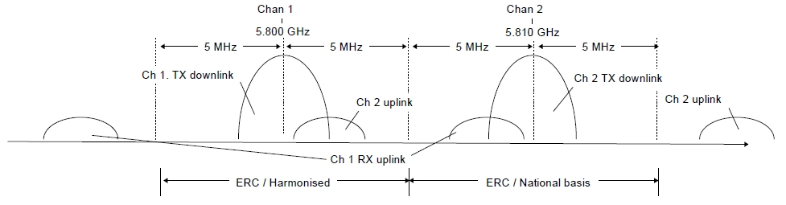

(RAST6(98)29　“Intelligent Transportation System - An ETSI View”)

Table [X]

Characteristics of backscatter (transponder) method

|  |  |  |  |  |
| --- | --- | --- | --- | --- |
| Item | Technical characteristic | | | |
| Medium data rate | | High data rate | |
| Carrier frequencies | | 5.8 GHz band for downlink | | 5.8 GHz band for downlink | |
| Sub-carrier frequencies | | 1.5 MHz/2 MHz (uplink) | | 10.7 MHz (uplink) | |
| RF carrier spacing (channel separation) | | 5 MHz | | 10 MHz | |
| Allowable occupied bandwidth | | Less than 5 MHz/channel | | Less than 10 MHz/channel | |
| Modulation method | | ASK (downlink carrier) PSK (uplink sub-carrier) | | ASK (downlink carrier) PSK (uplink sub-carrier) | |
| Data transmission speed (bit rate) | | 500 kbit/s (downlink) 250 kbit/s (uplink) | | 1 Mbit/s (downlink) 1 Mbit/s (uplink) | |
| Data coding | | FM0 (downlink) NRZI (uplink) | |  | |
| Communication type | | Transponder type | | Transponder type | |
| Maximum e.i.r.p.(1) | | ≤ +33 dBm (downlink) ≤ –24 dBm (uplink: single sideband) | | ≤ +39 dBm (downlink) ≤ –14 dBm (uplink: single sideband) | |
| (1) ERC Recommendation 70-03 specifies values of 2 W e.i.r.p. for active and 8 W e.i.r.p. for passive systems | | | | | |

### 6.5.1 Frequency usage

TABLE [X]

Frequency usage for ETC in Europe

|  |  |  |  |  |
| --- | --- | --- | --- | --- |
| Country | Frequency Band | Technology/ Standard | Service | Deployment or plan Year |
| Europe | 5 795-5 805 MHz  [5 805-5 815 MHz] | DSRC | Electronic Toll Collection | Enacted in [19XX] |

### 6.5.2 Standardization

TABLE [X]

Standard for ETC in Europe

|  |  |  |
| --- | --- | --- |
| SDO | Standard No. | Standard Title |
| ETSI | EN 300 674 | Road Transport and Traffic Telematics (RTTT); Dedicated Short Range Communication (DSRC) transmission equipment (500 kbit/s / 250 kbit/s) operating in the 5,8 GHz Industrial, Scientific and Medical (ISM) band |
| TS 102 486 | Test specifications for DSRC transmission equipment |

***[****Editor´s Note: the following text related to applications to be shifted to chapter 6.1 with legacy ITS application overview over all three regions****]***

**Applications**

(1) General

A large number of European countries are implementing electronic toll collection (ETC) system based on DSRC technology. ETC applications are considered to be a major driving force that will create the new market for a large number of DSRC equipment which provides the versatile services for other DSRC based applications. In addition to ETC, applications such as access control, parking management and payment, traffic information and emergency warning, freight and fleet management, traffic control etc. are proposed as ITS services in Europe. These applications are expected to be implemented significantly when ETC using DSRC technology becomes widely used.

The European project DELTA (DSRC Electronics Implementation for Transportation and Automotive applications) is aiming to integrate the DSRC communication link as basic equipment in any vehicle. The following list includes such possible future ITS applications.

– In-vehicle Signing to Assist for Safe Driving (Obtaining roadside traffic and travel information)

– Parking Garage Fee Payment

– MP3 Music Download While Fuelling

– Vehicle status for car rental automatic billing

– Software Installation (Service facility installs fleet management software on the vehicle)

– Mission Planning (A fleet operator plans and downloads mission data to the vehicle)

– Floating Car Data (Acquisition of travel-related information via DSRC)

– Multimodal Transport Information (Display of public transport vehicle information)

– Vehicle Control (Adaptive automatic cruise control)

– Service subscription

– Diagnostics (Service technician diagnostics fault via DSRC).

It should be noted, that for many of these services, there are competing technologies e.g. mobile communications with satellite positioning (GNSS). However, the specific characteristics of DSRC such as high data integrity (highly reliability) and low transmission latency (real time) will make it possible for DSRC to be used for most services associated with these applications.

Typical applications utilizing favourable characteristics of passive DSRC are described below. These applications are standardized within the European Committee for Standardization (CEN).

## 6.6 Region 2

*[Editor’s note: Text to be added]*

### 6.6.1 Frequency usage

TABLE [X]

Frequency usage for ETC in North and South America

|  |  |  |  |  |
| --- | --- | --- | --- | --- |
| Country | Frequency Band | Technology/ Standard | Service | Deployment or plan Year |
| U.S.A. | 902-928 MHz, | DSRC | Electronic Toll Collection | Enacted in [19XX] |
| Canada | 902-928 MHz | DSRC | Electronic Toll Collection | Enacted in [19XX] |
| Mexico | 902-928 MHz | DSRC | Electronic Toll Collection | Enacted in [19XX] |

### 6.6.2 Standardization

Table [X]

Standard for ETC in North and South America

|  |  |  |
| --- | --- | --- |
| SDO | Standard No. | Standard Title |
|  |  |  |
|  |  |

## 6.7 Region 3

***[****Editor´s Note: The following technical characteristics will be included in section 6.1 overview at a later stage]****]***

**Technical characteristics**

(1) Active (transceiver) method

The Japanese DSRC System adopts the active (transceiver) method. For the active (transceiver) method, the on-board equipment (OBE) is equipped with the same functions as roadside equipment (RSE) which is equipped with devices necessary for radiocommunication. More specifically, both RSE and OBE incorporate a 5.8 GHz band carrier frequency oscillator and have the same functionality for radio transmission. Figure [X] shows a typical block diagram for the OBE’s radio circuitry. The upper half of Figure[X] is the receiver, the lower half is the transmitter and the processing unit is to the right. The transmission and reception antennas may be shared. The OBE in the active (transceiver) method receives radio signals from the RSE with the antenna on the upper left. Each signal received passes through each functional block and is processed by the main processing unit as reception data. The transmission signal from the OBE is the 5.8 GHz band carrier signal from oscillator A modulated with transmission data. The signal is sent from the antenna on the bottomleft.

The active (transceiver) method can easily realize small or large communication zones by controlling the directivity of transmission antenna. Figure [X] shows examples of flexible communication zones forming in the typical configuration of the ETC gate. The footprint (communication zone) of an ETC antenna is very small (typically 3 m x 4 m). On the other hand, a large footprint of up to 30 meters in length can be realized by approach antenna for information dissemination. The Bit Error Rate (BER) within the footprints is very low (Less than 10-6). The main feature of the active (transceiver) method is a flexible zone forming, in addition to large volumes of information to be communicated with high reliability. These characteristics are indispensable for various ITS application services using DSRC.

Figure [X]

Typical configuration of OBE in active transceiver method

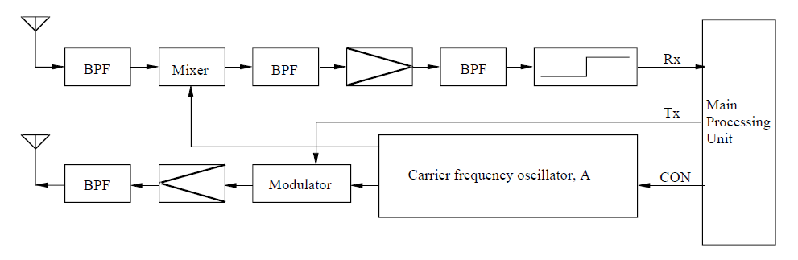

Figure [X]

Examples of DSRC antenna footprints in typical ETC toll gate

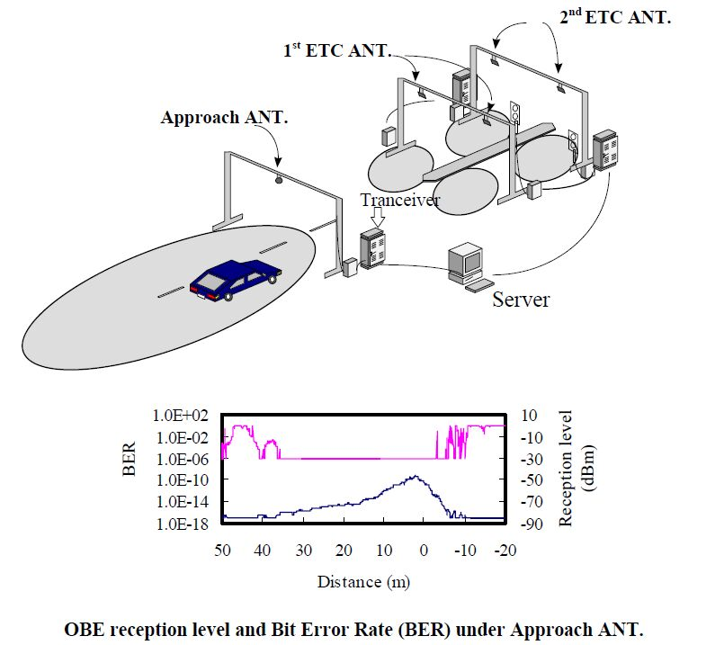

(2) Technical Characteristics of the Japanese Active Method

Technical characteristics of the Japanese active (transceiver) method are shown in Table 4.2, which is also an excerpt from Recommendation ITU-R M.1453-2. In this table there are two specifications in RF carrier spacing column. Wide spacing (10 MHz channel separation) is mainly for current ETC application with the ASK (Amplitude Shift Keying) modulation method. Narrow spacing (5 MHz channel separation) is for multi purpose DSRC application services with the ASK and/or QPSK (Quadrature Phase Shift Keying) modulation method. Specifications for the narrow spacing was added in October 2000, when the Japanese Ministry of Posts and Telecommunications (now MIC) revised the radio law according to the proposal of the Telecommunications Technology Council on general purpose DSRC system applications. The revision was proposed to and adopted by the ITU-R as the modified DSRC Recommendation ITU-R M.1453-1 in August 2002.

The maximum communication zone of DSRC is recommended to be within 30 meters to promote effective use of frequencies by reducing the re-use distance of RSE. FDD (Frequency Division Duplex) systems are also adopted to promote effective use of radio frequencies.

Technical characteristics of the Japanese active (transceiver) method are shown in Table 4.2, which is also an excerpt from Recommendation ITU-R M.1453-2. In this table there are two specifications in RF carrier spacing column. Wide spacing (10 MHz channel separation) is mainly for current ETC application with the ASK (Amplitude Shift Keying) modulation method. Narrow spacing (5 MHz channel separation) is for multi purpose DSRC application services with the ASK and/or QPSK (Quadrature Phase Shift Keying) modulation method. Specifications for the narrow spacing was added in October 2000, when the Japanese Ministry of Posts and Telecommunications (now MIC) revised the radio law according to the proposal of the Telecommunications Technology Council on general purpose DSRC system applications. The revision was proposed to and adopted by the ITU-R as the modified DSRC Recommendation ITU-R M.1453-1 in August 2002.

The maximum communication zone of DSRC is recommended to be within 30 meters to promote effective use of frequencies by reducing the re-use distance of RSE. FDD (Frequency Division Duplex) systems are also adopted to promote effective use of radio frequencies.

Table [X]

Characteristics of active (transceiver) method

|  |  |  |
| --- | --- | --- |
| Item | Technical characteristic | |
| Carrier frequencies | 5.8 GHz band for downlink and uplink | |
| RF carrier spacing (channel separation) | 5 MHz | 10 MHz |
| Allowable occupied bandwidth | Less than 4.4 MHz | Less than 8 MHz |
| Modulation method | ASK, QPSK | ASK |
| Data transmission speed (bit rate) | 1 024 kbit/s/ASK, 4 096 kbit/s/QPSK | 1 024 kbit/s |
| Data coding | Manchester coding/ASK, NRZ/QPSK | Manchester coding |
| Duplex separation | 40 MHz in case of FDD | |
| Communication type | Transceiver type | |
| Maximum e.i.r.p.(1) | ≤ 30 dBm (downlink)  (For a transmission distance of 10 m or less. Power supplied to antenna ≤ 10 dBm) | |
| ≤ 44.7 dBm (downlink)  (For a transmission distance of more than 10 m. Power supplied to antenna ≤ 24.77 dBm) | |
| ≤ 20 dBm (uplink)  (Power supplied to antenna ≤ 10 dBm) | |
| (1) European Radiocommunications Committee (ERC) Recommendation 70-03 specifies values of 2W e.i.r.p. for active and 8 W e.i.r.p. for passive systems | | |

### 6.7.1 Frequency usage

The usage status of ETC in APT countries is shown in Table 2. Many APT countries adopted ETC in frequency band of 2.4, 5.8 and 24 GHz. For ETC in some APT countries, DSRC technology and 5.8 GHz band has been used.

Table [X]

Frequency usage for ETC in Asia-Pacific

| Country | Frequency Band | Technology/ Standard | Service | Deployment or plan Year |
| --- | --- | --- | --- | --- |
| Australia | 5,725-5,795 MHz,  5,815-5,875 MHz,  24-24.25 GHz | - | Electronic tolling | - |
| China | 5,725-5,850 MHz | DSRC | ETC (Electronic Toll Collection) | Enacted in 2003 |
| Hong Kong | 2,400–2,4835 MHz | Exemption from Licensing Order | Electronic toll collection services | 1998 |
| Japan | 5,770-5,850 MHz | ETC (Electronic Toll Collection) | Collect highway toll (Communication) | Enacted in 1997 |
| DSRC  (Dedicated Short Range Communication) | -Collect highway toll -Provide various information (Communication, Broadcast) | Enacted in 2001  (Revised 2007) |
| Korea | 5,795-5,815 MHz | DSRC/  TTA Standard  (TTAS.KO-06.0025/R1) | ETC (Electronic Toll Collection)  BIS(Bus Information System) | 2006  (Highpass Tolling) |
| Singapore | 2,350-2,483.5 MHz | - | Electronic Road Pricing Systems | 1998 |
| Thailand | 5.470-5.850 GHz | Compliance Standard:  ETSI EN 300 440-1 or FCC Part 15.247 or  FCC Part 15.249 | RFID (e.g. Electronic Toll Collection) | 2008 |

### 

### 6.7.2 Standardization

Table [X]

Standard for ETC in Asia-Pacific

|  |  |  |
| --- | --- | --- |
| SDO | Standard No. | Standard Title |
| TTA | TTAS.KO-06.0025/R1 | Standard of DSRC Radio Communication between Road-side Equipment and On-board Equipment in 5.8 GHz band |
| TTAS.KO-06.0052/R1 | Test specification for DSRC L2 at 5.8GHz |
| TTAS.KO-06.0053/R1 | Test specification for DSRC L7 at 5.8GHz |
| ARIB | STD-T75 | Dedicated Short Range Communication (DSRC) System |

*[Editor´s Note: the following text referring to applications to be shifted to chapter 6.1 with legacy ITS application overview over all three regions***]**

**Applications**

As in Europe, Electronic toll collection (ETC) using DSRC is a forerunner of ITS applications in Japan. ETC service in Japan started in March 2001 and by the end of March 2003, the service covered approximately 900 toll gates through which 90% of expressway users pass. This indicates that the service was deployed nationwide in approximately two years. As of the end of March 2004, the number of toll gates increased to 1 300 and as of December 2005, the number of OBEs (ETC subscribers) reached ten million.

The rapid increase in ETC subscribers provides for favourable conditions for various applications to be served by DSRC technology using the same OBE (On board equipment). Research and development are underway through cooperation between the public and industries to develop multiple-purpose on-board equipment that realizes a variety of DSRC services.

Figure [X]

DSRC multiple applications being studied in Japan

1

The following nine application fields are being studied in Japan to extend applications in the vehicle. (Refer to Figure [X]):

(1) Parking lot management

(2) Gas filling station

(3) Convenience store

(4) Drive-through

(5) Logistics management

(6) Pedestrian support

(7) Specific region entry charging (Zone tolling)

(8) Information providing: semi-stationary state

(9) Information providing: high speed

# 7 Advanced ITS radio communication

## 7.1 Overview

Since 1994, Vehicle Information and Communication System (VICS) was used in Japan for delivering traffic and travel information to road vehicle drivers.

Nowadays, to extend beyond the existing ITS applications and to achieve traffic safety and reduce the environmental impact by the transportation sector, vehicle-to-vehicle (V2V), vehicle‑to‑infrastructure (I2V), infrastructure-to-vehicle (I2V) communications are studied. According to this progress, ITU-R WP 5A has developed report on advanced ITS radiocommunications [8]. In the report, traditional ITS and advanced ITS are classified by its technical characteristics as shown in table 6. Wireless Access in Vehicular Environments (WAVE) and Continuous Access for Land Mobiles (CALM) technologies could be inclusive in advanced ITS category.

## 7.2 Technical characteristics

Table [X]

Technical characteristic of Advanced ITS

|  |  |  |
| --- | --- | --- |
| Items | Traditional ITS (DSRC) | Advanced ITS (WAVE, CALM, etc) |
| Vehicular networking | V2I | V2I, V2V, V2N |
| Radio performance | Radio coverage: Max. 100 m  Data rate : ~ 4 Mbps  Packet size : ~100 bytes | Radio coverage: Max. 1 000 m  Data rate: Max. 27 Mbps  Packet size: Max. 2 kbytes  Latency : within 100 msec |

Figure [X]

Vehicle information & Communication (V2V, V2I, I2V)



## 7.3 Frequency usage

Among APT countries, Japan is studying 700 MHz in addition to 5.8 GHz band for V2V communication to transmit safety information. Also, Korea is studying to allocate optimum frequency band for V2V, V2I communication, and performed field test for V2V, V2I communication in experimental frequency band (5.835~5.855 GHz).

On the other hand, Europe plans to use of the 5.855~5.925 GHz frequency band for cooperative ITS according to the ECC decision in 2008, and the U.S. use the frequency band 5.850~5.925 GHz for the WAVE providing ITS applications with specific channels for safety. For interoperability and global harmonization, some APT countries are (e.g. Australia, Singapore) also considering these band for cooperative ITS systems.

Regards these activities, in Australia, the investigation has carefully examined the constraints created by existing and future service coordination requirements. These include, for example, the fixed-satellite service concerns over the unknown compounding effects of aggregated roadside and on board units which could constructively interfere with the FSS, and/or raise the overall noise floor within which the FSS operates. Moreover, the need to protect intelligent transport systems may severely limit the deployment of future FSS earth stations in the band 5 850-5 925 MHz. While studies have indicated these impacts will be minimal, mitigation and appropriate licensing strategies are under consideration.

## 7.4 Standardization

Table [X]

Global Standards on Advanced ITS radiocommunication

| SDO | Standard No. | Title |
| --- | --- | --- |
| ITU | ITU-R M.1890 | Intelligent transport systems - Guidelines and objectives |
| ITU | Report ITU-R M.2228 | Advanced intelligent transport systems (ITS) radiocommunications |
| ITU-R M.[V2X] | Radio interface standards of vehicle-to-vehicle and vehicle-to-infrastructure communication for intelligent transport systems applications |
| IEEE | IEEE 802.11-2012 | Wireless LAN Medium Access Control (MAC) and Physical Layer (PHY) Specifications |
| IEEE 1609 | Family of Standards for Wireless Access in Vehicular Environments (WAVE) |
| - IEEE 1609.0-2013 - IEEE Guide for WAVE – Architecture |
| - IEEE 1609.2 -2013- IEEE Standard for WAVE - Security Services for Applications and Management Messages |
| - IEEE 1609.3 -2010 – IEEE Standard for WAVE - Networking Services |
| - IEEE 1609.3 -2010/Cor 1-2012 – IEEE Standard for WAVE – Networking Services Corrigendum 1: Miscellaneous Corrections |
| - IEEE 1609.3 -2010/Cor 2-2014 – IEEE Standard for WAVE – Networking Services Corrigendum 2: Correct identified errors |
| - IEEE 1609.4 -2010- IEEE Standard for WAVE - Multi-Channel Operations |
| - IEEE 1609.4-2010/Cor 1-2014 – IEEE Standard for WAVE – Multi-channel Operation – Corrigendum 1: Correct identified errors |
| - IEEE 1609.11-2010 – IEEE Standard for WAVE – Over-the-Air Electronic Payment Data Exchange Protocol for ITS |
| - IEEE 1609.12-2012 – IEEE Standard for WAVE – Identifier Allocations |

## 7.5 Applications

*[Editor’s note: Text to be added]*

## 7.6 Region 1

*[Editor’s note: Text to be added]*

### 7.6.1 Frequency usage

### 7.6.2 Standardization

## 7.7 Region 2

*[Editor’s note: Text to be added]*

### 7.7.1 Frequency usage

### 7.7.2 Standardization

## 7.8 Region 3

### 7.8.1 Frequency usage

Table [X]

Frequency usage on Advanced ITS radiocommunication in Asia-Pacific

| Country | Frequency Band | Technology/ Standard | Service | Deployment or plan Year |
| --- | --- | --- | --- | --- |
| Japan | 76-90 MHz  (FM multiplex broadcasting) | VICS (Vehicle Information and Communications System) | Traffic information | Enacted in 1994 |
| 2,499.7 MHz (Radio beacon) |
| 5,770-5,850 MHz | Vehicle-to-Vehicle communications system | Safety information  (Communications) | Guidelines for field experiment in 2007 |
| 700 MHz band | Enacted in 2011 |
| Korea | T.B.D. | (TTAS.KO-06.0175,06- 0913,06- 0216,06- 0234,06- 242) | Vehicle to vehicle and vehicle to Infrastructure  communication | Field  Experiment |

### 7.8.2 Standardization

Table [X]

Standards on Advanced ITS radiocommunication in Asia-Pacific

|  |  |  |
| --- | --- | --- |
| SDO | Standard No. | Standard Title |
| TTA | TTAS.KO-06.0175 | Vehicle-to-Vehicle Communication System Stage1: Requirements |
| TTAS.KO-06.0193 | Vehicle-to-Vehicle Communication SystemStage2: Architecture |
| TTAS.KO-06.0216 | Vehicle-to-Vehicle Communication System Stage3 : PHY/MAC |
| TTAS.KO-06.0234 | Vehicle-to-Vehicle Communication System State 3 : Networking |
| TTAK.KO-06.0242 | Vehicle-to-Vehicle Communication System Stage3 : Application Protocol Interface |
| ARIB | STD-T109 | 700 MHz Band Intelligent Transport Systems |

# 8 Millimetre-wave vehicular and road radar

## 8.1 Overview

Sensor technologies for monitoring and identifying objects near vehicles are the most important safety-related base technologies for developing systems that will accommodate this purpose. Various types of sensors have been studied and developed, and through this research and development, it has become clear that a RADAR (Radio Detection and Ranging) using radio waves is suitable for this objective. An international effort to regulate short-range radar for vehicular applications is crucial for ensuring stable radar operations and effective use of frequency resources. In accordance with the Radio Regulation, the 60-61 GHz and 76-77 GHz bands were considered suitable for radar system due to the radio wave absorption characteristics in the atmosphere as described above. The 76 GHz band has already been assigned by the Federal Communications Commission (FCC) for vehicular radars in the United States of America. The Ministry of Internal Affairs and Communications (MIC) in Japan has assigned the 60-61 GHz and 76-77 GHz bands for low power, short-range vehicular radars. Furthermore, in accordance with European spectrum requirements for RTTT established in 2002, ETSI has adopted a European standard for low power vehicle radar operating in the 76-77 GHz band (EN 301 091) in 1998. In 2000, Recommendation ITU-R M.1452 for low power, short-range vehicular radar operating in the 60-61 GHz, and 76‑77 GHz bands was approved and published.

In Europe, Ultra wide band (UWB) short range radar (SRR) operating at 24 GHz is considered to be a key technology for the rapid and cost-effective introduction of many intelligent vehicle safety systems. In January 2005, the European Commission decided on the time-limited (until 1 July 2013) use of the 24 GHz range radio spectrum band for the ultra-wide band part of short-range vehicle radar equipment. After this deadline SRR equipment is intended to operate in the frequency band 77 to 81 GHz on a permanent base, see ECC/DEC/(04)03. Applications operating around the 24 GHz band would increasingly suffer significant levels of harmful interference if a certain level of penetration of vehicles using the 24 GHz range radio spectrum band for short-range radars was to be exceeded. According to CEPT (European Conference of Postal and Telecommunications Administrations), the sharing between earth exploration satellite services and short-range vehicle radar could only be feasible on a temporary basis.

## 8.2 Technical characteristics

(1) Low Power Vehicular Radar at 60 GHz and 76 GHz

Today the frequency allocation for vehicular radar application is in a rebuilding phase. Due to technological and commercial constraints the frequency allocation for these safety related applications has been done in the beginning of the last decade in the range of 24 GHz. In Europe e.g. this allocation has been done as an intermediate solution due to the incompatibility with the Radio Astronomy Service, EESS, the Fixed Service and military applications. Therefore the cut-off date of 1st July 2013 has been defined. In July 2011 the EC extends the cut-off date (with modified technical parameter) until 1st January 2018 to allow the car manufacturer a seamless implementation of the 79 GHz technology. The technological evolution during the last years leads to the fact that with a similar effort a higher performance can be reached today.

(2) High Resolution Vehicular Radar at 79 GHz

The industries are trying to seek globally or regionally harmonized frequency allocations for new vehicle radar technologies. The following frequency allocation is under consideration and the relevant study work has been undertaken by ITU-R WP 5A/B:

– 77 GHz to 81 GHz Short Range Radar (SRR) < 150 meter (high resolution)

At present, 77.5-78 GHz band is allocated worldwide on a primary basis to the amateur and amateur-satellite services. Therefore, a primary allocation in 77.5–78.0 GHz to the Radiolocation Service to cover continuously 77.0–81.0 GHz for Short-Range high-Resolution Radar has been discussed. This new agenda will be discussed in WRC-15.

(3) Ultra Wide Band (UWB) Radar

UWB technology employs very narrow or short duration pulses that result in very large or wideband transmission bandwidths (refer to Figure [X], “UWB monocycle time and frequency domains”). Generally UWB is defined as the radio signal whose fractional bandwidth is greater than 20% of the centre frequency or the 10 dB bandwidth occupies 500 MHz or more of spectrum. With appropriate technical standards, UWB devices can operate using spectrum occupied by existing radio services without causing interference, thereby permitting scarce spectrum resources to be used more efficiently.

Figure [X]

UWB monocycle time and frequency domains   
(UWB, "A possible area for standards", GSC 8 Presentation by FCC.)

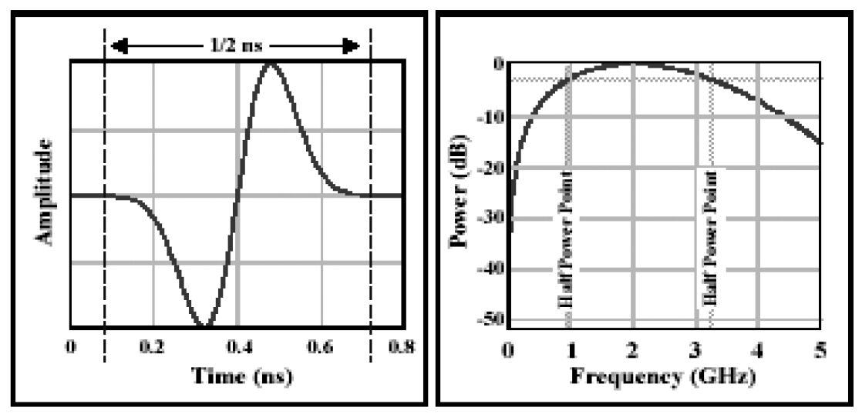

(4) Road radar

Incident detection service deployed in Korea enables drivers in vehicles to receive real-time information for unexpected road situation (obstacle, stopped and wrong way vehicle, frozen-road etc.) through real-time and automatic detection system using radar sensors to prevent unexpected accidents. It also provides traffic information within 1 km from radar sensor. It supports driver in heavy rains and foggy weather to receive real–time information by incident detection system.

FIGURE X

Incident detection service

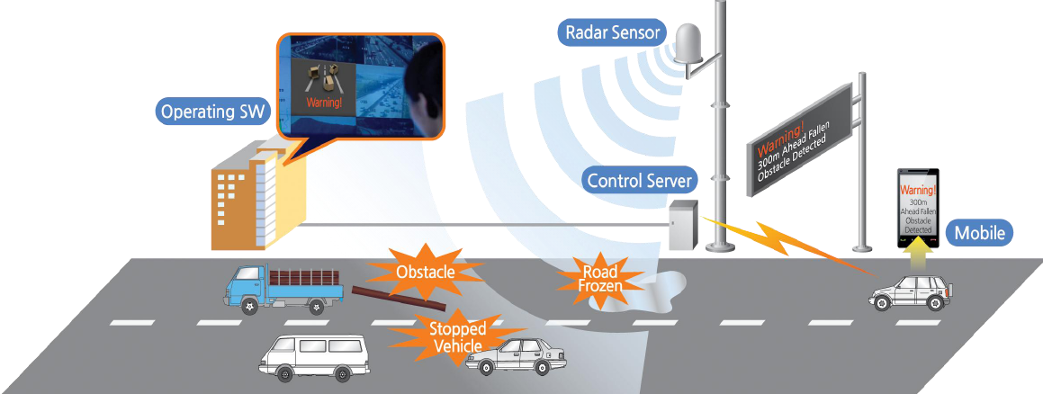

Characteristics of 34 GHz incident detection radar are given in Table x.:

## 8.3 Frequency usage

Table [X]

Global frequency usage on millimetre-wave vehicular radar

|  | 76 to 77 GHz | | | 77 to 81 GHz | | |
| --- | --- | --- | --- | --- | --- | --- |
|  | Regulation | Standard | Report/Notes | Regulation | Standard | Report/Notes |
| ITU | Recommendation ITU-R M.1452 |  | Report ITU-R SM.2067 | Recommendation ITU-R M.1452-2 |  |  |
| Recommendation ITU-R M.2057 |  |  | Recommendation ITU-R M.2057 |  |  |

## 8.4 Standardization

Table [X]

Global standard on millimetre-wave vehicular radar

|  |  |  |
| --- | --- | --- |
| SDO | Standard No. | Standard Title |
| ITU | ITU-R M.1452-2 | Millimetre wave radiocommunication systems for intelligent transport system applications |
| ITU-R M.2057 | Systems characteristics of automotive radars operating in the frequency band 76-81 GHz for intelligent transport systems applications |
| Report: ITU-R M.2322 | Systems Characteristics and Compatibility of Automotive Radars Operating in the 77.5-78 GHz Band for Sharing Studies |

## 8.5 Applications

*[Editor’s note: Text to be added]*

## 8.6 Region 1

*[Editor’s note: Text to be added]*

### 8.6.1 Frequency usage

Table [X]

Frequency usage on millimetre-wave vehicular radar in Europe

|  | 76 to 77 GHz | | | 77 to 81 GHz | | |
| --- | --- | --- | --- | --- | --- | --- |
|  | Regulation | Standard | Report/Notes | Regulation | Standard | Report/Notes |
| Europe  - ECC | -ERC/REC 70-03   Annex 5  -ECC/DEC/(02)01 | ETSI EN 301 091-1 V1.3.3 (2006-11) |  | - 2004/545/EC  -ERC/REC 70-03   Annex 5  -ECC/DEC/(04)03 | ETSI EN 302 264-1 V1.1.1 (2009-06) | - ECC/REP 056  - Partly: CEPT Report 003  - CEPT Report 36 &37 |
| - Russia | SFMC Decision No. 07-20-03-001 Annex 7 |  |  |  |  |  |
| Gulf States | CITC |  |  |  |  |  |

### 8.6.2 Standardization

Table [X]

Standards on millimetre-wave vehicular radar in Europe

|  |  |  |
| --- | --- | --- |
| SDO | Standard No. | Standard Title |
| ETSI | TR 101 983 | Radio equipment to be used in the 76 GHz to 77 GHz band; System Reference Document for Short-Range Radar to be fitted on road infrastructure |
| EN 301 091 parts 1-2 | Short Range Devices; Road Transport and Traffic Telematics (RTTT); Radar equipment operating in the 76 GHz to 77 GHz range; |
| EN 302 288 parts 1-2 | Short Range Devices; Road Transport and Traffic Telematics (RTTT); Short range radar equipment operating in the 24 GHz range; |
| EN 302 264 | Short Range Devices, Road Transport and Traffic Telematics (RTTT); Ultra Wide Band Radar Equipment Operating above 60 GHz |

## 8.7 Region 2

*[Editor’s note: Text to be added]*

### 8.7.1 Frequency usage

Table [X]

Frequency usage on millimetre-wave vehicular radar in North and South America

|  |  |  |  |  |  |  |
| --- | --- | --- | --- | --- | --- | --- |
|  | 76 to 77 GHz | | | 77 to 81 GHz | | |
|  | Regulation | Standard | Report/Notes | Regulation | Standard | Report/Notes |
| U.S.A. | FCC Part 15/15.253 |  |  |  |  |  |
| Canada | Spectrum Utilization Policies SP- 47 GHz | RSS210 |  |  |  |  |
| Mexico | Cofetel usually accepts FCC regulation |  |  |  |  |  |
| Brazil | ANATE resolution No.506 |  |  |  |  |  |

### 8.7.2 Standardization

Table [X]

Standards on millimetre-wave vehicular radar in North and South America

|  |  |  |
| --- | --- | --- |
| SDO | Standard No. | Standard Title |
|  |  |  |

## 8.8 Region 3

***[****Editor´s Note: The following technical characteristics will be included in section 8.1 overview at a later stage]****]***

**Technical characteristics**

*[Editor’s note: Text to be added]*

(1) Incident detection radar

Characteristics of 34 GHz incident detection radar are given in Table x.

TABLE X

Road radar system

| Characteristic(Parameter) | Value |
| --- | --- |
| **Operational characteristics** | |
| Application/Service | Road Incident Detection System |
| Typical installation | Road Side Pole(or gantry) |
| **Technical Characteristics** | |
| Max. range | 1 000 m |
| Frequency range | 34.275~34.875 GHz |
| Specified bandwidth (typical) | Up to 600 MHz |
| Peak Power (e.i.r.p) | Up to +55 dBm |
| Mean Power (e.i.r.p) | Up to +45 dBm |

### 8.8.1 Frequency usage

In APT countries, frequency bands of 22~26.5, 60, 76~77 and 79 GHz has been used. For global harmonization of ITS, APT countries like Australia are considering European activities which use 79 GHz as a permanent band. Also, Hong Kong is considering the plan to open the 77-81 GHz band for automotive radar systems utilizing ultra-wideband technology. In March 2010, the Ministry of Internal Affairs and Communications (MIC) in Japan has started a study group in the Information and Communications Council for the introduction of high-resolution radar in the 77-81 GHz frequency band for national use, and has allocated 78-81 GHz band for high-resolution radar in December 2012. [5]

Table [X]

Frequency usage on millimetre-wave vehicular radar in Asia-Pacific

|  | 76 to 77 GHz | | | 77 to 81 GHz | | |
| --- | --- | --- | --- | --- | --- | --- |
|  | Regulation | Standard | Report/Notes | Regulation | Standard | Report/Notes |
| Korea, Republic of | Rules on Radio Equipment (Article **29** Paragraph 9) (2013-01-03)” |  |  |  |  |  |
| China | Technical Specification for Micropower (Short Distance) Radio Equipments, part XIV |  |  |  |  |  |
| Japan |  | ARIB STD-T48 |  |  | ARIB STD-T111 |  |
| Singapore | IDA  TS SRD |  |  |  |  |  |
| Taiwan, China | LP002 2005-0324 |  |  |  |  |  |
| Thailand | NTC TS 1011-2549 |  |  |  |  |  |

### 8.8.2 Standardization

TABLE [X]

Standards on millimetre-wave vehicular radar in Asia-Pacific

|  |  |  |
| --- | --- | --- |
| SDO | Standard No. | Standard Title |
| ARIB | STD-T111 | 79 GHz Band High-Resolution Radar |

*[Editor´s Note: Applications to be shifted to 8.1 overview].*

**Applications**

Table [X]

Usage status of vehicular radar in Asia-Pacific

| Country | Frequency Band | Technology/ Standard | Service | Deployment or plan Year |
| --- | --- | --- | --- | --- |
| Australia | 22–26.5 GHz |  | Ultra-wideband short-range vehicle radar (UWB SRR) systems for collision avoidance | - |
| 76–77 GHz |  | Long-range vehicle radar (intelligent cruise control) |  |
| China | 76-77 GHz | Radar | Vehicular range radar | Enacted in 2005 |
| 24.25-26.65 GHz | Radar | Vehicular range radar | Enacted in 2012 |
| Hong Kong | 76–77 GHz | Exemption from licensing order | Vehicular radar systems | 2005 |
| Japan | 22-29 GHz | Quasi-millimetre and millimetre wave system | Detect obstacles (Sensor) | Enacted in 2010 |
| 60.5 GHz/76.5 GHz | Enacted in 1997 |
| 78-81 GHz | Enacted in 2012 |
| Korea | 76-77 GHz | Radar | Vehicular collision avoidance radar | 2008 |
| 24.25-26.65 GHz | Radar | Vehicular collision avoidance radar | 2012 |
| Singapore | 76-77 GHz | FCC Part 15 – 15.253 (c) or  EN 301 091 | Short-range radar systems such as automatic cruise control and collision warning systems for vehicle | 2001 |
| Thailand | 5.725-5.875 GHz | - | Radar application | Regulation adopted in 2007 |
| 24.05–24.25 GHz | - | Radar application | Regulation adopted in 2007 |
| 76-81 GHz | - | Radar application | Regulation adopted in 2007 |
| 76-77 GHz | Compliance Standard: FCC Part 15.253 or EN 301 091-1 | Vehicle radar application | Regulation adopted in 2006 |

# 9 Conclusions

*[Editor’s note: Text to be added]*

Intelligent transport systems attract many people’s interest because it could improve the safety of road traffic, ensure smoother traffic, reduce environmental burdens, and stimulate regional economic activity, etc. From the survey results, major deployed ITS systems in APT countries were classified as electronic toll collection, vehicular radar, and vehicle information & communication. As the importance of car safety is increasing, cooperative system is widely considered for international deployment. Especially in Europe, frequency band 5.855~5.925 GHz was assigned for cooperative systems and many development project was performed. Regards these activities, administrations should study the optimal frequency spectrum for cooperative systems and try to reach regional/international harmonization of spectrum arrangements.

References

[1] ETSI EN 302 665 V1.1.0, “Intelligent Transport Systems (ITS); Communications Architecture”

[2] <http://www.etsi.org/website/Technologies/IntelligentTransportSystems.aspx>

[3] APT/AWG/REP-18 (Rev.1)The usage of intelligent transport systems in APT Countries

____________